**OCR**

**What is OCR**

Optical character recognition, or OCR, defines the process of mechanically or electronically converting scanned images of handwritten, typed or printed text into machine-encoded text/digital output.

OCR takes images that include textual elements and attempts to recognize that text.

The output is a text string, and accuracy is measured as the degree of similarity between the recognized text and the text a human would be able to read from the image.

OCR is used to recognize printed text in paper documents, handwritten characters, and text elements in the physical environment, such as license plate numbers, street signs, and street numbers.

Traditional OCR algorithms are based on pattern matching, pattern recognition, or image correlation. These techniques, in a standard use case such as a document scanner, can recognize words and sentences with a very high level of accuracy.

However, in more challenging cases that include multiple font styles, camera motion blurring the image, or unclear human handwriting.

Legacy algorithms fall short at most cases and are gradually being replaced by deep learning methods.

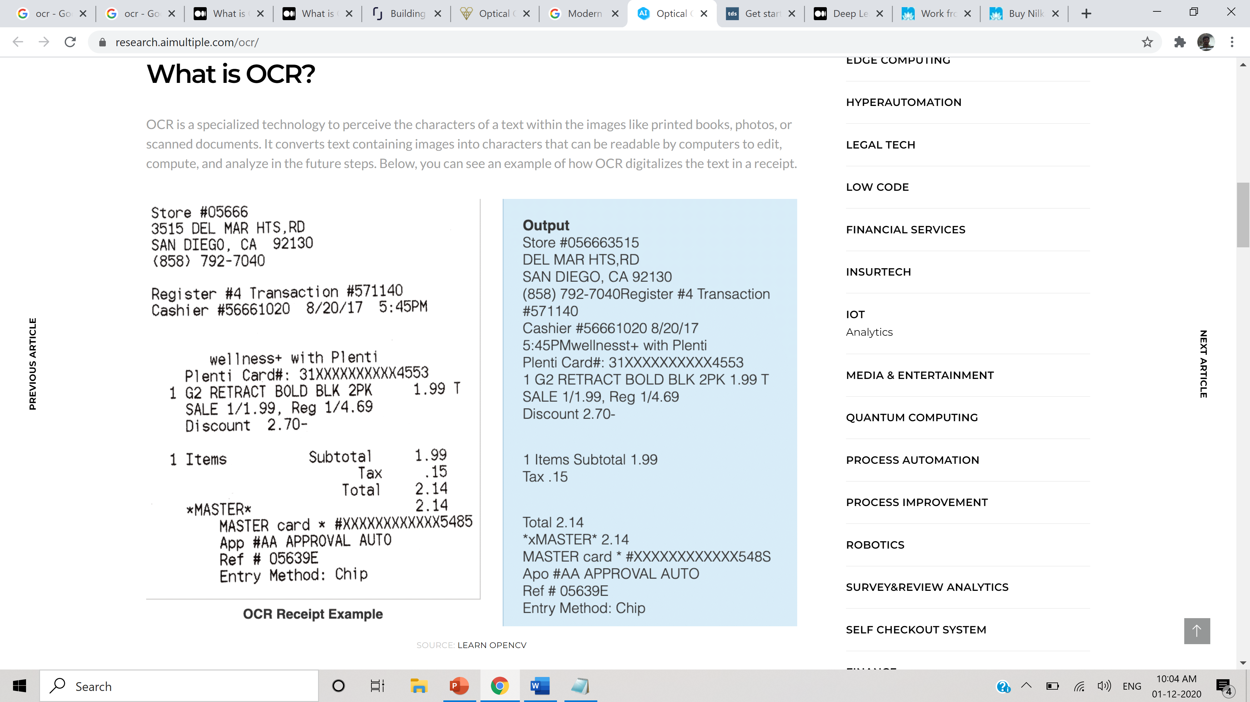

**Three steps of Optical Character Recognition**

1. Image Preprocessing
2. Character/Word Recognition
3. Post-Processing

**5 Main Advantages of Using an OCR**

* Data Access, Searchability and Usability
* Time and Storage Saving
* Improves Customer Satisfaction
* Top-Notch Translation
* Enhancing Security

**Deep Learning OCR Models**

* Text recognition using Deep learning involves two steps:
  + detecting and identifying a bounding box for text areas in the image
  + within each text area, individual text characters
* Initially the above two operations are done separately, but later on specialized deep learning models have evolved to help localize and detect text in images in a single shot
* Here are several commonly-used models
  + Convolutional-Recurrent Neural Network (CRNN)
  + Recurrent Attention Model (RAM)
  + Attention-OCR

**Top open source OCR packages**

* Free Open Source Packages
  + Calamari
  + OCRopus
  + Kraken
  + Tesseract
  + Easy OCR
  + Keras OCR
* Desktop Apps
  + Adobe Acrobat Pro
* Cloud Services
  + Abbyy Cloud
  + Google Cloud Vision
  + Microsoft Azure Computer Vision
  + Amazon’s Rekognition

**Top OCR Vendors**

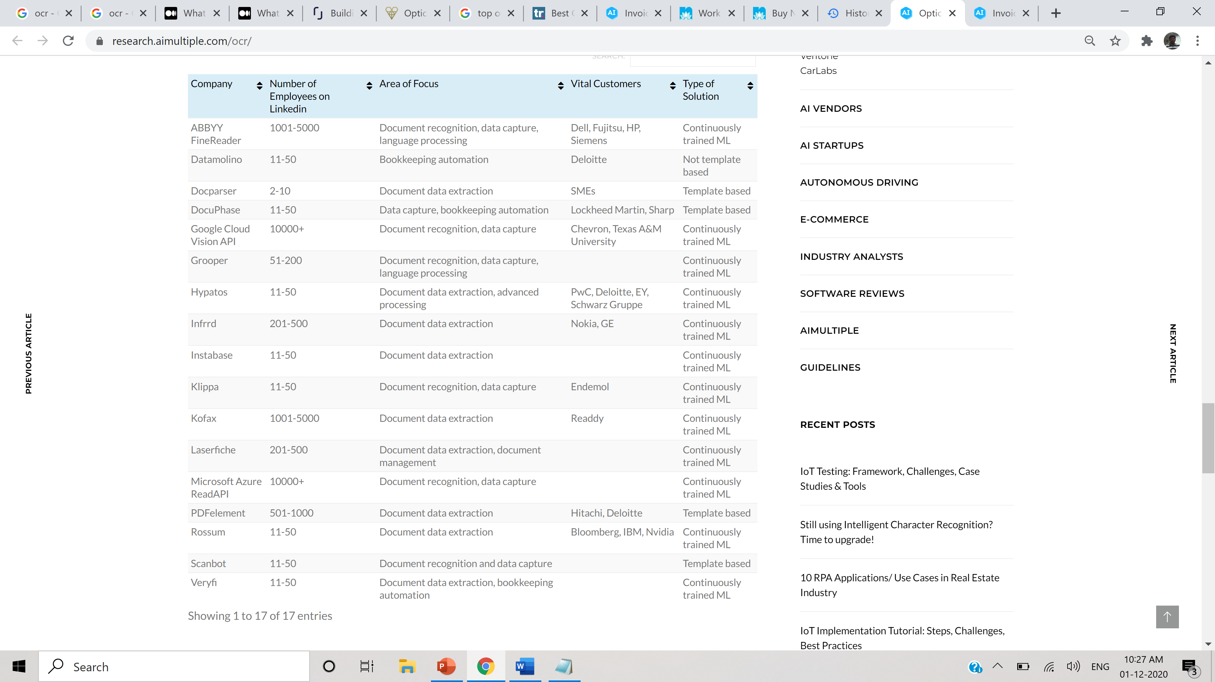

**Challenges in OCR**

Image Acquisition

Input Complexity (Highly Un-structured)

Image Qualities – Blur, Smudge, Noisy

Scale invariability of fonts/text

Image Background

Handwritten Texts

**Data capture**

**What is Data capture**

Every year organizations spend millions on systems to capture data which is generally generated by finance, ERP and CRM applications. However, despite living in a digital age, the majority of an organizations data is still provided in an unstructured format.

With out proper structuring, automating the Process Flow may not be possible, so organizations use component-based technology to create multiple automated, end to end solutions all working within the same platform, which is an extremely cost-effective way of growing your business.

Data capture is one the main key component in automating the process flow which aims at **Extracting and Digitizing key information from any physical or electronic document**

**Popular Methods of Data Capture**

* Keying - Manual, Nearshore
* Click Based Capture
* Template Based Capture
* Document Based Capture

**Popular Deep Learning Data Capture techniques**

* Regional Convolution Networks
* Segmentation Networks
* Table Nets

**Top Vendors for Data Capture**

* FlexiCapture
* Docparser
* Kofax Capture
* M-Files
* Adode Acrobot DC
* Esker
* Conga Composer
* NetDocuments
* OpenText ECM
* 12d Synergy

**Abbyy Flexi Capture**

**What is Data capture**