Services Australia

**MYGOV USER GUIDES**

Digital Engagement Branch

myGov Member Service On-boarding Technical Guide

Produced by: Citizen Access

Last Edited: 10/03/2023

Version: v1.0

Classification: For Official Use Only

**myGov Member Service On-Boarding Technical Guide**

|  |  |  |  |
| --- | --- | --- | --- |
| **Contents** | | Error! Bookmark not defined. | |
| **1.** | **Introduction** |  | **2** |
| **1.1** | **Purpose** |  | **2** |
| **1.2** | **Audience** |  | **2** |
| **1.3** | **Scope** |  | **2** |
| **1.4** | **Out of Scope** |  | **2** |
| **1.5** | **Assumptions** |  | **2** |
| **1.6** | **Terms and Acronyms** |  | **3** |
| **1.7** | **Status** |  | **4** |
| **2.** | **Technical process for integrating with mygov** |  | **5** |
| **3.** | **myGov Capabilities** |  | **6** |
| **4.** | **Appendices** |  | **9** |
| **4.1** | **Appendix 1 - Member Service on-boarding questionnaire** | | **9** |
| **4.2** | **Appendix 2 – myGov Details** |  | **21** |
| **4.3** | **Appendix 3 - Technical documentation available from myGov** | | **22** |
|  |  |  |  |

|  |  |
| --- | --- |
| Version v1.7.03 official use only | 1 |

**myGov Member Service On-Boarding Technical Guide**

1. **Introduction**

**1.1** **Purpose**

The purpose of this document is to provide assistance to the prospective Member Service architects and technical experts in implementing solutions to enable Member Service integration with myGov.

The questionnaire provided to the onboarding Member Service which helps facilitate the onboarding process.

**1.2** **Audience**

The target audience for this document is the technical lead or architect who is leading the onboarding process for the Member Service.

**1.3** **Scope**

The scope of this document is to provide:

An overview of the myGov capabilities and functions

A questionnaire to onboarding Member Services to gain a high-level of understanding of some of the technical requirements to onboard.

High-level technical activities required for integration A list of technical documentation available from myGov

**1.4** **Out of Scope**

This document does not include detailed technical information. Appendix 3 specifies available references. Further information may be made available on request.

**1.5** **Assumptions**

It is assumed that:

The prospective Member Service and myGov have agreed on the engagement scope; and

The prospective Member Service is familiar with the OIDC and has the required enabling technologies.

All staff working on the onboarding must;

**Version v1.7.03 official use only** **2**

**myGov Member Service On-Boarding Technical Guide**

1. Have security clearances
2. Be covered by appropriate contract / confidentiality agreements

**1.6** **Terms and Acronyms**

This table provides a list of all acronyms and any terms used within this document that will require explanation or expansion

|  |  |  |  |
| --- | --- | --- | --- |
| Term |  | Definition |  |
|  |  |  |  |
|  |  |  |  |
| Member Service |  | The Government Agency or Government Agency |  |
|  |  | Program participating in the myGov program |  |
|  |  |  |  |
|  |  |  |  |
| myGov Capability |  | A myGov capability offered as a Service to Member |  |
|  |  | Services |  |
|  |  |  |  |
|  |  |  |  |
| Engagement scope |  | List of myGov Capabilities the prospective Member |  |
|  |  | Service plans to utilise |  |
|  |  |  |  |
|  |  |  |  |
| Account Linking |  | Process associating a customer’s myGov and Member |  |
|  |  | Service accounts |  |
|  |  |  |  |
|  |  |  |  |
| Pairwise Identifier |  | Shared common identifier allowing a Member Service |  |
|  |  | and myGov to identify associated customer accounts |  |
|  |  | without storing primary account identifiers from the |  |
|  |  | other system. Other documents may refer to it as a Link |  |
|  |  | ID or MBUN (Meaningless But Unique Number). |  |
|  |  | Clarification by example: myGov identifies customer |  |
|  |  | accounts by username or email. Member Service MS1 |  |
|  |  | identifies customer’s account by internally issued |  |
|  |  | Customer Identification Number (CIN). myGov systems |  |
|  |  | would not store CINs and/or other MS1 data and MS1 |  |
|  |  | systems would not store myGov usernames and emails. |  |
|  |  | Both parties would only store Member Service Link |  |
|  |  | Identifier. |  |
|  |  |  |  |
|  |  |  |  |

**Version v1.7.03 official use only** **3**

**myGov Member Service On-Boarding Technical Guide**

|  |  |  |  |
| --- | --- | --- | --- |
| Term |  | Definition |  |
|  |  |  |  |
|  |  |  |  |
| Core Data |  | Customer’s first name, last name and date of birth |  |
|  |  |  |  |
|  |  |  |  |
| Profile Member |  | A Member Service that is authorised to provide Core |  |
| Service |  | Data to myGov |  |
|  |  |  |  |
|  |  |  |  |
| OIDC |  | OpenID Connect |  |
|  |  |  |  |
|  |  |  |  |
| Service Consumer |  | In context of the current document, Service Consumer is |  |
|  |  | a system component responsible for communicating |  |
|  |  | data to externally exposed myGov Web Service and |  |
|  |  | processing data returned by externally exposed myGov |  |
|  |  | Web Service |  |
|  |  |  |  |
|  |  |  |  |

**1.7** **Status**

This document in draft

**Version v1.7.03 official use only** **4**

**myGov Member Service On-Boarding Technical Guide**

1. **Technical process for integrating with mygov**

The process for a Member Service to implement integration with one or more myGov Business Services is as follows:

1. Member Service and Service Australia collaborate to establish which capabilities the Member Service wants to onboard to. A written agreement is established to deliver those chosen capabilities.
2. The Member Service provides the technical details and artefacts required by myGov in order to provision the Member Service (see Appendix 1 - Member Service on-boarding questionnaire).
3. myGov provisions the Member Service in the test environment and provides the technical details and artefacts required by the Member Service (e.g. WSDLs, secret credentials, security keys, etc.) to integrate in the test environment (see Appendix 2 – myGov Details).
4. The Member Service integrates with the myGov Business Service(s) in the test environment.
5. myGov and the Member Service test the integration in the test environment.
6. myGov provides the technical details and artefacts required by the Member Service (e.g. WSDLs, secret credentials, security keys, etc.) to integrate in the production environment.
7. myGov provisions the Member Service in the production environment and the Member Service deploys the integration implementation in the production environment.

**Version v1.7.03 official use only** **5**

**myGov Member Service On-Boarding Technical Guide**



1. **myGov Capabilities**

myGov Capabilities aim to make it easier for Member Service customers to access Member Services online, while allowing Member Services to leverage whole-of-government capabilities to interact with their customers. The table below provides a high-level description and list of detailed references for each of the myGov Capabilities.



|  |  |  |  |  |  |  |  |  |  |  |  |
| --- | --- | --- | --- | --- | --- | --- | --- | --- | --- | --- | --- |
|  | Ref |  | Service/Function |  |  |  | Description |  |  | myGov references |  |
|  |  |  | Name |  |  |  |  |  |  |  |  |
|  |  |  |  |  |  |  |  |  |  |  |  |
|  | |  |  | |  |  |  |  | |  | |
|  | **1** |  | OIDC Linking and |  |  |  | myGov implements a Federated | Identity |  | mygov-oidc-dev-guide.pdf |  |
|  |  |  | Authentication |  |  |  | model and achieves account linking using | |  |  |  |
|  |  |  |  |  |  |  | pseudonymous identifiers. An | Industry |  |  |  |
|  |  |  |  |  |  |  | standard protocol (Open ID Connect (OIDC)) | |  |  |  |
|  |  |  |  |  |  |  | is used to authenticate users. The following | |  |  |  |
|  |  |  |  |  |  |  | functions may be performed by member | |  |  |  |
|  |  |  |  |  |  |  | services using the OIDC authentication | |  |  |  |
|  |  |  |  |  |  |  | protocol. |  |  |  |  |

1. Account linking
2. Account unlinking
3. User Authentication – Single Sign-On (SSO)

Further details can be found in the attached

reference documents.



|  |  |
| --- | --- |
| Version v1.7.03 official use only | 6 |



**myGov Member Service On-Boarding Technical Guide**



|  |  |  |  |  |  |  |  |  |  |  |  |  |  |
| --- | --- | --- | --- | --- | --- | --- | --- | --- | --- | --- | --- | --- | --- |
|  | Ref |  | Service/Function |  | Description | |  |  | myGov references | |  |  |  |
|  |  |  | Name |  |  |  |  |  |  |  |  |  |  |
|  |  |  |  |  |  |  |  |  |  |  |  |  |  |
|  | **2** |  | Update Your Contact |  | The myGov Update Your Contact Details | | | | myGov | system | Interface | Spec |  |
|  |  |  | Details |  | Capability allows customers to update their | | | | Customer Details Change | | |  |  |
|  |  |  |  |  | contact details across participating linked | | | |  |  |  |  |  |
|  |  |  |  |  | Member Services with a single interaction. | | | | myGov TuO WS SIS Customer | | | |  |
|  |  |  |  |  | To integrate with this capability the following | | | | Details 2.3 | |  |  |  |
|  |  |  |  |  | web services should be implemented or | | | |  |  |  |  |  |
|  |  |  |  |  | consumed by the Member Service. Further | | | |  |  |  |  |  |
|  |  |  |  |  | details can be found in the attached | | | |  |  |  |  |  |
|  |  |  |  |  | reference documents | |  |  |  |  |  |  |  |
|  |  |  |  |  | Web services to be consumed by the Member | | | |  |  |  |  |  |
|  |  |  |  |  | Service: | |  |  |  |  |  |  |  |
|  |  |  |  |  | 1. | updateCustomerDetailsChangeStatus | | |  |  |  |  |  |
|  |  |  |  |  | Web services to be provided by Member | | | |  |  |  |  |  |
|  |  |  |  |  | Service: | |  |  |  |  |  |  |  |
|  |  |  |  |  | 1. | notifyCustomerDetailsChange | | |  |  |  |  |  |
|  |  |  |  |  |  | | | |  |  |  |  |  |
|  |  |  |  |  |  |  |  |  |  |  |  |  |  |
|  | **3** |  | myGov Inbox |  | The myGov Inbox Capability allows | | | | myGov | System | Interface | Spec |  |
|  |  |  |  |  | participating Member Services to send | | | | Digital Mail | |  |  |  |
|  |  |  |  |  | secure | messages | and | electronic |  |  |  |  |  |
|  |  |  |  |  | correspondence to their customers. To | | | | myGov Digital Mail v 3.3.pdf | | |  |  |
|  |  |  |  |  | integrate with this capability the following | | | |  |  |  |  |  |
|  |  |  |  |  |  |  |  |  |  |  |  |  |  |
|  |  |  |  |  |  |  |  |  |  |  |  |  |  |
|  |  |  |  |  |  |  |  |  |  |  |  |  |  |
|  | Version v1.7.03 official use only | | |  |  |  |  |  |  |  |  | 7 | |



**myGov Member Service On-Boarding Technical Guide**



|  |  |  |  |  |  |  |
| --- | --- | --- | --- | --- | --- | --- |
| Ref |  | Service/Function |  | Description | | myGov references |
|  |  | Name |  |  |  |  |
|  |  |  |  |  |  |  |
|  |  |  |  | web services should be implemented or | |  |
|  |  |  |  | consumed by the Member Service. Further | |  |
|  |  |  |  | details can be found in the attached | |  |
|  |  |  |  | reference documents | |  |
|  |  |  |  | Web services to be consumed by the Member | |  |
|  |  |  |  | Service: | |  |
|  |  |  |  | 1. | publishMessage |  |
|  |  |  |  | Web services to be provided by Member | |  |
|  |  |  |  | Service: | |  |
|  |  |  |  | 1. | retrieveAttachment |  |
|  |  |  |  | 2. | notifyReadReceipt |  |
|  |  |  |  |  |  |  |
|  |  |  |  |  |  |  |
|  |  |  |  |  |  |  |
|  |  |  |  |  |  |  |



|  |  |
| --- | --- |
| Version v1.7.03 official use only | 8 |



**myGov Member Service On-Boarding Technical Guide**



1. **Appendices**

**4.1** **Appendix 1 - Member Service on-boarding questionnaire**

**4.1.1.** **General Information**

The details collected in this section must be provided by any Member Service seeking to integrate with any myGov Capability.

|  |  |  |  |  |  |  |  |  |  |  |  |
| --- | --- | --- | --- | --- | --- | --- | --- | --- | --- | --- | --- |
|  |  | Item |  | Description |  |  |  | Member Service Value |  |  |  |
|  |  |  |  |  |  |  |  |  |
|  |  |  |  |  |  |  |  |  |  |  |  |
|  |  |  |  |  |  |  |  |  |  |  |  |
|  |  | Member Service official name |  | myGov uses the Member Services official |  |  |  |  |  |  |  |
|  |  |  |  |  |  |  |  |  |  |
|  |  |  |  | name for display and internal purposes. |  |  |  |  |  |  |  |
|  |  |  |  | Please provide exact text. Note: The |  |  |  |  |  |  |  |
|  |  |  |  | Member Service official name may be |  |  |  |  |  |  |  |
|  |  |  |  | different from the Department / Agency |  |  |  |  |  |  |  |
|  |  |  |  | official name. e.g. Medicare online |  |  |  |  |  |  |  |
|  |  |  | |  |  |  |  |  |  |  |  |
|  |  |  |  |  |  |  |  |  |  |  |  |
|  |  | Member Service abbreviation |  | A short acronym for the Member Service. |  |  |  |  |  |  |  |
|  |  |  |  |  |  |  |  |  |  |
|  |  |  |  | Must be three to eight characters in length. |  |  |  |  |  |  |  |
|  |  |  |  | This acronym will be used in web service |  |  |  |  |  |  |  |
|  |  |  |  | interactions between myGov and the |  |  |  |  |  |  |  |
|  |  |  |  | Member Service. e.g. MCA, CLK, ATO, DVA |  |  |  |  |  |  |  |
|  |  |  | |  |  |  |  |  |  |  |  |
|  |  |  |  |  |  |  |  |  |  |  |  |
|  |  | Member Service Name |  | myGov uses the Member Services name |  |  |  |  |  |  |  |
|  |  |  |  |  |  |  |  |  |  |
|  |  |  |  |  |  |  |  |  |  |  |  |
|  |  |  |  |  |  |  |  |  |  |  |  |
|  |  |  |  |  |  |  |  |  |  |  |  |
|  | Version v1.7.03 official use only | | |  |  | 9 | | | | |  |



**myGov Member Service On-Boarding Technical Guide**

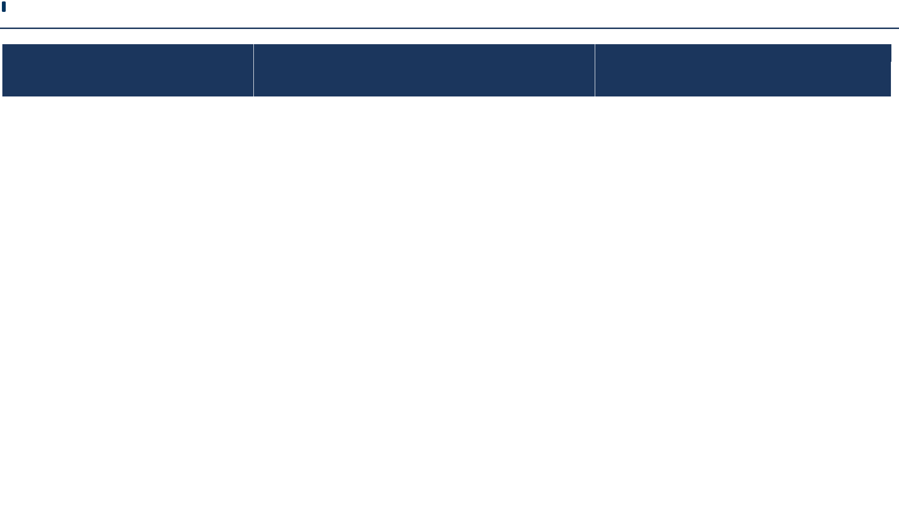

Item

Description

Member Service Value

|  |  |  |  |  |  |  |  |  |  |
| --- | --- | --- | --- | --- | --- | --- | --- | --- | --- |
|  |  |  |  |  |  |  |  |  |  |
|  | preference for Publish |  | preference for Publish Message Message |  |  |  |  |  |  |
|  |  |  |  |  |  |  |  |
|  | Message Notification |  | Notification. Please provide exact text. |  |  |  |  |  |  |
|  |  |  | Note: The Member Service Nname may be |  |  |  |  |  |  |
|  |  |  | different from the Department / Agency |  |  |  |  |  |  |
|  |  |  | official name. e.g. Medicare online |  |  |  |  |  |  |
|  |  |  |  |  |  |  |  |  |  |
|  |  |  |  |  |  |  |  |  |  |
|  |  | | This will be contact details of the technical |  |  |  | Name: |  |  |
|  | Technical Lead’s Contact |  |  |  |  |  |  |
|  | Details |  | lead who is coordinating the onboarding. |  |  |  | Email: |  |  |
|  |  |  |  |  |  |  |  |  |
|  |  |  |  |  |  |  | Phone Number: |  |  |
|  |  |  |  |  |  |  | Job Title: |  |  |
|  |  | |  | |  |  |  |  |  |
|  |  |  |  |  |  |  |  |  |  |
|  | Capability(ies) being |  | The capability(ies)that the Member Service |  |  |  | ☐ OIDC Linking and Authentication |  |  |
|  |  |  |  |  |  |  |
|  | integrated |  | plans to integrate. |  |  |  | ☐ Update Your Contact Details |  |  |
|  |  |  |  |  |  |  |  |  |
|  |  |  |  |  |  |  | ☐ myGov Inbox |  |  |
|  |  |  |  |  |  |  |  |  |  |
|  |  |  |  |  |  |  |  |  |  |



|  |  |
| --- | --- |
| Version v1.7.03 official use only | 10 |



**myGov Member Service On-Boarding Technical Guide**



**4.1.2.** **General Security Information**

The details collected in this section relate to the security profile of the Member Service environments to be white-listed to access myGov services, and the users of those environments. These details must be provided by any Member Service seeking to integrate with any myGov Capability.

|  |  |  |  |  |  |  |  |  |  |  |  |
| --- | --- | --- | --- | --- | --- | --- | --- | --- | --- | --- | --- |
|  |  | Item |  |  | Member Service Test Environment |  |  | Member Service Production Environment |  |  |  |
|  |  |  |  |  |  |  |  |  |
|  |  |  |  |  |  |  |  |  |  |  |  |
|  |  |  |  |  |  |  |  |  |  |  |  |
|  |  | Who will be accessing the |  |  | ☐ Staff from other Government |  |  | ☐ Staff from other Government |  |  |  |
|  |  |  |  |  |  |
|  |  | environments? |  |  | Departments |  |  | Departments |  |  |  |
|  |  |  |  |  | ☐ Staff from external companies |  |  | ☐ Staff from external companies |  |  |  |
|  |  |  |  |  | ☐ Staff from external developers |  |  | ☐ Staff from external developers |  |  |  |
|  |  |  |  |  | ☐ Other (specify) |  |  | ☐ Other (specify) |  |  |  |
|  |  |  |  |  | ……………………………………………… |  |  | ……………………………………………… |  |  |  |
|  |  |  |  |  |  |  |  |  |  |  |  |
|  |  |  |  |  |  |  |  |  |  |  |  |
|  |  | What will the external |  |  | ☐ Development |  |  | ☐ Development |  |  |  |
|  |  |  |  |  |  |  |  |  |
|  |  | users be doing? |  |  | ☐ Testing |  |  | ☐ Testing |  |  |  |
|  |  |  |  |  |  |  |  |  |  |
|  |  |  |  |  | ☐ Training |  |  | ☐ Training |  |  |  |
|  |  |  |  |  | ☐ Demonstrations |  |  | ☐ Demonstrations |  |  |  |
|  |  |  |  |  | ☐ Other (specify) |  |  | ☐ Other (specify) |  |  |  |
|  |  |  |  |  | ……………………………………………… |  |  | ……………………………………………… |  |  |  |
|  |  |  |  |  |  |  |  |  |  |  |  |
|  |  |  |  |  |  |  |  |  |  |  |  |
|  |  |  |  |  |  |  |  |  |  |  |  |
|  | Version v1.7.03 official use only | | |  |  |  | 11 | | | |  |



**myGov Member Service On-Boarding Technical Guide**

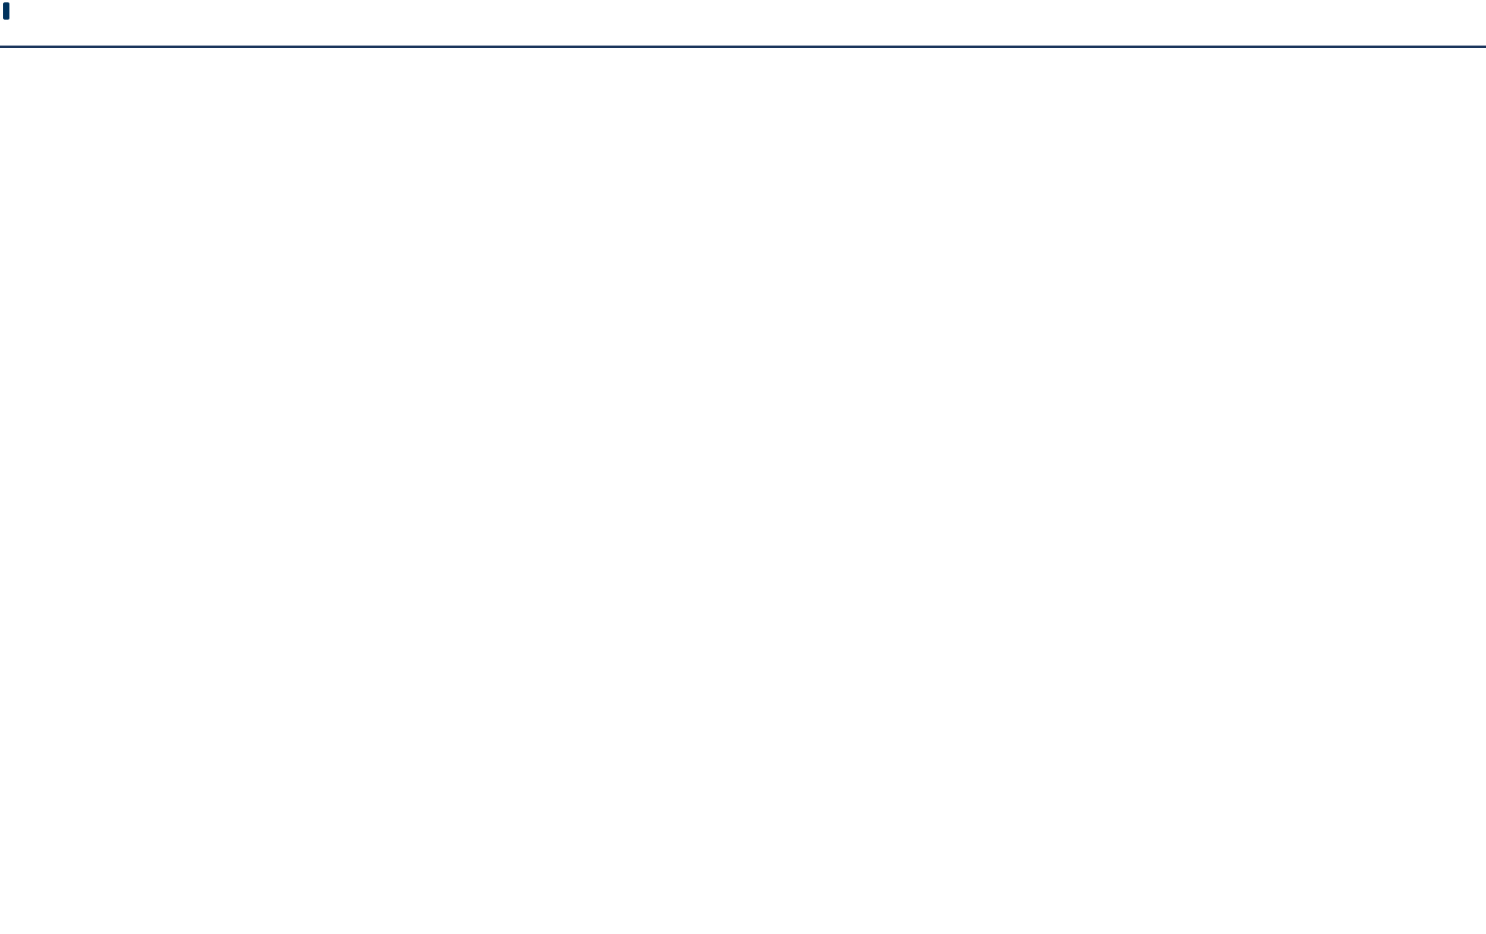

|  |  |  |  |  |  |  |  |  |  |  |
| --- | --- | --- | --- | --- | --- | --- | --- | --- | --- | --- |
|  |  | Item |  |  | Member Service Test Environment |  | Member Service Production Environment |  |  |  |
|  |  |  |  |  |  |  |  |
|  |  |  |  |  |  |  |  |  |  |  |
|  |  |  |  |  |  |  |  |  |  |  |
|  |  | Do all staff members |  |  | ☐ Yes ☐ No (answering no, prohibits staff |  | ☐ Yes ☐ No |  |  |  |
|  |  |  |  |  |  |  |  |
|  |  | working on the |  |  | from working on the onboarding) |  | Specify |  |  |  |
|  |  | onboarding have |  |  | Specify |  |  |  |  |
|  |  |  |  |  | ………………………………………………………….… |  |  |  |
|  |  | contract/confidentiality |  |  |  |  |  |  |
|  |  |  |  | ………………………………………………………….… |  |  |  |  |
|  |  | agreements? |  |  |  |  |  |  |  |
|  |  |  |  |  |  |  |  |  |  |  |
|  |  |  |  |  |  |  |  |  |  |  |
|  |  | Do users have security |  |  | ☐ Yes ☐ No (answering no, prohibits staff |  | ☐ Yes ☐ No |  |  |  |
|  |  |  |  |  |  |  |  |
|  |  | clearances? |  |  | from working on the onboarding) |  | Specify…………………………………………………………… |  |  |  |
|  |  |  |  |  | Specify…………………………………………………………… |  |  |  |  |
|  |  |  |  |  |  |  |  |  |  |
|  |  |  | |  |  |  |  | |  |  |
|  |  |  |  |  |  |  |  |  |  |  |
|  |  | Has external environment |  |  | ☐ No accreditation |  | ☐ No Accreditation |  |  |  |
|  |  |  |  |  |  |  |  |
|  |  | been accredited? |  |  | ☐ Meets Information Security Manual |  | ☐ Meets Information Security Manual |  |  |  |
|  |  |  |  |  |  |  |  |  |
|  |  |  |  |  | requirements |  | requirements |  |  |  |
|  |  |  |  |  | ☐ Other (specify) |  | ☐ Other (Specify) |  |  |  |
|  |  |  |  |  | …………………………………………….. |  | …………………………………………….. |  |  |  |
|  |  |  | |  |  |  |  |  |  |  |
|  |  |  |  |  |  |  |  |  |  |  |
|  |  | Will access be logged and |  |  | ☐ Logged and monitored ☐ Logged only |  | ☐ Logged and monitored ☐ Logged only |  |  |  |
|  |  |  |  |  |  |
|  |  | monitored? |  |  | ☐ Other (specify) |  | ☐ Other (specify) |  |  |  |
|  |  |  |  |  |  |  |  |  |
|  |  |  |  |  | ……………………………………………… |  | ……………………………………………… |  |  |  |
|  |  |  |  |  |  |  |  |  |  |  |
|  |  |  |  |  |  |  |  |  |  |  |
|  |  |  |  |  |  |  |  |  |  |  |

|  |  |
| --- | --- |
| Version v1.7.03 official use only | 12 |



**myGov Member Service On-Boarding Technical Guide**



Item

How long is access required?

Member Service Test Environment

* 6 Months ☐ 12 Months



Member Service Production Environment

Specify……………………………………………………………

|  |  |
| --- | --- |
| Version v1.7.03 official use only | 13 |



**myGov Member Service On-Boarding Technical Guide**



**4.1.3.** **OIDC Authentication/Linking Member Service Details**

The details collected in this section relate to the myGov OIDC Authentication/Linking Capability. These details must be provided by any Member Service seeking to integrate with that myGov Capability.

|  |  |  |  |  |  |  |  |  |  |  |  |  |  |  |  |  |
| --- | --- | --- | --- | --- | --- | --- | --- | --- | --- | --- | --- | --- | --- | --- | --- | --- |
|  |  | Item |  |  |  | Description |  |  |  | Member Service |  |  | Member Service |  |  |  |
|  |  |  |  |  |  |  |  |  |  |  |  |  |
|  |  |  |  |  |  |  |  |  |  | Test Environment |  |  | Production Environment |  |  |  |
|  |  |  |  |  |  |  |  |  |  |  |  |  | Value |  |  |  |
|  |  |  |  |  |  |  |  |  |  |  |  |  |  |  |  |  |
|  |  |  | |  |  |  | |  |  |  | |  |  | |  |  |
|  |  | OIDC Redirect |  |  |  | Per the OIDC Spec – the OIDC |  |  |  | List of valid URLs: |  |  | List of valid URLs: |  |  |  |
|  |  |  |  |  |  |  |  |  |  |  |  |  |
|  |  | URI’s |  |  |  | authorization_code will be redirected to |  |  |  |  |  |  |  |  |  |  |
|  |  |  |  |  |  | this URL. myGov supports multiple |  |  |  |  |  |  |  |  |  |  |
|  |  |  |  |  |  | redirect_uri’s for a given client_id. |  |  |  |  |  |  |  |  |  |  |
|  |  |  | |  |  |  |  |  |  |  | |  |  | |  |  |
|  |  |  |  |  |  |  |  |  |  |  |  |  |  |  |  |  |
|  |  |  | |  |  |  | |  |  |  | |  |  | |  |  |
|  |  | OIDC Initiation |  |  |  | myGov has 3 URL’s that it sends the |  |  |  | Linking URL: |  |  | Linking URL: |  |  |  |
|  |  | URL’s |  |  |  | customer to. At each one – myGov |  |  |  | SSO URL: |  |  | SSO URL: |  |  |  |
|  |  |  |  |  |  | expects to initiate an OIDC SSO – but |  |  |  |  |  |  |  |  |
|  |  |  |  |  |  |  |  |  | Unlinking URL: |  |  | Unlinking URL: |  |  |  |
|  |  |  |  |  |  | with different effects for each. These |  |  |  |  |  |  |  |  |
|  |  |  |  |  |  | are the linking, unlinking and SSO |  |  |  |  |  |  |  |  |  |  |
|  |  |  |  |  |  | endpoints. |  |  |  |  |  |  |  |  |  |  |
|  |  |  |  |  |  | The “linking” endpoint will be presented |  |  |  |  |  |  |  |  |  |  |
|  |  |  |  |  |  | on the services page, when the |  |  |  |  |  |  |  |  |  |  |
|  |  |  |  |  |  | customer is not linked to the member |  |  |  |  |  |  |  |  |  |  |
|  |  |  |  |  |  | service. When this URL is accessed – |  |  |  |  |  |  |  |  |  |  |
|  |  |  |  |  |  | the member service should perform an |  |  |  |  |  |  |  |  |  |  |
|  |  |  |  |  |  |  |  |  |  |  |  |  |  |  |  |  |
|  |  |  |  |  |  |  |  |  |  |  |  |  |  |  |  |  |
|  |  |  |  |  |  |  |  |  |  |  |  |  |  |  |  |  |
|  | Version v1.7.03 official use only | | | | | | |  |  |  |  | 14 | | | |  |



**myGov Member Service On-Boarding Technical Guide**



|  |  |  |  |  |  |  |  |  |  |  |  |  |  |
| --- | --- | --- | --- | --- | --- | --- | --- | --- | --- | --- | --- | --- | --- |
|  | Item |  |  |  | Description |  |  |  | Member Service |  | Member Service |  |  |
|  |  |  |  |  |  |  |  |  |  |
|  |  |  |  |  |  |  |  |  | Test Environment |  | Production Environment |  |  |
|  |  |  |  |  |  |  |  |  |  |  | Value |  |  |
|  |  |  |  |  |  |  |  |  |  |  |  |  |  |
|  |  |  |  |  |  |  |  |  |  |  |  |  |  |
|  |  |  |  |  |  | |  |  |  |  |  |  |  |
|  |  |  |  |  | IDP-initiated OIDC SSO and then funnel |  |  |  |  |  |  |  |  |
|  |  |  |  |  | the customer into a “linking” flow. |  |  |  |  |  |  |  |  |
|  |  |  |  |  | The “SSO” endpoint will only be shown |  |  |  |  |  |  |  |  |
|  |  |  |  |  | when the member service is linked (on |  |  |  |  |  |  |  |  |
|  |  |  |  |  | both the myGov dashboard and the |  |  |  |  |  |  |  |  |
|  |  |  |  |  | Services page). When it is accessed – |  |  |  |  |  |  |  |  |
|  |  |  |  |  | the member service should perform an |  |  |  |  |  |  |  |  |
|  |  |  |  |  | IDP-initiated OIDC SSO. |  |  |  |  |  |  |  |  |
|  |  |  |  |  | The “unlinking” endpoint will be |  |  |  |  |  |  |  |  |
|  |  |  |  |  | presented as the “unlink” button on the |  |  |  |  |  |  |  |  |
|  |  |  |  |  | services page. When this URL is |  |  |  |  |  |  |  |  |
|  |  |  |  |  | accessed – the member service should |  |  |  |  |  |  |  |  |
|  |  |  |  |  | perform an IDP-initiated OIDC SSO to |  |  |  |  |  |  |  |  |
|  |  |  |  |  | identify the user. It should then remove |  |  |  |  |  |  |  |  |
|  |  |  |  |  | the references to the link within the |  |  |  |  |  |  |  |  |
|  |  |  |  |  | member service record, call the myGov |  |  |  |  |  |  |  |  |
|  |  |  |  |  | Unlink API, and then return the customer |  |  |  |  |  |  |  |  |
|  |  |  |  |  | to the return_uri. |  |  |  |  |  |  |  |  |
|  |  |  |  |  |  |  |  |  |  |  |  |  |  |
|  |  |  |  |  |  |  |  |  |  |  |  |  |  |



|  |  |
| --- | --- |
| Version v1.7.03 official use only | 15 |



**myGov Member Service On-Boarding Technical Guide**

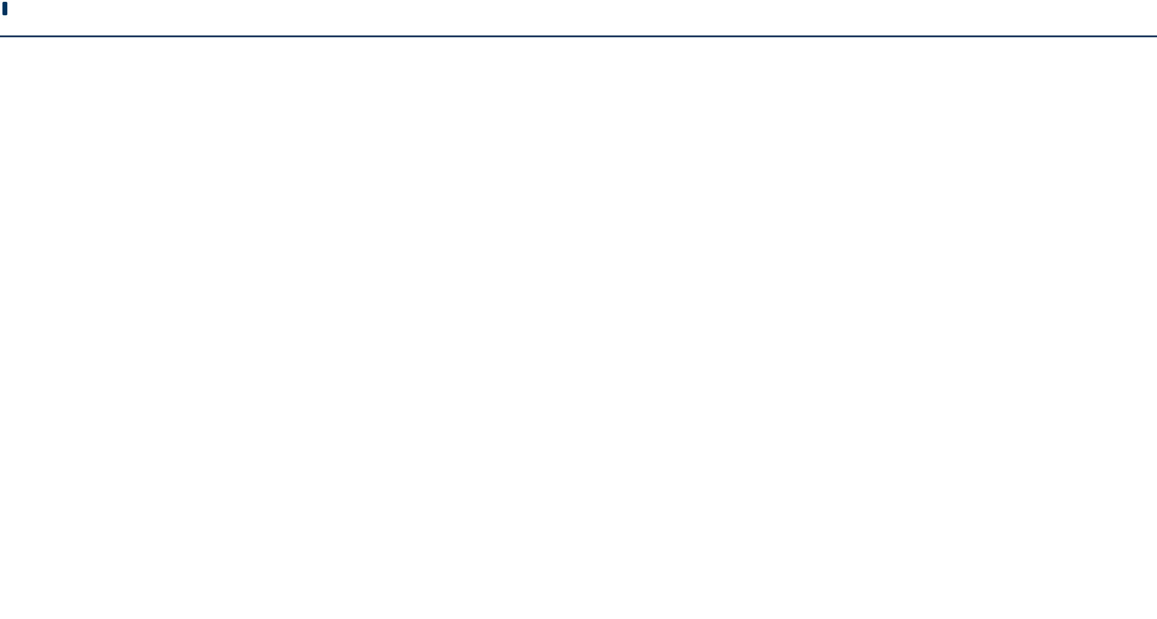

|  |  |  |  |  |  |  |  |  |  |  |  |  |  |
| --- | --- | --- | --- | --- | --- | --- | --- | --- | --- | --- | --- | --- | --- |
|  | Item |  |  |  | Description |  |  |  | Member Service |  | Member Service |  |  |
|  |  |  |  |  |  |  |  |  |  |
|  |  |  |  |  |  |  |  |  | Test Environment |  | Production Environment |  |  |
|  |  |  |  |  |  |  |  |  |  |  | Value |  |  |
|  |  |  |  |  |  |  |  |  |  |  |  |  |  |
|  |  |  |  |  |  |  |  |  |  |  |  |  |  |
|  |  | |  |  |  | |  |  | ☐ private_key_jwt |  | ☐ private_key_jwt |  |  |
|  | OIDC JWKS |  |  |  | If you are using private_key_jwt for |  |  |  |  |  |  |
|  | endpoint |  |  |  | security (which is recommended) – you |  |  |  | ☐ client_secret |  | ☐ client_secret (less |  |  |
|  |  |  |  |  | need to supply the URL to myGov. |  |  |  |  |  |  |
|  |  |  |  |  |  |  |  | (less secure) |  | secure) |  |  |
|  |  |  |  |  | Additionally – you need to allow myGov |  |  |  |  |  |  |
|  |  |  |  |  |  |  |  |  |  |  |  |  |
|  |  |  |  |  | to access your JWK. And if you use a |  |  |  |  |  |  |  |  |
|  |  |  |  |  | non-public CA for your TLS encryption – |  |  |  | If JWKS – supply |  | If JWKS – supply the |  |  |
|  |  |  |  |  | supply the relevant chain of trust. |  |  |  | the URL: |  | URL: |  |  |
|  |  |  |  |  |  |  |  |  |  |  |  |  |  |
|  |  | |  |  |  | |  |  |  | |  | |  |
|  | Notify Account |  |  |  | Endpoint for myGov to call the member |  |  |  | Hostname: |  | Hostname: |  |  |
|  |  |  |  |  |  |  |  |  |  |
|  | Change service |  |  |  | service implementation of the Notify |  |  |  | IP Address: |  | IP Address: |  |  |
|  | Endpoint |  |  |  | Account Change service. |  |  |  |  |  |  |
|  |  |  |  |  |  |  |  |  |  |  |  |
|  |  |  |  |  |  |  |  |  |  |  |  |  |
|  | (Mandatory for |  |  |  |  |  |  |  |  |  |  |  |  |
|  | mobile apps) |  |  |  |  |  |  |  |  |  |  |  |  |
|  |  |  |  |  |  |  |  |  |  |  |  |  |  |
|  |  |  |  |  |  |  |  |  |  |  |  |  |  |



|  |  |
| --- | --- |
| Version v1.7.03 official use only | 16 |



**myGov Member Service On-Boarding Technical Guide**



**4.1.4.** **Update Your Contact Details Member Service Details**

The details collected in this section relate to the myGov Update Your Contact Details Business Service. These details must be provided by any Member Service seeking to integrate with that myGov Business Service.

|  |  |  |  |  |  |  |  |  |  |  |  |
| --- | --- | --- | --- | --- | --- | --- | --- | --- | --- | --- | --- |
| Item |  |  | Description |  | Member Service |  |  |  | Member Service |  |  |
|  |  |  |  |  | Test Environment |  |  |  | Production |  |  |
|  |  |  |  |  | Value |  |  |  | Environment Value |  |  |
|  |  |  |  |  |  |  |  |  |  |  |  |
|  |  |  |  |  |  |  |  |  |  |  |  |
| Notify Customer Details |  |  | Endpoint for myGov to call the |  | Hostname: |  |  |  | Hostname: |  |  |
| Change service Endpoint |  |  | Member Service implementation of |  | IP Address: |  |  |  | IP Address: |  |  |
|  |  |  | the notify customer details change |  |  |  |  |  |  |
|  |  |  |  |  |  |  |  |  |  |  |
|  |  |  | service. |  |  |  |  |  |  |  |  |
|  |  |  |  |  |  | |  |  |  | |  |
|  |  |  |  |  |  |  |  |  |  |  |  |
| IP Addresses to be white- |  |  | Member Service gateway / proxy IP |  | IP Address(es): |  |  |  | IP Address(es): |  |  |
| listed for consuming the |  |  | address(es) for myGov to whitelist |  |  |  |  |  |  |  |  |
| Update Customer Details |  |  | so that the Member Service system |  |  |  |  |  |  |  |  |
| Change Status service |  |  | can call the required service. |  |  |  |  |  |  |  |  |
|  |  |  |  |  |  |  |  |  |  |  |  |
|  |  |  |  |  |  |  |  |  |  |  |  |



|  |  |
| --- | --- |
| Version v1.7.03 official use only | 17 |



**myGov Member Service On-Boarding Technical Guide**



**4.1.5.** **Digital Mail Member Service Details**

The details collected in this section relate to the myGov Digital Mail Business Service. These details must be provided by any Member Service seeking to integrate with that myGov Business Service.



Item

Default Read Receipt Settings

Description

A flag indicating a default value for whether a read

receipt should be sent to the Member Service

when a user reads a message sent by the Member

Service.

If this is “true” then by default a read receipt will

be sent the first time a user reads each message

sent by the Member Service.

Otherwise by default

a read receipt will not be sent.

This default setting

can be overridden by the



Member Service Test Environment Value

True/False

Member Service Production Environment Value

True/False

|  |  |
| --- | --- |
| Version v1.7.03 official use only | 18 |



**myGov Member Service On-Boarding Technical Guide**



|  |  |  |  |  |  |  |  |  |  |  |  |  |  |  |  |  |  |
| --- | --- | --- | --- | --- | --- | --- | --- | --- | --- | --- | --- | --- | --- | --- | --- | --- | --- |
|  |  | Item |  |  |  | Description |  |  |  | Member Service Test |  |  |  | Member Service |  |  |  |
|  |  |  |  |  |  |  |  |  |  | Environment Value |  |  |  | Production |  |  |  |
|  |  |  |  |  |  |  |  |  |  |  |  |  |  | Environment Value |  |  |  |
|  |  |  |  |  |  |  |  |  |  |  |  |  |  |  |  |  |  |
|  |  |  |  |  |  |  |  |  |  |  |  |  |  |  |  |  |  |
|  |  |  |  |  |  | Member Service on a per |  |  |  |  |  |  |  |  |  |  |  |
|  |  |  |  |  |  | message basis. |  |  |  |  |  |  |  |  |  |  |  |
|  |  |  | |  |  |  |  |  |  |  | |  |  |  | |  |  |
|  |  |  |  |  |  |  |  |  |  |  |  |  |  |  |  |  |  |
|  |  | Retrieve Attachment |  |  |  | Endpoint for myGov to call the |  |  |  | Hostname: |  |  |  | Hostname: |  |  |  |
|  |  | service endpoint |  |  |  | Member Service |  |  |  | IP Address: |  |  |  | IP Address: |  |  |  |
|  |  |  |  |  | implementation of the Retrieve |  |  |  |  |  |  |  |  |  |
|  |  |  |  |  |  |  |  |  |  |  |  |  |  |  |  |  |
|  |  |  |  |  |  | Attachment |  |  |  |  |  |  |  |  |  |  |  |
|  |  |  |  |  |  | service. |  |  |  |  |  |  |  |  |  |  |  |
|  |  |  | |  |  |  |  |  |  |  | |  |  |  | |  |  |
|  |  |  |  |  |  |  |  |  |  |  |  |  |  |  |  |  |  |
|  |  | Notify Read Receipt |  |  |  | Endpoint for myGov to call the |  |  |  | Hostname: |  |  |  | Hostname: |  |  |  |
|  |  | service Endpoint |  |  |  | Member Service |  |  |  | IP Address: |  |  |  | IP Address: |  |  |  |
|  |  |  |  |  | implementation of the Notify |  |  |  |  |  |  |  |  |  |
|  |  |  |  |  |  |  |  |  |  |  |  |  |  |  |  |  |
|  |  |  |  |  |  | Read Receipt |  |  |  |  |  |  |  |  |  |  |  |
|  |  |  |  |  |  | service. |  |  |  |  |  |  |  |  |  |  |  |
|  |  |  | |  |  |  |  |  |  |  | |  |  |  | |  |  |
|  |  |  |  |  |  |  |  |  |  |  |  |  |  |  |  |  |  |
|  |  | IP Addresses to be |  |  |  | Member Service gateway / proxy |  |  |  | IP Address(es): |  |  |  | IP Address(es): |  |  |  |
|  |  |  |  |  |  | IP address(es) for |  |  |  |  |  |  |  |  |  |  |  |
|  |  |  |  |  |  |  |  |  |  |  |  |  |  |  |  |  |  |
|  |  |  |  |  |  |  |  |  |  |  |  |  |  |  |  |  |  |
|  |  |  |  |  |  |  |  |  |  |  |  |  |  |  |  |  |  |
|  | Version v1.7.03 official use only | | | | |  |  |  |  |  |  | 19 | | | | |  |



**myGov Member Service On-Boarding Technical Guide**



Item

white-listed for consuming the Publish Message service

Description

myGov to whitelist so that the Member Service

system can call the required service.



Member Service Test Environment Value

Member Service Production Environment Value

|  |  |
| --- | --- |
| Version v1.7.03 official use only | 20 |



**myGov Member Service On-Boarding Technical Guide**

**4.2** **Appendix 2 – myGov Details**

After receiving the Member Service integration details from Appendix 1 - Member Service on-boarding questionnaire, myGov will generate a starting pack that includes the following information and artefacts.

|  |  |  |  |
| --- | --- | --- | --- |
| Item | Description | Status |  |
|  |  |  |  |
|  |  |  |  |
| Test End points | Test Environment URLs for | ☐ |  |
|  | Authentication, |  |  |
|  | Linking, and web services. |  |  |
|  |  |  |  |
|  |  |  |  |
| Test Message Signing | DHS-issued X.509 certificate for | ☐ |  |
| Certificate | Message Body |  |  |
|  | signing |  |  |
|  |  |  |  |
|  |  |  |  |
| Production End points | Production Environment URLs for | ☐ |  |
|  | Authentication, |  |  |
|  | Linking, and web services. |  |  |
|  |  |  |  |
|  |  |  |  |
| Production Message | DHS-issued X.509 certificate for | ☐ |  |
| Signing Certificate | Message Body |  |  |
|  | signing |  |  |
|  |  |  |  |
|  |  |  |  |

|  |  |
| --- | --- |
| Version v1.7.03 official use only | 21 |

**myGov Member Service On-Boarding Technical Guide**

**4.3** **Appendix 3 - Technical documentation available from myGov**

The table below presents detailed technical references available from myGov on request.

|  |  |  |  |  |  |  |  |  |
| --- | --- | --- | --- | --- | --- | --- | --- | --- |
| Ref. | |  | Document |  |  | Document Name |  |  |
|  |  |  |  |  |
|  |  |  | Description |  |  |  |  |  |
|  |  |  |  |  |  |  |  |  |
|  |  |  |  |  |  |  |  |  |
|  | | |  |  |  | | |  |
|  | [DHSEXTWSPROFv108] |  | DHS External |  | re | ferences/standards/DHS.External.Web.S |  |  |
|  |  |  | Web |  |  | ervices.Profile.v1.08.pdf |  |  |
|  |  |  | Services |  |  |  |  |  |
|  |  |  | Profile |  |  |  |  |  |
|  | | |  |  |  | | |  |
|  |  |  |  |  |  |  |  |  |
|  | | |  |  |  | | |  |
|  | [MGVAUTHPROTv14] |  | myGov |  |  | references/standards/Reliance Framework |  |  |
|  |  |  | Authenticati |  |  | Authentication Hub Protocol1.4.pdf |  |  |
|  |  |  | on Hub |  |  |  |  |
|  |  |  |  |  |  |  |  |
|  |  |  | Protocol |  |  |  |  |  |
|  |  |  | v1.4 |  |  |  |  |  |
|  | | |  |  |  | | |  |
|  |  |  |  |  |  |  |  |  |
|  | [MGVEXTWSPROFv09] |  | myGov |  |  | references/standards/Reliance |  |  |
|  |  |  |  |  |  |
|  |  |  | External Web |  |  | Framework.Web.Services.Profile.v0.9.pdf |  |  |
|  |  |  | Services |  |  |  |  |
|  |  |  |  |  |  |  |  |
|  |  |  | Profile v0.9 |  |  |  |  |  |
|  | | |  |  |  | | |  |
|  |  |  |  |  |  |  |  |  |
|  | | |  |  |  | | |  |
|  | [MGVOIDCUGv10009] |  | myGov OIDC |  |  | references/OIDC/myGov Auth HUB - |  |  |
|  |  |  | OAuth |  |  | Developers Guide to OAuth OIDC |  |  |
|  |  |  | Developers |  |  |  |  |
|  |  |  |  |  | v1.00.09.pdf |  |  |
|  |  |  | Guide |  |  |  |  |
|  |  |  |  |  |  |  |  |
|  |  |  |  |  |  |  |  |  |
|  |  |  |  |  |  |  |  |  |
|  | | |  |  |  | | |  |
|  | [MGVOIDCCLv10005] |  | myGov OIDC |  |  | references/OIDC/myGov Auth Hub |  |  |
|  |  |  | OAuth |  |  | Metadata for OAuth and OIDC clients |  |  |
|  |  |  | Metadata |  |  | v1.0.xlsx |  |  |
|  |  |  | Client |  |  |  |  |  |
|  |  |  | Checklist |  |  |  |  |  |
|  |  |  |  |  |  |  |  |  |
|  |  |  |  |  |  |  |  |  |

|  |  |
| --- | --- |
| Version v1.7.03 official use only | 22 |

**myGov Member Service On-Boarding Technical Guide**

|  |  |  |  |  |  |  |  |
| --- | --- | --- | --- | --- | --- | --- | --- |
| Ref. |  | Document |  |  | Document Name |  |  |
|  |  |  |  |  |
|  |  | Description |  |  |  |  |  |
|  |  |  |  |  |  |  |  |
|  |  |  |  |  |  |  |  |
|  | |  |  |  | | |  |
| [MGVTUOSISv20] |  | myGov |  |  | references/TuO/myGov.TuO.System.Interf |  |  |
|  |  | System |  |  | ace.Spec.v2.0.pdf |  |  |
|  |  | Interface |  |  |  |  |  |
|  |  | Spec |  |  |  |  |  |
|  |  | Customer |  |  |  |  |  |
|  |  | Details |  |  |  |  |  |
|  |  | Change |  |  |  |  |  |
|  | |  |  |  | | |  |
|  |  |  |  |  |  |  |  |
|  | |  |  |  | | |  |
| [MGVTUOWSDLv20150 |  | myGov TuO |  |  | references/TuO/v20150613.mygov.cd.ucd |  |  |
| 613] |  | Update |  |  | cs.memberservice.soap12.zip |  |  |
|  |  | Customer |  |  |  |  |  |
|  |  | Details |  |  |  |  |  |
|  |  | Change |  |  |  |  |  |
|  |  | Status WSDL |  |  |  |  |  |
|  |  | pack |  |  |  |  |  |
|  |  | v20150613 |  |  |  |  |  |
|  | |  |  |  | | |  |
|  |  |  |  |  |  |  |  |
|  | |  |  |  | | |  |
| [MGVTUOWSDLv20160 |  | myGov TuO |  |  | references/TuO/v20160305.mygov.cd.ncd |  |  |
| 305] |  | Notify |  |  | c.memberservice.soap12.zip9 |  |  |
|  |  | Customer |  |  |  |  |  |
|  |  | Details |  |  |  |  |  |
|  |  | Change |  |  |  |  |  |
|  |  | WSDL pack |  |  |  |  |  |
|  |  | v20160305 |  |  |  |  |  |
|  | |  |  |  | | |  |
|  |  |  |  |  |  |  |  |
|  | |  |  |  | | |  |
| [MGVDMISISv32] |  | myGov |  | re | ferences/DigiMail/mygov.digitalmail.soa |  |  |
|  |  | System |  |  | p.sis.3.2 - External.pdf |  |  |
|  |  | Interface |  |  |  |  |  |
|  |  | Spec Digital |  |  |  |  |  |
|  |  | Mail |  |  |  |  |  |
|  |  |  |  |  |  |  |  |
|  |  |  |  |  |  |  |  |

|  |  |
| --- | --- |
| Version v1.7.03 official use only | 23 |

**myGov Member Service On-Boarding Technical Guide**

|  |  |  |  |  |  |  |  |  |
| --- | --- | --- | --- | --- | --- | --- | --- | --- |
| Ref. | |  | Document |  |  | Document Name |  |  |
|  |  |  |  |  |
|  |  |  | Description |  |  |  |  |  |
|  |  |  |  |  |  |  |  |  |
|  |  |  |  |  |  |  |  |  |
|  | | |  |  |  | | |  |
| [M | GVDMIWSDLv201309 |  | myGov |  | references/DigiMail/v20130907.mygov.inb | |  |  |
| 07] | |  | Digital Mail |  |  | ox.publishmessage.virtual.soap12.zip |  |  |
|  |  |  | Publish |  |  |  |  |  |
|  |  |  | Message |  |  |  |  |  |
|  |  |  | WSDL pack |  |  |  |  |  |
|  |  |  | v20130907 |  |  |  |  |  |
|  | | |  |  |  | | |  |
|  |  |  |  |  |  |  |  |  |
|  | | |  |  |  | | |  |
| [M | GVDMIWSDLv201309 |  | myGov |  | re | ferences/DigiMail/v20130907.mygov.inb |  |  |
| 07] | |  | Digital Mail |  |  | ox.retrieveattachment.memberservice.soa |  |  |
|  |  |  | Retrieve |  | p12.zip | |  |  |
|  |  |  |  |  |  |  |  |
|  |  |  | Attachment |  |  |  |  |  |
|  |  |  | WSDL |  |  |  |  |  |
|  |  |  | pack |  |  |  |  |  |
|  |  |  | v20130907 |  |  |  |  |  |
|  |  |  |  |  |  |  |  |  |
|  |  |  |  |  |  |  |  |  |

|  |  |
| --- | --- |
| Version v1.7.03 official use only | 24 |