For the wireless communication between smart attendance device and the server, ZigBee-enabled devices are used. Xbee is one such device which implements the ZigBee standard. In a ZigBee network, the nodes can be classified as coordinator, router, and end device. In brief, a coordinator is responsible for forming the ZigBee sensor network, the router is responsible to route data between different end nodes in the network, end devices cannot route data they are either connected to a router or the coordinator and are designed in a way to consume very less power.

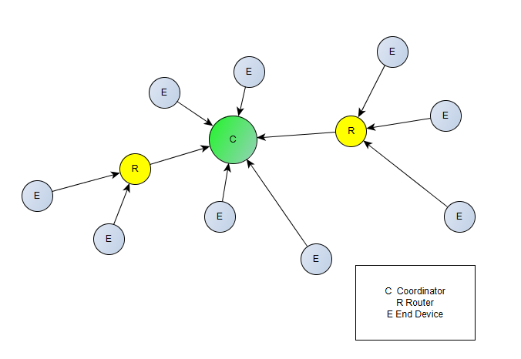

Communication using XBee is possible in two modes, AT (Transparent) mode or API (Application programming Interface) mode. AT mode is limited to fixed point-to-point communication between two XBee devices. However, in API mode it is possible to send and receive data from any XBee device. Additionally, other information can also be exchanged such as knowing the status of remote IO and ADC and also control them, feedback of the packet reception etc.

In this project the Xbee present at the server end is configured as the coordinator. The coordinator acts as a gateway device between the sensor network and the remote server PC, it is configured in API mode as it needs to know the address of the remote Xbee which sent the data to it. The Xbee in the handheld device is configured as an end device with AT mode. The destination address for the end devices is fixed with the address of the coordinator.