Experiment-3
Write a python program for Water Jug problem
Aim
To write and execute a Python program to solve the Water Jug Problem using Breadth-First Search (BFS) and obtain the required amount of water through a sequence of valid operations.
Algorithm
- Start with two empty jugs of capacities 4 litres and 3 litres.
- Represent the state as (Jug1, Jug2).
- Set the initial state as (0, 0).
- Define the goal as obtaining 2 litres in either jug.
- Use a queue to store possible states.
- Perform the following operations:
  - Fill Jug 1.
  - Fill Jug 2.
  - Empty Jug 1.
  - Empty Jug 2.
  - Pour Jug 1 into Jug 2.
  - Pour Jug 2 into Jug 1.
- Store visited states to avoid repeating the same state.
- Continue generating new states using BFS.
- Stop when a state containing 2 litres is reached.
- Display the sequence of states and the solution.

Coding
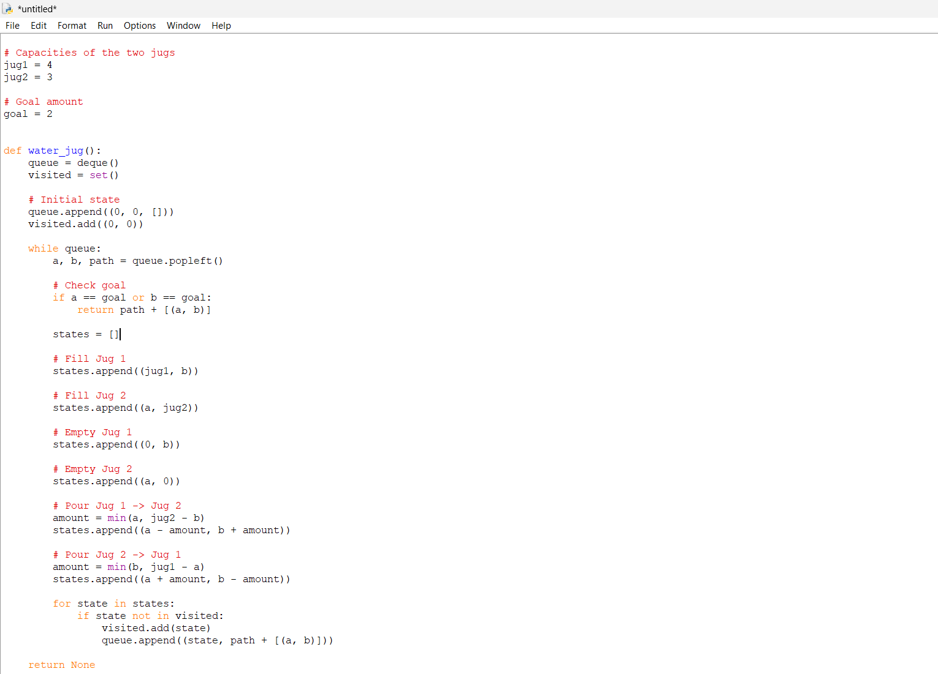
Ouput
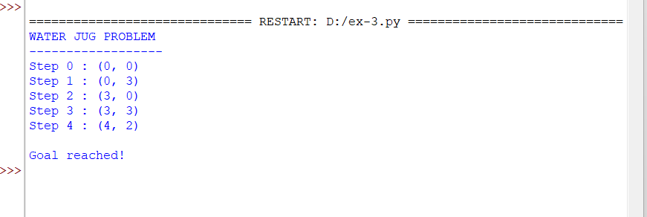
Result
The Water Jug Problem was successfully solved using the Breadth-First Search (BFS) algorithm. The program finds a sequence of operations to obtain 2 litres of water using 4-litre and 3-litre jugs.

Experiment-4
Write a python program for Cript-Arithemetic problem
Aim
To write and execute a Python program to solve a Crypt-Arithmetic problem using permutation and constraint checking, where each letter represents a unique digit.
Algorithm
- Start with the Crypt-Arithmetic equation SEND + MORE = MONEY.
- Identify all unique letters in the equation.
- Assign a different digit from 0 to 9 to each letter.
- Ensure that the first letters S and M are not zero.
- Generate possible digit combinations using permutations.
- Convert the letters into their corresponding numerical values.
- Check whether SEND + MORE = MONEY.
- If the equation is satisfied, display the digit assigned to each letter.
- Display the resulting numerical equation.
- If no combination satisfies the equation, display No solution exists.
Coding
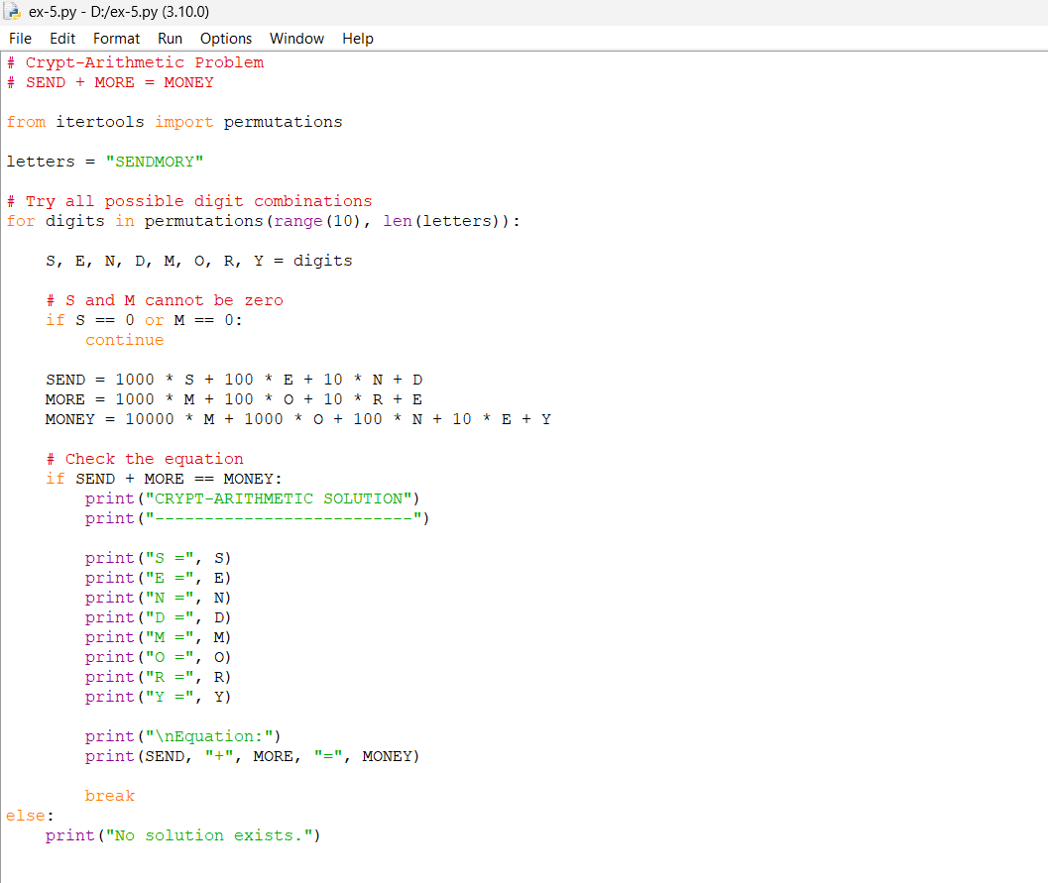
Output
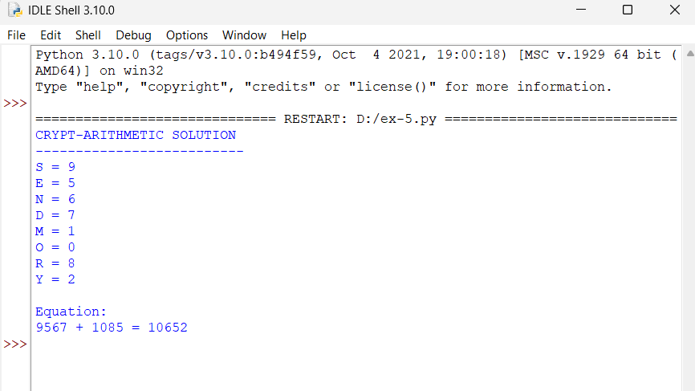

Result
The Crypt-Arithmetic problem was successfully solved using Python 3.10. The program finds a valid digit assignment:
9567 + 1085 = 10652
Thus, the given Crypt-Arithmetic equation is successfully solved.

Experiment-5
Write a python program for Missionaries Cannibal problem
Aim
To write and execute a Python program to solve the Missionaries and Cannibals Problem using Breadth-First Search (BFS) while ensuring that the missionaries are never outnumbered by cannibals.
Algorithm
- Start with 3 missionaries and 3 cannibals on the left bank.
- Place the boat on the left bank.
- Represent each state as (missionaries, cannibals, boat position).
- Check whether each state is valid:
  - Missionaries must not be outnumbered by cannibals on either bank.
  - The number of missionaries and cannibals must be within valid limits.
- Use a queue to perform Breadth-First Search (BFS).
- The boat can carry one or two people.
- Generate all possible valid states by moving the boat between the two banks.
- Store visited states to avoid repeating states.
- Continue until all missionaries and cannibals reach the right bank.
- Display the sequence of states as the solution.

Coding
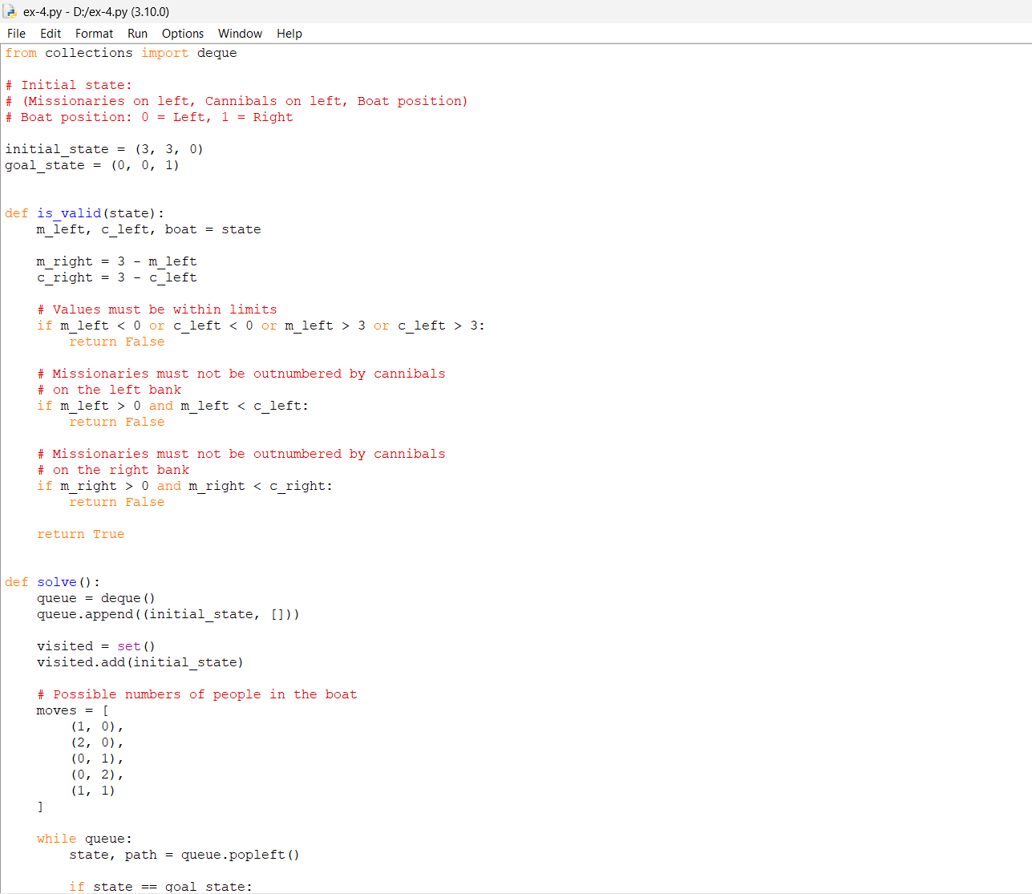
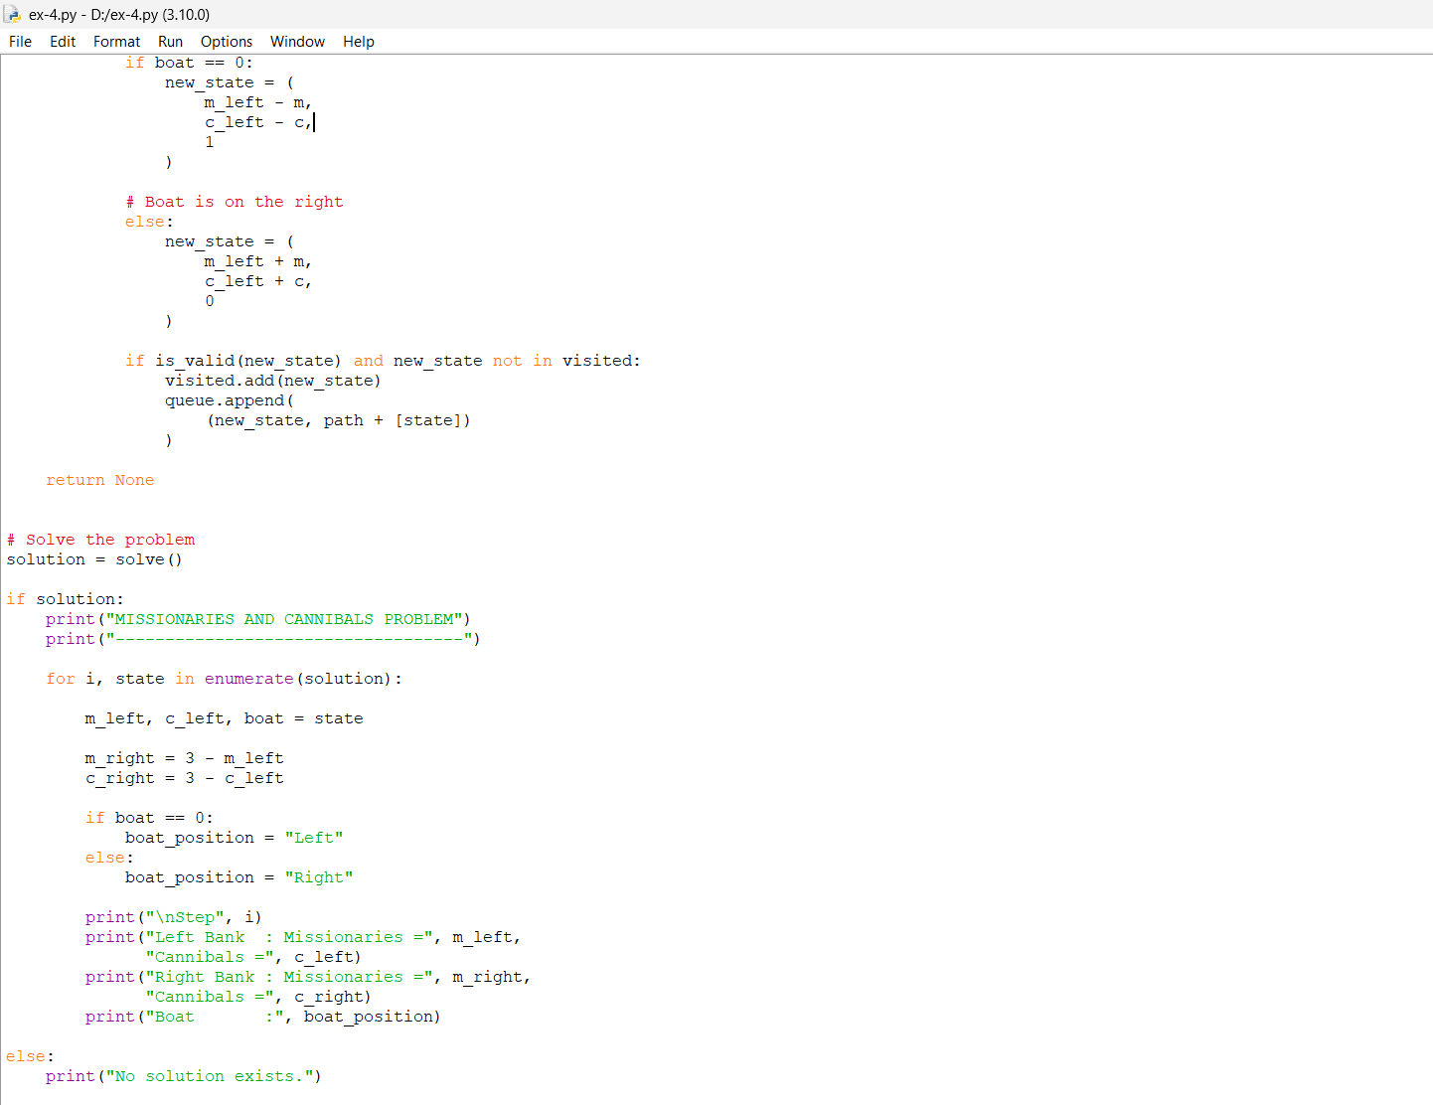
Output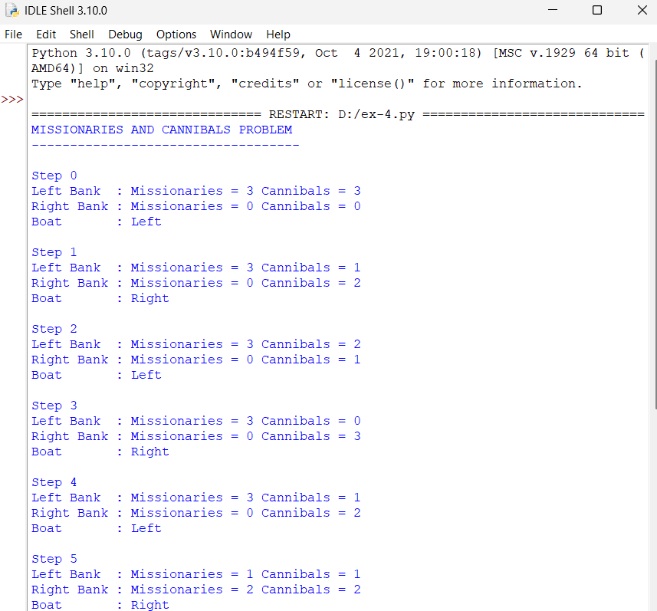

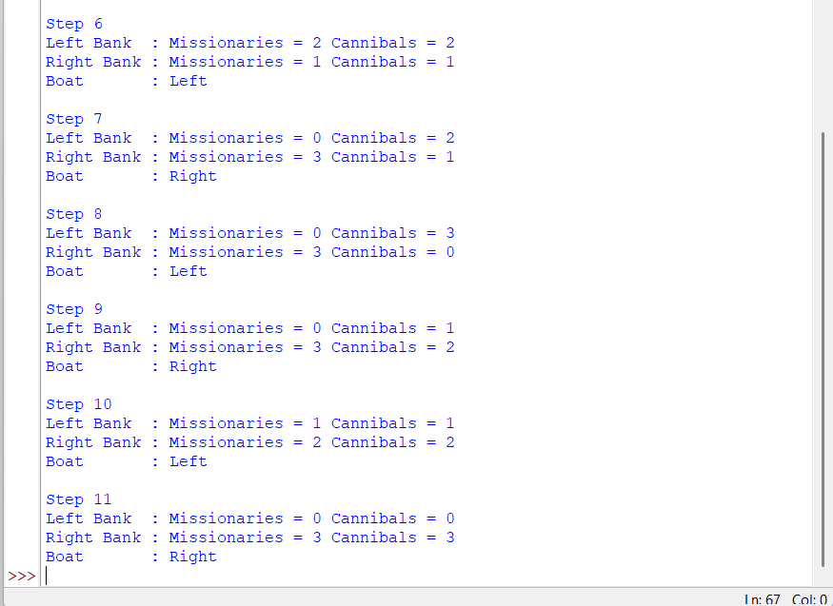

Result
The Missionaries and Cannibals Problem was successfully solved using the BFS algorithm . The program finds a valid sequence of boat movements that transfers all 3 missionaries and 3 cannibals safely to the opposite bank.

