**1.IF CONDITION THEN STATEMENT**

**DECLARE**

**n1 INT;**

**BEGIN**

**n1:=45;**

**IF n1>10 THEN**

**DBMS_OUTPUT.PUT_LINE('The Value is Greater Than 10');**

**END IF;**

**END;**

**/**

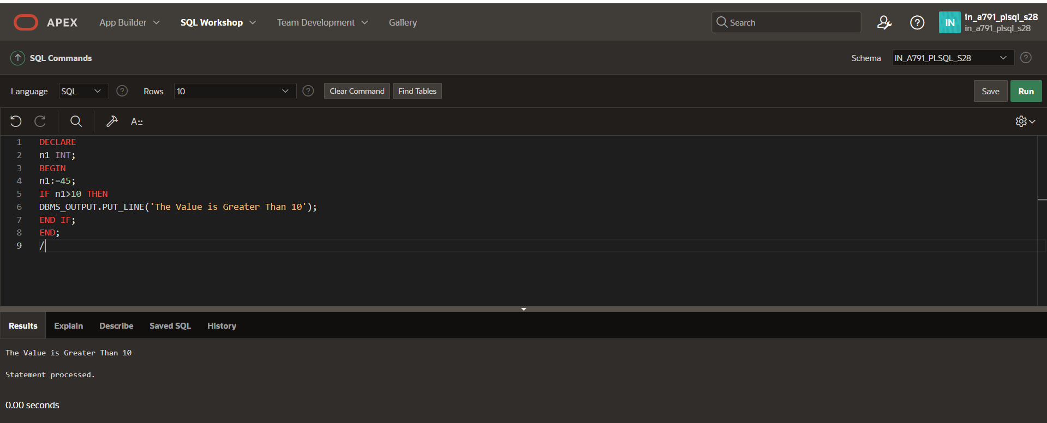

**2.IF CONDITION THEN ELSE STATEMENT**

**DECLARE**

**n1 INT;**

**BEGIN**

**n1:=7;**

**IF n1>10 THEN**

**DBMS_OUTPUT.PUT_LINE('The Value is Greater Than 10');**

**ELSE**

**DBMS_OUTPUT.PUT_LINE('The Value is Lesser Than 10');**

**END IF;**

**END;**

**/**

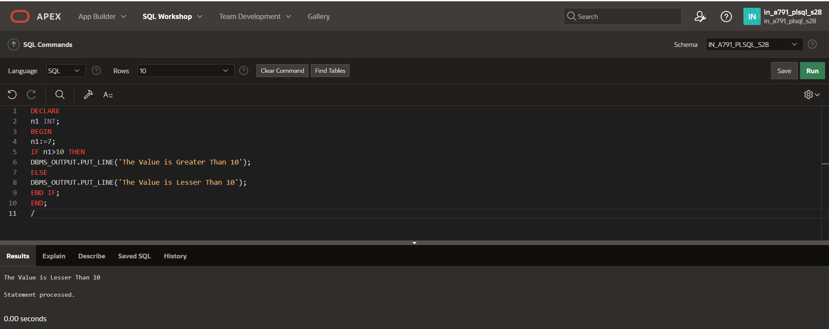

**3.NESTED IF CONDITION THEN STATEMENT**

**DECLARE**

**age NUMBER := 25;**

**status VARCHAR2(20);**

**BEGIN**

**IF age<18 THEN**

**status:='Minor';**

**ELSE**

**IF age<60 THEN**

**status:='Adult';**

**ELSE**

**status:='Senior';**

**END IF;**

**END IF;**

**DBMS_OUTPUT.PUT_LINE('Status: '||status);**

**END;**

**/**

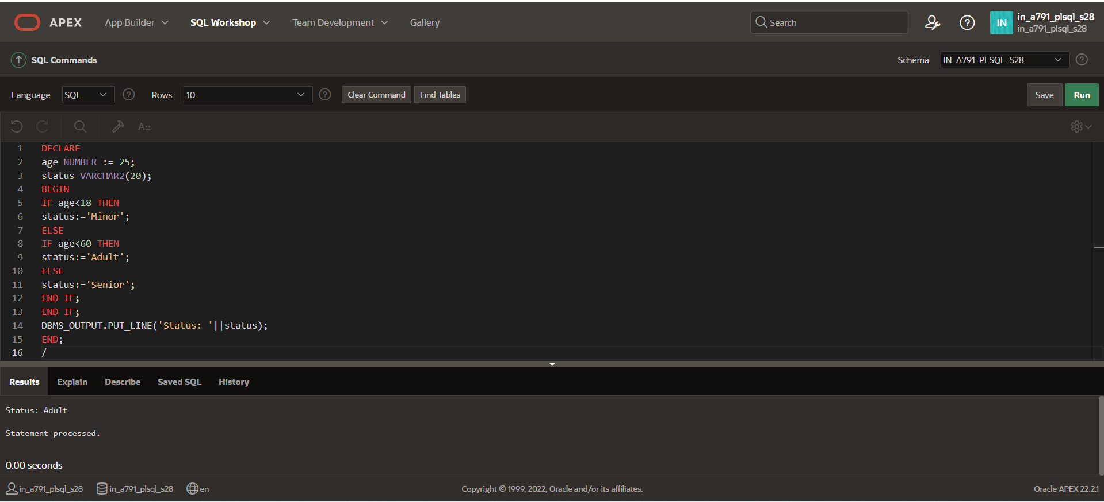

**4.FOR LOOP**

**DECLARE**

**n INT;**

**BEGIN**

**n:=5;**

**FOR i IN 1..n LOOP**

**IF i MOD 2 = 0 THEN**

**DBMS_OUTPUT.PUT_LINE(i||' is even');**

**ELSE**

**DBMS_OUTPUT.PUT_LINE(i||' is odd');**

**END IF;**

**END LOOP;**

**END;**

**/**

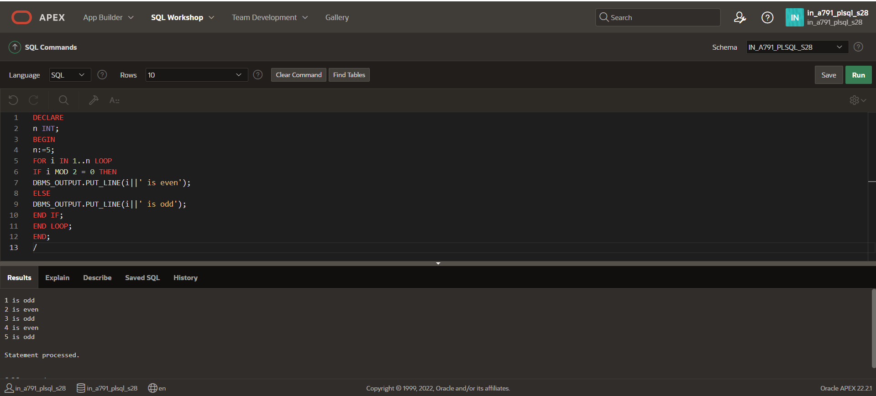

**5.WHILE LOOP**

**DECLARE**

**n INT;**

**i INT:=1;**

**BEGIN**

**n:=5;**

**WHILE i<=n LOOP**

**IF i MOD 2 = 0 THEN**

**DBMS_OUTPUT.PUT_LINE(i||' is even');**

**ELSE**

**DBMS_OUTPUT.PUT_LINE(i||' is odd');**

**END IF;**

**i:=i+1;**

**END LOOP;**

**END;**

**/**

