**18.Single Parameter and Multiple Parameter using Cursor in PL/SQL.**

**Single Parameter Cursor**

**CREATE TABLE EMPLOYEE4 (**

**EMP_ID NUMBER,**

**EMP_NAME VARCHAR2(100),**

**DEPT_ID NUMBER,**

**SALARY NUMBER**

**);**

**INSERT INTO EMPLOYEE4 VALUES(1,'Peter',100,10000);**

**INSERT INTO EMPLOYEE4 VALUES(2,'Ben',101,20000);**

**INSERT INTO EMPLOYEE4 VALUES(3,'Kiran',102,30000);**

**INSERT INTO EMPLOYEE4 VALUES(4,'Shaam',103,40000);**

**INSERT INTO EMPLOYEE4 VALUES(5,'Harsha',104,50000);**

**SELECT *FROM EMPLOYEE4 ORDER BY EMP_ID;**

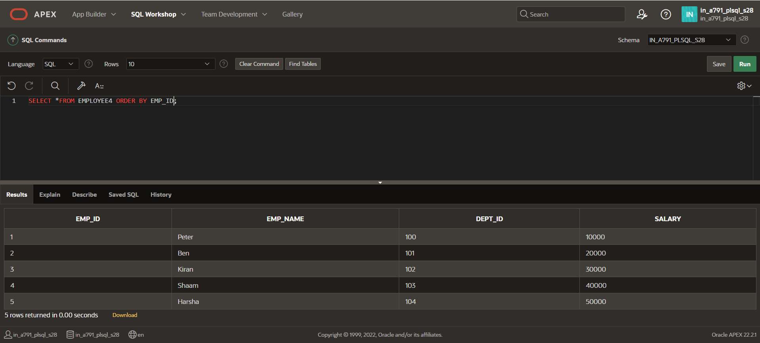

**DECLARE**

**CURSOR emp_cursor(p_dept_id NUMBER) IS SELECT EMP_ID, EMP_NAME, SALARY FROM EMPLOYEE4 WHERE DEPT_ID = p_dept_id;**

**BEGIN**

**FOR emp_record IN emp_cursor(100) LOOP**

**DBMS_OUTPUT.PUT_LINE('Emp ID: ' || emp_record.EMP_ID || ', Name: ' || emp_record.EMP_NAME || ', Salary: ' || emp_record.SALARY);**

**END LOOP;**

**END;**

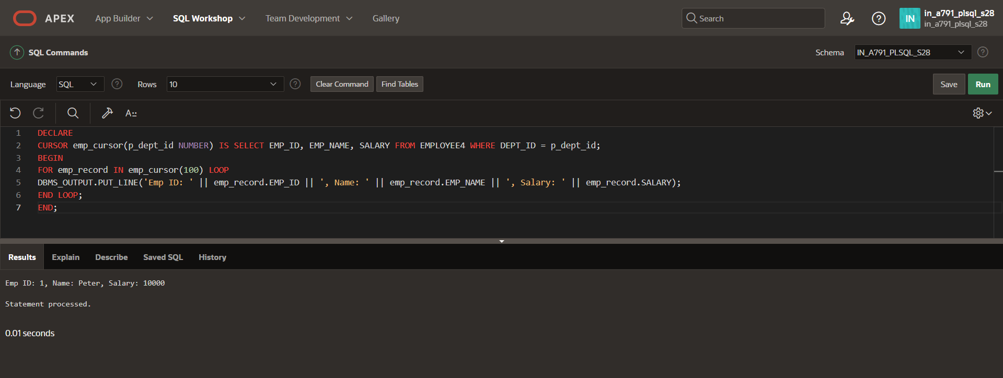

**Multiple Parameter Cursor**

**DECLARE**

**CURSOR emp_cursor(p_dept_id NUMBER, p_min_salary NUMBER) IS**

**SELECT EMP_ID, EMP_NAME, SALARY**

**FROM EMPLOYEE4**

**WHERE DEPT_ID = p_dept_id AND SALARY >= p_min_salary;**

**BEGIN**

**FOR emp_record IN emp_cursor(103, 3000) LOOP**

**DBMS_OUTPUT.PUT_LINE('Emp ID: ' || emp_record.EMP_ID || ', Name: ' || emp_record.EMP_NAME || ', Salary: ' || emp_record.SALARY);**

**END LOOP;**

**END;**

