**27.CREATE A PROCEDURE TO CALCULATE THE CONVEYANCE AS A 20% OF BASIC_SALARY THAT SHOULD BE ADDED TO NET SALARY.**

**CREATE TABLE EMPLOYEE5(EMP_ID INT PRIMARY KEY,EMP_NAME VARCHAR(20),BASIC_SALARY INT,CONVEYANCE INT,NET_SALARY INT);**

**INSERT INTO EMPLOYEE5 (EMP_ID,EMP_NAME,BASIC_SALARY) VALUES(1,'Wajith',30100);**

**INSERT INTO EMPLOYEE5 (EMP_ID,EMP_NAME,BASIC_SALARY) VALUES(2,'Ben',40500);**

**INSERT INTO EMPLOYEE5 (EMP_ID,EMP_NAME,BASIC_SALARY) VALUES(3,'Harsha',20700);**

**INSERT INTO EMPLOYEE5 (EMP_ID,EMP_NAME,BASIC_SALARY) VALUES(4,'Vishal',60000);**

**SELECT *FROM EMPLOYEE5 ORDER BY EMP_ID;**

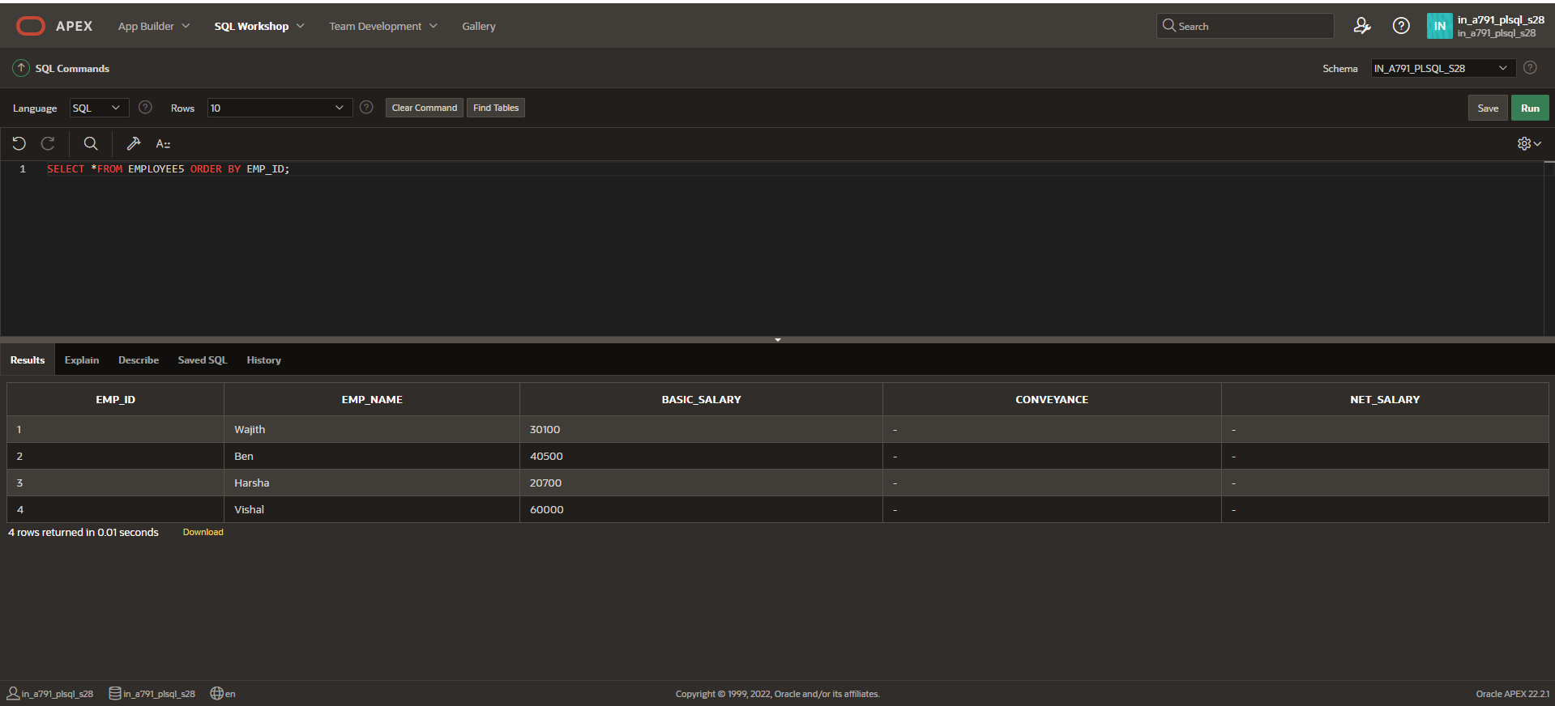

**CREATE OR REPLACE PROCEDURE E_N**

**IS**

**BEGIN**

**UPDATE EMPLOYEE5**

**SET CONVEYANCE = basic_salary * 0.2,**

**NET_SALARY = basic_salary + (basic_salary * 0.2);**

**END E_N;**

**BEGIN E_N;**

**END;**

**/**

**SELECT *FROM EMPLOYEE5 ORDER BY EMP_ID;**

