**29.TO CALCULATE THE DUE DATE OF RETURN THE BOOK TO LIBRARY USING FUNCTION.**

**CREATE TABLE lib_manage (**

**book_id INT PRIMARY KEY,**

**book_title VARCHAR(25),**

**author VARCHAR(25),**

**due_date DATE**

**);**

**INSERT INTO lib_manage VALUES(1,'The Life of Pi','author1',DATE '29-08-2024');**

**INSERT INTO lib_manage VALUES(2,'Mein Kamph','author2',DATE '03-10-2024');**

**INSERT INTO lib_manage VALUES(3,'Macbeth','author3',DATE '21-12-2024');**

**INSERT INTO lib_manage VALUES(4,'The Merchant of Venice','author4',DATE '12-01-2025');**

**SELECT *FROM LIB_MANAGE ORDER BY BOOK_ID;**

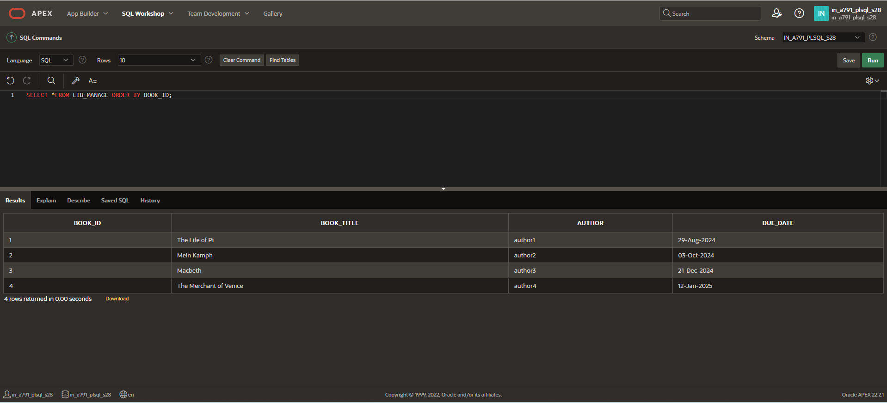

**CREATE OR REPLACE FUNCTION rem_days(v_book_id IN lib_manage.book_id%TYPE)**

**RETURN INT**

**IS**

**duedate DATE;**

**days_remaining INT;**

**BEGIN**

**SELECT due_date INTO duedate**

**FROM lib_manage**

**WHERE book_id = v_book_id;**

**days_remaining := duedate - SYSDATE;**

**RETURN days_remaining;**

**END;**

**/**

**OUTPUT STATEMENT:**

**DECLARE**

**r_d INT;**

**BEGIN**

**r_d := rem_days(2);**

**DBMS_OUTPUT.PUT_LINE('Days left to return: ' || r_d);**

**END;**

**/**

