**30.CREATE A COPY TABLE AND THEN ILLUSTRATE INSERT,SELECT.**

**CREATE TABLE PERSON2(EMP_ID INT PRIMARY KEY,EMP_FIRSTNAME VARCHAR(20),EMP_LASTNAME VARCHAR(20),HIRE_DATE DATE);**

**CREATE TABLE COPY_PERSON2 AS (SELECT *FROM PERSON2);**

**DESC COPY_PERSON2;**

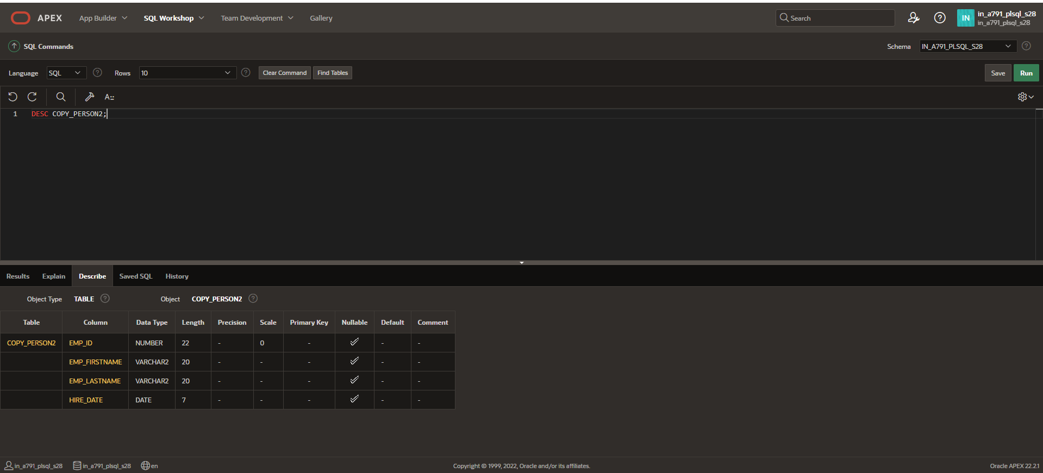

**INSERT INTO COPY_PERSON2 (EMP_ID,EMP_FIRSTNAME,EMP_LASTNAME) VALUES (1,'Peter','');**

**INSERT INTO COPY_PERSON2 (EMP_ID,EMP_FIRSTNAME,EMP_LASTNAME,HIRE_DATE) VALUES (2,'Ben','Duket','');**

**INSERT INTO COPY_PERSON2 (EMP_ID,EMP_FIRSTNAME,EMP_LASTNAME,HIRE_DATE) VALUES (3,'Harsha','Kyle',SYSDATE);**

**SELECT *FROM COPY_PERSON2;**

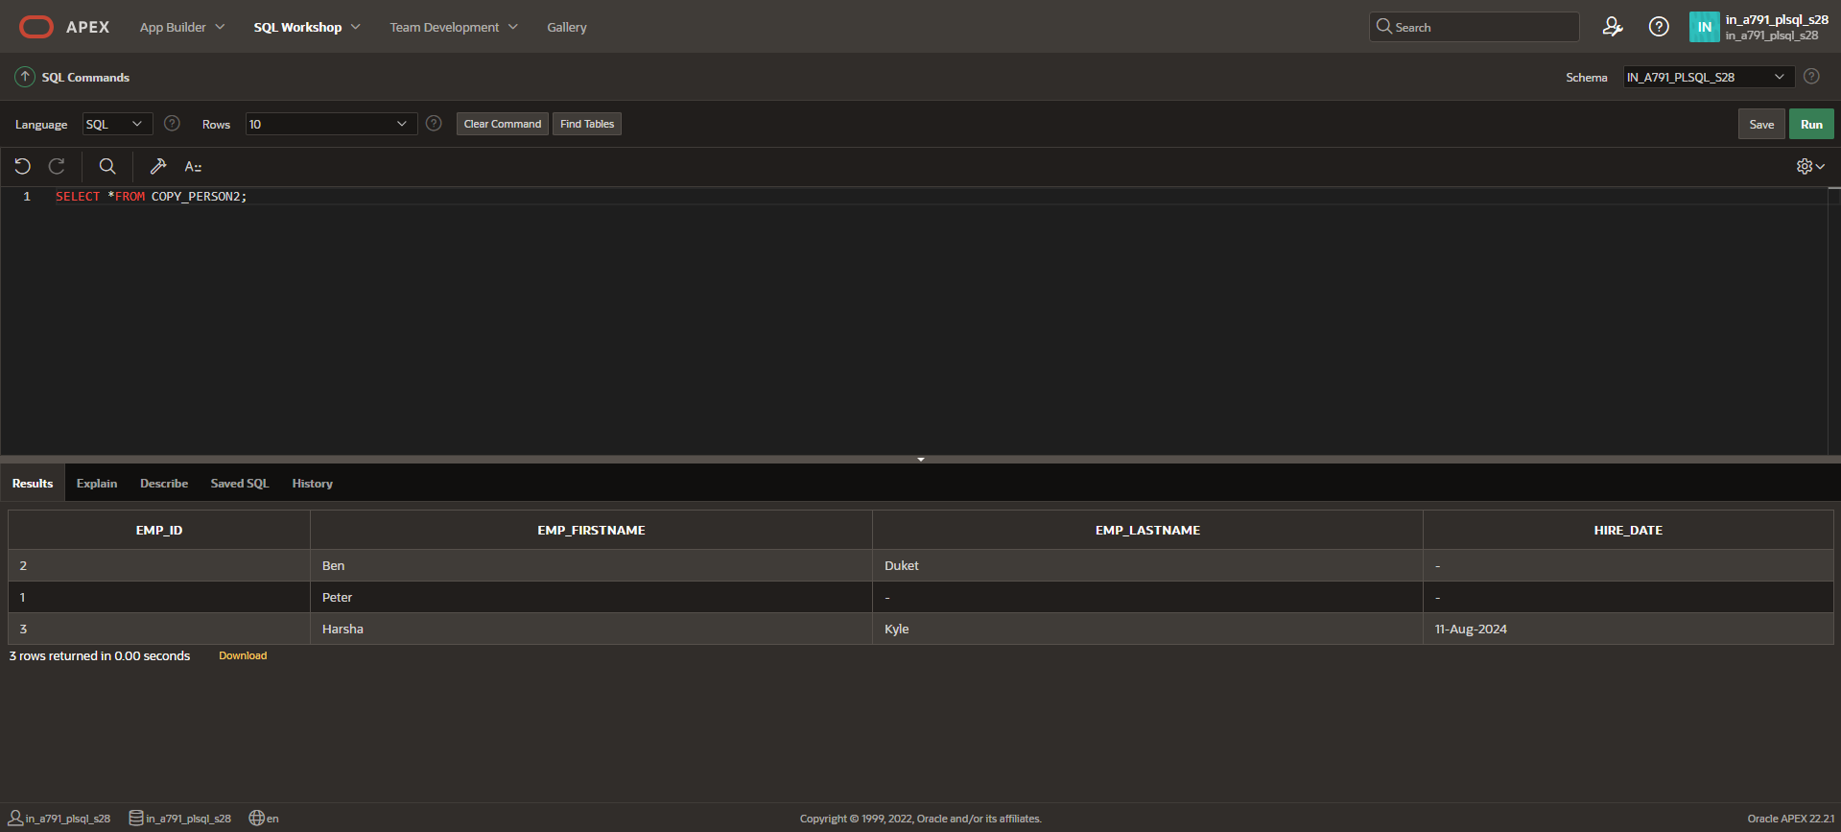

**SELECT EMP_FIRSTNAME,HIRE_DATE FROM COPY_PERSON2 WHERE EMP_ID=1;**

