**31.UPDATE AND DELETE COMMANDS IN COPY_TABLE**

**UPDATE COPY_PERSON2 SET EMP_ID=101 WHERE EMP_ID=5;**

**SELECT *FROM COPY_PERSON2 ORDER BY EMP_ID;**

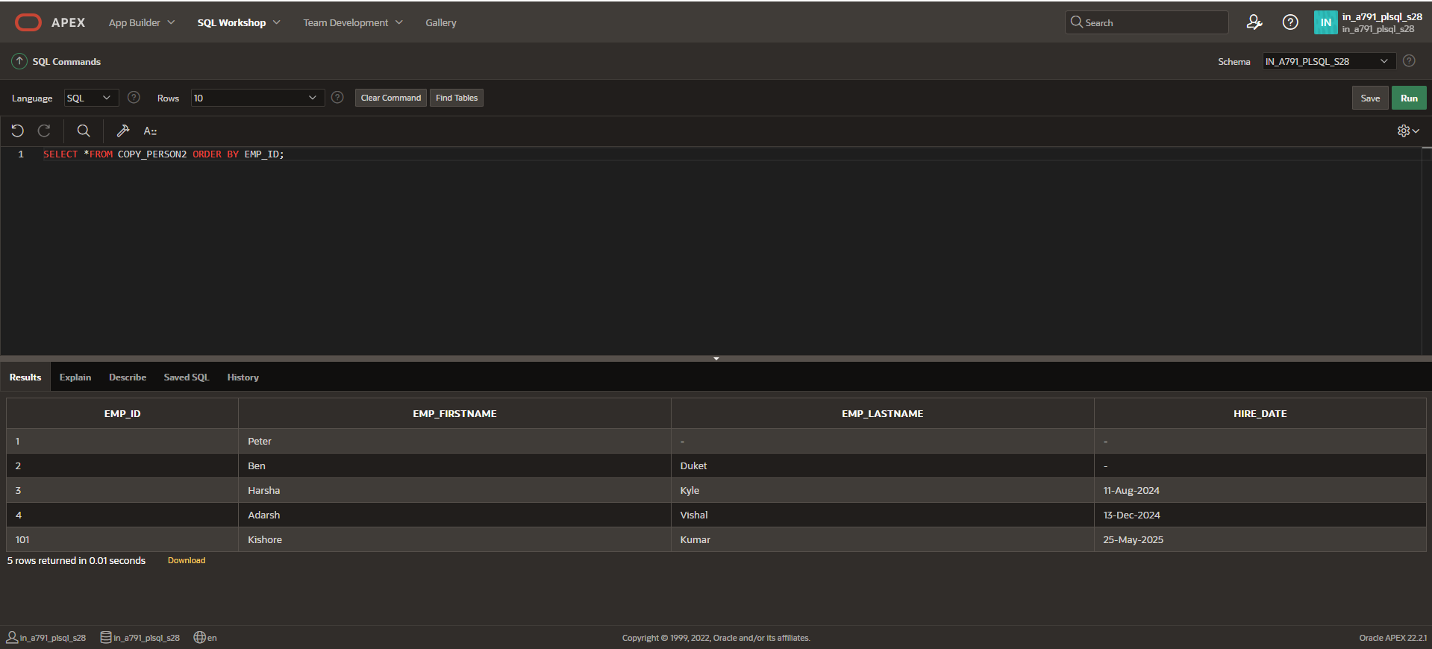

**UPDATE COPY_PERSON2 SET EMP_LASTNAME='Khan' WHERE EMP_ID<=5;**

**SELECT *FROM COPY_PERSON2 ORDER BY EMP_ID;**

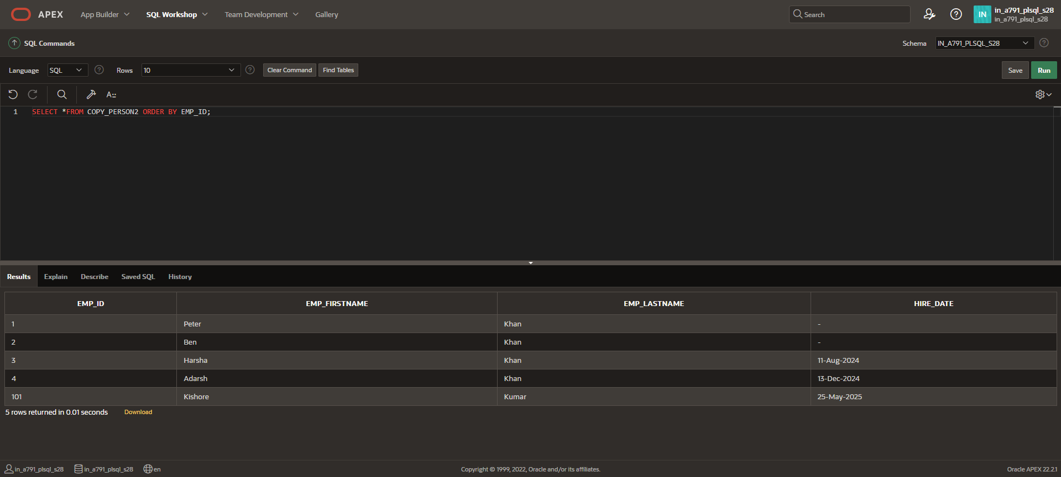

**UPDATE COPY_PERSON2 SET EMP_LASTNAME='Parker';**

**SELECT *FROM COPY_PERSON2 ORDER BY EMP_ID;**

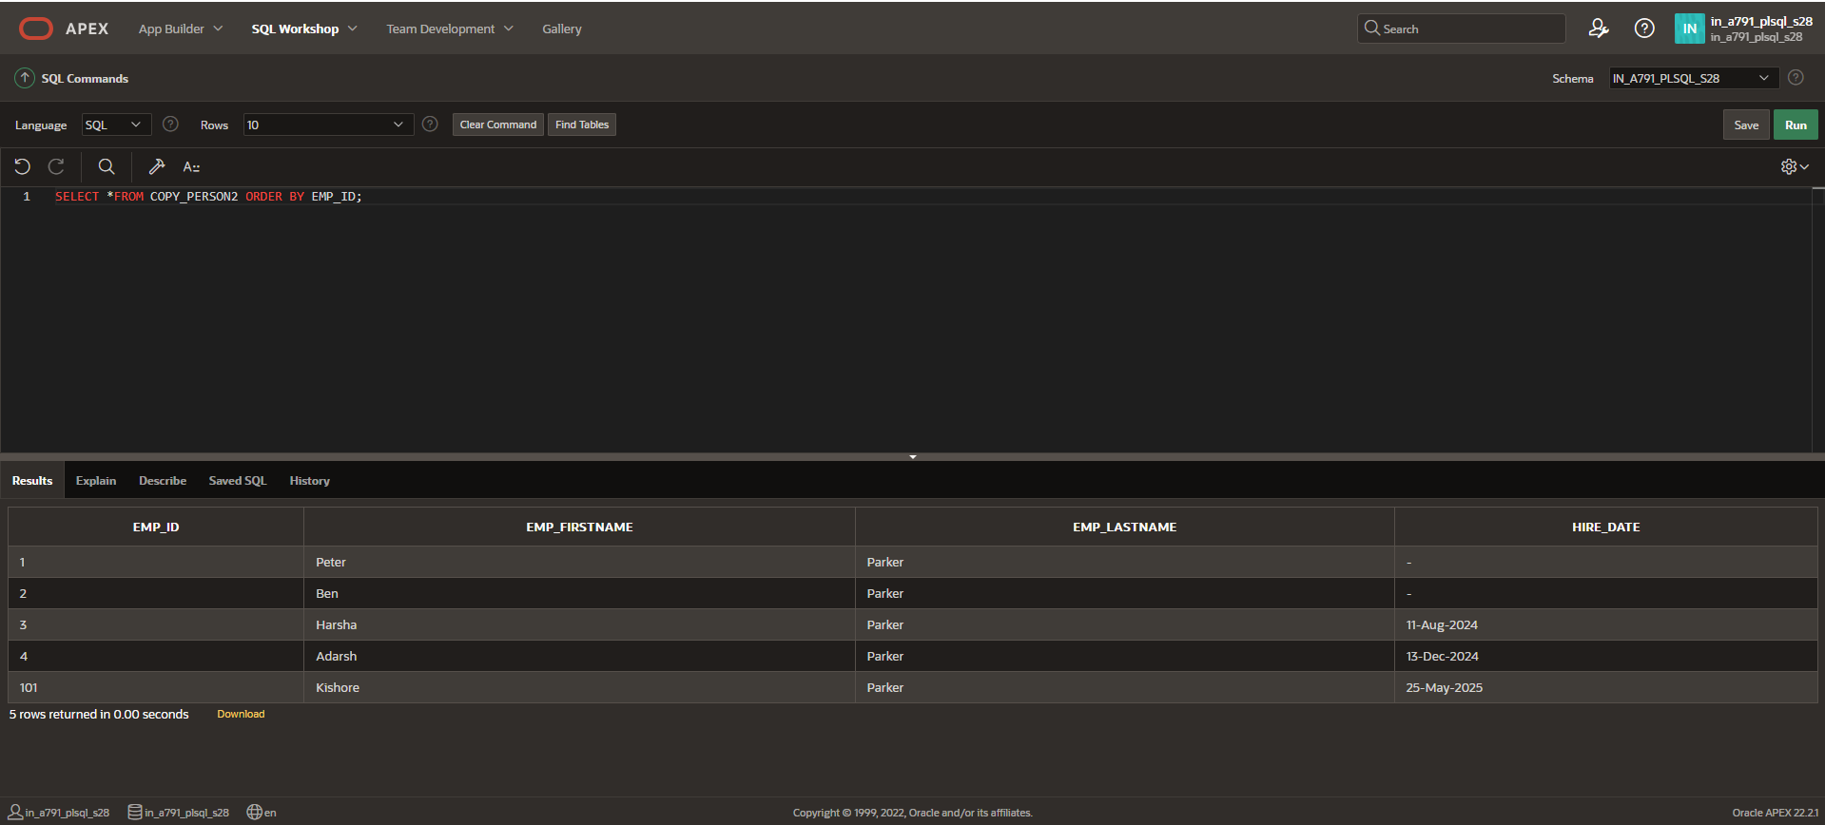

**UPDATE COPY_PERSON2 SET HIRE_DATE= (SELECT HIRE_DATE FROM COPY_PERSON2 WHERE EMP_ID = 1)WHERE EMP_ID= 3;**

**DELETE from COPY_PERSON2 WHERE EMP_ID =1;**

**DELETE from COPY_PERSON2 WHERE EMP_ID =2;**

**SELECT *FROM COPY_PERSON2 ORDER BY EMP_ID;**

