**35.** **Dynamic SQL with a DML Statement**

**CREATE TABLE DEPARTMENTS (DEPARTMENT_ID INT PRIARY KEY,DEPARTMENT_NAME VARCHAR(20),LOCATION_ID INT);**

**SELECT *FROM DEPARTMENTS ORDER BY DEPARTMENT_ID;**

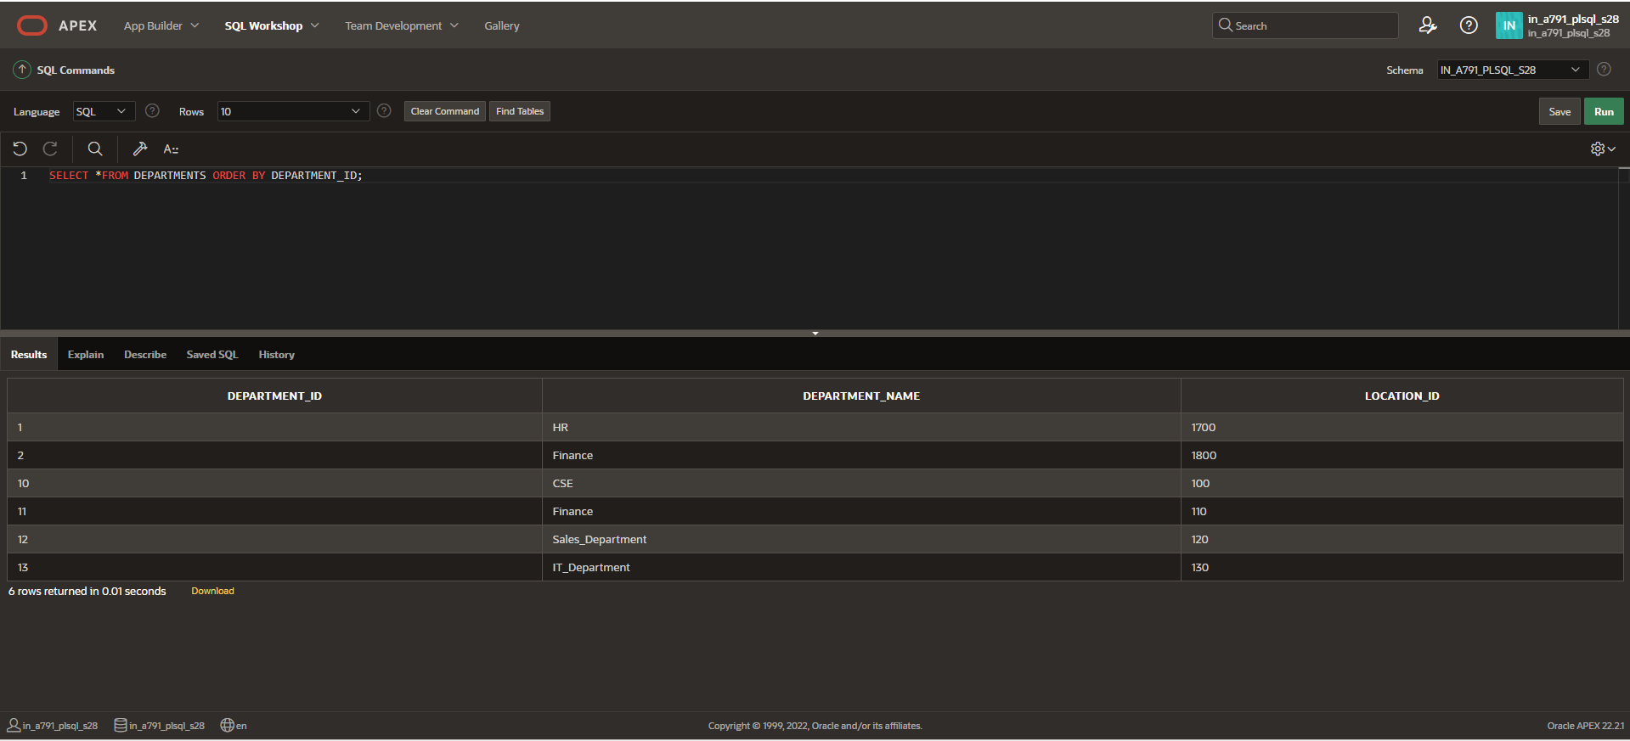

**FUNCTION CREATION**

**CREATE FUNCTION d_rows(p_table_name VARCHAR2)**

**RETURN NUMBER IS**

**BEGIN**

**EXECUTE IMMEDIATE 'DELETE FROM ' || p_table_name;**

**RETURN SQL%ROWCOUNT;**

**END;**

**DECLARE**

**LOCATION_ID NUMBER;**

**BEGIN**

**LOCATION_ID:= del_rows('DEPARTMENTS');**

**DBMS_OUTPUT.PUT_LINE(LOCATION_ID || ' rows deleted.');**

**END;**

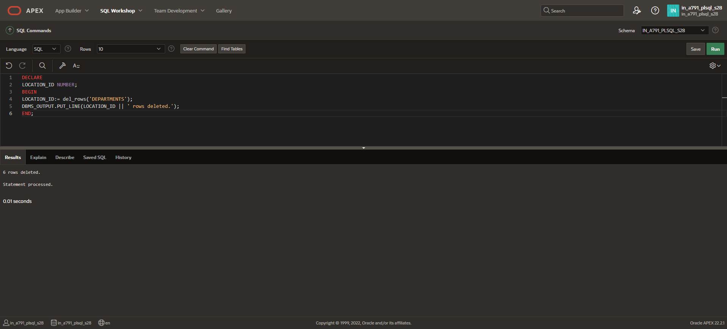

**DESC DEPARTMENTS;**

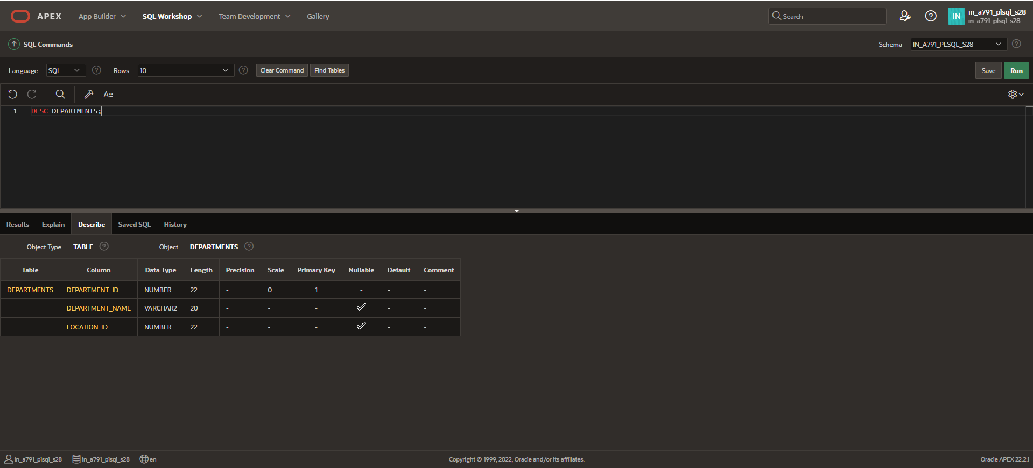

**SELECT *FROM DEPARTMENTS;**

