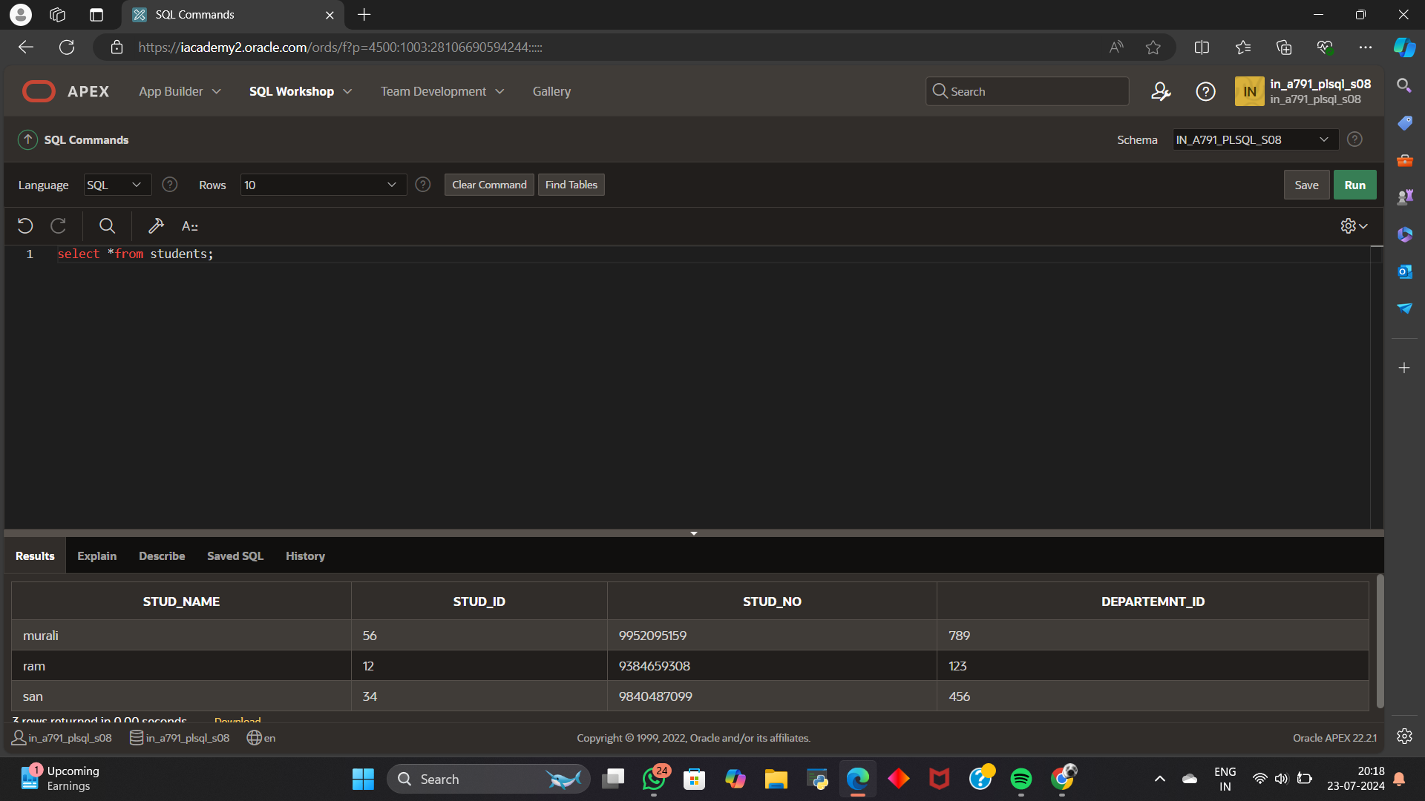

2.ALTER TABLE students

RENAME COLUMN stud_id TO s_id;

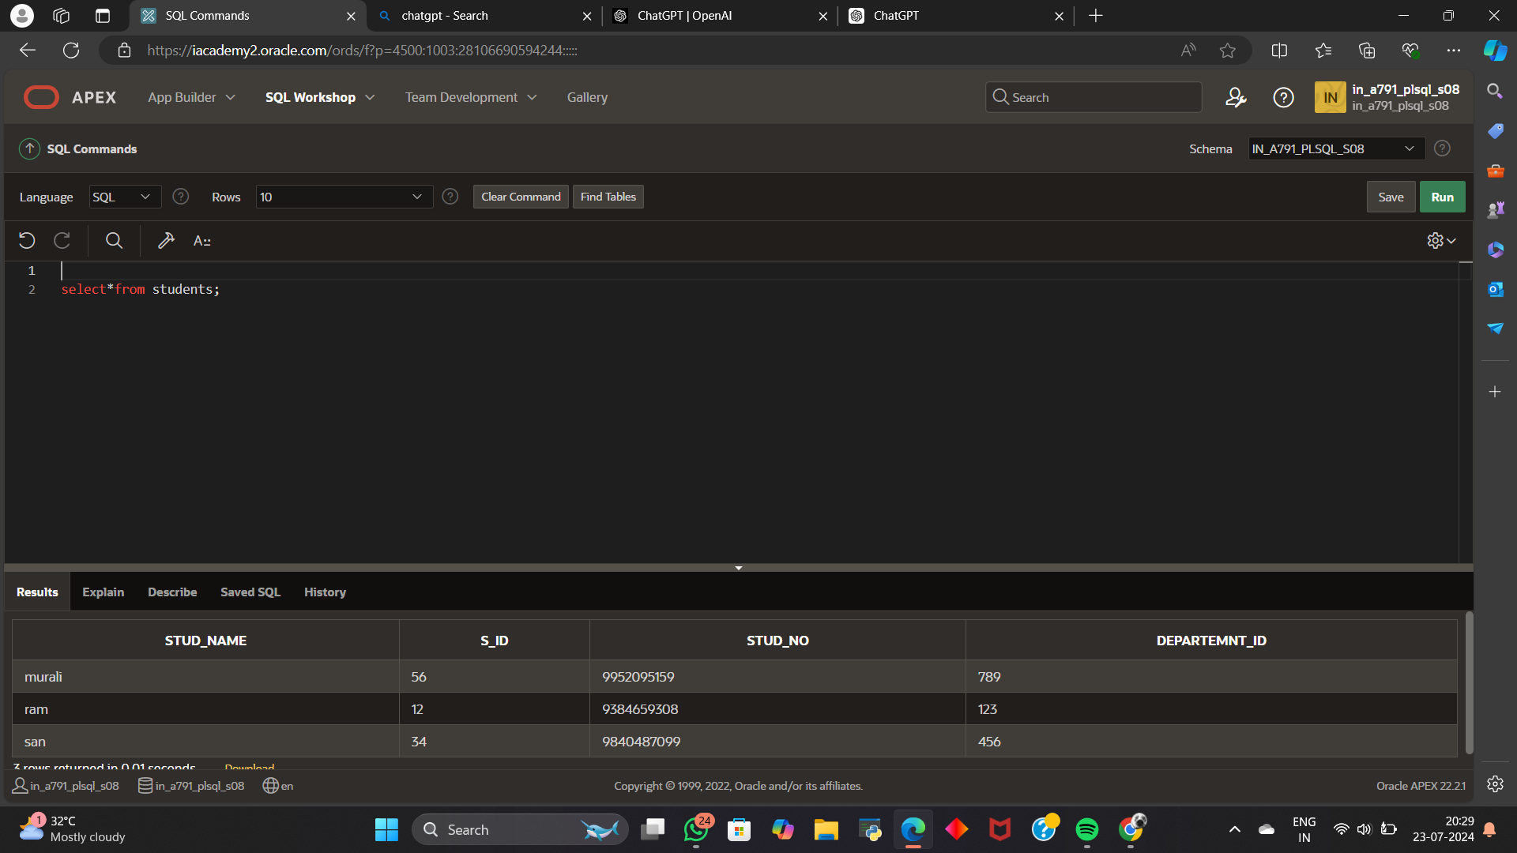

3.TRUNCATE TABLE STUDENTS;

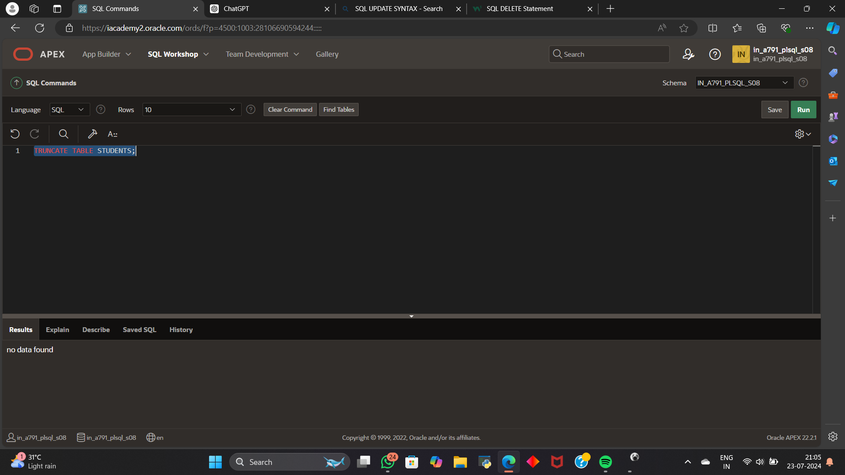

4. DROP TABLE STUDENTS

