1.SELECT * FROM students WHERE S_ID= 56;

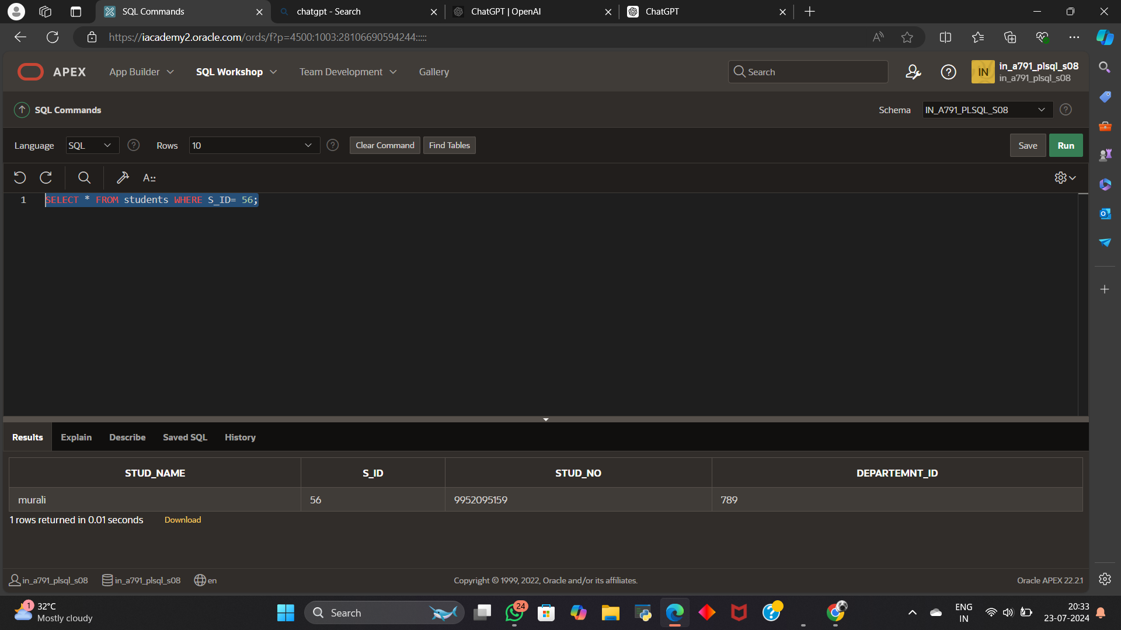

2.insert into students values('ram',12,9384659308,123);

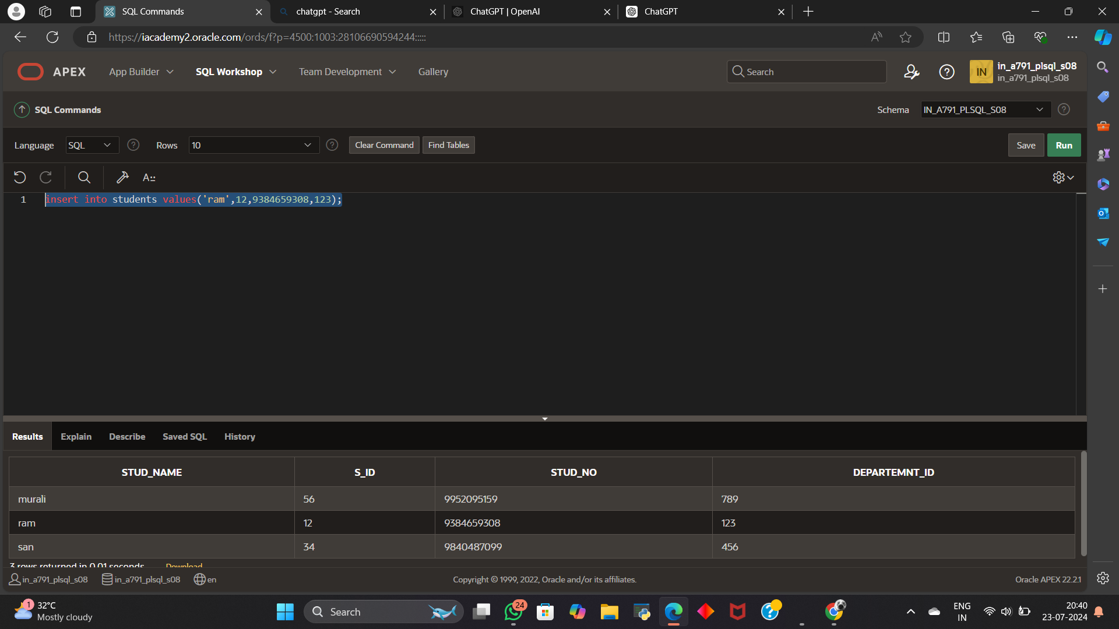

3.UPDATE students

SET stud_name = 'suriya'

WHERE S_ID = 56;

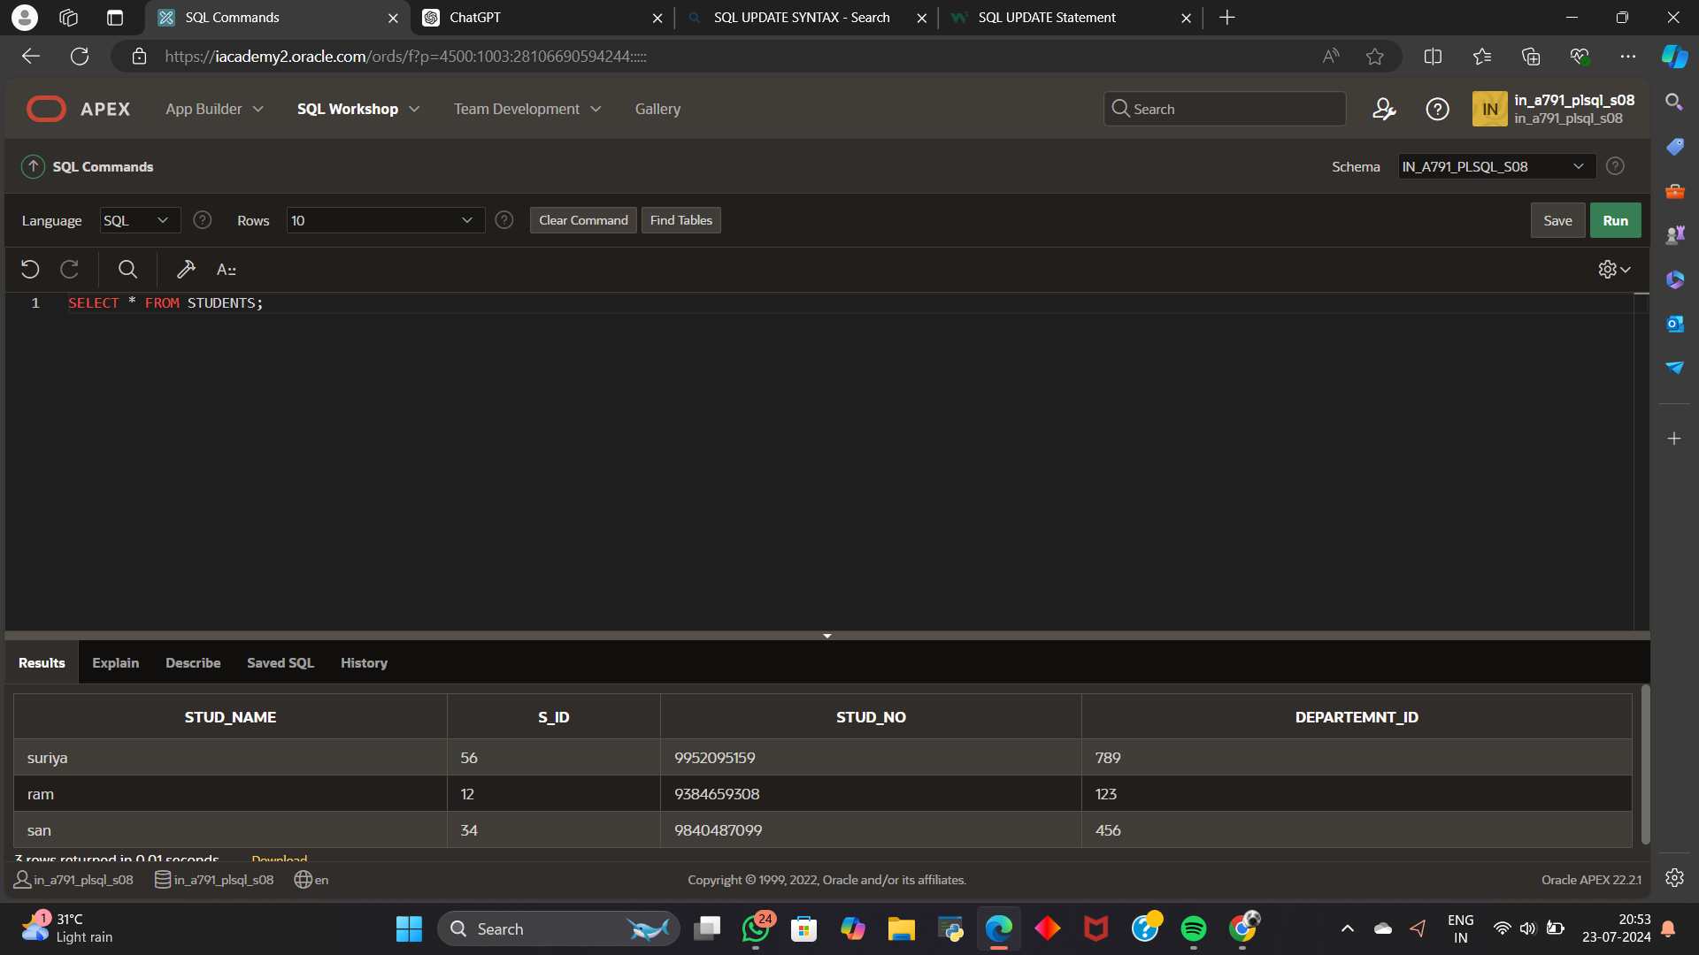

4. DELETE FROM STUDENTS WHERE DEPARTEMNT_ID=789;

