Assignment-3

Q1.

Code:

<!DOCTYPE html>

<html lang="en">

<head>

<meta charset="UTF-8">

<meta name="viewport" content="width=device-width, initial-scale=1.0">

<title>Gallery</title>

</head>

<body>

<img src="https://media.gq-magazine.co.uk/photos/62fcd87f4c951e9b75502f42/16:9/w_2560%2Cc_limit/Fight-club-brad-pitt-topless.jpg" width="1000"

height="500" alt="">

<img src="https://occ-0-2794-2219.1.nflxso.net/dnm/api/v6/9pS1daC2n6UGc3dUogvWIPMR_OU/AAAABajAQB6NjxNNMDr3ncD-KZD86GbvsSdsneMzfJpc8cC3dZikk_RlVVU7LAXRVieynorKlINiU6wLVF7Jsjv3SFCGaoeG5y78zog.jpg?r=5e1" height="500" width="1000">

<img src="https://www.themarysue.com/wp-content/uploads/2019/04/BEEs-new-book-gets-scathing-review-Christian-Bale-in-American-Psycho-2000.jpg?fit=1200%2C520" alt="">

<img src="https://encrypted-tbn0.gstatic.com/images?q=tbn:ANd9GcR2F_reqo5un9MrXSk4DWMyQuQxFMZefwjFfQ&usqp=CAU" height="500" width="1000">

</body>

</html>

Output:

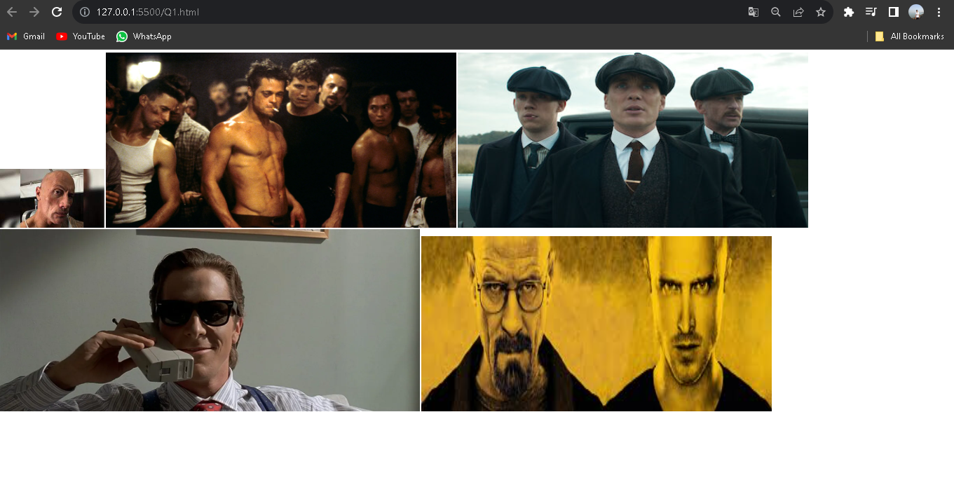

Q2.Code

<!DOCTYPE html>

<html lang="en">

<head>

<meta charset="UTF-8">

<meta name="viewport" content="width=device-width, initial-scale=1.0">

<title>Assignment 1</title>

</head>

<body>

<audio src="https://www.learningcontainer.com/wp-content/uploads/2020/02/Kalimba.mp3"

controls> Audio</audio>

<video src="https://rr1---sn-hpjgvnj5o-cvhe.googlevideo.com/videoplayback?expire=1702574264&ei=WOR6ZcTuHtChz7sPxYibsA0&ip=2a02%3A4780%3A11%3A1359%3A0%3A14fb%3Abefe%3A2&id=o-ALi5OUMlzuoRAJGSqIDCf6420EQXnxike0_sLiijtBft&itag=244&source=youtube&requiressl=yes&xpc=EgVo2aDSNQ%3D%3D&vprv=1&mime=video%2Fwebm&gir=yes&clen=16197591&dur=314.200&lmt=1699272278446855&keepalive=yes&fexp=24007246&c=ANDROID_TESTSUITE&txp=4535434&sparamaB1oJBwLFdkmqyp-gxw%3D%3D&title=Meherbaan+Full+Video+%7C+BANG+BANG%21+%7C+feat+Hrithik+Roshan+%26+Katrina+Kaif+%7C+Vishal+Shekhar&redirect_counter=1&rm=sn-cvhz77e&req_id=153b82191da9a3ee&cms_redirect=yes&cmsv=e&ipbypass=yes&mh=IF&mip=38.41.72.107&mm=31&mn=sn-hpjgvnj5o-cvhe&ms=au&mt=1702552439&mv=m&mvi=1&pcm2cms=yes&pl=24&lsparams=ipbypass,mh,mip,mm,mn,ms,mv,mvi,pcm2cms,pl&lsig=AAO5W4owRQIgDFc9MGlfXwYYTiTtxmQI1elwWck6MLqTwa69aNARVJMCIQCZYMADXno6rWNY7wIs2NHtVi8O56qLaH8Lbhx4g7eD2w%3D%3D" controls></video>

</body>

</html>

Output

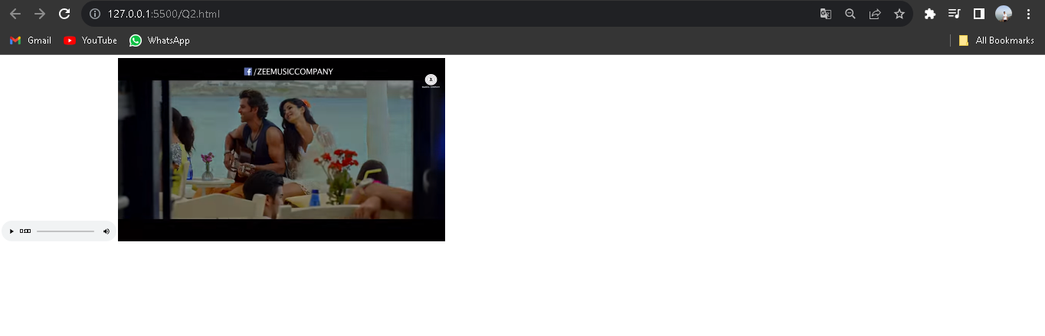

Q3

Code

<!DOCTYPE html>

<html lang="en">

<head>

<meta charset="UTF-8">

<meta name="viewport" content="width=device-width, initial-scale=1.0">

<title>Assignment 1</title>

</head>

<body>

<audio src="https://www.learningcontainer.com/wp-content/uploads/2020/02/Kalimba.mp3" controls muted autoplay

loop> Audio</audio>

<video src="https://rr1---sn-hpjgvnj5o-cvhe.googlevideo.com/videoplayback?expire=1702574264&ei=WOR6ZcTuHtChz7sPxYibsA0&ip=2a02%3A4780%3A11%3A1359%3A0%3A14fb%3Abefe%3A2&id=o-" controls muted autoplay

loop></video>

</body>

</html>

Output



Q4.

Code

<!DOCTYPE html>

<html lang="en">

<head>

<meta charset="UTF-8">

<meta name="viewport" content="width=device-width, initial-scale=1.0">

<title></title>

</head>

<body>

<iframe src="https://en.wikipedia.org/wiki/Physics_Wallah" style="border:0px #ffffff none;"

name="myiFrame"

scrolling="yes" frameborder="1" marginheight="0px" marginwidth="0px" height="3000px"

width="1000px"

allowfullscreen></iframe>

</body>

</html>

Output

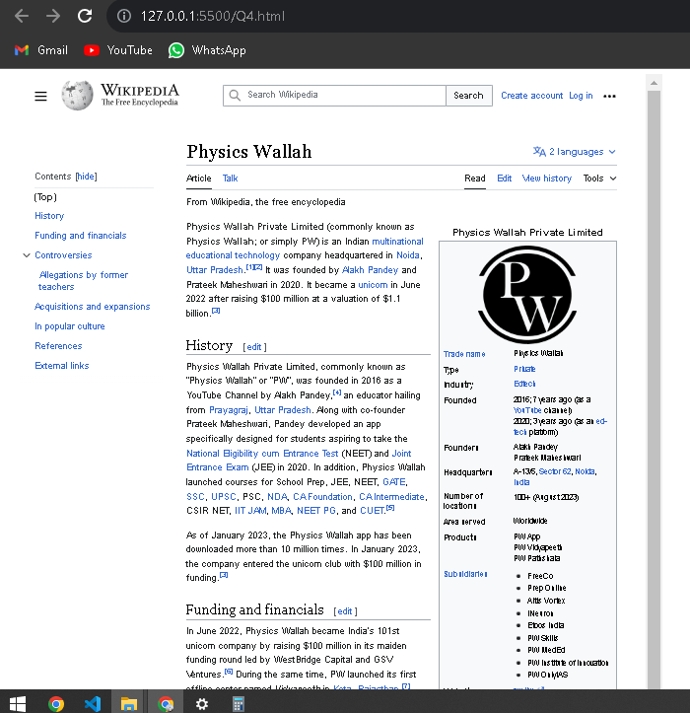

Q5.

Code:

<!DOCTYPE html>

<html lang="en">

<head>

<meta charset="UTF-8">

<meta name="viewport" content="width=device-width, initial-scale=1.0">

<title>Assignment 3</title>

</head>

<body>

<form>

<label for="firstName">First Name:

<input type="text" name="firstName" placeholder="Ram" id="firstName" required

minlength=3 max=20 />

</label>

<br>

<label for="lastName">Last Name:

<input type="text" name="lastName" placeholder="Parab" id="lastName" required min=3

max=20 />

</label>

<br>

<label for="email">Email:

<input type="email" name="email" placeholder="ramchandraparab.com" id="email" required />

</label>

<br>

<label for="password">Password:

<input type="password" name="password" placeholder="********" id="password" required

min=8 />

</label>

<br>

<label for="confirmPassword">Confirm Password:

<input type="password" name="confirmPassword" placeholder="********"

id="confirmPassword" required />

</label>

<br>

<label for="age">Age:

<input type="number" name="age" placeholder="21" id="age" required min=0 max=150 />

</label>

<br>

<label for="">Gender:

<input type="radio" id="male" value="male" name="gender" checked />

<label for="male">Male</label>

<input type="radio" id="female" value="female" name="gender" />

<label for="female">Female</label>

<input type="radio" id="other" value="other" name="gender" />

<label for="other">Other</label>

</label>

<br>

<label for="terms">terms:

<input type="checkbox" id="terms" required /> I agree to terms and conditions

</label>

<br>

<button type="submit">Register</button>

</form>

</body>

</html>

Output:

