

Automation of IGF Upload Tool – Design Document

Amendment Record / Control Sheet (ACS)

|  |  |  |  |  |  |  |  |
| --- | --- | --- | --- | --- | --- | --- | --- |
| Rev. No. | Date | Reason for Issue | Prepared by | Reviewed by | Approved by | Issued by | Details of Amendments / Revisions |
| 1.0 | 16/05/2015 | For Management Review & update | Anand Kumar B |  |  |  | New Document |
|  |  |  |  |  |  |  |  |
|  |  |  |  |  |  |  |  |
|  |  |  |  |  |  |  |  |
|  |  |  |  |  |  |  |  |

Table of Contents

Preface 3

Introduction 4

Overview 4

Purpose 4

Scope 4

System Overview 5

System Architecture 7

Architectural design 7

Decomposition description 8

Data Design 9

Database design 9

Description 9

Table schema details 9

Component Design 9

User Interface Design 10

Overview of User interface 10

User interface objects and actions 10

# 

# Preface

RJIL intends to roll-out a PAN India network to offer 4G connectivity to facilitate the Digital Lifestyle offerings to substantially large number of subscribers. To offer these Digital Lifestyle services, RJIL is developing very large Internet Data Centres (IDC) spread across PAN India. These IDC’s will be the point of convergence of multiple networks.

All IDCs and AG3 locations will be monitored and managed on a 24x7x365 basis from a central Network Operations Center (NOC) based at RCP. The IDC Infra & Management NOC is an integral part of the overall RJIL Central NOC.

Systems in IDC use to be racked/stacked and provisioned manually. In which admin gets network details from network team, assign IP manually to connect console of the server. Configure other parameters or firmware upgrade or OS installation use to happen manually. Enabling services or monitoring setup needs to be done through scripts which need to be run manually again after OS installation. Lot of time and manual effort is required in this process of provisioning.

This document describes on Data Upload Interface for CMDB with various options.

# Introduction

## Overview

This is a technical blue print for the project.

RJIL demand planning team engage with the customer to understand the requirement, take the decision on procuring the servers. Next to that server’s physical location will be decided and servers will be racked/stacked. Further to that PEI team will be providing data input via a standard IGF excel file. Post which the automatic provisioning starts and makes systems ready for validation. Upon final validation systems are released to customer.

## Purpose

This design document is for IGF Upload Tool development to cater to the needs of the PEI team to upload the data using a Web-Based UI to aid Auto-provisioning system to begin provisioning. This document describes system architecture, design view, components involved in it, user interface objects and their activities and work-flow.

## Scope

This document is intended to list the details of a Web-UI for uploading the new server data into CMDB database tables starting from Customer’s request capture to till the beginning of the Automation process.

# System Overview



Customer Raise a server request for their planned business need via an IGF file. Request will be received by the PEI team and will be finalized with back-and-forth communication with the customer. When the IGF data is ready to fed into system. The below 4 modules provide screens to provide User-Interface to upload data at different levels.

System consists of 4 major modules which include:

1. Create Profile
2. Create / Modify Request
3. Create / Modify RFI
4. Initiate Zero Touch Provisioning [Phase-2]

## System Architecture

### Architectural design

Please find architectural design diagram in the below image and also in the below embedded visio file.



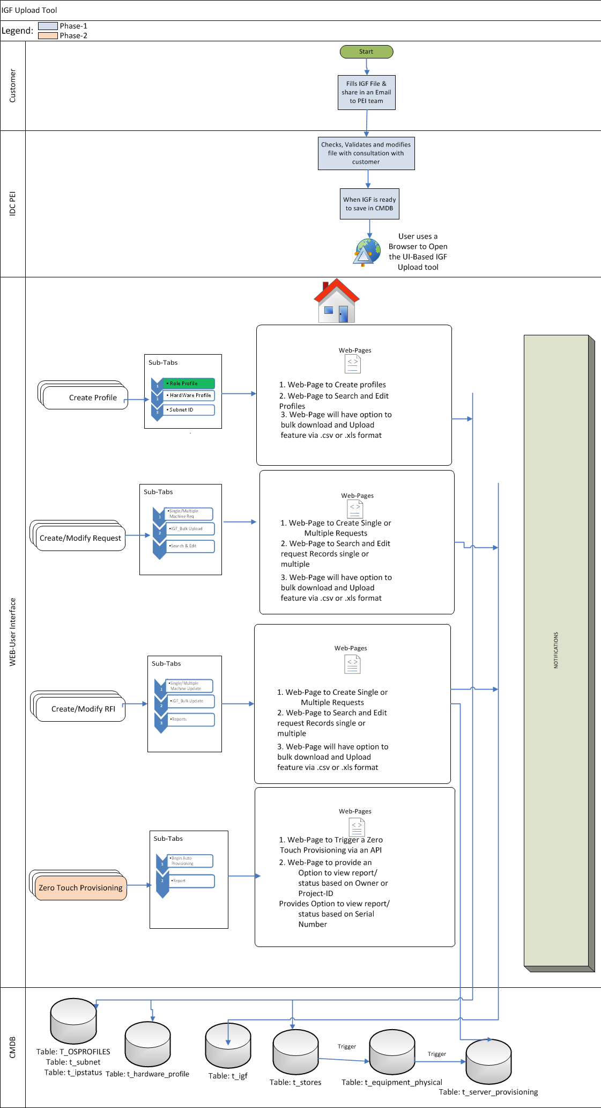

### Decomposition description

**i. Create Profile:**

* This Tab on the Web-UI provides 3 sub-tabs which provides

1. Front-end form to create a new **Role_Profile** for OS customization
2. Front-End form to create **Hardware_Profile** which describes the h/w specs of the Server and
3. Front-End form to create **Subnet ID.**

* Each sub-tab will have an option to search & edit the existing records.
* Each sub-tab will have an option to download the existing profiles
* Each sub-tab will have an option to upload the new profiles in bulk via a predefined format(a .csv or .xlsx file format)
* The inputs either single record or bulk file upload will be validated for mandatory fields.
* The Validated data will be rejected if data is invalid and the same is displayed on the UI and suggests User to re-do the same.
* Upon successful data validation the data will be uploaded into the CMDB.
* User will be getting the Message on the screen about the successful data saving.

**ii. Create / Modify Request**

* This tab on the Web-UI provides 3 sub-tabs which provides

1. Front-end form to create “Single/Multiple Machine Request”
2. Front-end form option “IGF Bulk Upload” to upload the data in bulk. [Supported Version is IGF-Version 3.0
3. Front-end form to “Search & Edit” to search existing records and edit the same.

* Each sub-tab will have an option to download the existing records.
* Each sub-tab will have an option to upload the new records in bulk via a predefined format(a .csv or .xlsx file format)
* The inputs either single record or bulk file upload will be validated for mandatory fields.
* The Validated data will be rejected if data is invalid and the same is displayed on the UI and suggests User to re-do the same.
* Upon successful data validation the data will be uploaded into the CMDB.
* User will be getting the Message on the screen about the successful data saving.

**iii. Create / Modify RFI**

* This tab on the Web-UI provides 3 sub-tabs which provides

1. Front-end form to create “Single/Multiple Machine Update”
2. Front-end form option “IGF Bulk Update” to update the data in bulk. [Supported Version is IGF-Version 3.0
3. Front-end form to “Search, Edit & Report” to search existing records and edit the same.

* Each sub-tab will have an option to download the existing records.
* Each sub-tab will have an option to upload the new records in bulk via a predefined format(a .csv or .xlsx file format)
* The inputs either single record or bulk file upload will be validated for mandatory fields.
* The Validated data will be rejected if data is invalid and the same is displayed on the UI and suggests User to re-do the same.
* Upon successful data validation the data will be uploaded into the CMDB.
* User will be getting the Message on the screen about the successful data saving.

1. **Initiate Zero Touch Provisioning [Phase-2]**

* This tab on the Web-UI provides 2 sub-tabs which provides

1. UI to Trigger Zero Touch Provisioning scripts on the Execution server.
2. UI to find the status/Reports of the different projects under execution

* The Report tab will provide an option to download the report in a file format.

### Data Design

2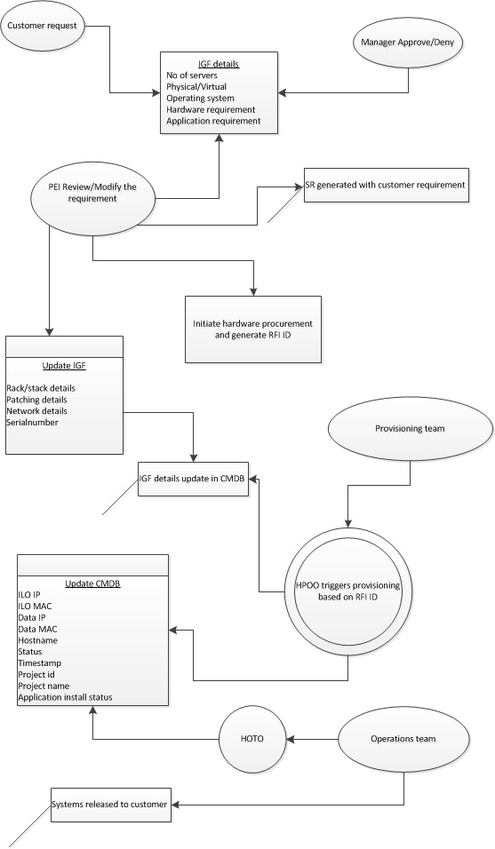

# Database design

## Description

Explain the CMDB tables, triggers, stored procedures etc. used in systems provisioning

Provisioning Tables

1. t_subnet
2. t_ipstatus
3. t_store
4. t_physical_equipment
5. t_server_provisioning
6. t_vm_provisioning
7. t_igf

**Triggers**

1. A trigger is on t_store table to replicate the data into t_physical_equipment upon insert.
2. A trigger is on t_physical_equipment to replicate the data into t_server_provision upon insert/update change.

**Stored Procedures** are None.

## Table Schema

Please open the below Excel sheet to find the tables schema.



## Table Input & Output details

|  |  |
| --- | --- |
| **Legend** | |
|  | 27 Mandatory fields for Automation |

|  |  |  |  |  |
| --- | --- | --- | --- | --- |
| **Sr No** | **Process Phase** | **Data Provided By  (Manual)** | **Input Fields** | **Output Table(CMDB)** |
| 1 | Procurement | PEI - Stores Team | SERIALNUMBER | cmdb.t_store |
| 2 | PEI - Stores Team | PONUMBER | cmdb.t_store |
| 3 | PEI - Stores Team | AMC_START_DATE | cmdb.t_store |
| 4 | PEI - Stores Team | AMC_END_DATE | cmdb.t_store |
| 5 | PEI - Stores Team | OWNER_EMAIL | cmdb.t_store |
| 6 | PEI - Stores Team | OWNER_CONTACTNO | cmdb.t_store |
| 7 | PEI - Stores Team | PROJECT_OWNER | cmdb.t_store |
| 8 | PEI - Stores Team | PROJECT_NAME | cmdb.t_equipment_physical |
| 9 | Planning, Engg & Implementation | PEI - Planning Team | POWER_MGMT | cmdb.t_equipment_physical |
| 10 | PEI - Planning Team | SPACE_MGMT | cmdb.t_equipment_physical |
| 11 | PEI - Planning Team | HW_MGMT | cmdb.t_equipment_physical |
| 12 | PEI - Planning Team | HDDINTERNAL | cmdb.t_equipment_physical |
| 13 | PEI - Planning Team | DEVICETYPE | cmdb.t_equipment_physical |
| 14 | PEI - Planning Team | CITY | cmdb.t_equipment_physical |
| 15 | PEI - Planning Team | FACILITY | cmdb.t_equipment_physical |
| 16 | PEI - Planning Team | FACILITYID | cmdb.t_equipment_physical |
| 17 | PEI - Planning Team | SERVERHALL | cmdb.t_equipment_physical |
| 18 | PEI - Planning Team | RACK_NAME | cmdb.t_equipment_physical |
| 19 | PEI - Planning Team | RACK_NUMBER | cmdb.t_equipment_physical |
| 20 | PEI - Planning Team | U_LOCATION | cmdb.t_equipment_physical |
| 21 | PEI - Planning Team | S_LOCATION | cmdb.t_equipment_physical |
| 22 | PEI - Implementation Team | ILO_PASSWD | cmdb.t_equipment_physical |
| 23 | PEI - Implementation Team | Role_profile | cmdb.t_server_provisioning |
| 24 | PEI - Implementation Team | Hardware_profile | cmdb.t_server_provisioning |
| 25 | PEI - Implementation Team | project_id | cmdb.t_server_provisioning |
| 26 | PEI - Implementation Team | profile | cmdb.t_server_provisioning |
| 27 | PEI - Implementation Team | vlan_id | cmdb.t_server_provisioning |
| 28 | PEI - Implementation Team | SAN_REQUIRED | cmdb.t_server_provisioning |
| 29 | PEI - Implementation Team | SAN_INTERFACE | cmdb.t_server_provisioning |
| 30 | PEI - Implementation Team | HA | cmdb.t_server_provisioning |
| 31 | PEI - Implementation Team | HA_PAIRING_NO | cmdb.t_server_provisioning |
| 32 | PEI - Implementation Team | OS_MGMT | cmdb.t_server_provisioning |
| 33 | Networking Pre-Requisites | PEI - Implementation Team | CITY | cmdb.t_ipstatus |
| 34 | PEI - Implementation Team | FACILITY | cmdb.t_ipstatus |
| 35 | PEI - Implementation Team | FACILITY_ID | cmdb.t_ipstatus |
| 36 | PEI - Implementation Team | IP | cmdb.t_ipstatus |
| 37 | PEI - Implementation Team | GATEWAY | cmdb.t_ipstatus |
| 38 | PEI - Implementation Team | SUBNET_MASK | cmdb.t_ipstatus |
| 39 | PEI - Implementation Team | vlan_id | cmdb.t_ipstatus |
| 40 | PEI - Implementation Team | SERVERHALL | cmdb.t_ipstatus |
| 41 | PEI - Implementation Team | ENVIRONMENT | cmdb.t_ipstatus |
| 42 | Automation | Provisioning - phase1 -automation | ILORSA_IP | cmdb.t_server_provisioning |
| 43 | Provisioning - phase1 -automation | ILORSA_SUBNET_MASK | cmdb.t_server_provisioning |
| 44 | Provisioning - phase1 -automation | ILORSA_GATEWAY | cmdb.t_server_provisioning |
| 45 | Provisioning - phase1 -automation | ILORSA_MAC_ADDR | cmdb.t_server_provisioning |
| 46 | Provisioning - phase1 -automation | ILORSA_STATUS | cmdb.t_server_provisioning |
| 47 | Provisioning - phase2 -automation | HOSTNAME | cmdb.t_server_provisioning |
| 48 | Provisioning - phase2 -automation | DATA_IP | cmdb.t_server_provisioning |
| 49 | Provisioning - phase2 -automation | DATA_SUBNET_MASK | cmdb.t_server_provisioning |
| 50 | Provisioning - phase2 -automation | DATA_GATEWAY | cmdb.t_server_provisioning |
| 51 | Provisioning - phase2 -automation | BOOTING_MAC_ADDR | cmdb.t_server_provisioning |
| 52 | Provisioning - phase2 -automation | BOOTING_INTERFACE | cmdb.t_server_provisioning |
| 53 | Provisioning - phase2 -automation | JOB_ID | cmdb.t_server_provisioning |
| 54 | Operations | Operations | HP_NODEGROUP | cmdb.t_server_provisioning |

|  |  |  |  |
| --- | --- | --- | --- |
| Action | TABLE NAME | Input Count | Output Count |
| Intake Tool & Scan Entry by Stores Team | cmdb.t_store | 8 | 8 |
| Intake tool & Scan Entry by Deployment Team | cmdb.t_equipment_physical | 15 | 23 |
| Intake Tool & Automation | cmdb.t_server_provisioning | 23 | 65 |
| Automation | cmdb.t_server_operations | 0 | 65 |

|  |  |  |  |  |  |
| --- | --- | --- | --- | --- | --- |
| **Sr No** | **Process Phase** | **Data Provided By  (Manual)** | **Contact Person** | **Input Fields** | **Output Table(CMDB)** |
| 1 | Procurement | PEI - Stores Team | Prakash / Kumar Kounder | SERIALNUMBER | cmdb.t_store |
| 2 | PEI - Stores Team | Prakash / Kumar Kounder | PONUMBER | cmdb.t_store |
| 3 | PEI - Stores Team | Prakash / Kumar Kounder | AMC_START_DATE | cmdb.t_store |
| 4 | PEI - Stores Team | Prakash / Kumar Kounder | AMC_END_DATE | cmdb.t_store |
| 5 | PEI - Stores Team | Prakash / Kumar Kounder | OWNER_EMAIL | cmdb.t_store |
| 6 | PEI - Stores Team | Prakash / Kumar Kounder | OWNER_CONTACTNO | cmdb.t_store |
| 7 | PEI - Stores Team | Prakash / Kumar Kounder | PROJECT_OWNER | cmdb.t_store |
| 8 | PEI - Stores Team | Prakash / Kumar Kounder | PROJECT_NAME | cmdb.t_equipment_physical |
| 9 | Planning, Engg & Implementation | PEI - Planning Team | Samarendra | POWER_MGMT | cmdb.t_equipment_physical |
| 10 | PEI - Planning Team | Samarendra | SPACE_MGMT | cmdb.t_equipment_physical |
| 11 | PEI - Planning Team | Samarendra | HW_MGMT | cmdb.t_equipment_physical |
| 12 | PEI - Planning Team | Samarendra | HDDINTERNAL | cmdb.t_equipment_physical |
| 13 | PEI - Planning Team | Samarendra | DEVICETYPE | cmdb.t_equipment_physical |
| 14 | PEI - Planning Team | Samarendra | CITY | cmdb.t_equipment_physical |
| 15 | PEI - Planning Team | Samarendra | FACILITY | cmdb.t_equipment_physical |
| 16 | PEI - Planning Team | Samarendra | FACILITYID | cmdb.t_equipment_physical |
| 17 | PEI - Planning Team | Samarendra | SERVERHALL | cmdb.t_equipment_physical |
| 18 | PEI - Planning Team | Samarendra | RACK_NAME | cmdb.t_equipment_physical |
| 19 | PEI - Planning Team | Samarendra | RACK_NUMBER | cmdb.t_equipment_physical |
| 20 | PEI - Planning Team | Samarendra | U_LOCATION | cmdb.t_equipment_physical |
| 21 | PEI - Planning Team | Samarendra | S_LOCATION | cmdb.t_equipment_physical |
| 22 | PEI - Implementation Team | Santosh | ILO_PASSWD | cmdb.t_equipment_physical |
| 23 | PEI - Implementation Team | Santosh | Role_profile | cmdb.t_server_provisioning |
| 24 | PEI - Implementation Team | Santosh | Hardware_profile | cmdb.t_server_provisioning |
| 25 | PEI - Implementation Team | Santosh | project_id | cmdb.t_server_provisioning |
| 26 | PEI - Implementation Team | Santosh | profile | cmdb.t_server_provisioning |
| 27 | PEI - Implementation Team | Santosh | vlan_id | cmdb.t_server_provisioning |
| 28 | PEI - Implementation Team | Santosh | SAN_REQUIRED | cmdb.t_server_provisioning |
| 29 | PEI - Implementation Team | Santosh | SAN_INTERFACE | cmdb.t_server_provisioning |
| 30 | PEI - Implementation Team | Santosh | HA | cmdb.t_server_provisioning |
| 31 | PEI - Implementation Team | Santosh | HA_PAIRING_NO | cmdb.t_server_provisioning |
| 32 | PEI - Implementation Team | Santosh | OS_MGMT | cmdb.t_server_provisioning |
| 33 | Networking Pre-Requisites | PEI - Implementation Team | Santosh | CITY | cmdb.t_ipstatus |
| 34 | PEI - Implementation Team | Santosh | FACILITY | cmdb.t_ipstatus |
| 35 | PEI - Implementation Team | Santosh | FACILITY_ID | cmdb.t_ipstatus |
| 36 | PEI - Implementation Team | Santosh | IP | cmdb.t_ipstatus |
| 37 | PEI - Implementation Team | Santosh | GATEWAY | cmdb.t_ipstatus |
| 38 | PEI - Implementation Team | Santosh | SUBNET_MASK | cmdb.t_ipstatus |
| 39 | PEI - Implementation Team | Santosh | vlan_id | cmdb.t_ipstatus |
| 40 | PEI - Implementation Team | Santosh | SERVERHALL | cmdb.t_ipstatus |
| 41 | PEI - Implementation Team | Santosh | ENVIRONMENT | cmdb.t_ipstatus |
| 42 | Automation | Provisioning - phase1 -automation | Anand | ILORSA_IP | cmdb.t_server_provisioning |
| 43 | Provisioning - phase1 -automation | Anand | ILORSA_SUBNET_MASK | cmdb.t_server_provisioning |
| 44 | Provisioning - phase1 -automation | Anand | ILORSA_GATEWAY | cmdb.t_server_provisioning |
| 45 | Provisioning - phase1 -automation | Anand | ILORSA_MAC_ADDR | cmdb.t_server_provisioning |
| 46 | Provisioning - phase1 -automation | Anand | ILORSA_STATUS | cmdb.t_server_provisioning |
| 47 | Provisioning - phase2 -automation | Anand | HOSTNAME | cmdb.t_server_provisioning |
| 48 | Provisioning - phase2 -automation | Anand | DATA_IP | cmdb.t_server_provisioning |
| 49 | Provisioning - phase2 -automation | Anand | DATA_SUBNET_MASK | cmdb.t_server_provisioning |
| 50 | Provisioning - phase2 -automation | Anand | DATA_GATEWAY | cmdb.t_server_provisioning |
| 51 | Provisioning - phase2 -automation | Anand | BOOTING_MAC_ADDR | cmdb.t_server_provisioning |
| 52 | Provisioning - phase2 -automation | Anand | BOOTING_INTERFACE | cmdb.t_server_provisioning |
| 53 | Provisioning - phase2 -automation | Anand | JOB_ID | cmdb.t_server_provisioning |
| 54 | Operations | Operations | Shankar | HP_NODEGROUP | cmdb.t_server_provisioning |

# User Interface Design

Please find the User Interface Design Mock-Screen in the below attached ppt.



## User interface objects and actions

Discussion of Web-UI Tabs and options.

|  |  |
| --- | --- |
| Component | Activity |
| Create Profiles | Provides 3 Sub-Tabs[Create Role Profile, H/w Profile, Subnet Declaration] |
| Create Profiles->1.Role_Profile | Provides an UI to create OS role profiles with single or bulk option. |
| Create Profiles->2.Hardware_Profile | Provides an UI to create hardware profiles with single or bulk option. |
| Create Profiles->3. Subnet | Provides an UI to create/announce a subnet with single or bulk option. |
| Create/Modify Request | Provides 3 Sub-Tabs [Create a Request for Single/Multiple Machines, a Bulk IGF Upload and a Search & Edit of records.] |
| Create/Modify Request->1. Single/Multiple Request | Provides an UI-Form to create a Single/Multiple request for provisioning. |
| Create/Modify Request->2. IGF Bulk Upload | Provides an UI- Browse and file upload option to upload IGF-Version3 formatted bulk request. This option will have a download option as well. |
| Create/Modify Request->3. Search & Edit | Provides an UI to search and edit single/multiple records view and do provide an option to bulk download and upload option. |
| Create/Modify RFI | Provides 3 Sub-Tabs[Single Machine Update, IGF Bulk Update, Report] |
| Create/Modify RFI->1. Single Machine Update | Provides an UI to retrieve the data and update to make it RFI |
| Create/Modify RFI -> 2. IGF Bulk Update | Provides an UI to bulk download and update records in bulk to create a RFI |
| Create/Modify RFI -> 3. Report | Provides an UI to see the records information. |
| Zero Touch Provisioning | Provides 2 Sub-Tabs[Begin Auto Provisioning, Reports] |
| Zero Touch Provisioning -> 1. Begin Auto Provisioning | Provides an UI to select the 'Project-ID' to trigger the Zero touch provisioning on the Execution server. |
| Zero Touch Provisioning -> 2. Reportsg | Povides an UI Option to view report/status based on Project_id Provides Option to view report/status based on Owner Provides Option to view report/status based on Serial Number |