SCCM – Application Management – HIPS 6.0.0 (Symantec)

Amendment Record / Control Sheet (ACS)

|  |  |  |  |  |  |  |  |
| --- | --- | --- | --- | --- | --- | --- | --- |
| Rev. No. | Date | Reason for Issue | Prepared by | Reviewed by | Approved by | Issued by | Details of Amendments / Revisions |
| 1.0 | 21/04/2015 | For Management Review & update | Bhushan Patil |  |  |  | New Document |
|  |  |  |  |  |  |  |  |
|  |  |  |  |  |  |  |  |
|  |  |  |  |  |  |  |  |
|  |  |  |  |  |  |  |  |

Contents

Package creation: 4

Collection creation: 8

Deployment creation: 11

Adding resources to collection: 16

* Package creation
* Collection creation
* Deployment creation
* Adding resources to Collection

# Package creation:

* On SCCM console, navigate to Packages. Use “Create Package” option.

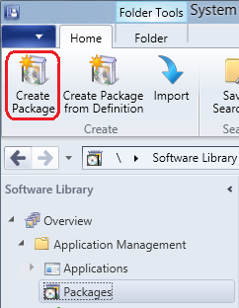

* In “Create Package and Program Wizard”, fill in the required details and give the path of the application source folder.

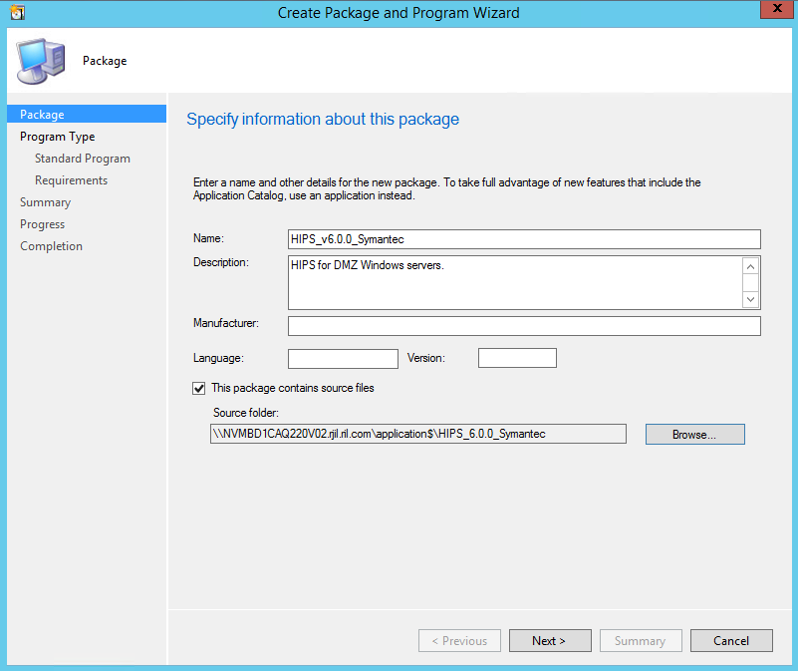

* At program type step, choose standard program.

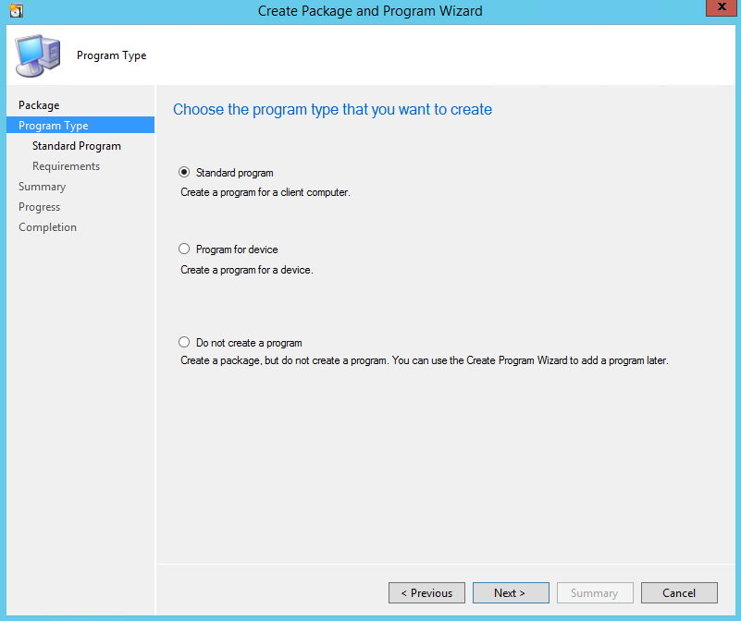

* Specify information about this standard program.

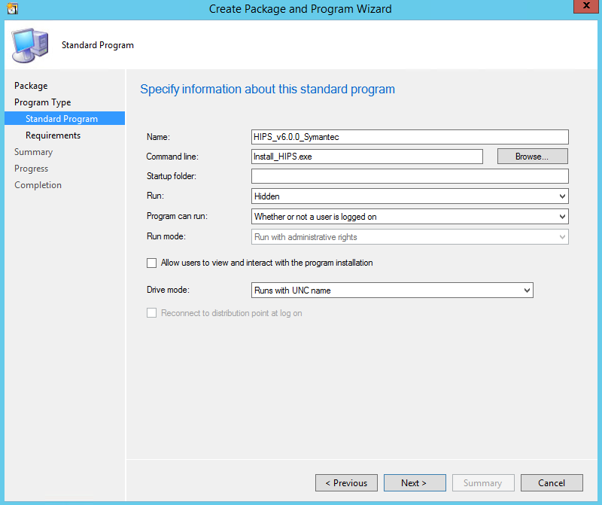

* Specify the requirements for this standard program.

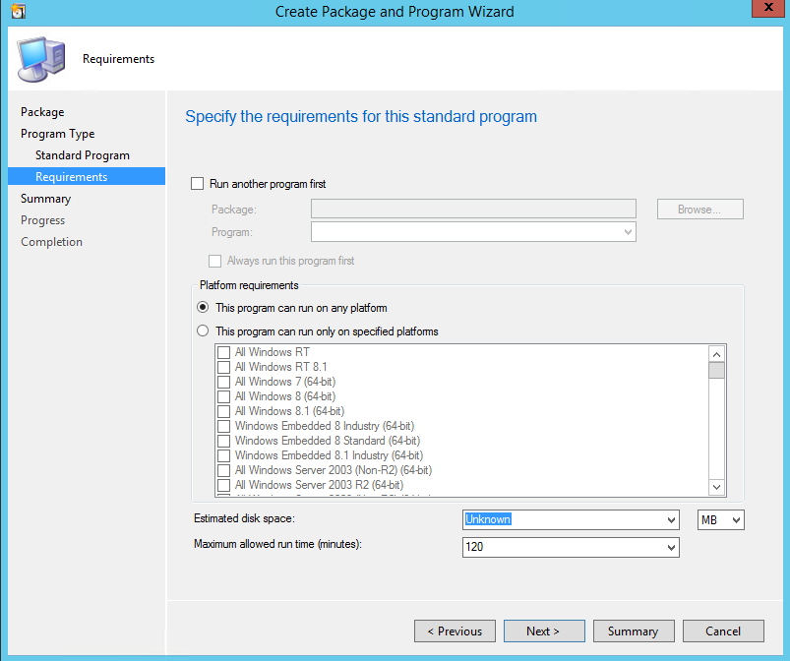

* Summary

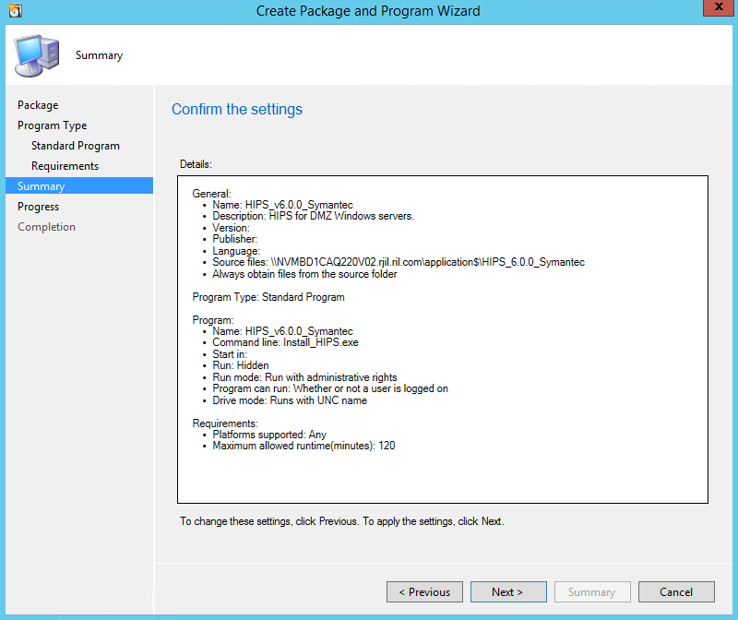

* Close

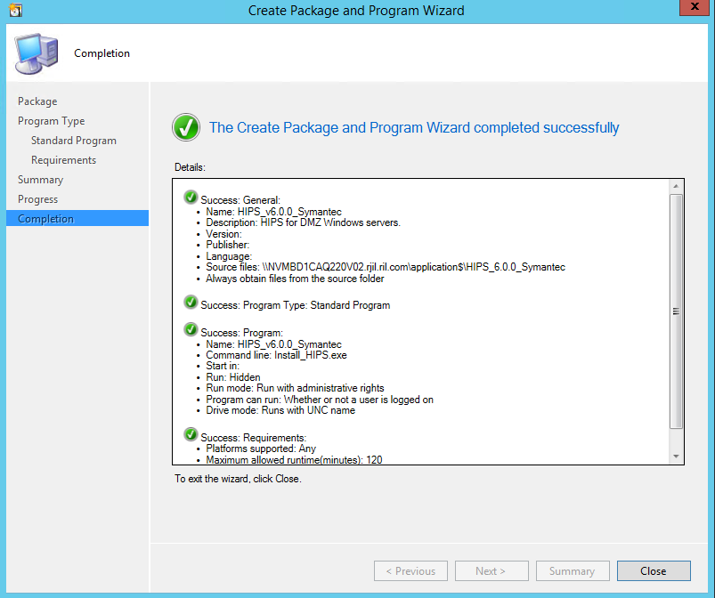

# Collection creation:

* Create Collection on SCCM Primary Site server. On SCCM console, navigate to Assets and Compliance > Device Collections > Application folder. Use “Create Device Collection” option.

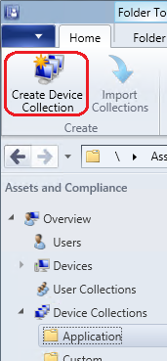

* Give appropriate name and limit this collection as required.

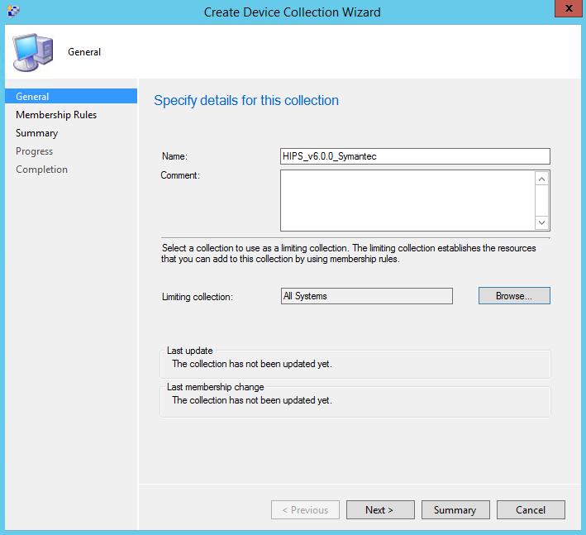

* Don’t add any resources. Resources can be added afterwards as per the requirement.

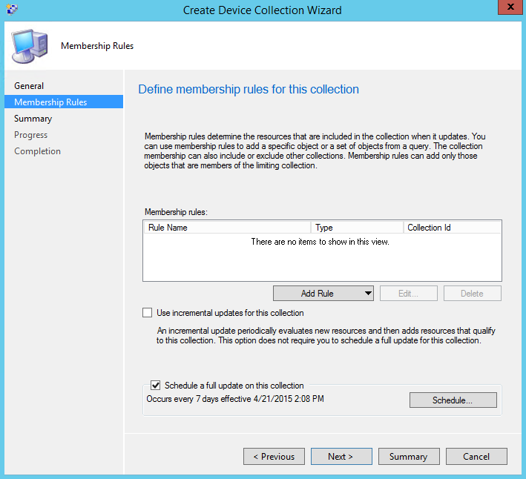

* Click “OK” for below warning.

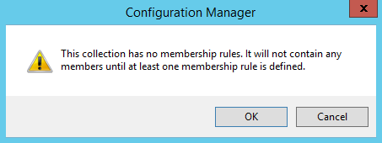

* Summary.

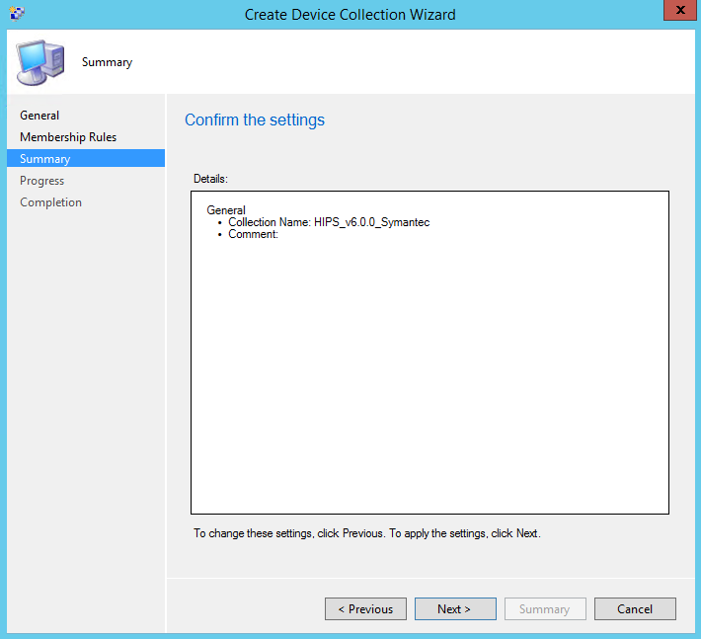

* Close.

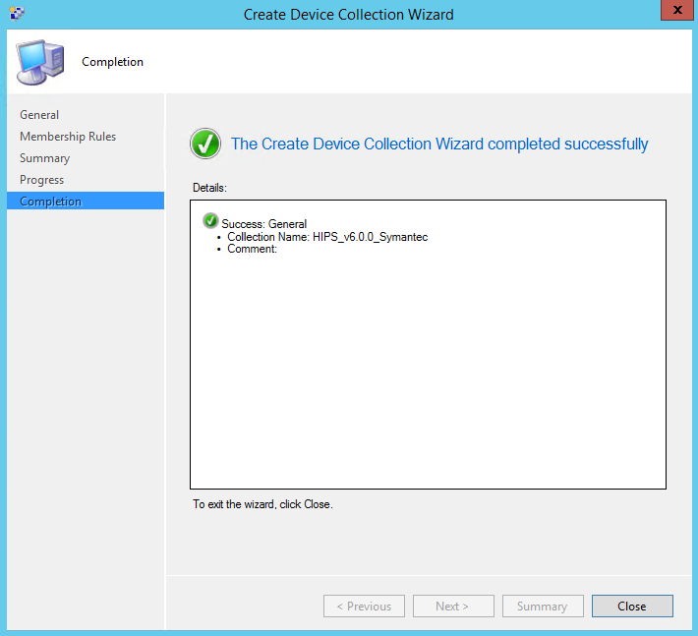

# Deployment creation:

* On SCCM console, select required package to be deployed and use “Deploy” option.

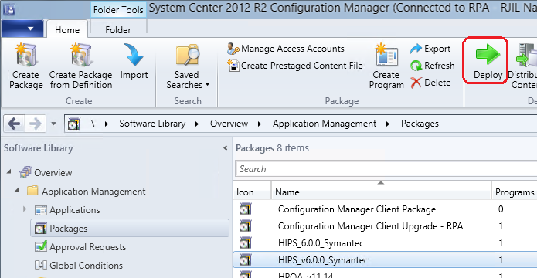

* Specify general information for this deployment. Use appropriate collection.

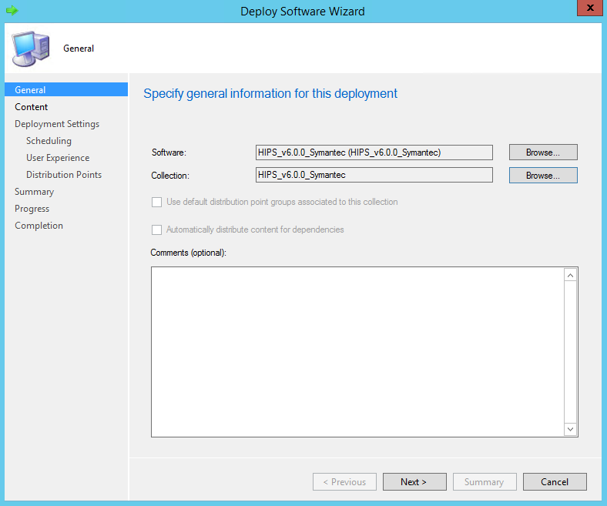

* Specify the content destination.

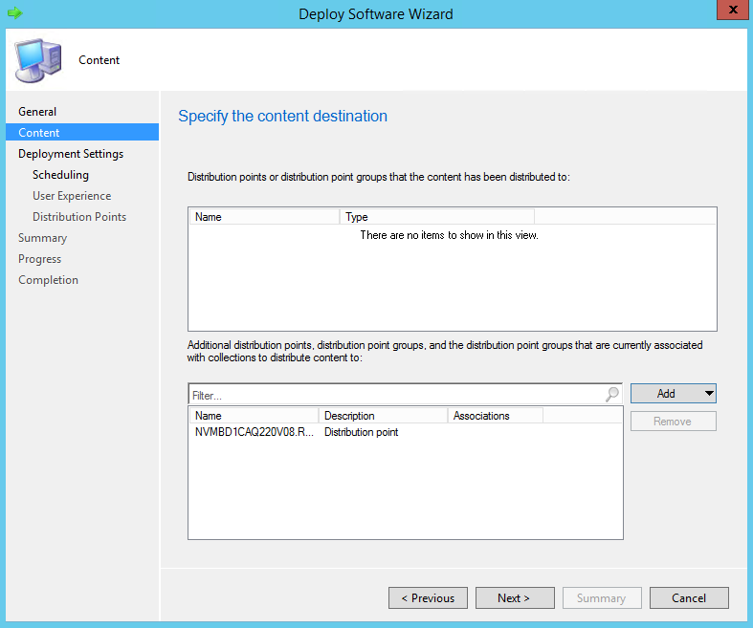

* Specify settings to control how this software is deployed.

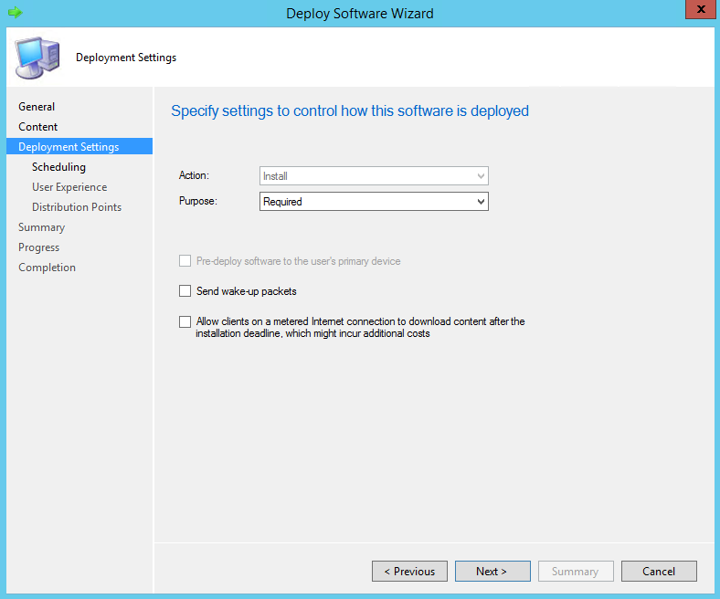

* Specify schedule for this deployment.

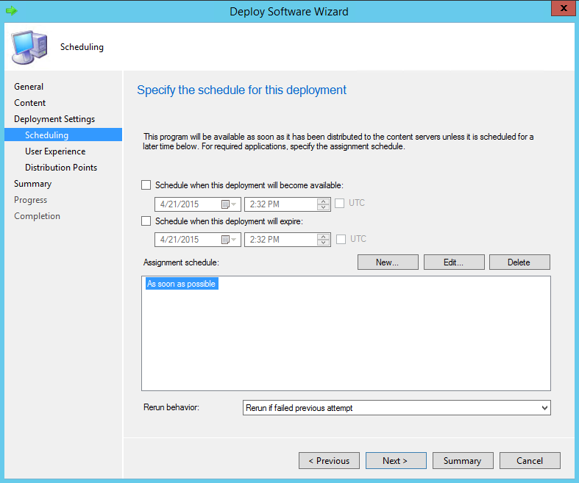

* Specify the user experience.

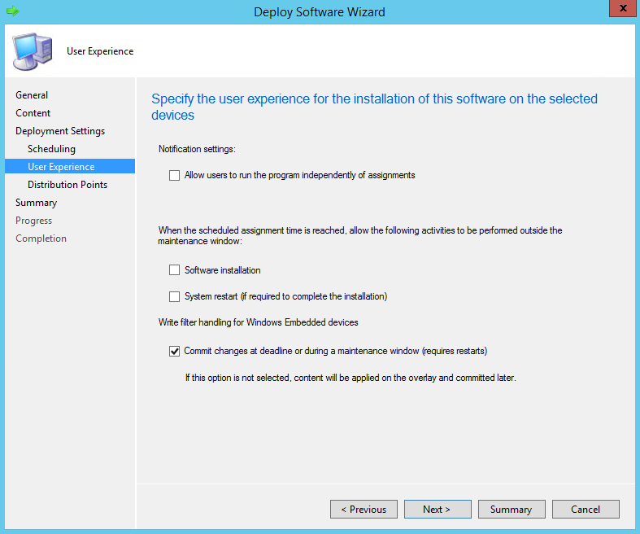

* Specify how to run the content of this program.

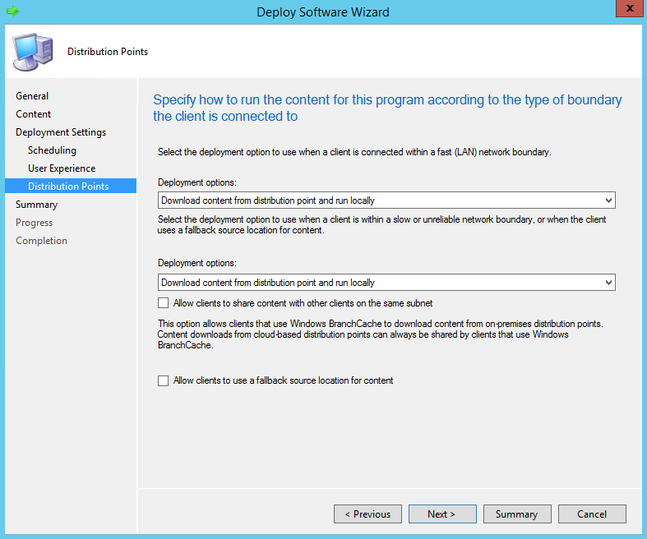

* Summary.

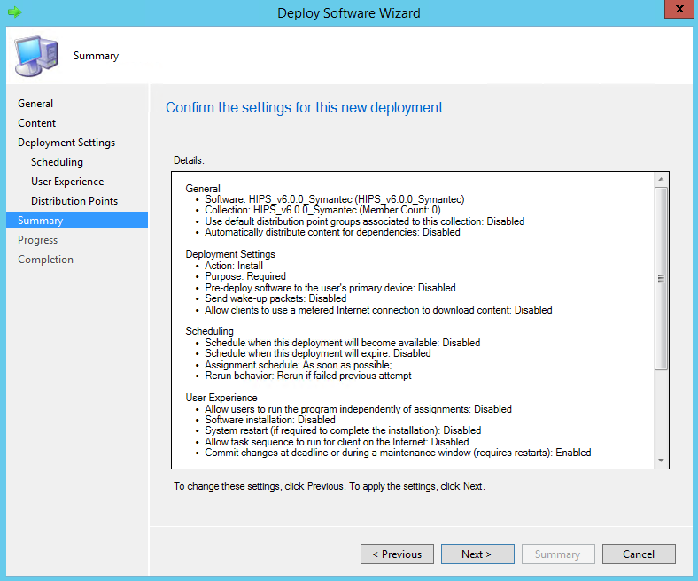

* Close.

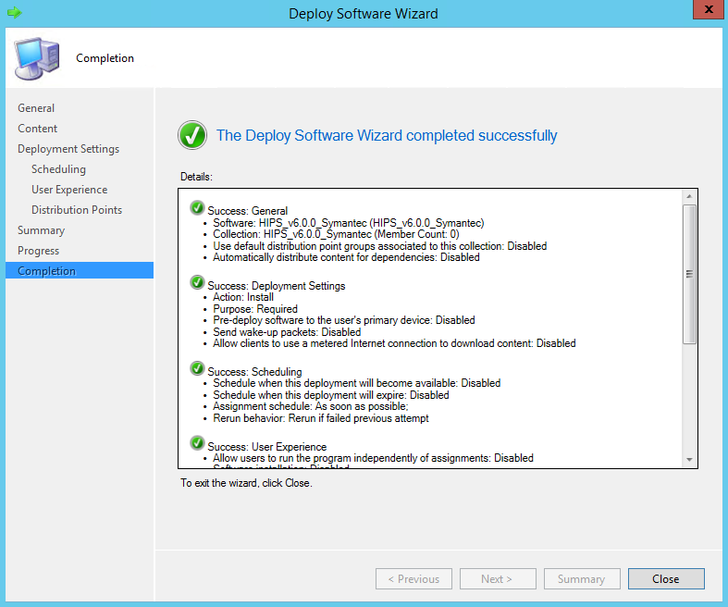

# Adding resources to collection:

* On SCCM console, select the collection and use “Add resources” option.

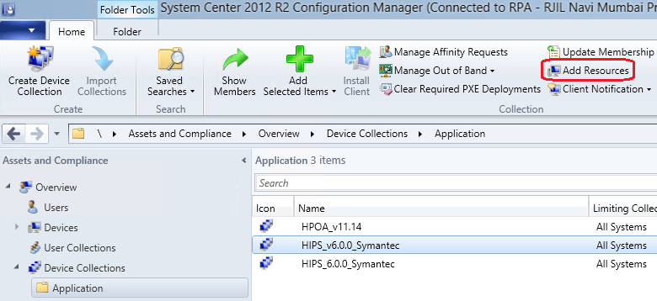

* Multiple resources can be searched and added.

