SCCM – OSD – Capture and Servicing

Amendment Record / Control Sheet (ACS)

|  |  |  |  |  |  |  |  |
| --- | --- | --- | --- | --- | --- | --- | --- |
| Rev. No. | Date | Reason for Issue | Prepared by | Reviewed by | Approved by | Issued by | Details of Amendments / Revisions |
| 1.0 | 21/04/2015 | For Management Review & update | Bhushan Patil |  |  |  | New Document |
|  |  |  |  |  |  |  |  |
|  |  |  |  |  |  |  |  |
|  |  |  |  |  |  |  |  |
|  |  |  |  |  |  |  |  |

Prepare a VM with base OS.

Create a Capture Media from SCCM 2012.

* On SCCM console, navigate to Task Sequences and select “Create Task Sequence Media” icon.

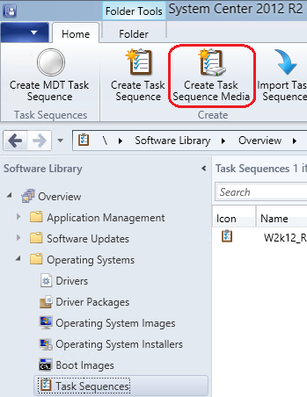

* Select Capture Media option.

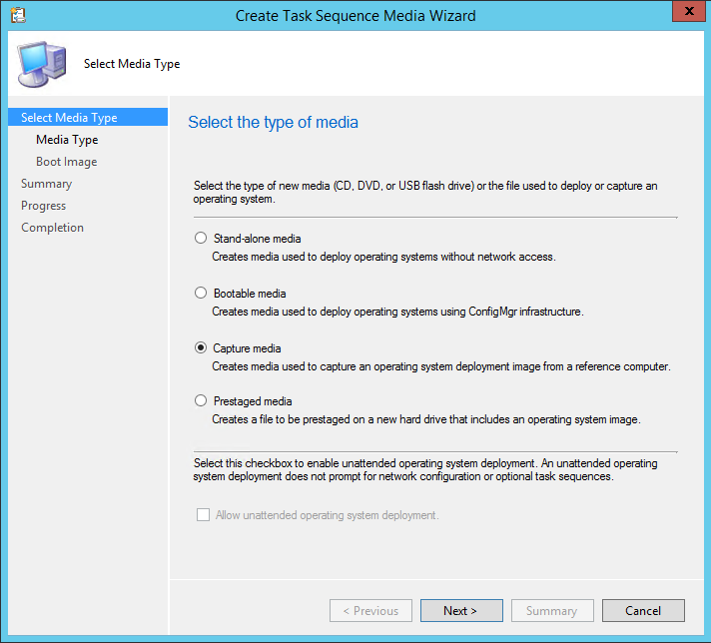

* Browse and give proper file name.

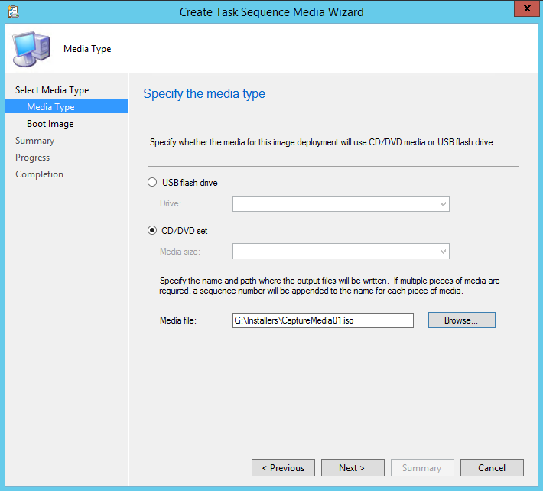

* Select 32 bit boot image and distribution point.

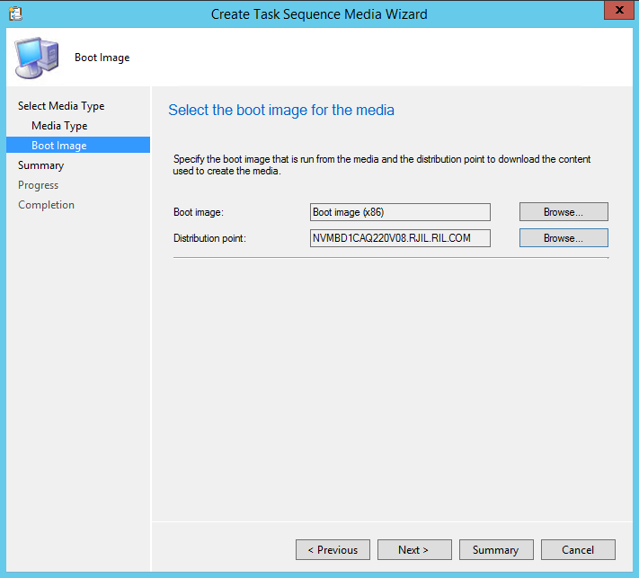

* On summary page, check the options that are selected.

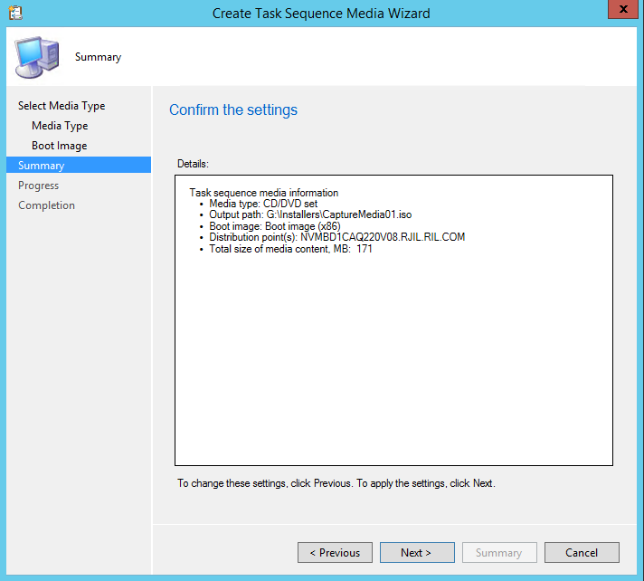

* Progress page:

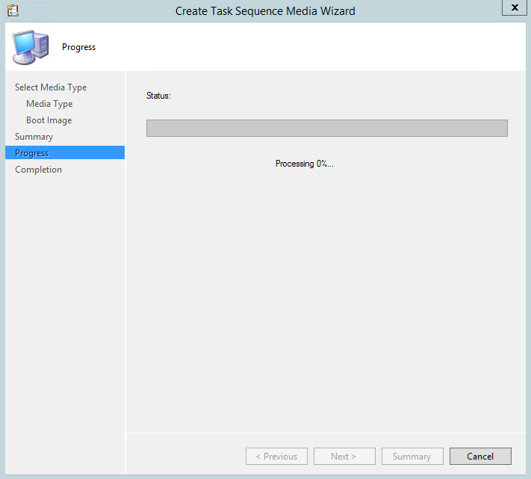

* Completion page:

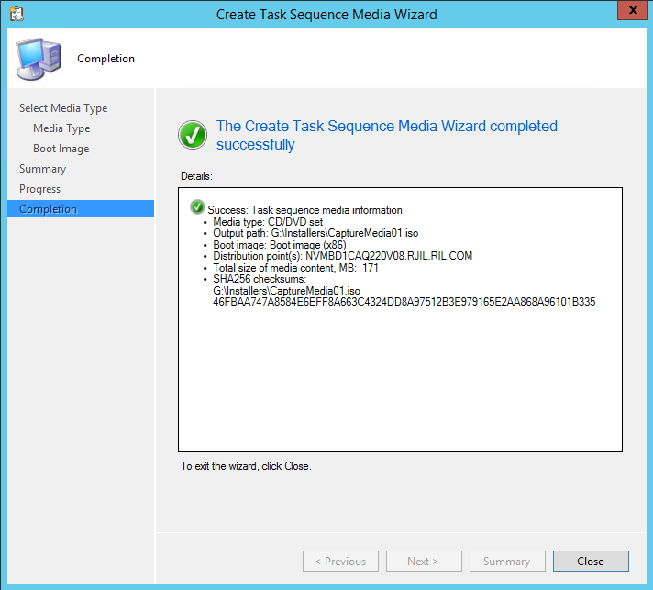

Use Capture Media on VM to capture image of VM.

* Mount Capture Media on VM and run “<CaptureMediaDrive>\SMS\bin\i386\TSMBAutorun.exe”.

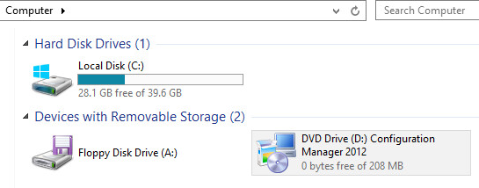

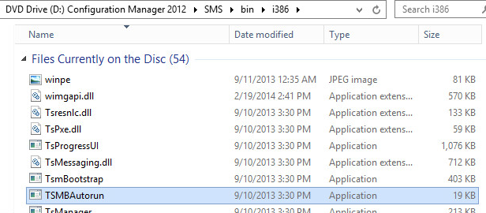

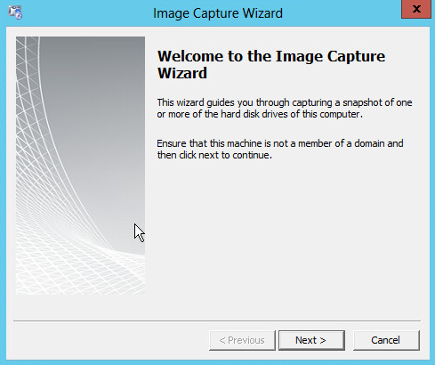

* Provide destination and file name for captured operating system image.

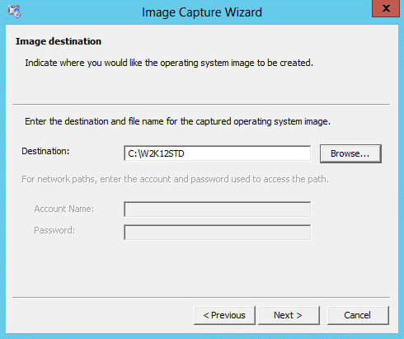

* You may add version and description.

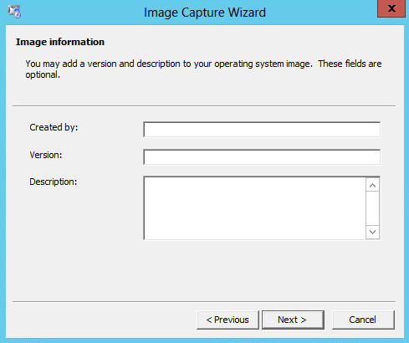

* Summary.

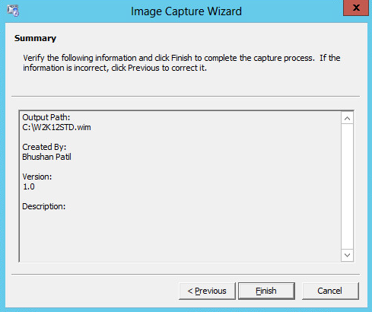

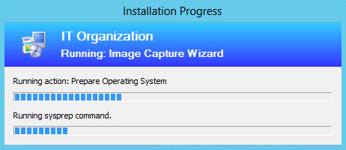

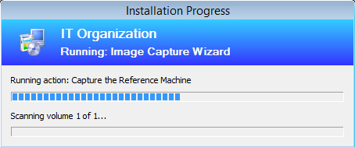

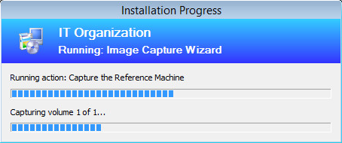

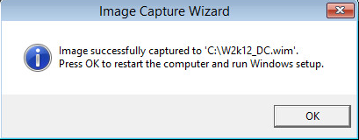

Use this captured image in SCCM 2012 to create Operating System Image.

* In SCCM console, navigate to Operating System Images and select “Add Operating System Image”

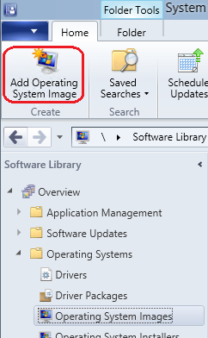

* Complete the wizard giving proper data source of the operating system image file.

Service this OS image using Schedule updates. All software updates applicable to this OS will be installed on this OS image.

* Once Operating System Image is created in SCCM console, use Schedule Updates to service the image.

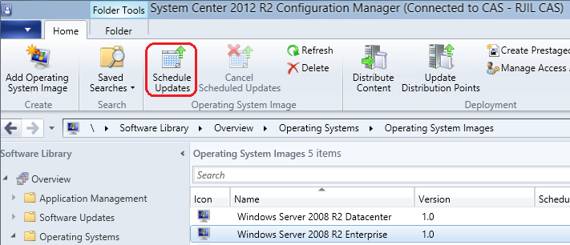

* Complete Schedule Updates wizard with required updates.