USER INTERFACE DESIGN

23CSE113
SUBMITTED BY
NAME | T. Ramcharan Reddy
ROLL NO | AV.SC.U4CSE25149
YEAR/SEM/SECTION | 1ST YEAR/ SEM-2/CSE-B
SUBMITTED TO
NAME | DR. RAJ KUMAR BATCHU
DESIGNATION | ASST.PROFFESSOR (Sl. Grade)
DEPARTMENT | SCHOOL OF COMPUTING

Samsung Website Clone - Project Explanation
This document explains the main features, HTML tags, CSS styles, and JavaScript functionality used in the Samsung website clone project.

1. Project Overview
The project is a Samsung-style website clone built using HTML, CSS, and JavaScript. It includes a navigation bar, dropdown mega menu, hero banners, product cards, a video banner, recommended products section, search popup, and footer.

2. Main Features Implemented
Header and Navigation Bar: Contains the Samsung logo, navigation links like Shop, Mobile, TV & AV, Appliances, and icons for search, cart, and profile.
Dropdown Mega Menu: When hovering over navigation items, a large dropdown opens with product cards and a discover sidebar.
Search Modal: Clicking the search icon opens a full-screen search modal with popular search options.
Hero Banner: Large banner section with text, image, and Buy button.
Second Hero Banner: Another promotional banner with heading, image, Learn more link, and Buy button.
Product Cards: Grid-based product sections showing product images, titles, and Buy buttons.
Background Video Banner: A video section using the video tag with overlay text and a register button.
Recommended Products: Horizontal scrollable product cards with image, title, price, and MRP.
Footer: Multi-column footer with notes, links, account, support, sustainability, and social section.

3. HTML Tags Used
<a> - Creates clickable links.
<body> - Contains all visible webpage content.
<br> - Used as part of the webpage structure.
<button> - Creates clickable buttons like Buy and close search.
<div> - Used to create layout containers like header, dropdown, hero banner, cards, and footer sections.
<footer> - Represents the bottom footer area.
<h1> - Main heading in the hero banner.
<h2> - Section or banner heading.
<h3> - Product and footer headings.
<h4> - Small headings like Discover and Popular Searches.
<head> - Contains title, CSS link, script links, and metadata.
<header> - Represents the top website header area.
<hr> - Creates divider line in dropdown.
<html> - Root element of the webpage.
<i> - Used as part of the webpage structure.
<img> - Displays images for products and banners.
<input> - Used as part of the webpage structure.
<li> - List items inside popular searches.
<link> - Connects the external CSS file.
<nav> - Contains navigation menu links.
<p> - Used for paragraph text and product names.
<script> - Connects JavaScript files and Lucide icons.
<section> - Used for the recommended products section.
<source> - Provides the video file source.
<span> - Used for small inline text like the logo or emoji.
<title> - Sets the browser tab title.
<ul> - Creates unordered list in search suggestions.
<video> - Adds the background video banner.

4. Important CSS Concepts Used
display: flex: Used for horizontal and vertical alignment in navbar, hero banners, icons, footer bottom, and buttons.
display: grid: Used for the main container, product sections, dropdown product grid, and footer columns.
position: relative/fixed/absolute: Used for dropdowns, search modal, video background, and hidden Buy buttons.
z-index: Controls which elements appear above others, especially search modal and dropdown menu.
gap: Adds spacing between flex/grid items.
padding and margin: Controls inner and outer spacing of sections.
border-radius: Creates rounded buttons, cards, and images.
transition: Adds smooth hover and animation effects.
transform: Used for hover movement, scaling, and dropdown animation.
object-fit: contain/cover: Controls how images and videos fit inside their boxes.
overflow-x: auto: Allows horizontal scrolling in recommended products.

5. Main CSS Classes Used
.about-title
.button-group
.buy-btn
.buy-btn-2
.card-buy-btn
.card-image
.close-search
.container
.discover-sidebar
.dropdown
.dropdown-content
.footer
.footer-bottom
.footer-info
.footer-links
.footer-notes
.hero-banner
.hero-banner-2
.hero-banner-video
.hero-content
.hero-content-2
.hero-image
.hero-image-2
.icon
.icons
.learn-more
.logo
.main
.main-nav
.nav-item
.popular-searches
.product-card
.product-card-item
.products-grid
.products-section
.rec-mrp
.rec-price
.recommended-card
.recommended-img-box
.recommended-row
.recommended-section
.register-btn
.search-body
.search-header
.search-icon
.search-input
.search-modal
.search-modal-content
.socials
.sparkle
.sub-text
.top-bar
.video-background
.video-content
.video-overlay

6. JavaScript Functionality
JavaScript is used to make the website interactive. It handles search modal opening/closing, scroll-based hero banner scaling, predefined search suggestions, and Lucide icon rendering.
Events used in JavaScript:
DOMContentLoaded event
click event
keydown event
scroll event

7. Files Used in This Project
index.html: Contains the webpage structure and content.
mainstyles.css: Contains all styling, layout, hover effects, dropdown design, hero banner design, product cards, video banner, and footer styles.
javascript.js: Contains interactivity such as search popup, scroll effects, and search recommendations.
Login.html/Register.html: Contains the webpage structure and styles and content.

8. Conclusion
This Samsung website clone demonstrates practical use of HTML for structure, CSS for layout and design, and JavaScript for interactivity. It is a good beginner-to-intermediate frontend project because it includes real website features such as navigation menus, product grids, modals, animations, and responsive-style sections.

Output:
Homepage:
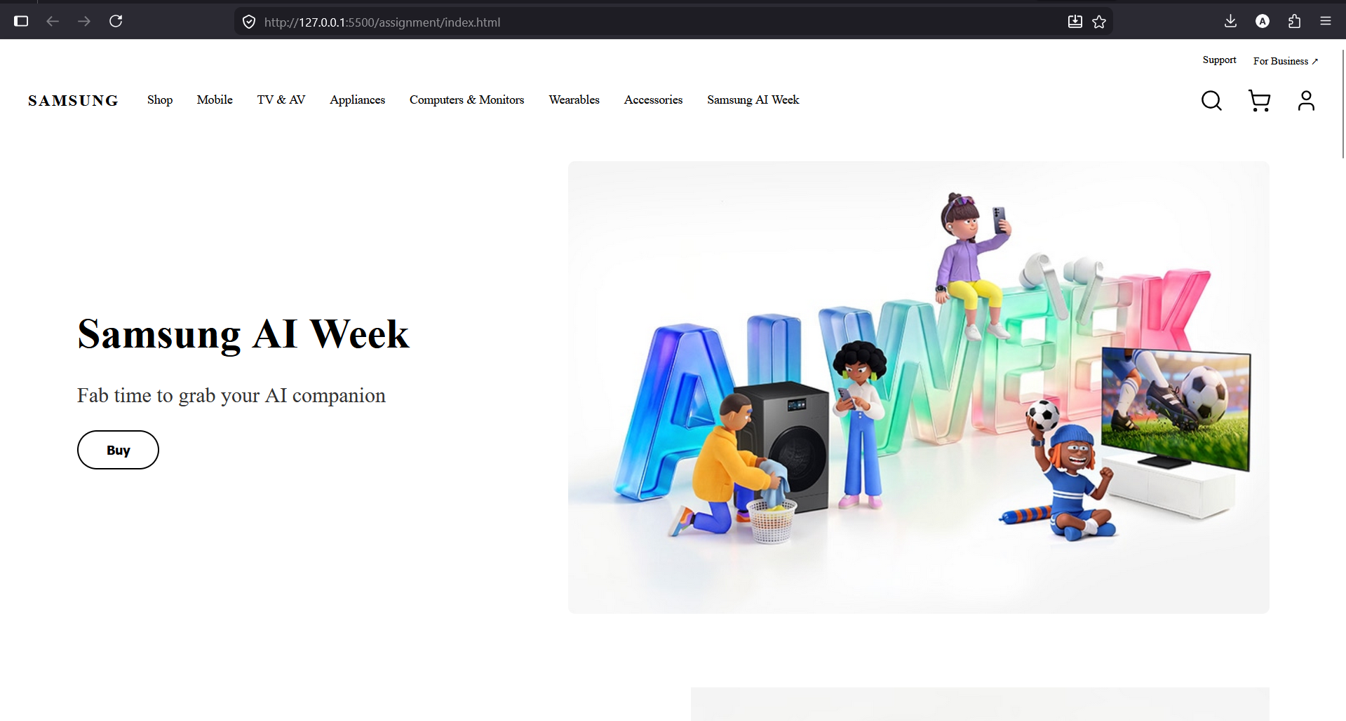
Dropdown:
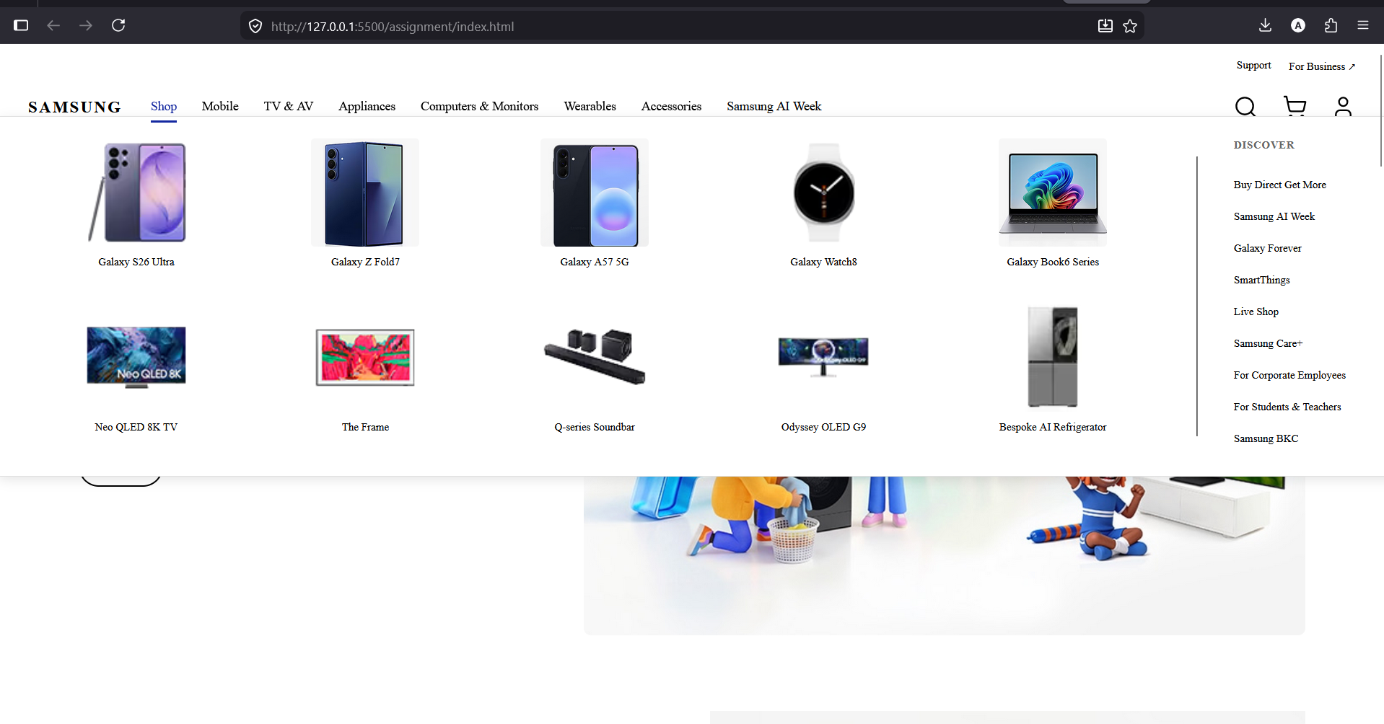
Search bar:
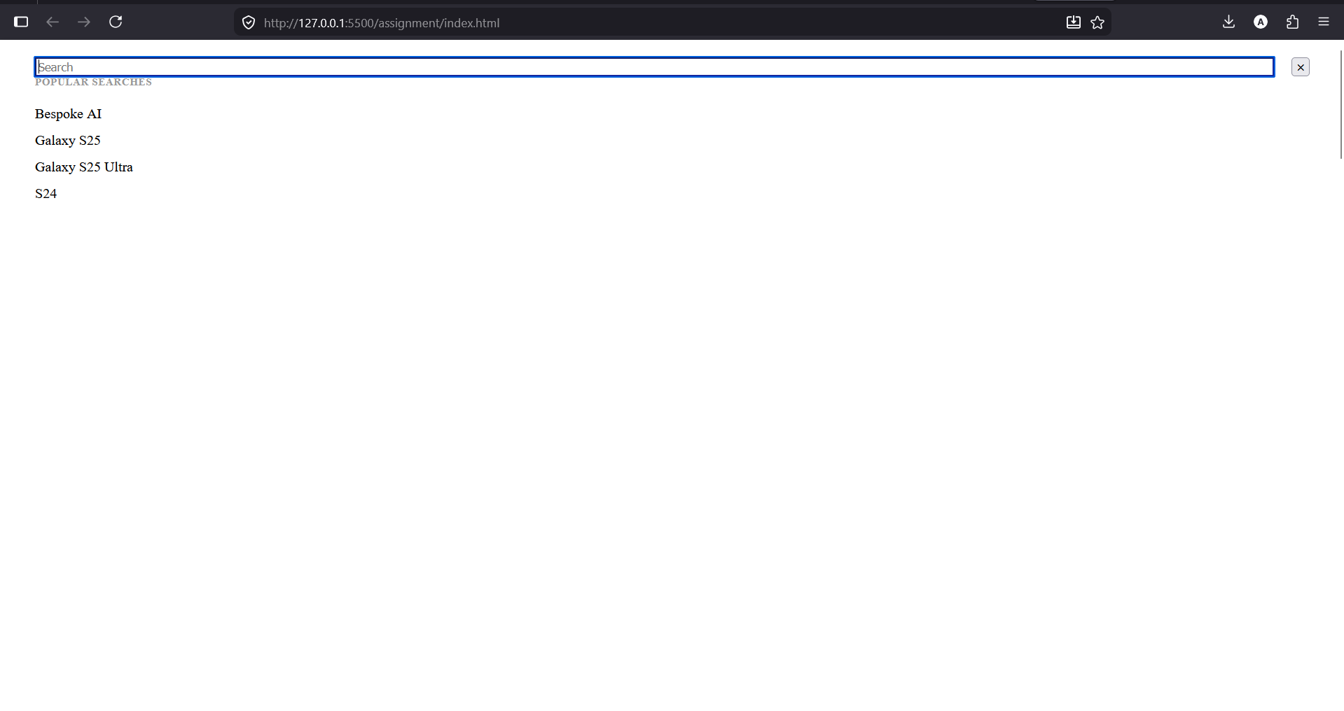
Product Cards:
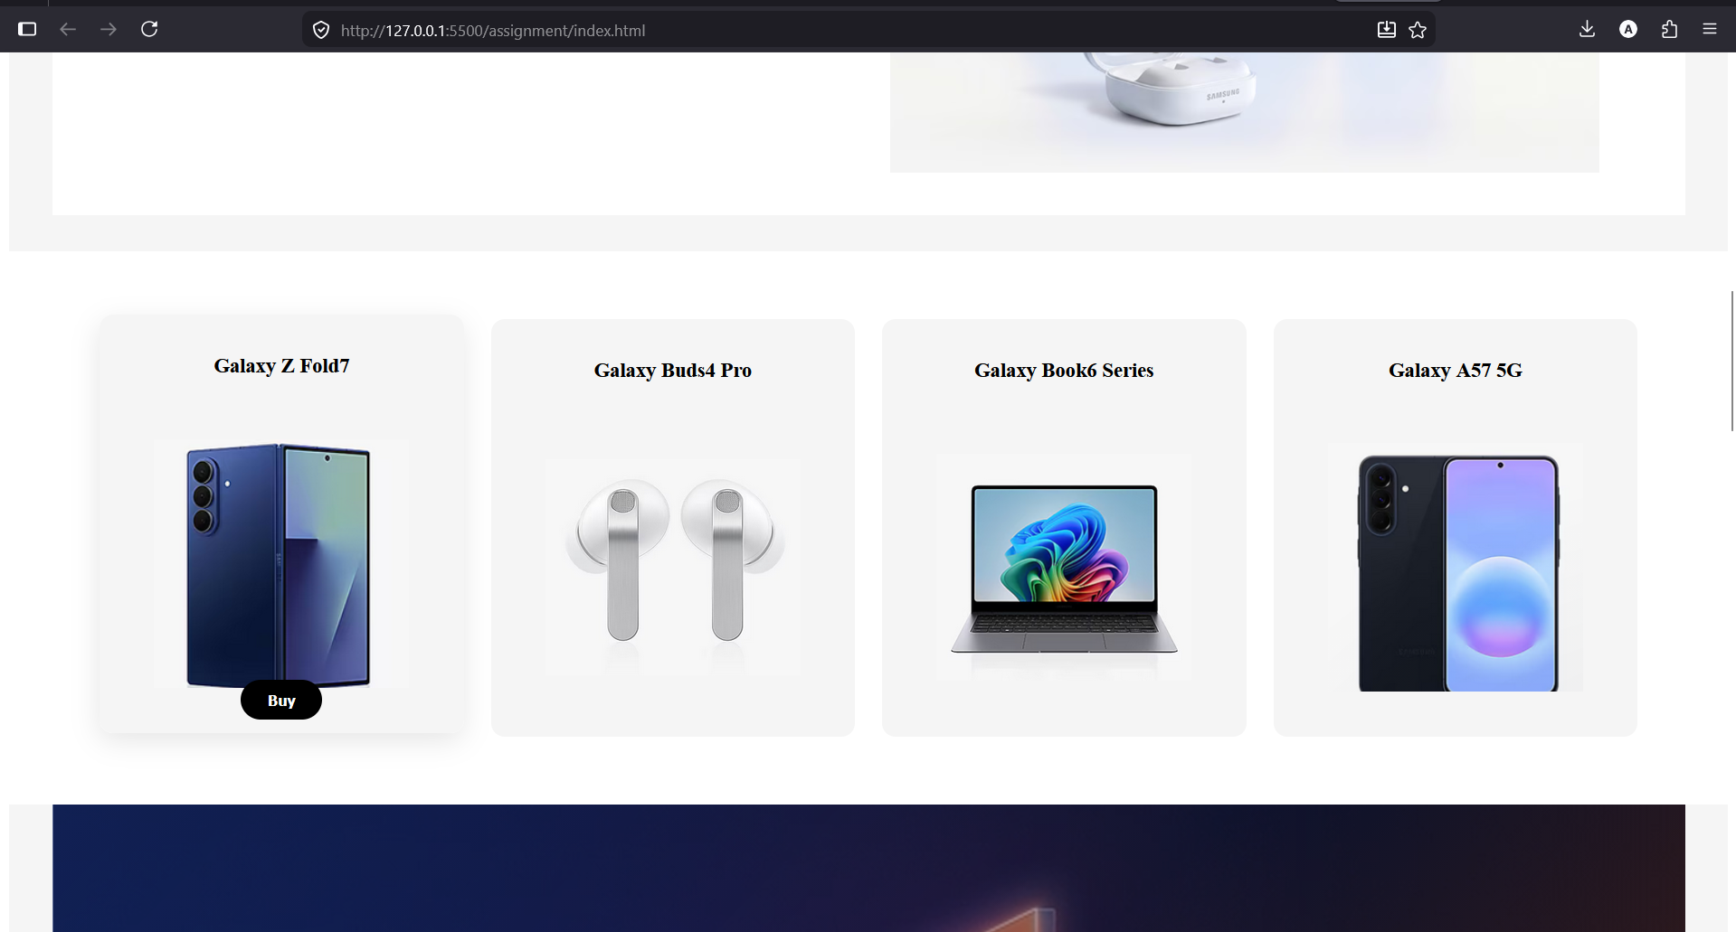
Video Banner:
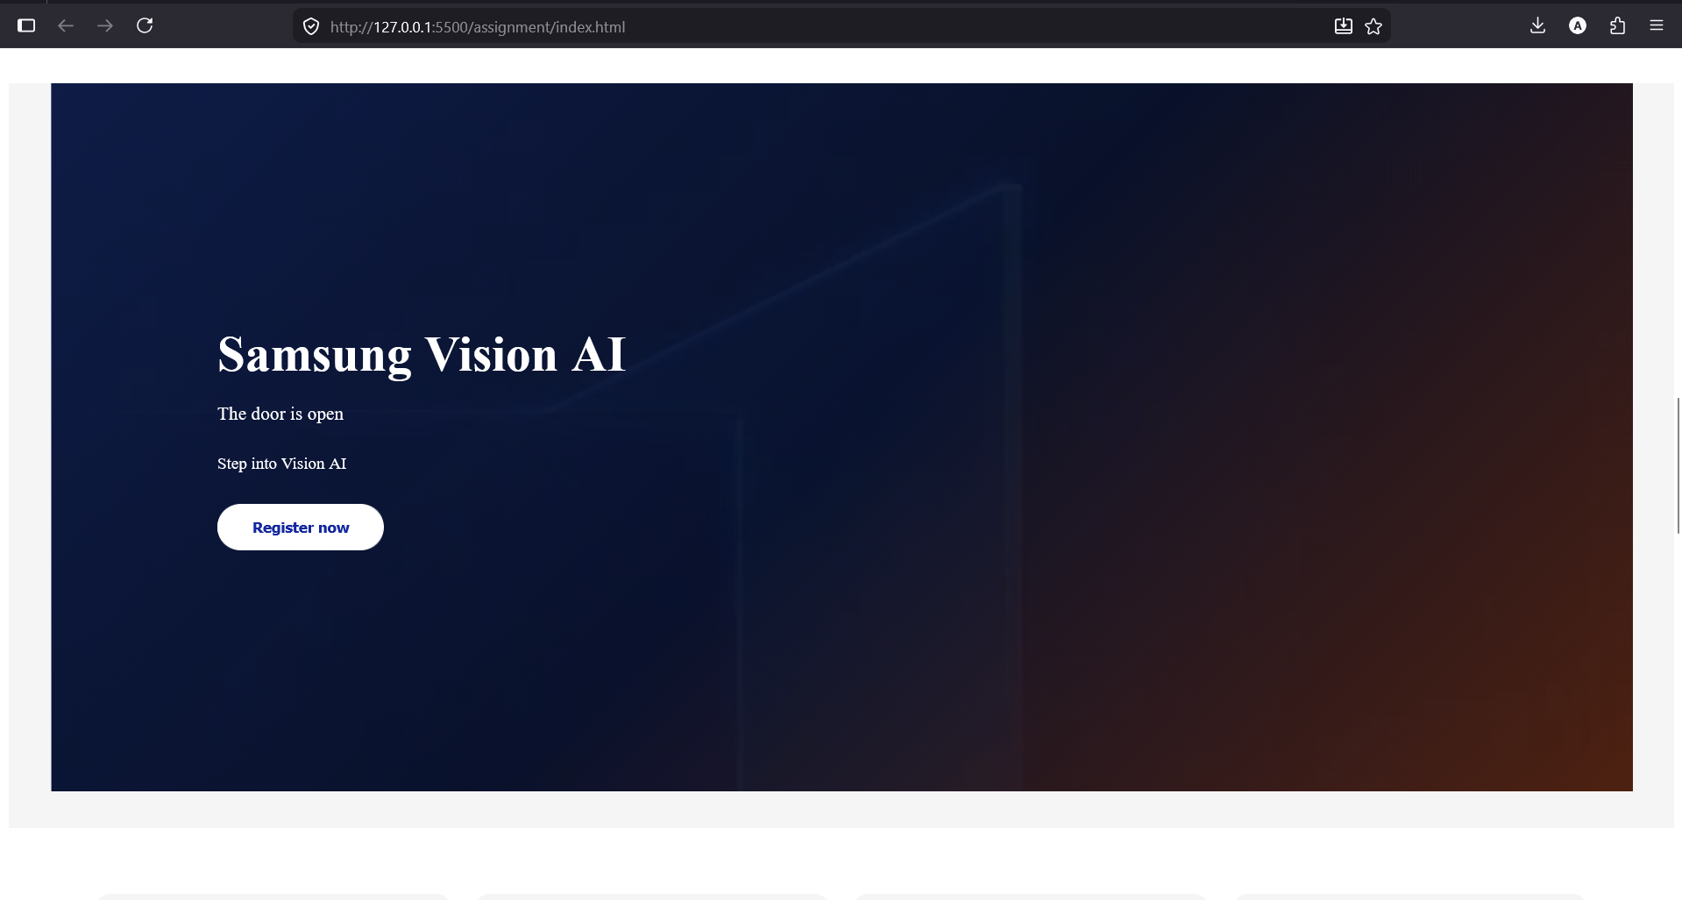
Footer:
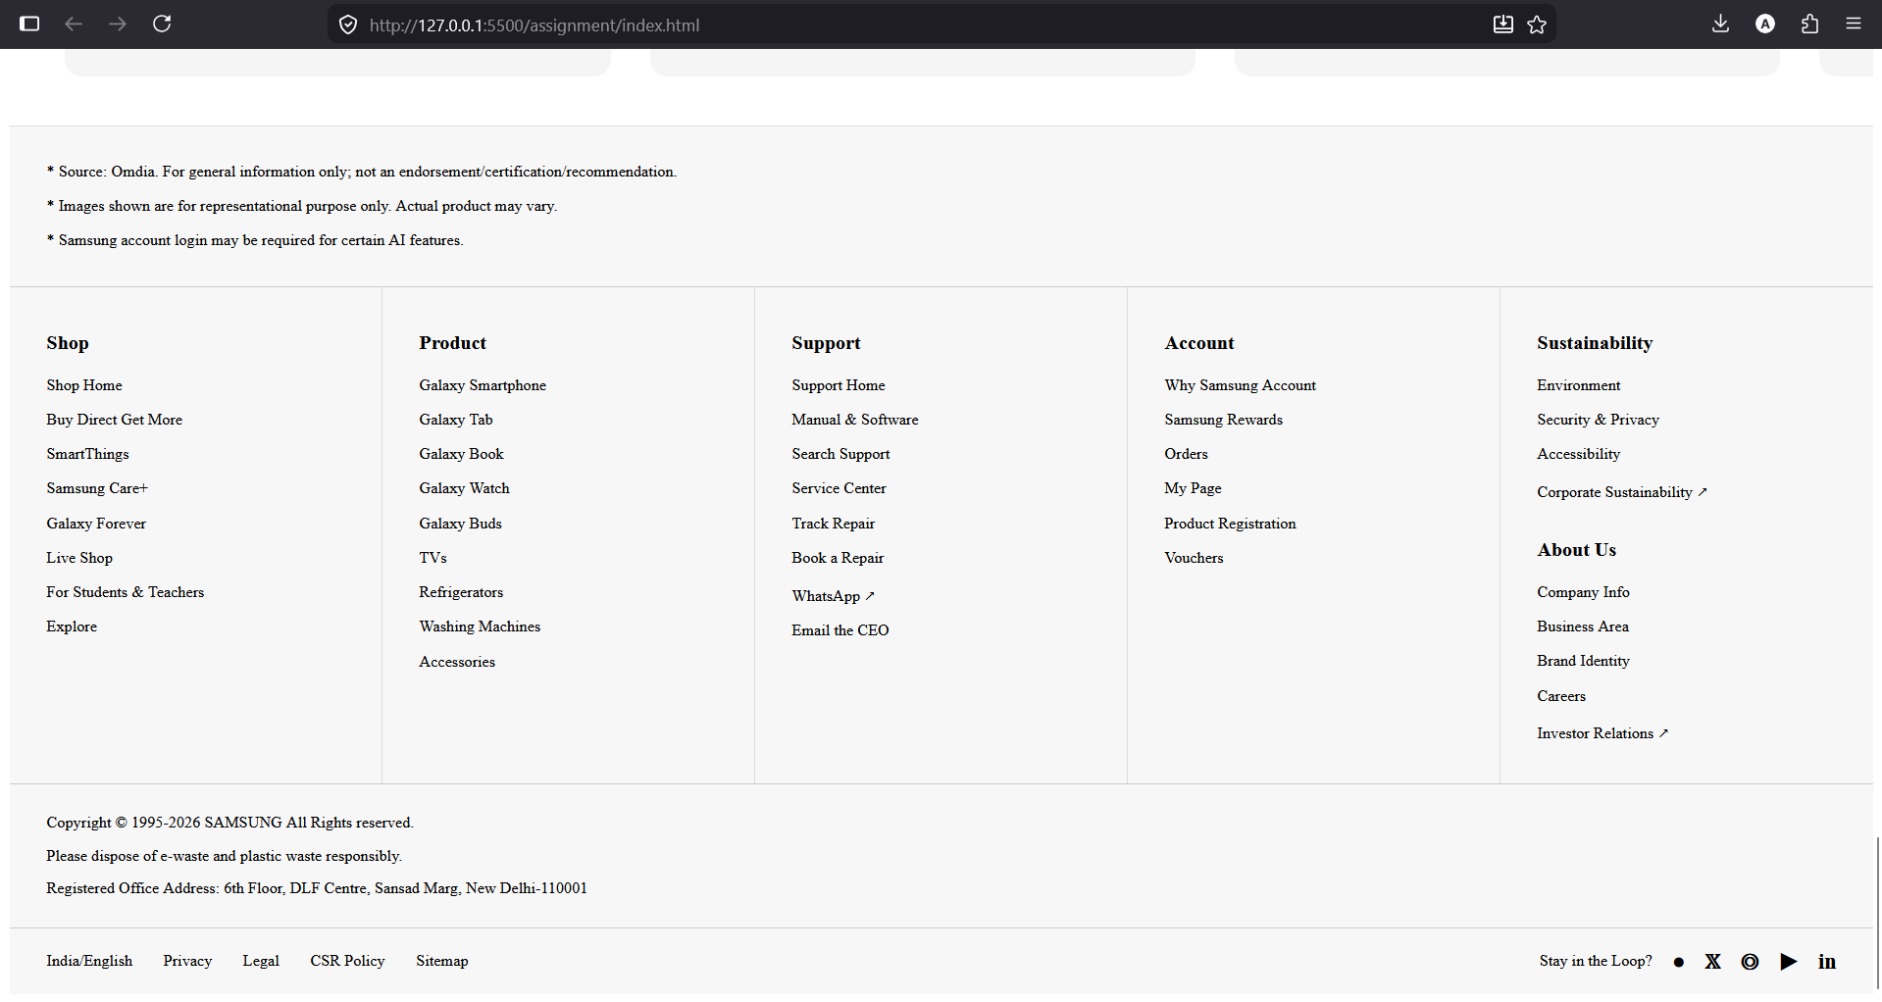
Login page:
