**User Manual**

**Inventory & Sales Tracking CLI App**

Employee Name: Nimmakayala Sri Sai Sanjeev Ramcharan

Employee ID: 2633329

Welcome! This guide will walk you through how to use the Inventory & Sales Tracking System through its Command-Line Interface (CLI).

The system allows you to manage products, customers, sales, reports, and data backups — all from one dashboard.

**Starting the Application:**

* open the terminal and run
* python <file path>

use the numbers to navigate through the system

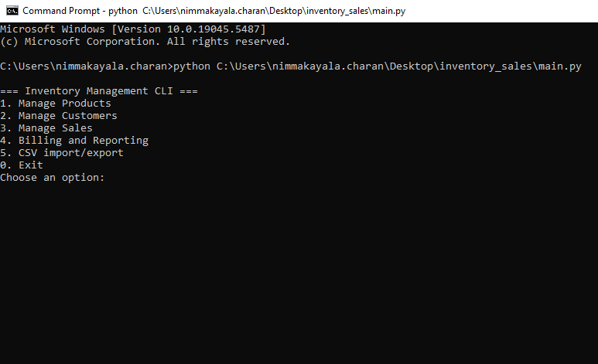

**1.Manage Products:**

You can access this manage products by selecting option 1

**Product Menu Options:**

**1.Add Product:**

For Adding new products with name, category, stock and price

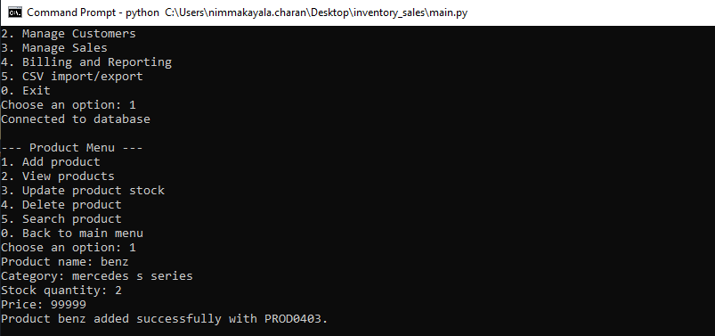

**2.** **View Products:**

It will view all products (paged view with next/previous)

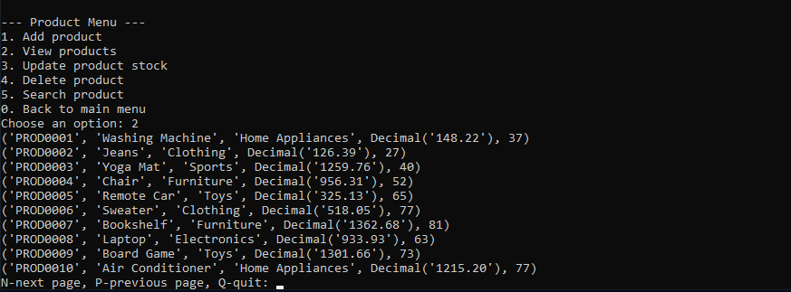

**3.** **Update Product:**

To Modify product name, category, quantity, or price.

**4. Delete Product:**

To delete a product permanently based on product id

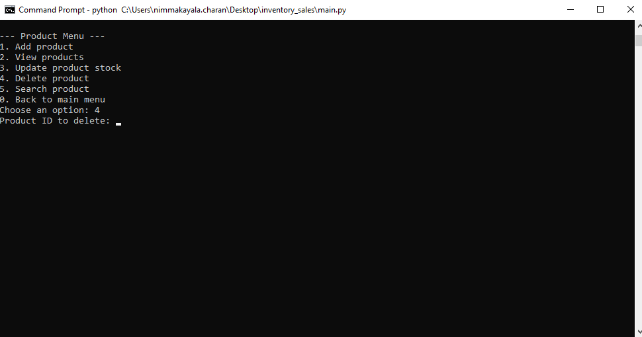

**5. Search Product:**

To find products by name or category.

**2. Manage Customers:**

You can select option 2 to manage the customers

**Customer Menu Options:**

**1.Add Customer:**

**2. View Customers:**

It will give Paginated view of all customers.

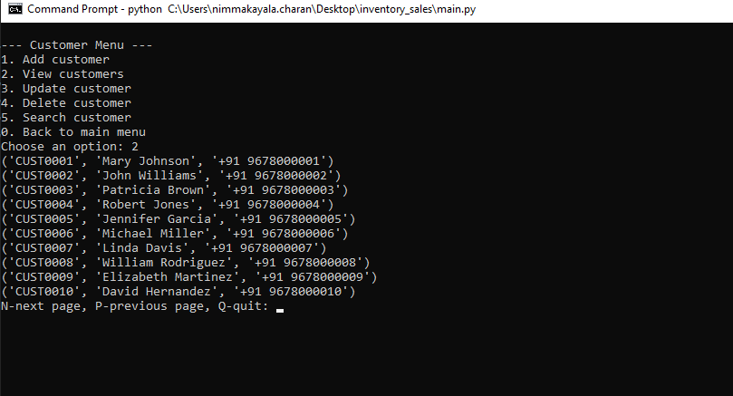

**3. Update Customer:**

To update customer details (name, phone)

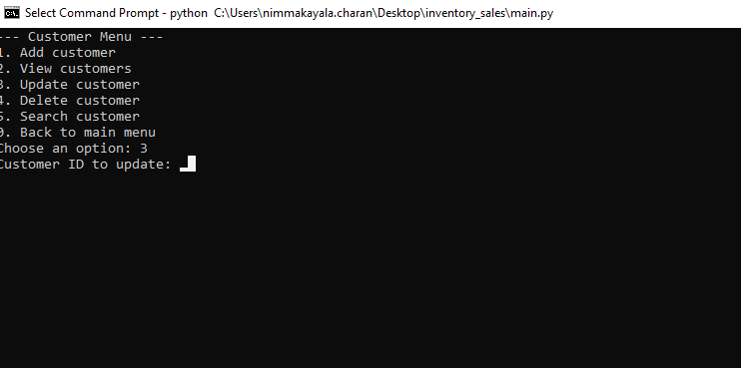

**4. Delete Customer:**

to delete a customer based on customer id

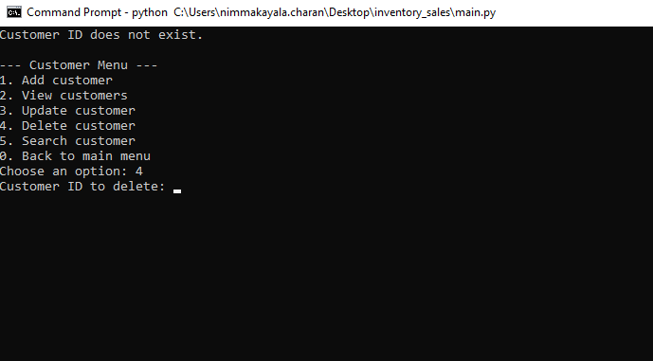

**5. Search Customer:**

To find customers

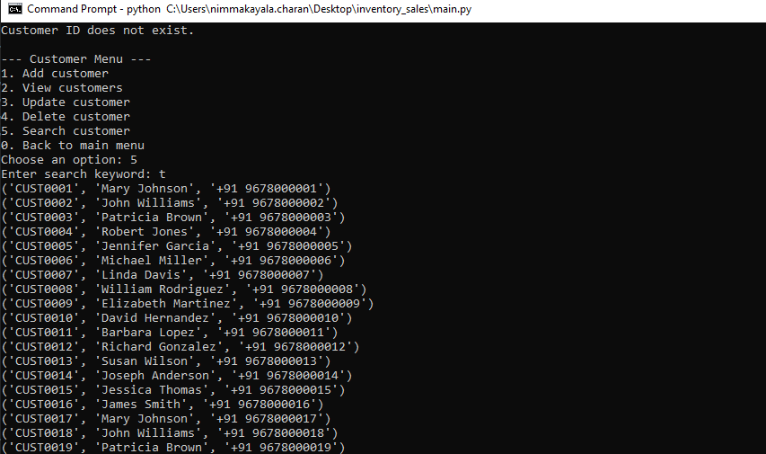

**3. Manage Sales:**

You can select option 3 manage the sales

**Sales Menu Options:**

**1.Record a Sale:**

We can giveInput Customer ID, Product ID, and Quantity. System calculates totals and updates stock

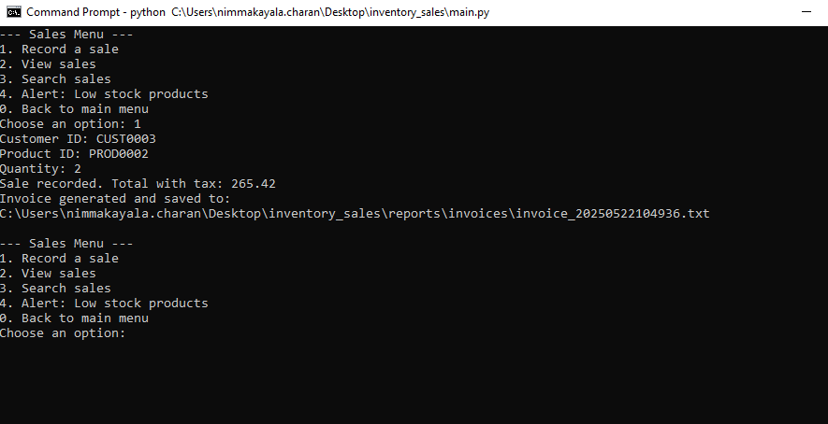

**2.View Sales:**

To list all sales records.

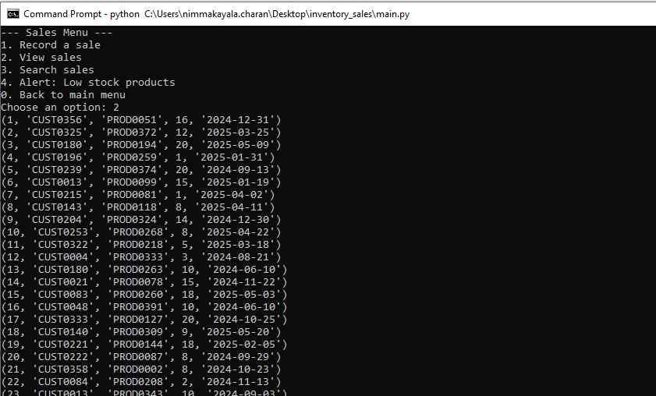

**3.** **Search Sales:**

by using search will Filter by Customer ID or Product ID.

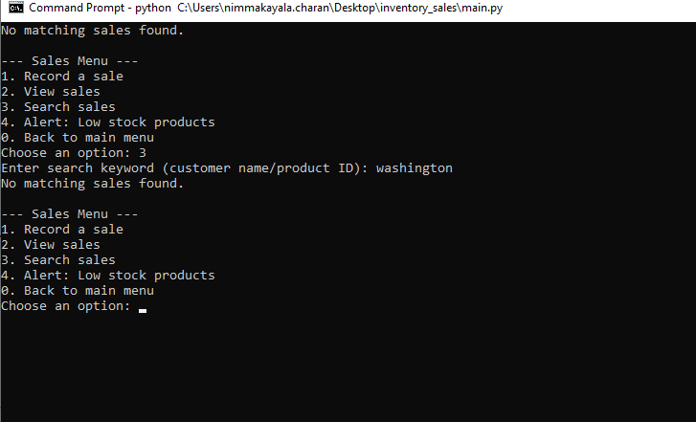

**4.Low Stock Alerts:**

To display low stock products

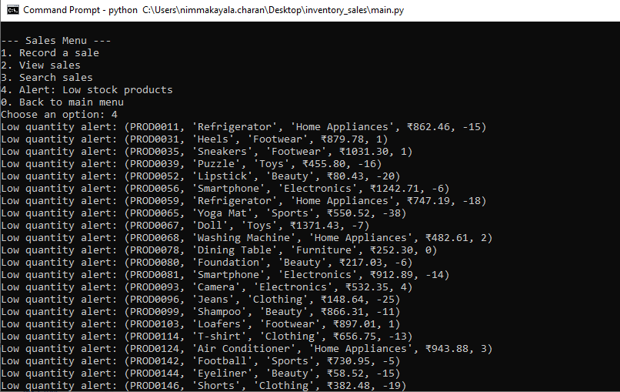

**4. Billing & Reporting:**

**Billing and reports Menu Options:**

**1.Daily Sales Summary:**

Views daily sales details

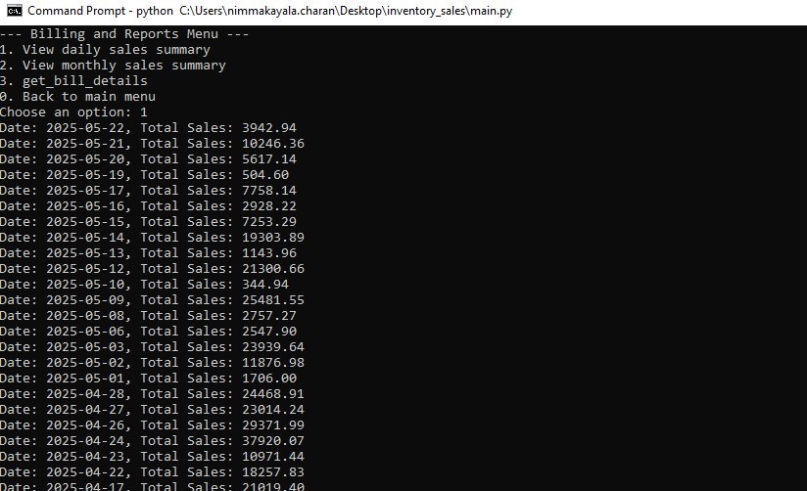

**2.Monthly Sales Summary:**

View total sales grouped by month

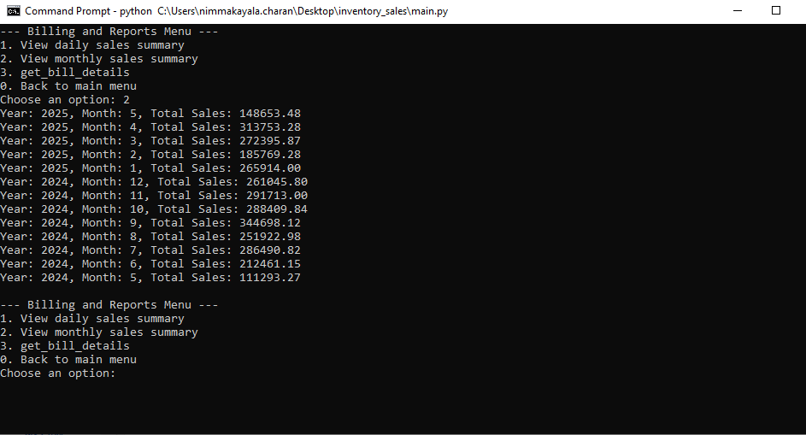

**3.get bill details:**

Views bill details based on sale id

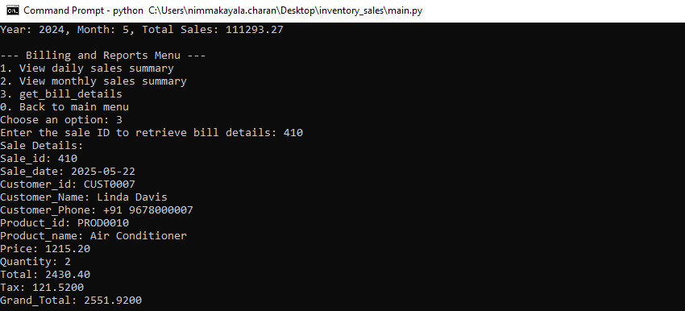

**5. CSV Import/Export:**

You can select option 5 for importing and exporting files into csv

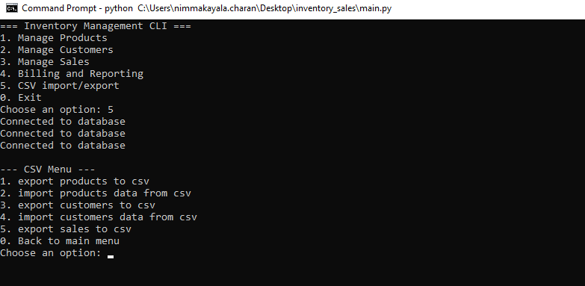

**CSV Menu Options:**

**1.Export Products** – Save all products to a CSV file.

**2.Import Products** – Load products from a CSV file.

**3.Export Customers** – Save customer data to CSV.

**4.Import Customers** – Load customers from a CSV file.

**5.Export Sales** – Export sales data.

**0.Back** – Return to the main menu.

**Invoices:**

Invoices are auto generated for every sale and saved as .txt files.

**How to give Input & Error Handling:**

* + Enter only numbers when asked to "Choose an option".
  + If an ID is invalid (like a product not found), the system will prompt you.
  + Leave fields blank to keep current values during updates.
  + CSV filenames must be typed with extension (e.g., products.csv.)

**Exiting the App:**

Choose option 0 from the main menu to safely exit the system.

**ER-Diagram**

