DBMS

PROJECT REPORT

Football league

Management system

Submitted by:

G. ram charan tej 21CSB0B17

T. jayanth vinny 21CSB0B57

Submitted to:

Dr. T. Ramakrishnudu

CONTENT:

➢ PROBLEM STATEMENT

➢ ER DIAGRAM

➢ RELATIONAL SCHEMA

➢ TABLE ASSUMPTIONS

➢ NORMALISATION

➢ TABLES CREATION

➢ SQL QUERIES

**PROBLEM STATEMENT: ->** The game football is loved by huge

population all over the world. It is useful to have a football database system about a league so that people who follow it can have easier access to statistics related to it.

-> The project would allow us to know the statistics of a player, team and also support functions like adding, modifying and removing team and player details, tracking team performance, recording match information, calculating match results and league rankings , etc.

**ENTITY RELATIONSHIP**

**DIAGRAM:**

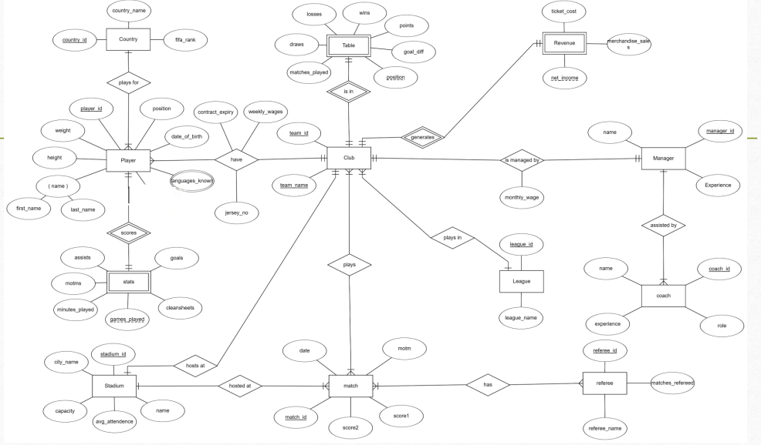

**RELATIONAL SCHEMA:**

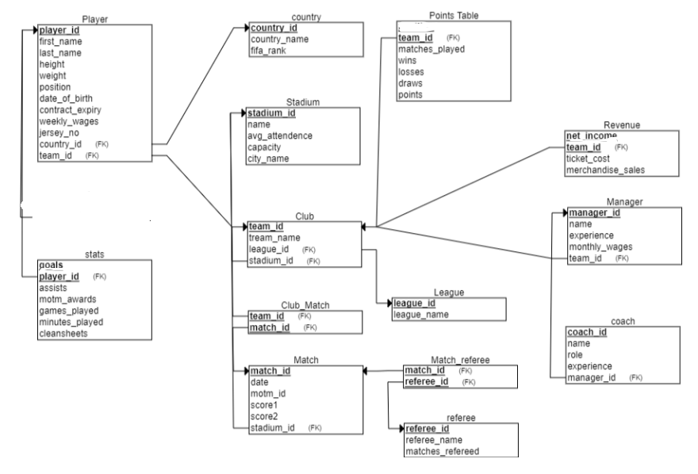

**TABLES**

**▪ Player :**

**➢ player entity holds information about players in the league**

**➢ This entity has player_id, first_name, last_name, height, weight,**

**position, date_of_birth, contract_expiry, weekly_wages, jersey_no,**

**country_id, team_id as attributes.**

**➢ This entity has player_id as primary key.**

**➢ This entity has country_id, team_id as foreign keys.**

**▪ Club:**

**➢ This entity holds information related to the team.**

**➢ It has team_id, team_name, league_id, stadium_id as attributes.**

**➢ This entity has team_id as primary key.**

**➢ It has league_id and stadium_id as foreign keys.**

**➢ It has one-many relationship with league entity and one-one relationship**

**with stadium entity.**

**▪ Country:**

**➢ This entity holds information related to the country.**

**➢ It has country_id, country_name and fifa_rank as attributes.**

**➢ It has country_id as foreign key.**

**▪ Stadium:**

**➢ This entity holds information regarding the stadium.**

* This entity holds stadium_id, avg_attendance,stadium_name,stadium_capacity as attributes
* This entity has stadium_id as primary key.

**▪ League:**

* This entity holds information about the league being played.
* It has league_id as primary_key.
* It has league_id,league_name as attributes.

**▪ Points_table:**

**➢ This entity is used to determine the position of a team in table and**

**ultimately the winner.**

**➢ It has team_id, wins, losses, draws, points, matches_played as attributes**

**➢It has team_id as foreign key.**

**▪ Manager_table:**

**➢ It describes the manager of the club.**

**➢ This entity has managerid,team_id, manager_name, experience,**

**monthly_wages, etc.**

**➢ It has team_id as foreign key.**

**▪ Coach:**

**➢ This entity tells about the coaches work under a certain manager.**

**➢ It has coach_id, manager_id, coach_name, happy.**

**➢ It has manager_id as foreign key.**

**▪ Revenue:**

**➢ This entity tells out revenue gained by a club , through ticket sales,and merchandise_sale.**

**➢ It has revenue as net_income, team_id, ticket_cost and merchandise sales as attributes.**

**▪ Stats:**

* **It tells about the performance of a player.**
* **It has goals, assists, player_id, motms, etc. as attributes.**
* **It has player_id as primary key as well as foreign key.**

**▪ Matching:**

**➢ It has score1, score2, match_id, motm_id, as attributes.**

* It gives information about score of a match.
* It has stadium_id as foreign key.
* **Match-referee:**
* It gives information about which match had which referee.
* It has referee_id, match_id combined as primary key**.**

**ASSUMPTIONS:**

**• We have assumed that there are only 5 teams in a league.**

* **We assumed the players are only from 5 countries.**

**• We have assumed the management of a single football league, rather than multiple football**

**leagues simultaneously.**

**• We have assumed only basic information like match results, goals, assists, etc. and excluded**

**information like yellow/red cards, suspensions, etc.**

**• We have only included data regarding current players, events and excluded historical data.**

**• We have focussed information mostly on player and team management rather than financial or ownership details.**

**• We have assumed that no transfers can happen between teams for players.**

**• We have considered only simple leagues which have simple round-robin structure and table**

**leader as winner rather than complex structure involving divisions, groups, playoffs or knockout stages which have been neglected.**

**• The data entered is through manual insertions so real-time updates are not possible.**

**Normal Forms:**

**1.FIRST NORMAL FORM(1NF): This is the most basic level of normalization. In 1NF,each table cell should contain only a single value, and each column should have unique name. The first normal form helps to eliminate duplicate data and simplify queries.**

**2.Second Normal Form(2NF):2NF eliminates redundant data requiring that each non-key attribute be dependent on the primary**

**key. This means that each column should be directly related to the primary key, not to other columns.**

**3.Third Normal Form(3NF):3NF builds on 2NF by requiring that all non-key attributes are independent on each other. This means that**

**each column should be directly related to the primary key,and not to any other columns in same table.**

**4.Boyce-codd Normal Form(BCNF): BCNF is a stricter form of 3NF that ensures that each determinant in a table is a super key. In other**

**words, BCNF that each non-key attribute is dependent only on the candidate key.**

**Functional dependencies and Normalization:**

**1.Player:**

**Player_id->{player_id, first_name, last_name, height, weight,**

**position, date_of_birth, contract_expiry, weekly_wages, jersey_no,team_id, country_id}**

**So here player_id is primary key.**

**1NF:As the table contains primary key and all the attributes are atomic attributes and there is no multivalued attributes so the table is in 1NF.**

**2NF: In this table there is only one primary key i.e,player_id and it is only single attribute so there is no partial dependency so the table is in 2NF.**

**3NF: In this table all functional dependencies are from candidate key (prime attribute) to non**

**prime attributes. So there is no transitive dependency so the table is in 3NF.**

**BCNF:Here all functional dependencies are from super key i.e. player_id to all other**

**attributes so the table is in BCNF.**

**Club:**

**team_id->{ team_id, team_name, league_id }**

**Hence the team_id is primary key.**

**1NF:As the table contains primary key and all the attributes are atomic attributes and there**

**is no multivalued attributes so the table is in 1NF.**

**2NF:In this table there is only one primary key i.e, team_id and it is only single attribute**

**so there is no partial dependency so the table is in 2NF.**

**3NF:In this table all functional dependencies are from candidate key(prime attribute) to non**

**prime attributes.so There is no transitive dependency so the table is in 3NF.**

**BCNF:Here all Functional dependencies are from super key i.e. team_id to all other**

**attributes so the table is in BCNF.**

**Country:**

**country_id->{ country_id, country_name and fifa_rank }**

**country_id,fifa_rank are candidate keys.**

**Take country_id as primary key.**

**1NF: As the table contains primary key and all the attributes are atomic attributes and there is no multivalued attributes so the table is in 1NF.**

**2NF: In this table the primary key is country_id and it is only single attribute so there is no partial dependency so the table is in 2NF.**

**3NF: In this table all functional dependencies are from candidate key(prime attribute) to non**

**prime attributes.so There is no transitive dependency so the table is in 3NF.**

**BCNF: Here all Functional dependencies are from super key country_id to all other attributes so the table is in BCNF.**

**Point_table:**

**team_id ->{ team_id, wins, losses, draws, points, matches_played }**

**Hence the team_id is primary key.**

**1NF:As the table contains primary key and all the attributes are atomic attributes and there is no multivalued attributes so the table is in 1NF.**

**2NF:In this table there is only one primary key i.e, points and it is only single attribute so there is no partial dependency so the table is in 2NF.**

**3NF:In this table all functional dependencies are from candidate key(prime attribute) to non**

**prime attributes.so There is no transitive dependency so the table is in 3NF.**

**BCNF: Here all Functional dependencies are from super key i.e. team _id to all other**

**attributes so the table is in BCNF.**

**manager:**

**manager_id->{ managerid,team_id, manager_name, experience,**

**monthly_wages }**

**Hence manager_id is primary key**

**1NF:As the table contains primary key and all the attributes are atomic attributes and there**

**is no multivalued attributes so the table is in 1NF.**

**2NF:In this table there is only one primary key i.e, manager_id and it is only single attribute so**

**there is no partial dependency so the table is in 2NF.**

**3NF:In this table all functional dependencies are from candidatekey(primeattribute) to non**

**prime attributes. so There is no transitive dependency so the table is in 3NF.**

**BCNF:Here all Functional dependencies are from super key i.e. manager_id to all other**

**attributes so the table is in BCNF.**

**Coach:**

**coach_id->{ coach_id, manager_id, coach_name }**

**1NF:As the table contains primary key and all the attributes are atomic attributes and there**

**is no multivalued attributes so the table is in 1NF.**

**2NF:In this table there is only one primary key i.e, coach_id and it is only single attribute so**

**there is no partial dependency so the table is in 2NF.**

**3NF:In this table all functional dependencies are from candidate key(prime attribute) to non**

**prime attributes.so There is no transitive dependency so the table is in 3NF.**

**BCNF:Here all Functional dependencies are from super key i.e. coach_id to all other**

**attributes so the table is in BCNF.**

**Revenue:**

**team_id->{ net_income, team_id, ticket_cost and merchandise sales)**

**1NF:As the table contains primary key and all the attributes are atomic attributes and there**

**is no multivalued attributes so the table is in 1NF.**

**2NF:In this table there is only one primary key i.e. team_id and it is only single attribute so**

**there is no partial dependency so the table is in 2NF.**

**3NF:In this table all functional dependencies are from candidatekey(primeattribute) to non**

**prime attributes.so There is no transitive dependency so the table is in 3NF.**

**BCNF:Here all Functional dependencies are from super key i.e. ad team_id to all other**

**attributes so the table is in BCNF.**

**stats:**

**player_id->{** **goals, assists, player_id, motms }**

**Hence player_id is primary key**

**1NF:As the table contains primary key and all the attributes are atomic attributes and there**

**is no multivalued attributes so the table is in 1NF.**

**2NF:In this table there is only one primary key i.e, player_id and it is only single attribute so**

**there is no partial dependency so the table is in 2NF.**

**3NF:In this table all functional dependencies are from candidatekey(primeattribute) to non**

**prime attributes.so There is no transitive dependency so the table is in 3NF.**

**BCNF:Here all Functional dependencies are from super key i.e. player_id to all other**

**attributes so the table is in BCNF.**

**Matching:**

**match_id->{** **score1, score2, match_id, motm_id,)**

**Hence the match_id is primary key.**

**1NF:As the table contains primary key and all the attributes are atomic attributes and there**

**is no multivalued attributes so the table is in 1NF.**

**2NF:In this table there is only one primary key i.e, match_id and it is only single attribute so**

**there is no partial dependency so the table is in 2NF.**

**3NF:In this table all functional dependencies are from candidatekey(primeattribute) to non**

**prime attributes.so There is no transitive dependency so the table is in 3NF.**

**BCNF:Here all Functional dependencies are from super key i.e. match_id to all other**

**attributes so the table is in BCNF.**

**TABLES CREATION:**

**Player:**

**create table player**

**(**

**player_id int,**

**first_name varchar(20),**

**last_name varchar(20),**

**height float,**

**weight float,**

**position1 varchar(20),**

**date_of_birth date,**

**contract_expiry date,**

**weekly_wages int,**

**jersy_no int,**

**country_id int,**

**team_id int,**

**FOREIGN KEY(country_id) REFERENCES country(country_id),**

**FOREIGN KEY(team_id) REFERENCES club(team_id),**

**PRIMARY KEY(player_id)**

**);**

**INSERT INTO player VALUES (1, 'Mike', 'Maignan', 188, 85, 'Goalkeeper', '1997-03-12', '2026-06-30', 125000, 1, 2, 1);**

**INSERT INTO player VALUES (2, 'Harry', 'Maguire', 194, 100, 'Defender', '1993-03-05', '2026-06-30', 225000, 5, 1, 1);**

**INSERT INTO player VALUES (3, 'Luke', 'Shaw', 185, 75, 'Defender', '1995-07-12', '2026-06-30', 175000, 23, 1, 1);**

**INSERT INTO player VALUES (4, 'Declan', 'Rice', 185, 78, 'Midfielder', '1999-01-14', '2028-06-30', 200000, 16, 1, 1);**

**INSERT INTO player VALUES (5, 'Jadon', 'Sancho', 180, 75, 'Forward', '2000-03-25', '2028-06-30', 250000, 25, 1, 1);**

**INSERT INTO player VALUES (6, 'Paul', 'Pogba', 191, 84, 'Midfielder', '1993-03-15', '2024-06-30', 350000, 6, 2, 1);**

**INSERT INTO player VALUES (7, 'Harry', 'Kane', 184, 77, 'Forward', '1987-02-14', '2024-06-30', 180000, 7, 1, 1);**

**INSERT INTO player VALUES (8, 'Mason', 'Greenwood', 181, 73, 'Forward', '2001-10-01', '2025-06-30', 100000, 11, 1, 1);**

**INSERT INTO player VALUES (9, 'Raphael', 'Varane', 191, 82, 'Defender', '1993-04-25', '2027-06-30', 200000, 19, 2, 1);**

**INSERT INTO player VALUES (10, 'Fred', 'Rodrigues', 169, 65, 'Midfielder', '1993-03-05', '2025-06-30', 120000, 17, 5, 1);**

**INSERT INTO player VALUES (11, 'Aaron', 'Wan-Bissaka', 183, 70, 'Defender', '1997-11-26', '2025-06-30', 120000, 29, 1, 1);**

**INSERT INTO player VALUES (12, 'Bruno', 'Fernandes', 179, 69, 'Midfielder', '1994-09-08', '2025-06-30', 300000, 18, 3, 1);**

**INSERT INTO player VALUES (13, 'Carlos', 'Casemiro', 184, 73, 'Midfielder', '1997-04-18', '2025-06-30', 100000, 34, 5, 1);**

**INSERT INTO player VALUES (14, 'De', 'Jong', 193, 85, 'Midfielder', '1996-12-13','2025-06-30',75000,21,4,1);**

**INSERT INTO player VALUES (15, 'Anthony', 'Martial', 181, 76, 'Forward', '1995-12-05', '2024-06-30', 150000, 9, 2, 1);**

**INSERT INTO player VALUES (16, 'Amad', 'Diallo', 183, 68, 'Forward', '2002-07-11', '2026-06-30', 80000, 19, 2, 1);**

**INSERT INTO player VALUES (17, 'Eric', 'Bailly', 187, 77, 'Defender', '1994-04-12', '2024-06-30', 100000, 3, 4, 1);**

**INSERT INTO player VALUES (18, 'Victor', 'Lindelof', 187, 81, 'Defender', '1994-07-17', '2024-06-30', 120000, 2, 1, 1);**

**INSERT INTO player VALUES (19, 'Jude', 'Bellingam', 170, 63, 'Midfielder', '1988-04-28', '2023-06-30', 100000, 8, 1, 1);**

**INSERT INTO player VALUES (20, 'Diogo', 'Dalot', 183, 72, 'Defender', '1999-03-18', '2025-06-30', 75000, 20, 3, 1);**

**--manchester united players**

**INSERT INTO player VALUES (21, 'Ederson', 'Moraes', 188, 86, 'Goalkeeper', '1993-08-17', '2025-06-30', 150000, 31, 5, 2);**

**INSERT INTO player VALUES (22, 'Ruben', 'Dias', 187, 85, 'Defender', '1997-05-14', '2026-06-30', 180000, 3, 3, 2);**

**INSERT INTO player VALUES (23, 'Aymeric', 'Laporte', 191, 85, 'Defender', '1994-05-27', '2025-06-30', 160000, 14, 3, 2);**

**INSERT INTO player VALUES (24, 'Kevin', 'De Bruyne', 181, 68, 'Midfielder', '1991-06-28', '2025-06-30', 350000, 17, 4, 2);**

**INSERT INTO player VALUES (25, 'Raheem', 'Sterling', 170, 69, 'Forward', '1994-12-08', '2023-06-30', 300000, 7, 1, 2);**

**INSERT INTO player VALUES (26, 'Ilkay', 'Gundogan', 180, 80, 'Midfielder', '1990-10-24', '2023-06-30', 180000, 8, 2, 2);**

**INSERT INTO player VALUES (27, 'Phil', 'Foden', 171, 67, 'Midfielder', '2000-05-28', '2026-06-30', 120000, 47, 1, 2);**

**INSERT INTO player VALUES (28, 'Gabriel', 'Jesus', 175, 73, 'Forward', '1997-04-03', '2023-06-30', 150000, 19, 5, 2);**

**INSERT INTO player VALUES (29, 'Fernandinho', 'Garcia', 179, 67, 'Midfielder', '1985-05-04', '2022-06-30', 120000, 25, 5, 2);**

**INSERT INTO player VALUES (30, 'John', 'Stones', 188, 70, 'Defender', '1994-05-28', '2026-06-30', 140000, 5, 1, 2);**

**INSERT INTO player VALUES (31, 'Bernardo', 'Silva', 173, 64, 'Midfielder', '1994-08-10', '2025-06-30', 170000, 20, 3, 2);**

**INSERT INTO player VALUES (32, 'Kyle', 'Walker', 183, 70, 'Defender', '1990-05-28', '2024-06-30', 180000, 2, 1, 2);**

**INSERT INTO player VALUES (33, 'Riyad', 'Mahrez', 179, 67, 'Forward', '1991-02-21', '2023-06-30', 250000, 26, 2, 2);**

**INSERT INTO player VALUES (34, 'Nathan', 'Ake', 180, 75, 'Defender', '1995-02-18', '2025-06-30', 120000, 6, 4, 2);**

**INSERT INTO player VALUES (35, 'Rodri', 'Hernandez', 191, 82, 'Midfielder', '1996-06-22', '2024-06-30', 160000, 16, 3, 2);**

**INSERT INTO player VALUES (36, 'Joao', 'Cancelo', 182, 74, 'Defender', '1994-05-27', '2025-06-30', 150000, 27, 3, 2);**

**INSERT INTO player VALUES (37, 'Ferran', 'Torres', 184, 73, 'Forward', '2000-02-29', '2025-06-30', 100000, 21, 5, 2);**

**INSERT INTO player VALUES (38, 'Manuel', 'Akanji', 185, 84, 'Defender', '1994-07-17', '2023-06-30', 110000, 22, 2, 2);**

**INSERT INTO player VALUES (39, 'Scott', 'Carson', 188, 83, 'Goalkeeper', '1985-09-03', '2023-06-30', 80000, 33, 1, 2);**

**INSERT INTO player VALUES (40, 'Erling', 'Haaland', 195, 77, 'Forward', '1998-01-07', '2026-06-30', 400000, 9, 1, 2);**

**--man city players**

**INSERT INTO player VALUES (41, 'Alisson', 'Becker', 191, 91, 'Goalkeeper', '1992-10-02', '2026-06-30', 150000, 1, 5, 3);**

**INSERT INTO player VALUES (42, 'Trent', 'Alexander-Arnold', 175, 69, 'Defender', '1998-10-07', '2024-06-30', 100000, 66, 1, 3);**

**INSERT INTO player VALUES (43, 'Virgil', 'van Dijk', 193, 92, 'Defender', '1991-07-08', '2023-06-30', 200000, 4, 4, 3);**

**INSERT INTO player VALUES (44, 'Joe', 'Gomez', 188, 77, 'Defender', '1997-05-23', '2024-06-30', 90000, 12, 1, 3);**

**INSERT INTO player VALUES (45, 'Andrew', 'Robertson', 178, 67, 'Defender', '1994-03-11', '2026-06-30', 120000, 26, 1, 3);**

**INSERT INTO player VALUES (46, 'Fabinho', '', 188, 78, 'Midfielder', '1993-10-23', '2026-06-30', 150000, 3, 5, 3);**

**INSERT INTO player VALUES (47, 'Jordan', 'Henderson', 182, 67, 'Midfielder', '1990-06-17', '2023-06-30', 120000, 14, 1, 3);**

**INSERT INTO player VALUES (48, 'Thiago', 'Alcantara', 174, 70, 'Midfielder', '1991-04-11', '2024-06-30', 180000, 6, 3, 3);**

**INSERT INTO player VALUES (49, 'Sadio', 'Mane', 175, 69, 'Forward', '1992-04-10', '2023-06-30', 200000, 10, 2, 3);**

**INSERT INTO player VALUES (50, 'Roberto', 'Firmino', 181, 76, 'Forward', '1991-10-02', '2023-06-30', 180000, 9, 5, 3);**

**INSERT INTO player VALUES (51, 'Mohamed', 'Salah', 175, 71, 'Forward', '1992-06-15', '2023-06-30', 250000, 11, 2, 3);**

**INSERT INTO player VALUES (52, 'Divock', 'Origi', 185, 75, 'Forward', '1995-04-18', '2024-06-30', 90000, 27, 3, 3);**

**INSERT INTO player VALUES (53, 'James', 'Milner', 175, 70, 'Midfielder', '1986-01-04', '2022-06-30', 150000, 7, 1, 3);**

**INSERT INTO player VALUES (54, 'Darwin', 'Nunez', 190, 82, 'Forward', '1999-06-24', '2026-06-30', 150000, 19, 3, 3);**

**INSERT INTO player VALUES (55, 'Alex', 'Oxlade-Chamberlain', 180, 70, 'Midfielder', '1993-08-15', '2023-06-30', 120000, 15, 1, 3);**

**INSERT INTO player VALUES (56, 'Curtis', 'Jones', 180, 72, 'Midfielder', '2001-01-30', '2026-06-30', 80000, 17, 1, 3);**

**INSERT INTO player VALUES (57, 'Xherdan', 'Shaqiri', 169, 72, 'Midfielder', '1991-10-10', '2023-06-30', 100000, 23, 2, 3;,**

**INSERT INTO player VALUES (58, 'Takumi', 'Minamino', 174, 67, 'Forward', '1995-01-16', '2024-06-30', 90000, 18, 4, 3);**

**INSERT INTO player VALUES (59, 'Rhys', 'Williams', 192, 78, 'Defender', '2001-02-03', '2025-06-30', 60000, 46, 1, 3);**

**INSERT INTO player VALUES (60, 'Nat', 'Phillips', 193, 89, 'Defender', '1997-03-21', '2023-06-30', 70000, 47, 1, 3);**

**--liverpool players**

**INSERT INTO player VALUES (61, 'Bernd', 'Leno', 190, 83, 'Goalkeeper', '1992-03-04', '2023-06-30', 120000, 1, 2, 4);**

**INSERT INTO player VALUES (62, 'Hector', 'Bellerin', 178, 74, 'Defender', '1995-03-19', '2023-06-30', 90000, 2, 3, 4);**

**INSERT INTO player VALUES (63, 'Gabriel', 'Magalhaes', 190, 78, 'Defender', '1997-12-19', '2025-06-30', 100000, 6, 5, 4);**

**INSERT INTO player VALUES (64, 'Ben', 'White', 185, 76, 'Defender', '1997-10-08', '2026-06-30', 110000, 4, 4, 4);**

**INSERT INTO player VALUES (65, 'Kieran', 'Tierney', 178, 70, 'Defender', '1997-06-05', '2024-06-30', 100000, 3, 2, 4);**

**INSERT INTO player VALUES (66, 'Thomas', 'Partey', 185, 82, 'Midfielder', '1993-06-13', '2025-06-30', 150000, 18, 2, 4);**

**INSERT INTO player VALUES (67, 'Granit', 'Xhaka', 185, 82, 'Midfielder', '1992-09-27', '2024-06-30', 120000, 34, 1, 4);**

**INSERT INTO player VALUES (68, 'Emile', 'Smith Rowe', 180, 72, 'Midfielder', '2000-07-28', '2026-06-30', 80000, 10, 1, 4);**

**INSERT INTO player VALUES (69, 'Bukayo', 'Saka', 178, 68, 'Midfielder', '2001-09-05', '2024-06-30', 90000, 7, 1, 4);**

**INSERT INTO player VALUES (70, 'Pierre-Emerick', 'Aubameyang', 187, 80, 'Forward', '1989-06-18', '2023-06-30', 200000, 14, 2, 4);**

**INSERT INTO player VALUES (71, 'Alexandre', 'Lacazette', 175, 73, 'Forward', '1991-05-28', '2022-06-30', 150000, 9, 2, 4);**

**INSERT INTO player VALUES (72, 'Nicolas', 'Pepe', 183, 73, 'Forward', '1995-05-29', '2024-06-30', 140000, 19, 1, 4);**

**INSERT INTO player VALUES (73, 'Ainsley', 'Maitland-Niles', 177, 70, 'Midfielder', '1997-08-29', '2023-06-30', 80000, 15, 1, 4);**

**INSERT INTO player VALUES (74, 'Eddie', 'Nketiah', 177, 70, 'Forward', '1999-05-30', '2024-06-30', 70000, 30, 2, 4);**

**INSERT INTO player VALUES (75, 'Emerson', 'Royal', 172, 68, 'Midfielder', '1999-04-14', '2026-06-30', 90000, 22, 5, 4);**

**INSERT INTO player VALUES (76, 'Rob', 'Holding', 190, 82, 'Defender', '1995-09-20', '2024-06-30', 80000, 16, 1, 4);**

**INSERT INTO player VALUES (77, 'Pablo', 'Marí', 193, 85, 'Defender', '1993-08-31', '2024-06-30', 90000, 22, 3, 4);**

**INSERT INTO player VALUES (78, 'Aaron', 'Ramsey', 183, 76, 'Midfielder', '1990-12-26', '2023-06-30', 120000, 8, 1, 4);**

**INSERT INTO player VALUES (79, 'Martin', 'Ødegaard', 178, 68, 'Midfielder', '1998-12-17', '2024-06-30', 110000, 11, 1, 4);**

**INSERT INTO player VALUES (80, 'Gabriel', 'Martinelli', 180, 73, 'Forward', '2001-06-18', '2024-06-30', 70000, 35, 5, 4);**

**-- arsenal players**

**INSERT INTO player VALUES (81, 'Edouard', 'Mendy', 197, 84, 'Goalkeeper', '1992-03-01', '2025-06-30', 120000, 16, 2, 5);**

**INSERT INTO player VALUES (82, 'Reece', 'James', 182, 84, 'Defender', '1999-12-08', '2025-06-30', 90000, 24, 1, 5);**

**INSERT INTO player VALUES (83, 'Antonio', 'Rudiger', 190, 85, 'Defender', '1993-03-03', '2023-06-30', 100000, 2, 4, 5);**

**INSERT INTO player VALUES (84, 'Thiago', 'Silva', 183, 79, 'Defender', '1984-09-22', '2023-06-30', 120000, 6, 5, 5);**

**INSERT INTO player VALUES (85, 'Ben', 'Chilwell', 178, 76, 'Defender', '1996-12-21', '2025-06-30', 110000, 21, 1, 5);**

**INSERT INTO player VALUES (86, 'NGolo', 'Kante', 168, 70, 'Midfielder', '1991-03-29', '2023-06-30', 150000, 7, 2, 5);**

**INSERT INTO player VALUES (87, 'Jorginho', '', 180, 70, 'Midfielder', '1991-12-20', '2023-06-30', 140000, 5, 3, 5);**

**INSERT INTO player VALUES (88, 'Mason', 'Mount', 178, 70, 'Midfielder', '1999-01-10', '2024-06-30', 120000, 19, 1, 5);**

**INSERT INTO player VALUES (89, 'Kai', 'Havertz', 188, 82, 'Midfielder', '1999-06-11', '2025-06-30', 160000, 29, 4, 5);**

**INSERT INTO player VALUES (90, 'Christian', 'Pulisic', 173, 69, 'Forward', '1998-09-18', '2024-06-30', 140000, 22, 1, 5);**

**INSERT INTO player VALUES (91, 'Timo', 'Werner', 180, 75, 'Forward', '1996-03-06', '2025-06-30', 160000, 11, 2, 5);**

**INSERT INTO player VALUES (92, 'Callum', 'Hudson-Odoi', 178, 70, 'Forward', '2000-11-07', '2024-06-30', 90000, 20, 1, 5);**

**INSERT INTO player VALUES (93, 'Mateo', 'Kovacic', 178, 78, 'Midfielder', '1994-05-06', '2024-06-30', 130000, 17, 3, 5);**

**INSERT INTO player VALUES (94, 'Kalidou', 'Koulibaly', 195, 89, 'Defender', '1991-06-20', '2025-06-30', 180000, 26, 2, 5);**

**INSERT INTO player VALUES (95, 'Andreas', 'Christensen', 188, 80, 'Defender', '1996-04-10', '2025-06-30', 90000, 4, 1, 5);**

**INSERT INTO player VALUES (96, 'Marcos', 'Alonso', 188, 85, 'Defender', '1990-12-28', '2023-06-30', 100000, 3, 5, 5);**

**INSERT INTO player VALUES (97, 'Trevoh', 'Chalobah', 187, 83, 'Defender', '1999-07-05', '2024-06-30', 80000, 29, 1, 5);**

**INSERT INTO player VALUES (98, 'Ethan', 'Ampadu', 185, 75, 'Midfielder', '2000-09-14', '2024-06-30', 70000, 23, 2, 5);**

**INSERT INTO player VALUES (99, 'Billy', 'Gilmour', 173, 63, 'Midfielder', '2001-06-11', '2024-06-30', 60000, 47, 1, 5);**

**INSERT INTO player VALUES (100, 'Armando', 'Broja', 192, 82, 'Forward', '2001-09-10', '2024-06-30', 60000, 31, 3, 5);**

**--chelsea players**

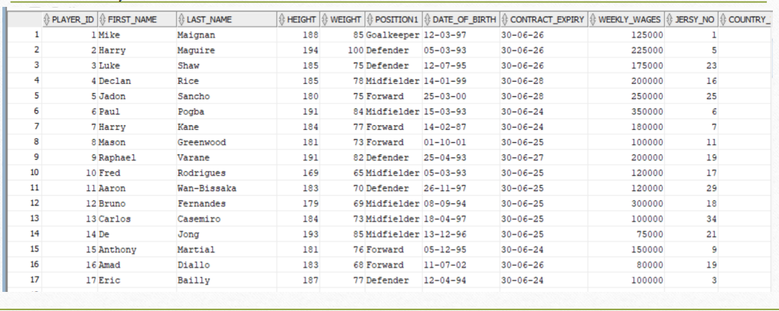

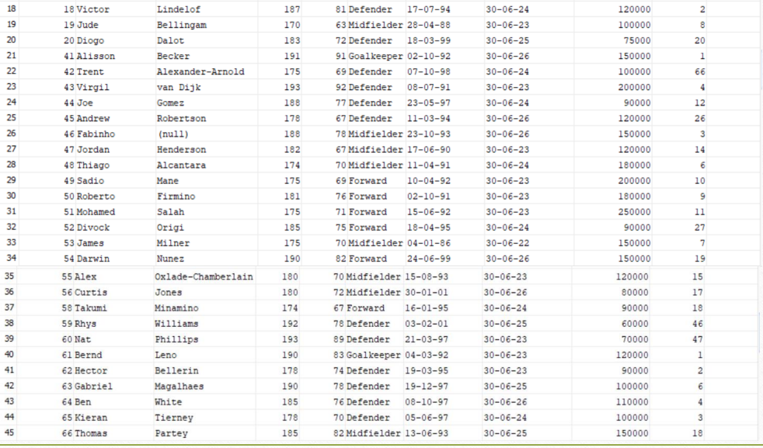

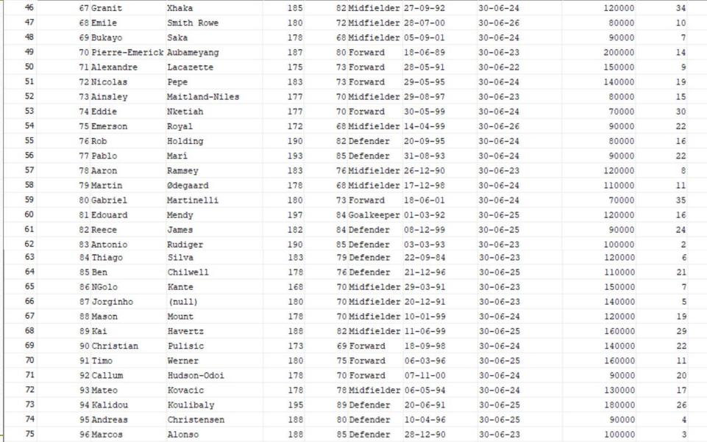

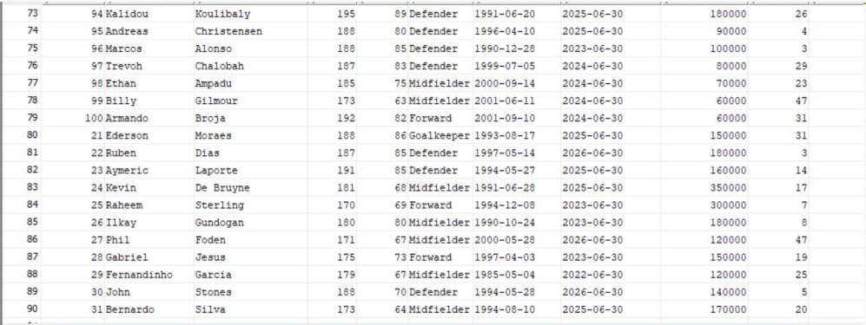

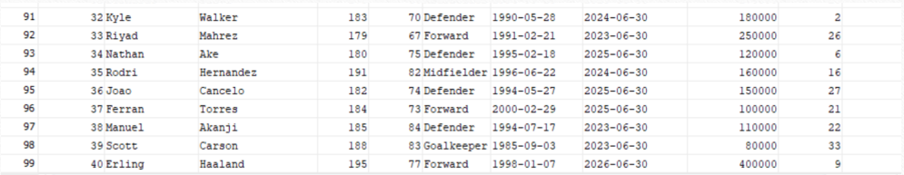

**Country:**

**create table country(**

**country_id int,**

**country_name varchar(20),**

**fifa_rank int,**

**PRIMARY KEY(country_id)**

**);**

**insert into country values(1,'England',2);**

**insert into country values(2,'France',1);**

**insert into country values(3,'Portugal',6);**

**insert into country values(4,'Netherlands',7);**

**insert into country values(5,'Brazil',3);**

**select* from country;**

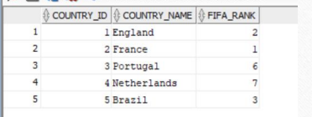

**Club:**

**create table club(**

**team_id int,**

**team_name varchar(20),**

**league_id int,**

**stadium_id int,**

**FOREIGN KEY(league_id) REFERENCES league(league_id),**

**FOREIGN KEY(stadium_id) REFERENCES stadium(stadium_id),**

**PRIMARY KEY(team_id)**

**);**

**insert into club values(1,'Manchester United',1,1);**

**insert into club values(2,'Manchester City',1,2);**

**insert into club values(3,'Liverpool F.C.',1,3);**

**insert into club values(4,'Arsenal F.C.',1,4);**

**insert into club values(5,'Chelsea F.C.',1,5);**

**select * from club;**

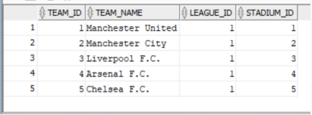

**Stadium:**

**create table stadium(**

**stadium_id int,**

**avg_attendance int,**

**stadium_name varchar(20),**

**stadium_capacity int,**

**PRIMARY KEY(stadium_id)**

**);**

**insert into stadium values(1,73960,'Old Trafford',74100);**

**insert into stadium values(2,53400,'Etihad',50000);**

**insert into stadium values(3,54000,'Anfield',51000);**

**insert into stadium values(4,60704,'Emirates',60000);**

**insert into stadium values(5,40341,'Stamford Bridge',39500);**

**select *from stadium;**

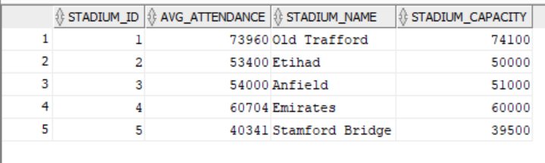

**Matches:**

**create table matching(**

**match_id int,**

**motm_id int,**

**score1 int,**

**score2 int,**

**stadium_id int,**

**FOREIGN KEY(stadium_id) REFERENCES stadium(stadium_id),**

**PRIMARY KEY(match_id)**

**);**

**insert into matching values(34,12,9,0,1);**

**insert into matching values(35,51,2,3,3);**

**insert into matching values(36,40,3,0,5);**

**insert into matching values(37,4,1,2,2);**

**insert into matching values(38,79,2,2,4);**

**select *from matching;**

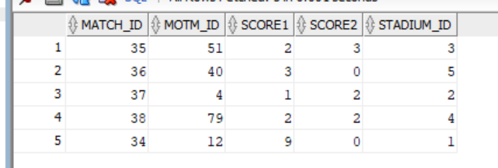

**League:**

**create table league(**

**league_id int,**

**league_name varchar(20),**

**PRIMARY KEY(league_id)**

**);**

**insert into league values(1,'Premier League');**



**create table club_match(**

**team_id int,**

**match_id int,**

**FOREIGN KEY(team_id) REFERENCES club(team_id),**

**FOREIGN KEY(match_id) REFERENCES matching(match_id),**

**primary key (team_id,match_id)**

**);**

**insert into club_match values(1,34);**

**insert into club_match values(3,34);**

**insert into club_match values(3,35);**

**insert into club_match values(4,35);**

**insert into club_match values(5,36);**

**insert into club_match values(2,36);**

**insert into club_match values(2,37);**

**insert into club_match values(1,37);**

**insert into club_match values(4,38);**

**insert into club_match values(5,38);**

**select* from club_match;**

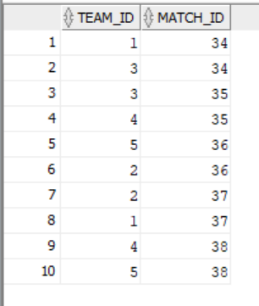

**Stats:**

**create table stats(**

**player_id int primary key,**

**goals int,**

**assists int,**

**motm_awards int,**

**cleansheets int,**

**minutes_played int,**

**games_played int,**

**FOREIGN KEY(player_id) REFERENCES player(player_id)**

**);**

**INSERT INTO stats VALUES (1, 0, 3, 2, 6, 990, 11);**

**INSERT INTO stats VALUES (2, 2, 1, 0, 4, 540, 6);**

**INSERT INTO stats VALUES (3, 1, 4, 1, 3, 720, 8);**

**INSERT INTO stats VALUES (4, 3, 2, 1, 5, 900, 10);**

**INSERT INTO stats VALUES (5, 7, 3, 3, 2, 820, 10);**

**INSERT INTO stats VALUES (6, 2, 1, 0, 1, 360, 4);**

**INSERT INTO stats VALUES (7, 1, 0, 0, 0, 180, 2);**

**INSERT INTO stats VALUES (8, 0, 2, 1, 2, 270, 3);**

**INSERT INTO stats VALUES (9, 4, 3, 2, 3, 810, 9);**

**INSERT INTO stats VALUES (10, 1, 1, 0, 0, 270, 3);**

**INSERT INTO stats VALUES (11, 3, 1, 1, 1, 450, 5);**

**INSERT INTO stats VALUES (12, 2, 4, 3, 4, 990, 11);**

**INSERT INTO stats VALUES (13, 0, 3, 0, 2, 540, 6);**

**INSERT INTO stats VALUES (14, 1, 2, 0, 0, 360, 4);**

**INSERT INTO stats VALUES (15, 2, 0, 1, 1, 540, 6);**

**INSERT INTO stats VALUES (16, 1, 0, 0, 0, 45, 1);**

**INSERT INTO stats VALUES (17, 1, 0, 0, 0, 180, 2);**

**INSERT INTO stats VALUES (18, 3, 2, 1, 2, 720, 8);**

**INSERT INTO stats VALUES (19, 0, 0, 0, 0, 180, 2);**

**INSERT INTO stats VALUES (20, 2, 1, 0, 1, 540, 6);**

**INSERT INTO stats VALUES (21, 0, 1, 2, 9, 1080, 12);**

**INSERT INTO stats VALUES (22, 2, 2, 1, 1, 720, 8);**

**INSERT INTO stats VALUES (23, 1, 0, 0, 0, 180, 2);**

**INSERT INTO stats VALUES (24, 3, 4, 2, 1, 900, 10);**

**INSERT INTO stats VALUES (25, 5, 4, 3, 1, 810, 9);**

**INSERT INTO stats VALUES (26, 1, 3, 1, 0, 360, 4);**

**INSERT INTO stats VALUES (27, 6, 7, 6, 2, 900, 10);**

**INSERT INTO stats VALUES (28, 2, 1, 0, 1, 540, 6);**

**INSERT INTO stats VALUES (29, 4, 1, 1, 0, 810, 9);**

**INSERT INTO stats VALUES (30, 1, 2, 0, 1, 270, 3);**

**INSERT INTO stats VALUES (31, 3, 1, 1, 2, 450, 5);**

**INSERT INTO stats VALUES (32, 0, 0, 0, 0, 0, 0);**

**INSERT INTO stats VALUES (33, 1, 0, 0, 0, 180, 2);**

**INSERT INTO stats VALUES (34, 2, 3, 1, 1, 720, 8);**

**INSERT INTO stats VALUES (35, 0, 0, 0, 0, 0, 0);**

**INSERT INTO stats VALUES (36, 1, 1, 0, 0, 270, 3);**

**INSERT INTO stats VALUES (37, 2, 0, 1, 1, 540, 6);**

**INSERT INTO stats VALUES (38, 0, 0, 0, 0, 0, 0);**

**INSERT INTO stats VALUES (39, 3, 2, 1, 2, 720, 8);**

**INSERT INTO stats VALUES (40, 12, 1, 4, 6, 990, 11);**

**INSERT INTO stats VALUES (41, 0, 2, 4, 5, 990, 11);**

**INSERT INTO stats VALUES (42, 1, 0, 0, 0, 180, 2);**

**INSERT INTO stats VALUES (43, 2, 1, 0, 1, 540, 6);**

**INSERT INTO stats VALUES (44, 0, 0, 0, 0, 0, 0);**

**INSERT INTO stats VALUES (45, 1, 1, 0, 0, 270, 3);**

**INSERT INTO stats VALUES (46, 2, 0, 1, 1, 540, 6);**

**INSERT INTO stats VALUES (47, 0, 0, 0, 0, 0, 0);**

**INSERT INTO stats VALUES (48, 3, 2, 1, 2, 720, 8);**

**INSERT INTO stats VALUES (49, 7, 4, 2, 4, 810, 9);**

**INSERT INTO stats VALUES (50, 2, 1, 0, 1, 540, 6);**

**INSERT INTO stats VALUES (51, 5, 3, 2, 2, 990, 11);**

**INSERT INTO stats VALUES (52, 2, 1, 0, 0, 360, 4);**

**INSERT INTO stats VALUES (53, 1, 0, 0, 0, 180, 2);**

**INSERT INTO stats VALUES (54, 0, 2, 1, 2, 270, 3);**

**INSERT INTO stats VALUES (55, 4, 3, 2, 3, 810, 9);**

**INSERT INTO stats VALUES (56, 1, 1, 0, 0, 270, 3);**

**INSERT INTO stats VALUES (57, 3, 1, 1, 1, 450, 5);**

**INSERT INTO stats VALUES (58, 2, 4, 3, 4, 990, 11);**

**INSERT INTO stats VALUES (59, 0, 0, 0, 0, 0, 0);**

**INSERT INTO stats VALUES (60, 1, 2, 0, 0, 360, 4);**

**INSERT INTO stats VALUES (61, 2, 0, 1, 1, 540, 6);**

**INSERT INTO stats VALUES (62, 0, 0, 0, 0, 0, 0);**

**INSERT INTO stats VALUES (63, 1, 1, 0, 0, 270, 3);**

**INSERT INTO stats VALUES (64, 2, 0, 1, 1, 540, 6);**

**INSERT INTO stats VALUES (65, 0, 0, 0, 0, 0, 0);**

**INSERT INTO stats VALUES (66, 3, 2, 1, 2, 720, 8);**

**INSERT INTO stats VALUES (67, 0, 0, 0, 0, 0, 0);**

**INSERT INTO stats VALUES (68, 2, 1, 0, 1, 540, 6);**

**INSERT INTO stats VALUES (69, 5, 3, 2, 2, 990, 11);**

**INSERT INTO stats VALUES (70, 2, 1, 0, 0, 360, 4);**

**INSERT INTO stats VALUES (71, 1, 0, 0, 0, 180, 2);**

**INSERT INTO stats VALUES (72, 0, 2, 1, 2, 270, 3);**

**INSERT INTO stats VALUES (73, 4, 3, 2, 3, 810, 9);**

**INSERT INTO stats VALUES (74, 1, 1, 0, 0, 270, 3);**

**INSERT INTO stats VALUES (75, 3, 1, 1, 1, 450, 5);**

**INSERT INTO stats VALUES (76, 2, 4, 3, 4, 990, 11);**

**INSERT INTO stats VALUES (77, 0, 0, 0, 0, 0, 0);**

**INSERT INTO stats VALUES (78, 1, 2, 0, 0, 360, 4);**

**INSERT INTO stats VALUES (79, 2, 0, 1, 1, 540, 6);**

**INSERT INTO stats VALUES (80, 5, 5, 2, 4, 720, 8);**

**INSERT INTO stats VALUES (81, 1, 1, 2, 4, 810, 9);**

**INSERT INTO stats VALUES (82, 0, 1, 0, 0, 90, 1);**

**INSERT INTO stats VALUES (83, 2, 3, 1, 1, 720, 8);**

**INSERT INTO stats VALUES (84, 0, 2, 1, 3, 720, 8);**

**INSERT INTO stats VALUES (85, 1, 1, 0, 0, 270, 3);**

**INSERT INTO stats VALUES (86, 2, 0, 1, 1, 540, 6);**

**INSERT INTO stats VALUES (87, 3, 0, 0, 3, 810, 9);**

**INSERT INTO stats VALUES (88, 3, 2, 1, 2, 720, 8);**

**INSERT INTO stats VALUES (89, 0, 0, 0, 2, 600, 8);**

**INSERT INTO stats VALUES (90, 2, 1, 0, 1, 540, 6);**

**INSERT INTO stats VALUES (91, 5, 3, 2, 2, 990, 11);**

**INSERT INTO stats VALUES (92, 2, 1, 0, 0, 360, 4);**

**INSERT INTO stats VALUES (93, 1, 0, 0, 0, 180, 2);**

**INSERT INTO stats VALUES (94, 0, 2, 1, 2, 270, 3);**

**INSERT INTO stats VALUES (95, 4, 3, 2, 3, 810, 9);**

**INSERT INTO stats VALUES (96, 1, 1, 0, 0, 270, 3);**

**INSERT INTO stats VALUES (97, 3, 1, 1, 1, 450, 5);**

**INSERT INTO stats VALUES (98, 2, 4, 3, 4, 990, 11);**

**INSERT INTO stats VALUES (99, 0, 0, 0, 0, 30, 1);**

**INSERT INTO stats VALUES (100, 1, 2, 0, 0, 360, 4);**

**select* from stats;**

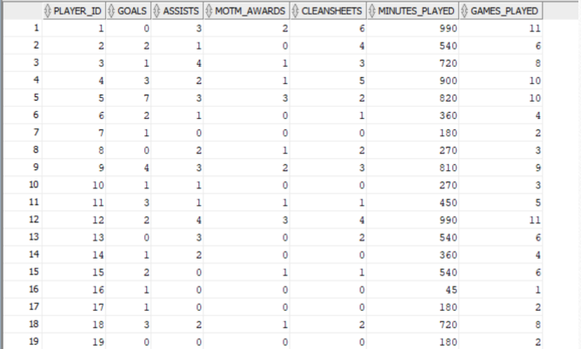

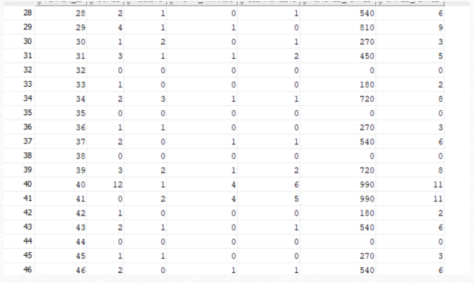





**Match referee:**

**create table match_referee(**

**referee_id int,**

**match_id int,**

**FOREIGN KEY(referee_id) REFERENCES referee(referee_id),**

**FOREIGN KEY(match_id) REFERENCES matching(match_id),**

**PRIMARY KEY (referee_id,match_id)**

**);**

**insert into match_referee values(1,34);**

**insert into match_referee values(2,34);**

**insert into match_referee values(3,34);**

**insert into match_referee values(4,35);**

**insert into match_referee values(5,35);**

**insert into match_referee values(6,35);**

**insert into match_referee values(3,36);**

**insert into match_referee values(7,36);**

**insert into match_referee values(8,36);**

**insert into match_referee values(2,37);**

**insert into match_referee values(5,37);**

**insert into match_referee values(6,37);**

**insert into match_referee values(3,38);**

**insert into match_referee values(4,38);**

**insert into match_referee values(7,38);**

**select *from match_referee;**

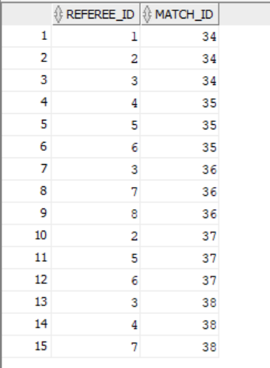

**Referee:**

**create table referee(**

**referee_id int,**

**referee_name varchar(20),**

**matches_refereed int,**

**PRIMARY KEY(referee_id)**

**);**

**INSERT INTO referee VALUES (1, 'Michael Oliver', 150);**

**INSERT INTO referee VALUES (2, 'Anthony Taylor', 200);**

**INSERT INTO referee VALUES (3, 'Martin Atkinson', 180);**

**INSERT INTO referee VALUES (4, 'Mike Dean', 220);**

**INSERT INTO referee VALUES (5, 'Kevin Friend', 160);**

**INSERT INTO referee VALUES (6, 'Craig Pawson', 140);**

**INSERT INTO referee VALUES (7, 'Andre Marriner', 190);**

**INSERT INTO referee VALUES (8, 'Paul Tierney', 130);**

**select *from referee;**

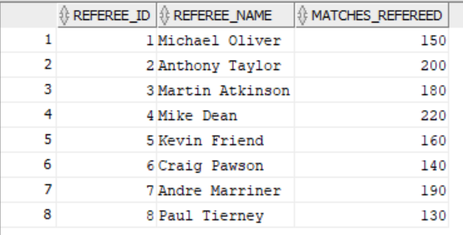

**Points Table:**

**create table points_table(**

**team_id int,**

**matches_played int,**

**wins int,**

**losses int,**

**draws int,**

**points int,**

**FOREIGN KEY(team_id) REFERENCES club(team_id),**

**PRIMARY KEY(team_id)**

**);**

**insert into points_table values(1,8,6,0,2,20);**

**insert into points_table values(2,8,4,2,2,14);**

**insert into points_table values(3,8,1,5,2,5);**

**insert into points_table values(4,8,5,0,3,15);**

**insert into points_table values(5,8,6,1,1,19);**

**select* from points_table order by points desc;**

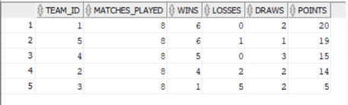

**Revenue:**

**create table revenue(**

**team_id int,**

**net_income int,**

**ticket_cost int,**

**merch_sales int,**

**FOREIGN KEY(team_id) REFERENCES club(team_id),**

**PRIMARY KEY(team_id)**

**);**

**insert into revenue values(1,65300000,105,102100000);**

**insert into revenue values(2,32000000,94,92100000);**

**insert into revenue values(3,60102000,90,82100000);**

**insert into revenue values(4,55000000,97,97020000);**

**insert into revenue values(5,5000000,80,932400000);**

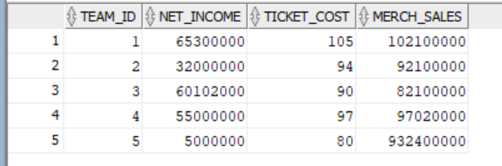

**Manager:**

**create table manager_table(**

**manager_id int,**

**team_id int,**

**manager_name varchar(20),**

**experience int,**

**monthly_wages int,**

**FOREIGN KEY(team_id) REFERENCES club(team_id),**

**PRIMARY KEY(manager_id)**

**);**

**INSERT INTO manager_table VALUES (1, 1, 'Erik Ten Haag', 10, 250000);**

**INSERT INTO manager_table VALUES (2, 2, 'Pep Guardiola', 15, 470000);**

**INSERT INTO manager_table VALUES (3, 3, 'Jurgen Klopp', 12, 360000);**

**INSERT INTO manager_table VALUES (4, 4, 'Mikel Arteta', 5, 140000);**

**INSERT INTO manager_table VALUES (5, 5, 'Mauricio Pochettino', 8, 205000);**

**select *from manager_table;**

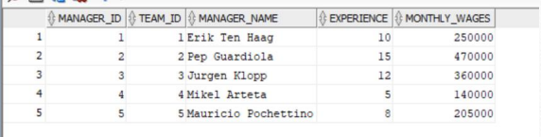

**Coach:**

**create table coach(**

**coach_id int,**

**manager_id int,**

**coach_name varchar(20),**

**experience int,**

**FOREIGN KEY(manager_id) REFERENCES manager_table(manager_id),**

**PRIMARY KEY(coach_id)**

**);**

**INSERT INTO coach VALUES (1, 1, 'Mike Phelan', 20);**

**INSERT INTO coach VALUES (2, 1, 'Kieran McKenna', 5);**

**INSERT INTO coach VALUES (3, 2, 'Juanma Lillo', 25);**

**INSERT INTO coach VALUES (4, 2, 'Brian Kidd', 30);**

**INSERT INTO coach VALUES (5, 3, 'Pepijn Lijnders', 15);**

**INSERT INTO coach VALUES (10, 3, 'Peter Krawietz', 10);**

**INSERT INTO coach VALUES (6, 4, 'Steve Round', 10);**

**INSERT INTO coach VALUES (9, 4, 'Albert Stuivenberg', 8);**

**INSERT INTO coach VALUES (7, 5, 'Anthony Barry', 8);**

**INSERT INTO coach VALUES (22, 5, 'Eddie Newton', 12);**

**select *from coach;**



**SQL QUERIES**

1. **1. Write a sql query to know winner of the league?**

Sol.

select team_name,points from club c,points_table p

where c.team_id = p.team_id and c.team_id=(select team_id from points_table where points=(select max(points) from points_table));

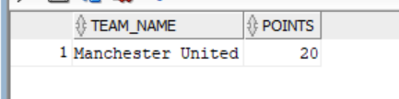

**2.** **Write an SQL query to show the league’s top goalscorer.**

Sol.

select first_name,last_name,goals from player p,stats s where p.player_id=s.player_id and

p.player_id= (select player_id from stats

where goals=(select max(goals) from stats));

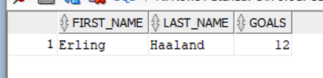

**3.** **Write an SQL trigger to update the points_table when a new row is inserted into matching table.**

Sol.

set serveroutput on;

create or replace trigger update_table after insert on matching for each row

declare

points_change int;

begin

if :new.score1> :new.score2 then points_change:=3;

elsif :new.score1= :new.score2 then points_change:=0;

else points_change:=-3;

end if;

update points_table

set matches_played= matches_played+1,

wins = wins + CASE WHEN points_change = 3 THEN 1 ELSE 0 END,

losses = losses + CASE WHEN points_change = -3 THEN 1 ELSE 0 END,

draws = draws + CASE WHEN points_change = 0 THEN 1 ELSE 0 END,

points = points + CASE WHEN points_change = 3 THEN 3 ELSIF 0 THEN 1 ELSE 0 END,

where team_id= (select team_id from club_match where match_id = :new.match_id and team_id = (select team_id from club where stadium_id=:new.stadium_id));

update points_table

set matches_played= matches_played+1,

wins = wins + CASE WHEN points_change = -3 THEN 1 ELSE 0 END,

losses = losses + CASE WHEN points_change = 3 THEN 1 ELSE 0 END,

draws = draws + CASE WHEN change = 0 THEN 1 ELSE 0 END,

points = points + CASE WHEN points_change = -3 THEN 3 ELSIF 0 THEN 1 ELSE 0 END,

where team_id= (select team_id from club_match where match_id = :new.match_id and team_id not in (select team_id from club where stadium_id=:new.stadium_id));

end;

/

**4. Write a sql query to show a team that has not won any matches.**

Sol.

SELECT t.team_id, t.team_name

FROM club t

JOIN points_table p ON t.team_id = p.team_id

WHERE p.wins IS NULL;

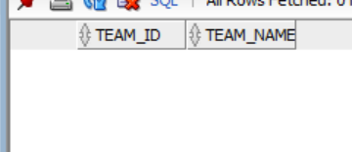

**5. Write an sql query to find the stadiums where a specific team played.**

Sol.

SELECT s.stadium_id, s.stadium_name

FROM stadium s, matching m WHERE s.stadium_id = m.stadium_id and m.match_id in (SELECT match_id FROM club_match WHERE team_id=&team_id);

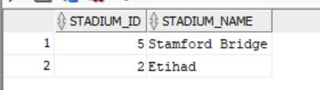

Input is 2.

**6. Write an SQL query to show the matches which ended as draw.**

Sol.

SELECT * FROM matching WHERE score1 = score2 ;

