EXPLORATORY DATA ANALYSIS (EDA) REPORT

Telco Customer Churn Analysis Using Microsoft Excel
Prepared By: Ram Charan

Table of Contents
- Introduction
- Project Objective
- Dataset Overview
- Data Cleaning & Profiling
- Exploratory Data Analysis
- Key Findings
- Conclusion

1. Introduction
Customer churn analysis is one of the most important business processes for subscription-based organizations. Understanding why customers discontinue services enables businesses to improve customer satisfaction, increase retention, and make informed strategic decisions.
This project performs Exploratory Data Analysis (EDA) on the Telco Customer Churn Dataset using Microsoft Excel. Pivot Tables and Pivot Charts were utilized to identify customer behavior, discover hidden patterns, and generate meaningful business insights.

2. Project Objective
The primary objectives of this project are:
• To examine the quality and structure of the dataset.
• To perform data cleaning and profiling.
• To explore customer demographics and service usage.
• To identify factors influencing customer churn.
• To generate business insights using Pivot Tables and Pivot Charts.
• To support data-driven decision making.

3. Dataset Overview
Dataset Name: Telco Customer Churn Dataset
Total Records: 7,043
Total Features (Columns): 21
Target Variable: Churn (Yes / No)

Feature Categories
Demographic Features
- Gender
- Senior Citizen
- Partner
- Dependents
Service Features
- Phone Service
- Multiple Lines
- Internet Service
- Online Security
- Online Backup
- Device Protection
- Tech Support
- Streaming TV
- Streaming Movies
Contract & Billing Features
- Contract
- Paperless Billing
- Payment Method
Numerical Features
- Tenure
- Monthly Charges
- Total Charges

4. Data Cleaning & Profiling
Before conducting exploratory analysis, the dataset was examined to ensure data quality and consistency.

Data Quality Checks
✔ Total Records Verified
✔ Total Features Verified
✔ Duplicate Records Checked
✔ Missing Values Verified
✔ Variable Classification Completed

Summary
The dataset contains 7,043 customer records with 21 attributes. No duplicate records or missing values were identified during the data validation process. The dataset is clean, complete, and suitable for exploratory data analysis.
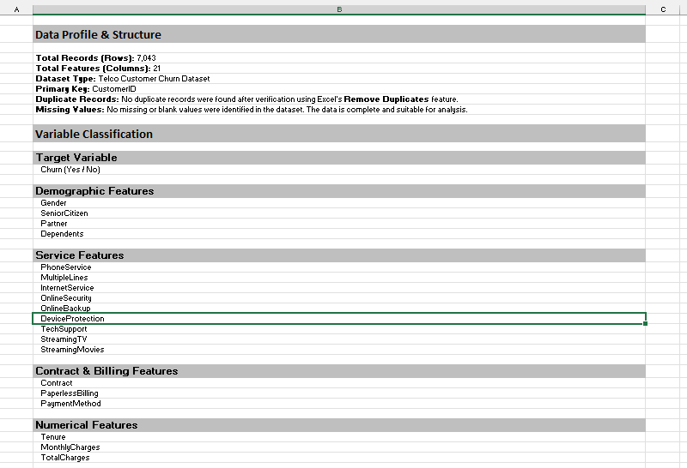
Figure 1: Data Cleaning & Profiling

5.1 Customer Contract & Payment Analysis
This section evaluates customer churn across different payment methods and contract types.
Charts Included:
- Customer Churn by Contract Type
- Customer Churn by Payment Method

Observation
Electronic Check customers demonstrate comparatively higher churn than customers using automatic payment methods. Longer contract durations contribute to stronger customer retention.
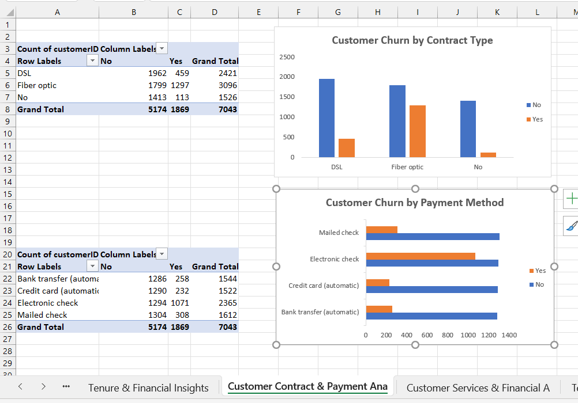
Insert Screenshot 3 Here
Figure 2: Customer Contract & Payment Analysis

5.2 Customer Services & Financial Analysis
This analysis explores the relationship between internet service type, monthly charges, and customer churn.
Charts Included:
- Customer Churn by Internet Service
- Average Monthly Charges by Churn Status

Observation
Fiber Optic customers experience a higher churn rate compared to DSL users. Customers who churn generally have higher average monthly charges.
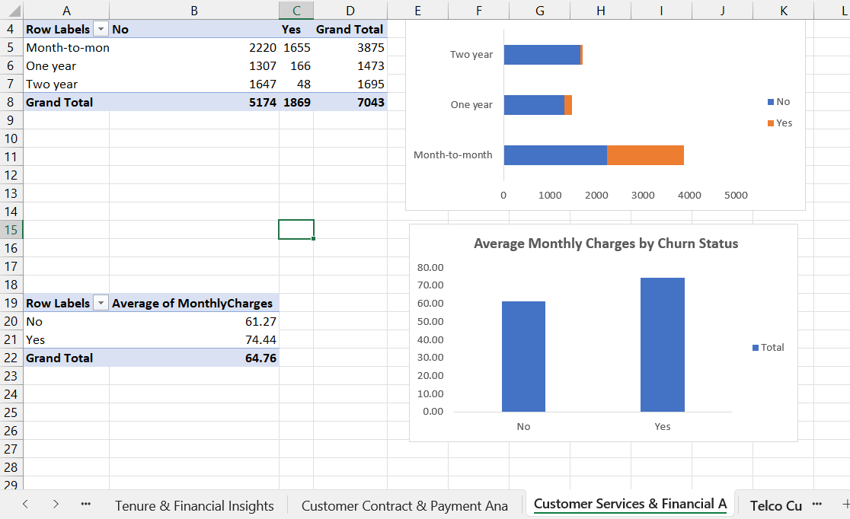
Figure 3: Customer Services & Financial Analysis

5.3 Customer Tenure & Financial Insights
This section analyzes customer tenure to understand retention patterns over time.
Chart Included:
- Customer Tenure Distribution

Observation
A large proportion of customers belong to the early tenure group (0–11 months). Customer retention improves as tenure increases, indicating greater loyalty among long-term customers.
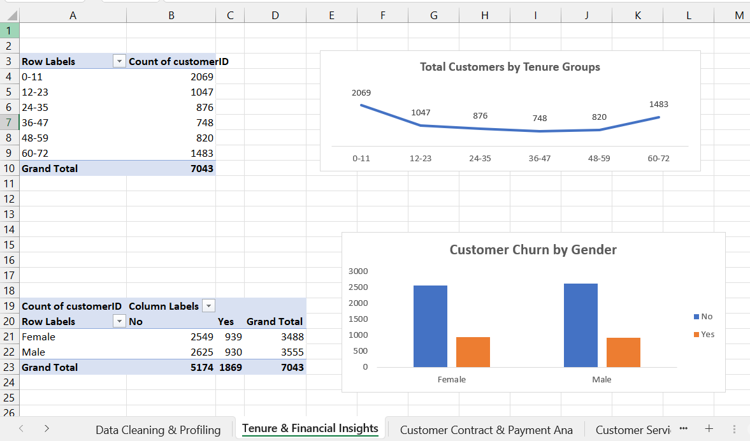
Figure 4: Customer Tenure & Financial Insights

6. Key Findings
• The customer base is nearly equally distributed between male and female customers.
• Month-to-Month contracts have the highest customer churn.
• Two-Year contracts demonstrate the strongest customer retention.
• Customers using Electronic Check experience higher churn than those using other payment methods.
• Fiber Optic internet service customers have comparatively higher churn.
• Customers with higher monthly charges are more likely to discontinue services.
• Long-term customers exhibit better retention than newly joined customers.

7. Conclusion
The exploratory data analysis successfully identified several factors that influence customer churn. Contract type, payment method, internet service, monthly charges, and customer tenure play an important role in customer retention. The insights obtained from this analysis can help organizations improve customer satisfaction, develop targeted retention strategies, and make informed business decisions.

Tools Used
- Microsoft Excel
- Pivot Tables
- Pivot Charts
- Data Cleaning & Profiling

Author
Ram Charan

