
PROJECT REPORT
(Project Semester: August – December 2026)
CALIFORNIA HOUSING PRICE PREDICTION
Predicting Median House Values of California Census Districts Using Statistical Analysis and Machine Learning
Submitted by
Sadu Ram Charan
Registration No.: 12502844
Programme and Section: Bachelor of Technology in Computer Science and Engineering & K2P24QR
Course Code: INT234
Under the Guidance of
Dr. Mrinalini Rana
Assistant Professor (U.Id 22138)
Discipline of CSE/IT
Lovely School of Computer Science and Engineering
Lovely Professional University, Phagwara
Punjab, India – 144411

DECLARATION
I, Sadu Ram Charan, student of Bachelor of Technology in Computer Science and Engineering under CSE/IT Discipline at Lovely Professional University, Punjab, hereby declare that all the information furnished in this project report is based on my own intensive work and is genuine.

Date: 31-10-2026
Signature: Sadu Ram Charan
Registration No. 12502844
Name of the student: Sadu Ram Charan

CERTIFICATE
This is to certify that Sadu Ram Charan bearing Registration no. 12502844 has completed INT234 project titled, “CALIFORNIA HOUSING PRICE PREDICTION — Predicting Median House Values of California Census Districts Using Statistical Analysis and Machine Learning” under my guidance and supervision. To the best of my knowledge, the present work is the result of his/her original development, effort and study.

Dr. Mrinalini Rana
Assistant Professor (U.Id 22138)
Lovely School of Computer Science and Engineering
Lovely Professional University
Phagwara, Punjab.

Date: 31-10-2026

ACKNOWLEDGEMENT
I express my sincere gratitude to my faculty coordinator, Dr. Mrinalini Rana, Lovely Professional University, for the guidance, encouragement and constructive feedback that shaped this project from the choice of problem to the final analysis. I also thank the School and the Discipline of CSE/IT for providing the academic environment and the course framework in which this work was carried out.
I acknowledge the original authors of the dataset, R. Kelley Pace and Ronald Barry, whose 1997 work made the California census data available through the StatLib repository, and the contributors who curated and re-published it on Kaggle and OpenML, as well as Aurélien Géron, whose public repository provided the copy used here. The project would not have been possible without the open-source scientific Python ecosystem: NumPy, pandas, SciPy, statsmodels, scikit-learn, XGBoost, SHAP, Matplotlib and Seaborn.
Finally, I thank my family and friends for their patience and support during the preparation of this report.

Sadu Ram Charan
Date: 31-10-2026

TABLE OF CONTENTS
1. Introduction 1
1.1 Background and Motivation 1
1.2 Problem Statement 1
1.3 Research Objectives 2
1.4 Contributions and Distinguishing Features 2
1.5 Tools and Computational Environment 3
1.6 Organisation of the Report 3
2. Source of Dataset 4
2.1 Provenance 4
2.2 Why this Dataset Was Selected 5
2.3 Data Dictionary 6
2.4 Ethical and Licensing Considerations 6
3. EDA Process 7
3.1 Workflow and Leakage Prevention 7
3.2 Data Quality Assessment 7
3.3 Training/Test Split 8
3.4 Descriptive Statistics 8
3.5 Distributions 9
3.6 Correlation Structure and Multicollinearity 10
3.7 Geographic Patterns 11
3.8 Preprocessing Pipeline and Mathematical Definitions 11
4. Analysis on Dataset 13
4.1 Analysis 1: Data Quality, Censoring and Imputation of total_bedrooms (Objective 1) 13
4.1.1 Introduction 13
4.1.2 General Description 13
4.1.3 Specific Requirements, Functions and Formulas 14
4.1.4 Analysis Results 14
4.1.5 Visualization and Interpretation 16
4.2 Analysis 2: Income as a Determinant of House Value (Objective 2) 17
4.2.1 Introduction 17
4.2.2 General Description 17
4.2.3 Specific Requirements, Functions and Formulas 17
4.2.4 Analysis Results 18
4.2.5 Visualization and Interpretation 19
4.3 Analysis 3: Geography: Ocean Proximity, Spatial Autocorrelation and Spatial Features (Objective 3) 20
4.3.1 Introduction 20
4.3.2 General Description 20
4.3.3 Specific Requirements, Functions and Formulas 21
4.3.4 Analysis Results 21
4.3.5 Visualization and Interpretation 23
4.4 Analysis 4: Engineered Ratio Features (Objective 4) 25
4.4.1 Introduction 25
4.4.2 General Description 25
4.4.3 Specific Requirements, Functions and Formulas 25
4.4.4 Analysis Results 26
4.4.5 Visualization and Interpretation 26
4.5 Analysis 5: Model Comparison and Selection (Objective 5) 27
4.5.1 Introduction 27
4.5.2 General Description 27
4.5.3 Specific Requirements, Functions and Formulas 28
4.5.4 Analysis Results 29
4.5.5 Visualization and Interpretation 31
4.6 Analysis 6: Error Analysis, Effect of Censoring and Explainability (Objective 6) 33
4.6.1 Introduction 33
4.6.2 General Description 33
4.6.3 Specific Requirements, Functions and Formulas 34
4.6.4 Analysis Results 34
4.6.5 Visualization and Interpretation 37
5. Conclusion 42
5.1 Summary of Findings 42
5.2 Recommendations 42
5.3 Limitations 43
6. Future Scope 44
7. References 45

LIST OF FIGURES
Figure 1: Data-quality overview: (a) missing values, (b) censoring of the target at $500,001, (c) censoring of housing age at 52 years 8
Figure 2: Distributions of all numeric variables with kernel-density curves (training set) 9
Figure 3: Spearman correlation matrix of numeric variables (training set) 10
Figure 4: Geographic distribution of districts: (a) house value, (b) ocean-proximity classes 11
Figure 5: Imputation strategies: (a) error on masked values, (b) downstream effect with 95 % confidence intervals 16
Figure 6: Relationship between median income and house value: (a) linear, quadratic and LOWESS fits, (b) log–log fit 19
Figure 7: (a) Residuals of the linear model against fitted values; (b) house value by income decile 19
Figure 8: House value by ocean-proximity class (violin plots with quartiles) 23
Figure 9: Moran scatter-plot: house value of a district against the average value of its eight neighbours 23
Figure 10: Change in cross-validated RMSE when spatial distance features are added (95 % CI) 24
Figure 11: Ratio features: (a) correlation with the target, raw vs. engineered; (b) change in CV-RMSE when ratios are added 26
Figure 12: Model comparison: (a) RMSE of each CV fold, (b) held-out test RMSE with R² 31
Figure 13: Predicted against actual median house value for XGBoost on the test set 31
Figure 14: Learning curve of XGBoost 32
Figure 15: Residual diagnostics: (a) residuals against predictions, (b) distribution, (c) normal Q–Q plot 37
Figure 16: Test RMSE by (a) ocean proximity, (b) income quintile, (c) true-value band; labels give the median absolute percentage error and n 37
Figure 17: Map of test residuals (actual minus predicted); blue = under-predicted, red = over-predicted 38
Figure 18: Permutation importance on the test set: (a) single input variables, (b) feature groups 39
Figure 19: SHAP summary plot: each dot is a district; colour shows the feature value, horizontal position its effect on the prediction 40
Figure 20: Partial dependence of the predicted value on (a) median income, (b) housing median age and (c) location 41

LIST OF TABLES
Table 1: Objective-to-analysis mapping 2
Table 2: Software environment 3
Table 3: Dataset provenance and verification 4
Table 4: Candidate datasets evaluated 5
Table 5: Data dictionary 6
Table 6: Data-quality audit of the raw file 7
Table 7: Train/test split 8
Table 8: Descriptive statistics (training set) 8
Table 9: Variance-inflation factors (log-transformed counts, standardised) 10
Table 10: Cleaning and preprocessing decisions 12
Table 11: Functions used in Analysis 1 14
Table 12: Comparison of districts with missing and observed total_bedrooms (training set) 15
Table 13: Masked-imputation experiment (5 % of observed values hidden) 15
Table 14: Downstream effect of the imputation strategy (5×2 repeated CV, gradient boosting) 15
Table 15: Functions used in Analysis 2 17
Table 16: Correlation between median income and median house value (training set) 18
Table 17: Regression results for house value on income 18
Table 18: House value by income decile (training set) 18
Table 19: Functions used in Analysis 3 21
Table 20: House value by ocean-proximity class (training set) 21
Table 21: Pairwise comparisons of ocean-proximity classes (Mann–Whitney U, Holm correction) 22
Table 22: Ablation of feature sets (5×2 repeated CV on the training set) 22
Table 23: Effect of adding spatial distance features 22
Table 24: Functions used in Analysis 4 25
Table 25: Rank correlation of raw counts and engineered ratios with house value (training set) 26
Table 26: Effect of adding ratio features (paired, corrected resampled t-test) 26
Table 27: Models compared 28
Table 28: Functions used in Analysis 5 28
Table 29: Hyper-parameter tuning (3-fold CV on the training set) 29
Table 30: Five-fold cross-validation of the tuned models (training set; basis of selection) 30
Table 31: Held-out test-set performance (evaluated once, after selection) 30
Table 32: Is XGBoost significantly better? (negative = XGBoost better) 30
Table 33: Functions used in Analysis 6 34
Table 34: Summary of test-set residuals 34
Table 35: Test error by ocean-proximity class 35
Table 36: Test error by income quintile 35
Table 37: Test error by true-value band (selection on the true value, see text) 35
Table 38: Effect of target censoring on test performance 35
Table 39: The ten largest test errors 36
Table 40: Permutation importance of the original input variables 36
Table 41: Grouped permutation importance 36
Table 42: Ten largest mean absolute SHAP values (TreeExplainer, 1,500 test districts) 36
Table 43: Summary of findings by objective 42

1. Introduction

1.1 Background and Motivation
Housing is the largest asset for most households and a central concern for lenders, insurers, municipal planners and policy makers. Estimating what a home or a neighbourhood is worth has traditionally relied on hedonic regression, in which price is explained by a handful of structural and locational attributes. Real housing markets, however, are characterised by non-linear effects, interactions between variables and strong spatial heterogeneity: the same level of income can correspond to very different prices on the coast and in the interior. Modern machine-learning methods, particularly ensembles of decision trees, can capture such patterns without the analyst specifying them in advance, but they must be validated carefully because they can also over-fit, leak information from the test data, or hide the limits of the data they were trained on.
This project builds a complete, reproducible predictive-analysis pipeline for a classic real-world housing problem: predicting the median house value of a California census district from the district’s demographic and geographic summary statistics. Rather than simply fitting a few models and reporting the best score, the project is organised around six measurable research objectives that interrogate the data, the features and the models, and that quantify what the data can and cannot support.

1.2 Problem Statement
Let x denote the vector of attributes of a census block group (longitude, latitude, median housing age, total rooms, total bedrooms, population, households, median income and ocean-proximity class) and let y be the median house value of that block group in US dollars. The task is a supervised regression problem: learn a function f such that f(x) predicts y for districts not seen during training, by minimising the expected squared prediction error
R(f) = E[ ( y − f(x) )² ] (1)
The learned model is evaluated on a held-out test set with the root-mean-squared error (RMSE), the mean absolute error (MAE) and the coefficient of determination (R²). The dataset has 20,640 rows, one numeric target, eight numeric predictors and one categorical predictor.

1.3 Research Objectives
Six non-redundant objectives drive the entire project. Each is defined by a research question, the variables and statistical methods required, the expected output and an explicit success measure. Every objective is investigated in Section 4, answered with actual results from the executed notebook, visualised and discussed. Table 1 maps each objective to its analysis.
Table 1: Objective-to-analysis mapping
Obj. | Research question | Required variables | Statistical / ML methods | Success measure | Sec.
O1 | Is the missingness in total_bedrooms ignorable, and which imputer recovers values best? How much of the data is censored? | total_bedrooms and all other variables; target, age and income caps | Mann-Whitney U, χ², masked-imputation experiment, CV | Masked-imputation RMSE; ΔCV-RMSE | 4.1
O2 | How strong, steep and linear is the income–value relationship? | median_income, median_house_value | Pearson/Spearman + bootstrap CI, OLS, F-test, log-log model, Breusch-Pagan | r (95 % CI), R², elasticity, BP p-value | 4.2
O3 | Does geography explain value, and do spatial features improve prediction? | ocean_proximity, longitude, latitude, city distances | Kruskal-Wallis, Holm-corrected tests, Moran’s I, ablation | ε², Moran’s I, ΔRMSE with 95 % CI | 4.3
O4 | Do per-household ratio features add value beyond raw counts? | rooms, bedrooms, population, households | Spearman comparison, ablation, corrected resampled t-test | ΔRMSE, ΔR², NB p-value | 4.4
O5 | Which of ≥ 4 models is best, and is it significantly better than the runner-up? | All features | Tuned CV, held-out test, paired bootstrap | CV/test RMSE, MAE, R²; CI of ΔRMSE | 4.5
O6 | Where does the best model fail, what is the effect of censoring, and what drives predictions? | Residuals, segments, features | Residual analysis, Moran’s I, permutation importance, SHAP, PDP | Segment RMSE/MedAPE; top-3 importance share | 4.6

1.4 Contributions and Distinguishing Features
- Leakage-safe design. The 80/20 split is made before any exploratory analysis; every imputer, scaler and encoder is fitted inside scikit-learn pipelines on training folds only; the test set is used once.
- Honest treatment of censoring. The target (capped at $500,001), housing age (52 years) and income (15.0001) are right-censored by the data publisher. The project quantifies the consequences instead of silently deleting or ignoring these rows.
- Statistical rigour in model comparison. Models are compared on identical folds with the Nadeau–Bengio corrected resampled t-test and a paired bootstrap on the test set, not just by ranking a single score.
- Spatial awareness. Spatial autocorrelation (Moran’s I) is measured for both the target and the final model’s residuals.
- Fair baselines and ablation. A naïve baseline, a linear model (with and without a log-transformed target) and four non-linear models are tuned under the same protocol; feature groups are evaluated by paired ablation.
- Explainability. Permutation importance, SHAP values and partial-dependence curves explain the final model.

1.5 Tools and Computational Environment
All analysis was executed in a Jupyter Notebook on a single CPU core with a fixed random seed (42). Table 2 lists the software versions recorded automatically by the notebook.
Table 2: Software environment
Component | Version / setting
Python | 3.12.3
pandas | 3.0.2
NumPy | 2.4.4
scikit-learn | 1.8.0
XGBoost | 3.4.1
Random seed | 42
Plotting | Matplotlib, Seaborn (figures saved at 200 dpi)
Statistics | SciPy, statsmodels
Explainability | SHAP

1.6 Organisation of the Report
Section 2 documents the source of the dataset and the reasons for selecting it. Section 3 describes the exploratory data analysis and preprocessing. Section 4 presents the six analyses, each with an introduction, a general description, the specific requirements, functions and formulas, the actual results and the visualisation with interpretation. Section 5 gives the conclusions, Section 6 the future scope and Section 7 the references.

2. Source of Dataset

2.1 Provenance
The dataset is the California Housing Prices dataset. It originates from the 1990 United States Census and was assembled for the study by Pace and Barry (1997) on sparse spatial autoregressions; it is distributed through the StatLib repository. Each row describes one census block group — the smallest geographic unit for which the Census Bureau publishes sample data, typically with a population of 600 to 3,000 people. The values are therefore aggregates over many households and contain no personal information.
The version used in this project contains ten columns, including the categorical variable ocean_proximity, and is the copy popularised by Géron (2019). It is published on Kaggle under the name California Housing Prices (user camnugent) and on OpenML (dataset 43705). The file analysed here was downloaded from Géron’s public GitHub repository because direct access to Kaggle was not available in the computing environment used. Table 3 lists the sources and the verification performed.
Table 3: Dataset provenance and verification
Item | Detail
Original source | StatLib repository; Pace, R. K. and Barry, R. (1997), Statistics & Probability Letters 33(3), 291–297
Kaggle listing | https://www.kaggle.com/datasets/camnugent/california-housing-prices
OpenML listing | https://api.openml.org/d/43705/json (dataset ID 43705)
File used | https://raw.githubusercontent.com/ageron/handson-ml2/master/datasets/housing/housing.csv
Rows × columns | 20,640 × 10 (matches the published descriptions)
SHA-256 of file | 8a3727f4cf54ac1a327f69b1d5b4db54c5834ea81c6e4efc0d163300022a685e
Date downloaded | 15-10-2026 (GitHub copy)
Verification | The Kaggle page itself could not be opened from the computing environment used. Size and origin were instead cross-checked against the Kaggle dataset description as republished by a third-party mirror, the OpenML metadata and the Keras documentation; the file was loaded unchanged and its checksum recorded.

Readers who wish to reproduce the work from the primary Kaggle page may download the file there and compare its checksum with the one in Table 3; the notebook reads the file from data/raw/housing.csv without modification.

2.2 Why this Dataset Was Selected
Five candidate datasets were downloaded and profiled before a choice was made. The criteria were: authentic and well-documented provenance, sufficient size for cross-validation, a meaningful continuous prediction target, genuine data-quality challenges to analyse, and enough structure (spatial, categorical, numeric) to support at least five distinct objectives. Table 4 summarises the comparison.
Table 4: Candidate datasets evaluated
Candidate | Size | Observed data issues | Provenance | Decision
California Housing | 20,640 × 10 | 207 missing; target capped (965 rows); age capped (1,273 rows) | 1990 US Census, StatLib, peer-reviewed origin | Selected
Diamonds | 53,940 × 10 | 146 duplicates; 20 zero dimensions; few categorical/spatial aspects | Web-scraped listings (2008) | Rejected: less rich analytical structure
Medical insurance | 1,338 × 7 | Very small sample; 1 duplicate | Textbook dataset | Rejected: too small for reliable CV/tuning
Telco customer churn | 7,043 × 21 | 11 blank TotalCharges | IBM sample (fictional customers) | Rejected: not real-world data
Bengaluru housing | 13,320 × 9 | 529 duplicates; 41 % missing society; text-valued area | Scraped listings, original source undocumented | Rejected: weak provenance

California Housing satisfies all criteria: it is real, peer-reviewed in origin, of moderate size (large enough for stable cross-validation yet light enough to tune several models), contains real data-quality problems (missing values, censoring at three variables) and has a pronounced spatial dimension that supports the geographic objectives. Its main limitation — the prices are from 1990 — is discussed in Section 5.

2.3 Data Dictionary
Table 5: Data dictionary
Variable | Type | Unit | Description
longitude | float | degrees | Block-group longitude (more negative = further west)
latitude | float | degrees | Block-group latitude (higher = further north)
housing_median_age | float | years | Median age of houses (capped at 52)
total_rooms | float | count | Total rooms in all houses of the block group
total_bedrooms | float | count | Total bedrooms in the block group (207 missing)
population | float | persons | Block-group population
households | float | count | Number of households
median_income | float | ×$10,000 | Median household income (capped at 15.0001)
median_house_value | float | USD | Target: median house value (capped at 500,001)
ocean_proximity | categorical | – | <1H OCEAN, INLAND, NEAR OCEAN, NEAR BAY, ISLAND

2.4 Ethical and Licensing Considerations
The data are aggregated census statistics and contain no names, addresses or other personal identifiers, so there is no privacy risk at the individual level. Users should consult the licence stated on the Kaggle page before redistributing the file. Because the data describe 1990 conditions, the models produced here must not be used to value present-day property; they illustrate the methodology.

3. EDA Process

3.1 Workflow and Leakage Prevention
The exploratory process followed a strict order designed to prevent information from the test data influencing any modelling decision. (1) The raw file was loaded unchanged and audited for quality. (2) Immediately afterwards, the data were split into a training set of 16,512 districts and a test set of 4,128 districts (80/20), stratified on five income bands because income is the strongest predictor and both sets must cover all income levels proportionally. (3) All further exploration — distributions, correlations, statistical tests — used the training set only. (4) All data-dependent preprocessing (imputation, scaling, encoding, feature construction) was embedded in scikit-learn pipelines so that it is re-fitted on the training portion of every cross-validation fold. (5) The test set was used once, at the very end, to evaluate the selected models.

3.2 Data Quality Assessment
Table 6: Data-quality audit of the raw file
Check | Result | Action
Missing values | 207 in total_bedrooms (1.00 % of rows); none elsewhere | Imputed inside pipeline (Objective 1)
Duplicate rows | 0 | None to remove
Inconsistent category labels | 0 whitespace/case issues; 5 valid classes | None required
Households ≤ 0 / population ≤ 0 | 0 / 0 | None required
Bedrooms > rooms | 0 | None required
Coordinates outside California | 0 | None required
Target censored at $500,001 | 965 rows (4.68 %) | Kept; effect quantified (Objectives 1, 6)
Housing age capped at 52 | 1273 rows (6.17 %) | Kept; flagged as limitation
Income capped at 15.0001 | 49 rows | Kept

Tukey’s 1.5×IQR rule flags many districts as outliers in the count variables (for example 1,287 in total_rooms and 1,196 in population). These are genuine districts — large urban block groups and sparsely populated resort areas — not data-entry errors, so they were retained. Their influence is handled by logarithmic transformation for the count features and by the use of tree-based models, which are insensitive to monotone transformations and extreme values.
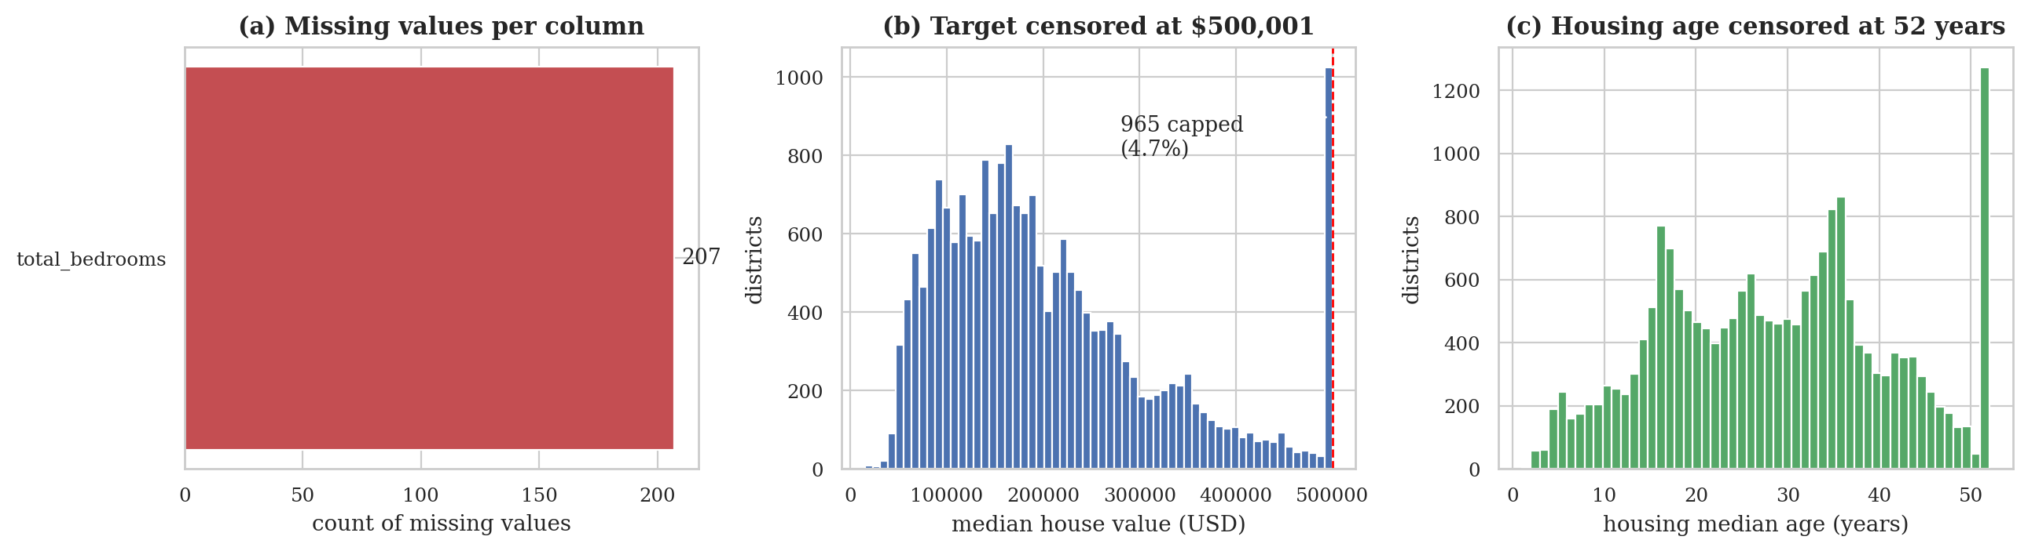
Figure 1: Data-quality overview: (a) missing values, (b) censoring of the target at $500,001, (c) censoring of housing age at 52 years
Figure 1 shows the three quality issues that matter for modelling. The spike at $500,001 in panel (b) means the true value of 4.7% of districts is at least $500,001 but unknown; any model trained on this variable will systematically under-estimate the most expensive districts. The same applies to the 52-year cap on housing age.

3.3 Training/Test Split
Table 7: Train/test split
Set | Rows | Share
Training | 16,512 | 80 %
Test (held out) | 4,128 | 20 %
Stratification | 5 income bands (≤1.5, 1.5–3, 3–4.5, 4.5–6, >6) | –
Random seed | 42 | –

3.4 Descriptive Statistics
Table 8: Descriptive statistics (training set)
Variable | n | Mean | Std | Min | Median | Max
longitude | 16,512 | -119.58 | 2.00 | -124.35 | -118.51 | -114.31
latitude | 16,512 | 35.64 | 2.14 | 32.54 | 34.26 | 41.95
housing_median_age | 16,512 | 28.65 | 12.57 | 1.00 | 29.00 | 52.00
total_rooms | 16,512 | 2,622.54 | 2,138.42 | 6.00 | 2,119.00 | 39,320.00
total_bedrooms | 16,354 | 534.91 | 412.67 | 2.00 | 433.00 | 6,210.00
population | 16,512 | 1,419.69 | 1,115.66 | 3.00 | 1,164.00 | 35,682.00
households | 16,512 | 497.01 | 375.70 | 2.00 | 408.00 | 5,358.00
median_income | 16,512 | 3.88 | 1.90 | 0.50 | 3.54 | 15.00
median_house_value | 16,512 | 207,005.32 | 115,701.30 | 14,999.00 | 179,500.00 | 500,001.00

The target has mean $207,005 and median $179,500; the mean exceeds the median because the distribution is right-skewed (skewness 0.99). The count variables are far more skewed: total_rooms has skewness 4.0 and population 4.7, which motivates the logarithmic transformation applied before scaling.

3.5 Distributions
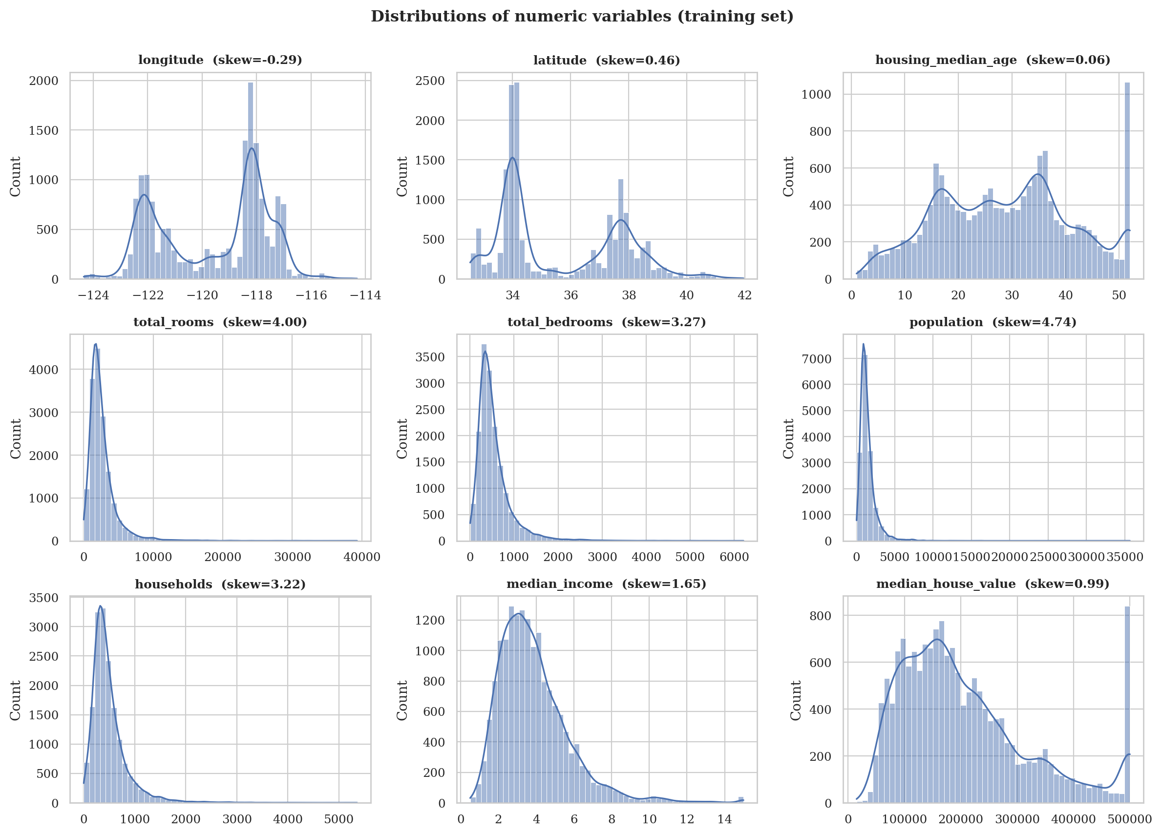
Figure 2: Distributions of all numeric variables with kernel-density curves (training set)
Figure 2 confirms three patterns. The count variables (rooms, bedrooms, population, households) are heavily right-skewed with long tails. Median income is also right-skewed and shows a small mass at its cap. Longitude and latitude are bimodal, reflecting the two main population clusters — the San Francisco Bay area and the Los Angeles basin.

3.6 Correlation Structure and Multicollinearity
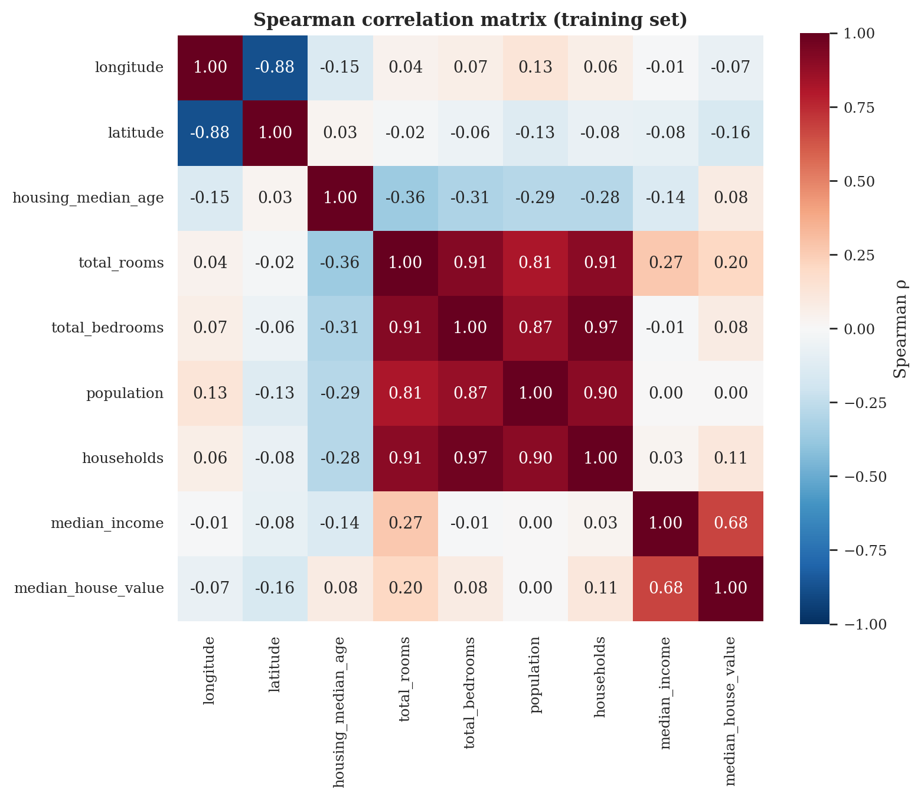
Figure 3: Spearman correlation matrix of numeric variables (training set)
Spearman’s rank correlation was used because it does not assume linearity or normality. The strongest correlate of the target is median_income (ρ = 0.68); housing_median_age (ρ = 0.08) and the counts have weaker associations. The four count variables are strongly inter-correlated, which is expected because they all scale with the size of the block group. Variance-inflation factors (VIF) computed on the standardised, log-transformed predictors quantify this collinearity (Table 9).
Table 9: Variance-inflation factors (log-transformed counts, standardised)
Variable | VIF
households | 29.0
total_bedrooms | 27.1
total_rooms | 20.4
latitude | 9.7
longitude | 9.3
population | 8.0
median_income | 2.3
housing_median_age | 1.2

VIF values above 10 indicate serious collinearity. Three of the four count variables (total_rooms, total_bedrooms, households) exceed 20, and longitude and latitude are close to 10 because the state’s population lies along a diagonal coastal band. Such collinearity does not harm the predictive accuracy of tree ensembles, but it makes linear-model coefficients unstable, which is one reason ratio features are examined in Objective 4.

3.7 Geographic Patterns
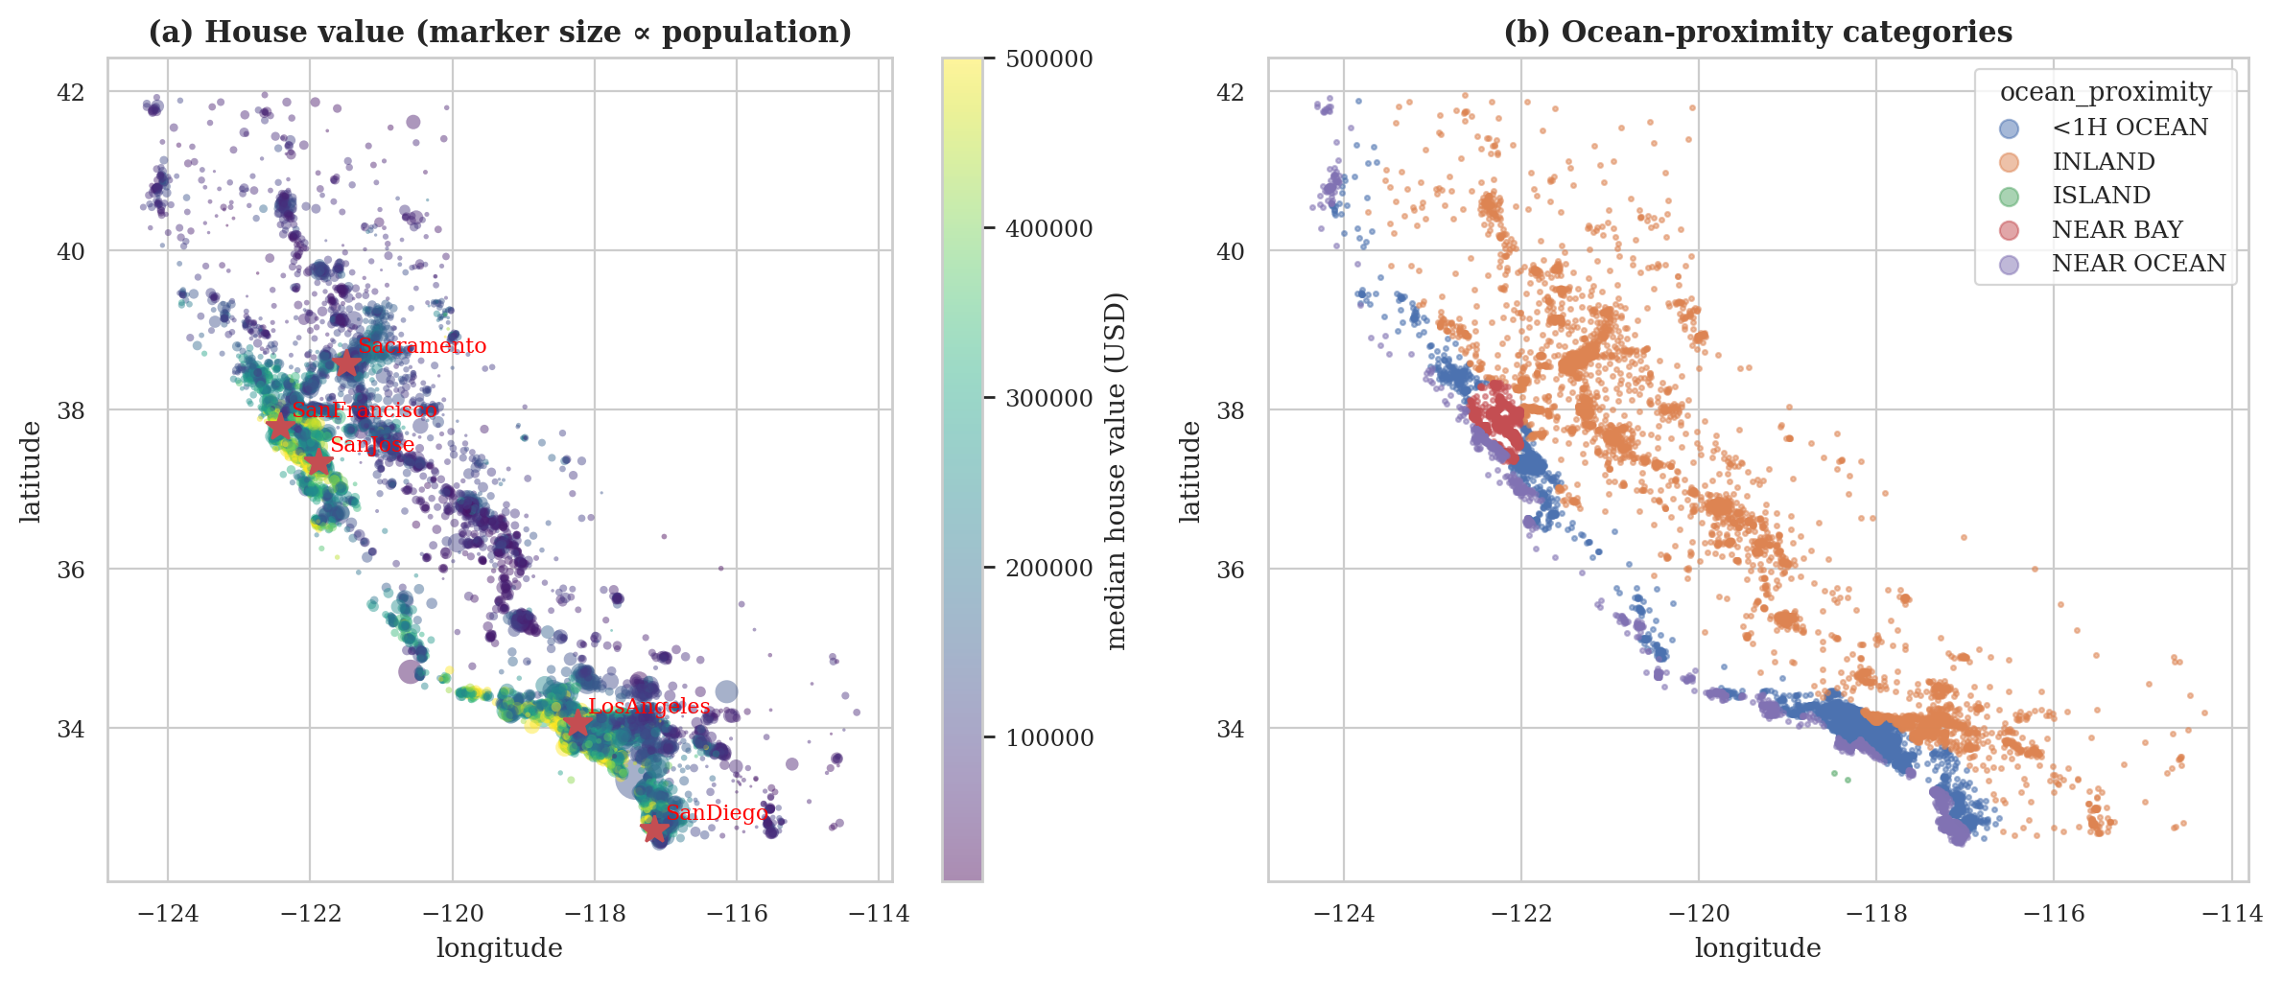
Figure 4: Geographic distribution of districts: (a) house value, (b) ocean-proximity classes
Figure 4 shows that expensive districts cluster along the coast and around the Bay area and Los Angeles, while the interior (the Central Valley and the deserts) is cheaper. The ocean-proximity classes reproduce this gradient. This strong spatial structure is quantified in Objective 3.

3.8 Preprocessing Pipeline and Mathematical Definitions
Preprocessing is a single scikit-learn pipeline: imputer → feature engineer → column transformer. The column transformer applies three branches: (i) count variables (and ratio features) are transformed with log1p and standardised, (ii) the remaining numeric variables are standardised, and (iii) the categorical variable is one-hot encoded. The definitions are:
x' = ln(1 + x) (log transform for skewed count features) (2)
z = ( x − μ_{train} ) / σ_{train} (standardisation, parameters learned on training folds only) (3)
d = 2R · arcsin √[ sin²(Δφ/2) + cos φ₁ cos φ₂ sin²(Δλ/2) ] (haversine distance, R = 6371 km) (4)
Table 10: Cleaning and preprocessing decisions
Decision | Justification
Keep censored rows | They are real districts; deleting them would bias the sample toward cheaper areas. The effect is quantified instead.
Keep outliers | Genuine districts (resorts, dense urban); handled by log transform and tree models.
Impute total_bedrooms in the pipeline | Imputing before the split would leak test-set information.
log1p + scaling for counts | Reduces skewness; required by distance-based and linear models.
One-hot encode ocean_proximity | Nominal variable with five classes; unknown classes ignored at prediction time.
Stratified split on income | Ensures the strongest predictor is represented equally in both sets.

4. Analysis on Dataset
This section presents the six analyses that answer the research objectives of Section 1.3. Each analysis follows the same structure: an introduction, a general description, the specific requirements, functions and formulas, the actual analysis results, and the visualisation with its interpretation. All numerical results were produced by the executed notebook and are stored in results/metrics.json.

4.1 Analysis 1: Data Quality, Censoring and Imputation of total_bedrooms (Objective 1)

4.1.1 Introduction
Real data are rarely complete or error-free. This analysis asks whether the 207 missing values of total_bedrooms are ignorable, which imputation strategy recovers the true values best, and how much of the data is censored by the data publisher. The answers determine how the data are prepared for every later analysis and model. Missing-data theory (Little and Rubin, 2019) distinguishes data that are missing completely at random (MCAR), at random given observed variables (MAR) and not at random (MNAR); imputation by borrowing information from other variables is justified when the mechanism does not depend on the missing value itself.

4.1.2 General Description
The analysis has four parts. First, the 'missing' and 'observed' groups are compared on every other variable (Mann-Whitney U test for numeric variables, χ² test for ocean proximity) to look for evidence that missingness is related to other characteristics. Second, five imputation strategies are compared in a masked-imputation experiment: 5 % of the observed bedroom counts of the training set are hidden at random, imputed, and compared with their true values; the experiment is repeated with five different random masks. Third, the strategies are compared by their effect on the cross-validated RMSE of a gradient-boosting model. Fourth, the extent of censoring in the target, age and income is documented (Table 5 in Section 3).

4.1.3 Specific Requirements, Functions and Formulas
Table 11: Functions used in Analysis 1
Function / class | Library | Purpose
mannwhitneyu, chi2_contingency | scipy.stats | Compare missing vs. observed groups
BedroomImputer (custom) | src/features.py | Median, group-median, ratio, k-NN and iterative imputation, fitted on training data only
KNNImputer, IterativeImputer | scikit-learn | Neighbour-based and regression-based imputation engines
cross_val_score, RepeatedKFold | scikit-learn | Paired downstream evaluation (5 folds × 2 repeats)
nadeau_bengio_ttest | src/evaluate.py | Corrected resampled t-test for CV score differences

The following formulas are used. The Mann–Whitney statistic for samples of sizes n₁ and n₂ with rank-sum R₁ is
U = n₁n₂ + n₁(n₁+1)/2 − R₁ r_{rb} = 2U /(n₁n₂) − 1 (5)
where r_{rb} is the rank-biserial correlation (effect size, between −1 and 1). The χ² statistic of independence is
χ² = Σ ( O_{ij} − E_{ij} )² / E_{ij} (6)
Imputation accuracy in the masked experiment is measured by
RMSE = √( (1/m) Σ ( x̂_{i} − x_{i} )² ), MAE = (1/m) Σ | x̂_{i} − x_{i} | (7)
The ratio imputer sets total_bedrooms = households × median(total_bedrooms / households), the k-NN imputer averages the value of the five nearest districts in the space of the eight standardised numeric variables, and the iterative imputer models total_bedrooms as a Bayesian ridge regression of the other variables. Because CV training sets overlap, differences between strategies are tested with the Nadeau–Bengio (2003) corrected resampled t-statistic
t = d̄ / √[ ( 1/k + n_{test}/n_{train} ) s_{d}² ] (8)
where d̄ and s_{d}² are the mean and variance of the per-fold score differences and k is the number of folds.

4.1.4 Analysis Results
Is the missingness related to other variables? In the training set 158 districts have missing total_bedrooms. Table 12 compares the missing and observed groups.
Table 12: Comparison of districts with missing and observed total_bedrooms (training set)
Variable | Median (missing group) | Median (observed group) | Mann–Whitney p | Rank-biserial r
housing_median_age | 31.0 | 29.0 | 0.15 | +0.066
total_rooms | 2,048.0 | 2,120.0 | 0.38 | -0.041
population | 1,168.0 | 1,164.0 | 0.46 | +0.034
households | 424.5 | 408.0 | 0.98 | +0.001
median_income | 3.3 | 3.5 | 0.19 | -0.061
median_house_value | 171,600.0 | 179,500.0 | 0.58 | -0.026

None of the six variables differs significantly between the groups (smallest p = 0.15), and all effect sizes are small (|r_{rb}| ≤ 0.07). The distribution of the missing values over ocean-proximity classes (<1H OCEAN 76, INLAND 43, NEAR OCEAN 24, NEAR BAY 15, ISLAND 0) does not differ from the overall class mix (χ² = 2.77, p = 0.60).
Which imputer recovers the hidden values best? Table 13 reports the masked-imputation experiment (mean over 5 random masks).
Table 13: Masked-imputation experiment (5 % of observed values hidden)
Imputation strategy | RMSE (rooms) | MAE (rooms) | Median abs. % error
k-NN (k = 5) | 59.0 ± 4.7 | 38.3 | 6.1 %
Iterative (BayesianRidge) | 64.7 ± 8.5 | 38.2 | 6.0 %
Ratio (households × median ratio) | 78.4 ± 13.1 | 34.8 | 4.4 %
Median | 419.5 ± 30.4 | 250.2 | 36.9 %
Group median (by ocean proximity) | 419.5 ± 30.0 | 250.1 | 36.7 %

Does the choice matter for prediction? Table 14 shows the cross-validated RMSE of a gradient-boosting model under each strategy and the paired difference from median imputation.
Table 14: Downstream effect of the imputation strategy (5×2 repeated CV, gradient boosting)
Strategy | Mean CV-RMSE | Δ vs. median (USD) | 95 % CI | Nadeau–Bengio p
Median | $48,496 | – | – | –
Group median (by ocean proximity) | $48,432 | -64 | [-244, 115] | 0.68
Ratio (households × median ratio) | $48,422 | -75 | [-207, 58] | 0.51
k-NN (k = 5) | $48,374 | -123 | [-268, 22] | 0.33
Iterative (BayesianRidge) | $48,489 | -8 | [-156, 141] | 0.95

4.1.5 Visualization and Interpretation
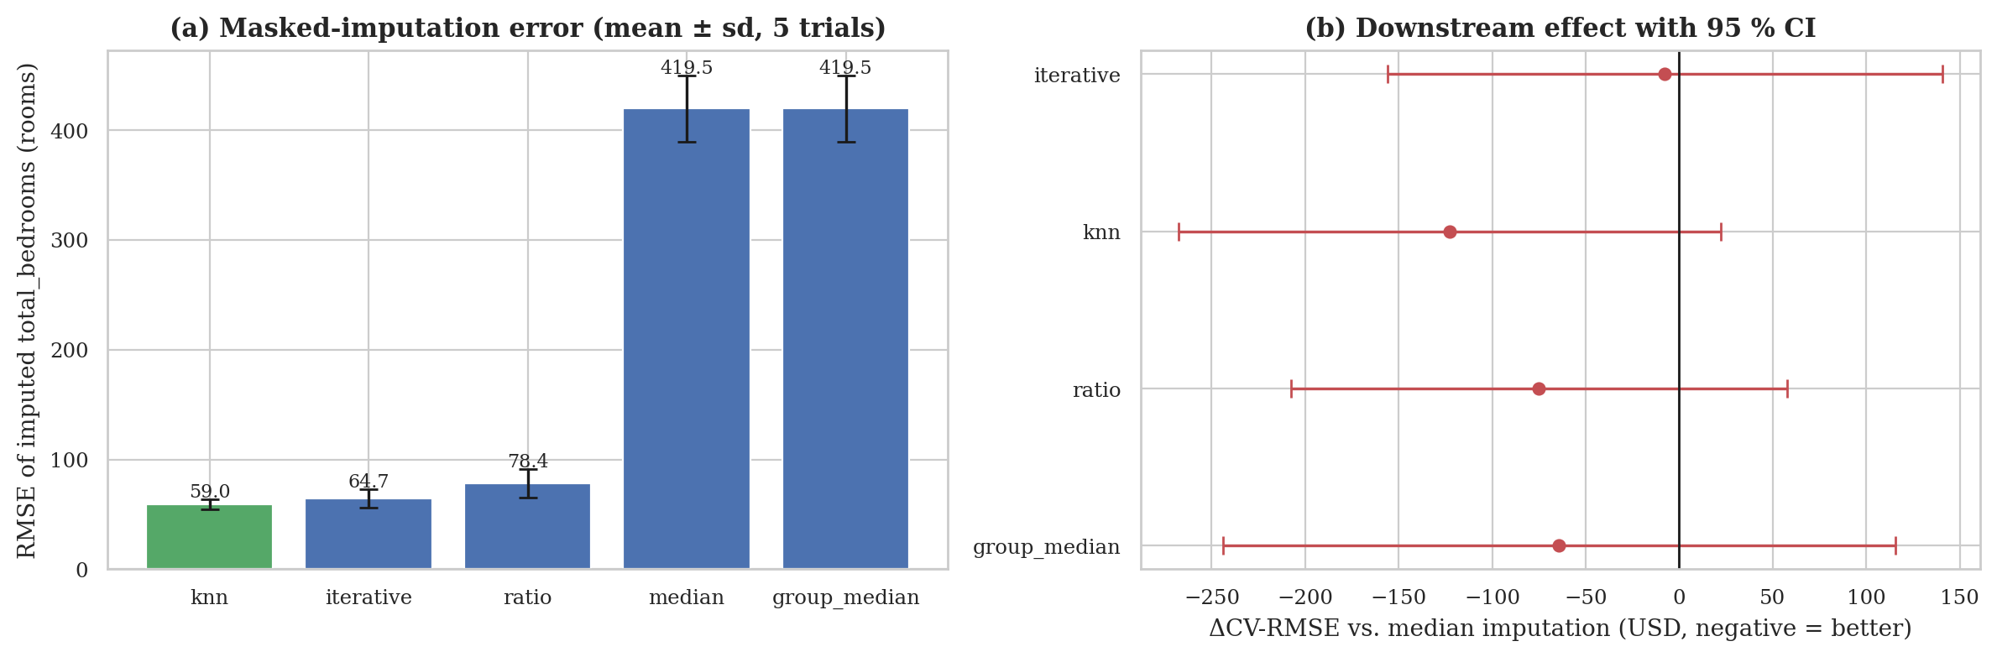
Figure 5: Imputation strategies: (a) error on masked values, (b) downstream effect with 95 % confidence intervals
Interpretation. The missingness shows no detectable relation with any observed variable, which is consistent with data missing completely at random; this cannot be proven from the data, but it supports treating the 207 rows by imputation rather than deletion. Strategies that use information from the other variables recover the hidden counts far better than a single constant: the k-NN imputer reaches an RMSE of 59.0 rooms against 419.5 for median imputation (86 % lower). This is expected because the number of bedrooms is almost proportional to the number of households and rooms of the district, whereas the group median adds nothing (ocean proximity barely informs bedroom counts). In contrast, Figure 5(b) shows that the downstream effect on house-value prediction is negligible: all differences are below 123 dollars (≈ 0.25 % of the RMSE) and none is significant. The reason is simply that only 1.0 % of the rows are affected.
Decision. The k-NN (k = 5) imputer was selected for all subsequent models because it is the most accurate at no cost in prediction quality. One practical observation from development: the unconstrained iterative imputer produced an impossible negative bedroom count for one district, so all model-based imputed values are clipped to the smallest observed count. Censoring: 965 districts (4.7 %) have the target capped at $500,001, 1273 (6.2 %) have housing age capped at 52 years and 49 have income capped at 15.0001. These values are retained, and their consequences are examined in Analyses 2 and 6.

4.2 Analysis 2: Income as a Determinant of House Value (Objective 2)

4.2.1 Introduction
Median household income is the single most important economic variable in housing-affordability analysis. This analysis quantifies the strength, the steepness and the functional form of the relationship between a district’s median income and its median house value, and tests whether classical regression assumptions (linearity and constant variance) hold. Knowing how much house value changes per unit of income, and whether the effect saturates at high incomes, informs both feature design and policy interpretation.

4.2.2 General Description
On the training set the analysis computes three correlation coefficients with bootstrap confidence intervals, fits three regression specifications (linear, quadratic, log–log), tests for non-linearity with an F-test, tests for heteroscedasticity with the Breusch–Pagan test, summarises value by income decile, and repeats the linear fit after excluding the censored rows to assess the sensitivity of the results to the $500,001 cap.

4.2.3 Specific Requirements, Functions and Formulas
Table 15: Functions used in Analysis 2
Function | Library | Purpose
pearsonr, spearmanr, kendalltau | scipy.stats | Linear and rank correlation
OLS (smf.ols) | statsmodels | Linear, quadratic and log–log regression with confidence intervals
anova_lm | statsmodels | F-test comparing nested linear and quadratic models
het_breuschpagan | statsmodels | Test for non-constant residual variance
lowess | statsmodels | Locally weighted smoother (Cleveland, 1979) as a model-free trend
bootstrap (1,000 resamples) | NumPy | Percentile confidence intervals for correlations (Efron, 1979)

r = Σ(x_{i} − x̄)(y_{i} − ȳ) / √[ Σ(x_{i} − x̄)² Σ(y_{i} − ȳ)² ] ρ_{s} = r( rank(x), rank(y) ) (9)
Linear: y = β₀ + β₁x + ε Quadratic: y = β₀ + β₁x + β₂x² + ε Log–log: ln y = α + η ln x + ε (10)
In the log–log model the slope η is the elasticity: a 1 % change in income is associated with an η % change in house value. The F-test for the added quadratic term is
F = [ (RSS_{lin} − RSS_{quad}) / 1 ] / [ RSS_{quad} / (n − 3) ] (11)
The Breusch–Pagan statistic is LM = nR²_{aux}, where R²_{aux} comes from regressing the squared residuals on the regressors; under constant variance LM follows a χ² distribution (Breusch and Pagan, 1979).

4.2.4 Analysis Results
Table 16: Correlation between median income and median house value (training set)
Measure | Estimate | 95 % bootstrap CI
Pearson r | 0.687 | [0.676, 0.696]
Spearman ρ | 0.676 | [0.666, 0.685]
Kendall τ | 0.494 | –

Table 17: Regression results for house value on income
Model | Key parameter | R² | Note
Linear OLS | slope = $41,736 per $10,000 (95 % CI $41,063–$42,409); intercept $45,241 | 0.4722 | Breusch–Pagan LM = 117.2, p < 0.001
Quadratic OLS | quadratic term = -1,059 | 0.4768 | F = 146.2, p < 0.001
Log–log OLS | elasticity η = 0.815 (95 % CI 0.802–0.829) | 0.4545 | Breusch–Pagan LM = 949.9, p < 0.001
Linear, uncapped rows only | slope = $39,837 (n = 15,726) | 0.4101 | Sensitivity to censoring

Table 18: House value by income decile (training set)
Decile | Income range (×$10k) | n | Median value | Mean value | % capped
1 | 0.50–1.90 | 1,652 | $91,200 | $110,008 | 0.7
2 | 1.90–2.36 | 1,652 | $112,500 | $127,273 | 0.2
3 | 2.36–2.74 | 1,650 | $137,300 | $147,413 | 0.6
4 | 2.74–3.14 | 1,651 | $152,500 | $167,158 | 0.7
5 | 3.14–3.54 | 1,651 | $165,800 | $184,972 | 1.2
6 | 3.54–3.97 | 1,651 | $181,600 | $202,691 | 1.7
7 | 3.97–4.44 | 1,656 | $198,300 | $221,193 | 3.0
8 | 4.44–5.12 | 1,646 | $221,250 | $238,770 | 3.0
9 | 5.12–6.16 | 1,651 | $260,500 | $279,955 | 5.0
10 | 6.16–15.00 | 1,652 | $390,300 | $390,634 | 31.5

4.2.5 Visualization and Interpretation
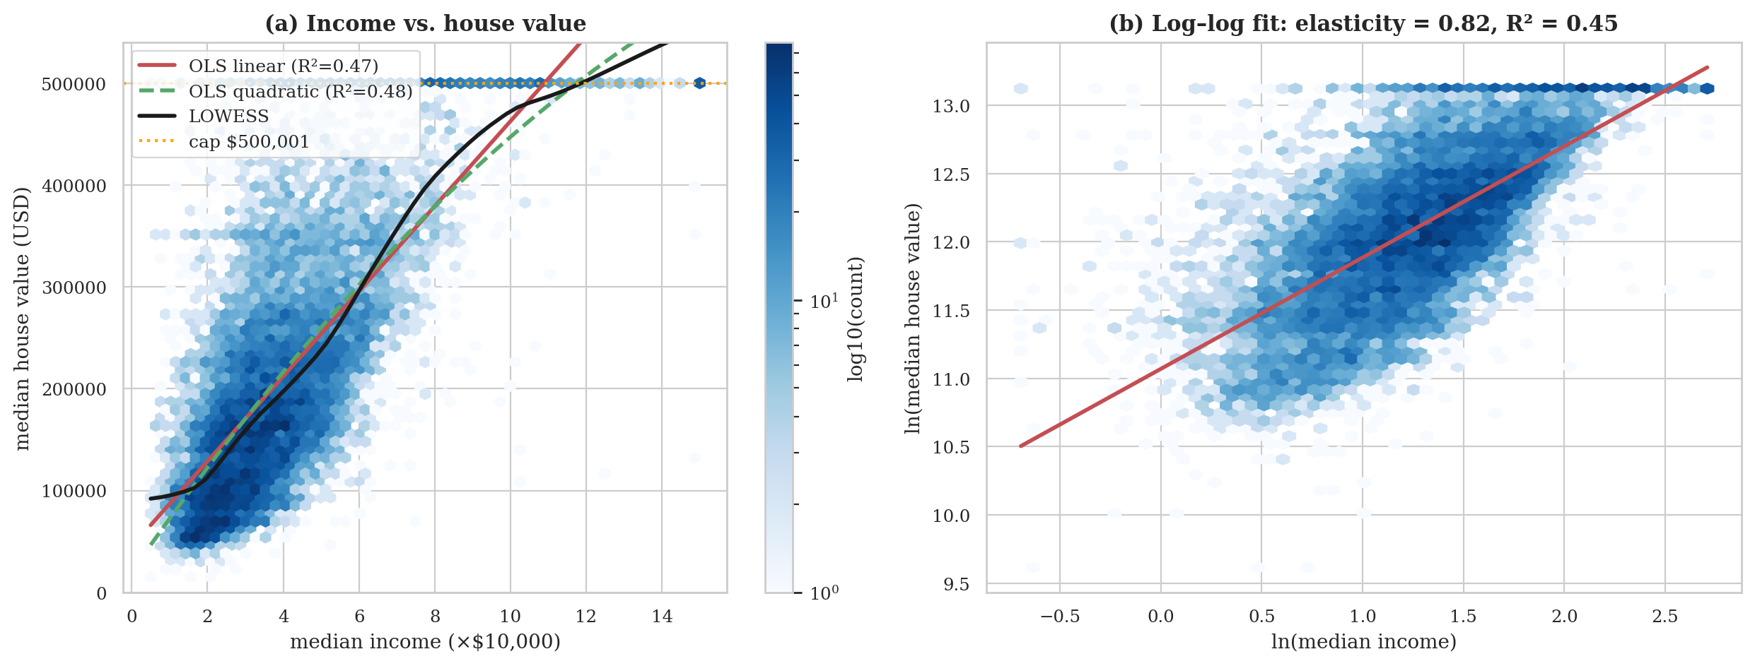
Figure 6: Relationship between median income and house value: (a) linear, quadratic and LOWESS fits, (b) log–log fit
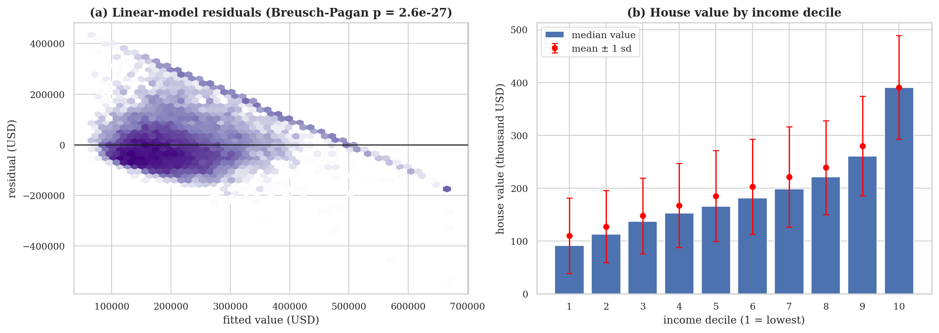
Figure 7: (a) Residuals of the linear model against fitted values; (b) house value by income decile
Interpretation. Income is strongly and positively related to value (Pearson r = 0.69, Spearman ρ = 0.68); the narrow bootstrap intervals show the estimate is precise. Each additional $10,000 of district median income is associated with about $41,736 higher median house value, yet income alone explains only 47.2 % of the variance, so more than half of the variation must come from other factors — notably location (Analysis 3). The log–log elasticity of 0.82 (below one) means that values rise less than proportionally with income. The median value of the top income decile is 4.3 times that of the bottom decile (Table 18).
The quadratic term is negative (-1,059), indicating diminishing returns at high incomes, and it is statistically significant (F = 146), but it raises R² by only 0.46 percentage points, so the departure from linearity is practically small in the central range of incomes. The LOWESS curve in Figure 6(a) flattens at the top where the $500,001 cap creates a horizontal band. Residual spread grows with the fitted value (Figure 7(a)); the Breusch–Pagan test rejects constant variance for both the linear and the log–log model (the log transform does not remove it, a possible contributor being the censored band), so classical standard errors should not be trusted and the bootstrap intervals are preferred. Finally, excluding capped rows lowers the slope from $41,736 to $39,837 and R² from 0.47 to 0.41; both the all-rows and the uncapped-rows estimates are biased in known ways (censoring compresses the top, truncation removes it), so the two should be read as a plausible range rather than a single truth.

4.3 Analysis 3: Geography: Ocean Proximity, Spatial Autocorrelation and Spatial Features (Objective 3)

4.3.1 Introduction
Location is the central principle of real-estate valuation. This analysis tests three questions: (a) do house values differ significantly between the ocean-proximity classes and how large is the difference; (b) are values spatially autocorrelated, i.e. are neighbouring districts more alike than distant ones; and (c) do features describing a district’s distance to the state’s major urban centres improve out-of-sample prediction beyond raw longitude and latitude?

4.3.2 General Description
For (a), the non-parametric Kruskal–Wallis test is used because the target is skewed and censored, followed by all pairwise Mann–Whitney tests with Holm’s correction for multiple comparisons. For (b), global Moran’s I is computed with weights defined by each district’s eight nearest neighbours. For (c), a paired ablation compares models with and without five hub-distance features (San Francisco, Los Angeles, San Diego, San Jose, Sacramento) and the distance to the nearest hub, using identical cross-validation folds, a regularised linear model (Ridge) and a gradient-boosting model. The ablation covers all four combinations of ratio and spatial feature sets (Table below) and is shared with Analysis 4.

4.3.3 Specific Requirements, Functions and Formulas
Table 19: Functions used in Analysis 3
Function | Library | Purpose
kruskal, mannwhitneyu | scipy.stats | Omnibus and pairwise group comparisons
multipletests (Holm) | statsmodels | Family-wise error control for 10 pairwise tests
morans_i (custom) | src/evaluate.py | Global Moran’s I, k-NN weights, haversine metric, permutation p-value
FeatureEngineer(spatial=True) | src/features.py | Haversine distances to five hubs and to the nearest hub
cross_validate, RepeatedKFold | scikit-learn | Paired CV-RMSE and R² for each feature set

H = [12 / (N(N+1))] Σ_{g} n_{g} R̄_{g}² − 3(N+1) ε² = ( H − k + 1 ) / ( N − k ) (12)
where R̄_{g} is the mean rank of group g, N the total sample size and k the number of groups; ε² is an effect-size measure between 0 and 1 (Tomczak and Tomczak, 2014). Holm’s method orders the m raw p-values and rejects the i-th smallest if it is below α/(m − i + 1). Moran’s I (Moran, 1950) with row-standardised weights w_{ij} is
I = [ n / S₀ ] · Σ_{i}Σ_{j} w_{ij} z_{i} z_{j} / Σ_{i} z_{i}², z_{i} = y_{i} − ȳ, E[I] = −1/(n−1) (13)
Values near +1 indicate strong positive spatial clustering. Significance is assessed by randomly permuting the values over locations (499 permutations).

4.3.4 Analysis Results
Table 20: House value by ocean-proximity class (training set)
Ocean proximity | n | Median value | Interquartile range | % capped
INLAND | 5,262 | $109,200 | $78,300 – $150,000 | 0.5
<1H OCEAN | 7,277 | $215,000 | $164,300 – $289,900 | 6.0
NEAR OCEAN | 2,124 | $228,200 | $150,000 – $319,900 | 8.0
NEAR BAY | 1,847 | $233,100 | $162,500 – $345,250 | 8.7
ISLAND | 2 | $351,100 | $319,300 – $382,900 | 0.0

The Kruskal–Wallis test rejects equal distributions (H = 5,283, p < 0.001) with an effect size of ε² = 0.32, which is a large effect. Table 21 gives the pairwise comparisons.
Table 21: Pairwise comparisons of ocean-proximity classes (Mann–Whitney U, Holm correction)
Pair (A vs B) | Median difference (USD) | Rank-biserial r | Holm-adjusted p | Significant (5 %)
<1H OCEAN vs INLAND | +105,800 | +0.71 | < 0.001 | Yes
<1H OCEAN vs ISLAND | -136,100 | -0.65 | 0.45 | No
<1H OCEAN vs NEAR BAY | -18,100 | -0.07 | < 0.001 | Yes
<1H OCEAN vs NEAR OCEAN | -13,200 | -0.01 | 0.51 | No
INLAND vs ISLAND | -241,900 | -0.95 | 0.098 | No
INLAND vs NEAR BAY | -123,900 | -0.70 | < 0.001 | Yes
INLAND vs NEAR OCEAN | -119,000 | -0.66 | < 0.001 | Yes
ISLAND vs NEAR BAY | +118,000 | +0.51 | 0.51 | No
ISLAND vs NEAR OCEAN | +122,900 | +0.56 | 0.51 | No
NEAR BAY vs NEAR OCEAN | +4,900 | +0.05 | 0.028 | Yes

Spatial autocorrelation. Moran’s I of the target is 0.793 (expected under spatial randomness -0.00006; permutation z = 212, p = 0.002, the smallest p attainable with 499 permutations).
Feature-set ablation. Table 22 lists the cross-validated results for the four feature sets (F0: raw variables; F1: plus ratio features; F2: plus spatial features; F3: both).
Table 22: Ablation of feature sets (5×2 repeated CV on the training set)
Feature set | Ridge RMSE | Ridge R² | Gradient-boosting RMSE | Gradient-boosting R²
F0 raw | $66,681 | 0.668 | $48,374 | 0.825
F1 +ratios | $65,650 | 0.678 | $47,090 | 0.834
F2 +spatial | $64,712 | 0.687 | $47,573 | 0.831
F3 +ratios+spatial | $63,371 | 0.700 | $46,389 | 0.839

Table 23: Effect of adding spatial distance features
Model | Comparison | ΔRMSE (USD) | 95 % CI | Relative change | NB p
Ridge | F0 raw → F2 +spatial | -1,969 | [-2,225, -1,714] | -3.0 % | < 0.001
Gradient boosting | F0 raw → F2 +spatial | -801 | [-1,035, -567] | -1.7 % | 0.003
Ridge | F1 +ratios → F3 +ratios+spatial | -2,278 | [-2,458, -2,098] | -3.5 % | < 0.001
Gradient boosting | F1 +ratios → F3 +ratios+spatial | -702 | [-932, -471] | -1.5 % | 0.005

4.3.5 Visualization and Interpretation
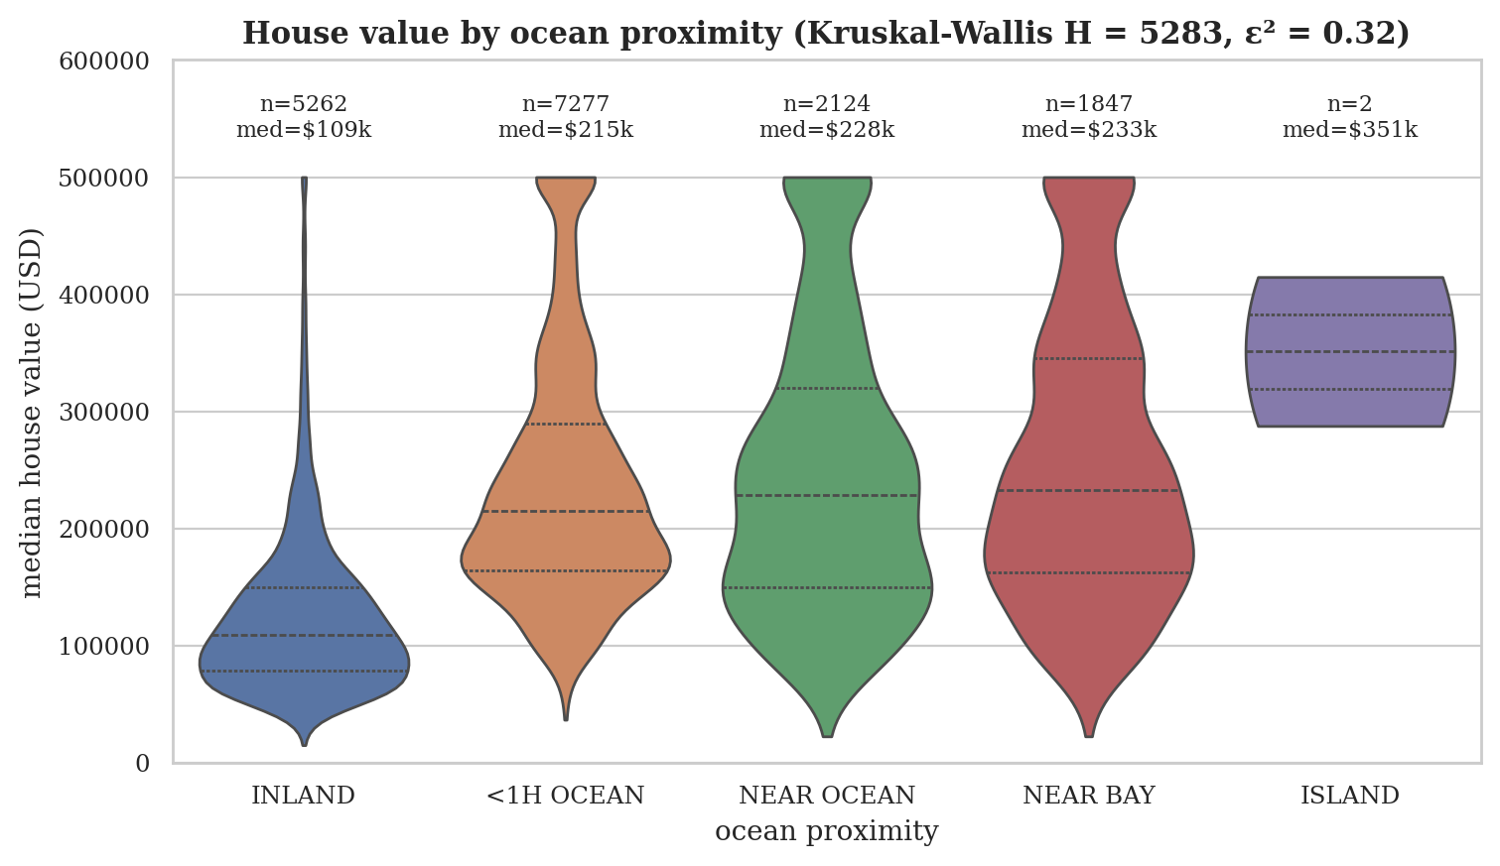
Figure 8: House value by ocean-proximity class (violin plots with quartiles)
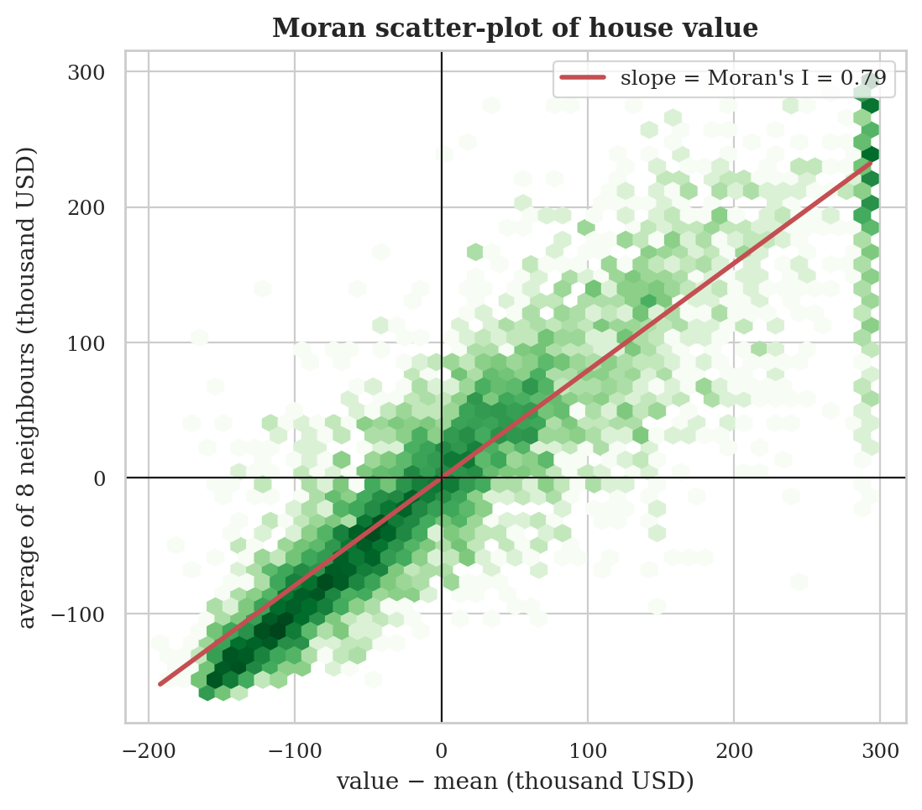
Figure 9: Moran scatter-plot: house value of a district against the average value of its eight neighbours
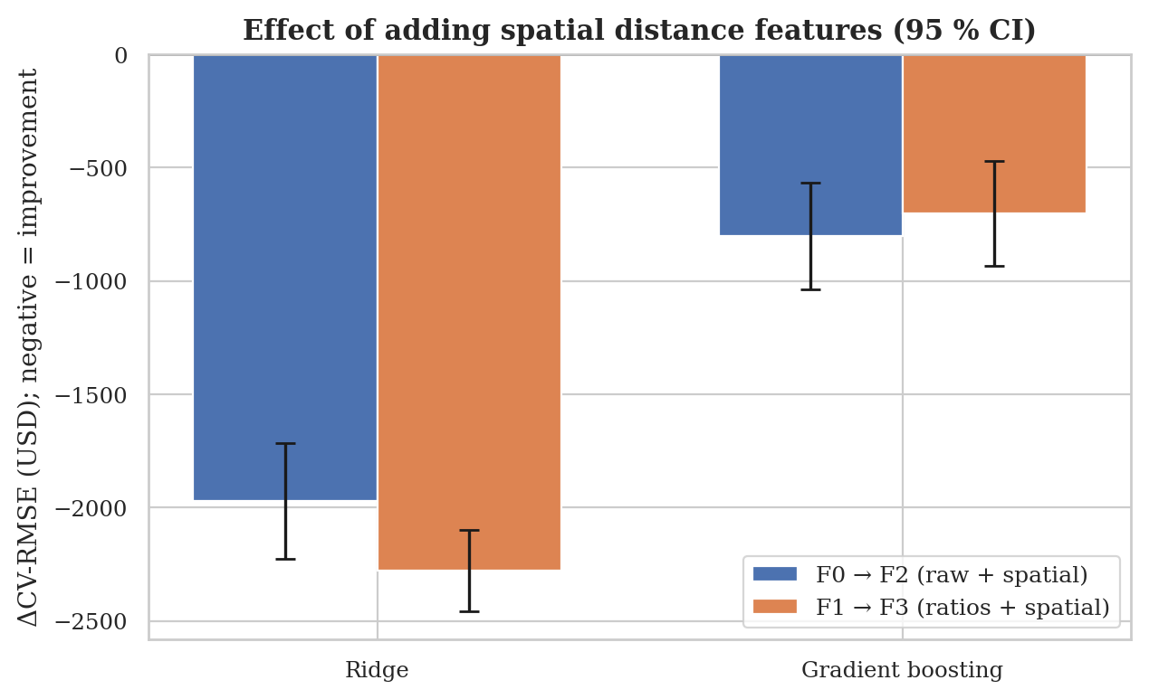
Figure 10: Change in cross-validated RMSE when spatial distance features are added (95 % CI)
Interpretation. Geography matters a great deal. Among classes with a meaningful sample, median value ranges from $109,200 in the INLAND class to $233,100 in the NEAR BAY class (the ISLAND class, with only 2 training districts, is excluded from this comparison), and ocean proximity alone explains a large share of the rank variation (ε² = 0.32). 5 of the 10 pairwise differences are significant after Holm correction; the non-significant ones involve the ISLAND class, which has only 2 training districts, so the test lacks power rather than demonstrating equality, and the <1H OCEAN versus NEAR OCEAN pair, whose medians are close. The very high Moran’s I of 0.79 shows that a district’s value is largely predictable from its neighbours’ values — prices form smooth spatial surfaces rather than random noise. This has two consequences: spatial information should help prediction, and random cross-validation is optimistic compared with predicting in a completely new region, because neighbouring districts appear in both training and test folds. This limitation is revisited in Section 5.
Adding hub-distance features significantly lowers the RMSE for both models in every comparison (Table 23). For Ridge the change is -3.0 % (F0 raw → F2 +spatial). For gradient boosting the change is -1.7 % (F0 raw → F2 +spatial). The gain is largest for the linear model, which can only represent location linearly through raw coordinates and therefore benefits most from explicit distance features; the tree ensemble can already carve up the coordinate space and gains less, but its improvement is still statistically significant.

4.4 Analysis 4: Engineered Ratio Features (Objective 4)

4.4.1 Introduction
The census file reports totals per block group — total rooms, total bedrooms, population and households. Such totals mostly measure the size of the district and are only indirectly related to how valuable its houses are. Features that divide one total by another describe the character of the housing: how spacious the dwellings are, what share of rooms are bedrooms, and how crowded the households are. This analysis tests whether three such ratio features carry information about value beyond the raw counts.

4.4.2 General Description
First, the rank correlation of each raw count and each engineered ratio with the target is compared. Second, the out-of-sample effect of adding the ratio features is evaluated with the paired ablation introduced in Analysis 3, using both a linear and a gradient-boosting model and two baselines (with and without the spatial features) so that the conclusion does not depend on one specific configuration.

4.4.3 Specific Requirements, Functions and Formulas
Table 24: Functions used in Analysis 4
Function | Library | Purpose
FeatureEngineer(ratios=True) | src/features.py | Creates the three ratio features inside the pipeline
spearmanr | scipy.stats | Rank correlation of each feature with the target
cross_validate (5×2 repeated CV) | scikit-learn | Paired CV-RMSE and R² for each feature set
nadeau_bengio_ttest | src/evaluate.py | Corrected resampled t-test of the RMSE differences

rooms_per_household = total_rooms / households (14)
bedrooms_per_room = total_bedrooms / total_rooms (15)
population_per_household = population / households (16)
ΔRMSE = RMSE_{with features} − RMSE_{without features} (negative = improvement) (17)

4.4.4 Analysis Results
Table 25: Rank correlation of raw counts and engineered ratios with house value (training set)
Feature | Type | Spearman ρ with target | Skewness
total_rooms | raw count | +0.204 | 4.0
total_bedrooms | raw count | +0.085 | 3.3
population | raw count | +0.001 | 4.7
households | raw count | +0.111 | 3.2
rooms_per_household | engineered | +0.263 | 21.4
bedrooms_per_room | engineered | -0.333 | 2.0
population_per_household | engineered | -0.257 | 87.9

Table 26: Effect of adding ratio features (paired, corrected resampled t-test)
Model | Comparison | ΔRMSE (USD) | 95 % CI | Rel. change | ΔR² | NB p
Ridge | F0 raw → F1 +ratios | -1,032 | [-1,351, -713] | -1.5 % | +0.010 | 0.004
Gradient boosting | F0 raw → F1 +ratios | -1,284 | [-1,722, -845] | -2.7 % | +0.009 | 0.006
Ridge | F2 +spatial → F3 +ratios+spatial | -1,341 | [-1,713, -968] | -2.1 % | +0.013 | 0.002
Gradient boosting | F2 +spatial → F3 +ratios+spatial | -1,184 | [-1,592, -776] | -2.5 % | +0.008 | 0.007

4.4.5 Visualization and Interpretation
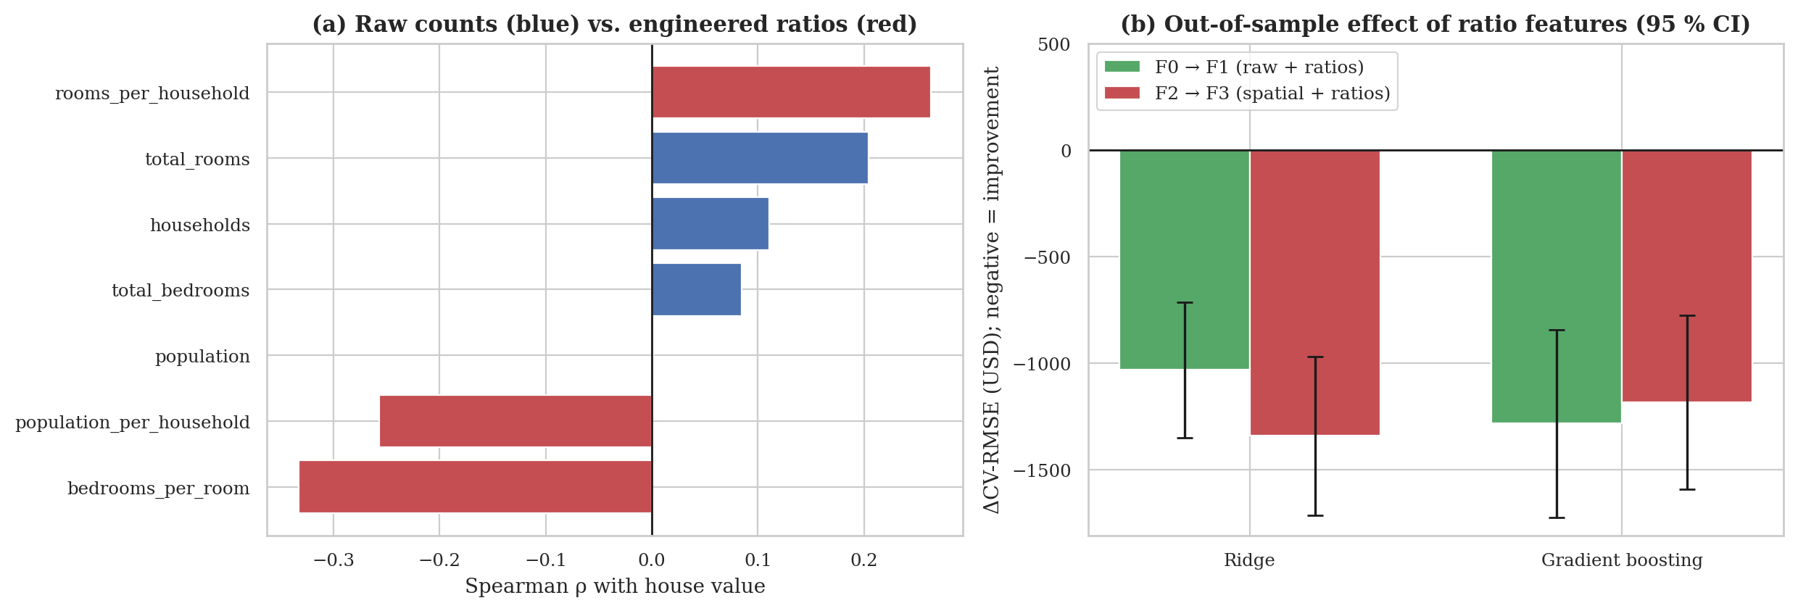
Figure 11: Ratio features: (a) correlation with the target, raw vs. engineered; (b) change in CV-RMSE when ratios are added
Interpretation. The strongest raw count, total_rooms, has |ρ| = 0.20, whereas the strongest engineered ratio, bedrooms_per_room, has |ρ| = 0.33; population alone is essentially uncorrelated with value (ρ = 0.001), yet population per household is clearly negatively related (crowding). The signs are economically sensible: roomier dwellings (more rooms per household) are associated with higher values, whereas a higher share of bedrooms among rooms and more people per household — typical of smaller or more crowded housing — are associated with lower values. The ratios are also less redundant than the raw counts, which are highly inter-correlated (mean |ρ| = 0.90 between pairs), whereas the ratios describe different aspects of the housing stock. They are, however, more skewed (Table 25: up to 88 for population_per_household, caused by a few districts with very few households), which is why they are log-transformed in the pipeline and why tree-based models, which are insensitive to such tails, are a natural fit.
In the ablation, adding the ratio features reduces the RMSE in 4 of 4 comparisons at the 5 % level (Table 26). For gradient boosting the improvement is 2.7 % without and 2.5 % with the spatial features; for Ridge it is 1.5 % and 2.1 %. The gains are modest in absolute size (roughly 1,032 to 1,341 dollars of RMSE) but consistent across models and baselines, which supports the conclusion that engineered ratios contain information the raw totals do not. Because the feature set with both ratio and spatial features gave the lowest gradient-boosting error (RMSE $46,389), it was selected as the feature set for the model comparison in Analysis 5.

4.5 Analysis 5: Model Comparison and Selection (Objective 5)

4.5.1 Introduction
Choosing the model that will be deployed is the central decision of a predictive-analysis project. A model that is too simple under-fits and misses real structure; one that is too flexible over-fits and fails on new data. This analysis compares one naïve baseline, a linear model and four non-linear model families under an identical, leakage-free protocol, selects the best on cross-validated evidence alone, and then tests whether the winner is significantly better than the runner-up rather than merely first in a ranking.

4.5.2 General Description
All models share the same preprocessing pipeline (imputer: k-NN; feature set: F3 +ratios+spatial, i.e. ratio and spatial features included, as selected in Analyses 1–4) and receive exactly the same training data. The protocol has four steps. (1) Hyper-parameters are tuned on the training set only, by grid search for the small search spaces (Ridge, k-NN) and by randomised search for the larger ones, with 3-fold cross-validation and RMSE as the criterion. (2) Each tuned model is re-evaluated with 5-fold cross-validation on the training set; the model with the lowest mean CV-RMSE is selected. (3) Only then are all models refitted on the full training set and evaluated once on the held-out test set. (4) The winner is compared with every other model using the corrected resampled t-test on the CV fold scores and a paired bootstrap of the RMSE difference on the test set. Table 27 describes the seven models.
Table 27: Models compared
Model | Family | Idea | Tuned hyper-parameters
Dummy (mean) | Baseline | Always predicts the training-set mean; any useful model must beat it | –
Ridge | Linear | Least squares with L2 penalty on coefficients; interpretable, fast | alpha
Ridge (log-target) | Linear | Ridge fitted to ln(price) and back-transformed with exp; tests whether the log transform helps dollar-scale error | alpha
k-NN | Instance-based | Averages the values of the nearest districts in feature space; exploits spatial neighbourhoods | n_neighbors, weights
Random Forest | Bagged trees | Average of many de-correlated deep trees grown on bootstrap samples (Breiman, 2001) | max_depth, min_samples_leaf, max_features
HistGB | Boosted trees | Gradient boosting on histogram-binned features (scikit-learn); sequentially fits trees to residuals (Friedman, 2001) | learning_rate, max_iter, max_leaf_nodes, min_samples_leaf, l2_regularization
XGBoost | Boosted trees | Regularised gradient boosting with second-order optimisation (Chen and Guestrin, 2016) | n_estimators, max_depth, learning_rate, subsample, colsample_bytree, min_child_weight

4.5.3 Specific Requirements, Functions and Formulas
Table 28: Functions used in Analysis 5
Function / class | Library | Purpose
Pipeline, ColumnTransformer | scikit-learn | Leakage-free preprocessing + model in one object
GridSearchCV, RandomizedSearchCV | scikit-learn | Hyper-parameter tuning with 3-fold CV
cross_validate (KFold, 5 folds) | scikit-learn | RMSE, MAE and R² per fold
Ridge, KNeighborsRegressor, RandomForestRegressor, HistGradientBoostingRegressor | scikit-learn | Model implementations
XGBRegressor | xgboost | Regularised gradient boosting
learning_curve | scikit-learn | Training/validation error against training-set size
paired_bootstrap_rmse_diff, nadeau_bengio_ttest | src/evaluate.py | Significance of the difference between two models

Evaluation metrics for n test districts with true values y_{i} and predictions ŷ_{i}:
RMSE = √( (1/n) Σ ( y_{i} − ŷ_{i} )² ) MAE = (1/n) Σ | y_{i} − ŷ_{i} | (18)
R² = 1 − Σ ( y_{i} − ŷ_{i} )² / Σ ( y_{i} − mean(y) )² (19)
MedAPE = median( | y_{i} − ŷ_{i} | / y_{i} ) × 100 (20)
The model families are defined by the equations below, where T_{b} is a tree grown on a bootstrap sample with random feature subsets, and h_{m} is a small tree fitted to the negative gradient of the loss with learning rate ν:
Ridge: min_{w} Σ ( y_{i} − w·x_{i} )² + α ‖w‖² (21)
k-NN: ŷ(x) = Σ_{i ∈ N_{k}(x)} w_{i} y_{i}, w_{i} ∝ 1/d(x, x_{i}) (22)
Random forest: ŷ(x) = (1/B) Σ_{b=1}^{B} T_{b}(x) (23)
Gradient boosting: F_{m}(x) = F_{m−1}(x) + ν h_{m}(x) (24)
XGBoost objective: Σ_{i} l( y_{i}, ŷ_{i} ) + Σ_{k} Ω( f_{k} ), Ω(f) = γT + ½ λ Σ_{j} w_{j}² (25)
The paired bootstrap resamples the test districts with replacement 2,000 times and recomputes RMSE(A) − RMSE(B) on each resample; the 2.5th and 97.5th percentiles give a 95 % confidence interval, which excludes zero when the difference is significant.

4.5.4 Analysis Results
Table 29: Hyper-parameter tuning (3-fold CV on the training set)
Model | Search (candidates) | Selected hyper-parameters | Tuning RMSE | Time (s)
Dummy (mean) | none | – | – | 0
Ridge | grid (5 of 5) | alpha = 1 | $63,400 | 1
Ridge (log-target) | grid (5 of 5) | alpha = 1 | $74,529 | 1
k-NN | grid (10 of 10) | n_neighbors = 10, weights = distance | $56,623 | 19
Random Forest | randomized (6 of 36) | min_samples_leaf = 1, max_features = 0.5, max_depth = 30 | $46,222 | 269
HistGB | randomized (12 of 162) | min_samples_leaf = 20, max_leaf_nodes = 63, max_iter = 300, learning_rate = 0.1, l2_regularization = 1 | $45,568 | 30
XGBoost | randomized (10 of 144) | subsample = 0.9, n_estimators = 800, min_child_weight = 1, max_depth = 8, learning_rate = 0.03, colsample_bytree = 0.7 | $43,534 | 87

Table 30: Five-fold cross-validation of the tuned models (training set; basis of selection)
Model | CV-RMSE (mean ± sd) | CV-MAE | CV-R² | Fit time per fold (s)
XGBoost | $42,926 ± 1,064 | $27,159 | 0.862 | 5.8
HistGB | $44,996 ± 1,097 | $29,094 | 0.849 | 0.8
Random Forest | $45,488 ± 996 | $29,085 | 0.845 | 13.6
k-NN | $56,184 ± 1,743 | $37,435 | 0.764 | 0.1
Ridge | $63,389 ± 1,063 | $45,556 | 0.700 | 0.1
Ridge (log-target) | $74,289 ± 3,659 | $44,727 | 0.587 | 0.1
Dummy (mean) | $115,699 ± 1,194 | $91,302 | -0.000 | 0.1

Table 31: Held-out test-set performance (evaluated once, after selection)
Model | Test RMSE | Test MAE | Test R² | MedAPE | Within ±20 % | Fit (s)
XGBoost | $40,980 | $26,522 | 0.871 | 9.7 % | 78.4 % | 6.8
HistGB | $43,024 | $28,095 | 0.858 | 10.3 % | 76.2 % | 1.3
Random Forest | $43,613 | $28,205 | 0.854 | 10.3 % | 75.9 % | 18.5
k-NN | $53,768 | $36,199 | 0.778 | 13.8 % | 64.9 % | 0.1
Ridge | $62,098 | $45,173 | 0.704 | 19.2 % | 51.8 % | 0.1
Ridge (log-target) | $71,014 | $43,775 | 0.613 | 16.4 % | 58.9 % | 0.1
Dummy (mean) | $114,165 | $90,807 | -0.000 | 38.7 % | 26.4 % | 0.1

Table 32: Is XGBoost significantly better? (negative = XGBoost better)
Compared with | Mean ΔCV-RMSE | Corrected-t p | ΔRMSE (test) | 95 % bootstrap CI
HistGB | -2,070 | 0.014 | -2,044 | [-2,687, -1,411]
Random Forest | -2,561 | 0.003 | -2,633 | [-3,355, -1,944]
k-NN | -13,257 | < 0.001 | -12,788 | [-14,221, -11,367]
Ridge | -20,462 | < 0.001 | -21,117 | [-22,721, -19,501]
Ridge (log-target) | -31,363 | < 0.001 | -30,033 | [-35,645, -25,184]
Dummy (mean) | -72,772 | < 0.001 | -73,185 | [-76,067, -70,372]

4.5.5 Visualization and Interpretation
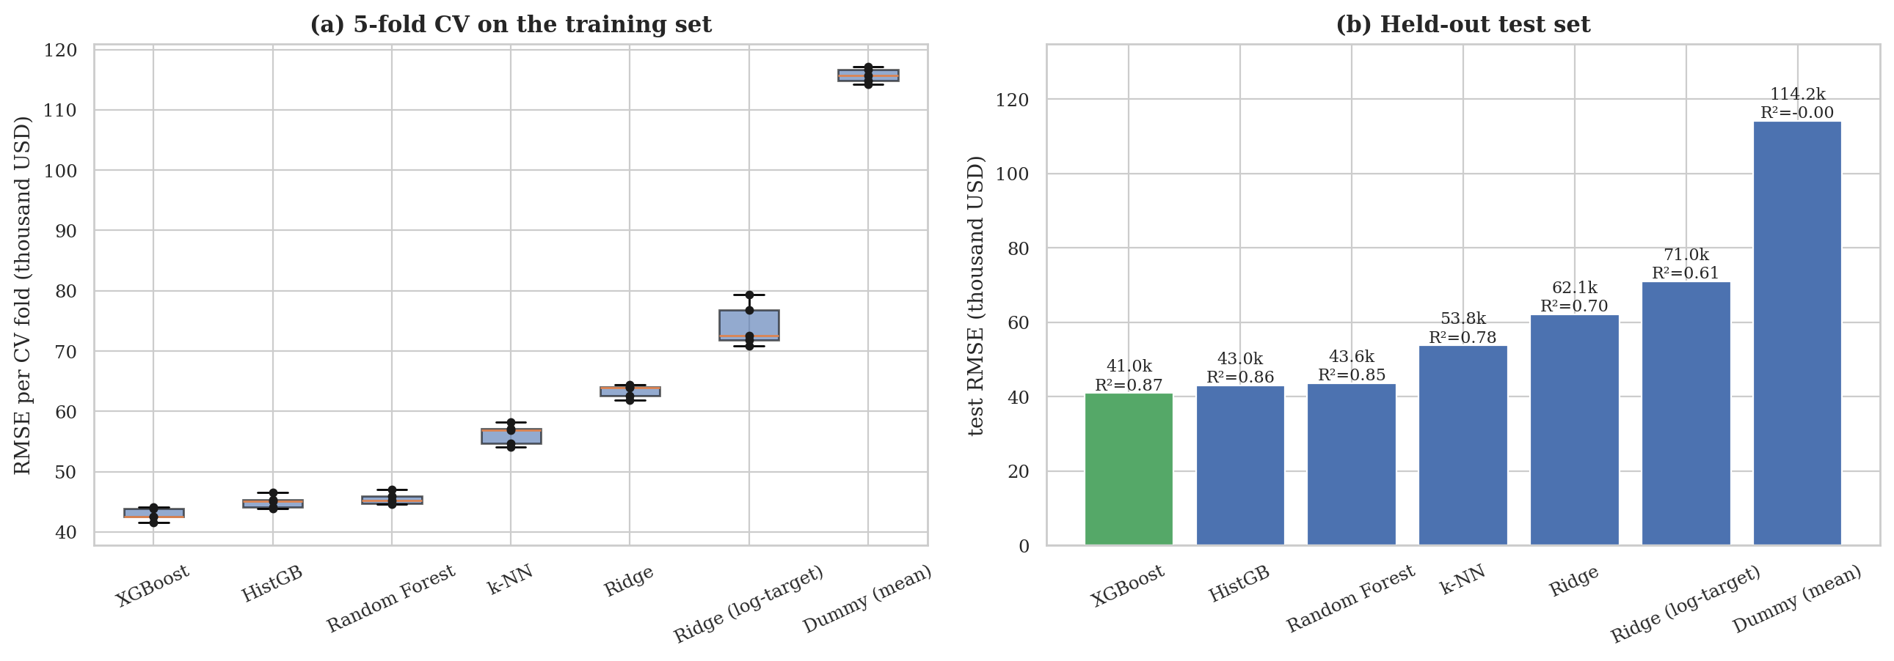
Figure 12: Model comparison: (a) RMSE of each CV fold, (b) held-out test RMSE with R²
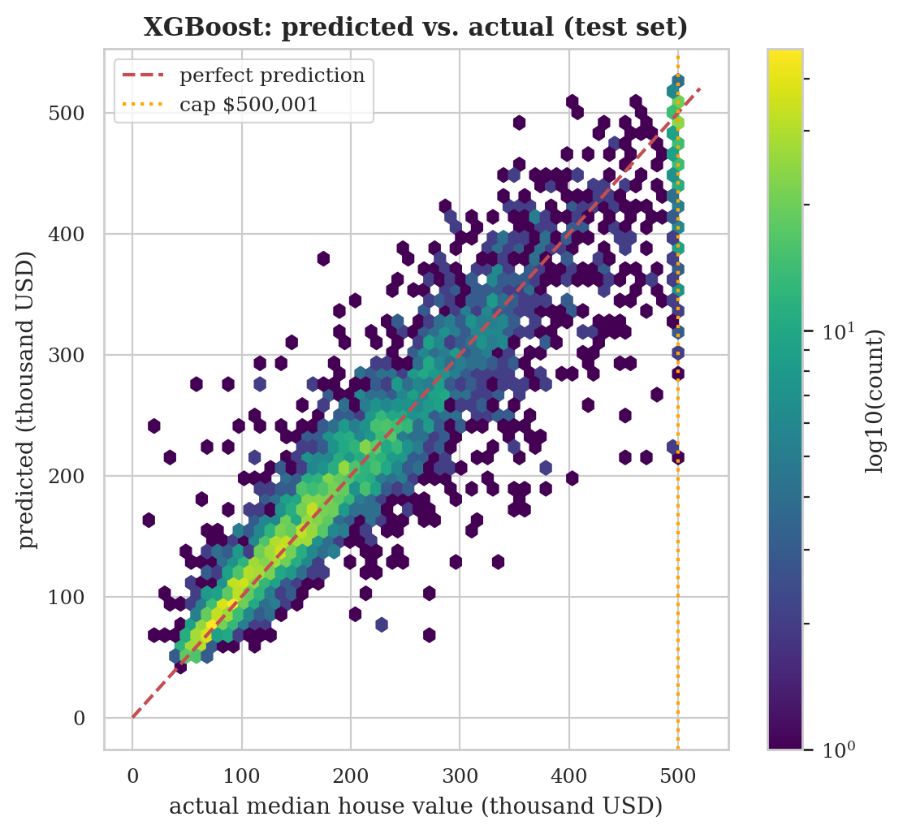
Figure 13: Predicted against actual median house value for XGBoost on the test set
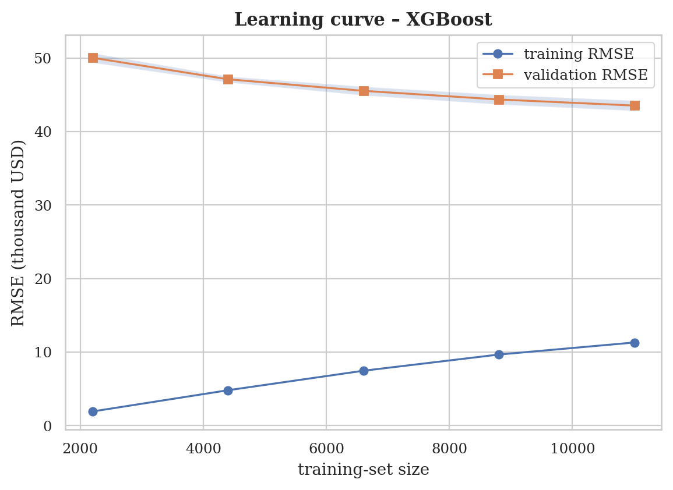
Figure 14: Learning curve of XGBoost
Interpretation. XGBoost is the best model by cross-validation (CV-RMSE $42,926) and by the independent test set: RMSE $40,980, MAE $26,522 and R² = 0.871. It reduces the error of the mean baseline by 64 %, and about 78 % of its predictions are within ±20 % of the true value (median absolute percentage error 9.7 %). The ranking by CV and by test set is identical (Figure 12), which gives confidence that the selection was not an artefact of one split. The tree ensembles (XGBoost, HistGB, Random Forest) form a clear leading group; k-NN is next, then the linear models, and the baseline is far behind. The large step between the linear models and the tree ensembles shows that the relationship between the district characteristics and value is substantially non-linear and interaction-driven (for example the effect of income depends on location).
Is the winner really better? Against the runner-up, HistGB, XGBoost has a lower test RMSE by 2,044 dollars (95 % bootstrap CI -2,687 to -1,411, which excludes zero) and the corrected resampled t-test on the CV folds gives p = 0.014. The advantage is therefore statistically reliable but small in practical terms (about 5 % of the RMSE); for an application in which training time or simplicity mattered, HistGB, which is several times faster to train (1.3 s against 6.8 s), would be a defensible alternative. Differences to Random Forest, k-NN and the linear models are larger and also significant.
Design lesson on the target transformation. Fitting the linear model to the logarithm of price and back-transforming (Ridge, log-target) gave a higher RMSE ($71,014) than fitting it to price directly ($62,098), although its median percentage error is lower (16.4 % against 19.2 %) and its MAE is similar ($43,775 against $45,173). The log model treats percentage errors evenly, so it describes typical districts better, but RMSE is dominated by the few very expensive districts, and back-transformation from the log scale under-predicts them. This is why the raw-target Ridge was used as the principal linear baseline: the choice of target transformation should follow the metric that matters for the application. It is also the reason a log-target handicap was removed from the main comparison after a preliminary check showed it understated what a linear model can achieve.
Bias–variance diagnosis. The learning curve of XGBoost (Figure 14) shows a large gap between training RMSE ($11,298) and validation RMSE ($43,534), the typical signature of a flexible boosted model that fits its training data very closely, yet the validation error is still falling as data are added (the last increase in training size lowered it by $826). Hence the model is not limited by capacity but by the amount of information; more districts, more features or stronger regularisation could further improve it, whereas simply tuning more would yield diminishing returns.

4.6 Analysis 6: Error Analysis, Effect of Censoring and Explainability (Objective 6)

4.6.1 Introduction
An accurate average score is not enough to trust a model. Stakeholders need to know where it fails, whether its errors are systematic, how much of the error is due to limitations of the data (here the cap on the target) and which variables drive its predictions. This analysis examines the residuals of the selected model, XGBoost, on the held-out test set, quantifies the effect of the $500,001 censoring, tests whether the residuals still contain spatial structure, and explains the model with permutation importance, SHAP values and partial-dependence plots.

4.6.2 General Description
Residuals (actual minus predicted) are summarised and tested for normality and constant variance. Errors are then broken down by ocean-proximity class, income quintile and true-value band. The effect of censoring is assessed in three ways: the share of squared error produced by capped districts, the metrics on uncapped districts only, and a sensitivity experiment in which the model is retrained without capped training districts. The spatial structure of the residuals is measured with Moran’s I and mapped. Finally, three complementary explanation methods are applied: permutation importance (the increase in test RMSE when a feature is shuffled), SHAP values (each feature’s additive contribution to each prediction) and partial-dependence plots (the average prediction as a feature is varied).

4.6.3 Specific Requirements, Functions and Formulas
Table 33: Functions used in Analysis 6
Function | Library | Purpose
jarque_bera, skew, probplot | scipy.stats | Residual normality diagnostics
lowess | statsmodels | Trend of residuals against predictions
morans_i (custom) | src/evaluate.py | Spatial autocorrelation of residuals
perm_importance (custom, grouped) | notebook | Permutation importance of single features and feature groups, 10 repetitions
TreeExplainer, summary_plot | shap | Exact SHAP values for tree ensembles (Lundberg and Lee, 2017)
partial_dependence | scikit-learn | Partial-dependence curves and surfaces

e_{i} = y_{i} − ŷ_{i} Bias = (1/n) Σ e_{i} JB = (n/6) [ S² + (K − 3)²/4 ] (26)
ΔRMSE_{j} = RMSE( X with column j shuffled ) − RMSE( X ) (27)
SHAP value: φ_{j} = Σ_{S ⊆ F∖{j}} [ |S|!(|F|−|S|−1)! / |F|! ] ( f_{S∪{j}}(x) − f_{S}(x) ) (28)
Partial dependence: PD_{j}(v) = (1/n) Σ_{i} f( x_{i,−j}, x_{j} = v ) (29)
where S and K in the Jarque–Bera statistic are the skewness and kurtosis of the residuals, F is the set of features in the SHAP formula, and the partial-dependence average runs over the sampled districts.

4.6.4 Analysis Results
Table 34: Summary of test-set residuals
Residual statistic | Value
Mean residual (bias) | −$453
Standard deviation | $40,978
Skewness | 1.02
Excess kurtosis | 6.55
Jarque–Bera statistic (p) | 8,098 (p < 0.001)
Spearman ρ between |residual| and prediction | 0.39

Table 35: Test error by ocean-proximity class
Ocean proximity | n | RMSE | MAE | Bias (actual − predicted) | MedAPE
<1H OCEAN | 1,859 | $42,611 | $28,149 | -552 | 8.6 %
INLAND | 1,289 | $30,221 | $18,627 | -622 | 10.8 %
ISLAND | 3 | $99,962 | $99,719 | +29,757 | 23.2 %
NEAR BAY | 443 | $42,987 | $30,598 | -2,593 | 9.5 %
NEAR OCEAN | 534 | $53,549 | $36,125 | +1,905 | 10.8 %

Table 36: Test error by income quintile
Income quintile | n | RMSE | MAE | Bias (actual − predicted) | MedAPE
Q1 (lowest) | 857 | $38,023 | $20,926 | +1,237 | 11.2 %
Q2 | 802 | $36,276 | $22,870 | -816 | 10.3 %
Q3 | 819 | $40,513 | $25,895 | -606 | 9.5 %
Q4 | 841 | $41,969 | $28,718 | -2,387 | 9.2 %
Q5 (highest) | 809 | $47,333 | $34,424 | +284 | 8.0 %

Table 37: Test error by true-value band (selection on the true value, see text)
True-value band | n | RMSE | MAE | Bias (actual − predicted) | MedAPE
<150k | 1,524 | $27,610 | $16,997 | -10,495 | 11.1 %
150-300k | 1,835 | $35,373 | $25,372 | -4,074 | 8.8 %
300-500k | 590 | $63,214 | $46,331 | +21,448 | 9.4 %
capped (500,001) | 179 | $78,994 | $54,121 | +49,977 | 6.3 %

Table 38: Effect of target censoring on test performance
Quantity | Value
Capped districts in the test set | 179 (4.3 %)
Share of total squared error from capped districts | 16.1 %
Mean prediction for capped districts (true value 500,001) | $450,024
Capped districts predicted below the cap | 76 %
RMSE / R², all test districts | $40,980 / 0.871
RMSE / R², uncapped districts only | $38,375 / 0.846
RMSE / R², retrained without capped training rows, evaluated on uncapped districts | $37,827 / 0.850

Spatial structure of residuals. Moran’s I of the test residuals is 0.062 (permutation z = 5.8, p = 0.002), compared with 0.79 for the raw target.
Table 39: The ten largest test errors
Longitude | Latitude | Income | Ocean proximity | Actual | Predicted | Residual
-117.36 | 33.17 | 2.32 | NEAR OCEAN | 500,001 | 211,064 | +288,937
-117.31 | 33.10 | 3.53 | NEAR OCEAN | 500,001 | 223,990 | +276,011
-118.13 | 34.13 | 4.83 | <1H OCEAN | 493,200 | 226,515 | +266,685
-118.30 | 34.06 | 1.82 | <1H OCEAN | 475,000 | 213,806 | +261,194
-118.32 | 34.10 | 1.73 | <1H OCEAN | 450,000 | 219,757 | +230,243
-118.39 | 34.03 | 3.14 | <1H OCEAN | 55,000 | 277,747 | -222,747
-118.33 | 34.15 | 2.37 | <1H OCEAN | 17,500 | 238,535 | -221,035
-118.31 | 34.06 | 2.82 | <1H OCEAN | 500,001 | 282,768 | +217,233
-114.62 | 33.62 | 0.54 | INLAND | 275,000 | 64,353 | +210,647
-117.68 | 33.51 | 6.32 | <1H OCEAN | 480,800 | 270,708 | +210,092

Table 40: Permutation importance of the original input variables
Feature shuffled | Increase in test RMSE | sd over repetitions
longitude | $46,789 | $688
total_rooms | $41,742 | $394
latitude | $41,277 | $409
median_income | $28,120 | $440
population | $18,712 | $521
households | $17,006 | $433
total_bedrooms | $15,828 | $317
ocean_proximity | $14,998 | $490
housing_median_age | $4,678 | $181

Table 41: Grouped permutation importance
Feature group shuffled | Increase in test RMSE | sd
location (lon + lat) | $48,443 | $857
size counts (rooms, bedrooms, pop., households) | $26,164 | $586

Table 42: Ten largest mean absolute SHAP values (TreeExplainer, 1,500 test districts)
Model feature | Mean |SHAP| (USD)
median_income | 29,700
ocean_proximity_INLAND | 24,313
population_per_household | 17,438
longitude | 15,501
latitude | 15,432
dist_LosAngeles_km | 9,807
dist_nearest_hub_km | 9,607
rooms_per_household | 9,494
bedrooms_per_room | 9,293
dist_SanJose_km | 7,590

4.6.5 Visualization and Interpretation
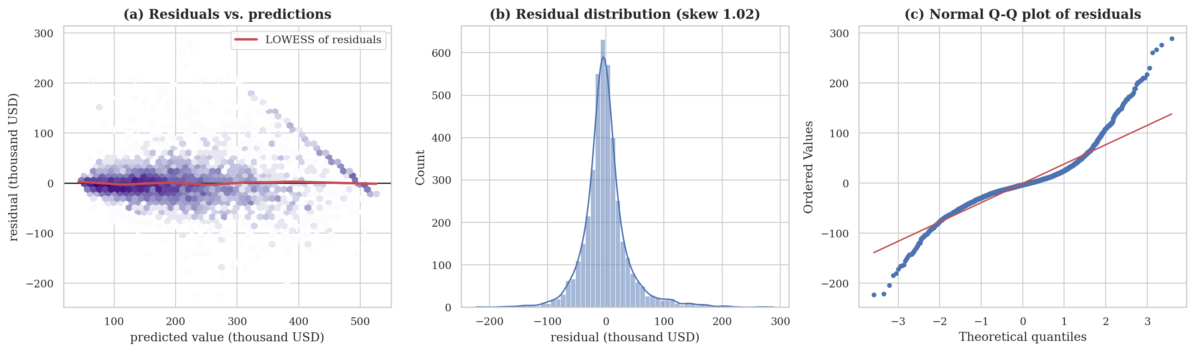
Figure 15: Residual diagnostics: (a) residuals against predictions, (b) distribution, (c) normal Q–Q plot
Residuals. The model is essentially unbiased (mean residual −$453), but its errors are heavy-tailed (excess kurtosis 6.6) and right-skewed (skewness 1.02), so normality is rejected (Jarque–Bera p < 0.001) and prediction intervals based on a normal assumption would be unreliable. Errors grow with the predicted value (ρ = 0.39): expensive districts are predicted with larger absolute errors. The diagonal band visible in Figure 15(a) is the signature of the censored target: every district whose true value is 500,001 produces a residual that decreases linearly with its prediction.
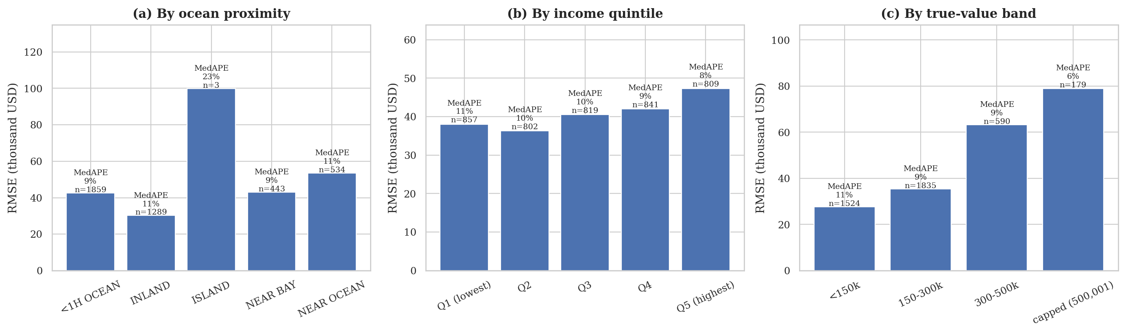
Figure 16: Test RMSE by (a) ocean proximity, (b) income quintile, (c) true-value band; labels give the median absolute percentage error and n
Segments. Among classes with a meaningful sample, the absolute error is lowest for INLAND districts (RMSE $30,221) and highest for NEAR OCEAN districts (RMSE $53,549), while the relative error is similar everywhere (median absolute percentage error 8.6–10.8 %). The ISLAND class contains only 3 test districts, so its large error is anecdotal. Across income quintiles the RMSE rises from $38,023 to $47,333 while the relative error falls from 11.2 % to 8.0 %: affluent districts have larger dollar errors simply because prices are larger. The value-band breakdown shows the classic regression-to-the-mean pattern (note that grouping by the true value guarantees such a pattern to some extent): cheap districts are over-predicted by $10,495 on average, whereas districts worth 300,000–500,000 are under-predicted by $21,448 and capped districts by $49,977.
Effect of censoring. The 179 capped districts are only 4.3 % of the test set but generate 16 % of the squared error, and 76 % of them are predicted below the cap, on average by $49,977. Their true value is at least 500,001 and probably much higher, so the real shortfall is larger than measured. Excluding them lowers the RMSE from $40,980 to $38,375. Retraining without capped training districts improves the score on uncapped districts only slightly (RMSE $37,827), and this variant cannot be deployed because it would be blind to the most expensive districts. The practical conclusion is that the cap limits the information in the data about the top of the market, and no modelling technique can fully recover it without censoring-aware methods (Section 6).
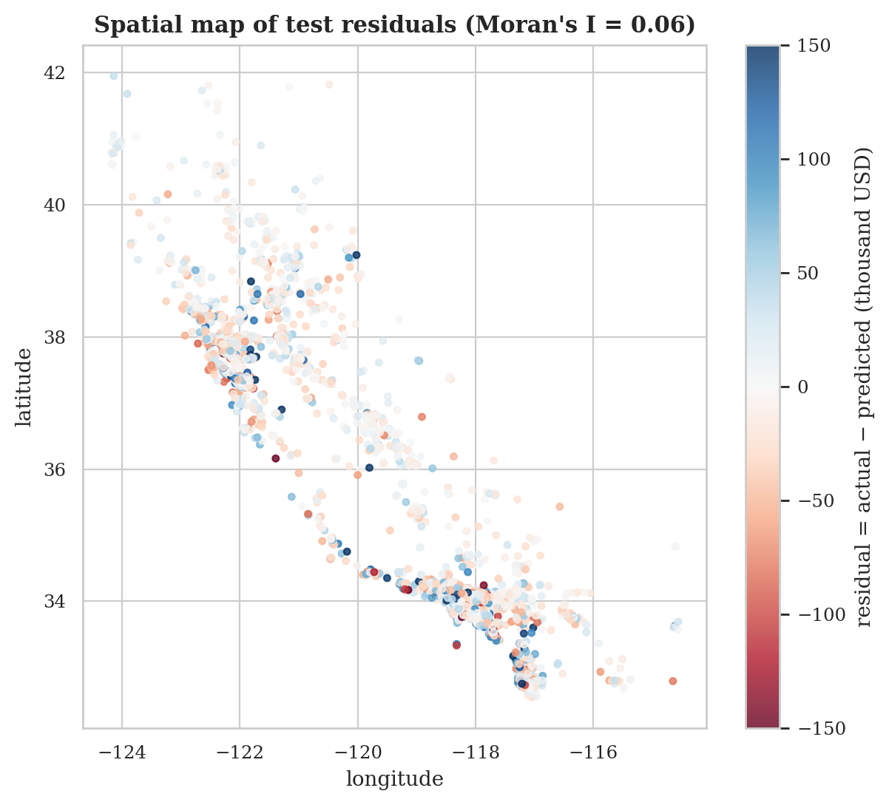
Figure 17: Map of test residuals (actual minus predicted); blue = under-predicted, red = over-predicted
Spatial residuals. The residuals retain a small but statistically significant positive spatial autocorrelation (I = 0.06, p = 0.002), far below the 0.79 of the raw target. The model, helped by the coordinate and hub-distance features, has therefore absorbed most of the spatial structure, but neighbouring districts still share some unexplained local effects, visible in Figure 17 as occasional patches of same-coloured points, mainly in the densely populated Bay area and Los Angeles basin. Local features (neighbourhood amenities, school quality, zoning) could capture them. The largest individual errors (Table 39) are mostly capped districts predicted far below the cap, together with a few districts with implausibly low values (for example 17,500 and 55,000) in Los Angeles that the model predicts at over 200,000; such cases may reflect atypical block groups and illustrate irreducible noise in aggregate census data.
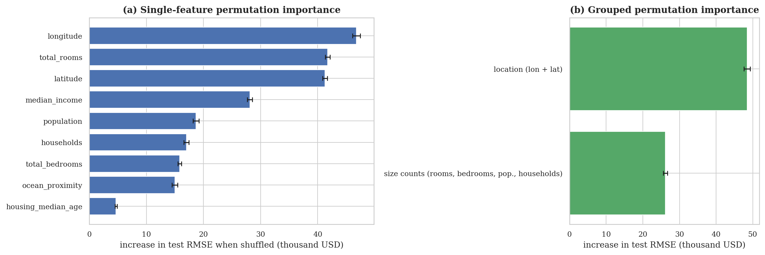
Figure 18: Permutation importance on the test set: (a) single input variables, (b) feature groups
Permutation importance. Shuffling longitude, total_rooms or latitude damages the predictions most, and the top three variables account for 57 % of the total importance; shuffling the pair longitude and latitude jointly raises the test RMSE by $48,443, which is more than the $26,164 of the four size counts together, so where a district is matters more than how big it is. Median income ranks 4th ($28,120); the high rank of total_rooms is largely an artefact of the pipeline, explained below. Two cautions apply. First, a raw column such as total_rooms enters the model also through the derived ratio features, so shuffling it disrupts several model inputs at once and its importance partly reflects those ratios. Second, strongly correlated variables share importance, so individual values should be read as ranks, not as additive shares.
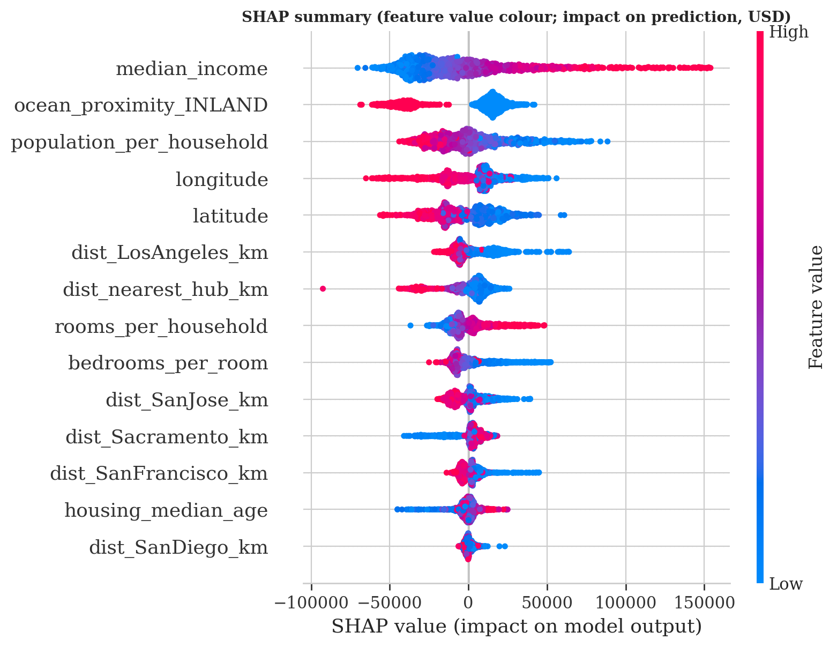
Figure 19: SHAP summary plot: each dot is a district; colour shows the feature value, horizontal position its effect on the prediction
SHAP. Exact Tree SHAP values for 1,500 test districts give a ranking that differs from permutation importance in an instructive way. Median income has the largest single mean absolute SHAP value ($29,700), followed by ocean_proximity_INLAND ($24,313) and population_per_household ($17,438); longitude and latitude (about $15,501 and $15,432) come next, then the distances to the hubs. The reason is that location information is spread over many correlated features — the coordinates, five hub distances and the ocean-proximity indicators — and SHAP divides the credit among them, whereas permuting a raw coordinate destroys the whole location signal at once. Adding up the mean absolute SHAP values of all location-related features gives $99,027, against $29,700 for income, so location is the dominant driver overall, in agreement with the permutation analysis, with income as the leading single feature.
The direction of the effects is economically coherent (Figure 19). High median income pushes the predicted value up, and the spread of the income dots to the right shows that high income can add well over $100,000 to a single prediction. High people per household (crowding) and an INLAND location push the prediction down. Districts in the south and west (low latitude, more negative longitude) receive positive contributions, consistent with the coastal premium seen in Analysis 3, and being close to a major hub (small distance) raises the prediction.
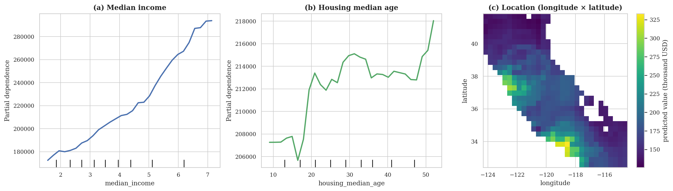
Figure 20: Partial dependence of the predicted value on (a) median income, (b) housing median age and (c) location
Partial dependence. Panel (a) shows an almost monotonic increase in the predicted value with income across the central 90 % of districts, with a steeper slope above an income of about 4.5 (roughly $45,000 in 1990 dollars): the model has learned a convex, accelerating effect rather than the straight line assumed by the linear model. Panel (b) shows that housing age has only a small average effect, within a range of roughly $12,000, with the lowest predictions for districts with houses of 15–17 years median age and higher predictions for very old housing stock. Panel (c) maps the average predicted value over the geographic coordinates, with cells far from any district masked: the highest predicted values lie along the coast around the San Francisco Bay area and the Los Angeles coast, and the lowest in the far north and the south-eastern interior, reproducing the coastal gradient of Analysis 3.

5. Conclusion

5.1 Summary of Findings
The project built a complete, leakage-free predictive-analysis pipeline for the California housing data and answered six research objectives with measured evidence. Table 43 summarises the answers.
Table 43: Summary of findings by objective
Obj. | Main finding
O1 | Missingness in total_bedrooms (207 rows) shows no relation to other variables; k-NN imputation recovers hidden values with RMSE 59 rooms against 420 for the median; downstream effect negligible. 4.7 % of targets, 6.2 % of ages are censored.
O2 | Income is strongly related to value (Pearson r = 0.69); +$10,000 income ↔ +$41,736; elasticity 0.82; mild concavity; heteroscedastic.
O3 | Ocean proximity has a large effect (ε² = 0.32); strong spatial autocorrelation (Moran’s I = 0.79); spatial features significantly improve prediction (−3.0 % RMSE for Ridge, −1.7 % for gradient boosting).
O4 | Ratio features are better correlated with value than raw counts and reduce RMSE by 2.7 % (gradient boosting) and 1.5 % (Ridge) on the raw feature set.
O5 | XGBoost is best: test RMSE $40,980, MAE $26,522, R² 0.87; significantly better than the runner-up HistGB (p = 0.014).
O6 | Errors are unbiased but heavy-tailed; capped districts (4.3 % of test) cause 16 % of the squared error; location, income and household density drive predictions; residuals retain a small spatial pattern (I = 0.06).

5.2 Recommendations
- Use a gradient-boosted tree model with ratio and spatial features for district-level valuation on this kind of data; the evidence (Analyses 3–5) shows consistent, significant gains from both feature groups.
- Treat censored targets explicitly. Report errors separately for capped districts, and consider censoring-aware methods before using the model for the top of the market.
- Validate spatially. Because values are strongly clustered in space, evaluate any model intended for new regions with geographically blocked validation, not only random folds.
- Report uncertainty. Because residuals are heavy-tailed and heteroscedastic, use prediction intervals that do not assume normality instead of single-number predictions.
- Prioritise better location data (coast distance, amenities, schools) over additional tuning, since the learning curve indicates the model is information-limited and residuals retain spatial structure.

5.3 Limitations
- Age of the data. Prices and incomes are from 1990; the model illustrates a method and must not be used to value present-day property.
- Censoring. The target, housing age and income are capped; the true values of the capped districts are unknown.
- Aggregation. Each row is a block-group summary; relationships found at this level do not necessarily hold for individual houses (ecological fallacy).
- Spatial dependence and optimistic validation. Random cross-validation lets neighbouring districts appear in both training and test sets, so the reported accuracy applies to interpolation within the observed region, not extrapolation to new regions.
- Small classes. The ISLAND class has only five districts in the entire file, so no conclusion about it is reliable.
- Limited tuning budget. Randomised searches evaluated 6–12 candidate settings on a single CPU core; a larger search might narrow the gaps between the top three models.
- Researcher choices. The five hub cities, the imputation candidates and the feature sets were chosen by the author; other reasonable choices might change effect sizes, although the qualitative conclusions were stable across the models and baselines tested.

6. Future Scope
The project can be extended in several directions that address the limitations identified above.
- Spatially blocked validation. Because values are strongly autocorrelated in space (Analysis 3), random cross-validation is optimistic. Grouping districts into geographic blocks (for example by k-means clusters of coordinates or by county) and holding out entire blocks would estimate how well the model generalises to unseen regions.
- Censoring-aware models. The $500,001 cap could be handled with a Tobit-style likelihood, survival-analysis methods that treat capped values as right-censored, or two-stage models that first classify capped districts and then regress on the rest.
- Richer location features. Distance to the actual coastline, elevation, school quality, crime and transport accessibility, or geohash/embedding representations of location, could be added from open geographic sources.
- More recent data. Retraining on contemporary American Community Survey or local listing data would make the model usable for present-day questions and would allow temporal validation.
- Uncertainty quantification. Quantile regression, conformal prediction or gradient-boosting prediction intervals would give a range around each prediction, which is essential for decision-making.
- Deployment. The saved pipeline could be wrapped in a REST API or a small web application, with monitoring for data drift.
- Model stacking and neural networks. Stacked ensembles or tabular neural networks with spatial embeddings could be benchmarked against the tuned tree ensembles under the same protocol.

7. References
[1] Breiman, L. (2001). Random forests. Machine Learning, 45(1), 5–32.
[2] Breusch, T. S., and Pagan, A. R. (1979). A simple test for heteroscedasticity and random coefficient variation. Econometrica, 47(5), 1287–1294.
[3] Chen, T., and Guestrin, C. (2016). XGBoost: A scalable tree boosting system. In Proceedings of the 22nd ACM SIGKDD International Conference on Knowledge Discovery and Data Mining (pp. 785–794).
[4] Cleveland, W. S. (1979). Robust locally weighted regression and smoothing scatterplots. Journal of the American Statistical Association, 74(368), 829–836.
[5] Cover, T., and Hart, P. (1967). Nearest neighbor pattern classification. IEEE Transactions on Information Theory, 13(1), 21–27.
[6] Efron, B. (1979). Bootstrap methods: Another look at the jackknife. The Annals of Statistics, 7(1), 1–26.
[7] Friedman, J. H. (2001). Greedy function approximation: A gradient boosting machine. The Annals of Statistics, 29(5), 1189–1232.
[8] Géron, A. (2019). Hands-On Machine Learning with Scikit-Learn, Keras and TensorFlow (2nd ed.). O’Reilly Media. Dataset file: https://github.com/ageron/handson-ml2/tree/master/datasets/housing
[9] Harris, C. R., et al. (2020). Array programming with NumPy. Nature, 585, 357–362.
[10] Hastie, T., Tibshirani, R., and Friedman, J. (2009). The Elements of Statistical Learning (2nd ed.). Springer.
[11] Hoerl, A. E., and Kennard, R. W. (1970). Ridge regression: Biased estimation for nonorthogonal problems. Technometrics, 12(1), 55–67.
[12] Holm, S. (1979). A simple sequentially rejective multiple test procedure. Scandinavian Journal of Statistics, 6(2), 65–70.
[13] Hunter, J. D. (2007). Matplotlib: A 2D graphics environment. Computing in Science and Engineering, 9(3), 90–95.
[14] Kruskal, W. H., and Wallis, W. A. (1952). Use of ranks in one-criterion variance analysis. Journal of the American Statistical Association, 47(260), 583–621.
[15] Little, R. J. A., and Rubin, D. B. (2019). Statistical Analysis with Missing Data (3rd ed.). Wiley.
[16] Lundberg, S. M., and Lee, S.-I. (2017). A unified approach to interpreting model predictions. In Advances in Neural Information Processing Systems 30 (pp. 4765–4774).
[17] Mann, H. B., and Whitney, D. R. (1947). On a test of whether one of two random variables is stochastically larger than the other. The Annals of Mathematical Statistics, 18(1), 50–60.
[18] McKinney, W. (2010). Data structures for statistical computing in Python. In Proceedings of the 9th Python in Science Conference (pp. 56–61).
[19] Moran, P. A. P. (1950). Notes on continuous stochastic phenomena. Biometrika, 37(1/2), 17–23.
[20] Nadeau, C., and Bengio, Y. (2003). Inference for the generalization error. Machine Learning, 52(3), 239–281.
[21] Nugent, C. (n.d.). California Housing Prices [Data set]. Kaggle. https://www.kaggle.com/datasets/camnugent/california-housing-prices
[22] OpenML. (n.d.). California housing dataset, ID 43705. https://api.openml.org/d/43705/json
[23] Pace, R. K., and Barry, R. (1997). Sparse spatial autoregressions. Statistics and Probability Letters, 33(3), 291–297.
[24] Pedregosa, F., et al. (2011). Scikit-learn: Machine learning in Python. Journal of Machine Learning Research, 12, 2825–2830.
[25] Seabold, S., and Perktold, J. (2010). Statsmodels: Econometric and statistical modeling with Python. In Proceedings of the 9th Python in Science Conference (pp. 92–96).
[26] Tomczak, M., and Tomczak, E. (2014). The need to report effect size estimates revisited: An overview of some recommended measures of effect size. Trends in Sport Sciences, 21(1), 19–25.
[27] Tukey, J. W. (1977). Exploratory Data Analysis. Addison-Wesley.
[28] Virtanen, P., et al. (2020). SciPy 1.0: Fundamental algorithms for scientific computing in Python. Nature Methods, 17, 261–272.
[29] Waskom, M. L. (2021). seaborn: statistical data visualization. Journal of Open Source Software, 6(60), 3021.

