Consider the following relationship between Student and Phone entity.
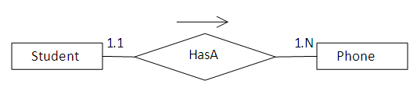
According to the relationship a student can have any number of phone numbers.
To create this relationship you need to have a STUDENT, PHONE and STUDENT_PHONE table. The relational model is shown below.
