Simple Object Access Protocol (SOAP) is a standard protocol specification for message exchange based on XML. Communication between the web service and client happens using XML messages.
A simple web service architecture has two components
- Client
- Service provider

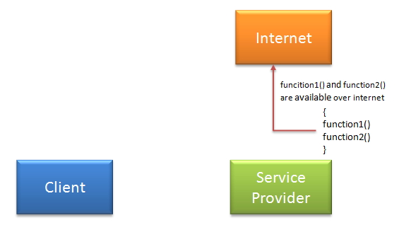

Here, in order to communicate client must know some information for e.g.
- Location of webservice server
- Signature/s of Functions available.
- Communication protocol
- End point

Service provider will create a standard XML file which will have all above information. So if this file is given to client then client will be able to access web service. This XML file is called WSDL.
What is WSDL?

WSDL stands for Web Service Description Language. It is an XML file that describes the technical details of how to implement a web service, more specifically the URI, port, method names, arguments, and data types. Since WSDL is XML, it is both human-readable and machine-consumable, which aids in the ability to call and bind to services dynamically. Using this WSDL file we can understand things like,
Port / Endpoint – URL of the web service
Security protocol that needs to be followed
Which protocol the web service uses etc.

There are two ways to access web service.

If Service provider knows client: If service provider knows its client then it will provide its wsdl to client and client will be able to access web service.

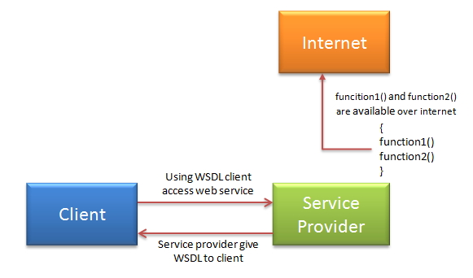

If Service provider does not know client:
Service provider register its WSDL to UDDI and client can access it from UDDI: UDDI stands for Universal Description, Discovery and Integration. It is a directory service. Web services can register with a UDDI and make themselves available through it for discovery. So following steps are involved.

- Service provider registers with UDDI.
- Client searches for service in UDDI.
- UDDI returns all service providers offering that service.
- Client chooses service provider
- UDDI returns WSDL of chosen service provider.
- Using WSDL of service provider, client accesses web service.

