Here are the important things to know about the basic structure of a JavaFX application:
- The main class for a JavaFX application extends the javafx.application.Application class. The start() method is the main entry point for all JavaFX applications.
- A JavaFX application defines the user interface container by means of a stage and a scene. The JavaFX Stage class is the top-level JavaFX container. The JavaFX Scene class is the container for all content. Following diagram creates the stage and scene and makes the scene visible in a given pixel size.
- In JavaFX, the content of the scene is represented as a hierarchical scene graph of nodes. In this example, the root node is a FlowPane object, which is a resizable layout node. This means that the root node's size tracks the scene's size and changes when the stage is resized by a user.
- The root node contains one child node, a button control with text, plus an event handler to print a message when the button is pressed.
Following diagram shows the scene graph for the Hello World application.
Figure 3-1 Hello World Scene Graph
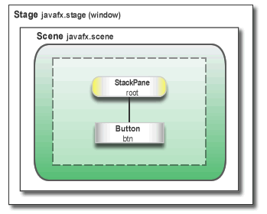

Run the Application
- In the Projects window, right-click the HelloWorld project node and choose Run.
- Click the Say Hello World button.
- Verify that the text ”Hello World!” is printed to the output window.
following diagram shows the Hello World application, JavaFX style.
Figure 3-2 Hello World, JavaFX style
