YUVAINTERN
Logistics Data Analyst Internship
WEEK 1 TASK
Strategic Data Collection & Preprocessing Blueprint

Detail | Information
Submitted by | Ram Balasaheb Darekar
Role | Logistics Data Analyst Intern
Organisation | YuvaIntern
Tools | Python | pandas | NumPy | scikit-learn | Matplotlib
Submission | October 2026

Table of Contents
1. Introduction and Objective
2. Understanding Logistics Data
3. Potential Public Data Sources
4. Data Collection Strategy
5. Preprocessing Methodology with Python
6. Handling Missing and Inconsistent Data
7. Data Normalization and Transformation
8. Documentation, Reproducibility and Transparency
9. Feasibility, Risks and Mitigation
10. Conclusion
11. References

1. Introduction and Objective
Logistics decisions such as route planning, warehouse allocation, demand forecasting and delivery scheduling are only as reliable as the data behind them. In practice, the data an analyst receives is rarely ready to use: files arrive in different formats, dates are written in several styles, units are mixed, some fields are empty and a few records are simply wrong. A model trained on such data produces misleading results, however advanced the algorithm is.
The objective of this document is to design a clear, repeatable strategy for finding, collecting and preprocessing publicly available logistics data using Python. It does not report model results. Instead, it explains what I would do, in what order, with which tools, and why, so that any reviewer could follow the same steps and reach the same cleaned dataset.
The plan is organised around the five questions every data-preparation task must answer:
- Where does the data come from, and can it be trusted and legally used?
- How will it be collected and stored without altering the original?
- What is wrong with it (missing, duplicated, inconsistent or extreme values)?
- How will it be fixed and put on a comparable scale?
- How will every change be recorded so the work can be reproduced and audited?

2. Understanding Logistics Data
Logistics data describes the movement of goods through a supply chain. Before choosing datasets, it helps to know what kinds of data exist, because each kind needs different cleaning.
Data Type | Typical Fields | Common Quality Issues
Shipment / delivery records | Order ID, dispatch time, delivery time, origin, destination, package count | Missing timestamps, delivery time earlier than dispatch time, duplicate orders
Geographic / route data | Latitude, longitude, distance, port or town names | Swapped coordinates, spelling variations in place names, impossible distances
Inventory and warehouse data | SKU, stock level, reorder point, storage location | Negative stock, inconsistent SKU codes, stale records
Trade and freight data | Country, commodity code, quantity, value, year | Different currencies and units, revised figures, missing years
Environmental / external data | Weather, holidays, traffic indicators | Different time zones, sensor gaps, merge mismatches

Because these types differ, the preprocessing plan must be flexible: a rule that works for shipment timestamps (for example, delivery cannot precede dispatch) is meaningless for trade values, where unit conversion matters more.

3. Potential Public Data Sources

3.1 Candidate datasets
Source | What It Offers | Why It Suits This Plan
Kaggle (Delivery Time Prediction and related logistics datasets) | Delivery records with timing, package counts, geography and weather | Tabular CSV files that can be loaded directly with pandas; good for demonstrating cleaning and merging
World Bank Logistics Performance Index (LPI) | Country-level scores on customs, infrastructure, tracking and timeliness | Reliable, well-documented indicators; useful for scaling and comparison across countries
UN Comtrade | International trade flows by commodity, partner and year | Shows real-world issues such as unit differences, missing years and revisions
Government open-data portals (for example data.gov.in or data.gov) | Freight, port, transport and traffic statistics | Official sources with clear licensing and metadata
OpenStreetMap / open geospatial data | Road networks and place coordinates | Helps validate distances and coordinates

3.2 Considerations when using public data
- Licence and permitted use: read the licence (for example CC0, CC BY or a government open licence) before using or redistributing any file, and credit the source.
- Provenance and reliability: prefer official or well-cited sources; record who published the data, when, and under what method.
- Freshness: check the last-updated date. Logistics conditions change quickly, so old data may not reflect current patterns.
- Coverage and bias: a dataset from one city or one company may not generalise. This limitation should be stated openly in any report.
- Privacy: even public logistics data can contain customer or driver identifiers. Such columns should be removed or anonymised and are not needed for analysis.
- Schema and documentation: a data dictionary or README is a sign of quality; without it, column meanings must be inferred and documented as assumptions.
- Selection rule: a dataset is shortlisted only if it has a clear licence, a documented schema, enough rows to support analysis, and fields that match the business question.

4. Data Collection Strategy
Collection is treated as a controlled process rather than a simple download, so that the raw data always remains traceable.

4.1 Steps
- Define the question first. For example: "Which factors affect delivery time?" This decides which columns and tables are required and prevents collecting unnecessary data.
- Shortlist and score sources. Each candidate from Section 3 is checked against licence, freshness, coverage and schema quality.
- Acquire the data. Files are downloaded manually from the platform, or through an official API or the Kaggle API where available. The download date and version are noted.
- Store raw data read-only. Original files go in a data/raw folder and are never edited. All cleaning produces new files in data/processed.
- Verify integrity. A SHA-256 checksum and row count are recorded for each file, so any later change can be detected.
- Create a source register. A small table records name, URL, licence, download date, file name and a short description of each dataset.

4.2 Suggested project structure

4.3 Example: loading and registering a file
import pandas as pd, hashlib, datetime, pathlib

path = pathlib.Path('data/raw/deliveries.csv')
checksum = hashlib.sha256(path.read_bytes()).hexdigest()

df = pd.read_csv(path)
print('Rows, columns:', df.shape)
print('SHA-256 :', checksum[:16], '...')
print('Loaded on :', datetime.date.today())

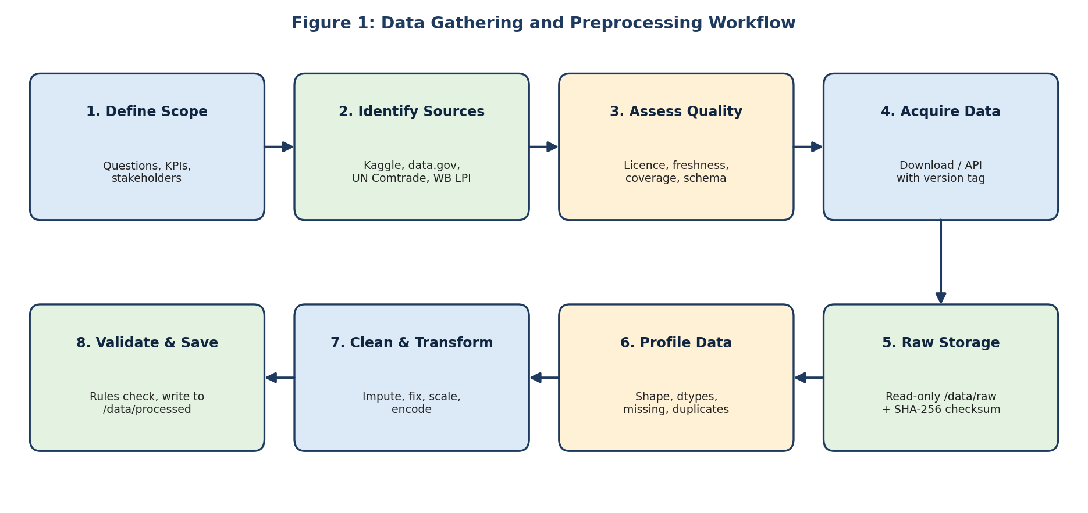

5. Preprocessing Methodology with Python
Preprocessing follows a fixed order so results are consistent. Each stage uses well-known Python libraries.
Library | Role in the Workflow
pandas | Loading files, inspecting structure, filtering, merging tables, handling dates, grouping and exporting results
NumPy | Numerical operations, handling NaN values, log transforms and vectorised calculations such as distance
scikit-learn | Imputation (SimpleImputer, KNNImputer), scaling (MinMaxScaler, StandardScaler) and encoding
Matplotlib / Seaborn | Histograms, box plots and missing-value maps to inspect data before and after cleaning
SciPy / statsmodels | Statistical checks such as z-scores and distribution tests
logging / pathlib | Recording each step and managing file paths in a reproducible way

5.1 Profiling before cleaning
No cleaning rule is chosen until the data has been profiled. Profiling answers: how big is it, what are the data types, how much is missing, and what do the distributions look like?
print(df.shape)
print(df.dtypes)
print(df.describe(include='all').T)

missing = df.isna().mean().sort_values(ascending=False) * 100
print(missing[missing > 0].round(2)) # % missing per column
print('Duplicate rows:', df.duplicated().sum())

5.2 Standardising structure
- Rename columns to lowercase snake_case so they are easy to reference.
- Strip leading and trailing spaces from text fields and unify capitalisation (for example "Pune", "pune " and "PUNE" become one value).
- Convert columns to correct types: dates with pd.to_datetime, numbers with pd.to_numeric(errors='coerce'), and low-cardinality text to the category type to save memory.
- Convert all values to one unit (for example seconds or minutes for time, kilometres for distance, one currency for cost) and record the conversion in the log.
df.columns = (df.columns.str.strip().str.lower()
.str.replace(r'[^a-z0-9]+', '_', regex=True))
df['starting_time'] = pd.to_datetime(df['starting_time'], errors='coerce')
df['delivery_time'] = pd.to_numeric(df['delivery_time'], errors='coerce')
df['town'] = df['town'].str.strip().str.title()

5.3 Merging multiple tables
Logistics datasets are often split into several files (for example deliveries, geography and weather). They are merged on a shared key, usually with a left join so no delivery is lost. After each merge, the row count is compared with the expected value to detect accidental duplication.
merged = deliveries.merge(weather, on='weather_key', how='left', validate='m:1')
assert len(merged) == len(deliveries), 'Row count changed after merge'

6. Handling Missing and Inconsistent Data

6.1 Missing values
Missing data should not be filled mechanically. The first step is to ask why it is missing: a blank delay field may legitimately mean "no delay", while a blank timestamp is a recording failure. The strategy depends on the column and the amount missing.
Situation | Approach | Reason
Less than about 5% missing in a numeric column, spread randomly | Median imputation | Median is not distorted by extreme delivery times
Numeric column linked to other features (for example temperature) | KNN or group-wise imputation (by town or hour) | Uses similar records, so values are more realistic
Categorical column (for example weather condition) | Mode, or a separate category "Unknown" | Keeps the row without inventing a precise value
Time-ordered readings (for example sensors) | Forward fill or interpolation | Values change gradually over time
Critical field missing (target such as delivery time, or key ID) | Drop the row | Imputing the target would bias any later model
More than about 40-50% missing in a column | Consider dropping the column | Too little real information remains

For important columns, a binary flag such as temperature_was_missing is added before imputation so that the fact of missingness is not lost.
df['temperature_missing'] = df['temperature'].isna().astype(int)
df['temperature'] = df['temperature'].fillna(
df.groupby('town')['temperature'].transform('median'))
df['conditions'] = df['conditions'].fillna('Unknown')
df = df.dropna(subset=['delivery_time']) # target must be real

6.2 Duplicates
Exact duplicates (all columns identical) are removed. Key-based duplicates (the same delivery ID with different values) are investigated first, and the most recent or most complete record is kept. The number removed is always logged.
before = len(df)
df = df.drop_duplicates()
df = df.sort_values('starting_time').drop_duplicates('delivery_id', keep='last')
print('Removed duplicates:', before - len(df))

6.3 Inconsistent and invalid values
- Category spelling: use value_counts() to spot variants, then map them to one standard label with a dictionary.
- Logical rules: delivery time must be positive; package count cannot be negative; latitude must lie between -90 and 90 and longitude between -180 and 180; delivery cannot finish before it starts.
- Date consistency: mixed date formats are parsed explicitly, and records that cannot be parsed are flagged rather than silently dropped.
- Business rules: values that break domain knowledge (for example a 5 km delivery recorded as 40 hours) are flagged for review.
rules = {
'non_positive_time': df['delivery_time'] <= 0,
'negative_packages': df['num_packages'] < 0,
'bad_latitude' : ~df['start_lat'].between(-90, 90),
}
for name, mask in rules.items():
print(name, mask.sum())
df = df[~pd.concat(rules.values(), axis=1).any(axis=1)]

6.4 Outliers
Outliers are detected with the IQR rule (values beyond 1.5 x IQR from the quartiles) and cross-checked with z-scores. They are not deleted automatically. In logistics, an extreme value may be a genuine event such as a storm or a breakdown. The decision process is: (1) check whether the value is physically possible, (2) check whether it is explained by another column, (3) if it is an error, correct or remove it, and (4) if it is genuine, keep it and consider a log transform or capping (winsorising) to limit its influence.
q1, q3 = df['delivery_time'].quantile([0.25, 0.75])
iqr = q3 - q1
low, high = q1 - 1.5*iqr, q3 + 1.5*iqr
df['time_outlier'] = ~df['delivery_time'].between(low, high)
print('Flagged outliers:', df['time_outlier'].sum())

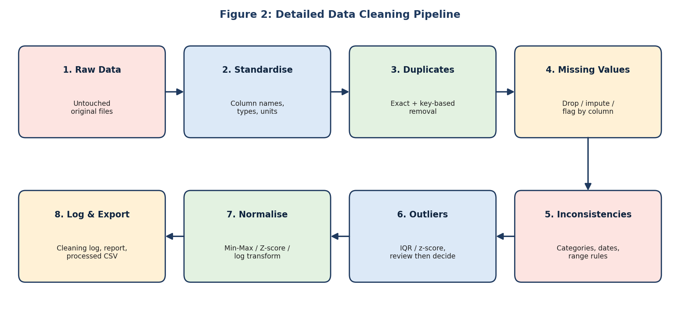

7. Data Normalization and Transformation
Variables in logistics data sit on very different scales: package counts may be single digits, delivery time thousands of seconds, and coordinates fractions of a degree. Algorithms that depend on distance or gradients (K-Means, KNN, linear models with regularisation, neural networks) can be dominated by the largest-scale feature unless the data is normalised.
Method | Formula / Idea | When I Would Use It
Min-Max scaling | (x - min) / (max - min), result between 0 and 1 | Bounded features without strong outliers; clustering and neural networks
Z-score standardisation | (x - mean) / standard deviation | Roughly normal features; regression and distance-based methods
Robust scaling | (x - median) / IQR | Features with many genuine outliers, such as delivery time
Log transform | log(1 + x) | Right-skewed values such as delivery time, distance or cost
Encoding | One-hot for nominal, ordinal mapping for ordered categories | Converting weather condition, vehicle type or town into numbers

A critical rule is to fit scalers only on the training split and then apply them to the test split. Fitting on the full dataset leaks information from the test data into training and gives over-optimistic results. Scaled copies are stored in separate columns or files, and the original values are preserved so results can still be reported in real units.
import numpy as np
from sklearn.model_selection import train_test_split
from sklearn.preprocessing import RobustScaler, MinMaxScaler

df['log_delivery_time'] = np.log1p(df['delivery_time'])

X_train, X_test = train_test_split(df[num_cols], test_size=0.2, random_state=42)
scaler = MinMaxScaler().fit(X_train) # fit on train only
X_train_s, X_test_s = scaler.transform(X_train), scaler.transform(X_test)

df = pd.get_dummies(df, columns=['conditions'], drop_first=True)

7.1 Feature engineering as part of preprocessing
- Extract hour, weekday and month from timestamps; add a weekend or holiday flag.
- Estimate straight-line distance from coordinates with the haversine formula in NumPy.
- Create ratios such as time per package to compare deliveries of different size.
def haversine(lat1, lon1, lat2, lon2):
r = 6371 # km
p1, p2 = np.radians(lat1), np.radians(lat2)
dphi, dl = p2 - p1, np.radians(lon2 - lon1)
a = np.sin(dphi/2)**2 + np.cos(p1)*np.cos(p2)*np.sin(dl/2)**2
return 2*r*np.arcsin(np.sqrt(a))

df['distance_km'] = haversine(df.start_lat, df.start_lon, df.end_lat, df.end_lon)
df['hour'] = df['starting_time'].dt.hour

8. Documentation, Reproducibility and Transparency
A cleaned dataset is only trustworthy if someone else can see exactly how it was produced. The plan therefore treats documentation as part of the work rather than an afterthought.
- Cleaning log: every step writes a line recording what was done, how many rows or values were affected, and why. This turns a hidden process into an auditable one.
- Scripts instead of manual edits: no change is made by hand in Excel. All steps are Python functions in src/, so running one script regenerates the processed data from raw data.
- Fixed random seeds: random_state=42 is used wherever randomness occurs, so splits and imputations are repeatable.
- Pinned environment: requirements.txt (or environment.yml) lists exact library versions, and the Python version is recorded.
- Version control: the project is kept in Git with meaningful commit messages; large data files are excluded and described in the source register instead.
- Data dictionary: a table lists each final column, its type, unit, meaning and any transformation applied.
- Before-and-after report: row counts, missing-value percentages and summary statistics are compared before and after cleaning to show the effect of every decision.
- Assumptions register: any judgement call (for example the imputation choice for a column) is written down with its justification.
import logging
logging.basicConfig(filename='logs/cleaning.log', level=logging.INFO,
format='%(asctime)s | %(message)s')

def log_step(step, before, after, note=''):
logging.info(f'{step}: {before} -> {after} rows. {note}')

n = len(df); df = df.drop_duplicates()
log_step('drop_duplicates', n, len(df), 'exact duplicates')

8.1 Cleaning log template
Step | Action | Column(s) | Rows Affected | Justification
1 | Remove exact duplicates | All | (logged) | Repeated records inflate counts
2 | Parse dates | starting_time | (logged) | Needed for time features
3 | Impute temperature | temperature | (logged) | Median by town; flag column added
4 | Remove invalid rows | delivery_time | (logged) | Non-positive time is impossible
5 | Flag outliers | delivery_time | (logged) | IQR rule; reviewed, not auto-deleted
6 | Scale numeric features | Numeric columns | All | Fit on training data only

8.2 Validation checks
Before the processed dataset is saved, automated checks confirm that the result is valid: no missing values remain in required columns, data types are as expected, values lie within allowed ranges, keys are unique, and the final row count can be explained by the log. If a check fails, the pipeline stops instead of saving bad data.
assert df['delivery_time'].gt(0).all()
assert df['delivery_id'].is_unique
assert df[required_cols].notna().all().all()
df.to_csv('data/processed/deliveries_clean.csv', index=False)

9. Feasibility, Risks and Mitigation
Risk | Mitigation
Dataset licence or access limits | Check licences at shortlisting; keep a backup candidate source
Very large files exceeding memory | Read in chunks (chunksize) or select only required columns and use efficient dtypes
Over-aggressive cleaning removes real events | Flag instead of delete; review outliers against domain logic
Data leakage during scaling or imputation | Fit all transformers on training data only, using scikit-learn Pipelines
Poor documentation of source data | Record assumptions; cross-check with a second source where possible
Results cannot be reproduced | Scripts, pinned versions, fixed seeds and a cleaning log

All tools in this plan (Python, pandas, NumPy, scikit-learn and Git) are free and run on a standard laptop, and the datasets are public, so the plan is practical to carry out within an internship timeline.

10. Conclusion
This document sets out a complete preparation strategy for public logistics data: choose sources by licence, quality and relevance; collect them into a read-only raw layer with checksums; profile before cleaning; handle missing, duplicate, inconsistent and extreme values with column-specific, justified rules; normalise features without leaking test information; and record every step in a log so that anyone can reproduce the result.
The main principle behind the plan is that preprocessing decisions should be deliberate and explainable. Following this blueprint, later stages such as exploratory analysis, delivery-time prediction and route planning can be built on data that is clean, documented and trustworthy.

11. References
- Kaggle. Delivery Time Prediction dataset and related logistics datasets. kaggle.com/datasets
- World Bank. Logistics Performance Index (LPI). lpi.worldbank.org
- United Nations. UN Comtrade Database. comtradeplus.un.org
- Government of India / US Government open-data portals. data.gov.in and data.gov
- pandas development team. pandas documentation. pandas.pydata.org/docs
- NumPy developers. NumPy documentation. numpy.org/doc
- Pedregosa et al. (2011). Scikit-learn: Machine Learning in Python. Journal of Machine Learning Research, 12.
- Wilkinson et al. (2016). The FAIR Guiding Principles for scientific data management and stewardship. Scientific Data, 3.

