1. A test is conducted which is consisting of 20 MCQs (multiple choices questions) with every MCQ having its four options out of which only one is correct. Determine the probability that a person undertaking that test has answered exactly 5 questions wrong.

**Code:**

import pandas as pd

import numpy as np

import scipy as sci

import matplotlib.pyplot as plt

import math

from scipy.stats import binom

*# Define the variable*

num_of_question = 20

*# probability of wrong answer of a single question*

prob_wrong_answer = 3/4 *# as one of the 4 question is right*

print('Probability of wrong answer of a single question:\t', prob_wrong_answer)

print('\nProbability of 5 wrong answers')

print('----------------------------')

print('\nSolution -1 - Mathemetical Model')

print('\t Using Formula: 20C5 * power((1-prob_wrong_answer),15) * power(prob_wrong_answer, 5)')

p_five_wrong_answer = (math.factorial(20)/(math.factorial(15)*math.factorial(5))) \* math.pow((1-prob_wrong_answer),15) * math.pow(prob_wrong_answer,5)

print('\nProbability of 5 wrong answers',p_five_wrong_answer)

print('\nSolution -2 - Using scipy - probability mass function')

print('\t Using Formula: binom.pmf(5,total_num_of_question,p_wrong_answer)')

p_five_wrong_answer=binom.pmf(5,num_of_question,prob_wrong_answer)

print('\nProbability of 5 wrong answers',p_five_wrong_answer)

**Output:**

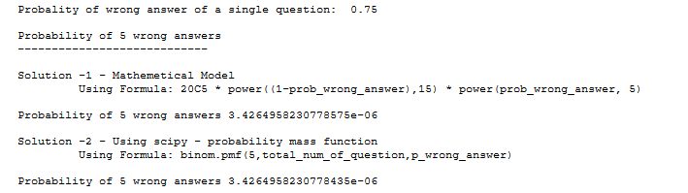

1. A die marked A to E is rolled 50 times. Find the probability of getting a “D” exactly 5 times.

**Code:**

import pandas as pd

import numpy as np

import scipy as sci

import matplotlib.pyplot as plt

import math

from scipy.stats import binom

*# Define the variable*

num_of_roll = 50

*# probability of getting D in single roll*

prob_D = 1/5 *# as in a roll, D has equal chance among A to E*

print('Probability of getting D in single roll:\t', prob_D)

print('\nProbability of getting D exactly 5 times')

print('--------------------------------------')

print('\nSolution -1 - Mathemetical Model')

print('\t Using Formula: 50C5 * power((1-prob_D),45) * power(prob_D, 5)')

p_five_D = (math.factorial(50)/(math.factorial(45)*math.factorial(5))) \* math.pow((1-prob_D),45) * math.pow(prob_D,5)

print('\nProbability of getting D exactly 5 times',p_five_D)

print('\nSolution -2 - Using scipy - probability mass function')

print('\t Using Formula: binom.pmf(5,total_num_of_roll,p_D)')

p_five_D=binom.pmf(5,num_of_roll,prob_D)

print('\nProbability of 5 wrong answers',p_five_D)

**Output:**

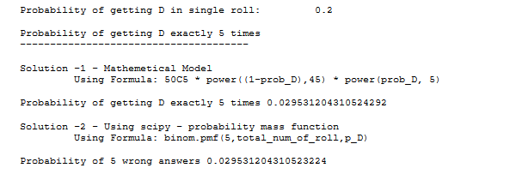

1. Two balls are drawn at random in succession without replacement from an urn containing 4 red balls and 6 black balls. Find the probabilities of all the possible outcomes.

**Code:**

import pandas as pd

import numpy as np

import scipy as sci

import matplotlib.pyplot as plt

import math

from scipy.stats import binom

*# Define the variable*

num_of_balls = 10

num_of_red_balls = 4

num_of_black_balls = 6

*# Two balls are drawn at random in succession without replacement*

*# If Red ball is denoted by R and Balck ball is denoted by B then*

*# Possible outcome - RR, RB, BR, BB*

*# probability of 1st ball red = 4/10*

*# probability of 2nd ball red = 3/9 [when first ball is red]*

*# probability of 2nd ball red = 4/9 [when first ball is black]*

*# probability of 1st ball black = 6/10*

*# probability of 2nd ball black = 5/9 [when first ball is black]*

*# probability of 2nd ball black = 6/9 [when first ball is red]*

probablity_RR = (4/10) * (3/9)

probablity_RB = (4/10) * (6/9)

probablity_BR = (6/10) * (4/9)

probablity_BB = (6/10) * (5/9)

*# Create a DF with the Probability distribution and random variable*

lst_color=['RR','RB','BR','BB']

df_probability=pd.DataFrame({'Color':lst_color, 'Probability':[probability_RR,probability_RB,probability_BR,probability_BB]})

print(df_probability)

*# Plot the Probabalities distributions*

plt.bar(df_probability.Color,df_probability.Probability,width=.3)

plt.xlabel('Color of the Balls')

plt.xticks(lst_color)

plt.ylabel('Probability')

plt.title('\nProbabalities distribution Plot\n')

plt.show()

**Output:**

