import pandas as pd

import numpy as np

import matplotlib.pyplot as plt

%matplotlib inline

df = pd.read\_csv('https://raw.githubusercontent.com/jackiekazil/data-wrangling/master/dat a/chp3/data-text.csv') df.head(2)

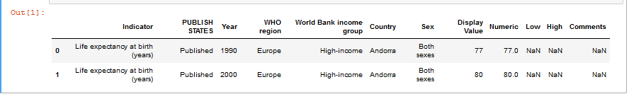

df1 = pd.read\_csv('https://raw.githubusercontent.com/kjam/data-wrangling-pycon/master/d ata/berlin\_weather\_oldest.csv') df1.head(2)

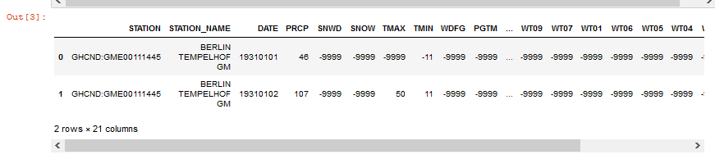

1. Get the Metadata from the above files.

Code:

df.info()

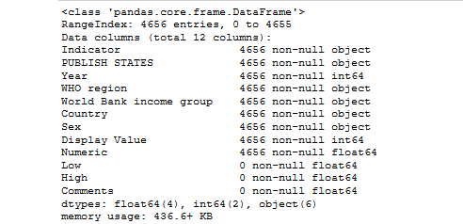

df1.info()

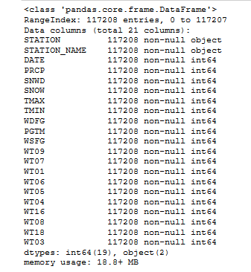

2. Get the row names from the above files.

Code:

df.columns



df1.columns



3. Change the column name from any of the above file.

Code:

df.rename(columns = {'Indicator':'Indicator\_id'}, inplace=True)

df.head(2)

Output:

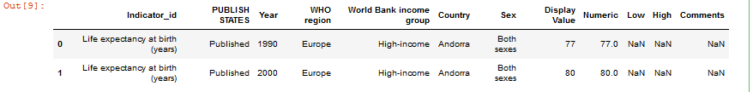

4. Change the column name from any of the above file and store the changes made permanently.

Code:

df.rename(columns = {'Indicator':'Indicator\_id'}, inplace=True)

df.head(2)

Output:

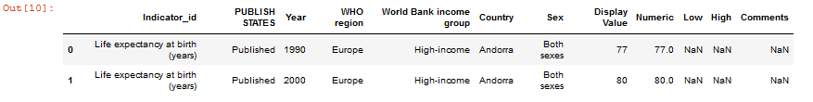

5. Change the names of multiple columns.

Code:

df.rename(columns = {'PUBLISH STATES':'Publication Status', 'WHO region':'WHO Region'}, inplace=True)

df.head(2)

Output:

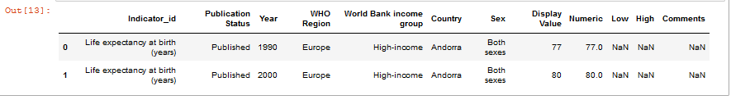

6. Arrange values of a particular column in ascending order.

Code:

df.sort\_values('Year').head(5)

Output:

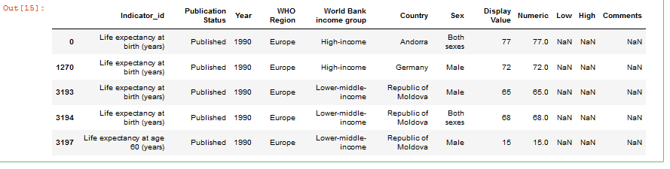

7. Arrange multiple column values in ascending order.

Code:

df.sort\_values(['Indicator\_id', 'Country', 'Year', 'WHO Region', 'Publication Status'],ascending=[True,True, True, True, True]).head(3)

Output:

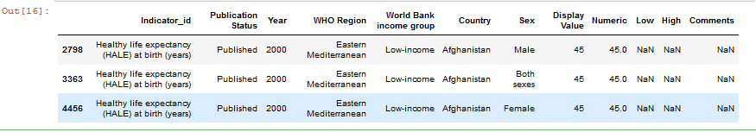

8. Make country as the first column of the dataframe

Code:

df = df[['Country', 'Indicator\_id', 'Publication Status', 'Year', 'WHO Region','World Bank income group','Sex', 'Display Value', 'Numeric','Low', 'High', 'Comments']]

df.columns

Output:



df.head(2)

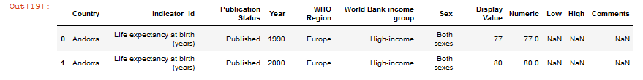

9. Get the column array using a variable

df.values

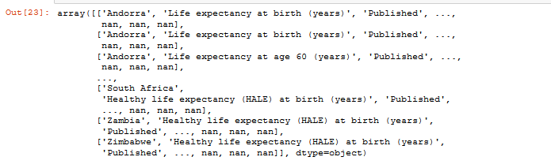

10. Get the subset rows 11, 24, 37

df.iloc[[11,24,37]]

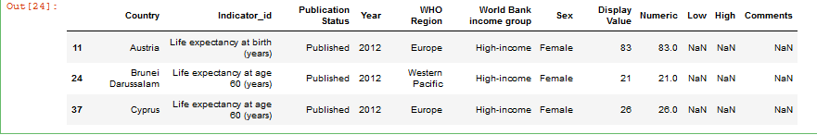

11. Get the subset rows excluding 5, 12, 23, and 56

excludedRows = df.index.isin([5,12,23,34,56])

df[~excludedRows]

Load datasets from CSV

Code:

users=pd.read\_csv('https://raw.githubusercontent.com/ben519/DataWrangling/master/Data/users.csv')

sessions=pd.read\_csv('https://raw.githubusercontent.com/ben519/DataWrangling/master/Data/sessions.csv')

products=pd.read\_csv('https://raw.githubusercontent.com/ben519/DataWrangling/master/Data/products.csv')

transactions=pd.read\_csv('https://raw.githubusercontent.com/ben519/DataWrangling/master/Data/transactions.csv')

users.head()

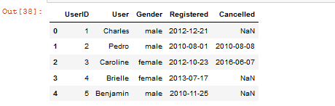

sessions.head()

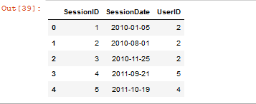

products.head()

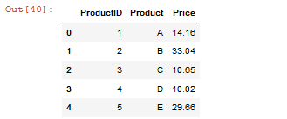

transactions.head()

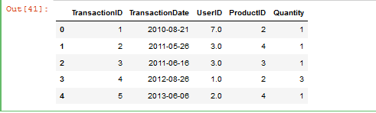

12. Join users to transactions, keeping all rows from transactions and only matching rows from users (left join)

Code:

pd.merge

display(pd.merge(transactions,users, on="UserID", how='left'))

Output:

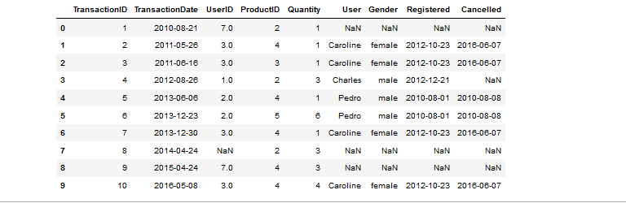

13. Which transactions have a UserID not in users?

Code:

display(transactions[~transactions['UserID'].isin(users['UserID'])])

Output:

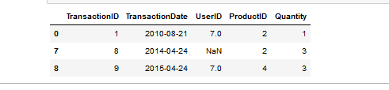

14. Join users to transactions, keeping only rows from transactions and users that match via UserID (inner join)

Code:

display(pd.merge(transactions,users, on='UserID', how='inner'))

Output:

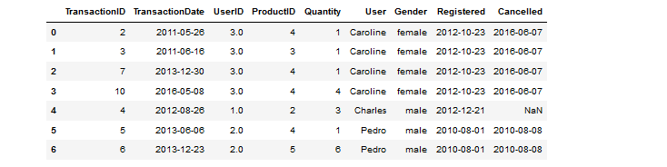

15. Join users to transactions, displaying all matching rows AND all non-matching rows (full outer join)

Code:

display(pd.merge(transactions,users, on='UserID', how='outer'))

Output:

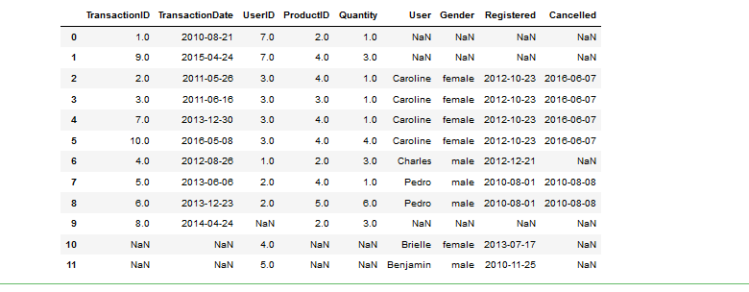

16. Determine which sessions occurred on the same day each user registered

Code:

display(pd.merge(sessions,users, on='UserID', how='inner'))

Output:

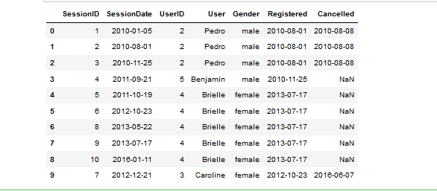

sameDayUserReg=pd.merge(sessions,users, on='UserID', how='inner')

sameDayUserReg

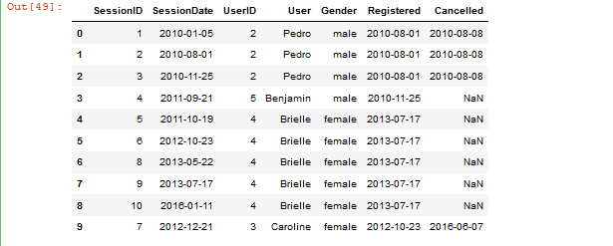

sameDayUserReg.loc[sameDayUserReg['SessionDate'] == sameDayUserReg['Registered']]

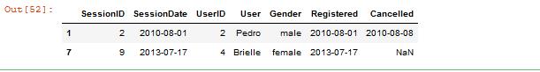

17. Build a dataset with every possible (UserID, ProductID) pair (cross join)

Code:

possibleDataSet = users.assign(value=1).merge(products.assign(value=1)).drop('value', 1)

display(possibleDataSet)

Output:

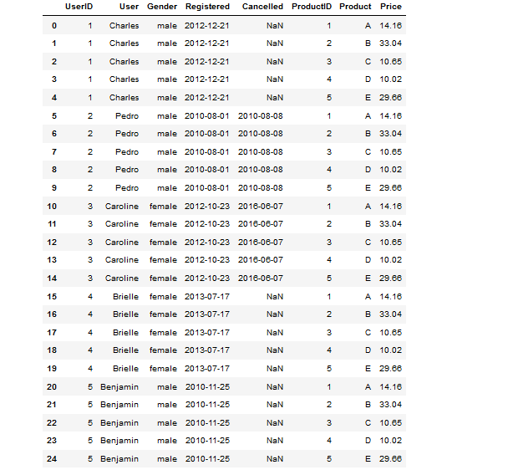

18. Determine how much quantity of each product was purchased by each user

Code:

display(transactions.sort\_values('Quantity'))

Output:

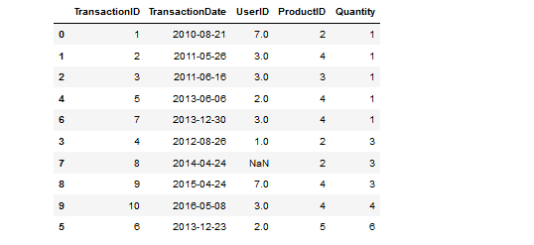

19. For each user, get each possible pair of pair transactions (TransactionID1, TransacationID2)

Code:

pd.merge(transactions, transactions, on='UserID')

Output:

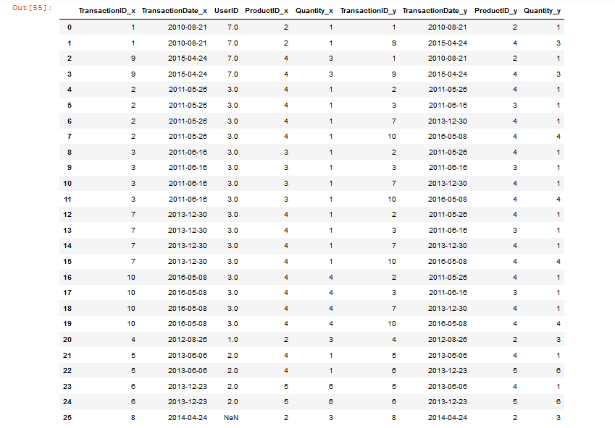

20. Join each user to his/her first occuring transaction in the transactions table

Code:

data=pd.merge(users, transactions.groupby('UserID').first().reset\_index(), how='left', on='UserID')

data

Output:

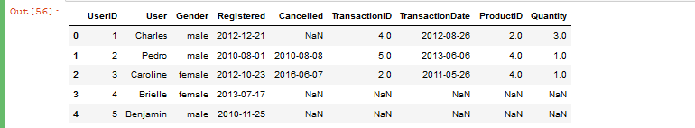

21. Test to see if we can drop columns

Code:

columns = list(data.columns)

list(data.dropna(thresh=int(data.shape[0] \* .9), axis=1).columns)

Output:

op27_1.PNG

Code:

missingInfo = list(data.columns[data.isnull().any()])

missingInfo

Output:

op27_2.PNG

Code:

for col in missingInfo:

missingNumber = data[data[col].isnull() == True].shape[0]

print('Missing Number for Col {}: {}'.format(col, missingNumber))

Output:

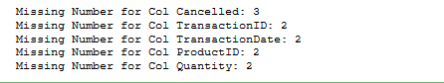

Code:

for col in missingInfo:

percentMissing = data[data[col].isnull() == True].shape[0] / data.shape[0]

print('Col Percent Missing {}: {}'.format(col, percentMissing))

Output:

