**2. Problem Statement**

**Scipy:**

We have the min and max temperatures in a city In India for each months of the year.

We would like to find a function to describe this and show it graphically, the dataset

given below.

Task:

1. fitting it to the periodic function

2. plot the fit

Data

Max = 39, 41, 43, 47, 49, 51, 45, 38, 37, 29, 27, 25

Min = 21, 23, 27, 28, 32, 35, 31, 28, 21, 19, 17, 18

**Expected Output:**

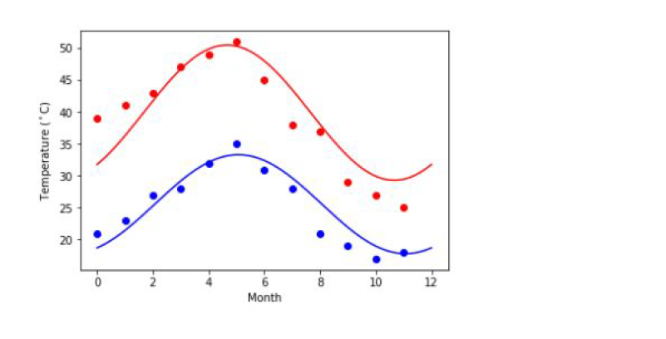

**Code:**

#We have the min and max temperatures in a city In India for each months of the year.We would like to find a function to describe this and show it graphically. Data: Max = 39, 41, 43, 47, 49, 51, 45, 38, 37, 29, 27, 25, Min = 21, 23, 27, 28, 32, 35, 31, 28, 21, 19, 17, 18#

import numpy as np

temp_max = np.array([39, 41, 43, 47, 49, 51, 45, 38, 37, 29, 27, 25])

temp_min = np.array([21, 23, 27, 28, 32, 35, 31, 28, 21, 19, 17, 18])

import matplotlib.pyplot as plt

months = np.arange(12)

plt.plot(months, temp_max, 'go')

plt.plot(months, temp_min, 'co')

plt.xlabel('Month')

plt.ylabel('Min and max temperature')

**Output:**

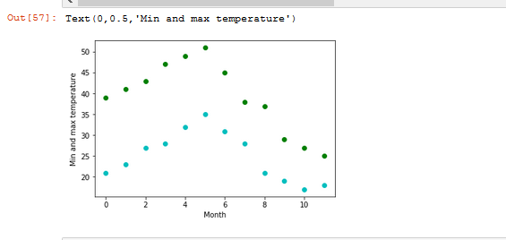

**1.Fitting it to the periodic function**

from scipy import optimize

def yearly_temps(times, avg, ampl, time_offset):

return (avg+ ampl * np.cos((times + time_offset) * 1.8 * np.pi / times.max()))

res_max, cov_max = optimize.curve_fit(yearly_temps, months, temp_max, [40, 20, 0])

res_min, cov_min = optimize.curve_fit(yearly_temps, months,temp_min, [-40, 20, 0])

**2.Plot the fit**

days = np.linspace(0, 12, num=365)

plt.figure()

plt.plot(months, temp_max, 'go')

plt.plot(days, yearly_temps(days, *res_max), 'm-')

plt.plot(months, temp_min, 'co')

plt.plot(days, yearly_temps(days, *res_min), 'y-')

plt.xlabel('Month')

plt.ylabel('Temperature ($^\circ$C)')

plt.show()

**Output:**

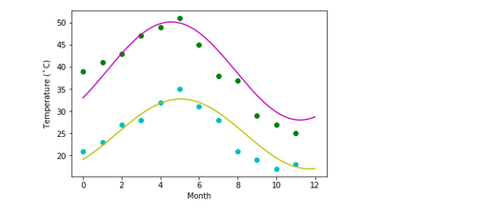

**Matplotlib:**

This assignment is for visualization using matplotlib:

data to use:

url=

https://raw.githubusercontent.com/Geoyi/Cleaning-Titanic-Data/master/titanic_original.cs

v

titanic = pd.read_csv(url)

**Code:**

import numpy as np

import pandas as pd

import matplotlib.pyplot as plt

import seaborn as sns

%matplotlib inline

filename = 'https://raw.githubusercontent.com/Geoyi/Cleaning-Titanic-Data/master/titanic_original.csv'

titanic_df = pd.read_csv('https://raw.githubusercontent.com/Geoyi/Cleaning-Titanic-Data/master/titanic_original.csv')

titanic_df.head()

Output:

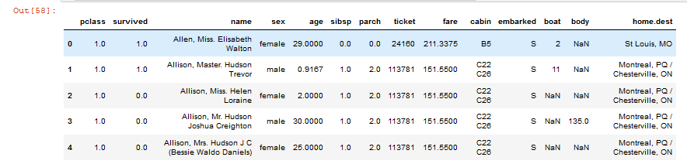

titanic_df.info()

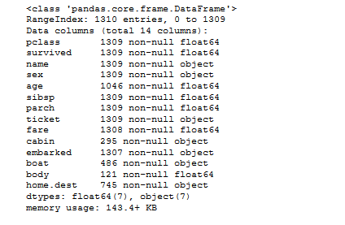

Charts to plot:

1. Create a pie chart presenting the male/female proportion

**Code:**

def draw_plot(titanic_df):

proportions = []

sum_instances = titanic_df['sex'].value_counts()

length = len(titanic_df['sex'])

proportions = list(sum_instances)

labels = ['Males','Females']

explode = (0,0.1)

sizes = proportions

fig, ax1 = plt.subplots(figsize = (6,6))

ax1.pie(sizes, explode = explode, labels = labels, shadow = True, startangle=90)

ax1.axis('equal')

ax1.set_title("Sex Proportions")

return plt.show()

draw_plot(titanic_df)

**Output:**

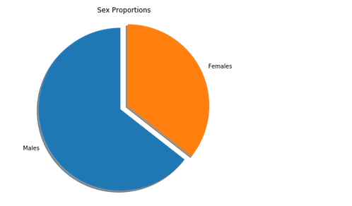

1. Create a scatterplot with the Fare paid and the Age, differ the plot color by gender

**Code:**

plt.scatter(titanic_df['age'], titanic_df['fare'], alpha=0.5, c=pd.factorize(titanic_df['sex'])[0])

**Output:**

