1. Blood glucose levels for obese patients have a mean of 100 with a standard deviation of 15. A researcher thinks that a diet high in raw cornstarch will have a positive effect on blood glucose levels. A sample of 36 patients who have tried the raw cornstarch diet have a mean glucose level of 108. Test the hypothesis that the raw cornstarch had an effect or not.

Code:

*# import the libraries*

import pandas as pd

import numpy as np

import scipy as sci

import matplotlib.pyplot as plt

import scipy.stats as stat

import math

from scipy.stats import binom

*# Given*

μ =100 *# population mean of Blood glucose levels for obese patients*

σ= 15 *# standard deviation of Blood glucose levels for obese patients (population)*

N = 36 *# No of Samples who have tried the raw cornstarch diet*

X= 108 *# sample mean (who have tried the raw cornstarch diet)*

print('\nCalculate Z Score Using Formula: (X - μ) / (σ/math.sqrt(N)')

Z = (X - μ) / (σ/math.sqrt(N))

print('\t Z-Score value is :',Z)

print('\nProbability of having mean less than 108:\n\t\t p = stats.norm.cdf(Z)')

p = stat.norm.cdf(Z) *# cdf function takes Z- score , returns standard normal probability*

print('\t i.e.\t p =',round(p,4))

print('\nThe probability of having mean more than 108:',round(1-p,4))

print('i.e. The probability of having mean more than 108 is lesser than Significance level 0.05')

print('\nSo, We can reject the Null Hypothesis')

print('i.e. Raw cornstarch diet does not have an affect')

Output:

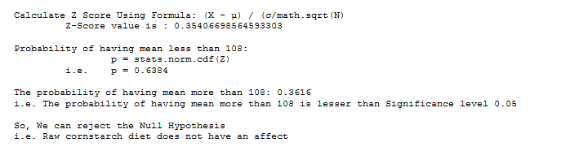

1. In one state, 52% of the voters are Republicans, and 48% are Democrats. In a second state, 47% of the voters are Republicans, and 53% are Democrats. Suppose a simple random sample of 100 voters are surveyed from each state. What is the probability that the survey will show a greater percentage of Republican voters in the second state than in the first state?

Code:

*# import the libraries*

import pandas as pd

import numpy as np

import scipy as sci

import matplotlib.pyplot as plt

import scipy.stats as stat

import math

from scipy.stats import binom

# Given

p_state1_republican =52/100 *# Republican voters in the first state 52%*

p_state1_democract = 48/100 *# Democrats voters in the first state 48%*

n_state1 = 100  *# No. of samples from first state=100*

p_state2_republican =47/100 *# Republican voters in the second state 47%*

p_state2_democract = 53/100 *# Democrats voters in the second state 53%*

n_state2 = 100 *# No. of samples from second state=100*

*# Calculate probability that the survey will show a greater percentage of Republican voters in the second state than in the first state*

*# Standard deviation*

σ= math.sqrt(((p_state1_republican*(1- p_state1_republican))/n_state1) + \

((p_state2_republican*(1- p_state2_republican))/n_state2))

print('Standard deviation:\t', round(σ,5))

*# Mean Difference*

mean_difference = p_state2_republican - p_state1_republican

print('Mean Difference:\t', round(mean_difference,5))

*# Z Score*

*# Z = (mean difference/Std Deviation)*

Z = mean_difference/σ

print('Z Score:\t\t', round(Z,5))

print('\nProbability of having greater Republican voters in the second state:\n\t\t p = stats.norm.cdf(Z)')

p = stat.norm.cdf(Z) *# cdf function takes Z- score , returns standard normal probability*

print('\t i.e.\t p =',round(p,4))

print('\ni.e. The probability that the survey will show a greater percentage of Republican voters \n' \'\t in the second state than in the first state is', round(p,4))

Output:

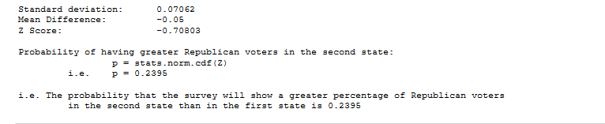

1. You take the SAT and score 1100. The mean score for the SAT is 1026 and the standard deviation is 209. How well did you score on the test compared to the average test taker.

Code:

*# Given*

X = 1100 *# My SAT Score. i.e. Sample value of SAT score*

σ = 209 *# Standard deviation of SAT score*

μ = 1026 *# Mean SAT score*

N = 1 *# No of Samples - only my score considered as sample*

print('\nZ Score Using Formula: (X - μ) / σ/math.sqrt(N)')

Z = (X - μ) / (σ/math.sqrt(N))

print('\t Z-Score value is :', Z)

print('\nProbability of having my score more than averge:\n\t\t p = stats.norm.cdf(Z)')

p = stat.norm.cdf(Z) *# cdf function takes Z- score , returns standard normal probability*

print('\t i.e.\t p =',round(p,4))

print('\ni.e. Probability of having my score more than average: ', round(p*100,2),'%')

Output:

