1. Open the command prompt and verify that Node.js is installed, then check its version.

1. Create a MySQL database

1. Execute node importCsv.js to import data into the database from the CSV data source.A screenshot of a computer

   Description automatically generated
2. Verify that the data has been successfully loaded into the database.  
   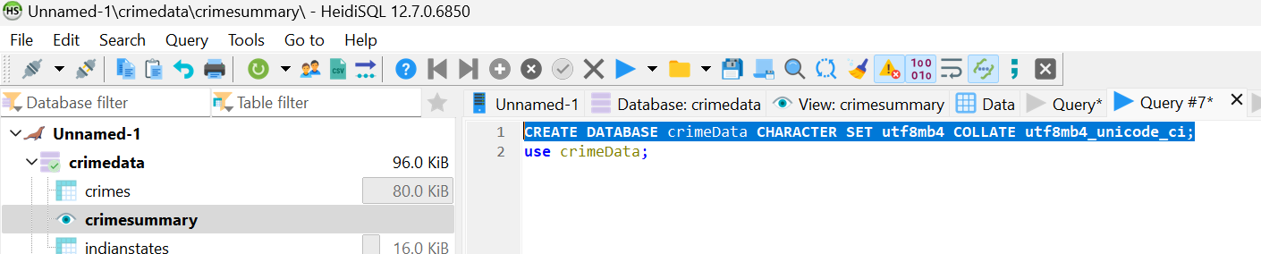
3. Execute node app.js to start the server, which will run on port 3000.

1. The dashboard can be accessed at http://localhost:3000  
   A map of india with dots and numbers

   Description automatically generated
2. By default, the dashboard displays data for all available years. You can filter the data using the dropdown menu, which shows only the years with available sample data, specifically from 2001 to 2021.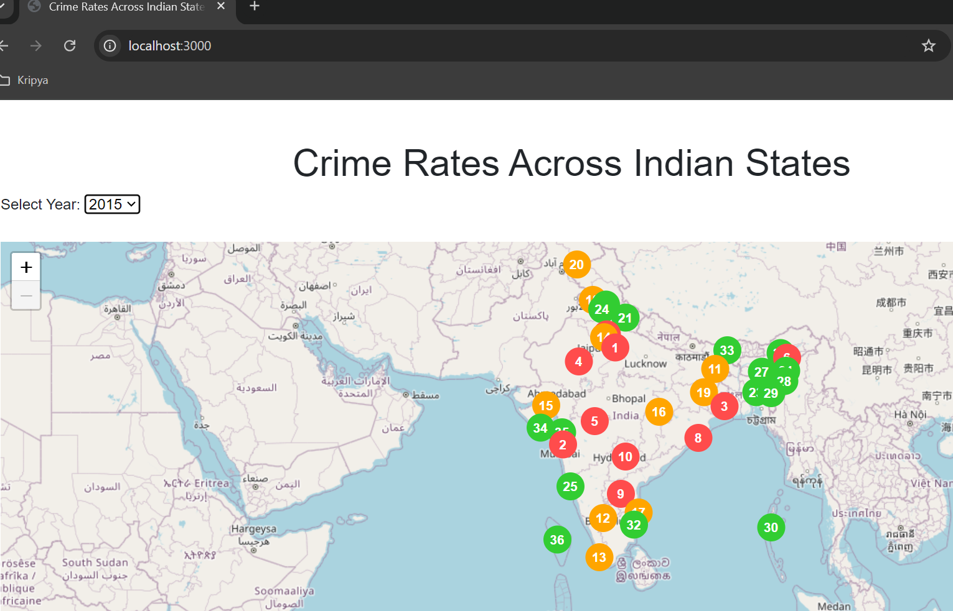
3. The color scheme on the map indicates the ranking of states: states ranked 1 to 10 are displayed in RED, those ranked 10 to 20 in Orange, and states ranked 21 and above in Green The map is designed to visually represent states from the highest crime rates to the lowest. (Preferably Map that shows states from higher rate to lower)

1. By clicking on a marker or the number displayed, a popup will appear showing quick data. Additionally, clicking the "State View" button will provide access to the detailed state report.

1. After clicking the "State View" button, a state selection box will appear, allowing users to switch between different states. This leads to an individual state page where crime data is displayed for the selected state.A screenshot of a data

   Description automatically generated