Student Organizing Team
 | Core Organizing Members
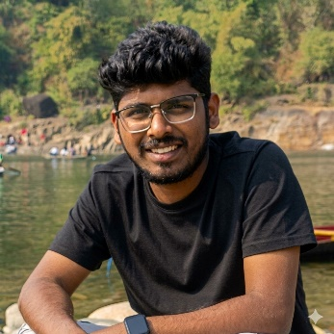 | 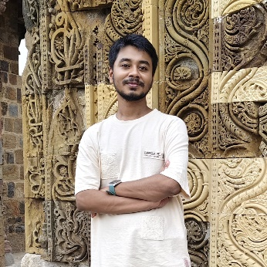 | 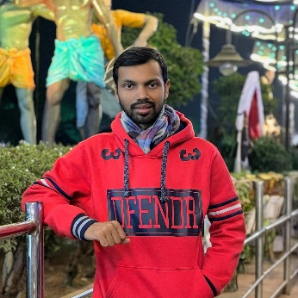
Mr. Kiran V Kottur  PhD Scholar, IIT Guwahati | Mr. Sagar Aditya  PhD Scholar, IIT Guwahati | Mr. Sayan Saha  PhD Scholar, IIT Guwahati
 | Other Organizing Members
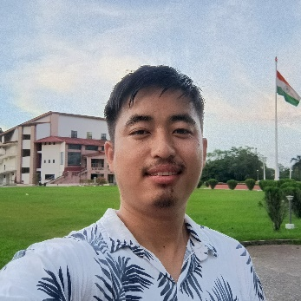 | 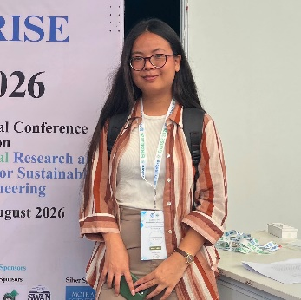 | 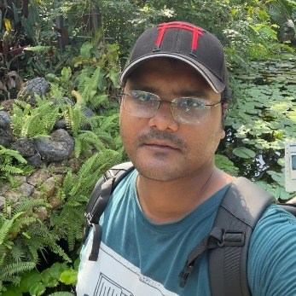
Mr. K Zamminsion  PhD Scholar, IIT Guwahati | Ms. Lamyanbi Naorem  PhD Scholar, IIT Guwahati | Mr. Monish Goswami  PhD Scholar, IIT Guwahati
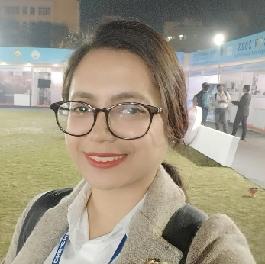 | 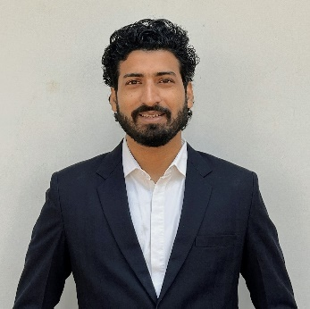 | 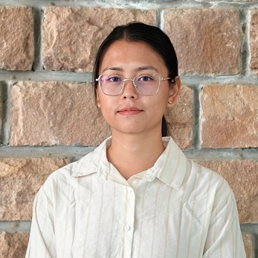
Ms. Sanjana Sinha  PhD Scholar, IIT Guwahati | Mr. Shahnawaz Ahmed  PhD Scholar, Gauhati University | Ms. Sweta Waikhom  PhD Scholar, IIT Guwahati
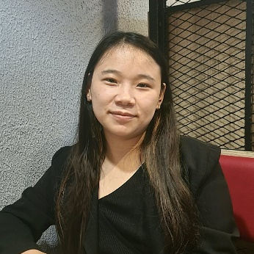 | 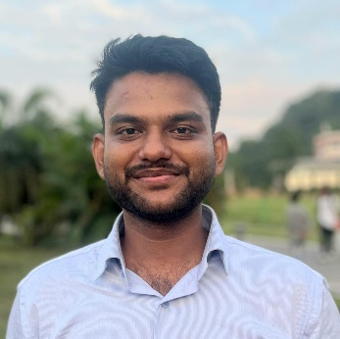 | 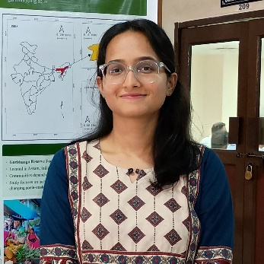
Ms. Bwenyele Tep  PhD Scholar, IIT Guwahati | Mr. Chandan Prajapati  PhD Scholar, IIT Guwahati | Ms. Garima Singh  PhD Scholar, IIT Guwahati
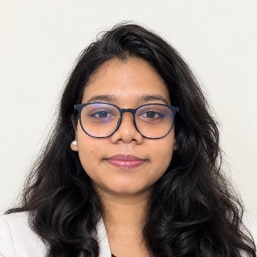 | 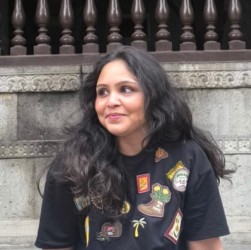 | 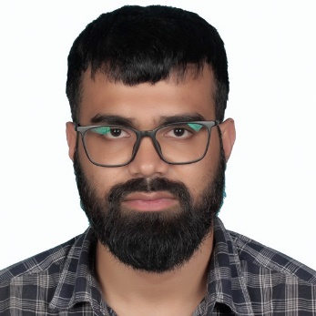
Ms. Susmita Marandi  PhD Scholar, IIT Guwahati | Ms. Vartika Anand  PhD Scholar, IIT Guwahati | Mr. Aminul Islam Choudhary  PhD Scholar, IIT Guwahati
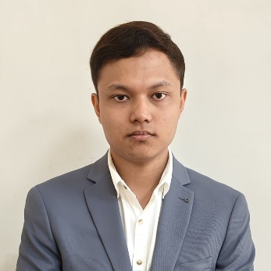 | 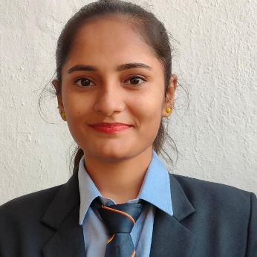 | 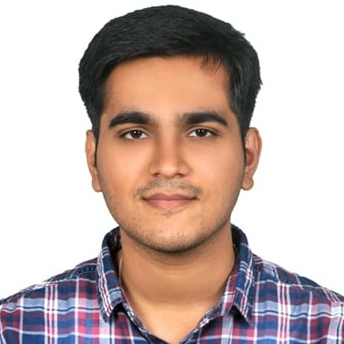
Mr. Debanga Raj Gogoi  PhD Scholar, IIT Guwahati | Ms. Archana Kashyap  PhD Scholar, IIT Guwahati | Mr. Akash Soni  M.Tech Scholar, IIT Guwahati
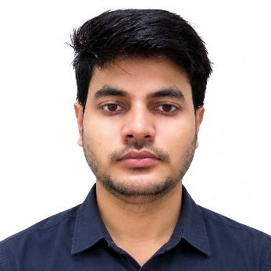 | 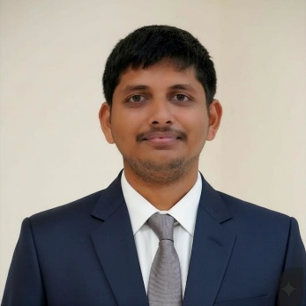 | 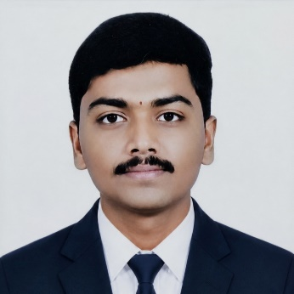
Mr. Aman Kumar  M.Tech Scholar, IIT Guwahati | Mr. Anshuman Ghosh  M.Tech Scholar, IIT Guwahati | Mr. Gundu Shashi Kiran  M.Tech Scholar, IIT Guwahati
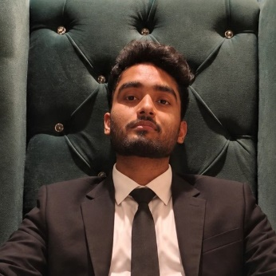 | 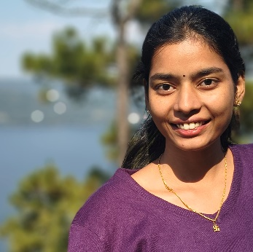 | 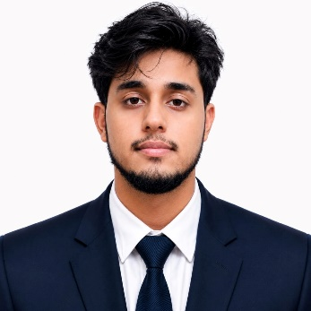
Mr. Jyotishman Deka  M.Tech Scholar, IIT Guwahati | Ms. Male Manogna  M.Tech Scholar, IIT Guwahati | Mr. Parijaat Sinha  M.Tech Scholar, IIT Guwahati
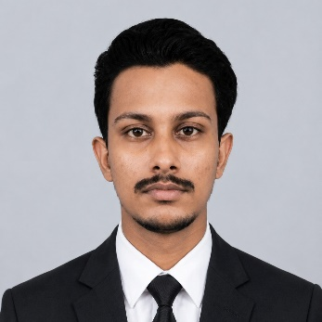 | 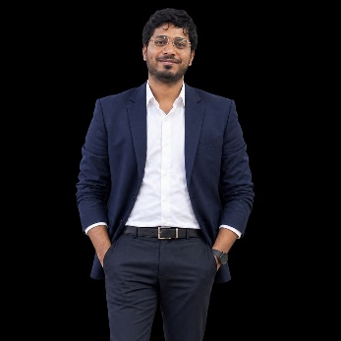 | 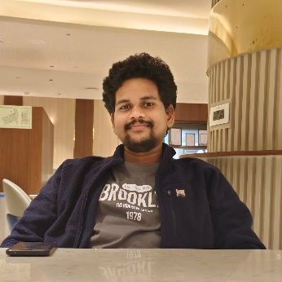
Mr. Saikat Saha  M.Tech Scholar, IIT Guwahati | Mr. Shaik Anwar Baba  M.Tech Scholar, IIT Guwahati | Mr. Vena Harsha Vardhan  M.Tech Scholar, IIT Guwahati

