IPL PERFORMANCE ANALYTICS
Mini Project — Data Analysis & Power BI Dashboard

Student Name : Shaik Policharla Rameeja Course / Batch: Data Analyst/Batch 2 Date : 29-09-2026

Project Objective

The objective of this project is to transform IPL match and player-related data into meaningful statistical insights. The analysis covers team performance, player performance, batting, bowling, match outcomes, toss decisions, venues, and season-wise trends using Python and Power BI.

Tools & Technologies
Python, Pandas, NumPy, Matplotlib, Seaborn, Jupyter Notebook, Microsoft Power BI Desktop, Power Query and DAX.

Dataset Description

The sample dataset contains 12,000 cleaned delivery-level records covering 50 matches across 5 seasons and 8 teams. Fields include match details, teams, toss information, winner, winning margins, Player of the Match, batsman, bowler, runs, extras, wickets, over and ball.

Data Cleaning

The raw sample was checked for data types, missing values and duplicate records. Duplicate records were removed, an inconsistent team name was standardized, Match_Date was converted to a date type, and appropriate numeric fields were handled. The cleaned dataset was then rechecked before analysis.

Metric | Example result
Cleaned records | 12,000
Unique matches | 50
Seasons | 5
Teams | 8
Venues | 8
Players appearing as batsmen | 11
Players appearing as bowlers | 10

Data Analysis

Question | Example result
Highest number of wins | Punjab Kings (12 wins)
Season with most matches | 2021 (10 matches)
Most Player of the Match awards | Rahul Verma (7 awards)
Highest run scorer | Rahul Verma (2,736 runs)

Highest wicket taker | Harsh Vardhan (59 wickets)
Most-used venue | Sawai Mansingh Stadium (12 matches)
Most common toss decision | Field (25 matches)
Toss winner also won | 54.00% of matches
Highest-run season | 2024 (4,771 runs)
Highest average-run team | Rajasthan Royals (221.43 runs/match)

Python Visualizations

The notebook contains all 14 requested visualizations: matches by season, wins by team, top 10 run scorers, top 10 wicket takers, Player of the Match awards, toss decision distribution, matches won/lost after winning the toss, season-wise runs, season-wise wickets, runs distribution, team performance comparison, venue match count, runs versus wickets, and a correlation heatmap.

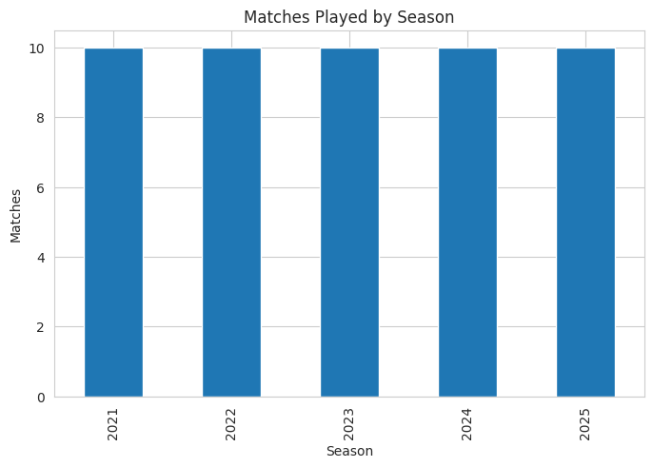
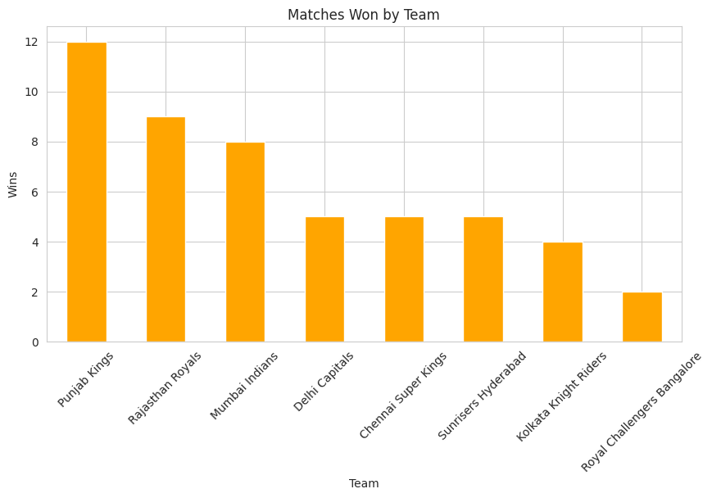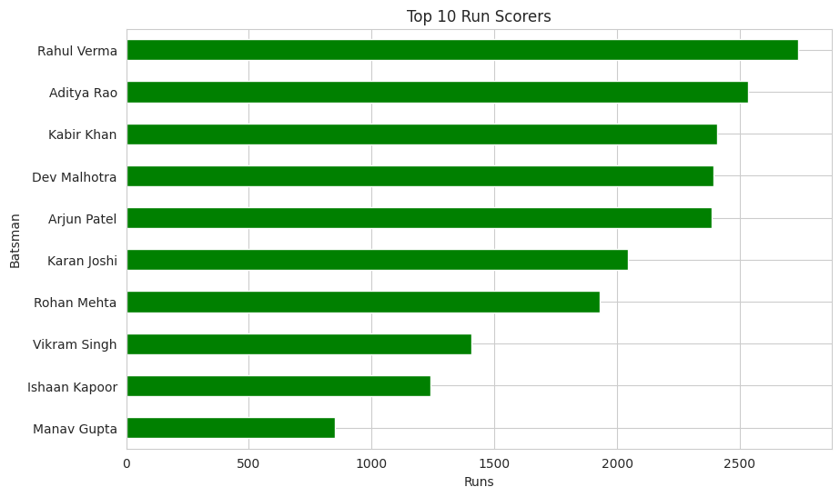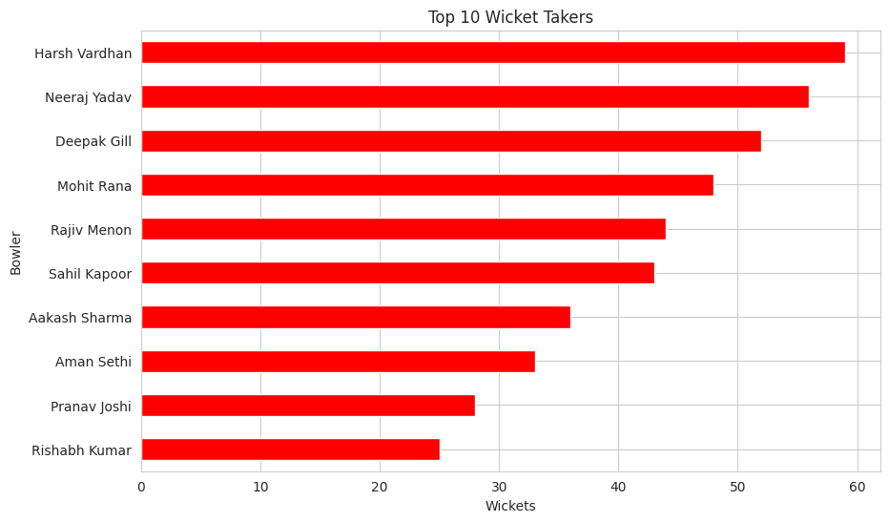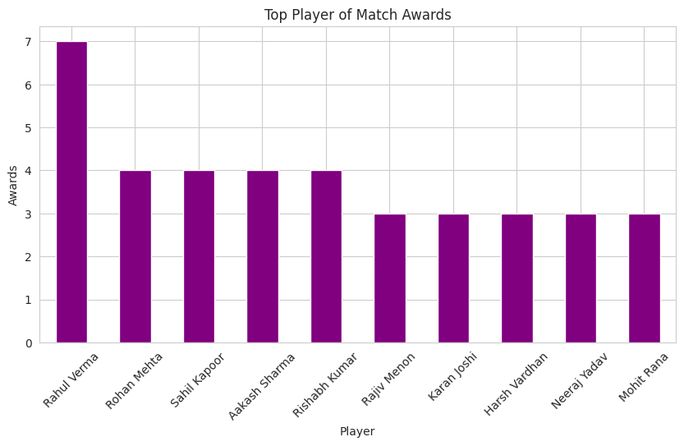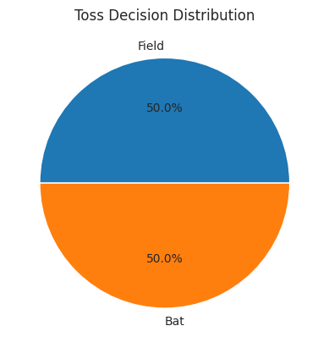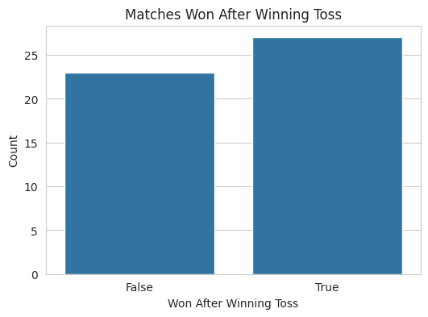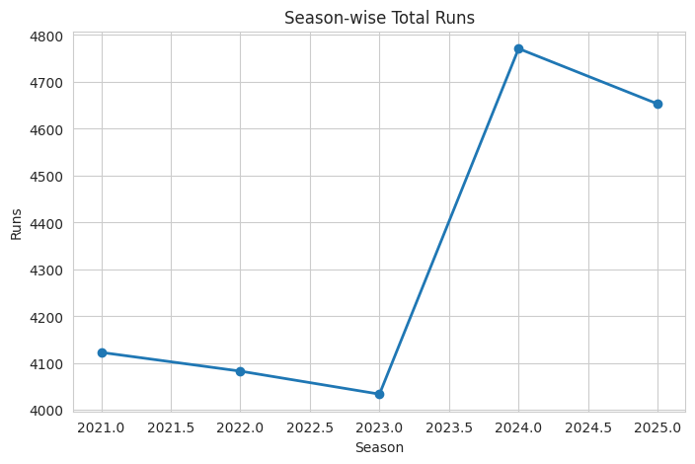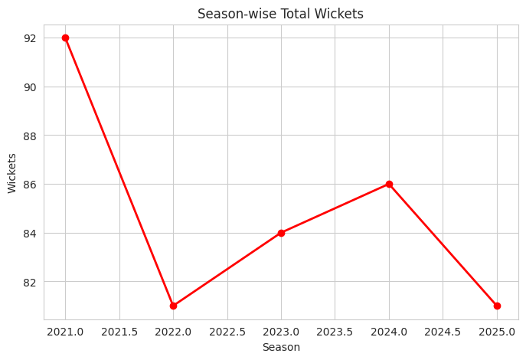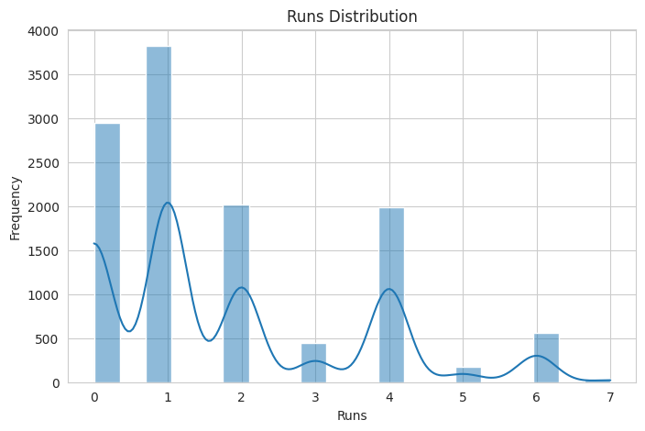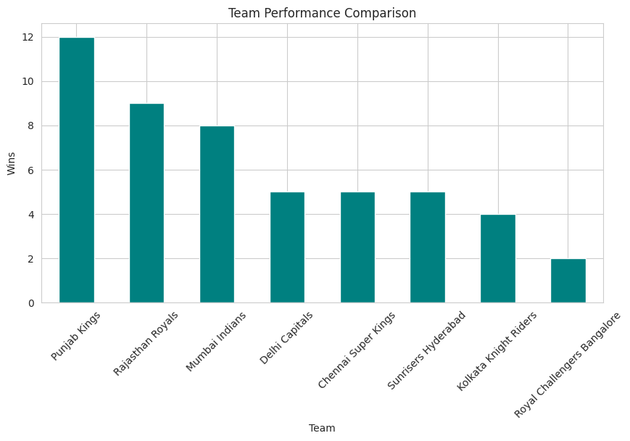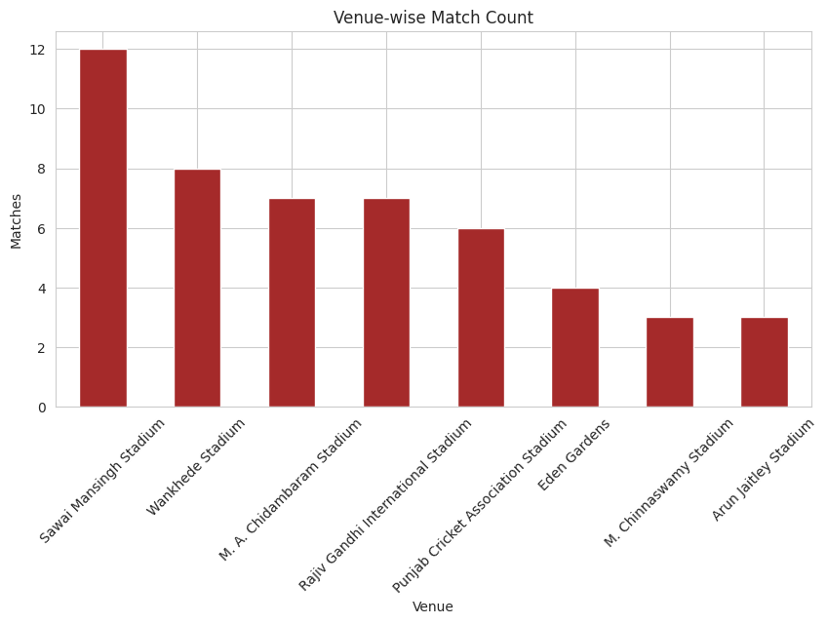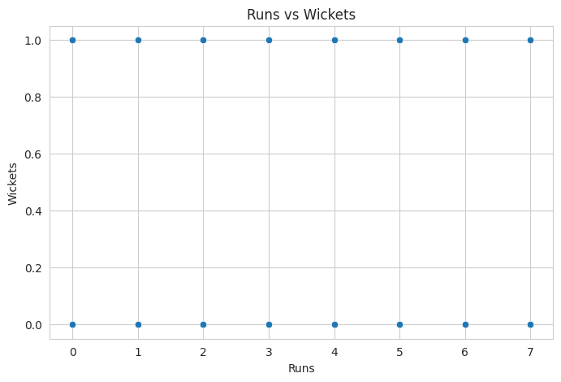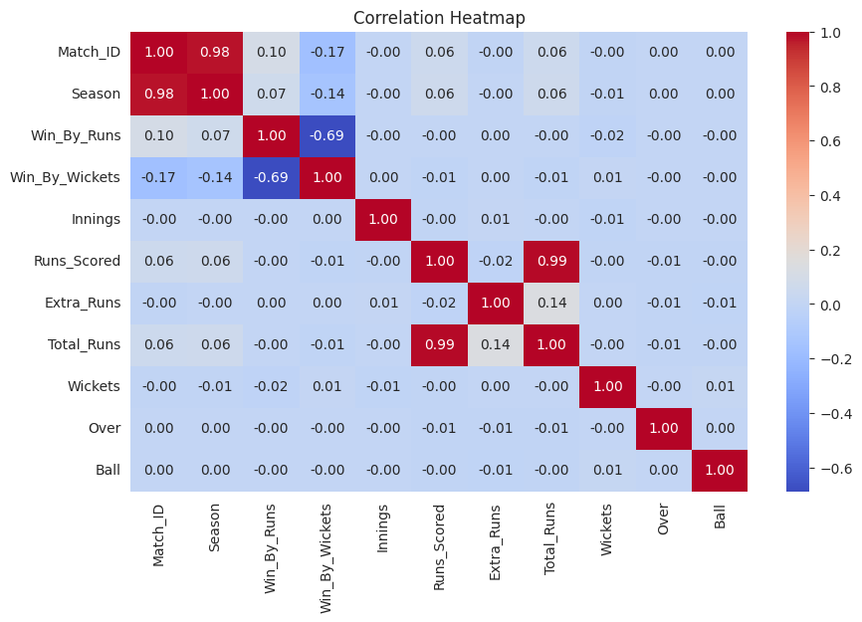

Power BI Dashboard Screenshot

The dashboard is designed around KPI cards, season and team performance charts, player leaderboards, venue and toss analysis, a team-performance matrix, and Season/Team/Venue slicers. The accompanying Power BI guide provides the DAX measures, visual field mappings and recommended layout.
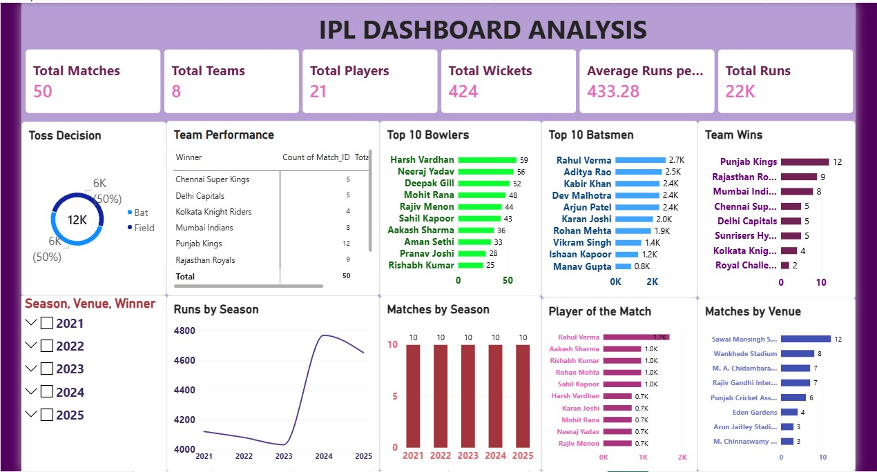

Key Insights

  - The sample contains 50 matches across 5 seasons.
  - Punjab Kings has the highest number of wins in this synthetic sample.
  - Rahul Verma received the most Player of the Match awards in the sample.
  - Rahul Verma is the leading run scorer in the sample.
  - Harsh Vardhan has the highest wicket total in the sample.
  - Sawai Mansingh Stadium is the most frequently used venue in the sample.
  - Field is the most common toss decision.
  - The toss winner also won 54.00% of matches in this sample.
  - Season 2024 records the highest total runs in the sample.
  - Rajasthan Royals has the highest average runs per match among teams in the sample.

Conclusion

This project demonstrates an end-to-end sports analytics workflow: loading raw data, checking and cleaning data quality, calculating match and player statistics, creating visualizations, and preparing an interactive Power BI dashboard. The same workflow can be reused with an actual IPL dataset. When real data is substituted, all reported figures and conclusions should be regenerated from that dataset.

