***DOCUMENTATION***

***ASSIGNMENT#1***

*Subject: WEB ENGINEERING*

*Name: Rameen Aamir*

*Class: BSCS 11-A*

CMS ID-368788

**MAIN PAGE DISPLAYING FACTS**

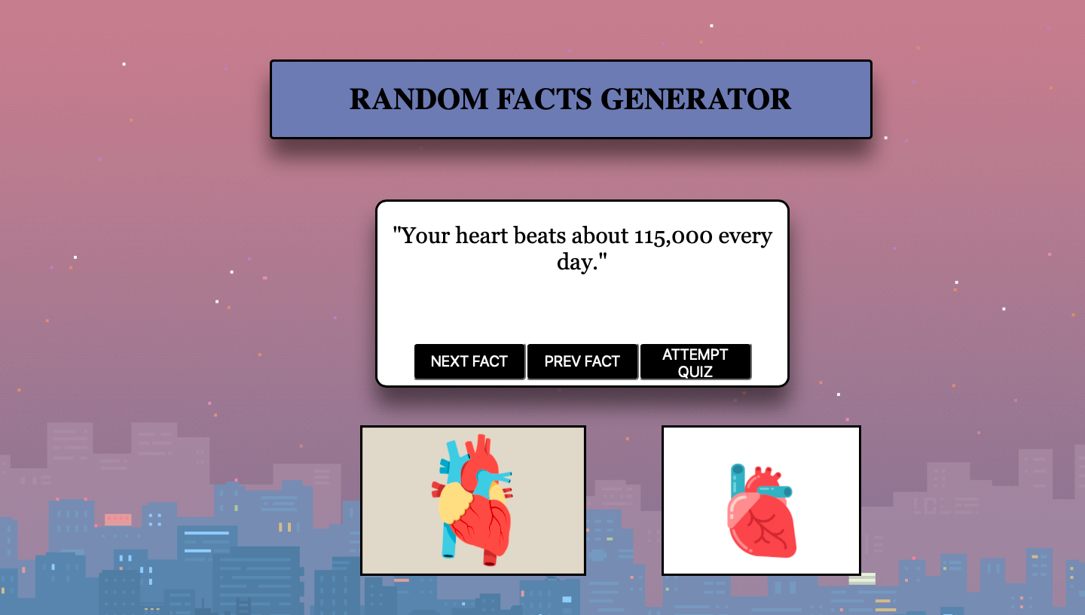

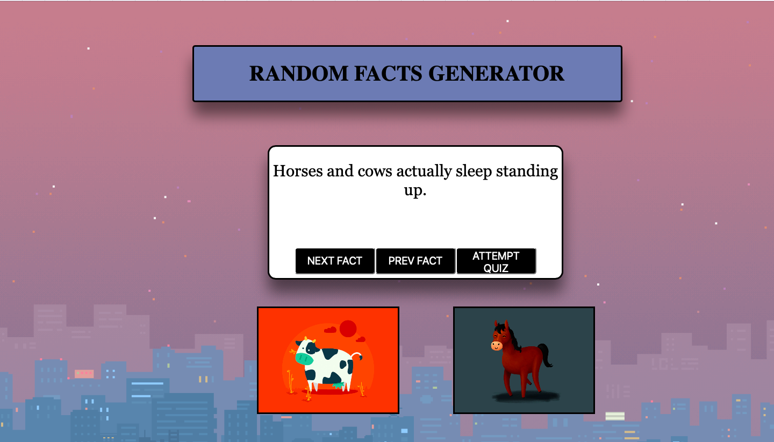

* **This is the main page that displays the facts along with visuals for better understanding.**
* **It has three buttons:**
* **NEXT:This displays the next fact.**
* **Prev:This displays the previous fact.**
* **Attempt Quiz:This takes you to the page to attempt the quiz.**

**QUIZ INSTRUCTIONS PAGE:**

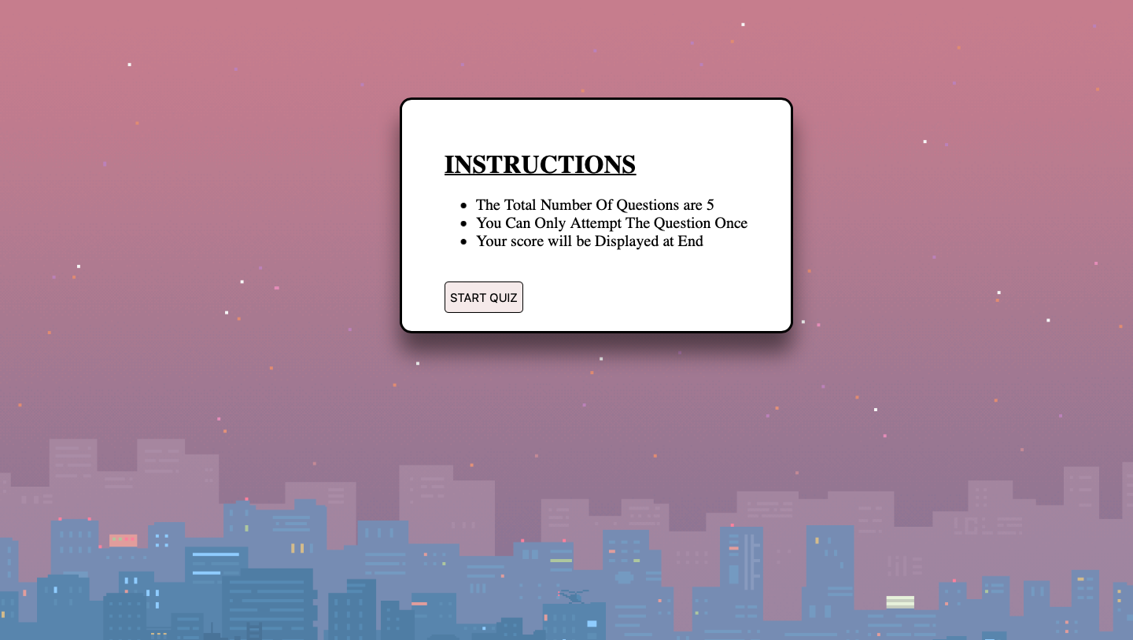

**This page contains instructions for attempting the quiz.**

**MAIN QUIZ PAGE:**

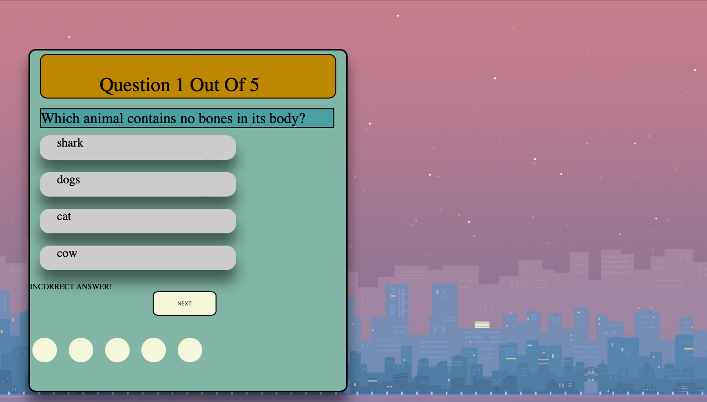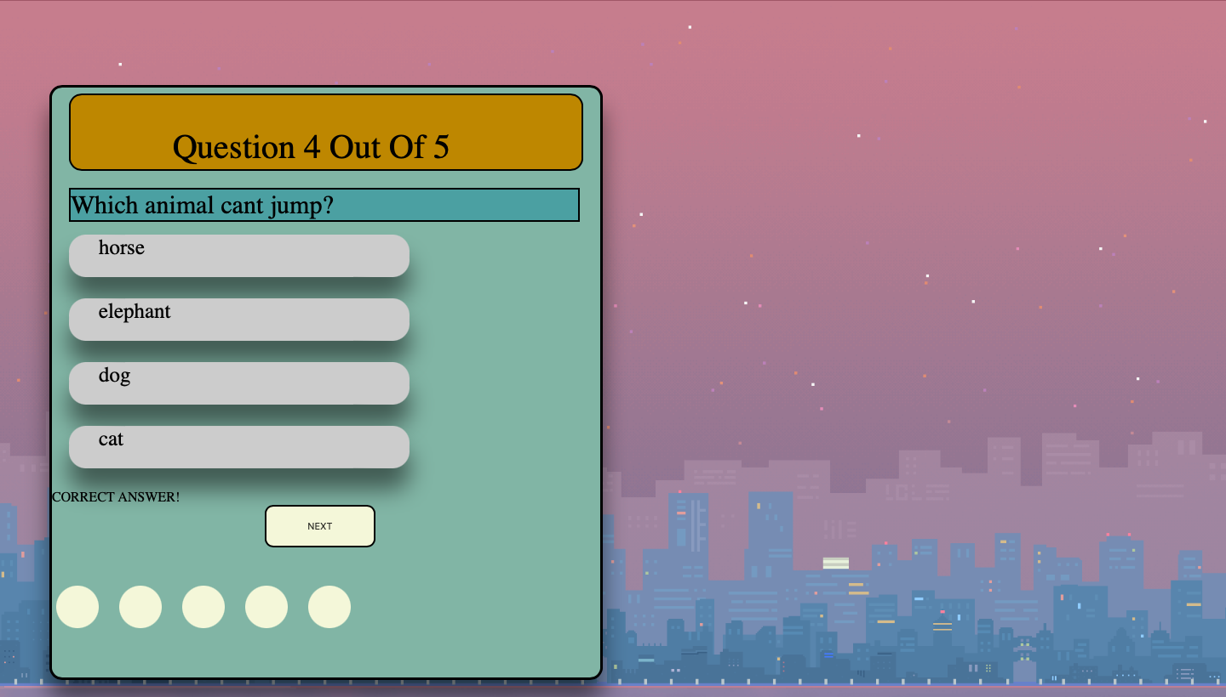

**This page displays random questions out of the pool of questions and takes the quiz.**

**RESULTS PAGE:**

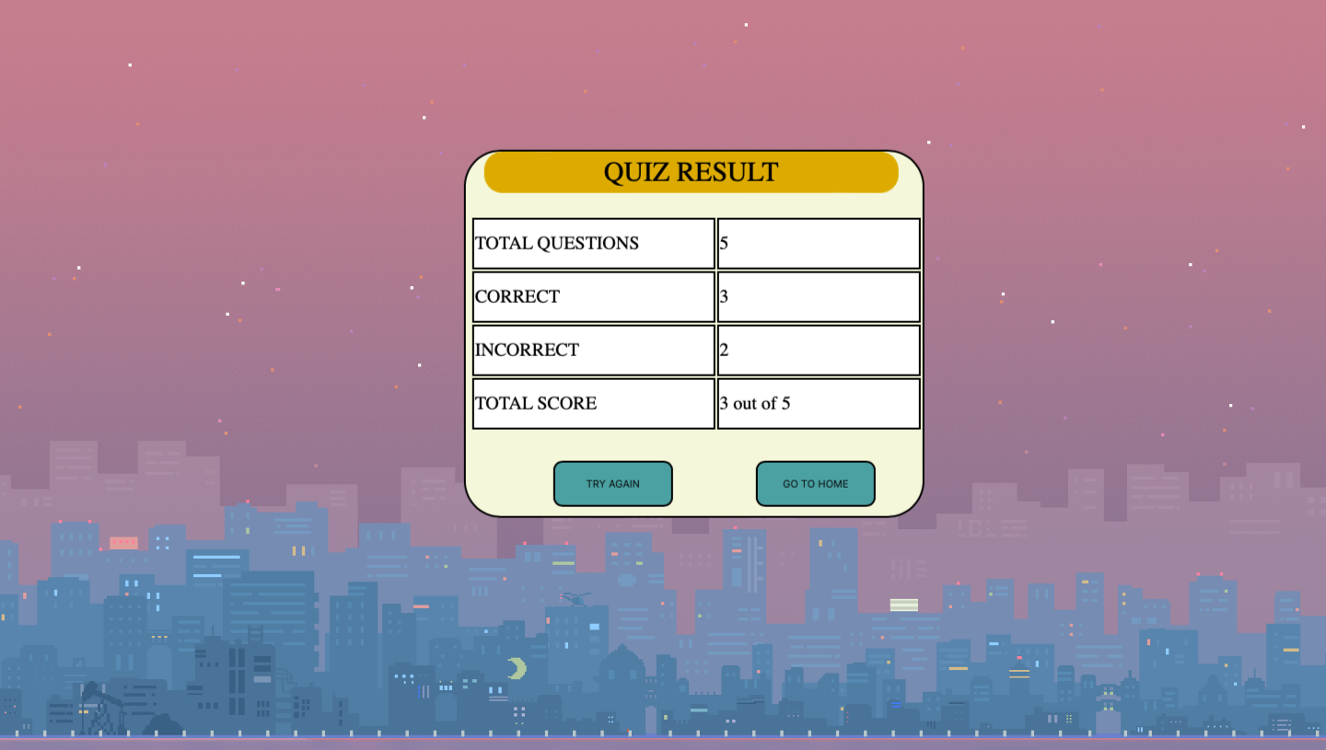

**This page displays the final result after attempting the quiz**

**NOTE: A VIDEO FOR FURTHER EXPLANATION IS ALSO INCLUDED IN ZIP FILE**