

National University Of Science And Technology (NUST)
Military College of Signals (MCS)

Final Year Project

Software Requirements Specification

For
Ignis Vision
1.2

Members:
Rimsha Irfan (Group Lead)
Mishal Tariq
Rameen Kashif
Hesan Mustafa

Supervisor:
Dr Ayesha Naseer

Date of Preparation:
29 September,2026

Supervisor Name : Dr Ayesha Naseer

Signature:____________________

Revision History
Name | Date | Reason for Changes | Version
Rameen  Kashif | 22 September, 2026 | Initial draft  Architecture, camera hardware, datasets, and system features finalized for SRS presentation | 1.0
Hesan  Mustafa | 27 September 2026 | Updated web app specifications, incident command features, backend stack, SDGs, and glossary terms | 1.1
Mishal  Tariq | 2 October ,  2026 | Refined Section 1 (Introduction, Purpose, Scope), Expanded Section 4 (System Features) with full use-case specifications, posture classification rules, RPI calculations, and Section 5 non-functional requirements | 1.2
Rimsha Irfan | 8 October, 2026 | Overhauled Section 2 (Overall Description) & Section 3 (Interfaces), added new system functions, updated hardware specs, corrected document formatting, and completed final SRS compilation | 2.0

Contents
1 Introduction 9
1.1 Purpose 9
1.2 Document Conventions 9
1.2.1 Main Headings 9
1.2.2 Second Level Subheadings 9
1.2.3 Third Level Subheadings 9
1.2.4 Further Level Subheadings (Level Four) 9
1.2.5 Document Settings 9
1.3 Intended Audience and Reading Suggestions 10
1.3.1 Intended Audience 10
1.3.2 Reading Suggestions 10
1.4 Product Scope 10
1.4.1 Purpose 11
1.4.2 Benefits 11
1.4.3 Objectives And Goal 11
1.4.4 Business Strategies 11
1.5 References 12
2 Overall Description 13
2.1 Product Perspective 13
2.1.1 System Architecture Diagram 13
2.1.2 Use Case Diagram 14
2.2 Product Functions 15
2.2.1 Thermal Human Detection 15
2.2.2 Posture Classification & Rescue Priority Index 15
2.2.3 Voice AI Assistant 15
2.2.4 Building Structure and Zone Risk Analysis 15
2.2.5 Simulation Trainer 15
2.2.6 Incident Management Dashboard 15
2.2.7 User Authentication and System Administration 15
2.3 User Classes and Characteristics 16
2.3.1 Field Responder (Primary) 16
2.3.2 Incident Commander (Primary) 16
2.3.3 Trainee / Training Staff (Secondary) 17
2.3.4 System Administrator (Secondary) 17
2.4 Operating Environment 18
2.4.1 Hardware Platform 18
2.4.2 Operating System 18
2.4.3 Web Browsers 19
2.4.4 Internet Availability 19
2.4.5 Coexistence with Other Software 19
2.5 Design and Implementation Constraints 20
2.5.1 Offline-First Mobile Requirement 20
2.5.2 Hardware Limitations 20
2.5.3 Training Data 20
2.5.4 Bilingual Requirement 20
2.5.5 Security Considerations 21
2.5.6 UI/UX 21
2.5.7 Design Conventions and Programming Standards 21
2.6 User Documentation 21
2.6.1 User Manual 21
2.6.2 Quick Start Guide 22
2.6.3 Online Help 22
2.7 Assumptions and Dependencies 22
2.7.1 Assumptions 22
2.7.2 Dependencies 22
3. External Interface Requirements 24
3.1 User Interfaces 24
3.1.1 Components 24
3.1.2 Logical Characteristics 25
3.1.3 Initial User Interfaces 26
3.2 Hardware Interfaces 29
3.2.1 User Devices 29
3.2.2 Thermal Imaging Camera 29
3.2.3 Phone Camera 30
3.2.4 Speakers 31
3.2.5 Server 31
3.3 Software Interfaces 31
3.3.1 Operating Systems 31
3.3.2 Mobile Application Framework 31
3.3.3 Web Application Frameworks 31
3.3.4 AI/ML Models and Libraries 32
3.3.5 Databases 33
3.3.6 Real-Time Communication Service 33
3.3.7 Data Upload Service 33
3.3.8 API Documentation 33
3.4 Communication Interfaces 33
3.4.1 USB / UVC 33
3.4.2 HTTP/HTTPS & RESTful APIs 34
3.4.3 Connectivity-Based Application Use 34
3.4.4 Data Upload from the Mobile Application 35
3.4.5 Communication Security 35
4 System Features 36
4.1 Thermal Human Detection 36
4.1.1 Description and Priority 37
4.1.2 Stimulus/Response System 37
4.1.3 Functional Requirements: 37
4.2 Posture Classification 37
4.2.1 Description and Priority 38
4.2.2 Stimulus/Response Sequences 38
4.2.3 Functional Requirements 38
4.3 Rescue Priority Index 39
4.3.1 Description and Priority 39
4.3.2 Stimulus/Response Sequences 39
4.3.3 Functional Requirements 40
4.4 Voice AI Assistant 40
4.4.1 Description and Priority 40
4.4.2 Stimulus/Response Sequences 41
4.4.3 Functional Requirements: 41
4.5 Building Structure And Zone Risk Analysis 41
4.5.1 Description and Priority 42
4.5.2 Stimulus/Response Sequences 42
4.5.3 Functional Requirements 42
4.6 Simulation Trainer 43
4.6.1 Description and Priority 43
4.6.2 Stimulus/Response Sequences 43
4.6.3 Functional Requirements: 43
4.7.1 Description and Priority 44
4.7.2 Stimulus/Response Sequences 44
4.8 User Authentication And System Administration 45
4.8.1 Description and Priority 46
4.8.2 Stimulus/Response Sequences 46
4.8.3 Functional Requirement: 46
5. Other Nonfunctional Requirements 47
5.1 Performance Requirements 47
5.1.1 Response Time 47
5.1.2 Throughput 47
5.1.3 Scalability 47
5.1.4 Resource Utilization 47
5.2 Safety Requirements 48
5.2.1 Data Protection 48
5.2.2 System Stability 48
5.2.3 Operational Safety 48
5.3 Security Requirements 49
5.3.1 Authentication and Authorization 49
5.3.2 Data Security 49
5.3.3 System Security 49
5.3.4 Thermal Footage and Incident Data Protection 49
5.4 Software Quality Attributes 50
5.4.1 Reliability 50
5.4.2 Usability 50
5.4.3 Maintainability 50
5.4.4 Portability 50
5.4.5 Interoperability 50
5.4.6 User Experience & Accessibility Requirements 51
5.5 Business Rules 52
5.5.1 Access Control Rules 52
5.5.2 Processing Rules 52
5.5.3 Data Retention Rules 53
5.5.4 Security Rules 53
6 Sustainable Development Goals (SDGs) 54
6.1 SDG 3 – Good Health and Well-being 54
6.2 SDG 9 – Industry, Innovation, and Infrastructure 54
6.3 SDG 11 – Sustainable Cities and Communities 54
6.4 SDG 17 – Partnerships for the Goals 54
7 Project Timeline 55

1 Introduction

1.1 Purpose
This document describes the software requirements for the development of project, ”Ignis Vision” , based on its Version 1.0. Ignis Vision is an AI-powered fire incident response system , that is developed in partnership with Rescue 1122 (Punjab Emergency Service) that detects human using thermal imaging , classifies their posture and prioritize victim by calculating Rescue Priority Index (RPI) in smoke affected , low visibility environments. It also classifies building zones into safe ,unsafe , and critical to assist fire fighters in making decisions and finding a safe path to victim’s rescue . The purpose of this document is to provide a complete , clear and unambiguous guide for the development team, project supervisor and evaluation committee serving as a baseline for all stakeholders on the project’s scope , functionality, features and quality standards

1.2 Document Conventions
The document is created using IEEE 29148 For Software requirements Specification

1.2.1 Main Headings
Format: uses Single digit number followed by the name of section(Times New Roman, size 16)

1.2.2 Second Level Subheadings
Format: Same number as the main heading it is under followed by one dot and subheading number followed by the name of subsection(Times New Roman, size 14)

1.2.3 Third Level Subheadings
Format: Sames rules as second level subheadings for number followed by name of section (Times New Roman , size 14)

1.2.4 Further Level Subheadings (Level Four)
Format: Font (Times New Roman, size 13)

1.2.5 Document Settings
- Font Size: 12pt , Times New Roman
- Margins:1’
- Line Spacing:1.5 lines

1.3 Intended Audience and Reading Suggestions

1.3.1 Intended Audience
- Developers
- Project Supervisor
- Rescue 1122 stakeholders
- UG Project Evaluation Team
- Testers

1.3.2 Reading Suggestions
The SRS begins with title and list of table of contents , All level 1 , level 2 , level 3 headings are given in the table of content, further subheadings are excluded .Each primary headings is followed by few subheadings
The product overview is provided in the beginning , followed by all the features , covering both functional and non-functional requirements as well as interface requirements. SRS concludes with appendices including a glossary

1.4 Product Scope
Ignis Vision is a dual-application AI fire incident response system developed in partnership with Rescue 1122 (Punjab Emergency Service). It consists of a lightweight, fully offline Android mobile application and a web application used when internet connectivity is available.
The mobile application is the field responder’s tool and the only application connected to the thermal imaging camera. It works in all conditions, with or without internet. Using a lightweight YOLO-family detection model running on the phone, it detects humans in smoke-filled, low-visibility environments and classifies each person’s posture as standing, sitting, lying or bending It then prioritizes victims by calculating a Rescue Priority Index (RPI). The mobile application supports two input modes: live video, where the thermal camera feed is analysed continuously while the responder moves, and still image, where a single thermal image captured from the camera or imported from the device is analysed. Results are shown on screen and given as spoken alerts.
The web application is used at the command post on desktops and laptops, and on mobile browsers, whenever internet is available. It does not display live thermal video. Instead, it analyses live RGB video from a phone’s camera to classify building zones as safe, caution, unsafe or blocked, using a YOLO-family segmentation model and SegFormer-B2. This also includes analysis of thermal images and video uploads along with an Incident Command Dashboard, Simulation Trainer, Incident Reports, and System Administration.

The two software applications have support for both English and Urdu interfaces, while the mobile application offers alert notifications by voice.
Victim Detection: Detecting and locating humans in thermal imagery, even in smoke-obstructed, low-visibility areas.
Two Input Modes: Live video analysis of the thermal camera feed and still image analysis of single thermal images in the mobile application, and analysis of uploaded thermal images and videos in the web application.
Posture-Based Prioritization: Classifying each person’s posture and prioritizing them by calculating a Rescue Priority Index to direct rescue operations.
Situational Awareness: Building structure and zone risk analysis from live RGB video, and an incident command dashboard for commanders, in the web application.
Training: A simulation trainer so responders can practise zone and posture classification against real incidents.
This project is a self-contained product made for a specific organizational partner (Rescue 1122) and is not a component of a larger system. It is designed as a scalable solution, with potential for expansion to other emergency service organizations in the future

1.4.1 Purpose
Ignis Vision is a tool that assists the fire fighters in locating the victims and prioritizing their rescue when visibility is low due to smoke during fire accidents. This product helps solve the major problem since manual and visual search is very time-consuming and risky. The system gives field responders and incident commanders a thermal, AI-assisted view of each victim, their posture, their priority and their location, together with an assessment of structural risk in the building.

1.4.2 Benefits
- Victims can be located quickly in smoke-filled, low-visibility environments.
- Objective, priority-based rescue using the Rescue Priority Index.
- Fully offline field operation through the mobile application, so victim detection remains available even with no internet connection during an incident.
- Usage flexibility via live streaming for constant scans whether moving or not, and still shots for close study.
- Hands-off operation via vocal cues so that rescuers need not look at the screen.
- Bi-lingual (English/Urdu) user interfaces for improved usability by local rescue teams.
- A web-based application for command level situational awareness and structural risk assessment, as well as training and incident review.

1.4.3 Objectives And Goal
The primary objective is to build a reliable, fully offline mobile application that offers thermal victim detection in live video and still image modes, posture classification, Rescue Priority Index calculation and spoken alerts. Alongside it, the project will build a web application that offers building structure and zone risk analysis from live RGB video, analysis of uploaded thermal images and videos, an incident management dashboard and a simulation trainer. The ultimate goal is to measurably reduce victim search and locate time during fire incidents, in partnership with Rescue 1122

1.4.4 Business Strategies
Ignis Vision’s strategy is built on a formal research partnership with a government emergency service organization (Rescue 1122) under an HEC-funded NRPU grant. This ensures the system is validated against real operational requirements rather than developed in isolation. The dual-application architecture gives each application a clear purpose: the mobile application handles all thermal victim detection in the field and meets responders’ strict offline requirement, while the web application provides structure analysis, incident management, training and review whenever internet is available

1.5 References
- IEEE Guide for Software Requirements Specification https://ieeexplore.ieee.org/document/278253/
- IEEE SRS Template
https://dspmuranchi.ac.in/pdf/Blog/srs_template-ieee.pdf
- SDT Dataset (TU Wien)
https://cvl.tuwien.ac.at/research/cvl-databases/sdt-icip/
- IPHPDT Dataset Paper (MDPI Sensors 2023, 23(1), 92)
https://www.mdpi.com/1424-8220/23/1/92
- ADE20k Dataset
ADE20K dataset
- PEER HUB ImageNet φ-Net PEER Hub ImageNet – Φ-Net
- SDNET2018 Concrete Crack Detection
GitHub - mukul-mschauhan/Structural-Defects: Building artificial intelligence-based crack detection algorithms for concrete structure · GitHub
- Received Data from Emergency & Disaster Management Directorate Cda

2 Overall Description

2.1 Product Perspective
Ignis Vision is an independent system aimed at solving an operational issue faced by Rescue 1122: locating and prioritizing victims inside smoke-filled structures during active fire incidents. The system does not belong to any larger system or product line.
The system consists of two products. The mobile application (Flutter, offline-first) is the only application connected to the thermal camera. Field responders use it in all conditions, with or without internet, for thermal human detection (live video and still image), posture classification, RPI and voice alerts. The web application (React frontend, FastAPI backend, PostgreSQL database) is used when internet is available, on desktops/laptops at the command post and on mobile browsers. It provides building structure and zone risk analysis from live RGB video captured with a phone’s camera, analysis of uploaded thermal images and videos, incident management, the simulation trainer, reports and administration. The web application does not display live thermal video.

2.1.1 System Architecture Diagram
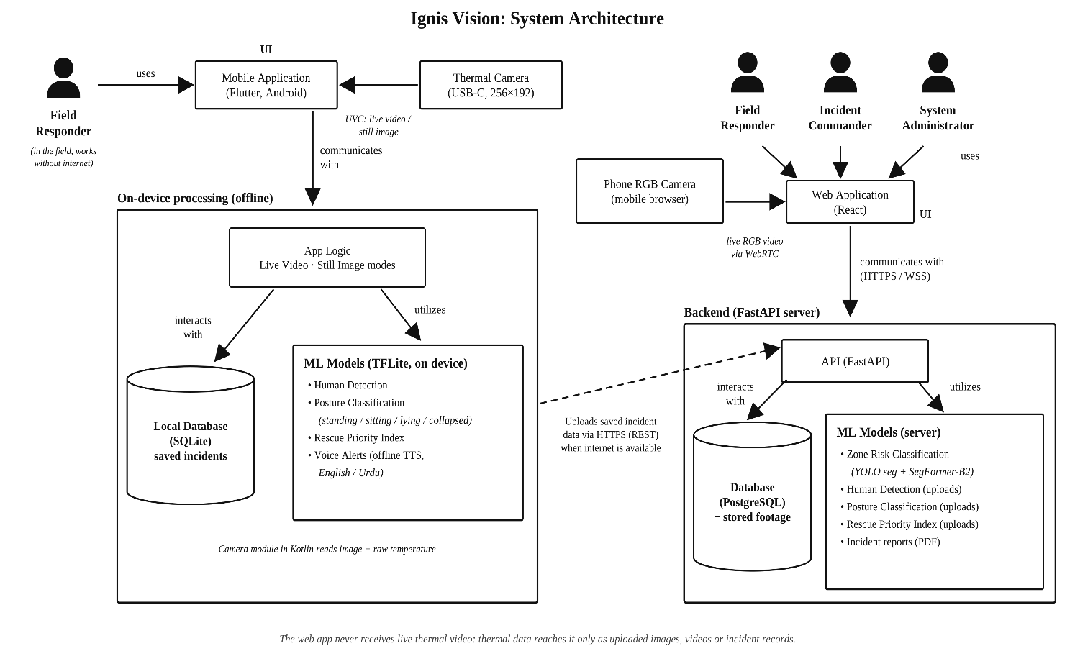
Figure 1. System Architecture Diagram of Ignis Vision showing the web application and the standalone offline mobile application.

2.1.2 Use Case Diagram
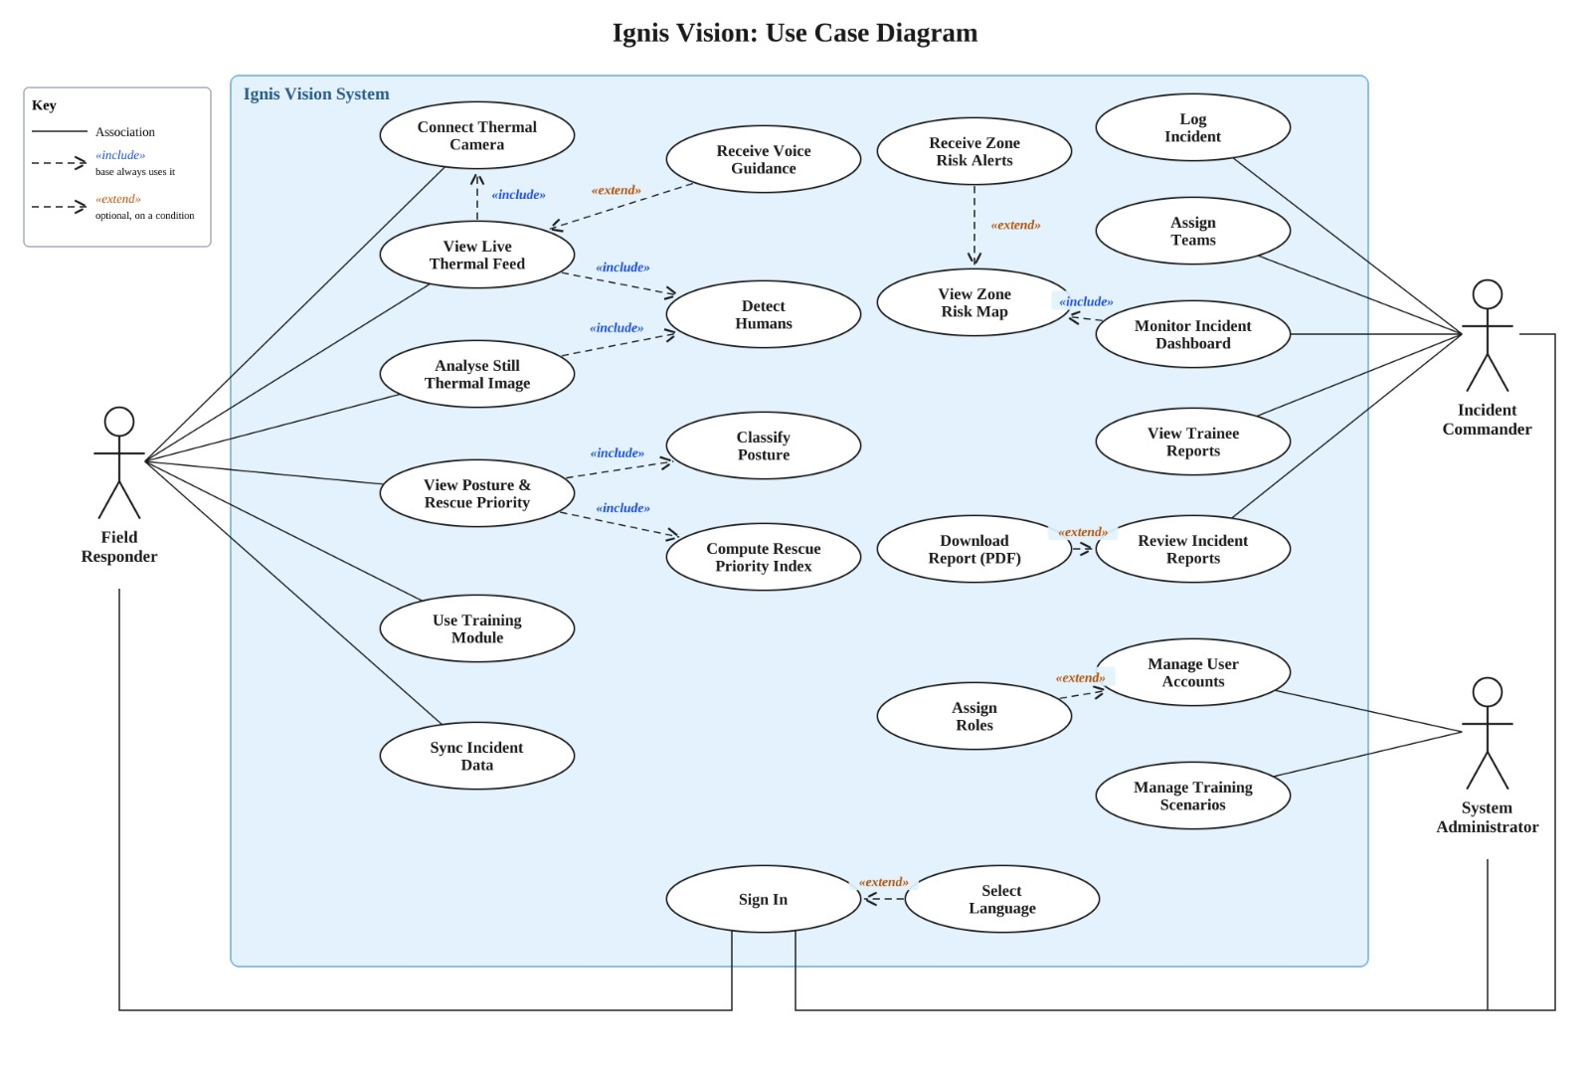

2.2 Product Functions
The primary functions of Ignis Vision are based on real-time thermal victim detection and prioritization, extended by full incident-management functionality on the web platform. The following is an overview of the main product functions:

2.2.1 Thermal Human Detection
Detects humans in live thermal camera video stream or in still images (2 modes supported) including situations in which smoke obscures the vision of normal cameras.

2.2.2 Posture Classification & Rescue Priority Index
Classification of posture of each individual along with calculating priority index value which represents the urgency for rescue of the individual. Develop a mathematical formula for Rescue Priority Index (RPI) which will take into account the posture, location, and environmental risks of the victim.

2.2.3 Voice AI Assistant
Provides oral and bilingual (English/Urdu) navigation guidance to the field responder and incident commander according to the real-time detection and priority.

2.2.4 Building Structure and Zone Risk Analysis
Classifies the level of risk of each building structure zone (safe, caution, unsafe, blocked) to help the incident commander (web application only).

2.2.5 Simulation Trainer
Allows trainees to practice zone and posture classification using real incident videos and compare their decisions with the model's (web application only).

2.2.6 Incident Management Dashboard
Provides an overview to incident commanders to log incidents, allocate teams and zones, monitor zone risk in real time and review victim detections uploaded from the mobile application and read the report of incidents (web application only).

2.2.7 User Authentication and System Administration
Demands authentication of all users and provides access to features related to that role only for the user. The System Administrator creates and maintains the user accounts, roles, training scenarios, and the status of the system.

2.3 User Classes and Characteristics
Ignis Vision has four user classes. The Field Responder and the Incident Commander are the primary user classes, since the system was built mainly for them. The Trainee and the System Administrator are secondary user classes that support training and day-to-day running of the system.

2.3.1 Field Responder (Primary)
Characteristics
The Field Responder is a Rescue 1122 firefighter who enters a smoke-filled building with a smartphone and the thermal camera attached to it. They use the offline mobile application with the thermal camera in all conditions, whether or not internet is available.
Field Responders use the system only during active fire incidents, but in those moments it is used continuously. They are trained in rescue operations but are not expected to have any technical background. They do not have free hands and their vision might be poor so they depend on spoken voice alerts from the system rather than looking at the screen. Such an interface should be simple and straightforward and include large buttons and as little reading as possible.
Privileges
Mobile application (thermal, always available):
- View the live thermal feed, or analyse a still thermal image, with detected victims marked.
- See each victim’s posture and RPI ranking.
- Receive spoken alerts in English or Urdu.
Web application on a mobile browser (when internet is available):
- Capture live RGB video of zones for structure analysis.
- View the zone risk map and receive alerts when a nearby zone becomes unsafe or blocked.

2.3.2 Incident Commander (Primary)
Characteristics
The Incident Commander is the senior Rescue 1122 officer in charge of an incident. They use the web application, usually on a laptop or desktop at the command post, and sometimes on a mobile browser. Internet connectivity is required.
The Incident Commanders will utilize this application throughout each incident and even when no incident is ongoing for purposes of reviewing reports and conducting training sessions. They are familiar with emergency situations and computer skills although they are not necessarily technical experts. They require a dashboard providing vast amounts of information fast and efficiently and can be understood quickly when under pressure.
Privileges
- Enter the record of new incidents with location and building details.
- Create building zones and allocate team to each zone.
- View the zone risk map, zone alerts and, where available, live RGB zone video from web sessions. Review recorded thermal footage and victim detections uploaded from the mobile application after the incident.
- Get an alert if the zone becomes unsafe or blocked.
- Download incident reports.
- Enter simulation trainer and get trainee reports.

2.3.3 Trainee / Training Staff (Secondary)
Characteristics
This class includes new Rescue 1122 recruits and the staff who train them. They use the simulation trainer in the web application, outside of real incidents, to practice classifying zone risk and victim posture. Usage is occasional, depending on the schedule of training. The trainees do not have much experience with the system, and therefore require feedback on what they did well and what was wrong.
Privileges
- Select and attempt training scenarios.
- Submit their own zone and posture classifications.
- Compare their answers with the model's output and see feedback.
- View their own past training results. Training staff can view the results of all trainees.
Recording of incidents, assigning the teams, viewing the incident dashboard, and checking incident reports is not possible for trainees.

2.3.4 System Administrator (Secondary)
Characteristics
System Administrator is one of the team members of the project team or the designated Rescue 1122 IT personnel who take care of the web application. The system administrator uses the system only at rare occasions, particularly when it comes to its installation and troubleshooting. Unlike the other classes, they are expected to have good technical knowledge.
Privileges
- Create, edit, and deactivate user accounts.
- Assign roles (Field Responder, Incident Commander, Trainee, Training Staff).
- Add or update training scenarios.
- Monitoring system status and logs.
The System Administrator does not take part in incident operations and does not make rescue decisions.

2.4 Operating Environment
Ignis Vision runs in two environments: a web application used when internet is available, and an offline mobile application used for all thermal detection. Only the mobile application connects to the thermal camera.

2.4.1 Hardware Platform
- Smartphone: An Android-based smartphone with a USB-C port that has USB OTG functionality to plug in the thermal camera. As the detection model is run using the mobile app on the phone itself, it would require a mid-range or above mobile phone.
- Thermal camera: A USB-C, UVC-compliant thermal imaging camera in the 256×192 resolution class. The camera has not been purchased yet, and the final model will be confirmed later (see Appendix B). The camera is used only with the mobile application.
- Computer: A desktop or laptop at the command post or office, used to access the web application through a browser.
- Server: A machine that runs the web application's backend, database, and detection model for web sessions. The server hardware and hosting arrangement have not been finalized yet and will be decided at the time of deployment (see Appendix B).

2.4.2 Operating System
- Mobile application: Android 9.0 and above.
- Web application (client side): Windows, macOS, and Linux on computers, and Android on smartphones, through a supported web browser.
- Server: The operating system of server will depend on the final hosting choice. A Linux-based system such as Ubuntu is the expected choice, since it is the most common environment for Python and FastAPI applications.
iPhones and iOS are not supported. iPhones do not support external UVC cameras, even on models with a USB-C port, so the thermal camera cannot be connected to them. iPads are also not supported in this version.

2.4.3 Web Browsers
The web app is compatible with the last two versions of the following browsers:
- Google Chrome for desktop and Android platforms
- Mozilla Firefox for desktop
- Microsoft Edge for desktop
There may be other browsers that can be used, however, their compatibility is not officially tested. As the web application uses access to the camera, it has to be launched using HTTPS protocol.

2.4.4 Internet Availability
The web application needs an internet connection, through Wi-Fi or mobile data. The mobile application needs no internet at all, except for the one-time first sign-in and for uploading saved incident data later.

2.4.5 Coexistence with Other Software
Ignis Vision needs to function alongside other applications/services that are installed on the user's phone/desktop without any glitches:
- Access to Camera: Only one application can use the thermal camera at one point in time. In case another application uses it, Ignis Vision would show an error message rather than crashing down.
- Text-to-Speech Engine: The voice guide in the mobile application relies on the text to speech engine available in the cell phone and which requires offline voices for English and Urdu languages.
- Phone calls/Audio: Voice guidance must not prevent incoming calls as responders might be required to communicate with their teammates during rescue.

2.5 Design and Implementation Constraints

2.5.1 Offline-First Mobile Requirement
The mobile application must run detection, posture classification, RPI calculation, and voice guidance entirely on the phone, with no network connection at all. This is the main constraint behind the mobile application's design. It rules out any cloud-based model, cloud text-to-speech, or online database in the mobile application.

2.5.2 Hardware Limitations
- Phone processing and memory: The detection algorithm needs to operate on an Android device and not on a computer. This is because the Android phone has much lower memory and processing capabilities when compared to a computer. It is for this reason that the mobile app relies on the nano version of YOLO-family detection model-pose, converted to TensorFlow Lite and quantized to reduce its size.
- Thermal camera:
    - The system depends on a USB-C, UVC-compliant thermal camera connected to the phone's USB-C port, so the phone must support USB OTG.
    - The camera's resolution (256×192 class) limits how much detail the model can see, especially for people far from the camera.

2.5.3 Training Data
The models are trained on publicly available datasets.
Human detection and posture classification: The SDT and IPHPDT thermal datasets are used. They are limited in size and were not recorded in real fire conditions, so model performance in actual fires cannot be fully confirmed until Rescue 1122 field data is available for fine-tuning.
Building structure and zone risk analysis: The following datasets are used:
- ADE20K, for understanding indoor scenes and building elements.
- PEER Hub ImageNet (Φ-Net), for structural damage recognition.
- SDNET2018, for concrete crack detection.
No public dataset exists for fire-damaged buildings or for structures in active fire conditions. To fill this gap, the team will create simulated fire scenarios for training and testing. This is a known limitation, since simulated data may not fully match what a building looks like during a real fire.

2.5.4 Bilingual Requirement
Both applications and the voice assistant must support English and Urdu on all screens and in all spoken guidance. Since Urdu is written right to left, screen layouts must display Urdu text correctly. Offline Urdu voice guidance also depends on the quality of the Urdu voice available on the phone.

2.5.5 Security Considerations
- Browsers only allow camera access on secure (HTTPS) pages, so the web application must always be served over HTTPS.
- All data sent between the browser and the backend, including incident data sent later from the mobile application, must be encrypted.
- Incident data must be handled according to Rescue 1122's data handling policies.

2.5.6 UI/UX
- Field Responder: he interface should be limited and almost entirely voice-based because the hands and eyes of the field responder are occupied
- Incident Commander: The dashboard will display all the important information but it should be organized for quick look of scanning under pressure.
2.5.7 Design Conventions and Programming Standards
- Style guides: Every language is to adhere to its style guide of coding: Python PEP 8, Flutter (Dart), React.
- Version Control: All codes should be version controlled using Git workspace.
2.6 User Documentation

2.6.1 User Manual
A complete manual in PDF format, covering:
- How to connect the thermal camera to the phone and give the required permissions.
- How to use the mobile application and the web application, on both computers and mobile browsers.
- When to use each application, depending on internet availability.
- How to read the detection screen, posture labels, RPI colors, and zone risk map.
- How incident data from the mobile application is sent to the web application once internet is available.
The manual will have separate sections for Field Responders, Incident Commanders, and Trainees, which will be allowing users to access their specific sections directly.

2.6.2 Quick Start Guide
A brief one or two-page document, applicable to Field Responders only, containing only basic instructions to connect the camera, launch the appropriate application, and start the detection. This is designed to be rapidly reviewed prior to deployment in the field and can be printed out along with the hardware.

2.6.3 Online Help
A help section inside the web application, where Incident Commanders and Trainees can look up how to use each screen without leaving the application.

2.7 Assumptions and Dependencies
2.7.1 Assumptions
The following are assumed to be true. If any of them turn out to be wrong, some requirements in this SRS may need to change.
- Thermal camera An appropriate thermal camera (InfiRay P2 Pro or alternative) can be acquired which allows accessing not only its video feed but also its raw temperature data.
- Detection through smoke: The thermal camera is able to detect people even through smoke. Very hot surfaces, flames, or heavy obstructions may reduce accuracy.
- Training data: The available public datasets, together with simulated fire scenarios, are enough to train initial models for human detection, posture classification, and building structure analysis.
- Offline Urdu voice: Responders' phone have an Urdu text-to-speech voice that works offline.
- Internet at the command post: The command post or office has a reliable internet connection for the web application.
- User training: Responders and commanders will receive training on how to use the system before using it in real incidents.
- First sign-in: Each responder signs in to the mobile application once with internet available before using it offline in the field.
2.7.2 Dependencies
The project depends on the following external factors:
- Rescue 1122:
- Providing field data for later fine-tuning of the models.
- Giving feedback during testing.
- Helping set the final RPI weights.
- Thermal camera hardware: The selected camera must work with the UVC integration code on Android.
- Open-source projects: The camera integration on the mobile application is adapted from open-source projects (e.g. thermal-camera-android). Any limitations in these projects will affect this system.
- Datasets: The training of model depends on the SDT, IPHPDT, ADE20K, PEER Hub Φ-Net, and SDNET2018 datasets and their usage terms.
- Browser support: The web application depends on browsers allowing access to the phone’s RGB camera over HTTPS.

3. External Interface Requirements

3.1 User Interfaces

3.1.1 Components
The following components need a graphical user interface:
- Splash and Onboarding Screen for both apps: Introductory screen of Ignis Vision. It will be explained briefly when opening the app for the first time.
- Sign-In and Language Selection Screen for both apps: Signs in the user and let them choose English or Urdu
- Live Detection Screen of both app:
- The main screen for Field Responders with two modes selected by large buttons:
  - Live Video: shows the live thermal feed with detected people marked, their posture labels and their RPI priority color.
  - Still Image: lets the user capture a frame from the thermal camera or import a thermal image from the device, then shows the same detections on that image.
  - In the web app, the phone's own camera is also used to capture the surroundings for structure analysis.
- Incident Dashboard (web app): The Incident Commander's main screen, showing the zone map, alerts, and the ranked victim list. Shows the zone map, alerts and, optionally, live RGB zone video from web sessions. Live thermal video is not shown. Thermal footage and detections uploaded from the mobile application appear in the incident record.
- Incident Setup & Team Assignment (Web App): Allows the Incident Commander to enter the incident, assign buildings and zones, and assign teams to zones.
- Structure and Zone Analysis View (web app): Shows the risk level of each zone as safe, caution, unsafe, or blocked, based on images from the phone's camera. Incident Commanders see the full view. Field Responders using the web app on a mobile browser see a simplified version.
- Simulation Trainer (Web App): Allows Trainees to complete the simulation exercise, identify zones and postures, and compare their results with that of the model's output.
- Incident Records & Reports View (Web App): Displays historical records of incidents with the corresponding detection, outcome, and video of the session.
- Data Upload Screen only on mobile app: Lists incidents saved on the phone that haven't been sent yet and let the user send them to the web application once internet is available.
- Admin Panel of web app: Lets the System Administrator manage user accounts, assigning roles, and add training scenarios.

3.1.2 Logical Characteristics
Elements on Every Screen
Every screen after sign-in shows:
- A language switch (English / Urdu).
- A Help button, in both the mobile app and the web app.
- A camera connection indicator on screens that use the camera.
- On the web app, an internet connection indicator.
GUI Standards
Colors:
- Both apps use a high-contrast color scheme that stays readable in low light and smoke.
- Victims are marked red, yellow, or green by RPI priority, the same way in both apps.
- Zone risk levels use their own set of colors, so they are never confused with victim markers.
Labelling with colors: Color is never used as the only cue. Every priority color and zone color always has a label in addition to the color itself, which makes it possible for colorblind users to understand what they are looking at.
Navigation:
- For mobile devices (mobile app and mobile browser version of the web app), navigation is minimized, with big buttons that can easily be pressed even with gloved fingers and in a rush.
- For desktops, navigation in the web app is based on the standard sidebar.
Language and layout: Everything is in the selected language. In case of the selection of Urdu, then everything gets set up in the right-to-left format.
Responsive Design
The application must be responsive for all screen sizes of the desktops, laptops, and mobile phones to function on a mobile browser.
Error Messages
- Error messages must be short, be presented in clear language, shown in the selected language, and must tell the user what to do next. As an example: "Camera disconnected. Verify the connection of cable and reconnect."
- Common errors that must be taken care of clearly:
  - The thermal camera is not connected or is disconnected.
  - Camera permission is denied, for either the thermal camera or the phone's camera.
- The internet connection is lost while using the web app.
- Sign-in fails.
- On the mobile app and the web app on a mobile browser, important errors are also spoken aloud, since the responder may not be looking at the screen.
Help
- Help button: Both apps have a Help button on every screen.
  - In the mobile app, help is stored on the phone so it works offline.
  - In the web application, it links to the online help.
- Onboarding: Both apps have feature to show the onboarding walkthrough on first use, and it can be opened again from settings.
Keyboard Shortcuts
No keyboard shortcuts are required. All functions are available through buttons and menus.

3.1.3 Initial User Interfaces
Following (Figure 3 to Figure 7) are some of the initial user interfaces to provide an idea about the UI and for the assistance of frontend developer.
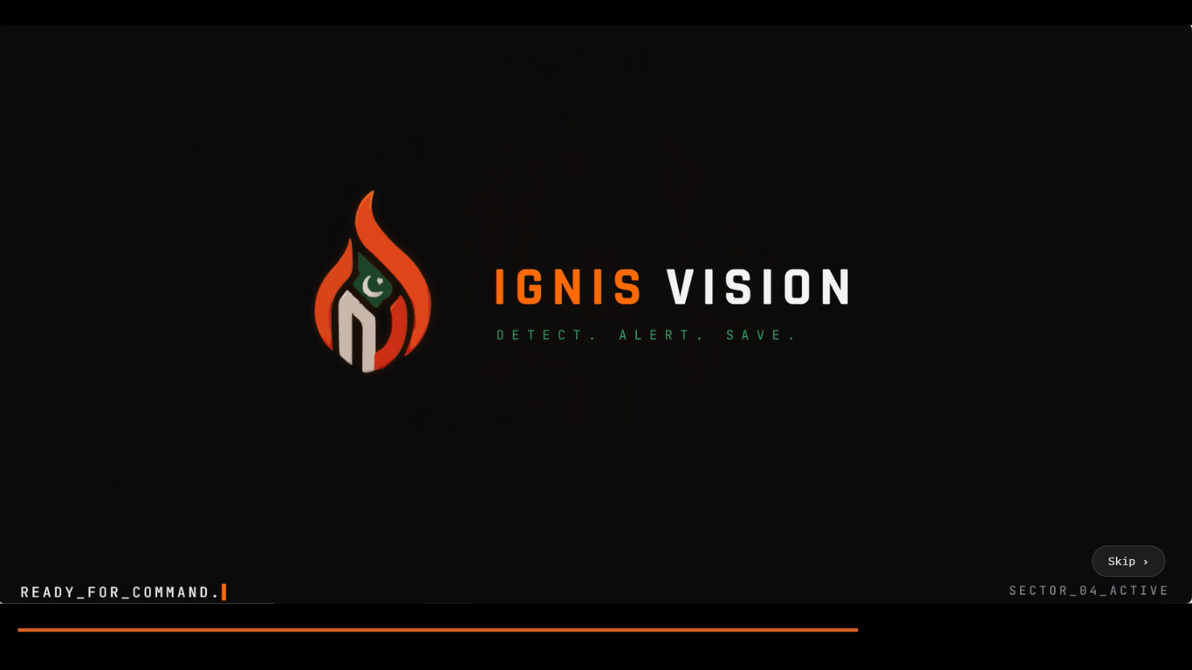
Figure 3. Splash Screen for Ignis Vision application
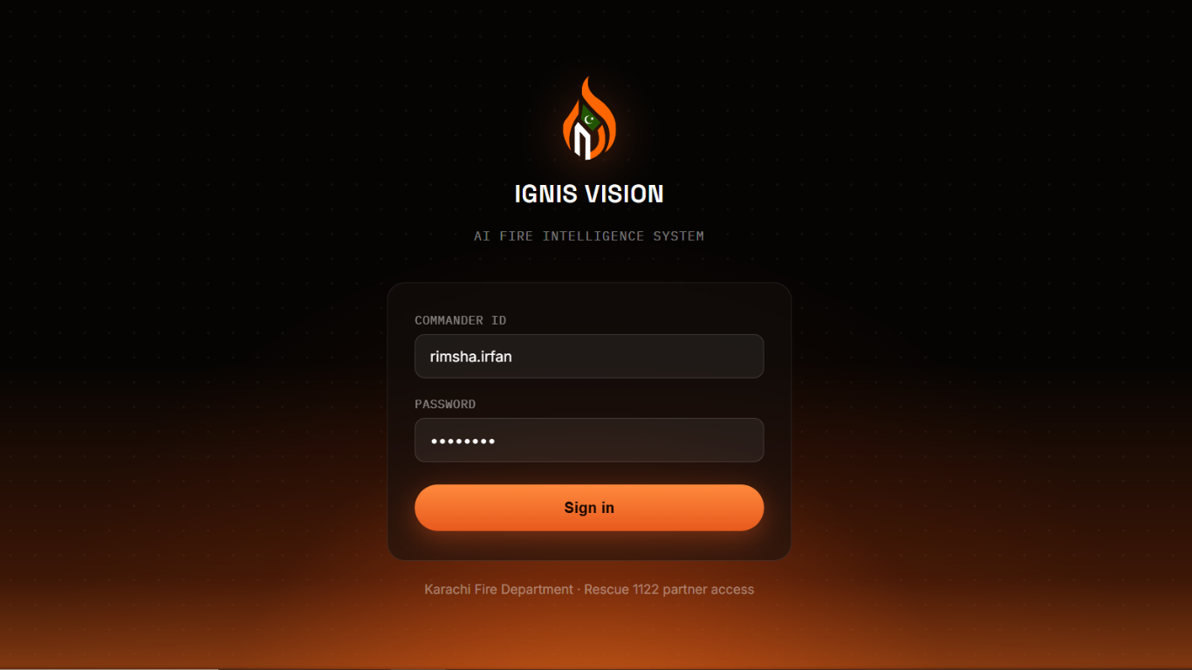
Figure 4. Login functionality for Ignis Vision Application
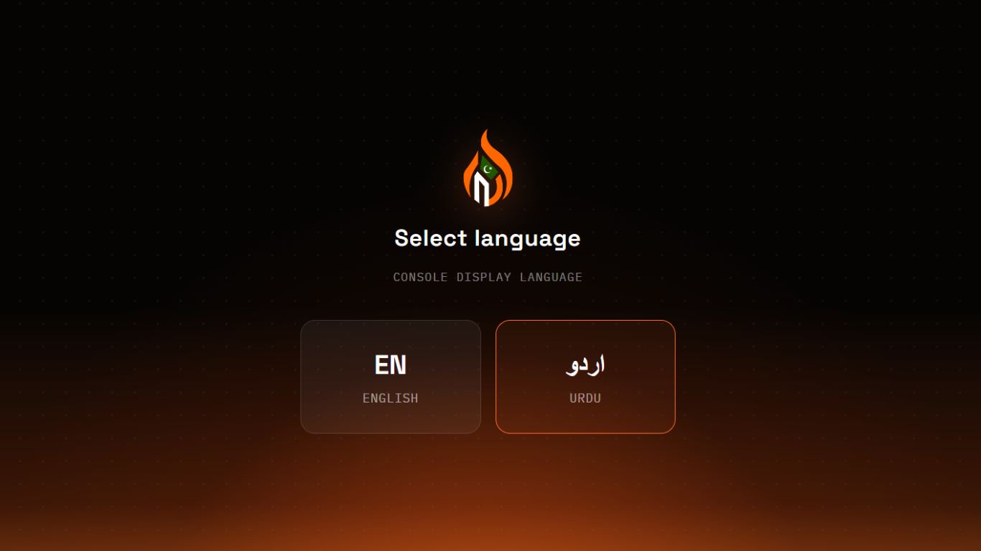
Figure 5. Language selection for Ignis Vision Application
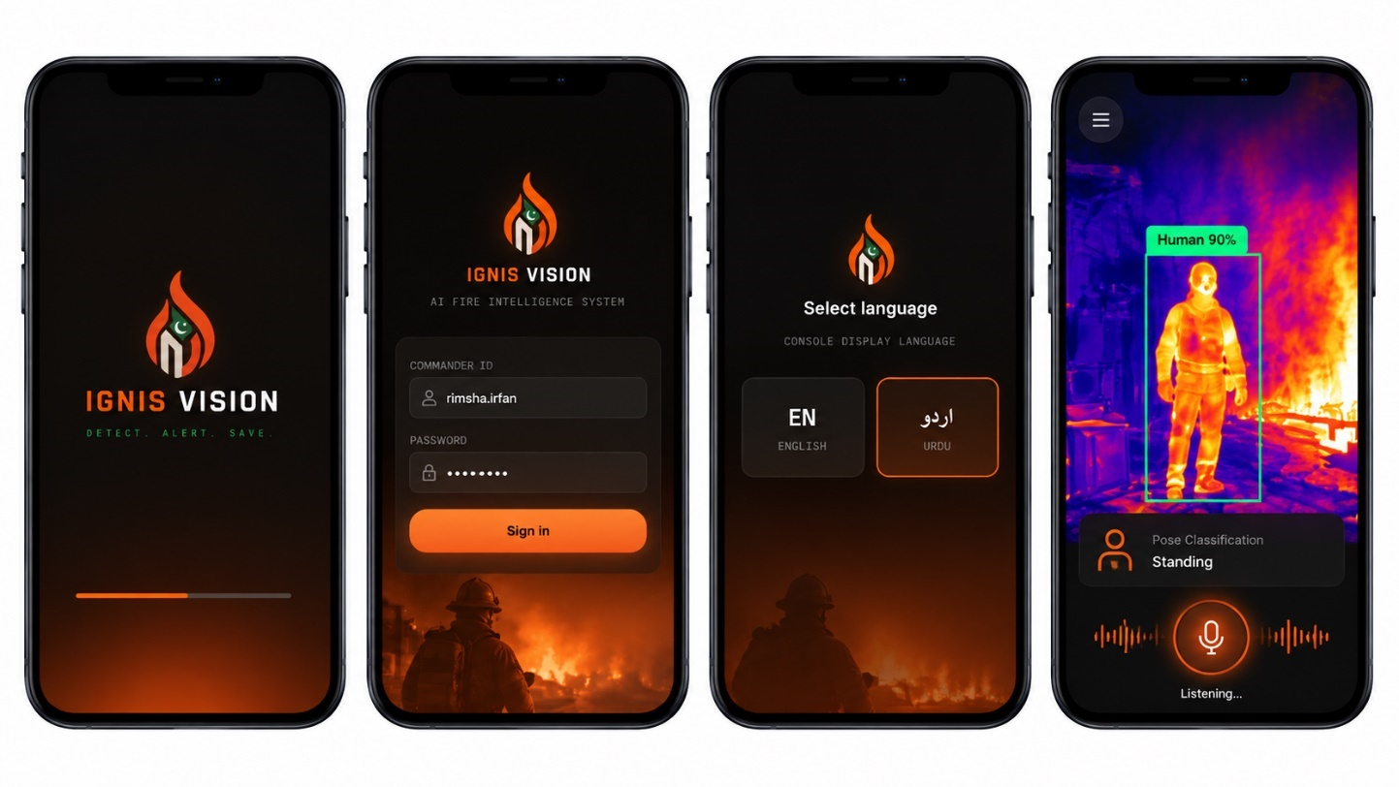
Figure 6. Mobile version screens for Ignis Vision Application
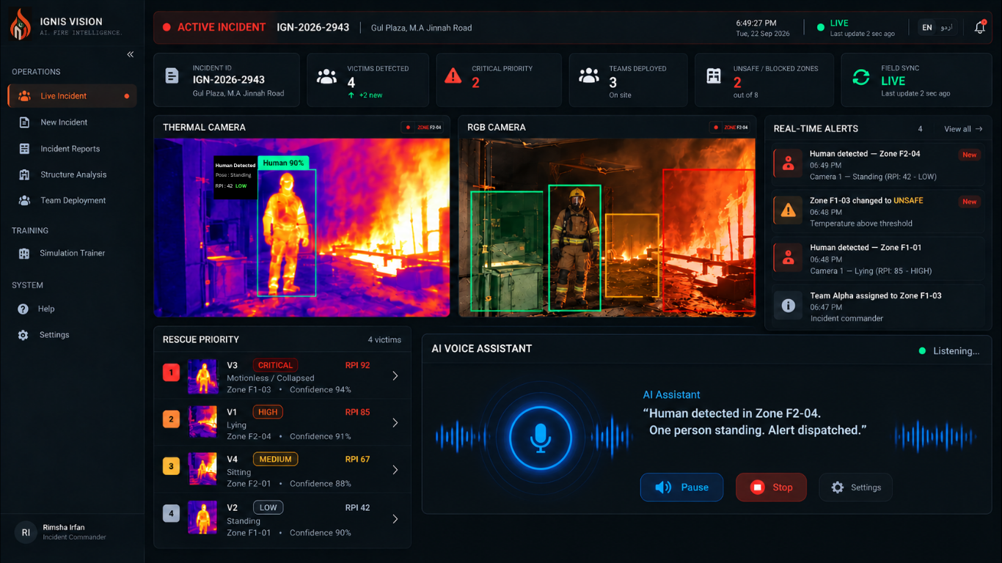
Figure 7. Web version full functionality dashboard for Ignis Vision Application
(Note: Interfaces may evolve during the development lifecycle based on usability testing and stakeholder feedback.)

3.2 Hardware Interfaces

3.2.1 User Devices
Android smartphone (mobile application, and web application via mobile browser) and desktop/laptop computer (web application).

3.2.2 Thermal Imaging Camera
The system works with a USB-C, UVC-compliant thermal imaging camera in the 256×192 resolution class. The camera has not been purchased yet, and the final model will be confirmed later (see Appendix B).
- Physical connection:
- The camera plugs directly into the phone’s USB-C port and is used only by the mobile application.
- The web application does not connect to the thermal camera; thermal data reaches the web application only as uploaded images, videos or incident data.
- Data from the camera: The software reads two kinds of data:
  - The colorized thermal video stream, which is shown on screen.
  - The raw temperature value for each pixel, which is used for detection and environmental risk.
- Control: The software connects and disconnects the camera, initiates and terminates the video stream, and puts the camera into the mode which supplies raw temperature data, if supported by the camera.
- Standard for Communication: The communication between the camera and the computer is done via USB using the UVC (USB Video Class) standard.
  - Computers usually recognize UVC cameras without extra drivers.
  - The camera can be accessed on Android over USB directly from the app because the Android camera system may not have provisions for external cameras.

3.2.3 Phone Camera
The web application makes use of the phone's built-in rear camera to capture regular color (RGB) images of the surroundings. These images are sent to the backend for building structure and zone risk analysis.
- Data: Color images or frames, captured at intervals during a web session.
- Control: The web application asks for camera permission through the browser, and starts and stops the capture.
The mobile application does not use the phone's camera, since structure analysis is only available in the web application.

3.2.4 Speakers
Both applications use the device's speaker, or connected earphones, to play spoken voice guidance. The software only sends audio out. It does not use the microphone, since the system does not take voice commands.

3.2.5 Server
The web application's backend runs on a server that receives camera frames and images from web sessions, runs the detection and structure analysis models, and stores incident data and recorded session footage. The server hardware has not been finalized and will be decided at the time of deployment (see Appendix B).

3.3 Software Interfaces
Ignis Vision connects with the following software components. The versions listed are the minimum planned versions. Exact versions will be fixed during implementation.

3.3.1 Operating Systems
- Mobile application: Android 9.0 and above.
- Web application (client): Any operating system running a supported browser
- Server: To be decided at deployment, with a Linux-based system such as Ubuntu expected (see Appendix B).

3.3.2 Mobile Application Framework
The mobile app is developed using Flutter 3.x (Dart) framework.
The thermal camera is handled by a native Kotlin module, which connects to Flutter through a platform channel. This is the only way data passes between the two parts. The Kotlin module sends each camera frame and its raw temperature data to Flutter, and Flutter sends back commands to start and stop the camera.

3.3.3 Web Application Frameworks
- Frontend: React 18 or above. The frontend:
  - Captures live RGB video from the phone’s camera, uploads thermal images and videos, sends them to the backend, and shows the results.
  - Sends frames and images to the backend.
  - Shows the results.
- Backend: FastAPI using Python 3.10+. Python has been chosen since it is the language used for model training and deployment. FastAPI’s capability for asynchronous programming enables real-time data streaming from multiple devices.

3.3.4 AI/ML Models and Libraries
- Person detection and pose estimation:
  - YOLO-family detection model-pose (nano), from the Ultralytics library, fine-tuned from the COCO-pose model.
  - On the mobile application, it runs on the phone using TensorFlow Lite, in a quantized version.
  - On the web application, it runs on the backend server.
- Posture classification: The detection model directly classifies each detected person into one of four posture classes: standing, sitting, lying and bending. The posture class is passed to the Rescue Priority Index, which converts it into a priority rating.
- Structure and zone risk analysis:
  - Runs on the backend for the web application only.
  - Models are trained on ADE20K, PEER Hub Φ-Net, and SDNET2018 which analyze images from the phone's camera to identify building elements, structural damage, and cracks.
  - The exact model architectures are still being finalized (see Appendix B).
- Text conversion to Speech:
  - The mobile application uses flutter_tts, which runs through the phone's own speech engine and works offline.
  - The web application will use either the browser's built-in speech or a cloud speech service. This has not been decided yet (see Appendix B).

3.3.5 Databases
The mobile application uses SQLite (via sqflite/drift) for local, offline structured data storage; data recorded in the mobile application remains on the device. The web application uses PostgreSQL, chosen for its fit with the system’s relational data structure

3.3.6 Real-Time Communication Service
The backend provides a WebSocket service used only by the web application.
- From the browser to the backend: RGB camera frames for structure analysis.
- From the backend to the browser: zone risk results and alerts.
- From the backend to the Incident Commander's dashboard: alerts, updated zone risk. Live video is not sent to the dashboard. Footage is recorded on the server instead.
The mobile application never connects to this service during an incident.

3.3.7 Data Upload Service
The backend provides a REST API that the mobile application uses to send its saved incident data once internet is available. The backend checks the data, adds it to PostgreSQL, and marks each incident as received, so the mobile application knows it doesn't need to send it again.

3.3.8 API Documentation
The backend's API endpoints and message formats will be documented using FastAPI's automatically generated OpenAPI documentation, which will be delivered with the system.

3.4 Communication Interfaces

3.4.1 USB / UVC
The thermal camera connects to the phone or laptop with a USB cable and communicates using the UVC (USB Video Class) standard. This type of connection doesn’t require any association or network at all. In the mobile application, everything from the camera to the voice guidance runs without any network at all.

3.4.2 HTTP/HTTPS & RESTful APIs
The web application's frontend and backend communicate using REST APIs over HTTPS. This is used for:
- signing in
- logging incidents, zones, and teams
- loading reports and recorded footage
- the training module and the admin panel
- receiving data uploaded later from the mobile application

3.4.3 Connectivity-Based Application Use
- Mobile application (all conditions): Field responders use it for thermal detection, posture classification, RPI and voice alerts, with no network use during an incident. Incident data is saved in SQLite and can be uploaded later.
- Web application (internet available): Used at the command post and on mobile browsers for structure and zone analysis from live RGB video, analysis of uploaded thermal images and videos, incident management, training and reports.
- No switching between applications is needed for thermal detection, because the mobile application is used in all conditions.

3.4.4 Data Upload from the Mobile Application
During an incident, the mobile application sends no data. Once internet is available, incident data saved on the phone can be sent to the web application from the Data Upload Screen.
- Transfer:
  - The data transfer is carried out via the REST API over HTTPS using the JSON format.
  - Each incident has an individual identifier. Using it, the backend checks that no duplicates of the received incident are saved.
  - If the transfer fails, incidents will remain on the phone and will be able to be transferred once more.
One direction only: The data upload goes only from the mobile application to the web application, and vice versa, data cannot be transferred from the web application to the mobile application. The only data the mobile application receives from the backend is the signed-in user’s account details (hashed credentials and role), downloaded at first sign-in and refreshed when internet is available.

3.4.5 Communication Security
- All interactions between the browser and the backend are protected with HTTPS and WSS protocols, so that the data is protected during transmission.
- Users should be logged in for using the web application, all requests to the backend are authenticated with the logged-in user and his role.
- Uploads from the mobile application are possible only for signed in users.

4 System Features

4.1 Thermal Human Detection
Use Case | Thermal Human Detection
Use Case ID | 01
Super Use Case | -
Actor(s) | Field Responder(primary),Incident Commander (observer, web application only)
Brief Description | The system detects humans in thermal imagery, either continuously from the live thermal camera feed (live video mode) or from a single captured or imported thermal image (still image mode), including in smoke filled conditions in low visibility using the detection model on the mobile application (live video or still image), or on the backend for thermal images and videos uploaded to the web application.
Pre Conditions | - The thermal camera is connected via USB-C to the phone (mobile application).  - The application has permission to access feed from USB.  - The detection model Yolo v8-pose is loaded on mobile application or backend on web application.
Basic Flow | - The field responder connects the thermal camera to the phone, opens the mobile application, and selects Live Video or Still Image mode.  - The application asks for permission to access feed if not provided.  - The live UVC camera feed is read by the native Kotlin module.  - The stream is decoded into individual frames, separating the colored video from the raw temperature data layer.  - Frames are passed to the TFLite detection model via a platform channel  - The model detects and locates humans present in each frame  - Detected humans are displayed on screen in bounding box
Post Conditions | - A bounding box is drawn on detected humans in real time on life feed  - Detection data is logged for current incident session , locally on mobile application and on database on web application
Alternative Flow | - If no humans are detected on frame , system continues on scanning without drawing a bounding box  - Still image mode: The user captures a frame from the thermal camera or imports a thermal image from the device. The system runs detection once on that image and displays the results. Posture classification and RPI are applied to that image.  - Live video mode while moving: Frames captured during rapid camera motion may be skipped. A person is confirmed only after being detected in consecutive analyses, so brief misses do not remove a tracked victim.  - Web upload: A user uploads a thermal image or video to the web application. The backend runs detection, posture classification and RPI, and displays the results.
Exceptional Flow | - If the camera got disconnected during the session , application displays alert on screen and on spoken  - If the camera feed cannot be decoded , application gives an error and reestablish the stream

4.1.1 Description and Priority
This is a high-priority feature since human detection is the foundational capability and the core feature of our system .Other features like posture classification, prioritization, voice guidance are all dependent on the output. Without this, no other feature can function.

4.1.2 Stimulus/Response System
Stimulus
The field responder directs connected thermal camera towards the smoke-filled area.
Response
The system processes the live thermal camera feed on the device in the mobile application. Thermal images and videos uploaded to the web application are processed on the server. And divide it into frames and draw bounding box if humans are detected in real time.

4.1.3 Functional Requirements:
- REQ-1: The mobile application must detect humans in the live thermal feed and in still thermal images without internet. The web application must detect humans in uploaded thermal images and videos.
- REQ-2: The system must process both the colored video and raw temperature data layer from the thermal camera
- REQ-3: The system must draw bounding boxes on the human detected on live feed in real-time for field use
- REQ-4: The system must continue working reliably in smoke filled areas with low visibility , consistent with thermal camera’s detection capability
- REQ-5: The system must log all detection event for the current incident session (locally on the mobile application and the backend database on web application)
- REQ-6: The system must support two input modes: live video (continuous analysis of the thermal camera feed) and still image (analysis of a single captured or imported thermal image).
- REQ-7: In live video mode, the system must analyse the feed at least 2 times per second and keep track of each detected person across analyses, so that detections remain stable while the responder moves.
- REQ-8: While the responder moves at walking pace, any person visible for at least 1 second must be detected and announced within 3 seconds.

4.2 Posture Classification

Use Case | Posture Classification
Use Case ID | 02
Super Use Case | -
Actor(s) | Field Responder(primary),Incident Commander (observer)
Brief Description | For each detected human , system estimated key skeleton points and classifies their posture as standing, lying, sitting and bending.
Pre Conditions | - A human has been detected according to Use Case 01  - The YOLO-family detection model-pose has been loaded on mobile application and from backend in web application
Basic Flow | - The system receives detected person from Use Case 01  - The detection model classifies the detected person’s posture as standing, sitting, lying or [4th class], together with a confidence score.  - The posture detected is shown along with the bounding box and passed on to UseCase-03 for computation of Rescue Priority Index
Post Conditions | - Each detected person has label along with the bounding box  - The posture class is available to Use Case-03 for computation
Alternative Flow | - If multiple people are detected , each person’s posture should be classified separately  - If a person posture changes , the label should be respectively updated
Exceptional Flow | - If the posture confidence is below the threshold (e.g. the person is partly hidden), the system shows the posture as low confidence

4.2.1 Description and Priority
This is a high priority feature since posture classification is the clearest indicator from the thermal feed for person’s condition . A person lying should be rescued on the highest priority , this posture is then used to compute Rescue Priority Index , so next use case is dependent on this feature

4.2.2 Stimulus/Response Sequences
Stimulus
A human has been detected according to Use Case-01
Response
The YOLO-family detection model-pose model estimates the detected person’s key skeleton points and classifies their posture, and the system labels the bounding box with the respective posture on the live feed.

4.2.3 Functional Requirements
- REQ-1: The system must clearly classify each detected human into one of the class : lying, sitting, standing, bending.
- REQ-2: The system must classify posture using the detection model running on the device (TFLite) in the mobile application and on the server in the web application
- REQ-3: The system shows the posture along with the bounding box on the live feed
- REQ-4: The system must update posture classification in real time as person posture changes
- REQ-5: The system must flag posture classifications below the confidence threshold as low confidence

4.3 Rescue Priority Index
Use Case | Rescue Priority Index
Use Case ID | 03
Super Use Case | -
Actor(s) | Field Responder(primary),Incident Commander (observer)
Brief Description | For each detected human , system calculates Rescue Priority Index to prioritize victims by urgency
Pre Conditions | - A human has been detected according to Use Case 01  - The detecting person’s posture has been classified according to Use Case 02
Basic Flow | - The system receives the posture class according to Use Case 02 and detection confidence according to Use Case 01  - The system detects the environmental risk value for the detected person’s location if it is available  - The system calculates the Rescue Priority Index (RPI) using a weighted combination of all three, posture class, detection confidence, and environmental risk  - Detected humans are then color coded (red/yellow/green) and ranked according to RPI on screen
Post Conditions | - Each detected person is color coded ,assigned RPI and have priority ranking  - The highest priority is highlighted visually as well as audibly
Alternative Flow | - If multiple people are detected , all are ranked , color coded and have a RPI value  - If reliable environment data is not available , its value is set to zero and RPI is calculated from posture classification and detection confidence
Exceptional Flow | - If skeleton key points cannot be estimated correctly system gives lower -confidence classification

4.3.1 Description and Priority
This is a high-priority feature since it enables the system’s main purpose assisting the responder who needs help most urgently not just detecting the victim.

4.3.2 Stimulus/Response Sequences
Stimulus
The posture of detected victim has been classified according to Use Case 02 and their detection confidence according to Use Case 01 as well as their environmental risk if it is available.
Response
The system calculates or recalculates Rescue Priority Index (RPI) color codes , and rank each detected person but its priority.

4.3.3 Functional Requirements
- REQ-1: The system must calculate a Rescue Priority Index using a weighted combination of posture classification, detection confidence, and environmental risk.
- REQ-2: The system must rank and color code victim by RPI priority (Critical/high/medium/low).
- REQ-3: The system must highlight high-priority victims visually and audibly.
- REQ-4: The system must update the RPI and rankings in real time as conditions change.
- REQ-5: The environmental risk weight must be adjustable supporting the value zero I it is not available

4.4 Voice AI Assistant
Use Case | Voice AI Assistant
Use Case ID | 04
Super Use Case | -
Actor(s) | Field Responder(primary),Incident Commander (observer)
Brief Description | The system provides spoken, bilingual (English/Urdu) guidance to field responder based on detections done in real time and priority ranking, as well as status updates to incident commander
Pre Conditions | - The device output audio must be available  - Detection and prioritization have already happened
Basic Flow | - A human is detected or priority of a person detected changes (e.g. a new victim is detected , an existing victim changed posture)  - The system generates an audio-based guidance sentence based on the detection and priority (e.g.: “a human in critical condition has been detected on your right ”, “Zone is not safe turn back” )  - The sentence can be converted in user preferred language (English/Urdu) using device text to speech on-device (mobile application) or cloud, browser text to speech (web application).  - The guidance audio is played through the device speaker
Post Conditions | - The field responder receives audio guidance without looking at the screen
Alternative Flow | - If user has selected Urdu, guidance is spoken in Urdu instead of English
Exceptional Flow | - If device text to speech is unavailable or the on device speaker is not working system displays text in the respective language on screen

4.4.1 Description and Priority
This is a medium-priority feature since the field responders operate with their hands and eyes occupied on field , spoken alerts might be their primary interaction with the system making this a high-priority feature even if it built on detection and prioritization features

4.4.2 Stimulus/Response Sequences
Stimulus
A new human is detected or an existing detection changes posture hence priority
Response
The system generates and speaks appropriately worded guidance in user preferred and selected language according to the detection, posture, priority and next guided step

4.4.3 Functional Requirements:
- REQ-1: The system must generate appropriately worded guidance based on live human detection, its posture and RPI priority ranking without requiring the user to look at screen
- REQ-2: The system must be able to provide spoken guidance in both Urdu and English
- REQ-3: The mobile application voice must fully function without internet connectivity using on-device text to speech
- REQ-4: The system must not require any guidance from user; guidance is one-sided only (from system to user) according to the current scope
- REQ-5: The web application voice assistant may use cloud-based text to speech sice web application is only used when internet is available

4.5 Building Structure And Zone Risk Analysis
Use Case | Building Structure & Zone Analysis
Use Case ID | 05
Super Use Case | -
Actor(s) | Incident Commander (primary), Field Responder (receives zone alerts, web application only)
Brief Description | The web application analyses building structure with two segmentation models, SegFormer B2 for building elements and YOLO-family detection model-seg for structural damage, and classifies zone as safe, caution, unsafe or blocked
Pre Conditions | - The incident has already been created in web application.  - Zone images are available in the web application for the session  - YOLO-family detection model-seg and SegFormer-B2 are loaded on backend
Basic Flow | - Incident commander creates an incident on the web application  - Images and videos of the incident are sent to backend in the session  - SegFormer-B2 performs semantic segmentation of each image , labelling segments as walls, ceiling , door, floor  - YOLO-family detection model-seg performs segmentation of same image by specifying the structural damage like cracks , collapsed section, debris  - The system merges output from both models and by analysing the extent of damage labels them as safe, caution , unsafe, blocked.  - The zone map is shown with color coded areas that shows risk status
Post Conditions | - The incident commander has color coded view of structural risk of the building structure  - The zone risk history is stored in the incident log
Alternative Flow | - If there is insufficient data for classification, it doesn’t classify the area rather than classifying it to a default risk level  - If an area is found to be obstructed , zone is classified as blocked
Exceptional Flow | - If a zone risk level changes quickly from safe to unsafe , system gives an alert to the incident commander in the web application  - If an image cannot be analyzed because of smoke filled areas, the zone keeps its last classification, and is not set to safe

4.5.1 Description and Priority
This is a medium priority feature since it supports the system’s broader scope for command-level situation awareness, and is outside of scope of mobile application also it runs two segmentation models (SegFormer-B2 and YOLO-family detection model-seg), it runs only on backend of web application

4.5.2 Stimulus/Response Sequences
Stimulus
The incident commander view zone map during an active incident , new zone image is received.
Response
The system segments building elements and analyses structural damage and updates the risk classification and provides updated color-coded zone map.

4.5.3 Functional Requirements
- REQ-1: The system should classify each zone into either of the four categories: safe, caution , unsafe or blocked.
- REQ-2: The system must use SegFormer-B2 to segment building like walls, floor, door, ceiling
- REQ-3: The system must use YOLO-family detection model-seg to detect and analyze structure damage like cracks , collapsed section, debris
- REQ-4: The system must merge outputs of both model to classify each zone to its risk level
- REQ-5: The system must show a color-coded zone map to the incident commander.
- REQ-6: The system must give a real time alert if zone classification changes quickly
- REQ-7: This feature is limited to Web application only , with both models in backend and is not required in mobile application.

4.6 Training Module
Use Case | Training Module
Use Case ID | 06
Super Use Case | -
Actor(s) | Trainee(primary)
Brief Description | The web application gives practice scenarios where he classifies zones and posture from images and videos of real incidents and compares it result from models
Pre Conditions | - The user has access to the training module  - Scenario images, videos and respective model output is available
Basic Flow | - The user/trainee selects a training scenario  - The system displays a real incident to classify zones and posture  - The trainee submits their classification  - The system compares the trainee classification against the input and shows result and feedback
Post Conditions | - The trainee classifies and submit their classification and results are displayed
Alternative Flow | - The trainee performs classification on same scenario to improve their accuracy
Exceptional Flow | - If the reference scenario output is not available, then that scenario cannot be used for classification

4.6.1 Description and Priority
This is a low-priority feature since it supports team training and allows field responders to be familiar with the system’s classification logic and is considered a lower-priority addition relative to the core detection and prioritization features.

4.6.2 Stimulus/Response Sequences
Stimulus
A trainee selects and performs classification on a training scenario.
Response
The system displays a training scenario, accepts the trainee’s classification, and displays a comparison against the model’s reference output.

4.6.3 Functional Requirements:
- REQ-1: The system must present videos and images of training scenarios for zone or posture classification practice.
- REQ-2: The system must compare a trainee’s submitted classification against the model’s output.
- REQ-3: The system must record and allow revision of a trainee’s scenario performance.
- REQ-4: This feature is only available on web application and is not required in the mobile application.
4.7 Incident Management Dashboard
Use Case | Incident Management Dashboard
Use Case ID | 07
Super Use Case | -
Actor(s) | Incident Commander (primary), Field Responder(secondary)
Brief Description | The web application gives a centralized dashboard for viewing active incident logs, assigning teams, monitor incident and review incident reports
Pre Conditions | - The incident commander has logged into the web application
Basic Flow | - The incident commander logs/enters a new incident, location and its structure details  - The incident commander assigns teams to respective zones  - The dashboard shows the color-coded zone map, zone alerts and, where available, live RGB zone video. Thermal footage and victim detections are added to the incident record when they are uploaded from the mobile application.
Post Conditions | - An incident record , including detections, zone classification , team assignment is shown and stored for reporting
Alternative Flow | - The incident commander may assign more field responders if needed to the zone during the incident
Exceptional Flow | - If internet is not available and and an active session is lost , the dashboard shows the last updated session

4.7.1 Description and Priority
This is a medium-priority feature since it unifies and shows incident commander full view of an active incident and is essential for the web application to function as a genuine command tool, even though it is built on top of the detection and prioritization features rather than replacing them.

4.7.2 Stimulus/Response Sequences
Stimulus
The incident commander logs a new emergency or opens an active incident.

Response
The system displays the live incident dashboard, including the zone map, alerts and optional live RGB zone video, and adds uploaded thermal detections to the incident record, and compiles a report once the incident is resolved.
4.7.3 Functional Requirements:
- REQ-1: The system must allow an incident commander to log a new incident with location and structure details.
- REQ-2: The system must allow teams to be assigned to specific zones.
- REQ-3: The system should display live RGB zone video from web sessions during an active incident.
- REQ-3a: The system must show the priority-ranked victim list from thermal data uploaded from the mobile application.”
- REQ-4: The system must compile and store an incident report upon incident resolution.
- REQ-5: The system must support bilingual (English/Urdu) languages across the dashboard.

4.8 User Authentication And System Administration
Use Case | User Authentication And System Administration
Use Case ID | 08
Super Use Case | -
Actor(s) | System Administrator (primary), Field Responder, Incident Commander, Trainee/Training Staff
Brief Description | User sign in with their username or password and are given access to the respective features. The System Administrator creates, edit, delete user accounts, maintain training scenarios, and monitors status of system
Pre Conditions | - The user has an account that has already been created by the System Administrator  - Internet connection is available on web application
Basic Flow | - The user opens the application and enters their username and password on the sign in screen  - The system verifies the credential from database  - The user is logged in, and his screen is displayed according to its role (System Administrator , Field Responder, Incident Commander, Trainee)  - When the System Administrator logs in, the system shows the administrator screen  - System Administrator creates, edits or deletes user accounts and their roles(System Administrator , Field Responder, Incident Commander, Trainee)  - The user signs out or is signed out after a period of inactivity
Post Conditions | - Only registered and authenticated user can access the system according to their role  - User can then use the application according to its role
Alternative Flow | - In the mobile application, the first sign-in on a device requires internet: the user’s credentials are verified by the backend, and a hashed copy of the credentials and the user’s role are stored securely on the device. Later sign-ins are verified offline against this stored copy, which is refreshed whenever internet is available. If the account is deactivated by the System Administrator, the stored copy is removed at the next online refresh.  - If a user forgets his password , he will ask the System Administrator to reset it
Exceptional Flow | - If credentials entered are incorrect , system displays an error

4.8.1 Description and Priority
This is a high-priority feature since every other feature is dependent on it and incident data is sensitive so it must be restricted to Rescue112 personnel . The System Administrator’s tools keep accounts, roles up to date

4.8.2 Stimulus/Response Sequences
Stimulus
A user opens the application and enters username and password, or System Administrator create, deletes or edit user account
Response
The system verifies the credentials and allow user to log in , or applies the administrator change

4.8.3 Functional Requirement:
- REQ-1: The system must require user to enter username and password first before using any of the system features.
- REQ-2: The system should allow user to use system according to their role (System Administrator , Field Responder, Incident Commander, Trainee)
- REQ-3: The system must allow system administrator to create, edit , delete user account and assign roles
- REQ-4: The system must allow System administrator to view system status and incident logs
- REQ-5: The system must store passwords only in hashed formats in database.
- REQ-6: The system must record all administrative changes
- REQ-7: The mobile application must support offline sign-in after a one-time online sign-in on that device, using securely stored hashed credentials.

5. Other Nonfunctional Requirements

5.1 Performance Requirements

5.1.1 Response Time
- Mobile Detection: While live video mode is running, the mobile app should show each detected person, their posture and their RPI within 1 second of the frame being captured.
- Still Image Analysis: A still thermal image should be analysed within 2 seconds on the phone. On the web app, results for an uploaded thermal image should appear within 5 seconds once the upload has finished.
- Voice Guidance: When a new victim is found or someone’s priority changes, the spoken alert must start within 2 seconds.
- Zone Analysis: A zone’s risk level should be updated on the zone risk map within 6 seconds of its RGB frame reaching the server.
- Web Response: Pages, buttons and sign-in on the web app should respond within 3 seconds under normal load, which we take as up to 10 users signed in at the same time.

5.1.2 Throughput
- Analysis Rate: During live video streaming, the mobile application has to be able to analyse at least two frames per second while ensuring the thermal stream is smooth.
- Concurrent Use: The back-end must be able to support at least 10 logged in users and 5 live zone capture instances simultaneously.

5.1.3 Scalability
- Adding Capacity: The backend needs to be designed such that the processing capacity is scalable and can be increased later on without modifying the application code.
- More Stations: The design of storage for incidents and users should be such that multiple Rescue 1122 stations can start using the system, thereby scaling up the application without having to redesign it.

5.1.4 Resource Utilization
- Battery: The mobile app needs to be able to detect incidents live for at least 60 minutes after full charge of the target mobile device with the thermal camera connected.
- Model Size: After quantization, the on-device detection model size needs to be less than 50 MB.

5.2 Safety Requirements

5.2.1 Data Protection
Incident logs, thermal video, victim detection, and personal information of users from the fire department are all part of Ignis Vision's scope. It is important that this information is protected from any loss, alteration, or breach, so as not to affect victims, the responder personnel, or the fire department itself due to poor handling of the data. Any personally identifiable information collected incidentally in thermal videos or zone pictures needs to be kept safe and used for improving models.

5.2.2 System Stability
- Failure Recovery: If the application or backend fails, it must restart and resume detection without the user having to reconnect the camera or sign in again during an active incident.
- Camera Disconnection: If the thermal camera is disconnected, the system must give a clear on-screen and spoken alert and resume automatically when the camera is reconnected.
- Backup: The web application’s database must be backed up automatically at least once a day.

5.2.3 Operational Safety
- Decision Support Only: The system is a decision-support tool and does not replace a responder’s own judgment or fire department’s standard operating procedures.
- Confidence Display: The system must not present detection confidence in a way that could be read as a guarantee that no victim is present in an unscanned or low-confidence area.
- Structural Risk Display: A zone that has not been analysed, or whose analysis is out of date, must never be shown as safe.
- Accidental Changes: Closing an incident, deleting records, and deactivating accounts must require confirmation.

5.3 Security Requirements

5.3.1 Authentication and Authorization
- Signing in: Each user will sign in first before using the application as specified in Section 4.8
- Role-Based Access Control: Access should be according to the user’s role(Field Responder, Incident Commander, Trainee, System Administrator)
- Session Management: Web session must be logged out after there is no activity for 30 minutes except during incident
- Password Security: Password will be stored in salted hashes in database not in plain text

5.3.2 Data Security
- Encryption in Transit: Communications between browser and backend must use HTTPS/WSS with TLS 1.2
- Encryption at Rest: Web Application’s PostgreSQL database and mobile application local database should be encrypted

5.3.3 System Security
- Protected API: Every request to the backend API, apart from sign-in, must carry a valid authentication token.
- Updates: Libraries and server software with known security issues should be updated before deployment and during maintenance.

5.3.4 Thermal Footage and Incident Data Protection
- Access: Incident records and recorded footage can only be opened by Incident Commanders and the System Administrator.
- Use of Footage: Footage and images sent to the backend are used only for incident review and for model improvement approved by Rescue 1122.
- Retention: Footage and incident logs are kept according to the rules in Section 5.5.3.

5.4 Software Quality Attributes

5.4.1 Reliability
- Offline Operation: Detection, posture classification, RPI and voice guidance on the mobile app must work with no network connection at all.
- Handling Errors: Dropped frames, a lost internet connection or a low-confidence result should never crash the app or fail silently. The user is told what happened and what to do next.

5.4.2 Usability
- Field Use: A responder should be able to start detection within 2 taps from the home screen, and follow the results mainly through voice without having to read the screen.
- Commander Dashboard: Zone alerts and high-priority victims should be visible on the dashboard without scrolling.
- Help: Help is available inside both apps, as described in Section 2.6.

5.4.3 Maintainability
- Replaceable Models: The detection and structure analysis models are kept separate from the user interface, so a model can be swapped without changing UI code.
- Version Control: All code and trained model versions are tracked in Git, following the conventions in Section 2.5.7.

5.4.4 Portability
- Mobile Platform: The mobile app must run on Android 9.0 and above.
- Web Platform: The web app must run on the browsers listed in Section 2.4.3, on Windows, macOS, Linux and Android.
- Deployment: The backend should be packaged (for example with Docker) so it can be moved to the final server without code changes.

5.4.5 Interoperability
- Reports: Incident reports must be downloadable as PDF.
- Thermal Camera: The mobile app must work with UVC-compliant thermal cameras that provide raw temperature data and whose integration has been verified (see Appendix B).
- APIs: The backend’s REST and WebSocket APIs are documented with OpenAPI (Section 3.3.8), so other Rescue 1122 systems can connect to it later.

5.4.6 User Experience & Accessibility Requirements
5.4.6.1 Responsive Design
- Screen Sizes: The web app must be usable on screens from 360 px wide (phones) up to desktop monitors.
- Touch Targets: Buttons on mobile screens must be at least 48 px, since responders may be wearing gloves
5.4.6.2 Theme and Visual Accessibility
- Dark Theme: The live detection screen uses a dark theme by default to cut glare in smoke and low light.
- Colour Labels: Priority and zone colours are always shown with a text label, so the screens still make sense to colour-blind users.
5.4.6.3 Language
- English and Urdu: Every screen and every spoken message must be available in English and Urdu, with Urdu laid out right to left.
- Switching Language: Users can switch language at any time without restarting the app or losing what they were doing.

5.5 Business Rules

5.5.1 Access Control Rules
- Account Management: The account and its associated roles can only be created and deactivated by the System Administrator.
- Incident Access: Only authorized personnel of Rescue 1122 and project participants can access the incident information. No access for trainees to live incidents and incident reports.
- Training Results: Trainees have access to their results; Training Staff have access to all trainees' results.

5.5.2 Processing Rules
- Victim priority: Victims are always listed and presented by their RPI ranking.
- Environmental Risk: In case environmental information is not available, the environmental risk weight in the RPI is assumed to be zero.
- Structure Analysis: Building structure and zone risk analysis runs only in the web application, on the backend.
- Unanalysed Zones: A zone without a current analysis is shown as unclassified, never as safe.

5.5.3 Data Retention Rules
- Retention Time: The retention of incidents and reports follows the data retention policy set out by Rescue 1122.
- Mobile Data: Incidents that are logged into the mobile application are stored in the device following the same data retention policy.
- Deletion: Deletion of incident records will only be done by the System Administrator and every single deletion must be documented.

5.5.4 Security Rules
- Password Rules: Passwords must be at least 8 characters long and contain both letters and numbers.
- Personal Accounts: Each person uses their own account. Accounts must not be shared between responders, so every action can be traced to one user.

6 Sustainable Development Goals (SDGs)
Ignis Vision is aligned towards meeting some of the United Nations Sustainable Development Goals since the primary objective of this organization is the safety of people.

6.1 SDG 3 – Good Health and Well-being
Through improved accuracy of locating and prioritizing victims during fire incidents, Ignis Vision helps prevent unnecessary harm to health and improves emergency medical results.

6.2 SDG 9 – Industry, Innovation, and Infrastructure
The Ignis Vision project uses AI and computer vision technologies to create innovative, reliable emergency response infrastructure in cooperation with a public organization for emergency services.

6.3 SDG 11 – Sustainable Cities and Communities
The project enhances the ability of the community to respond to disaster and helps make cities and communities more safe and resilient by addressing fire incidents.

6.4 SDG 17 – Partnerships for the Goals
The project is a result of collaboration between a university research department (NUST MCS) and government agency (Rescue 1122), with HEC funding to be pursued after project completion– a model of institutional collaboration called for by SDG 17.

7 Project Timeline

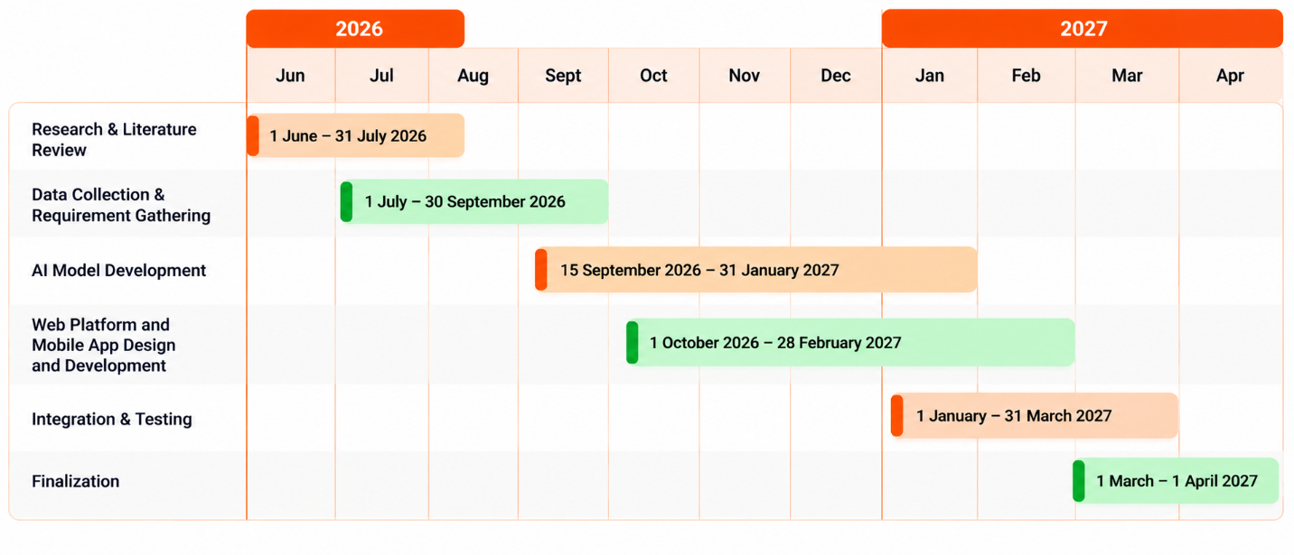Figure 8. Gantt Chart to show the timeline of the project from June, 2026 to May, 2027

Appendix A: Glossary
- AI (Artificial Intelligence): It refers to the simulation of human intelligence in machines that are capable of doing such tasks as learning and solving problems.
- API (Application Programming Interface): A collection of rules and protocols for building and interacting with software applications.
- CV (Computer Vision): A part of AI that enables computers to interpret and understand visual information from photos or videos.
- IEEE Institute of Electrical and Electronics Eng.
- NETD (Noise Equivalent Temperature Difference): A measure of the sensitivity of a thermal camera sensor to small temperature differences.
- NRPU (National Research Program for Universities): A research grant program funded by HEC.
- RBAC (Role-Based Access Control): A way to limit the access to the system such that a user can only use the features permitted by his/her assigned role.
- RPI (Rescue Priority Index): A computed score that integrates posture severity, detection confidence and environmental risk to rank detected victims by rescue urgency.
- SDG (Sustainable Development Goal): One of the 17 global goals set by United Nations
- SegFormer-B2: A semantic segmentation model based on transformers, in this system it classifies building elements such as walls, floors, ceilings, doors and columns.
- TFLite (TensorFlow Lite) – A light weight version of TensorFlow for ML inference on device.
- TTS (Text-to-Speech): The technology that converts text into speech.
- UVC (USB Video Class): A standard USB device class that enables the use of a camera without a special driver.
- YOLO-family detection model-pose: This is an extension of the YOLO (You Only Look Once) object detection architecture for human pose/keypoints estimation.
- YOLO-family detection model-seg: It is an extension of the YOLO architecture for instance segmentation, which detects structural damage such as cracks, spalling, collapsed sections and debris in this system.
Appendix B: To Be Determined List
- Thermal Camera Final Selection: TBD - Final thermal camera model (InfiRay P2 Pro or verified alternative) Sourcing confirmation still pending, any alternative model to the P2 Pro must have third-party UVC integration support confirmed.
- Model Accuracy Figures: The final accuracy and export format of the Kaggle-trained model are TBD and will be finalized after training is complete.
- Rescue Priority Index Weights: The exact values of w_p,w_c and w_r in the RPI formula are to be determined and will be tuned in consultation with Rescue 1122.
- Web Application Production Build: The web application is currently a prototype (HTML/JS); the production React/FastAPI/PostgreSQL implementation is TBD.
- Urdu Voice Assistant Quality: Quality of on-device Urdu text-to-speech on target Android hardware is TBD pending testing.6.Field Validation Data: The scope and schedule of Rescue 1122 field data collection for later-phase model fine-tuning is to be decided.
- Field Validation Data: The scope and schedule of Rescue 1122 field data collection for later-phase model fine-tuning is to be decided.
- Zone capture responsibility: Who captures live RGB zone video (a dedicated responder or the commander) is TBD with Rescue 1122.
- Live RGB feed on dashboard: whether live RGB zone video is shown on the Incident Commander dashboard is TBD, pending bandwidth and usability testing.

