PMAS-Arid Agriculture University, Rawalpindi
Department of Geoinformatics
Urban Thermal Environment and Vegetation Dynamics in Islamabad–Rawalpindi:
A Multi-Sensor Digital Image Processing Approach
5th Semester Project Report
Course: Advanced Digital Image Processing
Submitted by
Rameen Naeem
BS Geoinformatics
Registration No : 24-Arid-2433
Submitted to
Naeem Malik
November 2026

Abstract
Land surface temperature (LST) in the Islamabad–Rawalpindi Twin Cities was analysed with a multi-sensor digital image processing workflow that combines Landsat 8/9 Collection 2 Level-2 thermal data with Sentinel-2 surface reflectance. Two seasonal windows in 2025 were processed on a common 30 m grid: pre-monsoon (May–June) and post-monsoon (September–October). After cloud masking, radiometric scaling and median compositing, LST, NDVI, NDBI and NDWI were derived, and a five-class land-cover map was produced with a Random Forest classifier trained on pixels where ESA WorldCover and Dynamic World agree.
Mean LST was 43.6 °C before the monsoon and 32.4 °C after it. LST was negatively correlated with NDVI (r = −0.70 and −0.68) and positively correlated with NDBI (r = 0.79 and 0.76). A project-defined Urban Thermal Stress Index (UTSI) showed that dry agricultural and bare land, rather than the dense urban core, made up most of the high-stress area, and the hotspot pattern changed little when the index weights were varied. Built-up land had almost the same mean LST in Islamabad (43.8 °C) and Rawalpindi (43.9 °C) before the monsoon, so most of the difference between the two districts reflects their land-cover mix.
Landsat and MODIS LST agreed strongly in spatial pattern (r = 0.93 and 0.95) but Landsat values were 5.7–8.7 °C higher, so the temperature layers are used here for relative spatial comparison. The classification reached 91.5% overall accuracy (kappa 0.893) against a reference-product consensus; this figure is preliminary, and independent validation is recommended.
Keywords: land surface temperature, urban heat, Landsat, Sentinel-2, NDVI, NDBI, Random Forest, Google Earth Engine, Islamabad, Rawalpindi

Table of Contents
Abstract 2
Table of Contents 3
1. Introduction 5
1.1 Background 5
1.2 Problem statement 5
1.3 Research question 5
1.4 Objectives 5
1.5 Scope and hypotheses 5
1.6 Limitations of the study design 6
1.7 Report structure 6
2. Literature Review and Research Gap 7
2.1 Urban heat and thermal remote sensing 7
2.2 LST, vegetation and built-up surfaces 7
2.3 Spectral indices 7
2.4 Land-cover classification and reference products 7
2.5 Cloud-based processing and validation 7
2.6 Research gap 7
3. Study Area and Dataset Description 9
3.1 Study area 9
3.2 Temporal design 9
3.3 Datasets 9
3.4 Image acquisition 9
3.5 Bands and scale factors 10
3.6 Software environment 10
4. Digital Image Processing Methodology 11
4.1 Workflow overview 11
4.2 Preprocessing 11
4.3 Image enhancement 11
4.4 Spectral indices 11
4.5 Land surface temperature 12
4.6 Land-cover classification 12
4.7 Urban Thermal Stress Index 12
4.8 Statistical analysis 13
4.9 Validation approach 13
5. Results and Analysis 14
5.1 Image enhancement 14
5.2 Land surface temperature 16
5.3 Spectral indices 17
5.4 Land cover 18
5.5 Relationship between LST, vegetation and built-up intensity 20
5.6 Urban Thermal Stress Index and hotspots 21
5.7 Islamabad compared with Rawalpindi 23
5.8 Seasonal change 24
6. Validation and Accuracy Assessment 26
6.1 Land-cover classification 26
6.2 Land surface temperature 27
6.3 Statistical validation 28
6.4 Sensitivity of the UTSI to its weights 28
7. Discussion 30
7.1 Vegetation, built-up surfaces and temperature 30
7.2 Dry land, not only the urban core, drives the hotspots 30
7.3 Islamabad and Rawalpindi 30
7.4 The behaviour of NDWI and NDBI 30
7.5 Seasonal differences 30
7.6 Limitations 30
8. Conclusion and Recommendations 32
8.1 Conclusions 32
8.2 Recommendations 32
References 33
Appendix A: Scripts and Output Files 34
Appendix B: Interactive Project Dashboard 35
Appendix C: Additional Histograms…………………………………………………………36

1. Introduction

1.1 Background
Urban expansion replaces vegetated and permeable surfaces with buildings, roads and other impervious materials, which changes how land absorbs, stores and releases heat. Satellite thermal remote sensing makes it possible to measure land surface temperature over a whole metropolitan area and to relate it to surface characteristics such as vegetation cover and built-up intensity (Voogt and Oke, 2003). Islamabad and Rawalpindi, together known as the Twin Cities, form a rapidly growing metropolitan region on the Potohar Plateau and its northern foothills. The two cities differ in planning history, building density and surrounding land cover, which makes them a useful pair for comparison.

1.2 Problem statement
A single LST map shows where the surface is hot but does not explain how temperature relates to vegetation, built-up surfaces and land cover, or whether these relationships differ between seasons and cities. This project combines Landsat thermal data, Sentinel-2 multispectral data and a land-cover classification in one consistent digital image processing workflow for the Twin Cities.

1.3 Research question
How do vegetation, built-up surfaces and land-cover patterns influence the spatial distribution of Land Surface Temperature in Islamabad and Rawalpindi?

1.4 Objectives
- Acquire and preprocess Landsat 8/9 and Sentinel-2 imagery for May–June and September–October 2025.
- Extract Land Surface Temperature from Landsat Level-2 thermal data.
- Calculate the vegetation (NDVI), built-up (NDBI) and water (NDWI) indices.
- Classify land cover into five classes with a Random Forest classifier.
- Identify thermal hotspots and relatively cooler zones with a project-defined Urban Thermal Stress Index (UTSI).
- Analyse the relationship between LST, vegetation and built-up intensity.
- Compare Islamabad and Rawalpindi, and the pre- and post-monsoon seasons.
- Assess the reliability of the classification and of the temperature data.

1.5 Scope and hypotheses
The study covers Islamabad District (about 896 km²) and Rawalpindi District (about 5,227 km²), a combined area of about 6,123 km², analysed on a common 30 m grid in UTM Zone 43N (EPSG:32643). Two seasonal windows in 2025 are used: pre-monsoon (May–June) and post-monsoon (September–October). These are observation windows and not a measurement of the monsoon's causal effect.
Two hypotheses are tested: (H1) higher vegetation greenness is associated with lower LST, and (H2) higher built-up intensity is associated with higher LST. They are hypotheses to test and not results to assume.

1.6 Limitations of the study design
This study measures the surface thermal environment. It does not measure air temperature or the heat exposure that people experience at street level. It tests associations between LST and surface characteristics and does not prove causation. The analysis covers a single year and therefore does not describe long-term change.

1.7 Report structure
Chapter 2 reviews the literature and the research gap. Chapter 3 describes the study area and data. Chapter 4 explains the digital image processing methodology. Chapter 5 presents the results, Chapter 6 covers validation, Chapter 7 discusses the findings and their limitations, and Chapter 8 concludes with recommendations.

2. Literature Review and Research Gap

2.1 Urban heat and thermal remote sensing
The urban heat island is the tendency of built-up areas to be warmer than their surroundings, and it has long been explained through the energy balance of urban surfaces (Oke, 1982). Satellite sensors observe the surface rather than the air, so thermal remote sensing describes the surface urban heat island, which is related to but different from the air-temperature heat island (Voogt and Oke, 2003). For this reason, results from satellite LST should be described as the surface thermal environment.

2.2 LST, vegetation and built-up surfaces
A large body of work relates LST to vegetation abundance and impervious surface cover in urban areas. Weng et al. (2004), for example, examined the relationship between LST and vegetation abundance for urban heat island studies. The usual finding is that vegetated surfaces are cooler and sealed or dry bare surfaces are warmer, but the strength of the relationship depends on the city, the season and the spatial scale.

2.3 Spectral indices
Three normalized-difference indices are used here. NDVI contrasts near-infrared and red reflectance and measures vegetation greenness (Tucker, 1979). NDBI contrasts shortwave-infrared and near-infrared reflectance to highlight built-up surfaces (Zha et al., 2003), although bare soil can also give high values. NDWI contrasts green and near-infrared reflectance to highlight open water (McFeeters, 1996). The limitations of each index matter for interpretation in a dry landscape, and they are discussed in Chapter 7.

2.4 Land-cover classification and reference products
Random Forest is an ensemble of decision trees that handles many input features and gives a measure of feature importance (Breiman, 2001). Global land-cover products such as ESA WorldCover (Zanaga et al., 2022) and Dynamic World (Brown et al., 2022) provide 10 m land-cover information that can be used as reference data. Because these products have their own errors, agreement between two independent products is a useful filter for selecting more reliable reference pixels, although it does not replace independent validation.

2.5 Cloud-based processing and validation
Google Earth Engine gives access to the Landsat and Sentinel-2 archives without downloading every scene (Gorelick et al., 2017). Sentinel-2 is described by Drusch et al. (2012). Classification accuracy is normally assessed with a confusion matrix and the derived overall, producer's and user's accuracies (Congalton, 1991) and the kappa coefficient (Cohen, 1960). MODIS LST (Wan, 2014) is a widely used coarse-resolution product that can be used for a pattern comparison with Landsat.

2.6 Research gap
Earlier studies of the Twin Cities have focused mainly on land-cover change. Khan et al. (2020) estimated how land-cover changes in Islamabad between 1993 and 2018 warmed or cooled the surface, finding that conversion to impervious surfaces had a warming contribution of 1.52 °C. Mannan et al. (2021) compared Landsat imagery from 1990 and 2020 for Islamabad and Rawalpindi and reported rapid growth of built-up area in both cities. Among the studies reviewed here, none compares surface temperature, vegetation and built-up indices across both cities and both seasons in a single workflow.
Khan, M. S., Ullah, S., Sun, T., Rehman, A. U., and Chen, L. (2020). Land-use/land-cover changes and its contribution to urban heat island: A case study of Islamabad, Pakistan. Sustainability, 12(9), 3861. https://doi.org/10.3390/su12093861
Mannan, A., Yongxiang, F., Khan, T. U., Nizami, S. M., Mukete, B., Ahmad, A., Amara, U., Liu, J., and Muhammad, M. W. (2021). Urban growth patterns and forest carbon dynamics in the metropolitan twin cities of Islamabad and Rawalpindi, Pakistan. Sustainability, 13(22), 12842. https://doi.org/10.3390/su132212842
Land-Use/Land-Cover Changes and Its Contribution to Urban Heat Island: A Case Study of Islamabad, Pakistan

Many basic urban thermal studies present LST and vegetation maps independently. This project integrates thermal, multispectral and land-cover information within a consistent spatial and temporal framework to examine how urban surface characteristics are associated with thermal patterns across the Islamabad–Rawalpindi metropolitan area. It adds a seasonal comparison, a city-wise comparison, a project-defined thermal stress index with a weight-sensitivity test, and a comparison of Landsat LST with MODIS LST. The study investigates associations and does not claim that vegetation alone causes temperature differences.

3. Study Area and Dataset Description

3.1 Study area
The study area is Islamabad District (895.8 km²) and Rawalpindi District (5,226.8 km²), with a combined area of 6,122.7 km². Islamabad lies at the foot of the Margalla Hills and is a planned capital with a comparatively low-density, greener layout. Rawalpindi is an older and denser city on the Potohar Plateau, and its district extends over a large rural area that includes farmland and hill terrain. District boundaries were used so that both cities are analysed consistently, and this means the study area is much larger than the built-up cities alone. Climate is hot and dry before the monsoon in May–June, with monsoon rainfall in the following months.

3.2 Temporal design
Two seasonal windows in 2025 were used: pre-monsoon (1 May to 30 June 2025) and post-monsoon (1 September to 31 October 2025). A full historical year was used instead of incomplete current-year observations. The windows describe seasonal conditions and are not a direct measurement of the monsoon's causal effect.

3.3 Datasets
Table 1: Datasets used in the study.
Dataset | Earth Engine ID | Purpose | Resolution | Period
Landsat 8 C2 L2 | LANDSAT/LC08/C02/T1_L2 | Surface temperature (ST_B10), surface reflectance | 30 m | May–Oct 2025
Landsat 9 C2 L2 | LANDSAT/LC09/C02/T1_L2 | Surface temperature (ST_B10), surface reflectance | 30 m | May–Oct 2025
Sentinel-2 SR Harmonized | COPERNICUS/S2_SR_HARMONIZED | NDVI, NDBI, NDWI and spectral features | 10–20 m (aggregated to 30 m) | May–Oct 2025
ESA WorldCover v200 | ESA/WorldCover/v200 | Reference labels for classification | 10 m (aggregated to 30 m) | 2021
Dynamic World V1 | GOOGLE/DYNAMICWORLD/V1 | Reference labels for classification | 10 m (aggregated to 30 m) | May–Oct 2025
FAO GAUL 2015, level 2 | FAO/GAUL/2015/level2 | District boundaries | Vector | 2015
MODIS MOD11A2 (v061) | MODIS/061/MOD11A2 | Comparison of LST patterns | 1 km | May–Oct 2025

3.4 Image acquisition
Scenes were filtered by the study area boundary, the date range and cloud cover. Landsat scenes with CLOUD_COVER below 40% and Sentinel-2 scenes with CLOUDY_PIXEL_PERCENTAGE below 40% were retained. The number of scenes was recorded after filtering and is shown in Table 2. Counts are image tiles; several tiles can be acquired on the same date.
Table 2: Image acquisition summary.
Period | Sensor | Scenes found | Scenes used (cloud < 40%) | Unique dates | Split
Pre-monsoon | Landsat 8/9 L2 | 24 | 13 | 9 | Landsat 8: 6, Landsat 9: 7
Pre-monsoon | Sentinel-2 SR | 60 | 35 | 12 | —
Post-monsoon | Landsat 8/9 L2 | 19 | 16 | 11 | Landsat 8: 8, Landsat 9: 8
Post-monsoon | Sentinel-2 SR | 59 | 46 | 13 | —

Landsat acquisition dates used: pre-monsoon 10, 11, 18, 19, 26 and 27 May and 11, 12 and 19 June 2025; post-monsoon 15, 16, 23 and 24 September and 1, 2, 9, 10, 17, 25 and 26 October 2025. The Sentinel-2 dates are listed in the file Table2_image_acquisition.csv that accompanies this report.

3.5 Bands and scale factors
Landsat bands B2–B6 (blue, green, red, near-infrared, SWIR 1) and the surface temperature band ST_B10 were used. Sentinel-2 bands B2, B3, B4, B8 and B11 (blue, green, red, near-infrared, SWIR 1) and the Scene Classification Layer (SCL) were used. Landsat Collection 2 Level-2 values must be scaled before analysis: surface reflectance = DN × 0.0000275 − 0.2, and surface temperature (K) = DN × 0.00341802 + 149.0, converted to degrees Celsius by subtracting 273.15. Sentinel-2 reflectance was scaled by dividing by 10,000.

3.6 Software environment
Image acquisition and compositing were done in Google Earth Engine through its Python API. Analysis, statistics and figures were produced locally in Python 3.12 using NumPy, pandas, rasterio, geopandas, SciPy, scikit-learn, matplotlib and seaborn, in Visual Studio Code. All scripts are listed in Appendix A.

4. Digital Image Processing Methodology

4.1 Workflow overview
- Image acquisition and filtering (Landsat 8/9 and Sentinel-2).
- Preprocessing: cloud masking, radiometric scaling, clipping, compositing and spatial alignment.
- Image enhancement (display only): contrast stretching, histogram equalization, false-colour composites, median and Gaussian filtering.
- Spectral index calculation (NDVI, NDBI, NDWI) and LST extraction.
- Random Forest land-cover classification.
- Seasonal differencing, threshold segmentation and UTSI hotspot analysis.
- Statistical analysis, city comparison and validation.

4.2 Preprocessing
Cloud masking. For Landsat, pixels flagged in QA_PIXEL as fill, dilated cloud, cirrus, cloud or cloud shadow were removed, together with pixels flagged as radiometrically saturated in QA_RADSAT. For Sentinel-2, pixels classified in the SCL as no data, saturated or defective, cloud shadow, medium- or high-probability cloud, cirrus or snow were removed.
Radiometric scaling. The scale factors in Section 3.5 were applied to Landsat reflectance and temperature, and Sentinel-2 reflectance was divided by 10,000.
Compositing and cropping. A median composite was built for each season and sensor, and all layers were clipped to the combined Islamabad–Rawalpindi boundary.
Spatial alignment. Sentinel-2 composites (10–20 m) were aggregated to 30 m by averaging the native pixels within each 30 m cell, and all layers were placed on a common 30 m grid in EPSG:32643, giving rasters of 3,578 × 3,166 pixels. The Landsat thermal information is therefore genuinely 30 m, and the optical layers were aggregated to match it, not the reverse.

4.3 Image enhancement
Four enhancement operations were demonstrated on a 24 km window over the twin-city core: a linear contrast stretch between the 2nd and 98th percentiles, histogram equalization, false-colour composites (NIR–Red–Green and SWIR–NIR–Red), and filtering. Filtering used a 3 × 3 median filter and a Gaussian filter with σ = 1 pixel. Enhancement was used only for display. All statistics, correlations and classifications use the original, unenhanced layers so that scientific measurements are not altered.

4.4 Spectral indices
NDVI = (NIR − Red) / (NIR + Red)
NDBI = (SWIR1 − NIR) / (SWIR1 + NIR)
NDWI = (Green − NIR) / (Green + NIR)
The indices were calculated from the 30 m Sentinel-2 composites for each season. NDBI alone is not a reliable building classifier because bare soil can give high values, and NDWI highlights open water but also responds to dry, non-vegetated surfaces.

4.5 Land surface temperature
LST (°C) = (ST_B10 × 0.00341802 + 149.0) − 273.15
The supplied Landsat Level-2 surface temperature product was used, so no further emissivity correction was applied. Seasonal median LST composites were produced from Landsat 8 and Landsat 9 together, and the mean, minimum, maximum and standard deviation were calculated for each season.

4.6 Land-cover classification
Five classes were mapped: built-up, vegetation, agriculture, water and bare land. The input features were the five reflectance bands and the three indices from both seasons, giving 16 features per pixel.
Reference labels were derived from ESA WorldCover and Dynamic World, each reclassified to the five classes (trees, shrub and grass to vegetation; cropland to agriculture). Only pixels where the two products agree were used as reference pixels. The two products agreed on 64.4% of valid pixels. The reference pixels were split by space, not at random: the map was divided into blocks of 100 × 100 pixels (3 km), 70% of the blocks were used for training and the remaining 30% for testing, which limits the optimistic effect of spatial autocorrelation. Class-balanced samples were drawn, with up to 6,000 training pixels and 2,000 test pixels per class (30,000 and 10,000 pixels in total). The Random Forest used 100 trees with balanced class weights and a fixed random seed of 42.

4.7 Urban Thermal Stress Index
The UTSI is a project-defined indicator that combines LST, NDVI and NDBI. Each variable was min-max normalised to 0–1 after clipping the lowest and highest 1% of values, so that a few outlier pixels do not compress the scale:
UTSI = 0.5 × LSTn + 0.3 × (1 − NDVIn) + 0.2 × NDBIn
The weights are design choices, not scientific constants. For each season, pixels were assigned to relatively low, moderate or high thermal stress using the mean ± 0.5 standard deviations of the UTSI, so the classes are relative and are not absolute temperature thresholds. A sensitivity analysis was run with five weight sets (the baseline 0.5/0.3/0.2, LST-heavy 0.6/0.2/0.2, equal weights, vegetation-heavy 0.4/0.4/0.2, and built-up-heavy 0.4/0.2/0.4) and compared the top 20% hotspot pixels and the rank correlation with the baseline.
Critical hotspots were defined by threshold segmentation as pixels in the hottest 10% of LST that were also in the least-vegetated 25% of NDVI. A morphological opening with a 3 × 3 structuring element was applied to a 90th-percentile LST hotspot mask to remove isolated pixels.

4.8 Statistical analysis
Pearson correlation, Spearman rank correlation and the coefficient of determination (R²) of a linear regression were calculated between LST and each index, using a random sample of 60,000 valid pixels per season. Seasonal change was calculated by image differencing (post-monsoon minus pre-monsoon) for LST and NDVI. For the city comparison, the Islamabad and Rawalpindi boundaries were rasterised to the 30 m grid and the statistics were computed separately for each district.

4.9 Validation approach
The classification was assessed on held-out spatial blocks using overall accuracy, producer's accuracy, user's accuracy, F1-score and the kappa coefficient. The Landsat LST was compared with MODIS MOD11A2 daytime LST by aggregating Landsat to blocks of 33 × 33 pixels (about 990 m) and comparing about 2,400 blocks per season. The sensitivity of the UTSI to its weights was tested as described in Section 4.7.

5. Results and Analysis

5.1 Image enhancement
Contrast stretching widened the narrow, dull range of the original reflectance, making roads, built-up areas and vegetation easier to tell apart (Figure 1). Histogram equalization produced an almost flat histogram and the highest contrast, but it can exaggerate noise. The false-colour composites separate vegetation, built-up surfaces and bare soil more clearly than true colour (Figure 2).
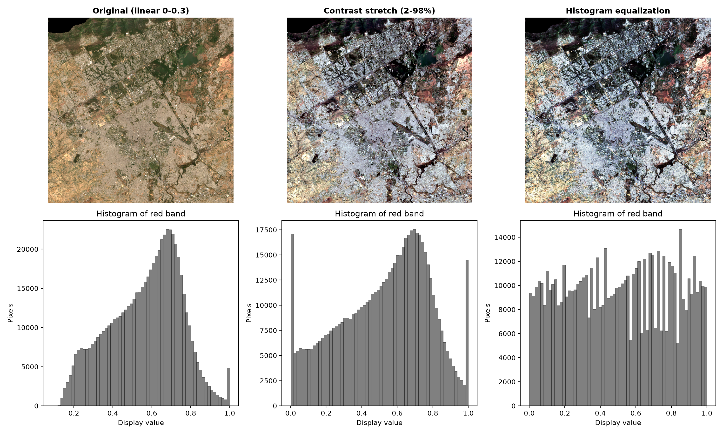
Figure 1: Original, contrast-stretched and histogram-equalized Sentinel-2 true-colour image of the twin-city core, with histograms of the red band.
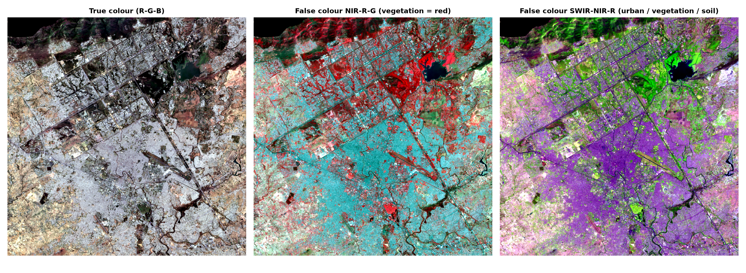
Figure 2: True-colour and false-colour composites (NIR–Red–Green and SWIR–NIR–Red).
Filtering reduced pixel-to-pixel noise (Table 3). The median filter reduced the roughness of NDVI by about 47% and the Gaussian filter by about 65%. The effect on LST was smaller because the 30 m thermal layer is already smooth. Median filtering removes isolated noisy pixels while keeping edges, and Gaussian smoothing blurs edges as it averages.
Table 3: Noise reduction by filtering (roughness = standard deviation of the difference between neighbouring pixels; lower values are smoother).
Layer | Version | Roughness
LST (°C) | Original | 0.3039
LST (°C) | Median filter 3 × 3 | 0.2762
LST (°C) | Gaussian filter, σ = 1 | 0.2402
NDVI | Original | 0.0925
NDVI | Median filter 3 × 3 | 0.0488
NDVI | Gaussian filter, σ = 1 | 0.0327

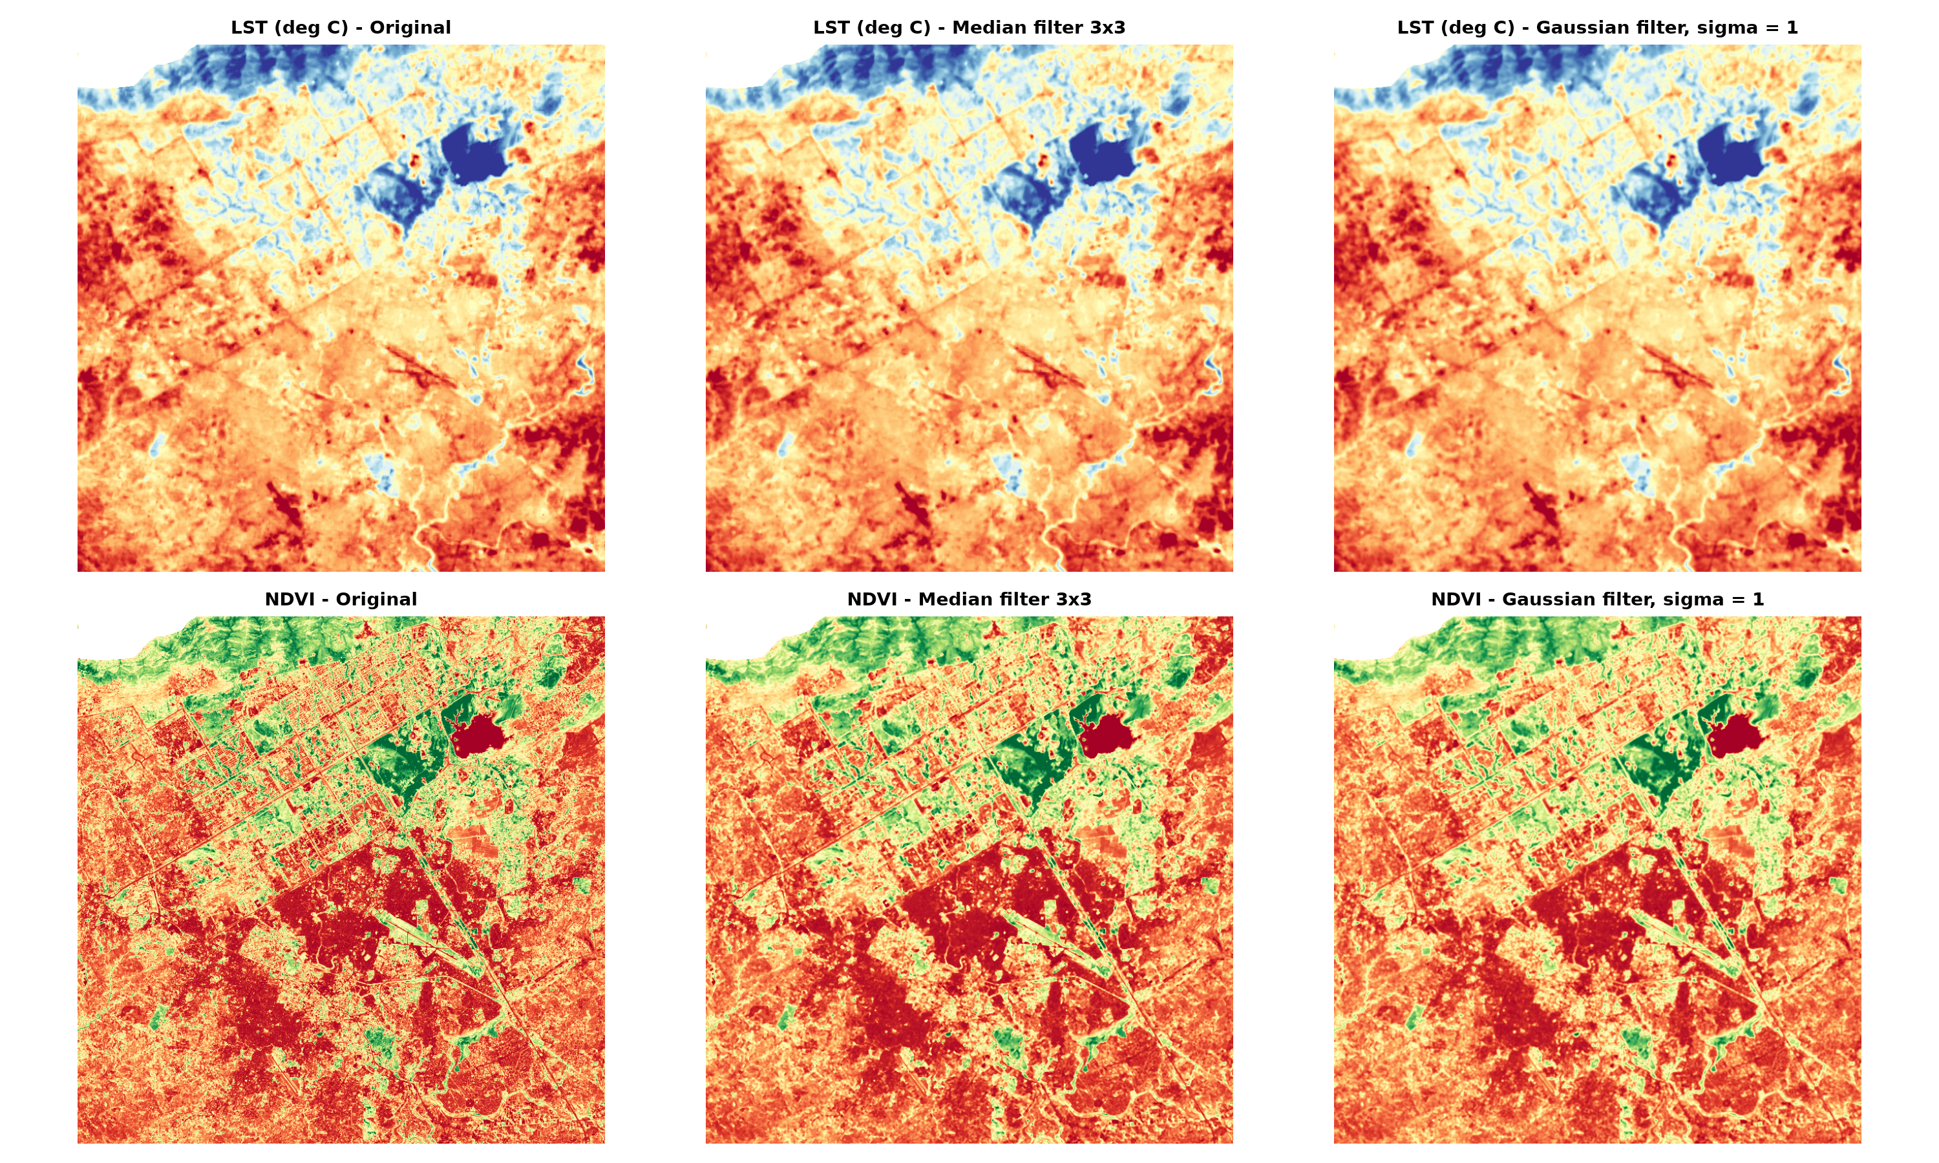
Figure 3: Median and Gaussian filtering of LST and NDVI (display only).
Threshold segmentation of the pre-monsoon LST at the 90th percentile identified 63,328 hotspot pixels in the zoom window. A 3 × 3 morphological opening removed 3,200 isolated pixels (5.1%), leaving 60,128 pixels (Figure 4).
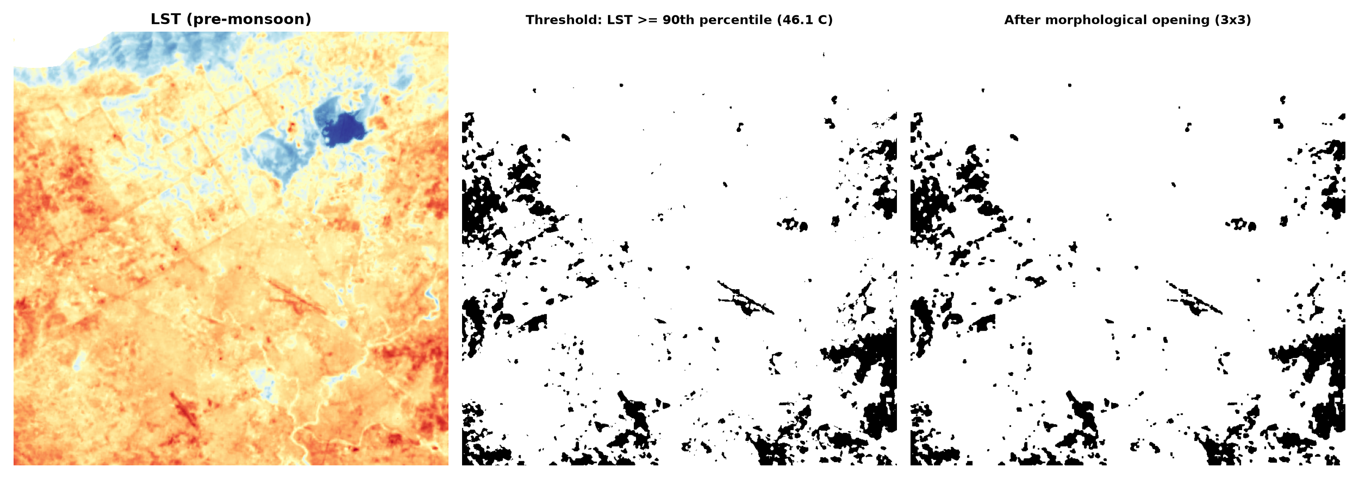
Figure 4: Threshold segmentation of the hottest 10% of LST and refinement by morphological opening.

5.2 Land surface temperature
Table 4: Seasonal LST statistics (°C) for the combined study area.
Season | Mean | Std. dev. | Minimum | Maximum
Pre-monsoon (May–June 2025) | 43.62 | 5.22 | 20.54 | 58.40
Post-monsoon (Sep–Oct 2025) | 32.41 | 4.61 | 13.92 | 44.74

Mean LST was 43.6 °C before the monsoon and 32.4 °C after it, a decrease of about 11 °C. The LST maps show cooler surfaces in the northern hills and hotter surfaces over the southern plain (Figure 5). The pre-monsoon histogram is shifted to higher temperatures and has a wider spread than the post-monsoon histogram (Figures 6 and 7).
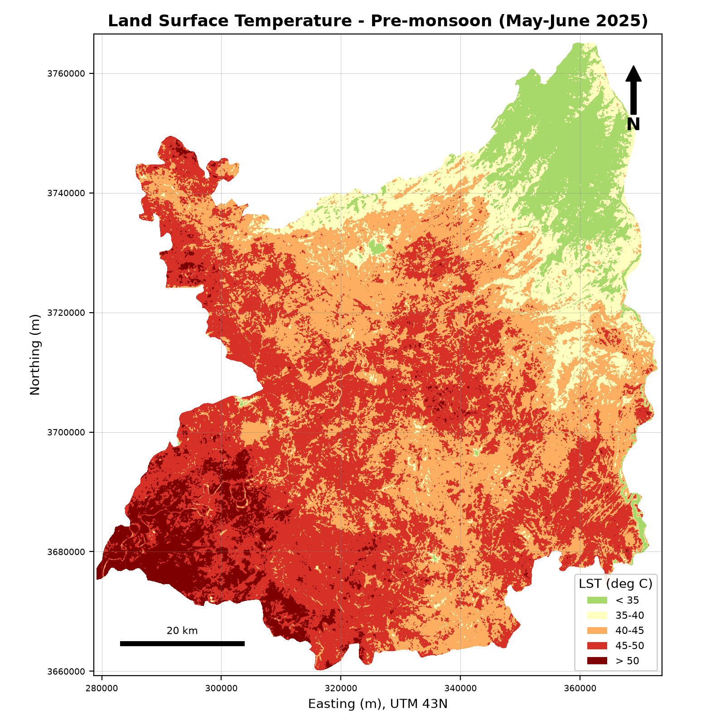 | 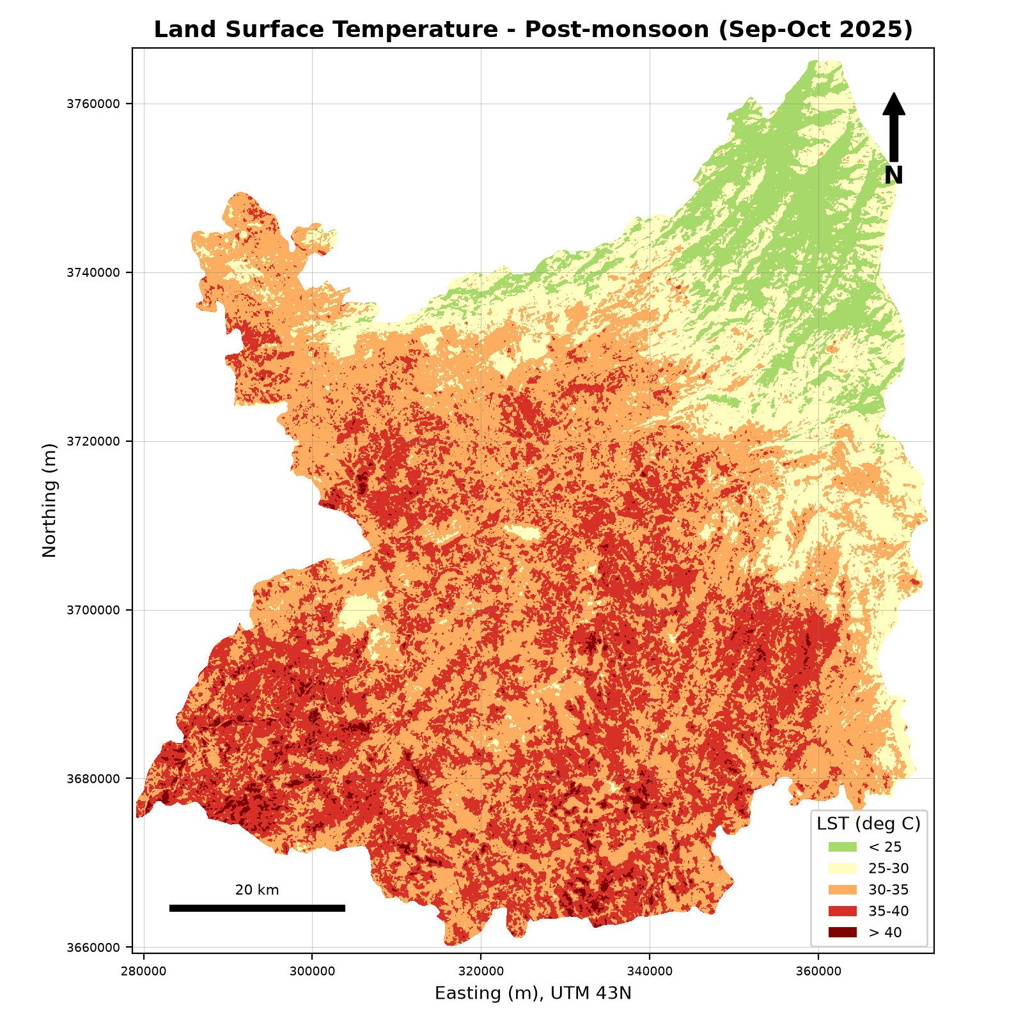
Figure 5: Land surface temperature, pre-monsoon (left) and post-monsoon (right).
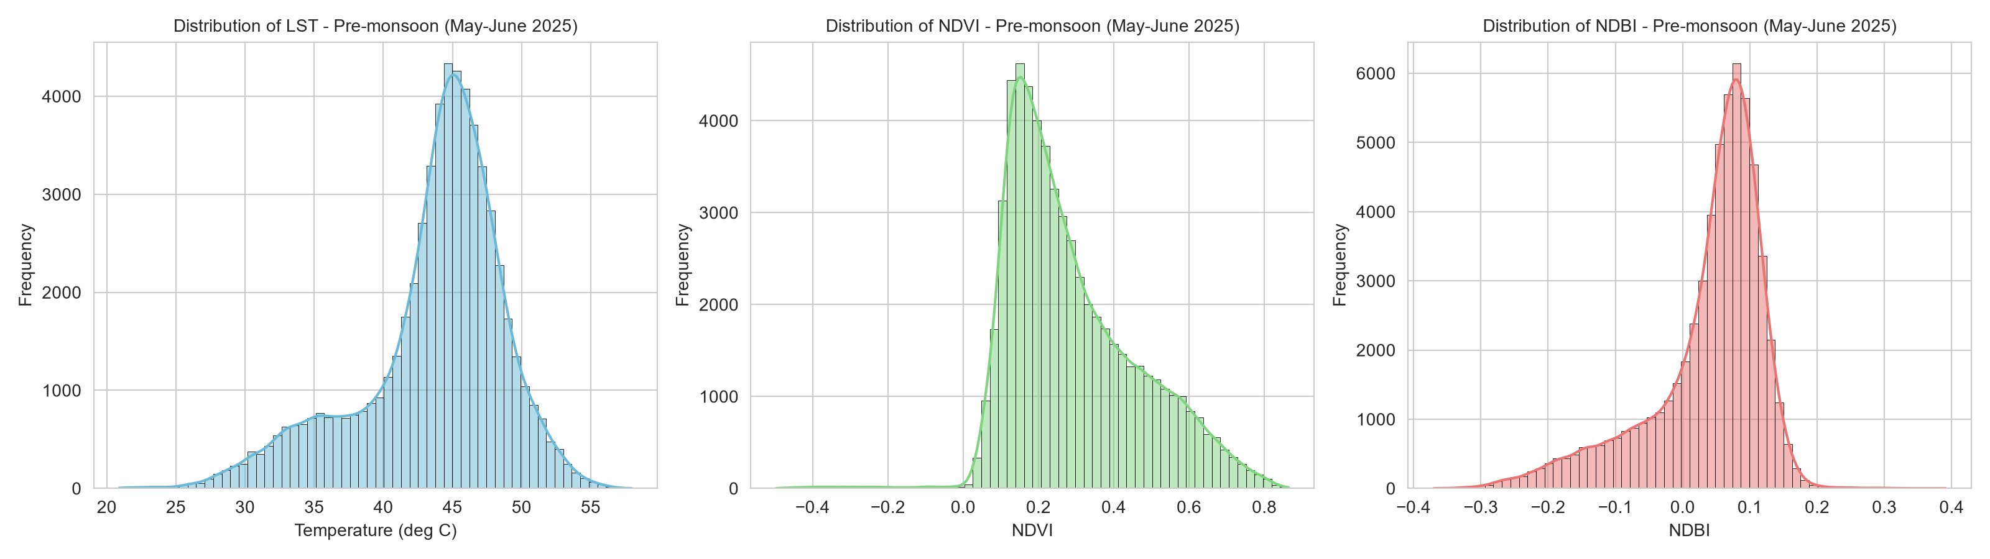
Figure 6: Distributions of LST, NDVI and NDBI, pre-monsoon (random sample of 60,000 pixels).
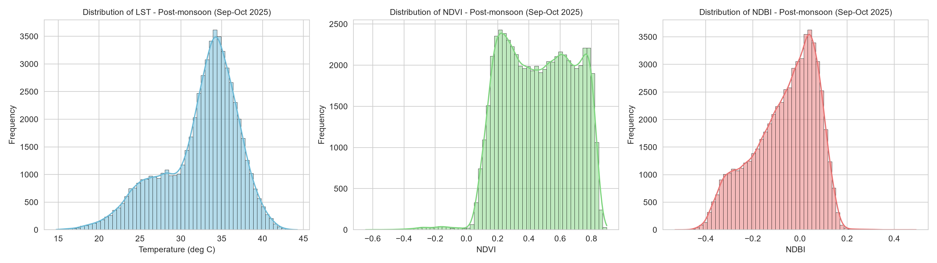
Figure 7: Distributions of LST, NDVI and NDBI, post-monsoon (random sample of 60,000 pixels).

5.3 Spectral indices
Table 5: Spectral index statistics for the combined study area.
Season | Index | Mean | Std. dev. | Minimum | Maximum
Pre-monsoon | NDVI | 0.290 | 0.172 | −0.529 | 0.907
Pre-monsoon | NDBI | 0.037 | 0.087 | −0.503 | 0.600
Pre-monsoon | NDWI | −0.360 | 0.131 | −0.837 | 0.638
Post-monsoon | NDVI | 0.460 | 0.221 | −0.908 | 0.938
Post-monsoon | NDBI | −0.064 | 0.133 | −0.550 | 0.790
Post-monsoon | NDWI | −0.481 | 0.170 | −0.840 | 0.945

Mean NDVI rose from 0.29 to 0.46 after the monsoon, which reflects vegetation recovery after rainfall. Mean NDBI fell from 0.037 to −0.064 and mean NDWI fell from −0.36 to −0.48. NDWI values were negative on average in both seasons, as expected in a landscape with little open water.
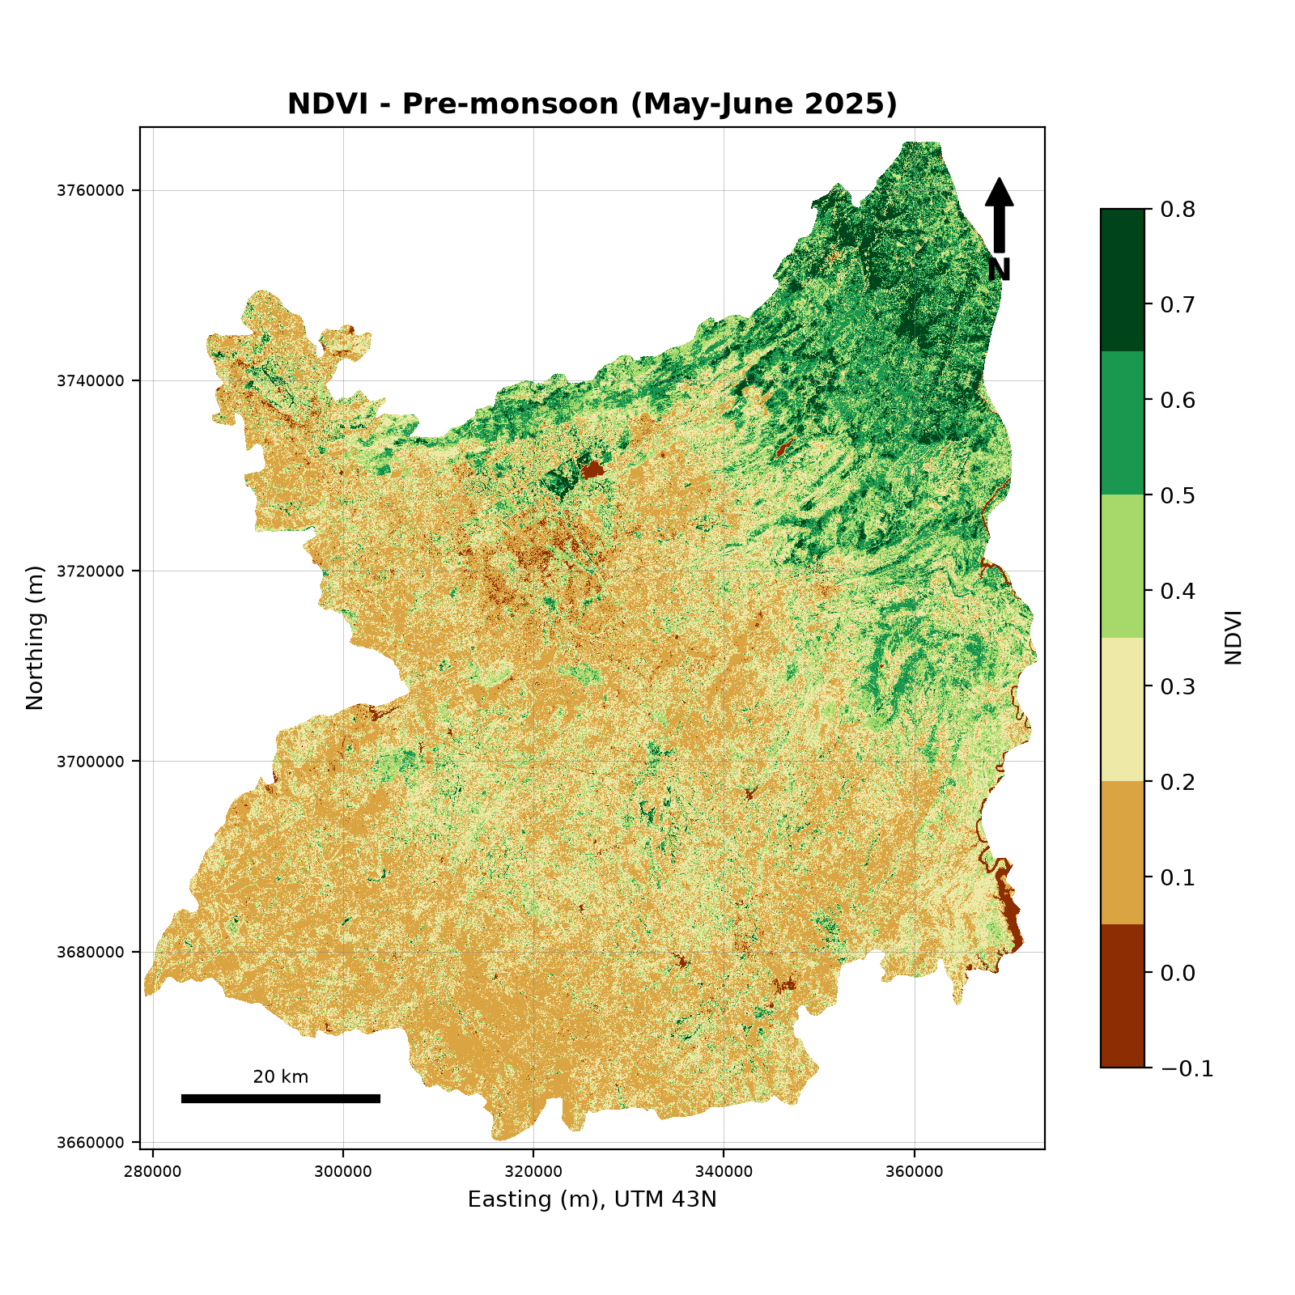 | 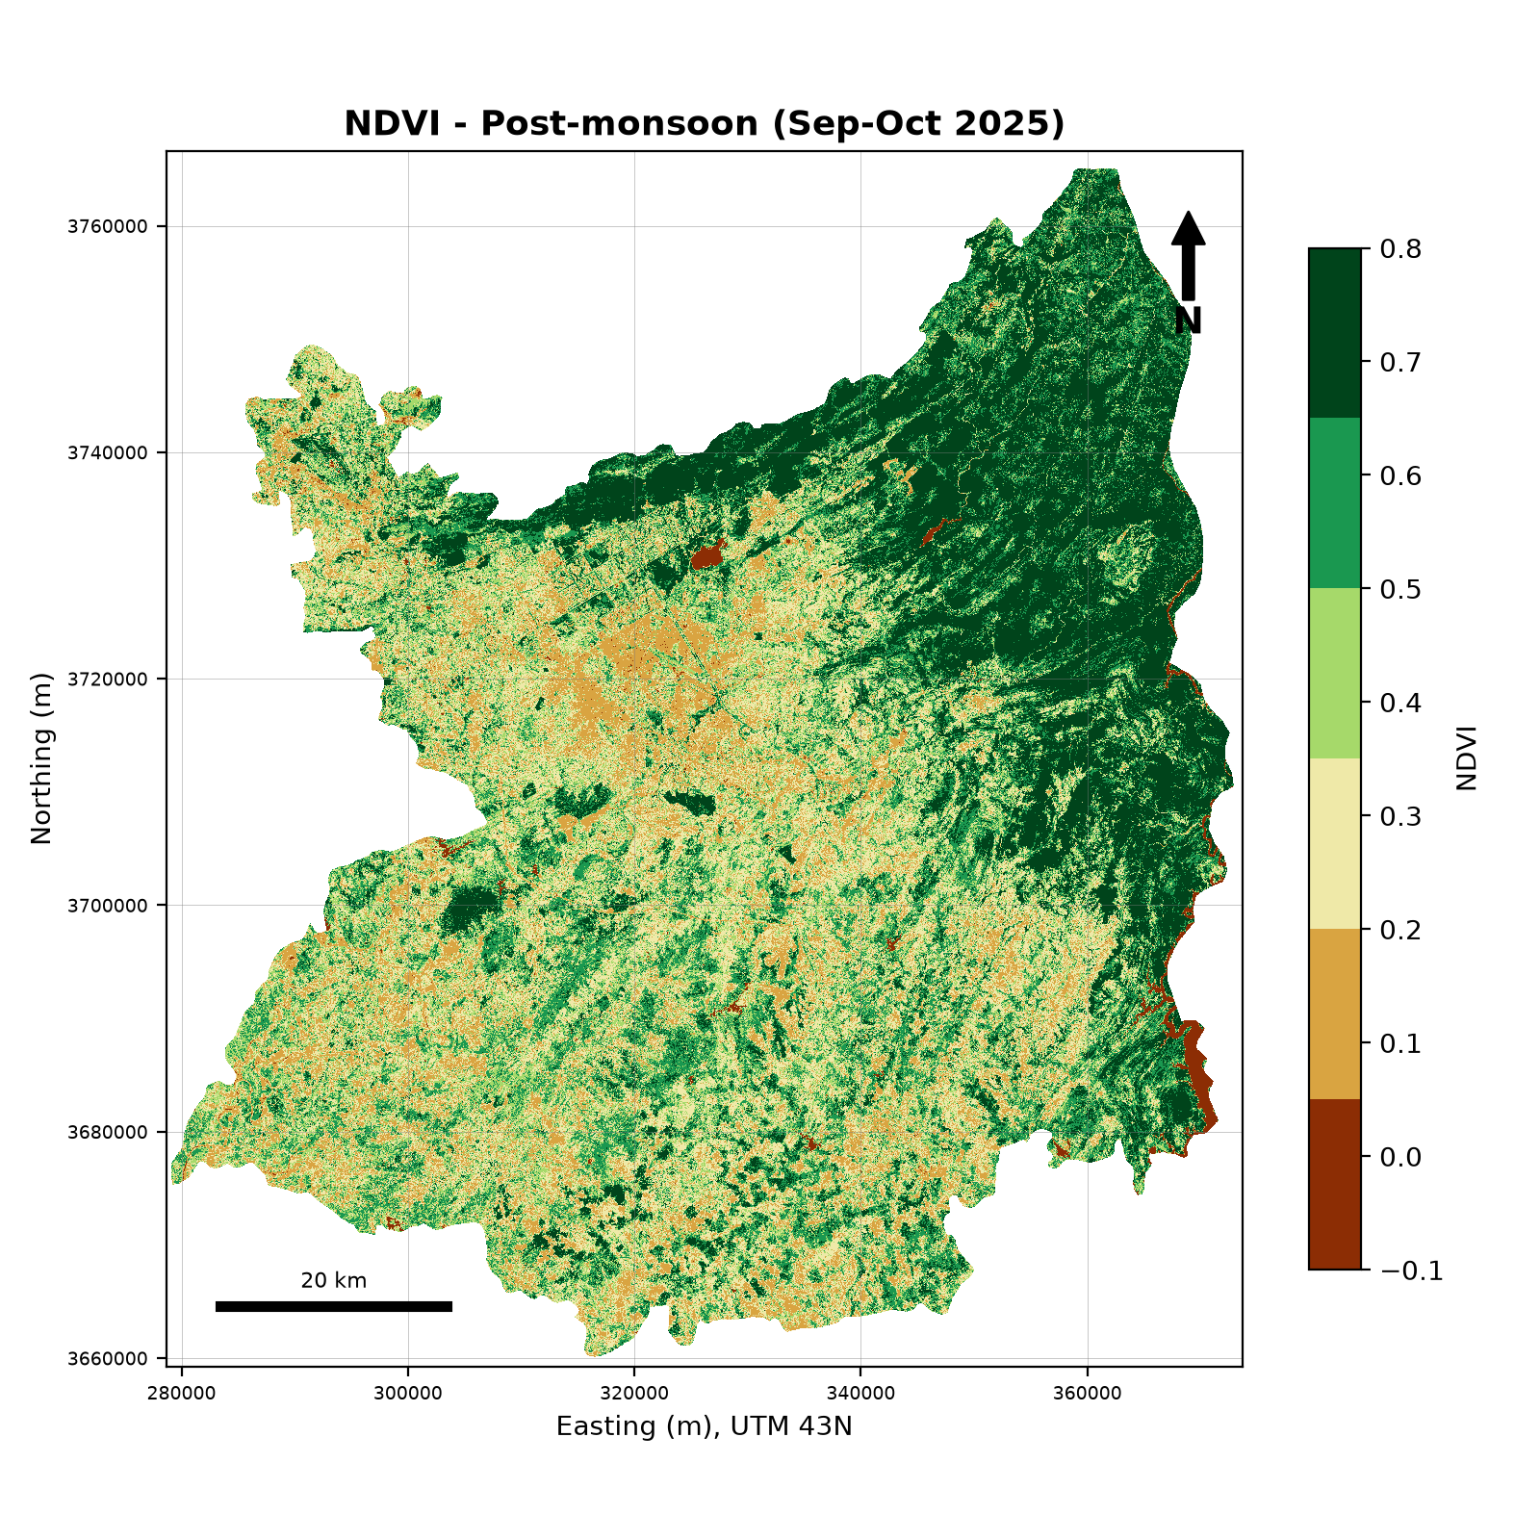
Figure 8: NDVI, pre-monsoon (left) and post-monsoon (right).
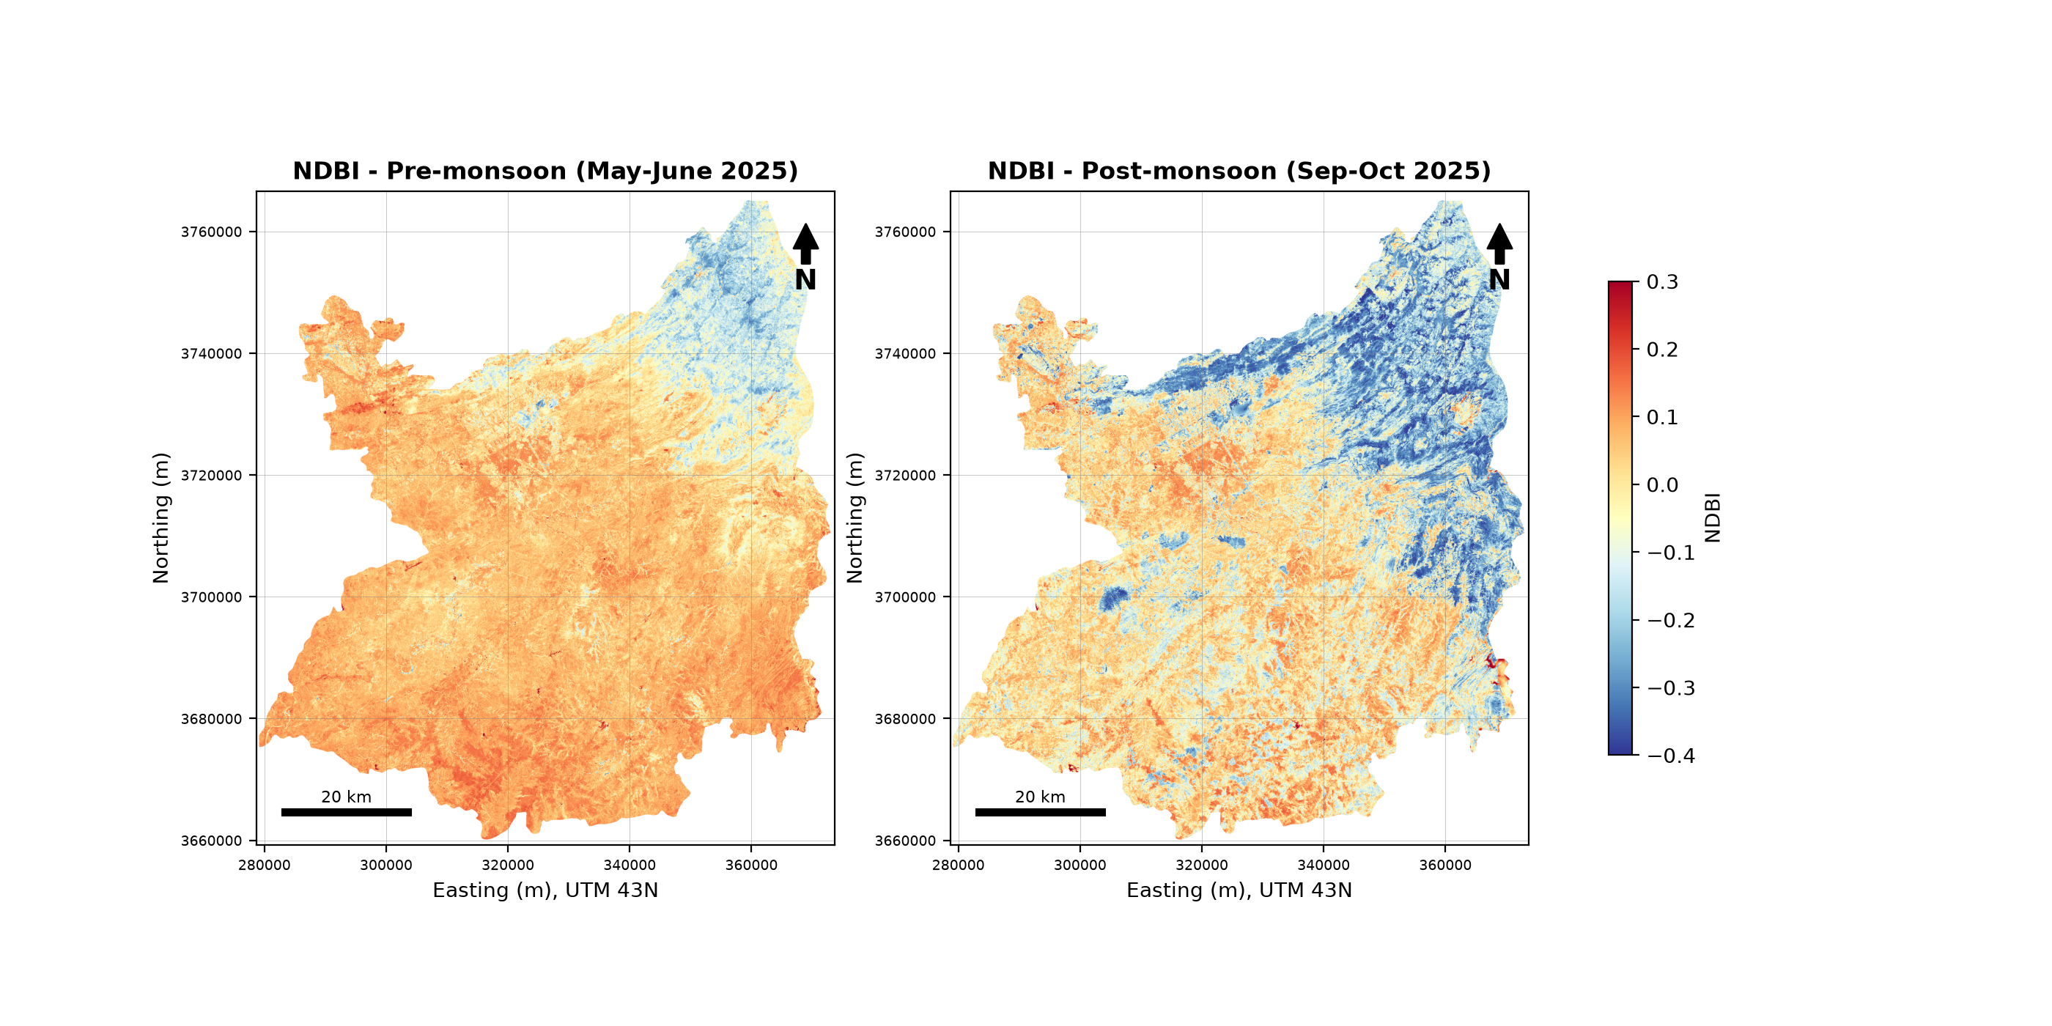
Figure 9: NDBI, pre-monsoon and post-monsoon.
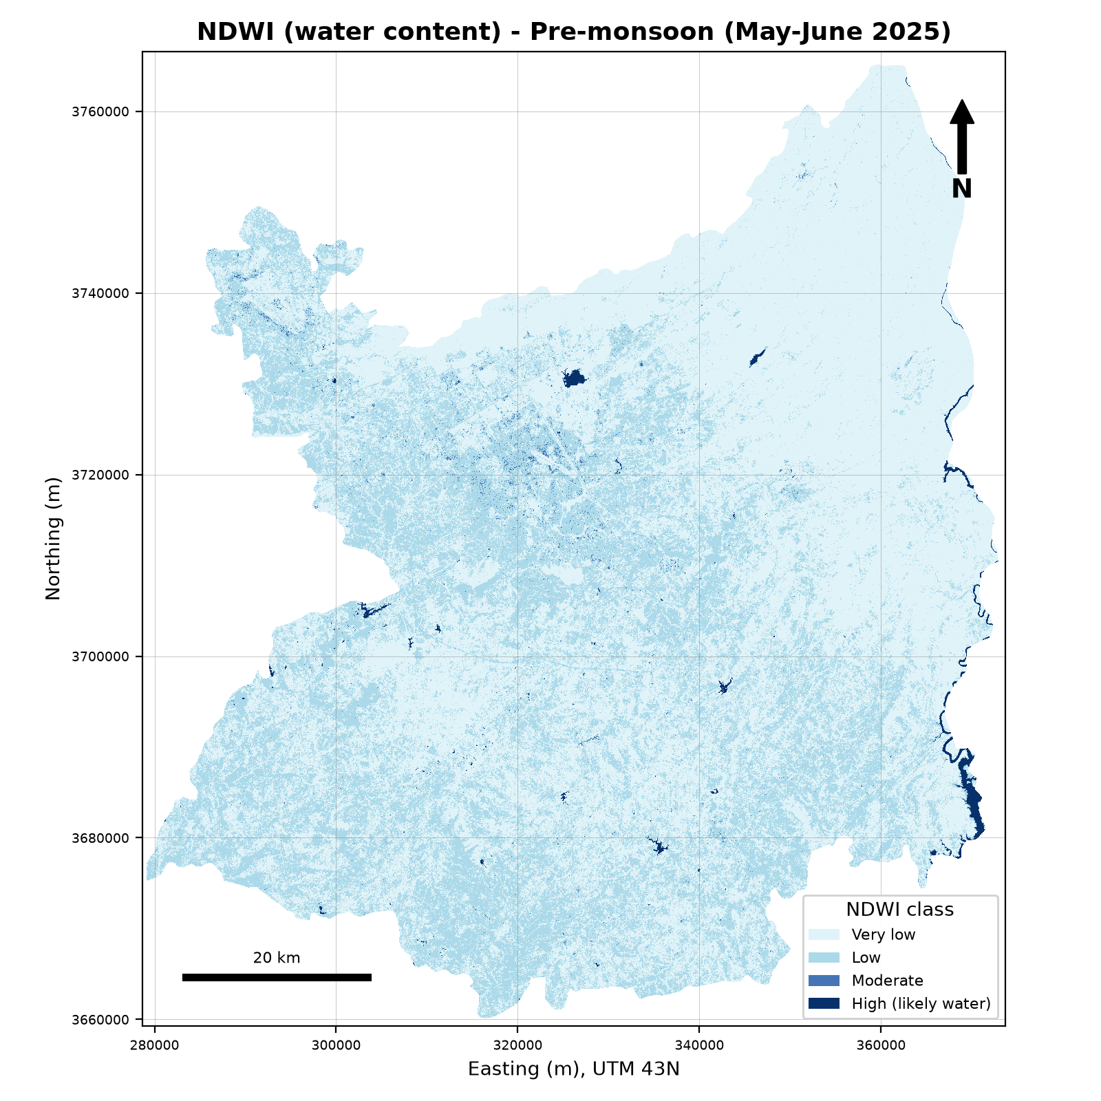 | 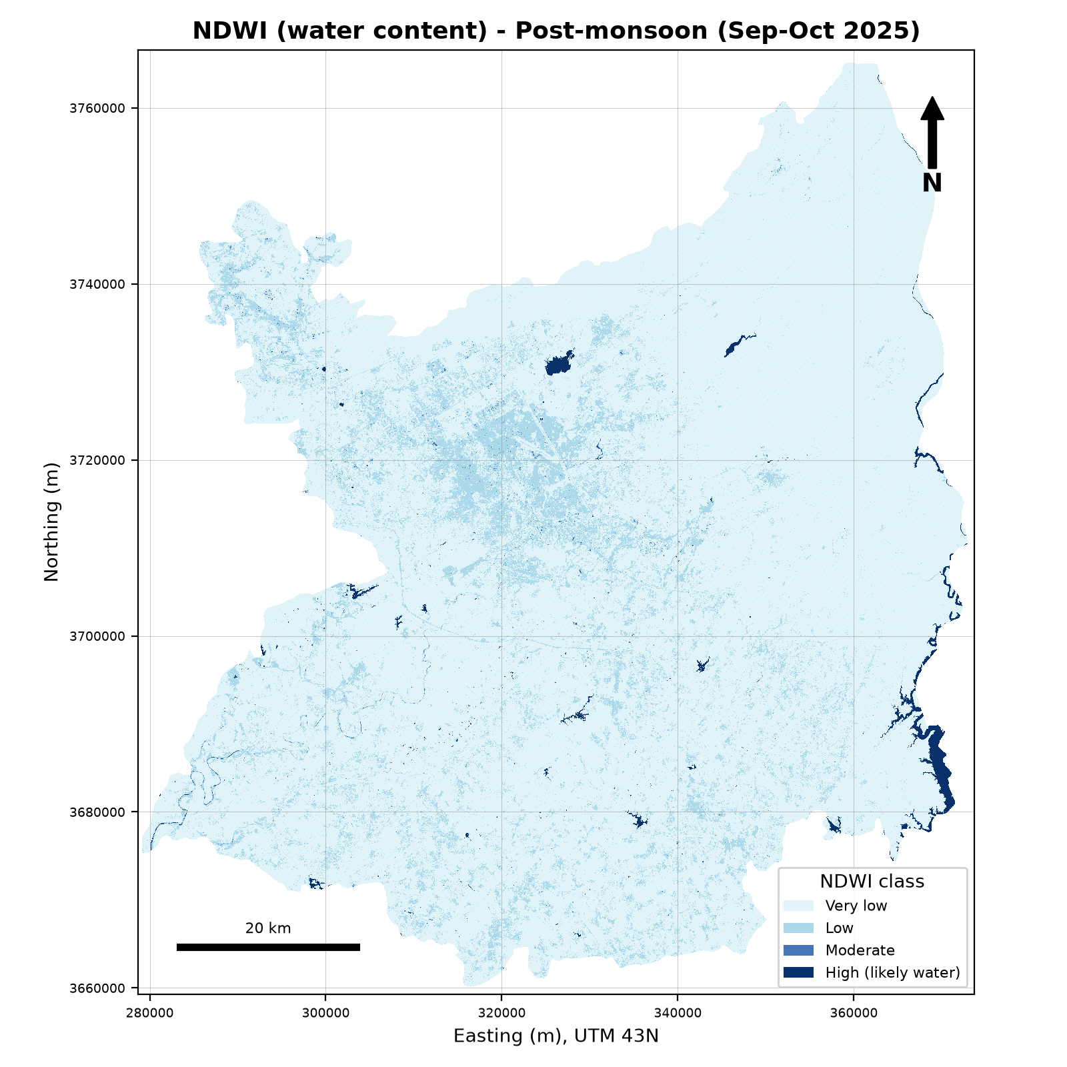
Figure 10: NDWI classes, pre-monsoon (left) and post-monsoon (right).

5.4 Land cover
The Random Forest classification shows built-up land concentrated in the urban core of the twin cities, vegetation mainly in the northern hills, and agriculture mainly on the southern plain (Figure 11). Vegetation was the largest class (42.3%), followed by agriculture (34.1%) and built-up land (14.7%) (Table 6).
Table 6: Land-cover area and percentage.
Class | Area (km²) | Share of area (%)
Built-up | 903.5 | 14.7
Vegetation | 2,592.3 | 42.3
Agriculture | 2,088.3 | 34.1
Water | 88.0 | 1.4
Bare land | 456.7 | 7.5

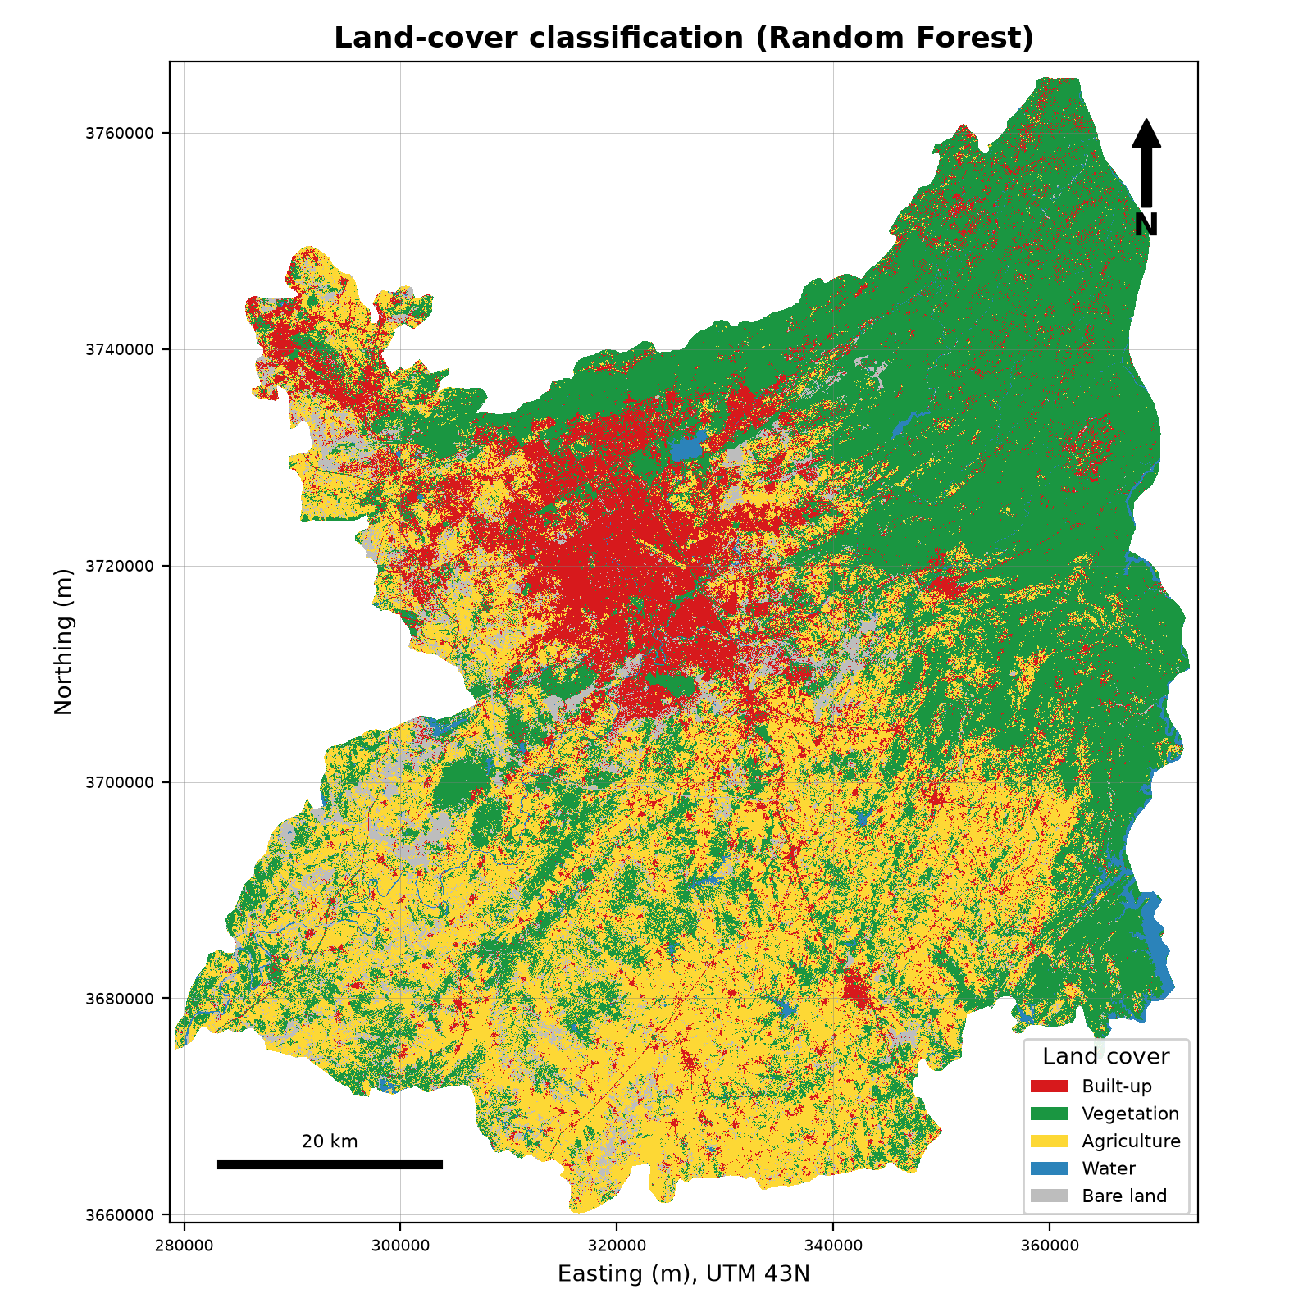
Figure 11: Land-cover classification of the Islamabad–Rawalpindi study area (Random Forest, 30 m).
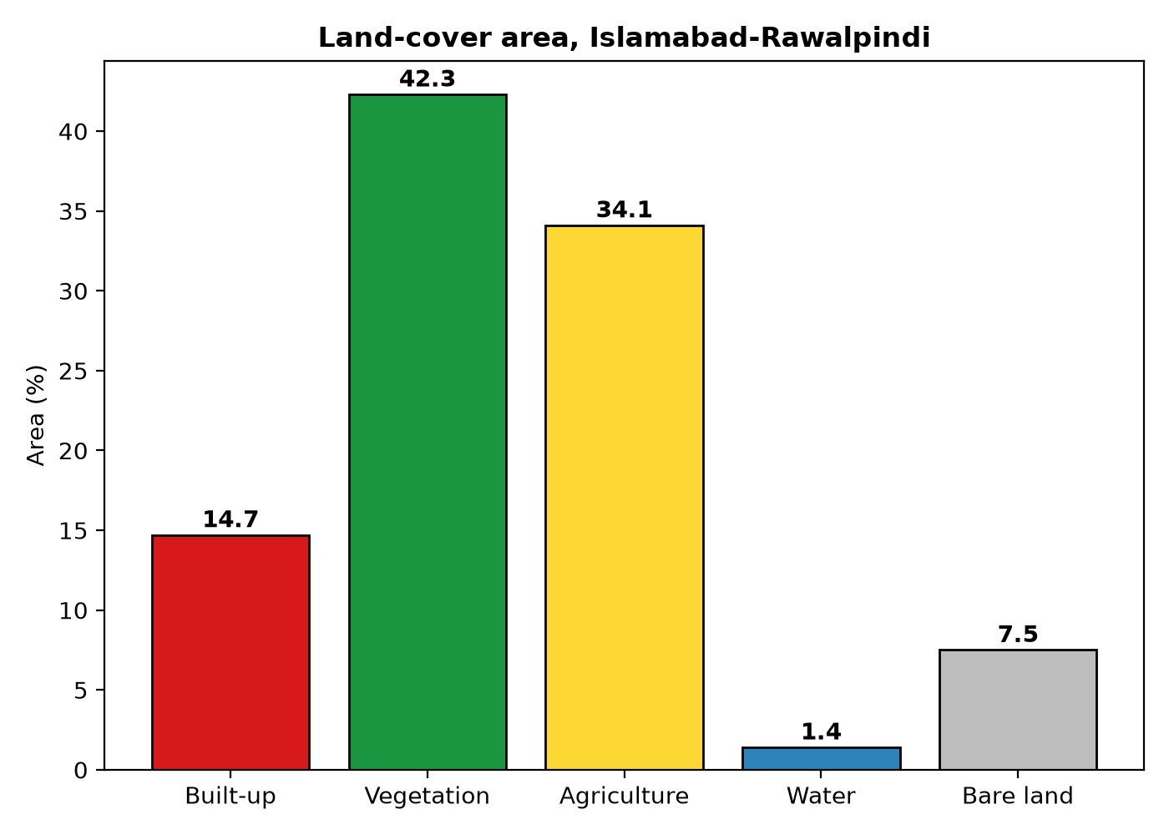
Figure 12: Land-cover area share.

5.5 Relationship between LST, vegetation and built-up intensity
Table 7: Correlation between LST and the spectral indices (random sample of 60,000 pixels per season).
Season | Index | Pearson r | Spearman ρ | R² (linear regression)
Pre-monsoon | NDVI | −0.703 | −0.686 | 0.495
Pre-monsoon | NDBI | 0.790 | 0.686 | 0.625
Pre-monsoon | NDWI | 0.576 | 0.619 | 0.332
Post-monsoon | NDVI | −0.677 | −0.725 | 0.458
Post-monsoon | NDBI | 0.761 | 0.766 | 0.579
Post-monsoon | NDWI | 0.563 | 0.696 | 0.318

LST was strongly negatively correlated with NDVI and strongly positively correlated with NDBI in both seasons, which supports hypotheses H1 and H2. NDBI had the strongest relationship (R² = 0.63 before the monsoon). Spearman correlations were close to the Pearson values, so the relationships do not depend on a few extreme pixels. NDWI was positively correlated with LST. In this dry landscape NDWI is higher over bare and built surfaces than over vegetation, so this correlation should not be read as a water effect; NDWI is reliable here only for identifying open water.
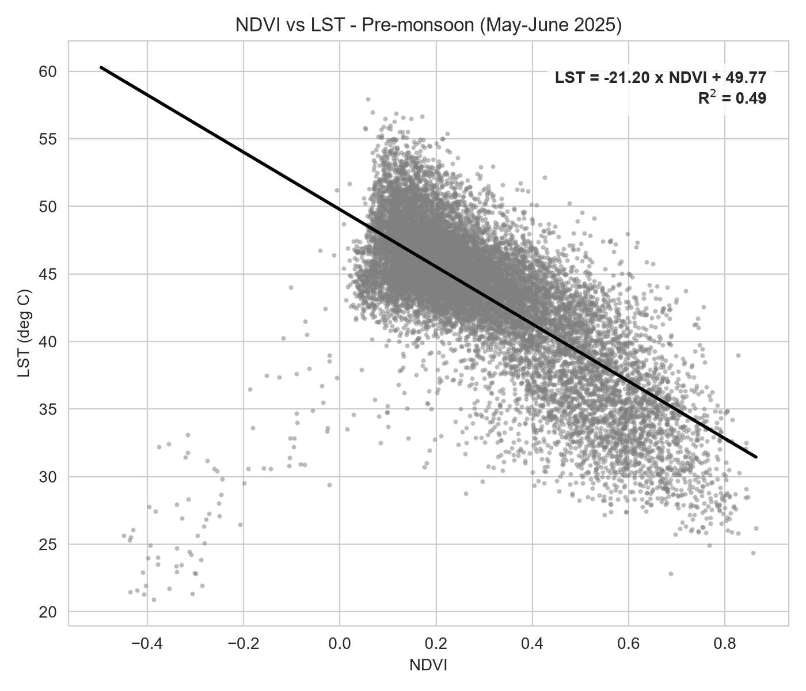 | 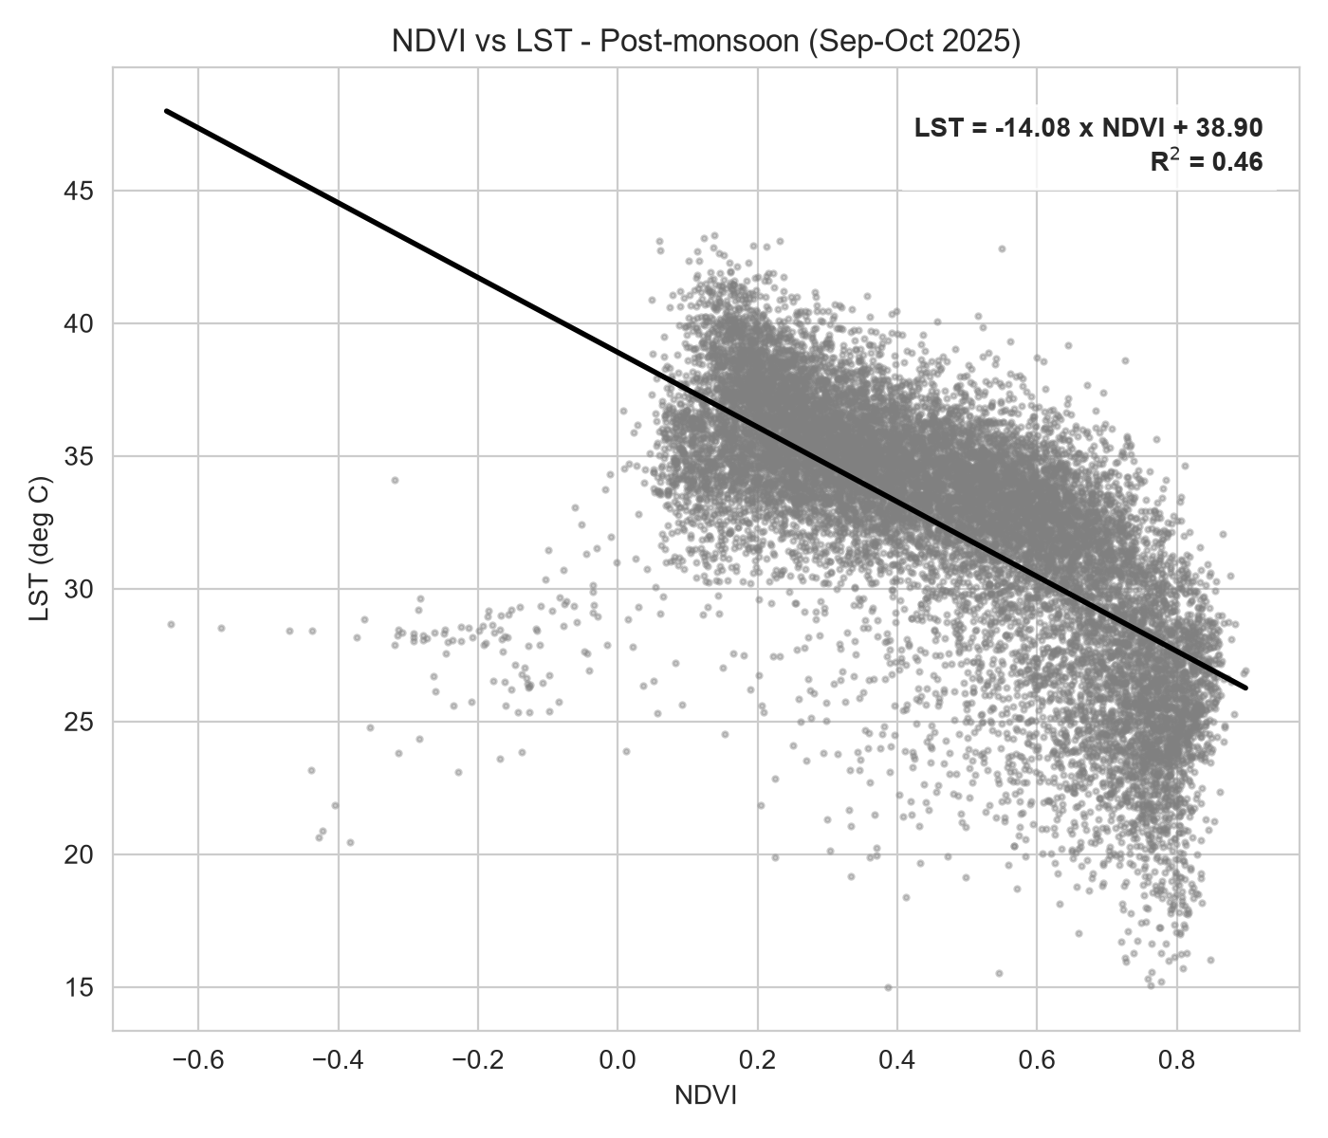
Figure 13: LST against NDVI with the fitted regression line, pre-monsoon (left) and post-monsoon (right).
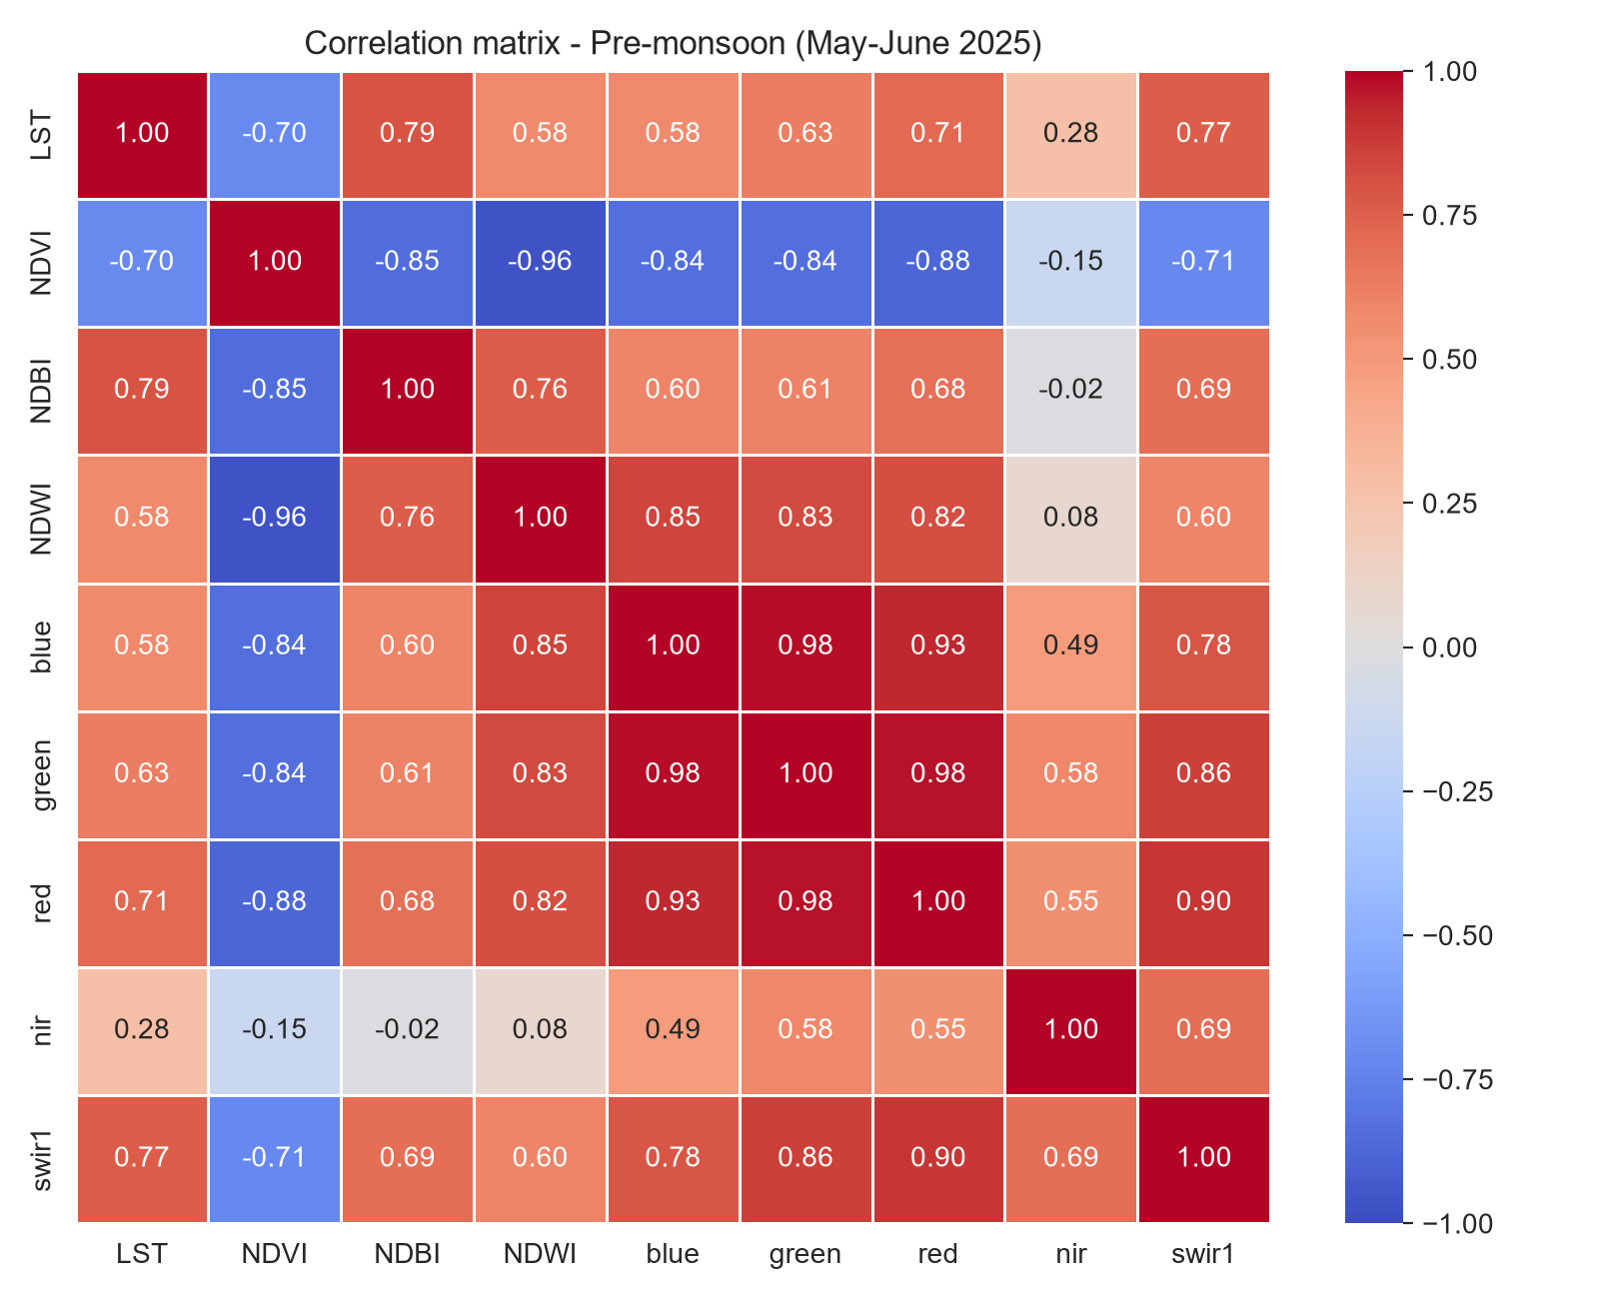 | 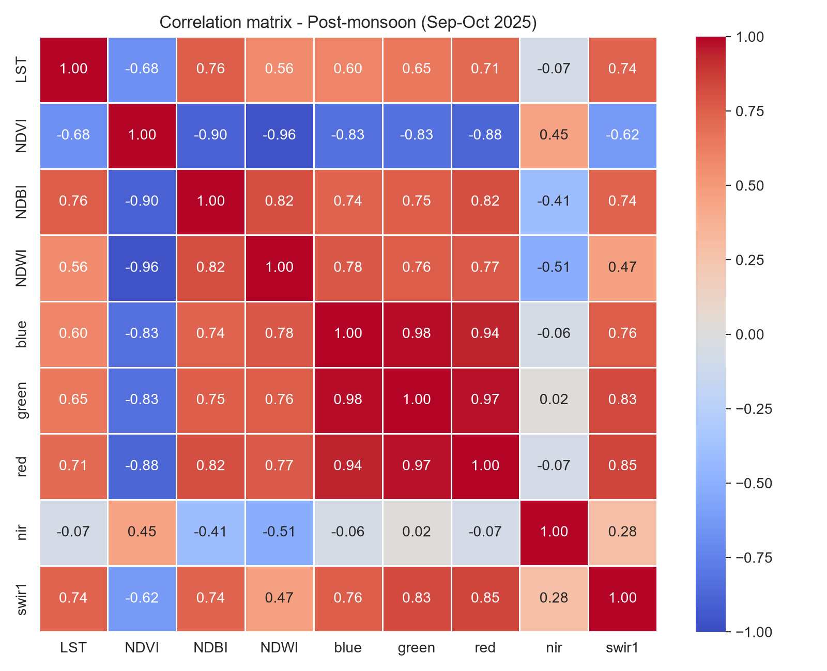
Figure 14: Correlation matrices of LST, indices and reflectance bands, pre-monsoon (left) and post-monsoon (right).
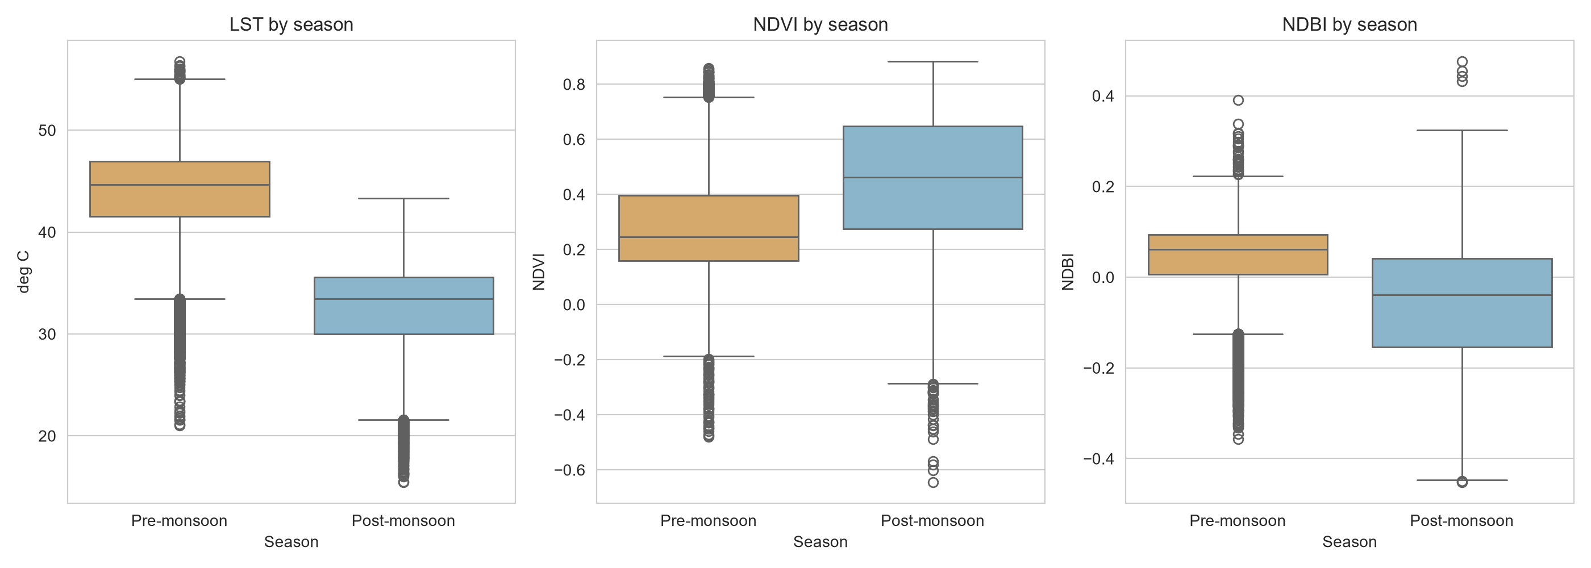
Figure 15: Seasonal comparison of LST, NDVI and NDBI.
LST differed clearly between land-cover classes (Figure 16). Vegetation and water were the coolest classes, and agriculture and bare land were the warmest. Before the monsoon, agricultural and bare surfaces were warmer than built-up land, which is plausible in May–June when fields are dry or fallow.
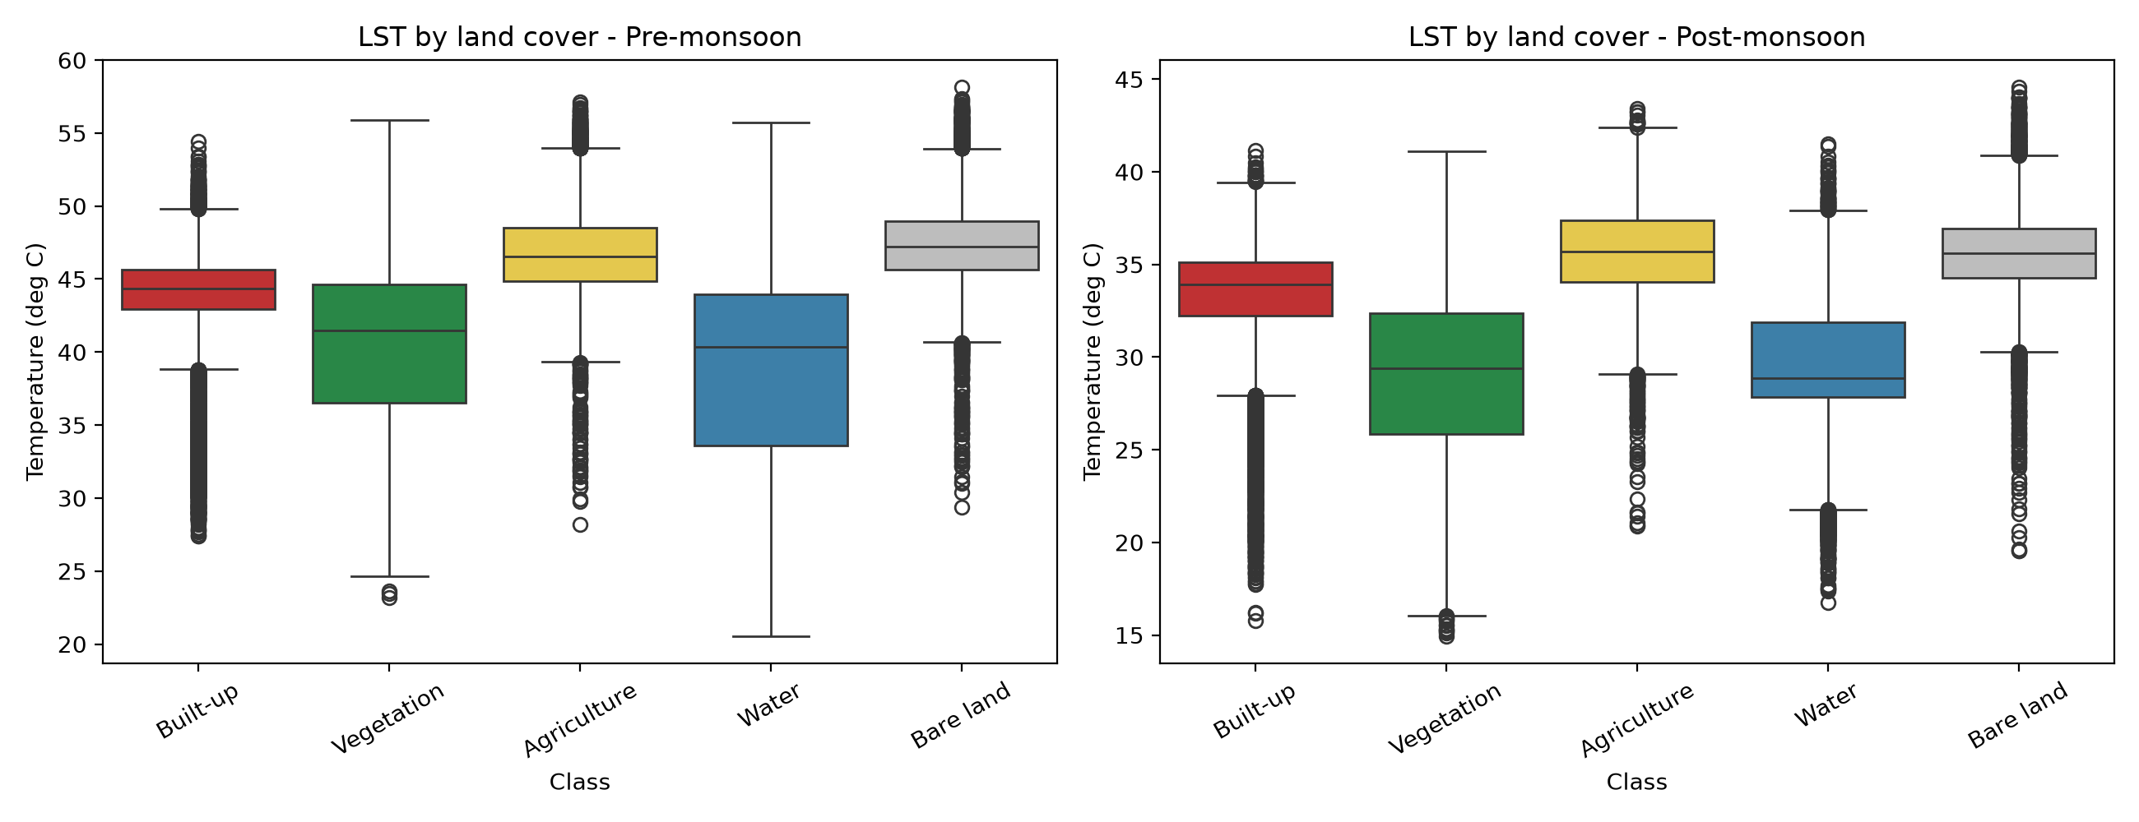
Figure 16: LST by land-cover class, pre-monsoon and post-monsoon.

5.6 Urban Thermal Stress Index and hotspots
Table 8: Area of the relative UTSI classes.
Season | UTSI class | Area (km²) | Share (%)
Pre-monsoon | Low thermal stress | 1,490.4 | 24.3
Pre-monsoon | Moderate thermal stress | 2,301.6 | 37.6
Pre-monsoon | High thermal stress | 2,336.3 | 38.1
Post-monsoon | Low thermal stress | 1,811.8 | 29.6
Post-monsoon | Moderate thermal stress | 2,020.7 | 33.0
Post-monsoon | High thermal stress | 2,295.8 | 37.5

The class shares are similar in the two seasons because the thresholds are derived from each season's own mean and standard deviation. The classes should therefore be compared in where they fall and not in how much area they cover.
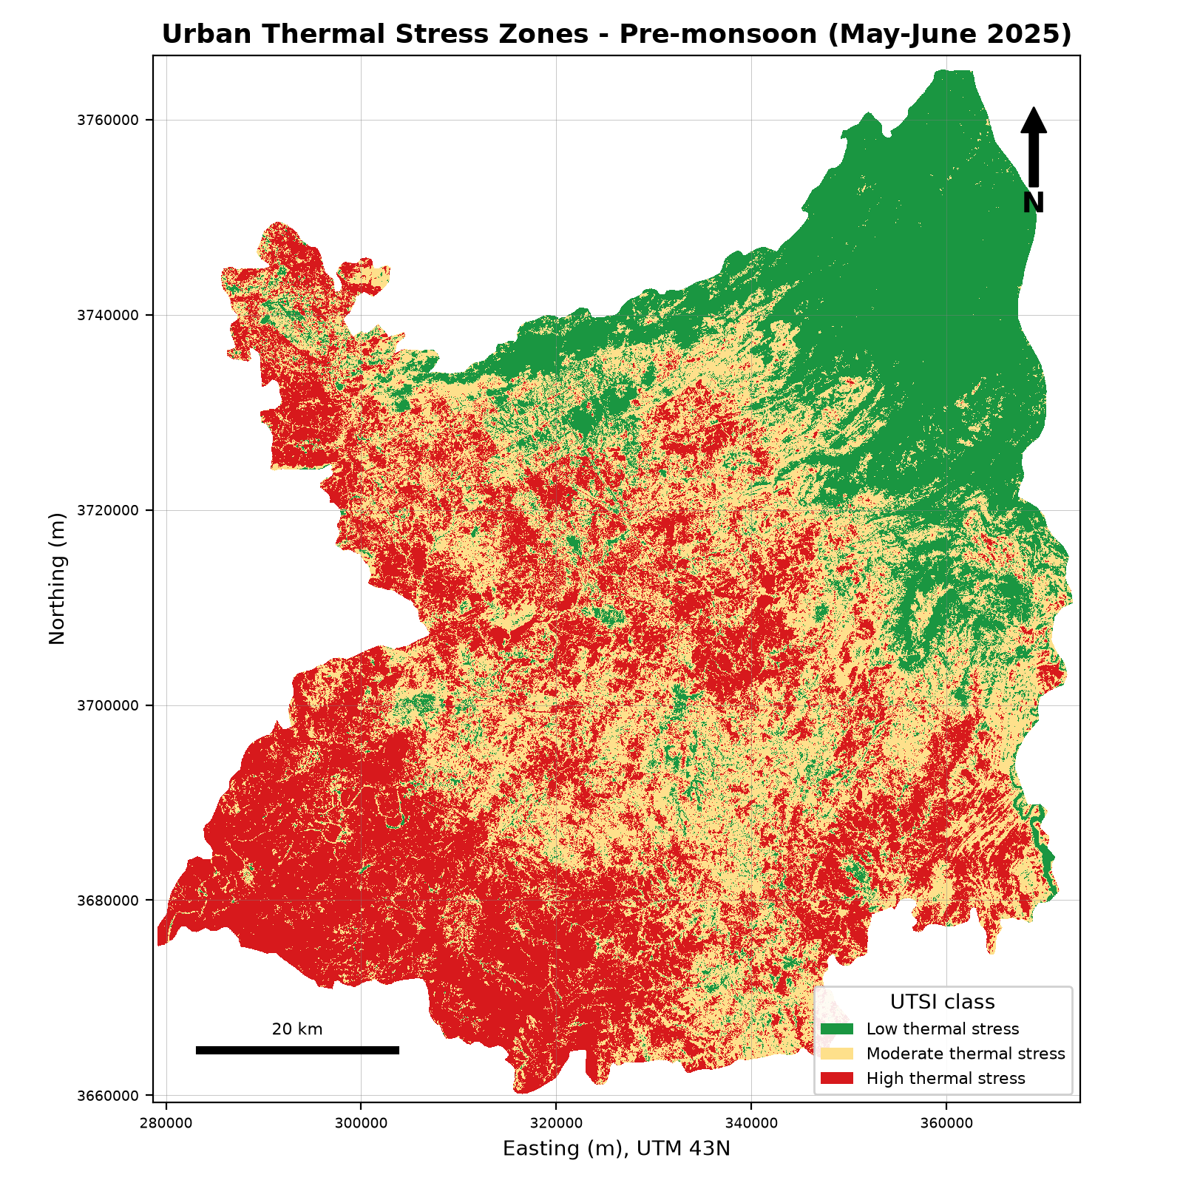 | 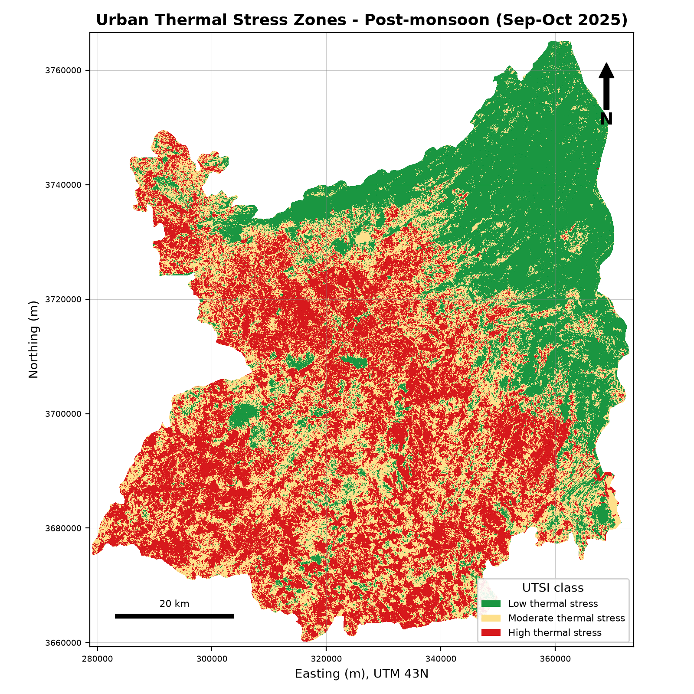
Figure 17: Urban Thermal Stress zones, pre-monsoon (left) and post-monsoon (right).
Table 9: Composition of the high-stress class by land cover.
Season | Land cover | % of the class that is high stress | % of all high-stress area in the class
Pre-monsoon | Built-up | 39.5 | 15.3
Pre-monsoon | Vegetation | 11.4 | 12.7
Pre-monsoon | Agriculture | 61.1 | 54.6
Pre-monsoon | Water | 15.7 | 0.6
Pre-monsoon | Bare land | 86.1 | 16.8
Post-monsoon | Built-up | 59.5 | 23.4
Post-monsoon | Vegetation | 1.1 | 1.3
Post-monsoon | Agriculture | 61.6 | 56.0
Post-monsoon | Water | 35.9 | 1.4
Post-monsoon | Bare land | 90.3 | 18.0

Bare land was the most stressed class (86% before and 90% after the monsoon), and vegetation was the least stressed (11% and 1%). Agriculture contributed the largest share of the high-stress area (about 55%) because it is both extensive and mostly in the high class. Built-up land was moderately stressed, and its high-stress share rose from 39.5% to 59.5% after the monsoon, because the index is relative and vegetation recovery lowers the baseline elsewhere. It does not mean built-up land became hotter.
Table 10: Critical hotspots (hottest 10% of LST and least-vegetated 25% of NDVI), area in km².
Season | Total (% of area) | Built-up | Vegetation | Agriculture | Water | Bare land
Pre-monsoon | 364.9 (5.95%) | 7.0 | 9.1 | 243.3 | 0.9 | 104.5
Post-monsoon | 460.0 (7.51%) | 14.6 | 0.0 | 371.8 | 0.4 | 73.2

Critical hotspots covered 365 km² before the monsoon and 460 km² after it, and were mostly agricultural and bare land. Only 7 and 15 km² were classified as built-up. In this district the strongest combination of high temperature and low vegetation is therefore found on dry farmland and bare ground of the southern plain, not in the dense urban core.

5.7 Islamabad compared with Rawalpindi
Table 11: Comparison of Islamabad and Rawalpindi districts.
Metric | Islamabad pre | Rawalpindi pre | Islamabad post | Rawalpindi post
Area analysed (km²) | 895.5 | 5,223.9 | 895.5 | 5,223.9
LST mean (°C) | 43.12 | 43.70 | 31.76 | 32.52
LST std. dev. (°C) | 3.20 | 5.48 | 3.44 | 4.77
LST minimum (°C) | 28.28 | 20.53 | 20.58 | 13.92
LST maximum (°C) | 52.88 | 58.40 | 41.83 | 44.74
NDVI mean | 0.292 | 0.290 | 0.446 | 0.463
NDBI mean | 0.032 | 0.037 | −0.073 | −0.063
NDWI mean | −0.352 | −0.362 | −0.462 | −0.485
High thermal stress (% of area) | 24.3 | 40.5 | 33.3 | 38.2
Pearson r, LST–NDVI | −0.632 | −0.728 | −0.702 | −0.678
Pearson r, LST–NDBI | 0.665 | 0.805 | 0.783 | 0.760

Table 12: Land-cover composition of the two districts (%).
Class | Islamabad | Rawalpindi
Built-up | 35.9 | 11.1
Vegetation | 39.1 | 42.8
Agriculture | 17.1 | 37.0
Water | 1.3 | 1.4
Bare land | 6.6 | 7.6

Islamabad has about three times the built-up share of Rawalpindi District (35.9% against 11.1%) but a slightly lower mean LST (by 0.6 °C before the monsoon and 0.8 °C after it). Rawalpindi has a much larger agricultural share (37.0% against 17.1%) and a wider temperature range, because its district includes cooler hills as well as hot plains. When the same land-cover class is compared in the two districts (Table 13), the temperatures are very similar. Built-up land was 43.81 °C in Islamabad and 43.87 °C in Rawalpindi before the monsoon. The difference between the two districts therefore comes mostly from land-cover mix and not from different behaviour of the same surface type. Agriculture and bare land were 1.3–1.9 °C warmer in Rawalpindi before the monsoon.
Table 13: Mean LST (°C) by land-cover class and district.
Class | Islamabad pre | Rawalpindi pre | Islamabad post | Rawalpindi post
Built-up | 43.81 | 43.87 | 33.17 | 33.38
Vegetation | 41.13 | 40.42 | 28.97 | 28.96
Agriculture | 45.59 | 46.85 | 34.27 | 35.84
Water | 37.84 | 38.47 | 28.97 | 29.57
Bare land | 45.81 | 47.65 | 34.68 | 35.75

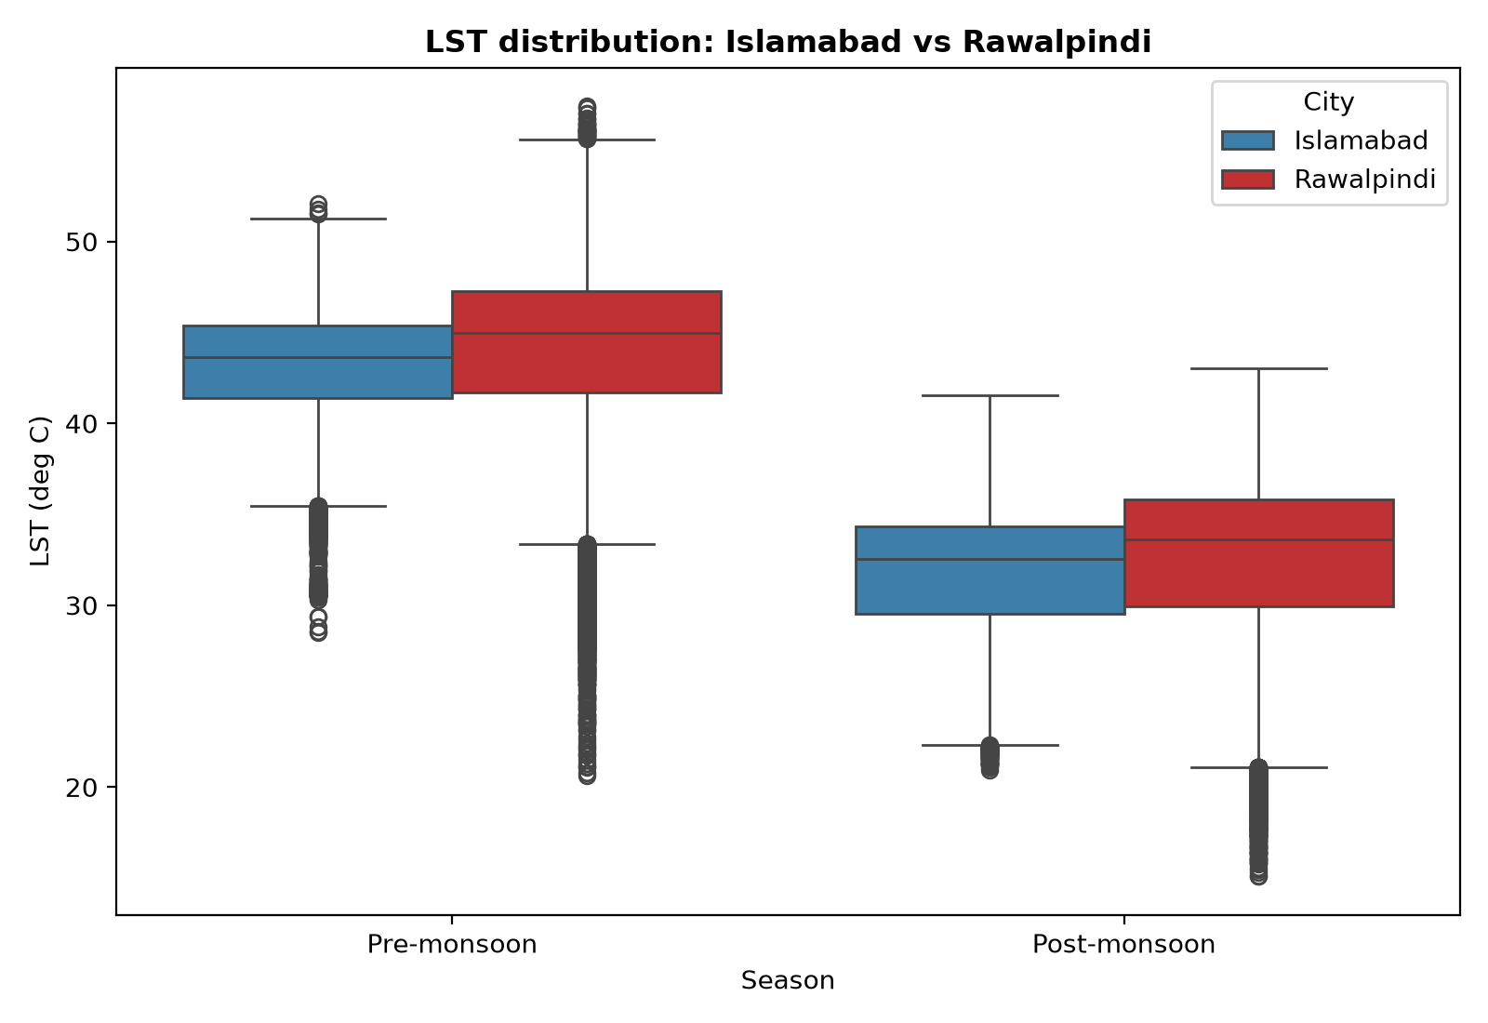
Figure 18: LST distribution in Islamabad and Rawalpindi.
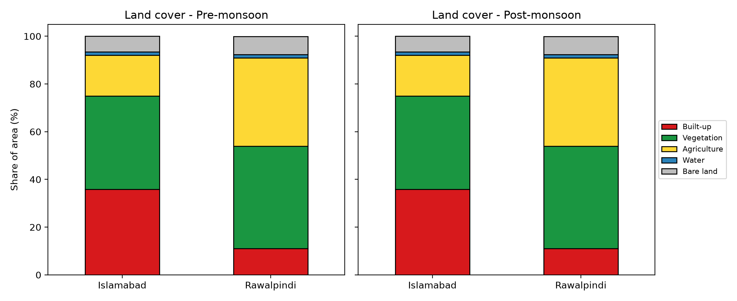
Figure 19: Land-cover composition of Islamabad and Rawalpindi.

5.8 Seasonal change
Table 14: Seasonal change (post-monsoon minus pre-monsoon) from image differencing.
Metric | Value
Mean change in LST | −11.21 °C
Mean change in NDVI | +0.170
Pixels with an NDVI increase | 56.4%

The mean LST decrease of 11.2 °C agrees with the difference between the two seasonal means in Table 4. NDVI increased on average by 0.17, but only 56.4% of pixels increased, so a large part of the area stayed the same or decreased. Irrigated cropland that is green in May–June and dry or harvested afterwards is one plausible reason.
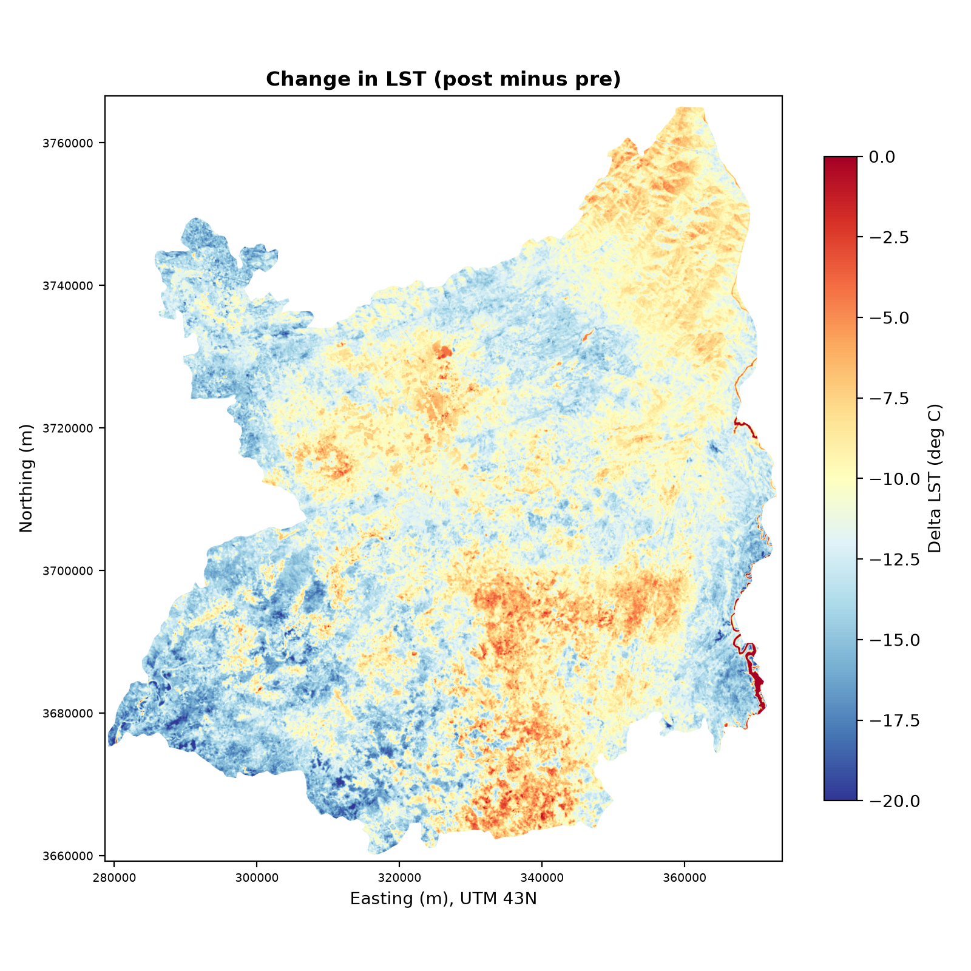 | 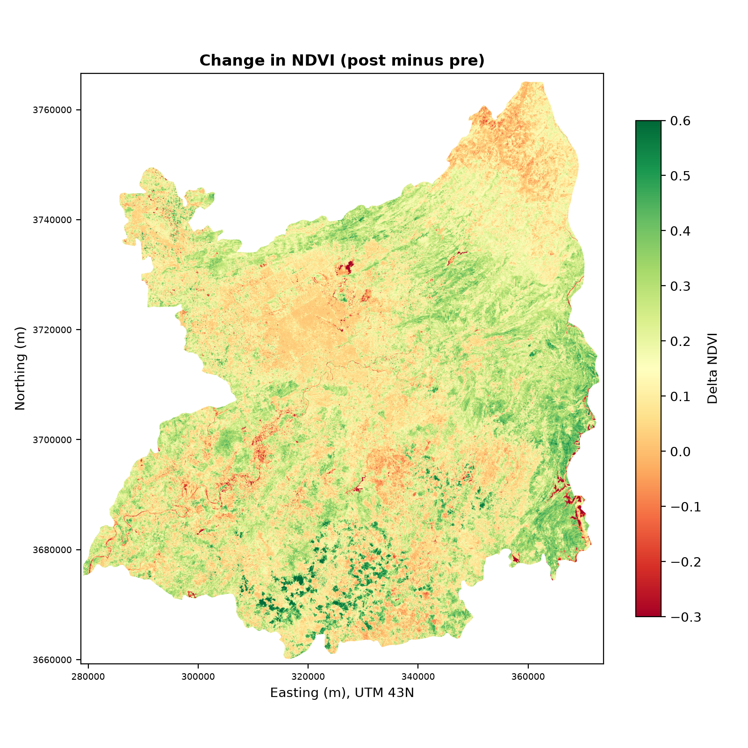
Figure 20: Change in LST (left) and NDVI (right), post-monsoon minus pre-monsoon.

6. Validation and Accuracy Assessment

6.1 Land-cover classification
The classification was assessed on 10,000 test pixels (2,000 per class) from spatial blocks that were not used for training (Table 15). Overall accuracy was 91.5% and the kappa coefficient was 0.893. Water was classified most accurately (F1 = 0.989) and agriculture least accurately (F1 = 0.856).
Table 15: Classification accuracy on held-out spatial blocks.
Class | Producer's accuracy | User's accuracy | F1-score | Test samples
Built-up | 0.934 | 0.932 | 0.933 | 2,000
Vegetation | 0.900 | 0.912 | 0.906 | 2,000
Agriculture | 0.868 | 0.846 | 0.856 | 2,000
Water | 0.984 | 0.995 | 0.989 | 2,000
Bare land | 0.888 | 0.892 | 0.890 | 2,000
Overall accuracy | 0.915 |  |  | 10,000
Kappa | 0.893

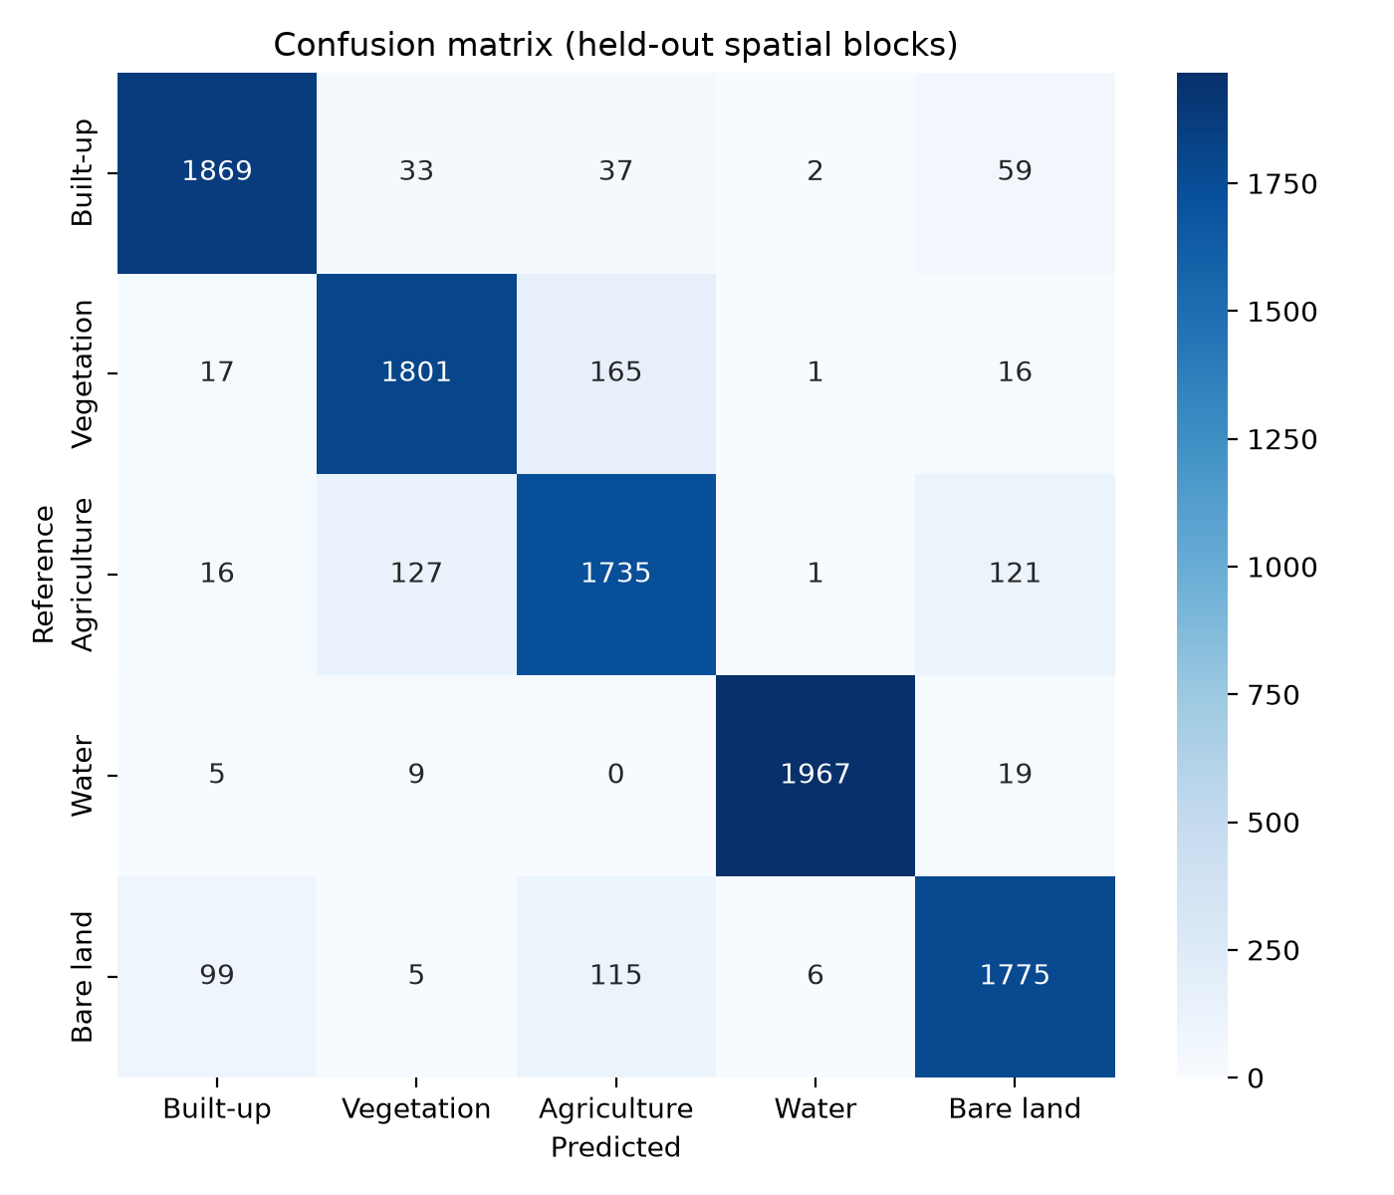
Figure 21: Confusion matrix on held-out spatial blocks.
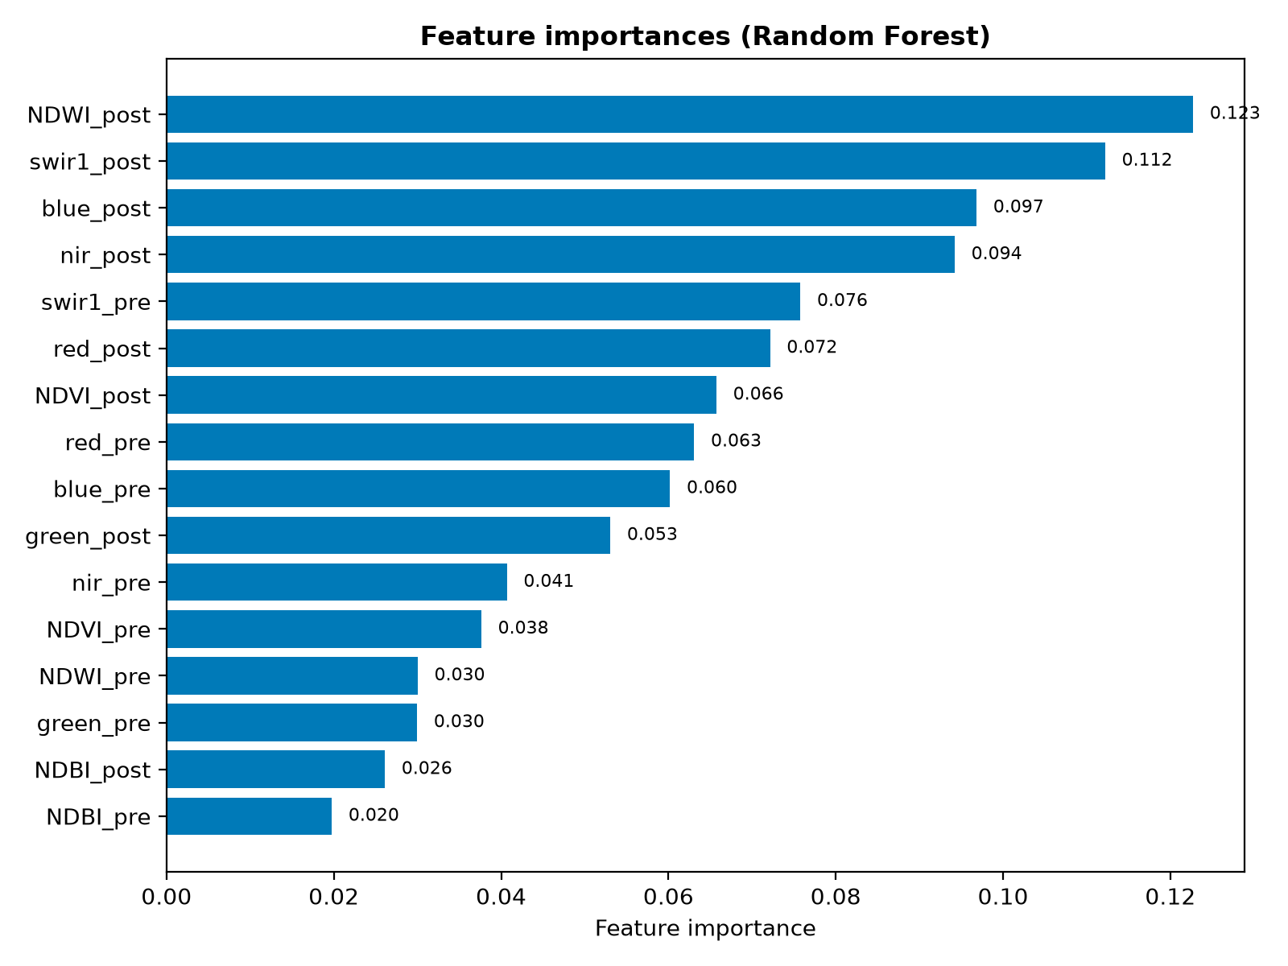
Figure 22: Random Forest feature importance for the 16 input features.
Important limitation. The reference pixels come from places where ESA WorldCover and Dynamic World agree, and this was only 64.4% of valid pixels. The 35.6% of pixels where the products disagree are probably the harder cases, and they were left out of both training and testing. The accuracy above is therefore an agreement with reference-product consensus and not an independent accuracy, and the true accuracy is probably lower. The WorldCover product also refers to 2021, while the imagery is from 2025. The plan for this project calls for about 300 independently interpreted reference points, stratified by class (at least 50 per class), and this independent validation has not yet been carried out. It is listed as the first recommendation in Chapter 8.

6.2 Land surface temperature
Table 16: Comparison of Landsat LST (aggregated to about 1 km) with MODIS MOD11A2 daytime LST.
Metric | Pre-monsoon | Post-monsoon
Blocks compared | 2,437 | 2,432
Pearson r | 0.929 | 0.951
R² | 0.864 | 0.904
Landsat mean (°C) | 43.64 | 32.27
MODIS mean (°C) | 34.91 | 26.62
Bias, Landsat − MODIS (°C) | +8.73 | +5.66
RMSE (°C) | 9.09 | 6.11
MAE (°C) | 8.73 | 5.67
Regression slope | 1.594 | 1.830

The spatial patterns of Landsat and MODIS agree strongly (r = 0.93 and 0.95), so both products identify the same places as relatively hotter or cooler. The absolute values do not agree: Landsat is 5.7–8.7 °C warmer, and the slope above 1 shows a wider spread in Landsat. The likely reasons are that MODIS averages over 1 km and over an 8-day period, that the Landsat composite uses only clear-sky scenes, and that the products use different emissivity assumptions, which matters most over dry bare soil and farmland. These explanations have not been tested here. The comparison is a check of spatial pattern and is not an accuracy figure for the temperature values, and absolute Landsat temperatures should be interpreted with caution. LST is also not the same physical quantity as the air temperature measured at weather stations.
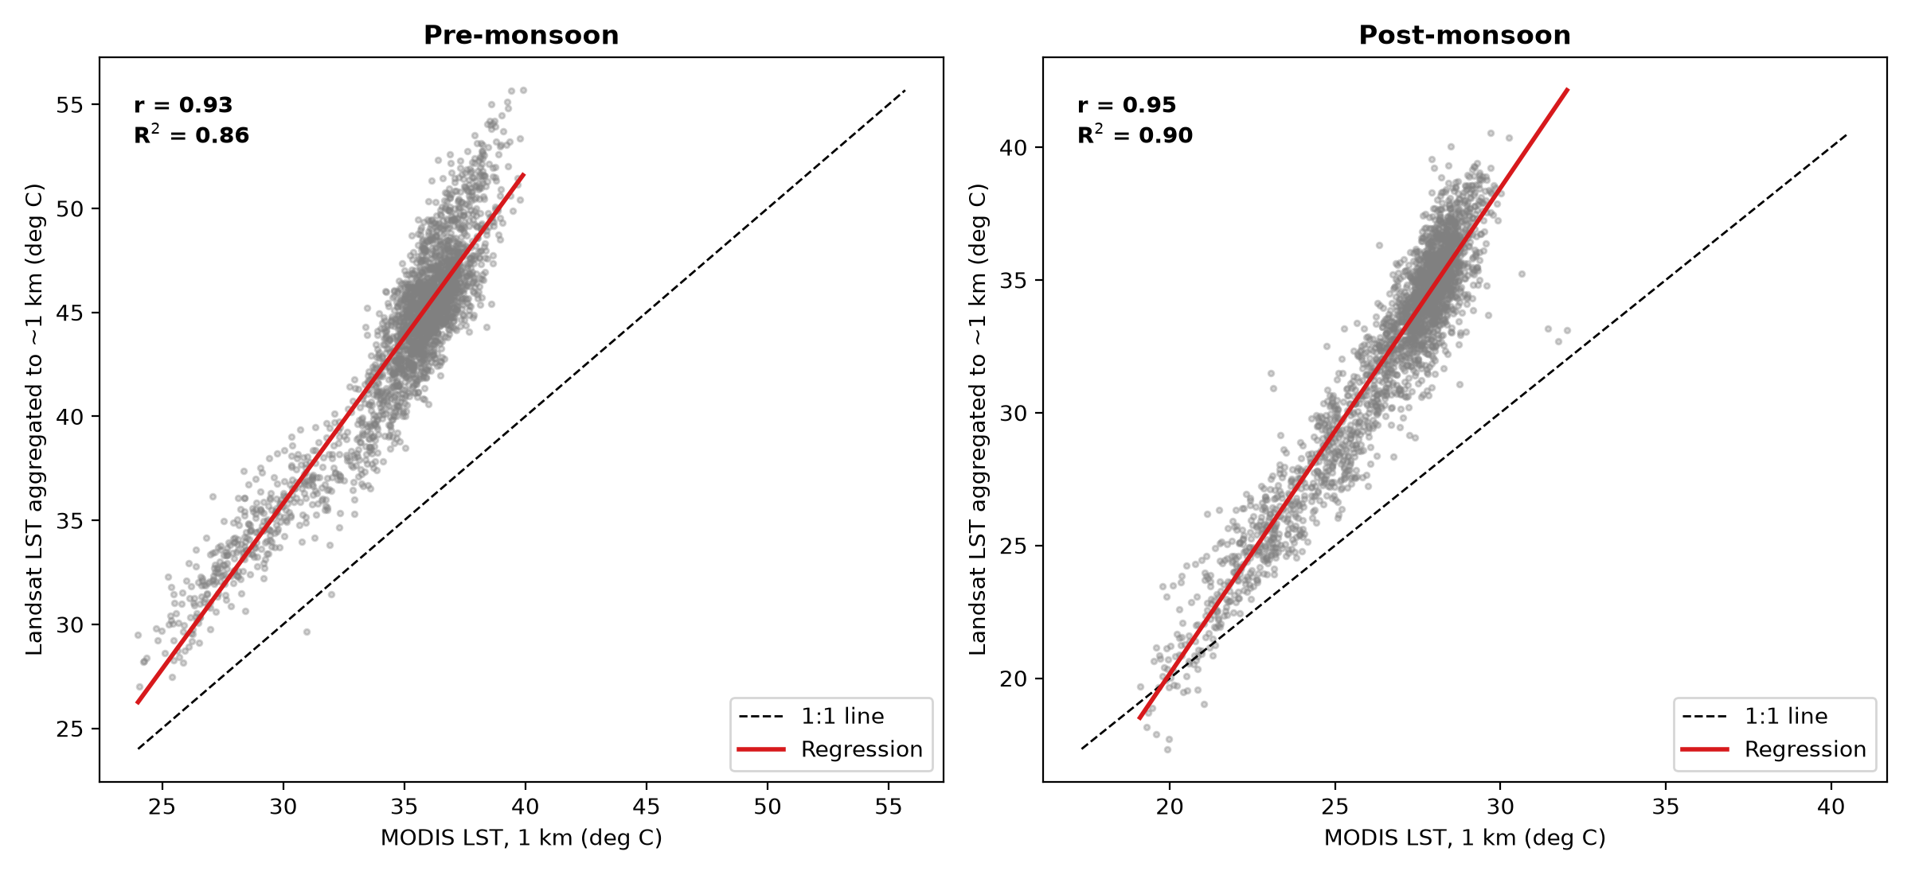
Figure 23: Landsat LST aggregated to about 1 km against MODIS LST, with the 1:1 line and the regression line.

6.3 Statistical validation
Pearson and Spearman correlations gave consistent results (Table 7), and the regression R² values are reported there. Because each correlation is based on tens of thousands of pixels, almost any difference would be statistically significant, so the size of the effect is reported and not p-values. Neighbouring pixels are not independent, which is another reason to avoid reading significance tests literally. No predictive model was built, so RMSE and MAE are reported only for the Landsat–MODIS comparison.

6.4 Sensitivity of the UTSI to its weights
For the post-monsoon season, the overlap of the top 20% hotspot pixels with the baseline was 92.6% for equal weights, 94.4% for vegetation-heavy weights and 95.1% for built-up-heavy weights, with Spearman rank correlations of at least 0.994. The hotspot pattern is therefore stable when the weights are varied.
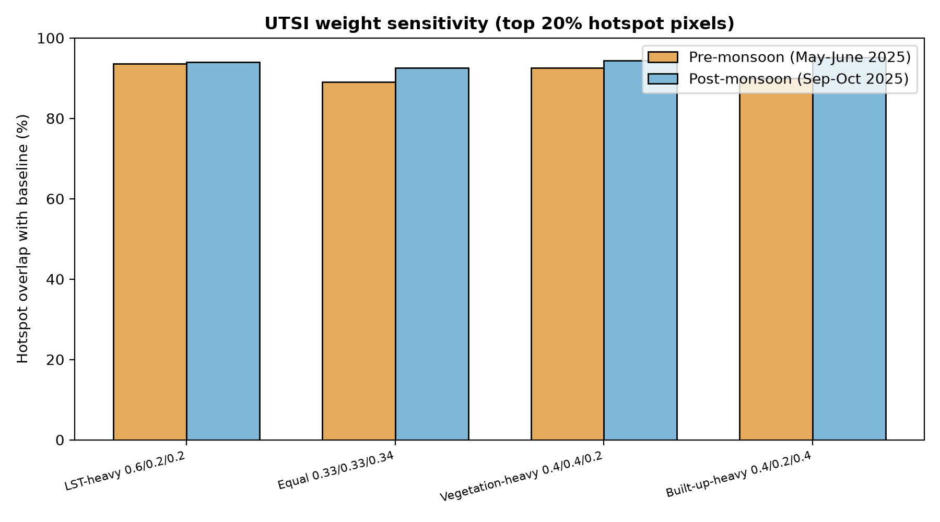
Figure 24: Overlap of the top 20% UTSI hotspot pixels between alternative weight sets and the baseline.

7. Discussion

7.1 Vegetation, built-up surfaces and temperature
The results support both hypotheses. Greener surfaces were cooler (r = −0.70 before and −0.68 after the monsoon) and surfaces with higher NDBI were warmer (r = 0.79 and 0.76). These are associations. LST is also affected by elevation, soil moisture, surface material and the time of day, and none of these was separated from vegetation and built-up intensity in this study.

7.2 Dry land, not only the urban core, drives the hotspots
The thermal stress hotspots were mostly dry agricultural land and bare ground on the southern plain. Built-up land was warm but formed a small share of the high-stress area (about 15–23%). The agriculture class very likely includes fallow and harvested fields in May–June, which are dry and hot, but this was not verified with field data. For urban greening, the results suggest looking at the built-up areas with high UTSI as well as at the large rural hotspots, and a built-up-only analysis would answer the urban question more directly.

7.3 Islamabad and Rawalpindi
Islamabad is much more built-up but slightly cooler at district level. Within the same land-cover class the two districts are very similar, so the district-level difference is mostly a difference in land-cover mix and in the surroundings (hills in Islamabad, large dry plains in Rawalpindi). Elevation is a confounding factor: the lowest temperatures in Rawalpindi District come from hill areas in its north and east.

7.4 The behaviour of NDWI and NDBI
NDWI correlated positively with LST because, in this dry landscape, it is high over bare and built surfaces and low over vegetation. It was therefore used only to identify open water. NDBI also responds to bare soil, which is one reason why a land-cover classification was added.

7.5 Seasonal differences
Temperatures were 11 °C lower after the monsoon, and vegetation greenness was higher. The correlation between LST and NDVI was similar in the two seasons. The seasonal windows differ in more than rainfall, including sun angle and air temperature, so the comparison describes the two periods and does not isolate the effect of the monsoon.

7.6 Limitations
- Classification reference. Labels come from reference-product consensus, not from independent field or imagery-based samples, and the 91.5% accuracy is probably optimistic (Section 6.1).
- Reference date. ESA WorldCover refers to 2021, while the imagery is from 2025.
- LST accuracy. Landsat LST is systematically warmer than MODIS (Section 6.2), so the absolute values need caution.
- Compositing. Median composites from scenes with cloud cover below 40% favour clear days and hide day-to-day variation.
- Study area. District boundaries include large rural and hill areas, so district-wide statistics describe more than the cities.
- Elevation. No terrain data were used, so elevation effects are not separated from vegetation and land cover.
- UTSI weights. The weights are design choices. The sensitivity test shows a stable pattern but does not make them physical constants.
- Duration. A single year was analysed, so no long-term trend can be claimed.
- Surface, not air. LST is a surface quantity and does not describe the temperature that people experience.

8. Conclusion and Recommendations

8.1 Conclusions
- A complete digital image processing workflow, from Landsat and Sentinel-2 acquisition to classification and thermal stress mapping, was implemented for the Islamabad–Rawalpindi Twin Cities with free data and open tools.
- Mean LST was 43.6 °C before and 32.4 °C after the monsoon, with a mean decrease of 11.2 °C and a mean NDVI increase of 0.17.
- LST was negatively associated with NDVI and positively associated with NDBI in both seasons (|r| = 0.68–0.79), supporting both hypotheses as associations and not as proof of cause.
- The highest thermal stress was found mainly on dry agricultural and bare land of the southern plain, and the hotspot pattern was stable under changes in the UTSI weights.
- Islamabad and Rawalpindi differ mainly in land-cover mix. The same land-cover class had almost the same LST in both districts.
- Landsat and MODIS agree in spatial pattern but not in absolute temperature, so the LST layers are best used for relative comparison.

8.2 Recommendations
- Carry out independent validation of the land-cover map with about 300 stratified reference points interpreted from high-resolution imagery, and report the resulting accuracy.
- Repeat the thermal analysis for the built-up areas only, using an urban-core mask, to answer the urban heat question more directly.
- Add terrain data (for example SRTM elevation) to separate elevation effects from land-cover effects.
- Extend the analysis to several years and to the winter season to test whether the relationships are stable.
- Compare the satellite LST with ground-based surface temperature measurements or same-day MODIS and Landsat observations to understand the bias.
- Use the critical hotspot map, together with local knowledge, to select areas for field investigation of greening options.

References
Breiman, L. (2001). Random forests. Machine Learning, 45(1), 5–32.
Brown, C. F., Brumby, S. P., Guzder-Williams, B., et al. (2022). Dynamic World, near real-time global 10 m land use land cover mapping. Scientific Data, 9, 251.
Cohen, J. (1960). A coefficient of agreement for nominal scales. Educational and Psychological Measurement, 20(1), 37–46.
Congalton, R. G. (1991). A review of assessing the accuracy of classifications of remotely sensed data. Remote Sensing of Environment, 37(1), 35–46.
Drusch, M., Del Bello, U., Carlier, S., et al. (2012). Sentinel-2: ESA's optical high-resolution mission for GMES operational services. Remote Sensing of Environment, 120, 25–36.
Gorelick, N., Hancher, M., Dixon, M., Ilyushchenko, S., Thau, D., and Moore, R. (2017). Google Earth Engine: Planetary-scale geospatial analysis for everyone. Remote Sensing of Environment, 202, 18–27.
McFeeters, S. K. (1996). The use of the Normalized Difference Water Index (NDWI) in the delineation of open water features. International Journal of Remote Sensing, 17(7), 1425–1432.
Oke, T. R. (1982). The energetic basis of the urban heat island. Quarterly Journal of the Royal Meteorological Society, 108(455), 1–24.
Tucker, C. J. (1979). Red and photographic infrared linear combinations for monitoring vegetation. Remote Sensing of Environment, 8(2), 127–150.
Voogt, J. A., and Oke, T. R. (2003). Thermal remote sensing of urban climates. Remote Sensing of Environment, 86(3), 370–384.
Wan, Z. (2014). New refinements and validation of the collection-6 MODIS land-surface temperature/emissivity product. Remote Sensing of Environment, 140, 36–45.
Weng, Q., Lu, D., and Schubring, J. (2004). Estimation of land surface temperature–vegetation abundance relationship for urban heat island studies. Remote Sensing of Environment, 89(4), 467–483.
Zanaga, D., Van De Kerchove, R., Daems, D., et al. (2022). ESA WorldCover 10 m 2021 v200. Zenodo. https://doi.org/10.5281/zenodo.7254221
Zha, Y., Gao, J., and Ni, S. (2003). Use of normalized difference built-up index in automatically mapping urban areas from TM imagery. International Journal of Remote Sensing, 24(3), 583–594.

Appendix A: Scripts and Output Files
All processing was scripted so that the analysis can be repeated. The scripts are stored in the folder 11_Scripts of the project.
Table 17: Scripts used in the project.
Script | Purpose
01_test_gee.py | Tests the Earth Engine connection and the district boundaries.
02_export_from_gee.py | Builds the seasonal Sentinel-2 and Landsat composites and exports the four GeoTIFFs.
03_maps_and_charts.py | Maps of LST, NDVI, NDBI and NDWI; histograms, scatter plots, correlation matrices, seasonal box plots; Tables 4, 5 and 7.
04_export_reference.py | Exports the reclassified WorldCover and Dynamic World reference layers.
05_random_forest.py | Random Forest classification, accuracy assessment, land-cover map and charts.
06_utsi.py | Urban Thermal Stress Index, hotspot statistics and weight sensitivity analysis.
07_city_comparison.py | Islamabad and Rawalpindi comparison tables and charts.
08_enhancement_differencing.py | Enhancement figures, filtering, threshold segmentation, morphological opening and seasonal differencing.
09_tables_1_2.py | Dataset table and image acquisition table.
10_modis_validation.py | Comparison of Landsat LST with MODIS LST.

Intermediate and final rasters (seasonal composites, the classified land-cover map and the UTSI layers) are stored as GeoTIFFs in the project folders 02_Raw_Data, 06_Classification and 05_Thermal_Analysis, and all statistical tables are stored as CSV files in 07_Statistics/Tables.

Appendix B: Interactive Project Dashboard
To make the results easier to browse, an interactive HTML dashboard (Dashboard.html) was prepared from the same outputs as this report. It opens in any web browser. Its sidebar has sections for an overview, final maps, charts and histograms, statistics tables, a season comparison and land cover. The overview page shows four summary indicators and a seasonal comparison (Figure 25).
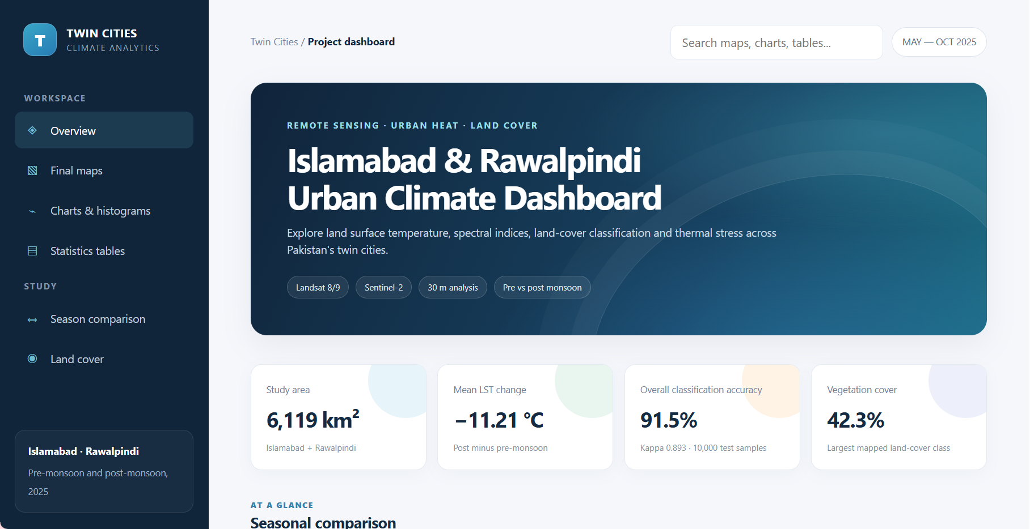
Figure 25: Overview page of the project dashboard.
Table 18: Indicators shown on the dashboard overview page and where they appear in this report.
Dashboard indicator | Value | Report section
Study area (Islamabad + Rawalpindi) | 6,119 km² | Table 11 (area with valid data; the boundary area is 6,122.7 km²)
Mean LST change (post minus pre-monsoon) | −11.21 °C | Section 5.8, Table 14
Overall classification accuracy | 91.5% (kappa 0.893; 10,000 test samples) | Section 6.1, Table 15
Vegetation cover (largest class) | 42.3% | Section 5.4, Table 6

The classification accuracy shown on the dashboard is the accuracy against the reference-product consensus. It should be read together with the limitation in Section 6.1, and it is not an independent accuracy.

Appendix C: Additional Histograms
Figure 26: Histogram post monsoon
Figure 27: Histogram pre monsoon

