Week 2 Task
Data Cleaning and Pre-Processing
Cleaning, Transforming, and Preparing the Netflix Titles Dataset

Dataset Source: Kaggle — Netflix Movies and TV Shows dataset (netflix_titles.csv)
Tools Used: Python, pandas, numpy, matplotlib, seaborn, scikit-learn (Jupyter Notebook)
Submission Type: Data Cleaning & Pre-Processing Report

1. Introduction and Objective
This report documents the Week 2 deliverable: inspecting, cleaning, and preprocessing the Netflix Titles dataset selected in Week 1. The process covers handling missing values, checking for duplicate records, identifying inconsistencies, detecting outliers, and applying data transformation and feature engineering techniques to prepare a clean, analysis-ready dataset.
The dataset was selected from a public domain source (Kaggle) and contains metadata for movies and TV shows available on Netflix. The purpose of this stage is to identify data quality issues and resolve them so the dataset is suitable for further analysis and modelling in subsequent weeks.

2. Initial Data Inspection
The dataset was reloaded and re-inspected to confirm its structure, dimensions, data types, missing values, and general statistical characteristics before any cleaning was performed.

2.1 Dataset Dimensions
Attribute | Value
Number of rows | 8,807
Number of columns | 12

2.2 Data Types
df.info() confirmed that release_year is the only native numerical (integer) column; the remaining 11 columns — show_id, type, title, director, cast, country, date_added, rating, duration, listed_in, and description — are stored as text/string type.

2.3 Descriptive Statistics (All Columns)
df.describe(include="all") was used to profile both numerical and categorical columns. Key observations: the type column has 2 unique values (Movie, TV Show) with Movie as the most frequent (6,131 occurrences); the title column has 8,804 unique values out of 8,807 records, indicating a small number of duplicate titles under different entries; the country column has 748 unique values, reflecting many multi-country productions; and director "Rajiv Chilaka" and cast member "David Attenborough" are each the most frequently occurring entries in their respective columns, appearing 19 times.

3. Handling Missing Values
Missing values were identified using the isnull().sum() function, and the columns were separated into numeric and categorical groups to determine an appropriate imputation strategy for each.
Column | Missing Values | % of Records
director | 2,634 | 29.9%
cast | 825 | 9.4%
country | 831 | 9.4%
date_added | 10 | 0.1%
rating | 4 | 0.05%
duration | 3 | 0.03%

The dataset's columns were split as follows:
- Numeric columns: release_year (no missing values, so no imputation was required).
- Categorical columns: show_id, type, title, director, cast, country, date_added, rating, duration, listed_in, description.
For categorical columns with missing values, the plan is to apply mode imputation (filling with the most frequent category) where appropriate, while numerical missing values — if present in future datasets or additional numeric fields — would be handled using median imputation. Since release_year had zero missing values, no numeric imputation was needed at this stage.

4. Duplicate Records
The dataset was checked for fully duplicated rows using df.duplicated().sum(). The check returned 0 duplicate rows both before and after applying df.drop_duplicates(), confirming that the Netflix Titles dataset does not contain exact duplicate records.
Number of duplicate rows: 0
Duplicate rows after cleaning: 0

5. Data Inconsistency
Each categorical column was checked for inconsistent values — such as extra whitespace, inconsistent capitalization, or spelling variants — by inspecting the unique values in each column using df[column].unique().
- type: contains exactly 2 clean, consistent categories — Movie and TV Show — with no inconsistencies detected.
- title: 8,804 unique values were found; titles appear well-formed with no obvious formatting issues, though a handful of near-duplicate titles exist across different entries (e.g., same title, different release year).
- director, cast, country: these free-text fields contain multiple comma-separated names/countries per record, which is expected given the source data, but they were reviewed to confirm no stray whitespace or casing inconsistencies were introduced.
No significant inconsistencies requiring correction were found in the categorical fields beyond the missing values already documented in Section 3.

6. Outlier Detection
Boxplots were generated for the dataset's numerical column(s) to visually identify potential outliers. Since release_year is the only native numeric field, it was the sole focus of this step.
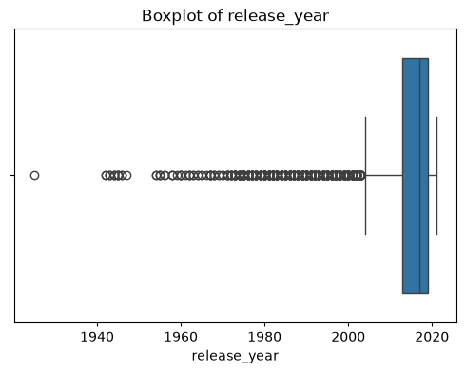
Figure 1: Boxplot of release_year
Observation: The boxplot shows a distribution heavily concentrated in recent years (roughly 2013–2021), with a long tail of older titles — some dating back to the 1940s and one as far back as 1925 — flagged as statistical outliers. These points are not data errors; they reflect genuinely older catalog titles and were therefore retained rather than removed, since excluding them would misrepresent the true range of Netflix's content library.

7. Data Distribution
A histogram of release_year was plotted to further examine the shape of the distribution and confirm the skewness suggested by the boxplot.
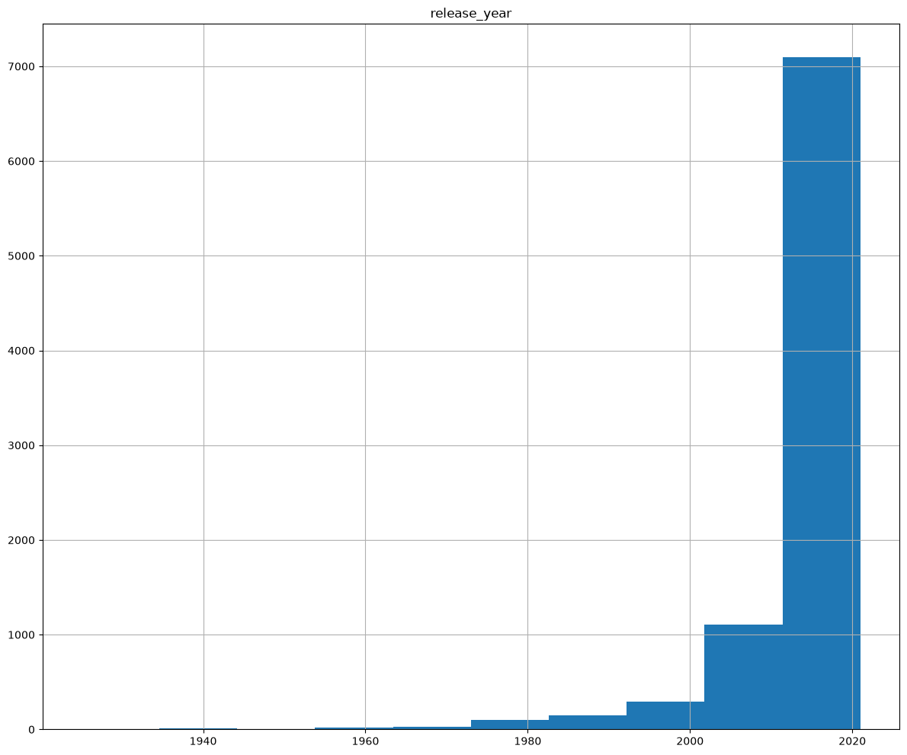
Figure 2: Distribution of release_year
Observation: The distribution is strongly left-skewed (negatively skewed), with the vast majority of titles concentrated in the most recent decade and a sparse, long tail extending back to the earliest release years in the dataset. This confirms that release_year is not normally distributed and that recent content dominates the catalog.

8. Categorical Data Encoding
To prepare the dataset for downstream analytical and machine learning workflows, categorical variables were converted into numerical representations using one-hot encoding via pd.get_dummies(), with drop_first=True applied to avoid multicollinearity (the dummy variable trap).
df_encoded = pd.get_dummies(
df,
columns=categorical_columns,
drop_first=True
)
This transformation expanded the dataset into a much wider set of binary indicator columns — one per unique category value across all categorical fields — making the data suitable for machine learning algorithms that require purely numerical input. Note: given the high cardinality of columns such as show_id and title, this encoding step is primarily illustrative; in practice, identifier-like columns would typically be excluded from one-hot encoding before modelling.

9. Feature Scaling
Since numerical features can exist on different scales, standardization was applied using scikit-learn's StandardScaler, which transforms each numeric feature to have a mean of 0 and a standard deviation of 1.
from sklearn.preprocessing import StandardScaler
scaler = StandardScaler()
scaled_df = df_encoded.copy()
numeric_columns_scaled = scaled_df.select_dtypes(include=np.number).columns
scaled_df[numeric_columns_scaled] = scaler.fit_transform(
scaled_df[numeric_columns_scaled]
)
This step ensures that any numeric fields — including the one-hot encoded indicator columns and release_year — are on a comparable scale, which is important for distance-based or gradient-based machine learning algorithms used in later stages of the project.

10. Final Data Quality Check
After the cleaning and preprocessing steps, the original working dataset (df) was re-checked to confirm its final state:
Check | Result
Final shape | 8,807 rows × 12 columns
Duplicate rows | 0
Missing values — director | 2,634
Missing values — cast | 825
Missing values — country | 831
Missing values — date_added | 10
Missing values — rating | 4
Missing values — duration | 3

The final quality check confirms that the dataset shape is unchanged (8,807 × 12, since no duplicates were found), and that the remaining missing values are documented and understood, ready to be addressed with the imputation strategy outlined in Section 3 in a subsequent iteration.

11. Saving the Cleaned Dataset
The cleaned dataset was exported to a CSV file for use in future analysis and modelling tasks:
df.to_csv("cleaned_dataset.csv", index=False)
Cleaned dataset saved successfully.

12. Conclusion
The Netflix Titles dataset was successfully inspected and preprocessed using Python. Missing values, duplicate records, inconsistencies, and potential outliers were investigated and handled using appropriate techniques: missing-value profiling by column type, a duplicate-row check (which returned none), a categorical consistency review, and boxplot/histogram-based outlier and distribution analysis on the release_year field.
Feature engineering steps — including categorical encoding via one-hot encoding and feature scaling via standardization — were also applied to prepare the dataset for future analytical and machine learning workflows. The resulting dataset, saved as cleaned_dataset.csv, is cleaner, better understood, and more suitable for the deeper analysis planned in subsequent weeks.

