MediTrack Pro
Pharmacy Inventory & Prescription Management System

Database System - Final Project
Phase 1: Entity-Relationship Diagram (ERD) Design

Group Leader: Syed Nalain Abbas (102)

Members: Rameesha Tariq (118)

BS Artificial Intelligence – 4B

Subject: Database System

Submitted To: Ma’am Asma

1. Introduction
MediTrack Pro is a comprehensive database system designed to manage pharmacy operations efficiently. It handles patient information, doctor prescriptions, medicine inventory, supplier management, and stock tracking.
The Entity Relationship Diagram (ERD) represents the conceptual design of the database. It consists of 8 main entities and clearly defines the relationships between them. The design follows normalization rules (mainly 3NF) to reduce data redundancy while maintaining data integrity. All relationships in the ERD are one-to-many (1:M), which is the most common and suitable cardinality for this type of system.
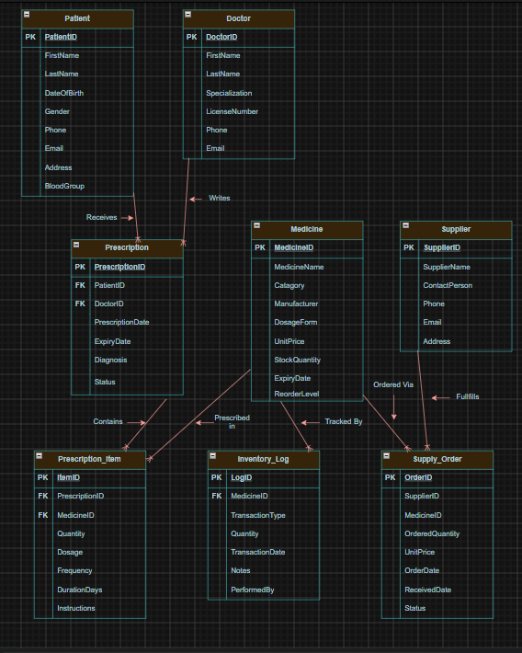

2. Entities Description
1. Patient
This entity stores all personal and contact information of patients who visit the pharmacy. It includes basic details such as name, date of birth, gender, contact number, email, address, and blood group. Each patient can receive multiple prescriptions over time.

2. Doctor
The DOCTOR entity contains information about registered doctors who issue prescriptions. It includes the doctor’s name, specialization, license number, phone, and email. One doctor can write many prescriptions for different patients.

3. Medicine
This is the central entity of the system. It stores details of all medicines available in the pharmacy such as medicine name, category, manufacturer, unit price, current stock quantity, reorder level, expiry date, and description. Medicines are linked to prescriptions, inventory logs, and supply orders.

4. Supplier
The SUPPLIER entity maintains records of all medicine suppliers. It includes supplier name, contact person, phone number, email, and address. One supplier can provide multiple supply orders to the pharmacy.

5. Prescription
This entity records every prescription issued by a doctor to a patient. It contains prescription date, expiry date, status, and additional notes. Each prescription is linked to one patient and one doctor.

6. Prescription_Item
PRESCRIPTION_ITEM is a junction entity that handles the details of medicines prescribed in each prescription. Since one prescription can contain multiple medicines, this table stores quantity, dosage, frequency, duration, and special instructions for each medicine. It resolves the many-to-many relationship between PRESCRIPTION and MEDICINE.

7. Inventory_log
This entity maintains a complete history of all stock movements (inward and outward) for every medicine. It records transaction type (Purchase, Sale, or Adjustment), quantity changed, date, and notes. It helps in tracking stock changes and auditing inventory.

8. Supply_Order
The SUPPLY_ORDER entity manages all purchase orders placed with suppliers. It records order quantity, unit price, order date, received date, and current status (Pending, Received, etc.). This entity helps maintain the supply chain and restocking process.

3. Attributes, Primary Keys & Foreign Keys

1. Patient
Attribute | Data Type | Constraint
PatientID | INT | Primary Key (PK)
FirstName | VARCHAR(50) | NOT NULL
LastName | VARCHAR(50) | NOT NULL
DateOfBirth | DATE | NOT NULL
Gender | CHAR(1) | CHECK (M/F/O)
Phone | VARCHAR(15) | UNIQUE
Email | VARCHAR(100) | UNIQUE
Address | VARCHAR(200) | —
BloodGroup | VARCHAR(5) | CHECK (A+/A-/B+…)

2. Doctor
Attribute | Data Type | Constraint
DoctorID | INT | Primary Key (PK)
FirstName | VARCHAR(50) | NOT NULL
LastName | VARCHAR(50) | NOT NULL
Specialization | VARCHAR(100) | —
LicenseNumber | VARCHAR(30) | UNIQUE, NOT NULL
Phone | VARCHAR(15) | —
Email | VARCHAR(100) | —

3. Medicine
Attribute | Data Type | Constraint
MedicineID | INT | Primary Key (PK)
MedicineName | VARCHAR(150) | NOT NULL
Category | VARCHAR(50) | —
Manufacturer | VARCHAR(100) | —
DosageForm | VARCHAR(50) | CHECK (Tablet/Capsule…)
UnitPrice | DECIMAL(10,2) | NOT NULL, ≥ 0
StockQuantity | INT | DEFAULT 0, ≥ 0
ExpiryDate | DATE | —
ReorderLevel | INT | DEFAULT 50

4. Supplier
Attribute | Data Type | Constraint
SupplierID | INT | Primary Key (PK)
SupplierName | VARCHAR(150) | NOT NULL
ContactPerson | VARCHAR(100) | —
Phone | VARCHAR(15) | —
Email | VARCHAR(100) | —
Address | VARCHAR(200) | —

5. Prescription
Attribute | Data Type | Constraint
PrescriptionID | INT | Primary Key (PK)
PatientID | INT | Foreign Key → Patient(PatientID)
DoctorID | INT | Foreign Key → Doctor(DoctorID)
PrescriptionDate | DATE | DEFAULT today
ExpiryDate | DATE | —
Diagnosis | VARCHAR(300) | —
Status | VARCHAR(20) | CHECK (Pending/Dispensed…)

6. Prescription_Item
Attribute | Data Type | Constraint
ItemID | INT | Primary Key (PK)
PrescriptionID | INT | Foreign Key → Prescription(PrescriptionID)
MedicineID | INT | Foreign Key → Medicine(MedicineID)
Quantity | INT | NOT NULL, > 0
Dosage | VARCHAR(50) | —
Frequency | VARCHAR(50) | —
DurationDays | INT | —
Instructions | VARCHAR(300) | —

7. Inventory_Log
Attribute | Data Type | Constraint
LogID | INT | Primary Key (PK)
MedicineID | INT | Foreign Key → Medicine(MedicineID)
TransactionType | VARCHAR(20) | CHECK (Restock/Dispensed/Expired…)
Quantity | INT | NOT NULL
TransactionDate | DATETIME | DEFAULT now
Notes | VARCHAR(300) | —
PerformedBy | INT | —

8. Supply_Order
Attribute | Data Type | Constraint
OrderID | INT | Primary Key (PK)
SupplierID | INT | Foreign Key → Supplier(SupplierID)
MedicineID | INT | Foreign Key → Medicine(MedicineID)
OrderedQuantity | INT | NOT NULL, > 0
UnitPrice | DECIMAL(10,2) | —
OrderDate | DATE | DEFAULT today
ReceivedDate | DATE | —
Status | VARCHAR(20) | CHECK (Ordered/Received…)

4. Relationships Between Entities
The ERD contains only one-to-many (1:M) relationships, which are implemented using foreign keys in the child tables. Below is the detailed explanation of each relationship:
- PATIENT to PRESCRIPTION One Patient can have many Prescriptions, but each Prescription belongs to only one Patient. (Relationship: 1:M)
- DOCTOR to PRESCRIPTION One Doctor can issue many Prescriptions, but each Prescription is written by only one Doctor. (Relationship: 1:M)
- PRESCRIPTION to PRESCRIPTION_ITEM One Prescription can contain many Prescription_Items (different medicines), but each Prescription_Item belongs to only one Prescription. (Relationship: 1:M)
- MEDICINE to PRESCRIPTION_ITEM One Medicine can be prescribed in many Prescription_Items, but each Prescription_Item refers to only one Medicine. (Relationship: 1:M)
- MEDICINE to INVENTORY_LOG One Medicine can have many Inventory_Log entries (history of stock changes), but each log entry is related to only one Medicine. (Relationship: 1:M)
- MEDICINE to SUPPLY_ORDER One Medicine can appear in many Supply_Orders, but each Supply_Order line refers to only one Medicine. (Relationship: 1:M)
- SUPPLIER to SUPPLY_ORDER One Supplier can have many Supply_Orders, but each Supply_Order is placed with only one Supplier. (Relationship: 1:M)

5. Summary of the Design
The ERD is designed with 8 core entities to cover all major functionalities of a pharmacy system:
- Patient and doctor management
- Prescription handling with detailed item information
- Real-time medicine inventory with logging
- Supplier and purchase (supply order) management
All many-to-many relationships have been properly resolved using junction tables (PRESCRIPTION_ITEM and SUPPLY_ORDER). The design ensures data consistency, reduces redundancy, and supports future implementation of triggers, stored procedures, and reports.
This ERD serves as the foundation for the subsequent phases of the project, including table creation (DDL), data manipulation (DML), advanced queries, and automation features.

