

MediTrack Pro
  - Pharmacy Inventory & Prescription Management System
Database System — Final Project

Phase 2: SQL Components
DDL · DML · Aggregate Functions · User-Defined Functions

Group Leader: Syed Nalain Abbas (102)
Member: Rameesha Tariq (118)
Program: BS Artificial Intelligence – 4B
Subject: Database System
Submitted To: Ma'am Asma

Table of Contents
Section | Page
1. Introduction | 3
2. Part 1 — DDL (Data Definition Language) | 4
2.1 Database Creation | 4
2.2 Table 1: Patient | 4
2.3 Table 2: Doctor | 5
2.4 Table 3: Medicine | 5
2.5 Table 4: Supplier | 6
2.6 Table 5: Prescription | 6
2.7 Table 6: Prescription_Item | 7
2.8 Table 7: Inventory_Log | 8
2.9 Table 8: Supply_Order | 8
3. Part 2 — DML (Data Manipulation Language) | 9
3.1 INSERT Statements | 9
3.2 UPDATE Statements | 12
3.3 DELETE Statements | 13
3.4 SELECT Statements | 14
4. Part 3 — Aggregate Functions | 15
5. Part 4 — User-Defined Functions (UDFs) | 18
5.1 Scalar Functions | 18
5.2 Table-Valued Functions | 21
6. Conclusion | 23

1. Introduction
This report presents Phase 2 of the MediTrack Pro database project. In Phase 1, we designed the Entity Relationship Diagram (ERD) consisting of 8 core entities. In this phase, we extend the project by implementing the actual SQL components that bring the database to life.
The four main components covered in this report are listed below.
DDL (Data Definition Language) is used to create the database structure and all 8 tables with their columns, data types, and foreign key constraints.
DML (Data Manipulation Language) is used to insert sample data into all tables and perform update, delete, and select operations on that data.
Aggregate Functions are SQL built-in functions like COUNT, SUM, AVG, MAX, and MIN used to generate useful pharmacy reports and numeric summaries.
User-Defined Functions (UDFs) are custom reusable functions created by us to perform specific tasks such as calculating prescription cost and checking stock availability status.

2. Part 1 DDL (Data Definition Language)
DDL stands for Data Definition Language. It includes SQL commands that are used to define and create the structure of the database and its tables. DDL commands do not deal with actual data ,they only define where and how data will be stored.
The main DDL command used in this project is CREATE. We use it to first create the database and then to create all 8 tables with their column names, data types, primary keys, and foreign key constraints.

2.1 Database Creation
The first step is to create the MediTrackPro database in SQL Server. After creating it, the USE command selects it so that all the following CREATE TABLE statements are executed inside this database.
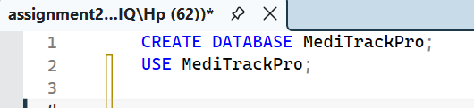

2.2 Table 1: Patient
Description: The Patient table stores personal and contact information of all patients registered in the pharmacy. Each patient can have multiple prescriptions issued over time. This is a root table meaning it has no foreign keys - other tables reference it.
Primary Key: PatientID Foreign Keys: None
Attribute | Data Type | Constraint | Description
PatientID | INT | PRIMARY KEY | Unique identifier for each patient
FirstName | VARCHAR(50) | NOT NULL | Patient first name
LastName | VARCHAR(50) | NOT NULL | Patient last name
DOB | DATE |  | Date of birth
Gender | VARCHAR(10) |  | Male or Female
Phone | VARCHAR(15) | UNIQUE | Contact phone number
Address | VARCHAR(200) |  | Home address
BloodGroup | VARCHAR(5) |  | e.g. A+, B-, O+

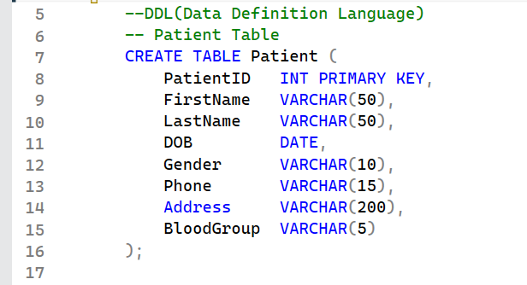

2.3 Table 2: Doctor
Description: The Doctor table contains information about licensed doctors who issue prescriptions to patients. One doctor can write many prescriptions. This is also a root table with no foreign key dependencies.
Primary Key: DoctorID Foreign Keys: None
Attribute | Data Type | Constraint | Description
DoctorID | INT | PRIMARY KEY | Unique identifier for each doctor
FirstName | VARCHAR(50) | NOT NULL | Doctor first name
LastName | VARCHAR(50) | NOT NULL | Doctor last name
Specialization | VARCHAR(100) |  | Medical specialization area
LicenseNo | VARCHAR(30) | UNIQUE | Medical license number
Phone | VARCHAR(15) |  | Contact number

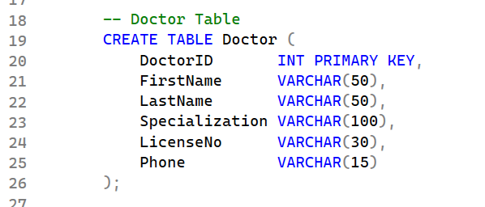

2.4 Table 3: Medicine
Description: The Medicine table is the central table of the entire system. It stores all medicine details including stock quantity, unit price, expiry date, and reorder level. This table is linked to the Prescription_Item, Inventory_Log, and Supply_Order tables.
Primary Key: MedicineID Foreign Keys: None
Attribute | Data Type | Constraint | Description
MedicineID | INT | PRIMARY KEY | Unique identifier for each medicine
MedicineName | VARCHAR(100) | NOT NULL | Full name of the medicine
Category | VARCHAR(50) |  | e.g. Analgesic, Antibiotic
DosageForm | VARCHAR(50) |  | Tablet, Capsule, Syrup, etc.
UnitPrice | DECIMAL(10,2) |  | Price per unit in PKR
StockQty | INT |  | Current units available in stock
ExpiryDate | DATE |  | Expiry date of the medicine batch
ReorderLevel | INT |  | Minimum stock before reorder needed
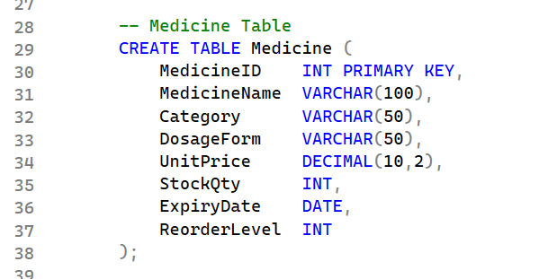

2.5 Table 4: Supplier
Description: The Supplier table maintains records of all medicine suppliers who deliver stock to the pharmacy. One supplier can fulfill many supply orders. This is a root table with no foreign key dependencies.
Primary Key: SupplierID Foreign Keys: None
Attribute | Data Type | Constraint | Description
SupplierID | INT | PRIMARY KEY | Unique identifier for each supplier
SupplierName | VARCHAR(100) | NOT NULL | Company or supplier name
ContactPerson | VARCHAR(100) |  | Name of the contact representative
Phone | VARCHAR(15) |  | Contact phone number
Address | VARCHAR(200) |  | Supplier business address

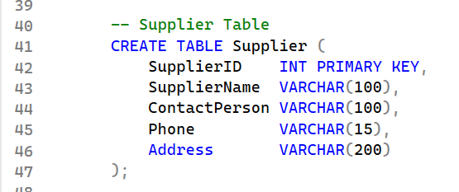

2.6 Table 5: Prescription
Description: The Prescription table records every prescription issued by a doctor to a patient. It stores the diagnosis, prescription date, expiry date, and current dispensing status. This table references both Patient and Doctor through foreign keys.
Primary Key: PrescriptionID Foreign Keys: Patient(PatientID), Doctor(DoctorID)
Attribute | Data Type | Constraint | Description
PrescriptionID | INT | PRIMARY KEY | Unique prescription number
PatientID | INT | FOREIGN KEY → Patient | Patient who received the prescription
DoctorID | INT | FOREIGN KEY → Doctor | Doctor who wrote the prescription
PrescriptionDate | DATE |  | Date the prescription was issued
Diagnosis | VARCHAR(200) |  | Medical diagnosis or condition
Status | VARCHAR(20) |  | Pending, Dispensed, or Expired
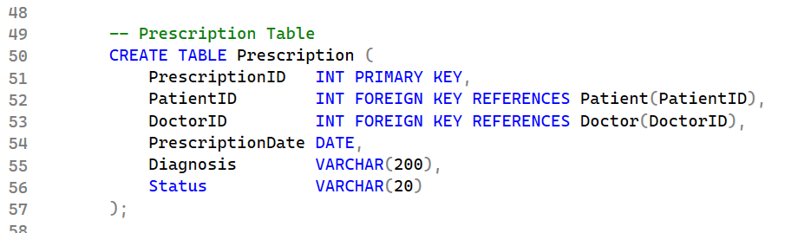

2.7 Table 6: Prescription_Item
Description: Prescription_Item is a junction table that links prescriptions to medicines. Since one prescription can contain many medicines and one medicine can appear in many prescriptions, this table resolves that many-to-many relationship. It stores dosage, frequency, and duration for each medicine in a prescription.
Primary Key: ItemID Foreign Keys: Prescription(PrescriptionID), Medicine(MedicineID)
Attribute | Data Type | Constraint | Description
ItemID | INT | PRIMARY KEY | Unique line item ID
PrescriptionID | INT | FOREIGN KEY → Prescription | Parent prescription
MedicineID | INT | FOREIGN KEY → Medicine | Medicine being prescribed
Quantity | INT |  | Number of units to dispense
Dosage | VARCHAR(50) |  | Dosage amount e.g. 500mg
Frequency | VARCHAR(50) |  | e.g. Twice daily, Once daily
DurationDays | INT |  | Number of days for the course
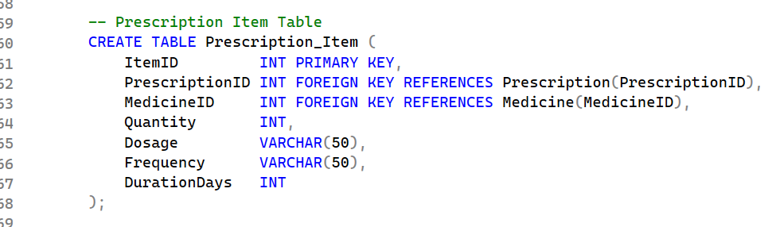

2.8 Table 7: Inventory_Log
Description: The Inventory_Log table maintains a full audit trail of every stock movement for every medicine. Each time stock is added (Restock), removed (Dispensed), or lost (Damaged), a new record is added here. This table is essential for stock auditing and tracking.
Primary Key: LogID Foreign Keys: Medicine(MedicineID)
Attribute | Data Type | Constraint | Description
LogID | INT | PRIMARY KEY | Unique log entry ID
MedicineID | INT | FOREIGN KEY → Medicine | Medicine that was affected
TransactionType | VARCHAR(20) |  | Restock, Dispensed, or Damaged
Quantity | INT |  | Number of units in the transaction
LogDate | DATE |  | Date the transaction occurred
Notes | VARCHAR(200) |  | Additional remarks or details
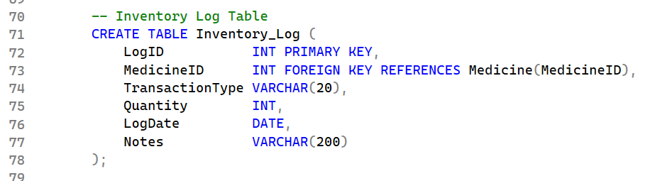

2.9 Table 8: Supply_Order
Description: The Supply_Order table manages all purchase orders placed with suppliers for restocking medicines. It tracks ordered quantity, unit price, order date, received date, and current order status. It references both Supplier and Medicine tables.
Primary Key: OrderID Foreign Keys: Supplier(SupplierID), Medicine(MedicineID)
Attribute | Data Type | Constraint | Description
OrderID | INT | PRIMARY KEY | Unique order ID
SupplierID | INT | FOREIGN KEY → Supplier | Supplier fulfilling the order
MedicineID | INT | FOREIGN KEY → Medicine | Medicine being ordered
OrderedQty | INT |  | Total units ordered
UnitPrice | DECIMAL(10,2) |  | Price per unit at time of order
OrderDate | DATE |  | Date the order was placed
Status | VARCHAR(20) |  | Ordered, Received, or Cancelled
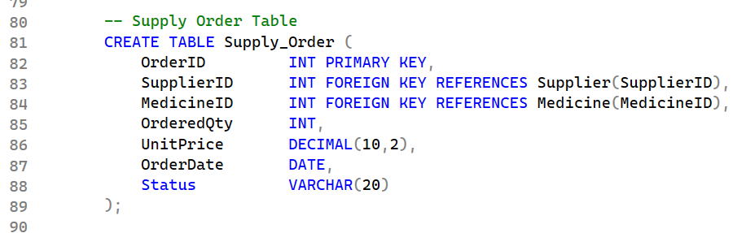

3. Part 2 DML (Data Manipulation Language)
DML stands for Data Manipulation Language. It includes SQL commands used to work with actual data inside the tables. The four main DML operations are INSERT to add data, UPDATE to modify data, DELETE to remove data, and SELECT to retrieve data.
In this section we populate all 8 tables with sample data, perform update and delete operations, and run several SELECT queries to retrieve meaningful results from the database.

3.1 INSERT Statements
INSERT is used to add new rows of data into a table. We insert sample data into all 8 tables in the correct order. Tables with no foreign keys are filled first, then tables that depend on them.

INSERT into Patient
We insert 5 patient records with their personal details.
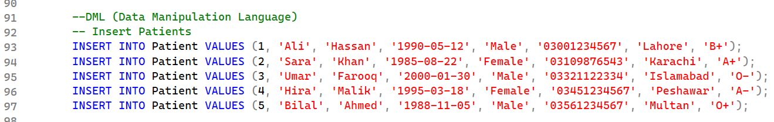

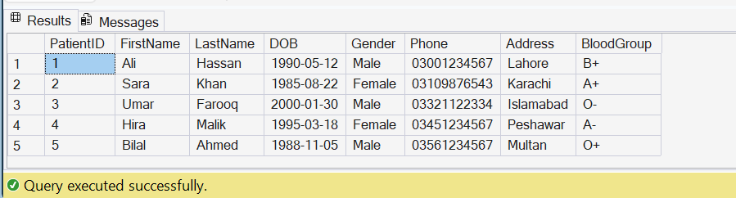

INSERT into Doctor
We insert 3 doctor records with their specializations and license numbers.
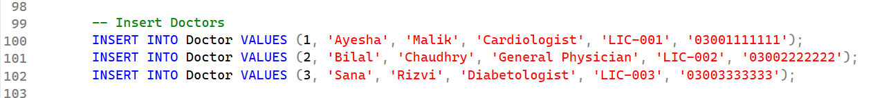

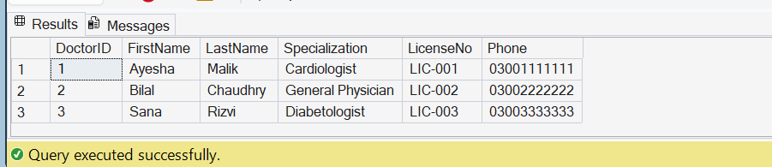

INSERT into Medicine
We insert 6 medicine records with pricing, stock, expiry, and reorder level details.
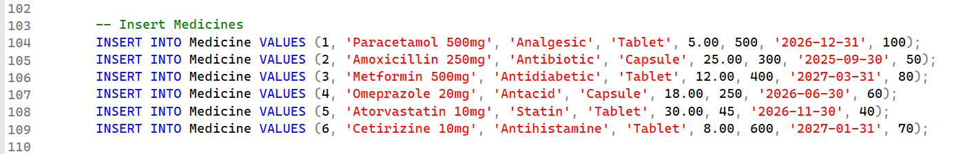

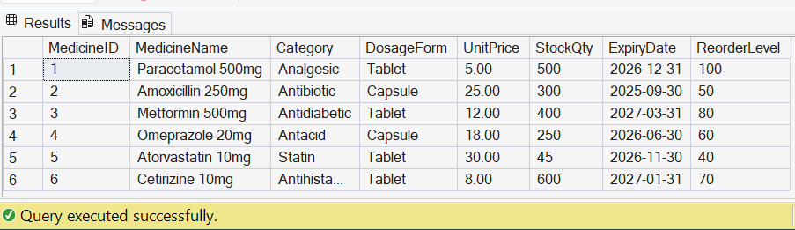

INSERT into Supplier
We insert 2 supplier records with contact and address details.
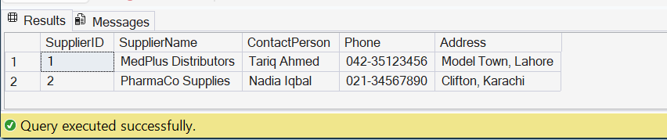

INSERT into Prescription
We insert 5 prescription records. PatientID and DoctorID values used here must already exist in the Patient and Doctor tables.
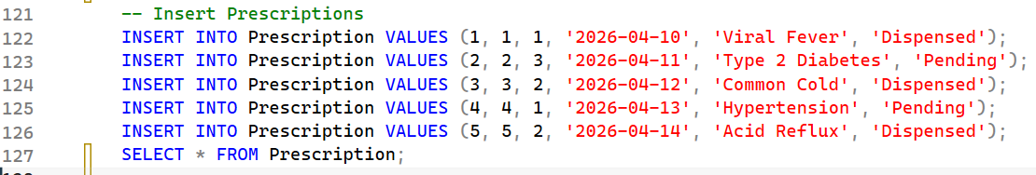
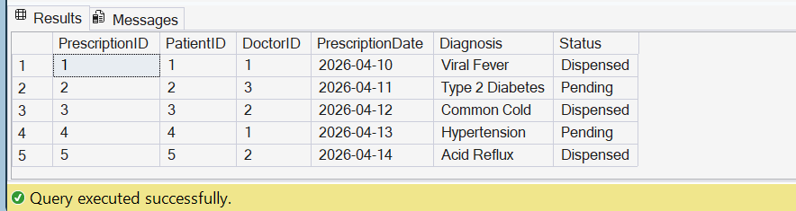

INSERT into Prescription_Item
We insert 7 prescription item records linking prescriptions to medicines with dosage, frequency, and duration details.
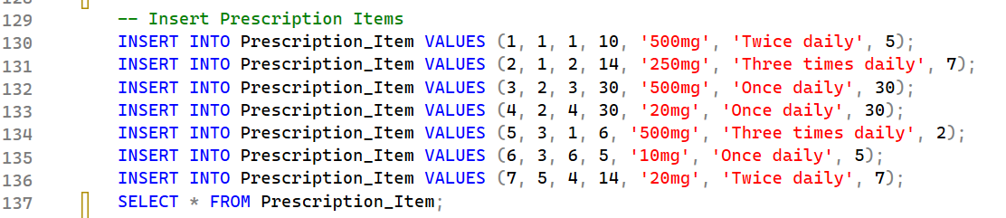

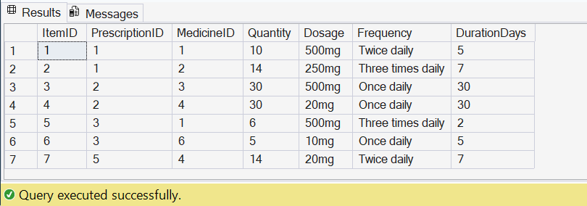

INSERT into Inventory_Log
We insert 4 inventory log entries recording stock movements for medicines.
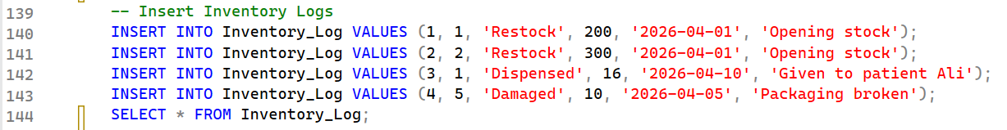

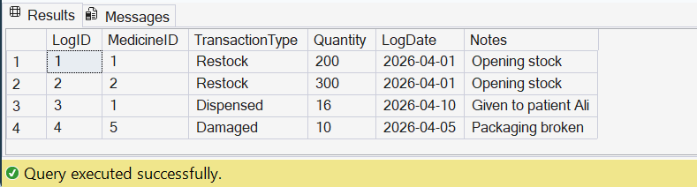

INSERT into Supply_Order
We insert 3 supply order records for medicines ordered from suppliers.
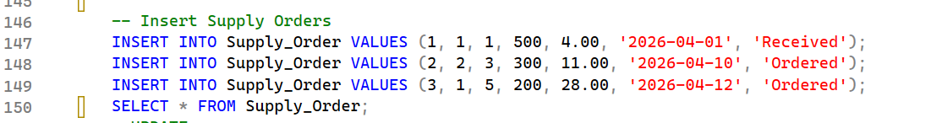
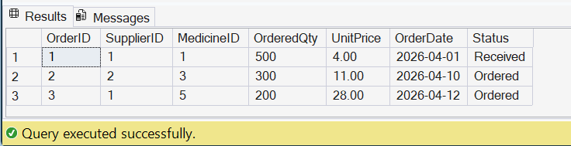

3.2 UPDATE Statements
UPDATE is used to modify existing records in a table. The WHERE clause specifies which row to update. Without WHERE, all rows in the table would be affected, so it must always be included.
We perform 4 update operations on different tables below.
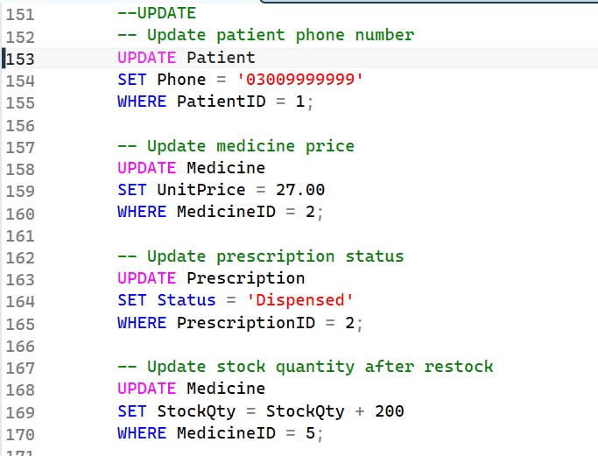

3.3 DELETE Statements
DELETE removes specific rows from a table. Like UPDATE, it must always be used with a WHERE clause. Without WHERE, every row in the table would be deleted.
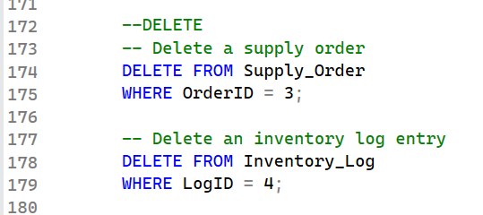

3.4 SELECT Statements
SELECT is used to retrieve data from the database. It is the most frequently used DML command. We can filter results using WHERE, combine multiple tables using joins, and sort using ORDER BY.

Query 1: View all patients
This query retrieves all columns and all rows from the Patient table.
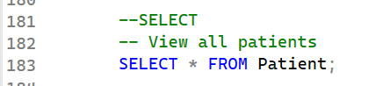

Query 2: View all medicines
This query retrieves all medicine records to see the complete drug catalogue.
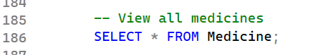
Query 3: View only Pending prescriptions
This query uses WHERE to filter and show only prescriptions that have not been dispensed yet.
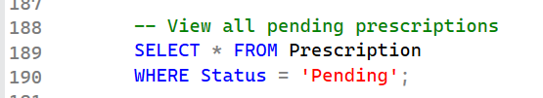

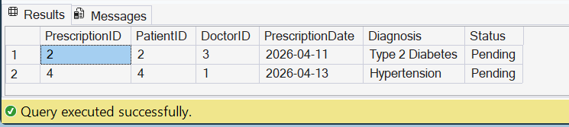
Query 4: Prescriptions with patient names
This query combines the Prescription and Patient tables to show names alongside prescription details.
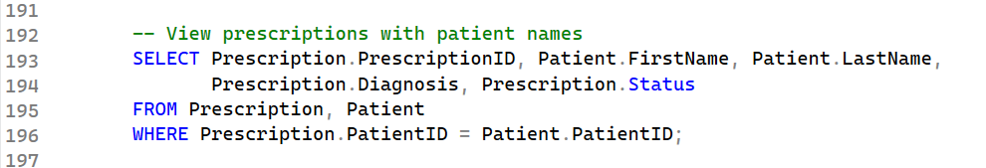

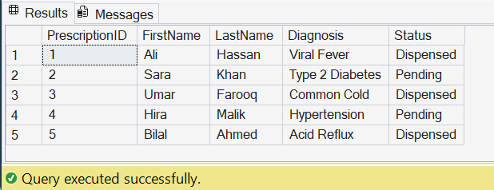
Query 5: Medicines with low stock
This query finds all medicines where the current stock is below the reorder level. These medicines need to be restocked urgently.
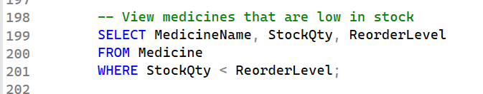
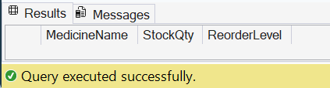

4. Part 3 Aggregate Functions
Aggregate functions perform calculations on a group of rows and return a single summary result. They are mainly used for reports and analysis. Aggregate functions are used inside the SELECT clause and can be combined with GROUP BY to produce grouped summaries.
The five main aggregate functions in SQL are COUNT, SUM, AVG, MAX, and MIN.
Query 1: COUNT - Total number of registered patients
This query counts the total number of rows in the Patient table. COUNT(*) counts every row regardless of NULL values and tells us how many patients are in the system.
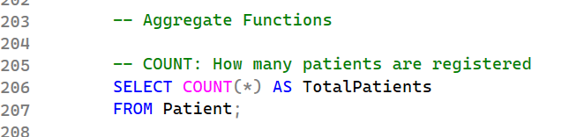
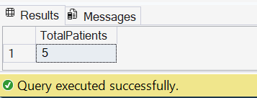

Query 2: COUNT with GROUP BY - Prescriptions written by each doctor
This query counts how many prescriptions each doctor has written. GROUP BY DoctorID groups all rows by doctor first, then COUNT(*) counts the rows in each group.
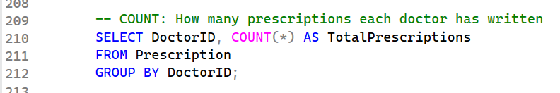
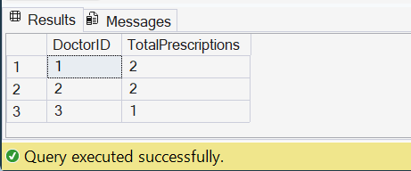
Query 3: SUM - Total stock units available
This query adds up the StockQty column across all medicines to find the total number of medicine units available in the pharmacy.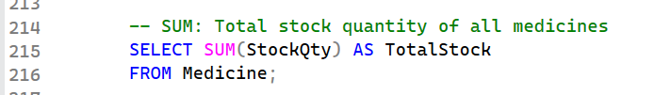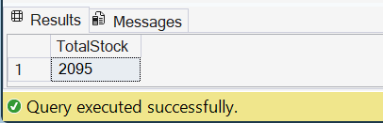

Query 4: SUM - Total monetary value of all stock
This query calculates the total rupee value of all medicines in stock. It multiplies StockQty by UnitPrice for every medicine and sums all the results together.
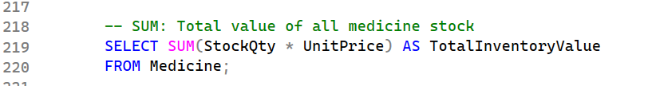
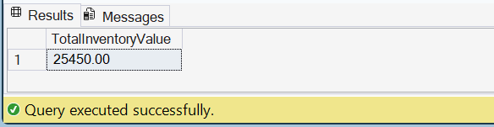
Query 5: AVG - Average unit price of all medicines
This query returns the average price per unit across all medicines. AVG adds all UnitPrice values and divides by the count of medicines.
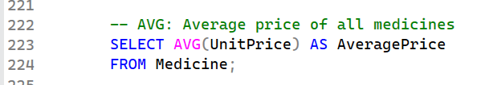
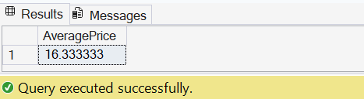
Query 6: AVG with GROUP BY - Average price per category
This query groups medicines by their Category and calculates the average unit price within each group. This helps compare pricing across different medicine types.
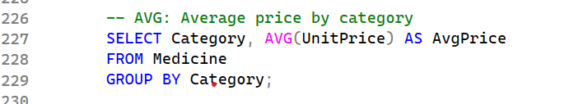
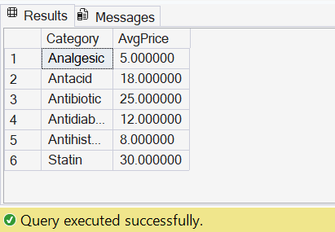

Query 7: MAX - Most expensive medicine
This query finds the highest unit price among all medicines. MAX scans all UnitPrice values and returns the largest one.
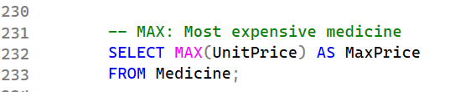
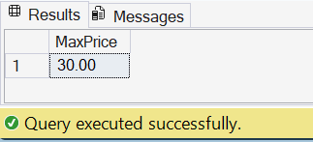

Query 8: MIN - Cheapest medicine
This query finds the lowest unit price among all medicines. MIN returns the smallest value found in the UnitPrice column.
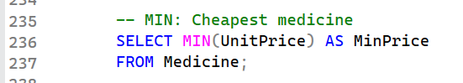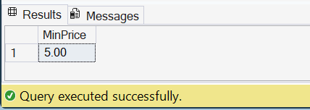
Query 9: HAVING - Categories with more than one medicine
This query uses HAVING to filter grouped results. It groups medicines by Category, counts how many are in each group, then HAVING keeps only groups with more than 1 medicine. WHERE filters before grouping but HAVING filters after grouping.
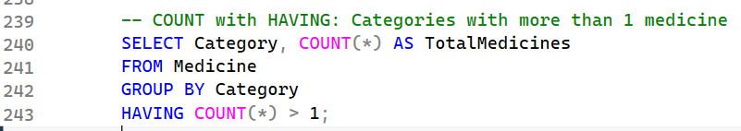
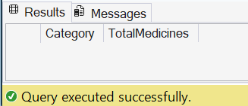
Query 10: SUM with GROUP BY - Total quantity prescribed per medicine
This query calculates the total quantity prescribed for each medicine across all prescription items. GROUP BY MedicineID separates data by medicine and SUM adds up all quantities for each.
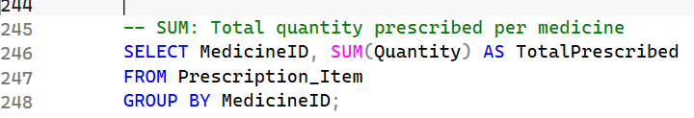
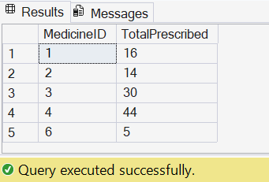

5. Part 4 User-Defined Functions (UDFs)
A User-Defined Function (UDF) is a function created by the programmer to perform a specific task and return a result. Unlike built-in functions, UDFs are custom made and tailored to the specific needs of the project.
SQL Server supports two types of UDFs used in this project.
Scalar Function takes one or more input parameters and returns a single value such as a number or text. It is called using SELECT dbo.FunctionName(value).
Table-Valued Function takes one or more input parameters and returns an entire table as the result. It is called using SELECT * FROM dbo.FunctionName(value) just like a regular table.

5.1 Scalar Functions
Scalar functions return exactly one value. They are useful when you need to look up or calculate a single piece of information. We create three scalar functions in this project.

UDF 1 fn_PatientName
Type: Scalar Function Purpose: This function accepts a PatientID as input and returns the full name of that patient as a single text value. It searches the Patient table for the matching row and combines FirstName and LastName into one string. Input: @PatientID (INT) Returns: VARCHAR(100) — the patient's full name
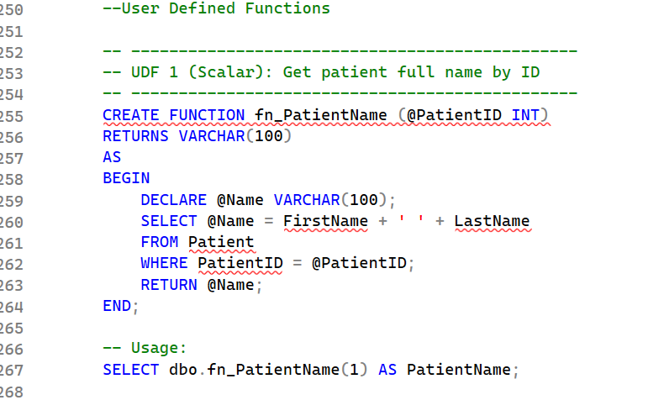
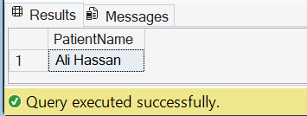
UDF 2 fn_PrescriptionCost
Type: Scalar Function Purpose: This function calculates the total cost of all medicines in a specific prescription. It multiplies each medicine's quantity by its unit price and returns the total sum. This is useful for billing and cost tracking in the pharmacy. Input: @PrescriptionID (INT) Returns: DECIMAL(10,2) — the total cost with 2 decimal place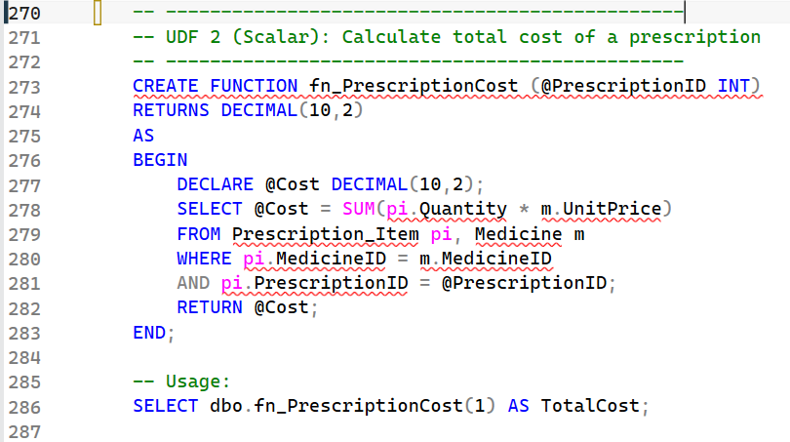
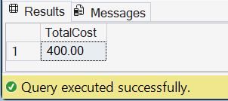
UDF 3 fn_StockStatus
Type: Scalar Function Purpose: This function checks the current stock level of a medicine and returns one of three status labels. If stock is zero it returns "Out of Stock", if stock is below reorder level it returns "Low Stock", otherwise it returns "Available". This is very useful for generating stock alerts. Input: @MedicineID (INT) Returns: VARCHAR(20) — one of three status labels
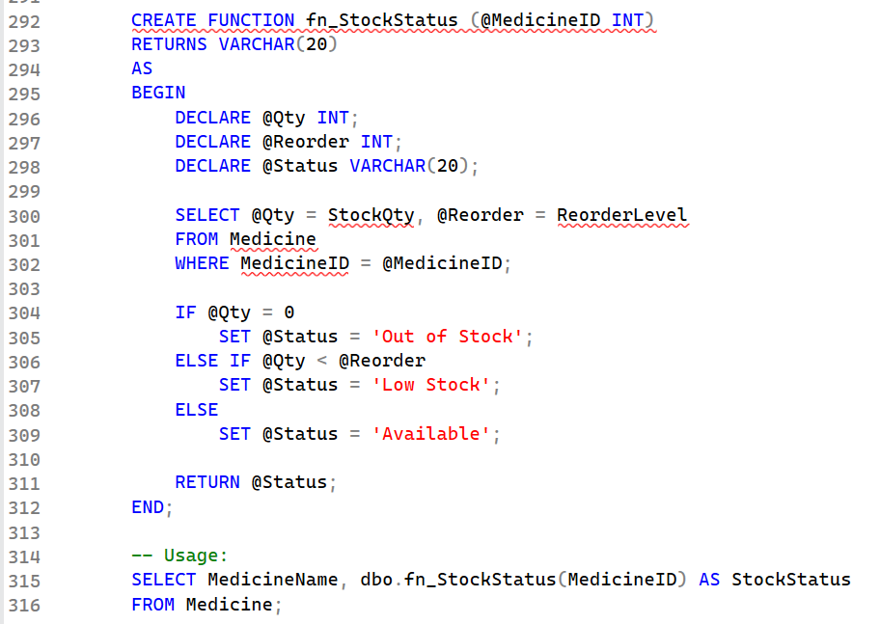
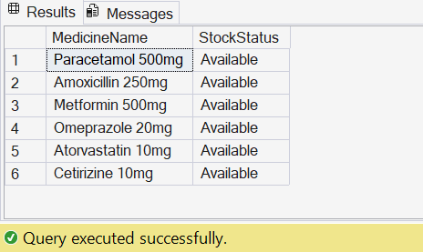

5.2 Table-Valued Functions
Table-Valued Functions return a full table of results instead of a single value. They behave like a virtual table and are queried using SELECT * FROM dbo.FunctionName(parameter). We create two table-valued functions in this project.

UDF 4 fn_PatientPrescriptions
Type: Table-Valued Function Purpose: This function accepts a PatientID and returns a table showing all prescriptions that belong to that specific patient. It is useful for displaying a patient's full prescription history without writing a new query every time. Input: @PatientID (INT) Returns: TABLE — all prescriptions for that patient
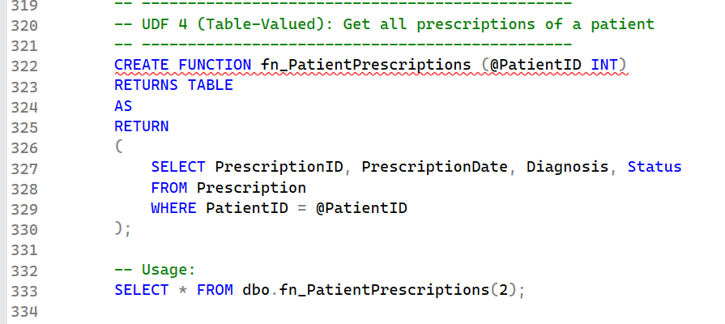
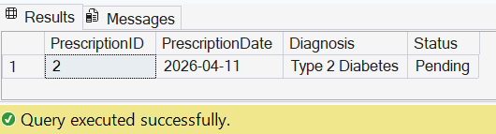

UDF 5 fn_LowStockMedicines
Type: Table-Valued Function Purpose: This function accepts a stock threshold value and returns a table of all medicines whose current stock quantity is below that threshold. The pharmacist can use this function daily to quickly see which medicines need to be reordered before they run out. Input: @Threshold (INT) — stock level below which medicines are considered low Returns: TABLE — all medicines below the given threshold
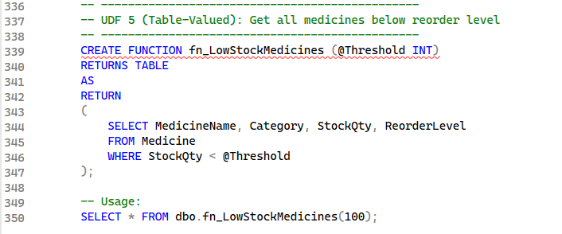
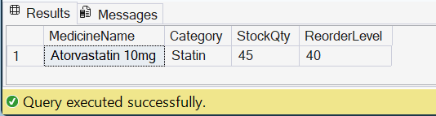

6. Conclusion
In this phase of the MediTrack Pro database project, we successfully designed and implemented all four major SQL components required for a working pharmacy management system.
In Part 1, DDL was used to create the complete database structure consisting of 8 interrelated tables. Each table was designed with appropriate data types and foreign key constraints to enforce referential integrity between related entities such as Patient, Doctor, Prescription, and Medicine. The tables were created in the correct order to satisfy all foreign key dependencies.
In Part 2, DML operations were performed to populate all 8 tables with realistic sample data. INSERT statements added records into every table. UPDATE statements were used to modify existing data such as changing a patient phone number, updating a medicine price, and marking a prescription as dispensed. DELETE statements removed records that were no longer needed. Five SELECT queries were written to retrieve and display data in useful formats including a multi-table join.
In Part 3, ten aggregate function queries were written using COUNT, SUM, AVG, MAX, and MIN. These queries produced summary reports such as total inventory value, prescription counts per doctor, average medicine price by category, and total units prescribed per medicine. The GROUP BY clause was used to group results and the HAVING clause was used to filter grouped data.
In Part 4, five User-Defined Functions were created. Three scalar functions return single values including a patient full name, a prescription total cost, and a medicine stock status label. Two table-valued functions return full result tables including all prescriptions for a given patient and all medicines below a given stock threshold.

