

MediTrack Pro
  - Pharmacy Inventory & Prescription Management System
Database System - Final Project

Phase 3 — Views, Stored Procedures, Normalization & Indexes

Group Leader: Syed Nalain Abbas (102)
Member: Rameesha Tariq (118)
Program: BS Artificial Intelligence – 4B
Subject: Database System
Submitted To: Ma'am Asma

Part 1 Views
A View is a saved SELECT query that works like a virtual table. It does not store data on its own. Every time we call the view it runs the query and shows fresh results. Views are useful because they save time and make queries simpler.

View 1 vw_ActivePrescriptions
What it does: This view shows all prescriptions that are still Pending along with the patient name and doctor name. The pharmacist can just call this view instead of writing a join query every time.
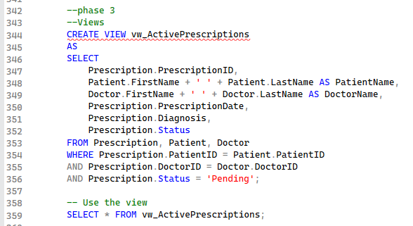

View 2 vw_MedicineStock
What it does: This view shows all medicines with their current stock and a simple status label. If stock is 0 it shows Out of Stock, if below reorder level it shows Low Stock, otherwise it shows Available.

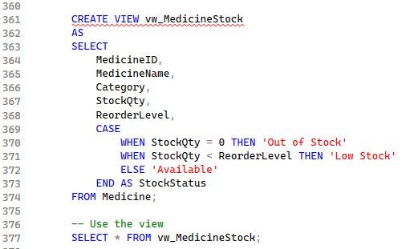

View 3 vw_PrescriptionItems
What it does: This view shows the full detail of every prescription. It shows the patient name, medicine name, dosage, frequency, and how many days the course is for. This is useful for the pharmacist when preparing medicines.

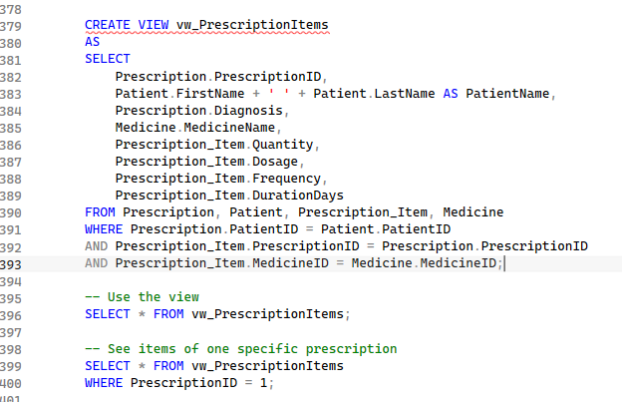

View 4 vw_SupplierOrders
What it does: This view shows all supply orders with the supplier name and medicine name included. This makes it easy to see all orders in one place without remembering how to join the tables.

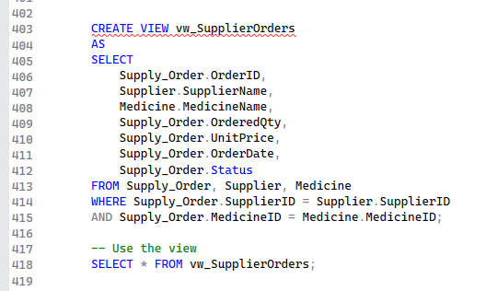

View 5 vw_PatientList
What it does: This view shows a simple clean list of all patients with just their name, phone number, gender, and blood group. This is useful for the front desk staff.

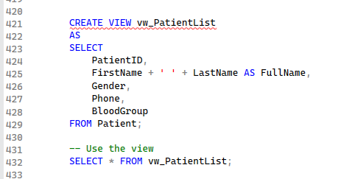

Part 2 Stored Procedures
A Stored Procedure is a block of SQL code that is saved in the database with a name. Instead of writing the full SQL every time, we just call the procedure by name and pass values to it. This saves time and reduces mistakes.

Stored Procedure 1 sp_AddNewPatient
What it does: This procedure adds a new patient record. The receptionist calls this procedure with the patient details and the record is added automatically.
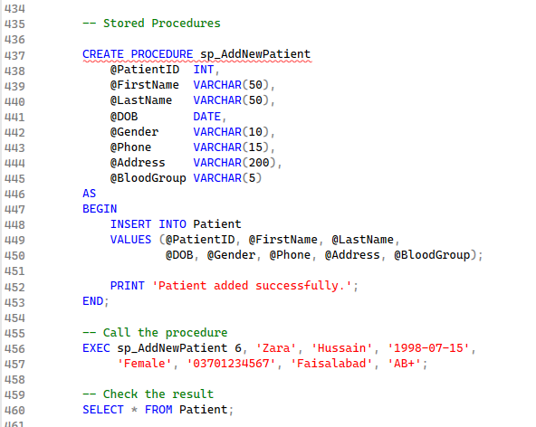

Stored Procedure 2 sp_AddNewMedicine
What it does: This procedure adds a new medicine to the Medicine table. Staff can use this whenever a new drug arrives at the pharmacy.

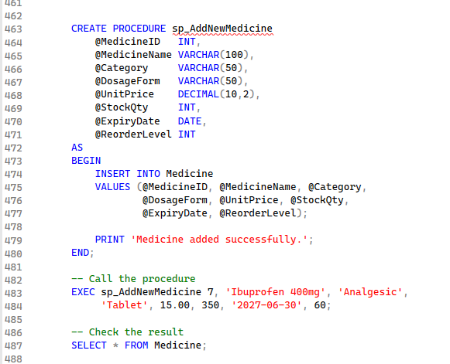

Stored Procedure 3 sp_RestockMedicine
What it does: This procedure adds stock to an existing medicine and also records the restock in the Inventory_Log table. Both steps happen together with one call.

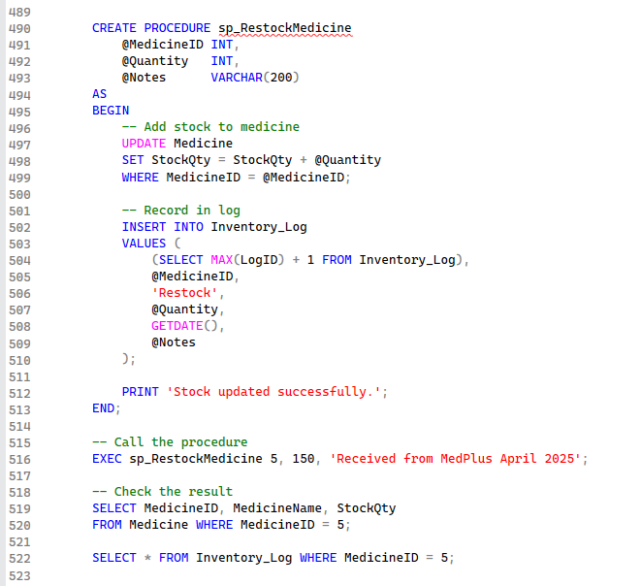

Stored Procedure 4 sp_GetPatientPrescriptions
What it does: This procedure takes a PatientID and shows all prescriptions and medicines for that patient. The doctor or pharmacist can use this to quickly check a patient's history.

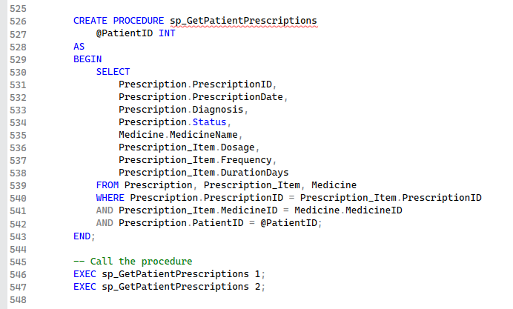

Stored Procedure 5 sp_UpdatePrescriptionStatus
What it does: This procedure updates the status of a prescription. For example when a pharmacist dispenses medicines, they call this procedure to mark the prescription as Dispensed.

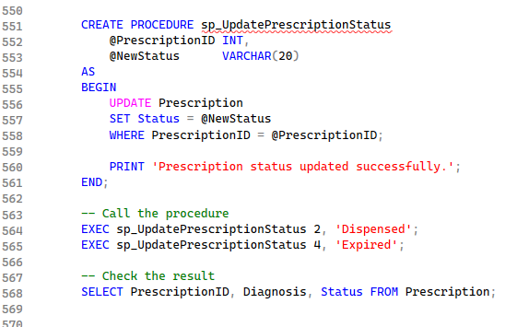

Part 3 Indexes
An Index helps SQL Server find rows faster. Without an index SQL Server has to check every single row in a table one by one to find a match. With an index it can jump directly to the right rows. This is very important when a table has thousands of records.
A simple way to understand it is like the index at the back of a textbook. Instead of reading every page to find a topic you look at the index and go directly to the right page number.
SQL Server automatically creates an index on every Primary Key column. We create additional indexes on other columns that are searched frequently.

Index 1 idx_Patient_Phone
Why: Staff often search for a patient by their phone number when they call. An index on Phone makes this search fast.

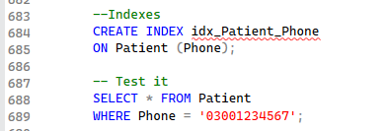

Index 2 idx_Medicine_Category
Why: Pharmacists often filter medicines by category to see all Antibiotics or all Analgesics at once. An index on Category speeds this up.

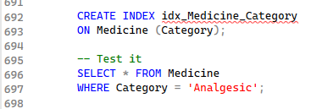

Index 3 idx_Prescription_Status
Why: The Status column is filtered very often to find Pending prescriptions. An index here makes this common search faster.
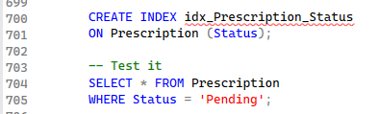

Index 4 idx_Prescription_PatientID
Why: PatientID in the Prescription table is used in almost every join when we look up a patient's prescriptions. An index here speeds up all those queries.

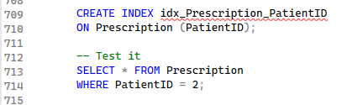

Index 5 idx_Medicine_ExpiryDate
Why: The pharmacy checks expiring medicines regularly. An index on ExpiryDate makes these date searches run much faster.

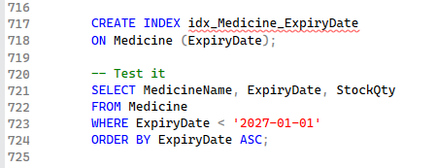

Index 6 idx_InventoryLog_MedicineID
Why: Every time we check the stock history of a medicine we filter Inventory_Log by MedicineID. An index here keeps these log queries fast.

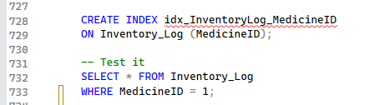

Index Summary
Index Name | Table | Column | Why We Created It
idx_Patient_Phone | Patient | Phone | Patients are often searched by phone
idx_Medicine_Category | Medicine | Category | Medicines are filtered by category often
idx_Prescription_Status | Prescription | Status | Status is filtered constantly
idx_Prescription_PatientID | Prescription | PatientID | Used in every patient prescription lookup
idx_Medicine_ExpiryDate | Medicine | ExpiryDate | Expiry checks are done regularly
idx_InventoryLog_MedicineID | Inventory_Log | MedicineID | Log is always filtered by medicine

Conclusion Phase 3
In Phase 3 of the MediTrack Pro project we successfully added four advanced database features.

In the Views section we created 5 views that make data retrieval easier. Instead of writing complex join queries every time, the pharmacist and staff can just call a view by name to get the information they need in a clean format.

In the Stored Procedures section we created 5 procedures that handle common operations. These include adding new patients, adding medicines, restocking inventory with automatic logging, retrieving patient prescription history, and updating prescription status. All of these can now be done with a single EXEC call.

In the Indexes section we created 6 indexes on columns that are used frequently in searches and joins. These include the patient phone number, medicine category, prescription status, patient ID in prescriptions, medicine expiry date, and medicine ID in the inventory log. These indexes will make the system run faster as the data grows over time.

