Producer:

Execute the producer.py to ingest the records from CSV into ecommerce kafka topic

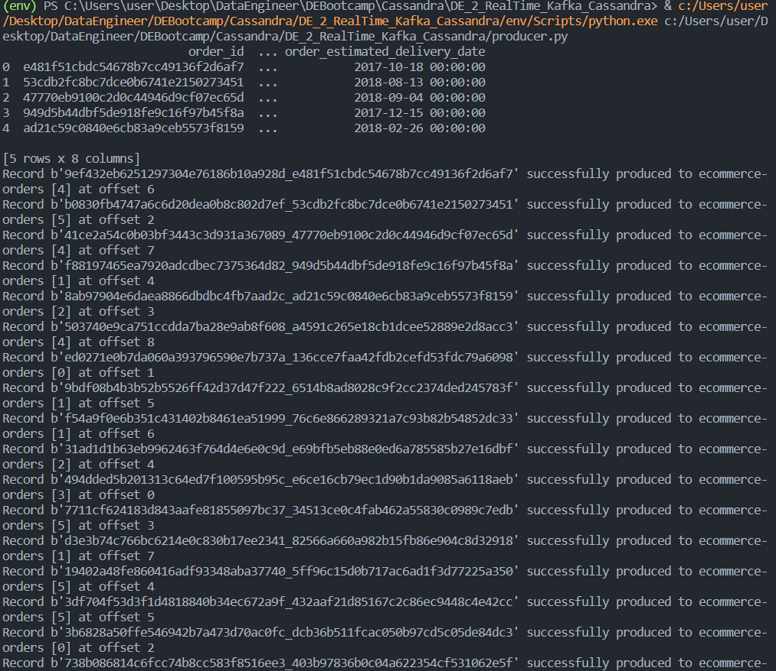

Consumer:

Execute the consumer.py subscribes to the ecommerce topic and fetch the data from the topic perform required transformation and load into order table in Cassandra inside ecommerce keyspace

