Cs211082

s.m.rameez raza

task1:

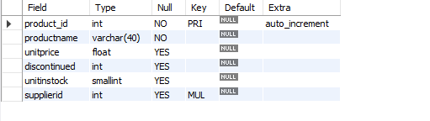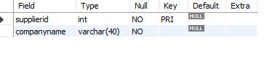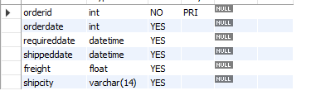

Task2:

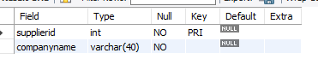

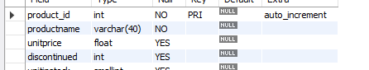

Task3:

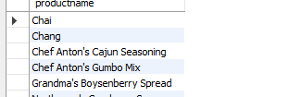

Task 4:

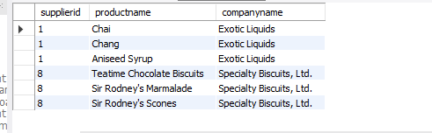

Task 5:

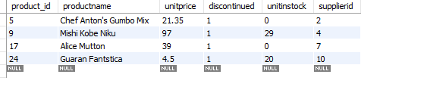

Task 6:

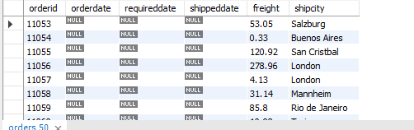

Task7:

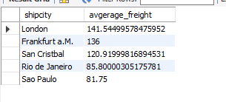

Task8:

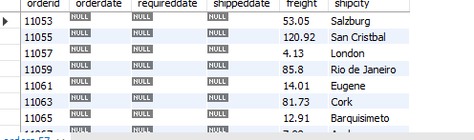

Task9:

