**Lab01_Assignment**

**Task Screenshots:**

**Task1:**

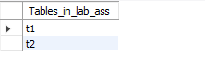

**Task2:**

**Table 1**

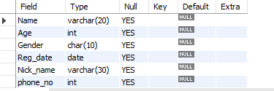

**Table 2**

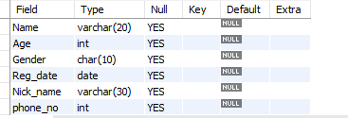

**Task 3 & 4:**

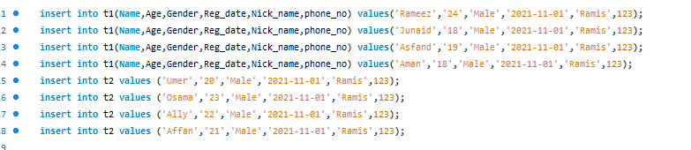

**Task 5:**

**Table 1**

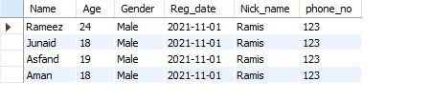

**Table 2**

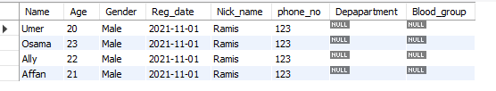

**Task 6:**



**Task 7:**

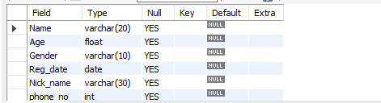

**Task 8:**



**Task 9:**

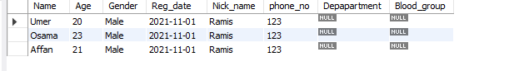

**Task 10:**

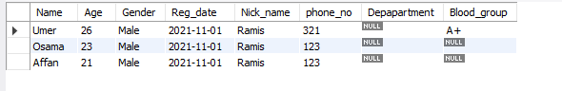

**Mysql Code:**

create database lab_ass;

use lab_ass;

create table t1(Name varchar(20), Age int,Gender char(10), Reg_date date, Nick_name varchar(30), phone_no int);

create table t2(Name varchar(20), Age int,Gender char(10), Reg_date date,Nick_name varchar(30), phone_no int);

show tables;

describe t1;

describe t2;

insert into t1(Name,Age,Gender,Reg_date,Nick_name,phone_no) values('Rameez','24','Male','2021-11-01','Ramis',123);

insert into t1(Name,Age,Gender,Reg_date,Nick_name,phone_no) values('Junaid','18','Male','2021-11-01','Ramis',123);

insert into t1(Name,Age,Gender,Reg_date,Nick_name,phone_no) values('Asfand','19','Male','2021-11-01','Ramis',123);

insert into t1(Name,Age,Gender,Reg_date,Nick_name,phone_no) values('Aman','18','Male','2021-11-01','Ramis',123);

insert into t2 values ('Umer','20','Male','2021-11-01','Ramis',123);

insert into t2 values ('Osama','23','Male','2021-11-01','Ramis',123);

insert into t2 values ('Ally','22','Male','2021-11-01','Ramis',123);

insert into t2 values ('Affan','21','Male','2021-11-01','Ramis',123);

select * from t1;

select * from t2;

alter table t2 add Depapartment varchar(30), add Blood_group varchar(10);

alter table t1 modify Age float(2),modify Gender varchar(10);

truncate table t1;

delete from t2 where Name='Ally';

update t2 set Age=26,phone_no=321, Blood_group='A+'

where Name='Umer';