**Lab02_Assignment**

**Task Screenshots:**

**Task1:**

create table Employees (emp_id int, f_name varchar(50),l_name varchar(50), designation varchar(50), salary float, birth_date date, hire_date date, department varchar (50), city varchar(50));

**Task2:**

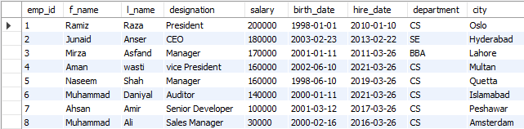

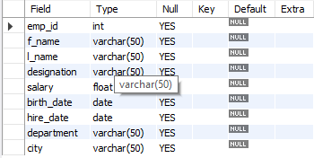

**Task 3:**

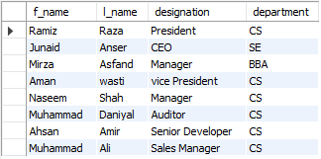

**Task 4:**

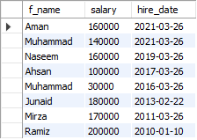

**Task 5:**

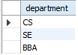

**Task 6:**



**Task 7:**

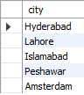

**Task 8:**

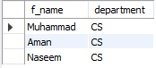

**Task 9:**



**Task 10:**

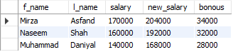

**Mysql Code:**

create database assignment_2;

use assignment_2;

create table Employees (emp_id int, f_name varchar(50),l_name varchar(50), designation varchar(50), salary float, birth_date date, hire_date date, department varchar (50), city varchar(50));

insert into Employees values ('1','Ramiz','Raza','President','200000','1998-01-01','2010-01-10','CS','Oslo'),('2','Junaid','Anser','CEO','180000','2003-02-23','2013-02-22','SE','Hyderabad'),('3','Mirza','Asfand','Manager','170000','2001-01-11','2011-03-26','BBA','Lahore'),('4','Aman','wasti','vice President','160000','2002-06-10','2021-03-26','CS','Multan'),('5','Naseem','Shah','Manager','160000','1998-06-10','2019-03-26','CS','Quetta'),('6','Muhammad','Daniyal','Auditor','140000','2000-01-11','2021-03-26','CS','Islamabad'),('7','Ahsan','Amir','Senior Developer','100000','2001-03-12','2017-03-26','CS','Peshawar'),('8','Muhammad','Ali','Sales Manager','30000','2000-02-16','2016-03-26','CS','Amsterdam');

describe Employees;

select f_name,l_name,designation,department from Employees;

select f_name,salary,hire_date from Employees order by hire_date desc;

select distinct department from Employees;

select f_name, l_name from Employees

where salary <= 40000 and hire_date between '2021-01-01' and '2021-12-31';

select city from Employees

where city like "%r%" or city like"%i%";

select f_name, department from Employees

where hire_date between "2019-02-01" and "2021-10-31" order by hire_date desc,salary asc;

select f_name, l_name from Employees

where designation = 'Manager' and city = 'Lahore';

select f_name, l_name, salary , salary * 1.2 as new_salary , salary * 0.2 as bonous from Employees

where designation = 'Manager' or designation = 'Auditor' ;