April 2011

Identification: A Non-technical Discussion of a Technical Issue

David A. Kenny Stephanie Milan
University of Connecticut

To appear in Handbook of Structural Equation Modeling (Richard Hoyle, David Kaplan, George Marcoulides, and Steve West, Eds.) to be published by Guilford Press.

Thanks are also due to Betsy McCoach, Rick Hoyle, William Cook, Ed Rigdon, Ken Bollen, and Judea Pearl who proved us with very helpful feedback on a prior draft of the paper. We also acknowledge that we used three websites in the preparation of this chapter: Robert Hanneman (http://faculty.ucr.edu/~hanneman/soc203b/lectures/identify.html), Ed Rigdon (http://www2.gsu.edu/~mkteer/identifi.html), and the University of Texas (http://ssc.utexas.edu/software/faqs/lisrel/104-lisrel3).
Identification: A Non-technical Discussion of a Technical Issue
Identification is perhaps the most difficult concept for SEM researchers to understand. We have seen SEM experts baffled and bewildered by issues of identification. We too have often encountered very difficult SEM problems that ended up being problems of identification. Identification is not just a technical issue that can be left to experts to ponder; if the model is not identified the research is impossible. If a researcher were to plan a study, collect data, and then find out that the model could not be uniquely estimated, a great deal of time has been wasted. Thus, researchers need to know well in advance if the model they propose to test is in fact identified. In actuality, any sort of statistical modeling, be it analysis of variance or item response theory, has issues related to identification. Consequently, understanding the issues discussed in this chapter can be beneficial to researchers even if they never use SEM.
We have tried to write a non-technical account. We apologize to the more sophisticated reader that we omitted discussion of some of the more difficult aspects of identification, but we have provided references to more technical discussions. That said, the chapter is not an easy chapter. We have many equations and often the discussion is very abstract. The reader may need to read, think, and re-read various parts of this chapter.
The chapter begins with key definitions and then illustrates two models’ identification status. We then have an extended discussion on determining whether a model is identified or not. Finally, we discuss models that are under-identified.
Definitions
Identification concerns going from the known information to the unknown parameters. In most SEMs, the amount of known information for estimation is the number of elements in the observed variance-covariance matrix. For example, a model with 6 variables would have 21 pieces of known information, 6 variances and 15 covariances. In general, with k measured variables, there are k(k + 1)/2 knowns. In some types of models (e.g., growth curve modeling), the knowns also include the sample means, making the number of knowns equal k(k + 3)/2.
Unknown information in a specified model includes all parameters (i.e., variances, covariances, structural coefficients, factor loadings) to be estimated. A parameter in a hypothesized model is either freely estimated or fixed. Fixed parameters are typically constrained to a specific value, such as one (e.g., the unitary value placed on the path from a disturbance term to an endogenous variable or a factor loading for the marker variable) or zero (e.g., the mean of an error term in a measurement model), or a fixed parameter may be constrained to be equal to some function of the free parameters (e.g., set equal to another parameter). Often, parameters are implicitly rather than explicitly fixed to zero by exclusion of a path between two variables. When a parameter is fixed, it is no longer an unknown parameter to be estimated in analysis.
The correspondence of known versus unknown information determines whether a model is under-identified, just-identified, or over-identified. A model is said to be identified if it is possible to estimate a single, unique estimate for every free parameter. At the heart of identification is solving of a set of simultaneous equations where each known value, the observed variances, covariances and means, is assumed to be a given function of the unknown parameters.
An under-identified model is one in which it is impossible to obtain a unique estimate of all of the model’s parameters. Whenever there is more unknown than known information, the model is under-identified. For instance, in the equation:
10 = 2x + y
there is one piece of known information (the 10 on the left-side of the equation), but two pieces of unknown information (the values of x and y). As a result, there are infinite possibilities for estimates of x and y that would make this statement true, e.g., {x = 4, y = 2}, {x = 3, y = 4}. Because there is no unique solution for x and y, this equation is said to be under-identified. It is important to note that it is not the case that the equation cannot be solved, but rather that there are multiple, equally valid, solutions for x and y.
The most basic question of identification is whether the amount of unknown information to be estimated in a model (i.e., number of free parameters) is less than or equal to the amount of known information from which the parameters are estimated. The difference between the known versus unknown information typically equals the model’s degrees of freedom. In the example of under-identification above, there was more unknown than known information, implying negative degrees of freedom. In his seminal description of model identification, Bollen (1989) labeled non-negative degrees of freedom, or the t rule, as the first condition for model identification. Although the equations are much more complex for SEM, the logic of identification for SEM is identical to that for simple systems of linear equations. The minimum condition of identifiability is that for a model to be identified there must at least as many knowns as unknowns. This is a necessary condition: All identified models meet the condition, but some models, that meet this condition are not identified, two examples of which we present later.
In a just-identified model, there is an equal amount of known and unknown information and the model is identified. Imagine, for example, two linear equations:
10 = 2x + y
2 = x − y
In this case, there are two pieces of unknown information (the values of x and y) and two pieces of known information (10 and 2) to use in solving for x and y. Because the number of knowns and unknowns is equal, it is possible to derive unique values for x and y that exactly solve these equations, specifically x = 4 and y = 2. A just-identified model is also referred to as a saturated model.
A model is said to be over-identified if there is more known information than unknown information. This is the case, for example, if we solve for x and y using the three linear equations:
10 = 2x + y
2 = x − y
5 = x + 2y
In this situation, it is possible to generate solutions for x and y using two equations, such as {x = 4, y = 2}, {x = 3, y = 1}, and {x = 5, y = 0}. Notice, however, that none of these solutions exactly reproduces the known values for all three equations. Instead, the different possible values for x and y all result in some discrepancy between the known values and the solutions using the estimated unknowns.
One might wonder why an over-identified model is preferable to a just-identified model, which possesses the seemingly desirable attributes of balance and correctness. One goal of model testing is falsifiability and a just-identified model cannot be found to be false. In contrast, an over-identified model is always wrong to some degree, and it is this degree of wrongness that tells us how good (or bad) our hypothesis is given available data. Only over-identified models provide fit statistics as a means of evaluating the fit of the overall model.
There are two different ways in which a model is not identified. In the first, and most typical case, the model is too complex with negative model degrees of freedom and, therefore, fails to satisfy the minimum condition of identifiability. Less commonly, a model may meet the minimum condition of identifiability, but the model is not identified because at least one parameter is not identified. Although we normally concentrate on the identification of the overall model, in these types of situations we need to know the identification status of specific parameters in the model. Any given parameter in a model can be under-identified, just-identified, or over-identified. Importantly, there may be situations when a model is under-identified yet some of the model’s key parameters may be identified.
Sometimes a model may appear to be identified, but there are estimation difficulties. Imagine, for example, two linear equations:
10 = 2x + y
20 = 4x + 2y
In this case, there are two pieces of unknown information (the values of x and y) and two pieces of known information (10 and 20) and the model would appear to be identified. But if we use these equations to solve for x or y, there is no solution. So although we have as many knowns as unknowns, given the numbers in the equation there is no solution. When in SEM a model is theoretically identified, but given the specific values of the knowns, there is no solution, we say that the model is empirically under-identified. Although there appears to be two different pieces of known information, these equations are actually a linear function of each other and, thus, do not provide two pieces of information. Note if we multiply the first equation by 2, we obtain the second equation, and so there is just one equation.
Going from Knowns to Unknowns
To illustrate how to determine whether a model is identified, we describe two simple models, one being a path analysis and the other a single latent variable model. To minimize the complexity of the mathematics, we standardize all variables except disturbance terms. Later in the chapter, we do the same for a model with a mean structure.
We consider first a simple path analysis model, shown in Figure 1:
X₂ = aX₁ + U
X₃ = bX₁ + cX₂ + V
where U and V are uncorrelated with each other and with X₁. We have 6 knowns, consisting of 3 variances, which all equal one because the variables are standardized, and 3 correlations. We can use the algebra of covariances (Kenny, 1979) to express them in terms of the unknowns:
r₁₂ = a
r₁₃ = b + cr₁₂
r₂₃ = br₁₂ + c
1 = s₁²
1 = a²s₁² + s_{U}²
1 = b²s₁² + c²s₂² + bcr₁₂ + s_{V}²
We see right away that we know s₁² equals 1 and that path a equals r₁₂. However, the solution for b and c are a little more complicated:
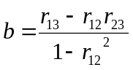
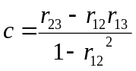
Now that we know a, b, and c, the last two remaining unknowns s_{U}² and s_{V}²: s_{U}² = 1 – a² and s_{V}² = 1 – b² – c² – 2r₁₂. The model is identified because we can solve for the unknown model parameters from the known variances and covariances.
As a second example, let us consider a simple model in which all the variables have zero means:
X₁ = fF + E₁
X₂ = gF + E₂
X₃ = hF + E₃
where E₁, E₂, E₃, and F are uncorrelated, all variables are mean deviated and all variables, except the E’s, have a variance of 1. We have also drawn the model in Figure 2. We have 6 knowns, consisting of 3 variances, which all equal one because the variables are standardized, and 3 correlations. We have 6 unknowns, f, g, h, s_{E1}², s_{E1}² and s_{E1}². We can express the knowns in terms of the unknowns:
r₁₂ = fg
r₁₃ = fh
r₂₃ = gh
1 = f² + s_{E1}²
1 = g² + s_{E2}²
1 = h² + s_{E3}²
We can solve for f, g, and h by
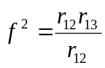, 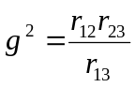, 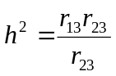
The solution for the error variances are as follows: s_{E1}² = 1 – f², s_{E2}² = 1 – g², and s_{E3}² = 1 – h². The model is identified because we can solve for the unknown model parameters from the known variances and covariances.
Over-identified Models and Over-identifying Restrictions
An example of an over-identified model is shown in Figure 1, if we assume that path c is equal to zero. Note that there would be one less unknown than knowns. A key feature of an over-identified model is that at least one of the model’s parameter has multiple estimates. For instance, there are two estimates of path b, one being r₂₃ and the other being r₁₃/r₁₂. If we set these two estimates equal and rearrange terms, we have r₁₃ − r₂₃r₁₂ = 0. This is what is called an over-identifying restriction, which represents a constraint on the covariance matrix. Path models with complete mediation (X → Y → Z) or spuriousness (X ← Y → Z) are over-identified and have what is called d-separation (Pearl, 2009).
All models with positive degrees of freedom, i.e., more knowns than unknowns, have over-identifying restrictions. The standard χ² test in SEM evaluates the entire set of over-identifying restrictions.
If we add a fourth indicator for the model in Figure 2, we have an over-identified model with 2 degrees of freedom (10 knowns and 8 unknowns). There are three over-identifying restrictions:
r₁₂r₃₄ − r₁₃r₂₄ = 0, r₁₂r₃₄ − r₁₄r₂₃ = 0, r₁₃r₂₄ − r₁₄r₂₃ = 0
Note that if two of the restrictions hold, however, the third must also hold; consequently, there are only two independent over-identifying restrictions. The model’s degrees of freedom equal the number of independent over-identifying restrictions. Later we shall see that some under-identified models have restrictions on the known information.
If a model is over-identified, researchers can test over-identified restrictions as a group using the χ² test or individually by examining modification indices. One of the themes of this chapter is that there should be more focused tests of over-identifying restrictions. When we discuss specific types of models, we return to this issue.
How Can We Determine If a Model Is Identified?
Earlier we showed that one way to determine if the model is identified is to take the knowns and see if you can solve for the unknowns. In practice, this is almost never done. (One source described this practice as “not fun.”) Rather, very different strategies are used. The minimum condition of identifiability or t rule is a starting point, but because it is just a necessary condition, how can we know for certain if a model is identified? Here we discuss three different strategies to determine whether or not a model is identified: formal solutions, computational solutions, and rules of thumbs.
Formal Solutions
Most of the discussion about identification in the literature focuses on this approach. There are two rules that have been suggested, the rank and order conditions, for path models but not factor analysis models. We refer the reader to Bollen (1989) and Kline (2004) for discussion of these rules. Recent work by Bekker, Merkens, and Wansbeek (1994) and Bollen and Bauldry (2010) provided fairly general solutions. As this is a non-technical introduction to the topic of identification, we do not provide the details here. However, in our experience neither of these rules is of much help to the practicing SEM researcher, especially those who are studying latent variable models.
Computational Solutions
One strategy is to input one’s data into a SEM program and if it runs, it must be identified. This is the strategy that most people use to determine if their model is identified. The strategy works as follows: The computer program attempts to compute the standard errors of the estimates. If there is a difficulty in the computation of these standard errors (i.e., the information matrix cannot be inverted), the program warns that the model may not be identified.
There are several drawbacks with this approach. First, if poor starting values are chosen, the computer program could mistakenly conclude the model is under-identified when in fact it may be identified. Second, the program does not indicate whether the model is theoretically under-identified or empirically under-identified. Third, the program very often is not very helpful in indicating which parameters are under-identified. Fourth, and most importantly, this method of determining identification gives an answer that comes too late. Who wants to find out that one’s model is under-identified after taking the time to collect data?
Rules of Thumb
In this case, we give up on a general strategy of identification and instead determine what needs to be true for a particular model to be identified. In the next two sections of the chapter, we give rules of thumb for several different types of models.
Can There Be a General Solution?
Ideally, we need a general algorithm to determine whether or not a given model is identified or not. However, it is reasonable to believe that there will never be such an algorithm. The question is termed to be undecidable; that is, there can never be an algorithm that we can employ to determine if any model is identified or not. The problem is that SEMs are so varied that there may not be a general algorithm that can identify every possible model; at this point, however, we just do not know if a general solution can be found.
Rules for Identification for Particular Types of Models
We first consider models with measured variables as causes, what we shall call path analysis models. We consider three different types of such models: models without feedback, models with feedback, and models with omitted variables. After we consider path analysis models, we consider latent variable models. We then combine the two in what is called a hybrid model. In the next section of the chapter, we discuss the identification of over-time models.
Path Analysis Models: Models without Feedback
Path analysis models without feedback are identified if the following sufficient condition is met: Each endogenous variable’s disturbance term is uncorrelated with all of the causes of that endogenous variable. We call this the regression rule [which we believe is equivalent to the non-bow rule by Brito and Pearl (2002)], because the structural coefficients can be estimated by multiple regression. Bollen’s (1989) recursive rule and null rule are subsumed under this more general rule. Consider the model contained in Figure 3. The variables X₁ and X₂ are exogenous variables and X₃, X₄, and X₅ are endogenous. We note that U₁ is uncorrelated with X₁ and X₂ and U₂ and U₃ are uncorrelated with X₃, which makes the model identified by the regression rule. In fact, the model is over-identified in that there are four more knowns than unknowns.
The over-identifying restrictions for models over-identified by the regression rule can often be thought of as deleted paths; i.e., paths that are assumed to be zero and so are not drawn in the model, but if they were all drawn the model would still be identified. These deleted paths can be more important theoretically than the specified paths because they can potentially falsify the model. Very often these deleted paths are direct paths in a mediational model. For instance, for the model in Figure 3, the deleted paths are from X₁ and X₂ to X₃ and X₄, all of which are direct paths.
We suggest the following procedure in testing over-identified path models. Determine what paths in the model are deleted paths, the total being equal to the number of knowns minus unknowns. For many models, it is clear exactly what the deleted paths are. In some cases, it may make more sense not to add a path between variables, but to correlate the disturbance terms. One would also want to make sure that the model is still identified by the regression rule after the deleted paths are added. After the deleted paths are specified, the model should now be just-identified. That model is estimated and the deleted paths are individually tested, perhaps with a lower alpha due to multiple testing. Ideally, none of them should be statistically significant. Once the deleted paths are tested, one estimates the specified model, but includes deleted paths that were found to be nonzero.
Path Analysis Models: Models with Feedback
Most feedback models are direct feedback models: two variables directly cause one another. For instance, Frone, Russell, and Cooper (1994) studied how Work Satisfaction and Home Satisfaction mutually influence each other. To identify such models, one needs a special type of variable, called an instrumental variable. In Figure 4, we have a simplified version of the Frone et al. (1994) model. We have a direct feedback loop between Home and Work Satisfaction. Note the pattern for the Stress variables. Each causes one variable in the loop but not the other: Work Stress causes Work Satisfaction and Home Stress causes Home Satisfaction. Work Stress is said to be an instrumental variable for path from Work to Home Satisfaction, in that it causes Work Satisfaction but not Home Satisfaction; Home Stress is said to be an instrumental variable for path from Home to Work Satisfaction, in that it causes Home Satisfaction but not Work Satisfaction. We see that the key feature of an instrumental variable: It causes one variable in the loop but not the other. For the model in Figure 4, we have 10 knowns and 10 unknowns, and the model is just-identified. Note that the assumption of a zero path is a theoretical assumption and not something that is empirically verified.
These models are over-identified if there are an excess of instruments. In the Frone et al. (1994) study, there are actually three instruments for each path making a total of four degrees of freedom. If the over-identifying restriction does not hold, it might indicate that we have a “bad” instrument, an instrument whose assumed zero path is not actually zero. However, if the over-identifying restrictions do not hold, there is no way to know for sure which instrument is the bad one.
As pointed out by Rigdon (1995) and others, only one instrumental variable is needed if the disturbance terms are uncorrelated. So in Figure 4, we could add a path from Work Stress to Home Satisfaction or from Home Stress to Work Satisfaction if the disturbance correlation was fixed to zero.
Models with indirect feedback loops can be identified by using instrumental variables. However, the indirect feedback loop of X₁ → X₂ → X₃ → X₁ is identified if the disturbance terms are uncorrelated with each other. Kenny, Kashy, and Bolger (1998) give a rule that we call here the one-link rule that appears to be a sufficient condition for identification: If between each pair of variables there is no more than one link (a causal path or a correlation), then the model is identified. Note this rule subsumes the regression rule.
Path Analysis Models: Omitted Variables
A particularly troubling problem in the specification of SEMs is the problem of omitted variables: two variables in a model share variance because some variable not included in the model causes both of them. The problem has also been called spuriousness, the third-variable problem, confounding, and endogeneity. We can use an instrumental variable to solve this problem. Consider the example in Figure 5. We have a variable, Treatment, that is a randomized variable believed to cause the Outcome. Yet not everyone complies with the treatment; some assigned to receive the intervention refuse it and some assigned to the control group somehow receive the treatment. The compliance variable mediates the effect of the intervention, but there is the problem of omitted variables. Likely there are common causes of compliance and the outcome, i.e., omitted variables. In this case, we can use the Treatment as an instrumental variable to estimate the model’s parameters in Figure 5.
Confirmatory Factor Analysis Models
Identification of confirmatory factor analysis (CFA) models or measurement models is complicated. Much of what follows here is from Kenny, Kashy, and Bolger (1998) and O’Brien (1994). Readers should consult Hayashi and Marcoulides (2006) if they are interested in the identification of exploratory factor analysis models.
To identify variables with latent variables the units of measurement of the latent variable need to be fixed. This is usually done by fixing the loading of one indicator, called the marker variable, to one. Alternatively, the variance of the latent variable can be fixed to some value, usually one.
We begin with a discussion of simple structure where each measure loads on only one latent variable and there are no correlated errors. Such models are identified if there are at least two correlated latent variables and two indicators per latent variable. The difference between knowns and unknowns with k measured variables and p latent variables is k(k + 1)/2 – k + p – p(p + 1)/2. This number is usually very large and so the minimum condition of identifiability is typically of little value for the identification of CFA models.
For CFA models, there are three types of over-identifying restrictions and all involve what are called vanishing tetrads (Bollen & Ting, 1993), the product of two correlations minus the product of two other correlations equals zero. The first set of over-identifying restrictions involves constraints within indicators of the same latent variable. If there are four indicators of the same latent variable, the vanishing tetrad is of the form: r_{X1X2}r_{X3X4} − r_{X1X3}r_{X2X4} = 0, where the four X variables are indicators of the same latent variables. For each latent variable with four or more indicators, the number of independent over-identifying restrictions is k(k – 3)/2 where k is the number of indicators. The test of these constraints within a latent variable evaluates the single-factoredness of each latent variable.
The second set of over-identifying restrictions involves constraints across indicators of two different latent variables: r_{X1Y1}r_{X2Y2} − r_{X1Y2}r_{X2Y1} = 0 where X₁ and X₂ are indicators of one latent variable and Y₁ and Y₂ indicators of another. For each pair of latent variables with k indicators of one and m of the other, the number of independent over-identifying restrictions is (k – 1)(m – 1). The test of these constraints between indicators of two different variables evaluates potential method effects across latent variables.
The third set of over-identifying restrictions involves constraints within and between indicators of the same latent variable: r_{X1X2}r_{X3Y1} − r_{X2Y1}r_{X1X3} = 0 where X₁, X₂, and X₃ are indicators of one latent variable and Y₁ an indicator of another. These constraints have been labeled consistency constraints (Costner, 1969) in that they evaluate whether a good indicator within is also a good indicator between. For each pair of latent variables with k indicators of one and m of the other (k and m both greater than or equal to 3), the number of independent over-identifying restrictions is (k – 1) + (m – 1) given the other over-identifying restrictions. These constraints evaluate whether any indicators load on another factor.
Ideally, these three different sets of over-identifying constraints could be separately tested as they suggest very different types of specification error. The first set suggests correlated errors within indicators of the same factor. The second set suggests that correlated errors across indicators of different factor or method effects. Finally, the third set suggests an indicator loads on two different factors. For over-identified CFA models, which include almost all CFA models, we can either use the overall χ² to evaluate the entire set of constraints simultaneously, or we can examine the modification indices to evaluate individual constraints. Bollen and Ting (1993) show how more focused tests of vanishing tetrads can be used to evaluate different types of specification errors. However, to our knowledge no SEM program provides focused tests of these different sorts of over-identifying restrictions.
If the model contains correlated errors, then the identification rules need to be modified. For the model to be identified, then each latent variable needs two indicators that do not have correlated errors, and every pair of latent variables needs at least one indicator of each that does not share correlated errors. We can also allow for measured variables to load on two or more latent variables. Researchers can consult Kenny et al. (1998) and Bollen and Davis (2009) for guidance about the identification status of these models.
Adding means to most models is straightforward. One gains k knowns, the means, and k unknowns, the intercepts for the measured variables, where k is the number of measured variables, with no effect at all on the identification status of the model. Issues arise if we allow a latent variable to have a mean (if it is exogenous) or an intercept (if it is exogenous). One situation where we want to have factor means (or intercepts) is when we wish to test invariance of mean (or intercepts) across time or groups. One way to do so, for each indicator, we fix the intercepts of same indicator to be equal across times or groups, set the intercept for the marker variable to zero, and free the latent means (or intercepts) for each time or group (Bollen, 1989).
Hybrid Models
A hybrid model combines a CFA and path analysis model (Kline, 2004). These two models are typically referred to as the structural model and the measurement model. Several authors (Bollen, 1989; Kenny et al., 1998; O’Brien, 1994) have suggested a two-step method approach to identification of such models. A hybrid model cannot be identified unless the structural model is identified. Assuming that the structural model is identified, we then determine if the measurement model is identified. If both are identified, then the entire model is identified. There is the special case of the measurement model that becomes identified because the structural model is over-identified, an example of which is given later in the chapter when we discuss single-indicator over-time models.
Within hybrid models, there are two types of specialized variables. First are formative latent variables for which the “indicators” cause the latent variable instead of the more standard reflective latent variable which causes its indicators (Bollen & Lennox, 1991). For these models to be identified, two things need to hold: One path to the latent factor is fixed to a nonzero value, usually one, and the latent variable has no disturbance term. Bollen and Davis (2009) describe a special situation where a formative latent variable may have a disturbance.
Additionally, there are second-order factors which are latent variables whose indicators are themselves latent variables. The rules of identification for second-order latent variables are the same as regular latent variables, but here the indicators are latent, not measured.
Identification in Over-time Models
Autoregressive Models
In these models, a score at one time causes the score at the next time point. We consider here single-indicator models and multiple-indicator models.
Single-indicator models. An example of this model with two variables measured at four times is contained in Figure 6. We have the variables X and Y measured at four times and each assumed to be caused by a latent variable. The latent variables have an autoregessive structure: Each latent variable is caused by the previous variable. The model is under-identified, but some parameters are identified: They include all of the causal paths between latent variables, except those from Time 1 to Time 2, and the error variances for Times 2 and 3. We might wonder how it is that the paths are identified when we have only a single indicator of X and Y. The variables X₁ and Y₁ serve as instrumental variables for the estimation of the paths from LX₂ and LY₂, and X₂ and Y₂ serve as instrumental variables for the estimation of the paths from LX₃ and LY₃. Note in each case, the instrumental variable (e.g., X₁) causes the “causal variable” (e.g., LX₂) but not the outcome variable (e.g., LX₃).
A strategy to identify the entire model is to set the error variances, separately for X and Y, to be equal across time. We can test the plausibility of the assumption of equal error variances for the middle two waves’ error variances, separately for X and Y.
Multiple-indicator models. For latent variable, multiple indicator models, just two waves are needed for identification. In these models, errors from the same indicator measured at different times normally need to be correlated. This typically requires a minimum of three indicators per latent variable. If there are three or more waves, one might wish to estimate and test a first-order autoregressive model in which each latent variable is caused only by that variable measured at the previous time point.
Latent Growth Models
In the latent growth model (LGM), the researcher is interested in individual trajectories of change over time in some attribute. In the SEM approach, change over time is modeled as a latent process. Specifically, repeated measure variables are treated as reflections of at least two latent factors, typically called an intercept and slope factor. Figure 7 illustrates a latent variable model of linear growth with 3 repeated observations where X₁ to X₃ are the observed scores at the three time points. Observed X scores are a function of the latent intercept factor, the latent slope factor with factor loadings reflecting the assumed slope, and time-specific error. Because the intercept is constant over time, the intercept factor loadings are constrained to 1 for all time points. Because linear growth is assumed, the slope factor loadings are constrained from 0 to 1 with an equal increment of 0.5 in between. An observation at any time point could be chosen as the intercept point (i.e., the observation with a 0 factor loading), and slope factor loadings could be modeled in various ways to reflect different patterns of change.
The parameters to be estimated in a LGM with T time points include means and variances for the intercept and slope factors, a correlation between the intercept and the slope factors, and error variances, resulting in a total of 5 + T parameters. The known information will include T variances, T(T – 1)/2 covariances, and T means for a total of T(T + 3)/2. The difference between knowns and unknowns is (T(T + 3)/2) − (T + 5). To illustrate, if T = 3, df = 9 – 8 = 1. To see that the model is identified for three time points, we first determine what the knowns equal in terms the unknowns, and then see if have a solution for unknowns. Denoting I for the intercept latent factor and S for slope, the knowns equal:
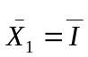, 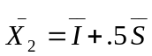, 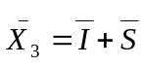
s₁² = s_{I}² + s_{E1}², s₂² = s_{I}² + .25s_{S}² + s_{IS} + s_{E2}², s₃² = s_{I}² + s_{S}² + 2s_{IS} + s_{E3}²
s₁₂ = s_{I}² + .5s_{IS} , s₁₃ = s_{I}² + s_{IS} , s₂₃ = s_{I}² + 1.5s_{IS} + 0.5s_{S}²
The solution for the unknown parameters in terms of the knowns is
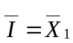, 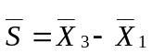
s_{I}² = 2s₁₂ − s₁₃, s_{S}² = 2s₂₃ ₊ + 2s₁₂ − 4s₁₃, s_{IS} = 2(s₁₃ − s₁₂)
s_{E1}² = s₁² − 2s₁₂ + s₁₃, s_{E2}² = s₂² − .5s₁₂ - .5s₁₃ , s_{E3}² = s₃² + s₁₃ − 2s₂₃
There is an over-identifying restriction of 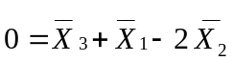which simply states that the means have a linear relationship with time.
Many longitudinal models include correlations between error terms of adjacent waves of data. A model that includes serially correlated error terms constrained to be equal would have one additional free parameter. A model with serially correlated error terms that are not constrained to be equal ─ which may be more appropriate when there are substantial time differences between waves ─ has T − 1 additional free parameters. As a general guideline, if a specified model has a fixed growth pattern and includes serially correlated error terms (whether set to be equal or not), there must be at least four waves of data for the model to be identified. Note that even though a model with three waves has one more known than unknown, we cannot “use” than extra known to allow for correlated errors. This would not work because that extra known is lost to the over-identifying restriction on the means.
Specifying a model with nonlinear growth also increases the number of free parameters in the model. There are two major ways that nonlinear growth is typically accounted for in SEM. The first is to include a third factor reflecting quadratic growth in which the loadings to observed variables are constrained to the square of time based on the loadings of the slope factor (Bollen & Curran, 2006). Including a quadratic latent factor increases the number of free parameters by 4 (a quadratic factor mean and variance and 2 covariances). The degrees of freedom for the model would be: T(T + 3)/2 − (T + 9). To be identified, a quadratic latent growth model must therefore have at least 4 waves of data and 5 if there were also correlated errors.
Another common way to estimate nonlinear growth is to fix one loading from the slope factor (e.g., the first loading) to 0 and one loading (e.g., the last) to 1 and allow intermediate loadings to be freely estimated (Meredith & Tisak, 1990). This approach allows the researcher to determine the average pattern of change based on estimated factor loadings. The number of free parameters in this model increases by T − 2. The degrees of freedom for this model, therefore, would be (T(T + 3)/2) − (2T + 3). For this model to be identified, there again must be at least 4 waves of data and 5 for correlated errors.
The LGM can be extended to a model of latent difference scores or LDS. The reader should consult McArdle and Hamagami (2001) for information about the identification of these models. Also, Bollen and Curran (2004) discuss the identification of a combined LGM and autoregressive models.
A Longitudinal Test of Spuriousness
Very often with overtime data, researchers estimate a causal model in which one variable causes another with a given time lag, much as in Figure 6. Alternatively, we might estimate a model with no causal effects, but rather the source of the covariation is due to unmeasured variables. The explanation of the covariation between variables is entirely due to spuriousness, the measured variables are all caused by common latent variables.
We briefly outline the model, a variant of which was originally proposed by Kenny (1975). The same variables are measured at two times and are caused by multiple latent variables. Though not necessary, we assume that the latent variables are uncorrelated with each other. A variable i’s factor loadings are assumed to change by a proportional constant k_{i}, making A₂ = A₁K where K is a diagonal matrix with elements k_{i}. Although the model as a whole is under-identified, the model has restrictions on the covariances, as long as there are three measures. There are constraints on the synchronous covariances such that for variables i and j ─ s_{1i,1j} = k_{i}k_{j}s_{2i,2j} where the first subscript indicates the time and the second indicates the variable ─ and constraints on the cross-lagged covariances ─ k_{i}s_{1i,2j} = k_{j}s_{2i,1j}. In general, the degrees of freedom of this model are n(n − 2), where n is the number of variables measured at each time. To estimate the model, we create 2n latent variables each of whose indicators is a measured variable. The loadings are fixed to one for the time 1 measurements and to k_{i} for time 2. We set the time 1 and time 2 covariances to be equal and the corresponding cross-lagged correlations to be equal. (The Mplus setup is available at the http://www.handbookofsem.com). If this model provides a good fit, then we can conclude that data can be explained by spuriousness.
The reason why we would we want to estimate the model is rule out spuriousness as an explanation of the covariance structure. If such a model had a poor fit to the data, we could argue that we need to estimate causal effects. Even though the model is not identified, it has restrictions that allow us to test for spuriousness.
Under-Identified Models
SEM computer programs work well for models that are identified but not for models that are under-identified. As we shall see, sometimes these models contain some parameters that are identified, even if the model as a whole is not identified. Moreover, it is possible that for some under-identified models, there are restrictions which make it possible to test the fit of the overall model.
Models that Meet the Minimum Condition but Are Not Identified
Here we discuss two examples of a model that is not identified but meet the minimum condition. The first model, presented in Figure 8, has 10 knowns and 10 unknowns, and so the minimum condition is met. However, none of the parameters of this model are identified. The reason is that the model contains two restrictions of r₂₃ − r₁₂r₁₃ = 0 and r₂₄ − r₁₂r₁₄ = 0 (see Kenny, 1979, pp. 106-107). Because of these two restrictions, we lose two knowns, and we no longer have as many knowns or unknowns. We are left with a model for which we can measure its fit but we cannot estimate any of the model’s parameters. We note that if we use the classic equation that the model’s degrees of freedom equal the knowns minus the unknowns, we would get the wrong answer of zero. The correct answer for the model in Figure 8 is two.
The second model, presented in Figure 9, has 10 parameters and 10 unknowns, and so it meets the minimum condition. For this model, some of the paths are identified and others are under-identified. The feedback paths a and b are not identified, nor are the variances of U and V, or their covariance. However, paths c, d, and e are identified and path e is over-identified.
Note for both of these models, although neither is identified, we have learned something important. For the first, the model has an over-identifying restriction, and for the second, several of the parameters are identified. So far as we know, the only program that provides a solution for under-identified models is Amos, which tests the restrictions in Figure 8 and estimates of the identified parameters for the model in Figure 9. Later in the chapter, we discuss how it is possible to estimate models that are under-identified with other programs besides Amos.
We suggest a possible reformulation of the t rule or the minimum condition of identifiability: For a model to be identified, the number of unknowns plus the number of independent restrictions must be less than or equal to the number of knowns. We believe this to be a necessary and sufficient condition for identification.
Under-identified Models for Which One or More Model Parameter Can Be Estimated
In Figure 10, we have a model in which we seek to measure the effect of stability or the path from the Time 1 latent variable to the Time 2 latent variable. If we count the number of parameters, we see that there are 10 knowns and 11 unknowns, 2 loadings, 2 latent variances, 1 latent covariance, 4 error variances, and 2 error covariances. The model is under-identified because it fails to meet the minimum condition of identifiability. That said, the model does provide interesting information: the correlation (not the covariance) between the latent variables which equals √[(r_{12,21}r_{11,22})/(r_{11,21}r_{12,22})]. Assuming that the signs of r_{11,21} and r_{12,22} are both positive, the sign of latent variable correlation is determined by the signs of r_{12,21} and r_{11,22} which should both be the same. The standardized stability might well be an important piece of information.
Figure 11 presents a second model that is under-identified but from which theoretically relevant parameters can be estimated. This diagram is of a growth curve model in which there are three exogenous variables. For this model, we have 20 knowns and 24 unknowns (6 paths, 6 covariances, 7 variances, 3 means, and 2 intercepts) and so the model is not identified. The growth curve part of the model is under-identified, but the effects of the exogenous variables on the slope and the intercept are identified. In some contexts, these may be the most important parameters of the model.
Empirical Under-identification
A model might be theoretically identified in that there are unique solutions for each of the model’s parameters, but a solution for one or more of the model’s parameter is not defined. Consider the earlier discussed path analysis presented Figure 1. The standardized estimate b is equal to:
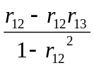
This model would be empirically under-identified if r₁₂² = 1, making the denominator zero, commonly called perfect multicollinearity.
This example illustrates a defining feature of empirical under-identification: When the knowns are entered into the solution for the unknown, the equation is mathematically undefined. In the example, the denominator of an estimate of an unknown is equal to zero, which is typical of most empirical under-identifications. Another example is presented earlier in Figure 2. An estimate of a factor loading would be undefined when one of the correlations between the three indicators was zero because the denominator of one of the estimates of the loadings equals zero.
The solution can also be mathematically undefined for other reasons. Consider again the model in Figure 2 and r₁₂r₁₃r₂₃ < 0; that is, either one or three of the correlations are negative. When this is the case the estimate of the loading squared equals a negative number which would mean that the loading was imaginary. (Note that if we estimated a single-factor model by fixing the latent variance to one and one or three of the correlations are negative, we would find a non-zero χ² with zero degrees of freedom.)
Empirical under-identification can occur in many situations, some of which are unexpected. One example of an empirically under-identified model is a model with two latent variables, each with two indicators, with the correlation between factors equal to zero (Kenny et al., 1998). A second example of an empirically under-identified model is the multitrait-multimethod matrix with equal loadings (Kenny & Kashy, 1992). What is perhaps odd about both of these examples is that a simpler model (the model with a zero correlation or a model with equal loadings) is not identified, whereas the more complicated model (the model with a correlation between factors or model with unequal loadings) is identified.
Another example of empirical under-identification occurs for instrumental variable estimation. Consider the model in Figure 4. If the path from Job Stress to Job Satisfaction were zero, then the estimate of the path from Job to Family Satisfaction would be empirically under-identified; correspondingly, if the path from Family Stress to Family Satisfaction were zero, then the estimate of the path from Family to Job Satisfaction would be empirically under-identified.
There are several indications that a parameter is empirically under-identified. Sometimes, the computer program indicates that the model is not identified. Other times, the model does not converge. Finally, the program might run but produce wild estimates with huge standard errors.
Just-Identified Models That Do Not Fit Perfectly
A feature of just-identified models is that the model estimates can be used to reproduce the knowns exactly: The chi square should equal zero. However, some just-identified models fail to reproduce exactly the knowns. Consider the model in Figure 1. If the researcher were to add an inequality constraint that all paths were positive, but one or more of the paths was actually negative, then the model would be unable to exactly reproduce the knowns and the chi square value would be greater than zero with zero degrees of freedom. Thus, not all just-identified models result in perfect fit.
What to Do with Under-identified Models?
There is very little discussion in the literature about under-identified models. The usual strategy is to reduce the number of parameters to make the model identified. Here we discuss some other strategies for dealing with an under-identified model.
In some cases, the model can become identified if the researcher can measure more variables of a particular type. This strategy works well for multiple indicator models: If one does not have an identified model with two indicators of a latent variable, perhaps because their errors must be correlated, one can achieve identification by obtaining another indicator of the latent construct. Of course, that indicator needs to be a good indicator. Also for some models, adding an instrumental variable can help. Finally, for some longitudinal models, adding another wave of data helps. Of course, if the data were already collected, it can be difficult to find another variable.
Design features can also be used to identify models. For example, if units are randomly assigned to levels of a causal variable, then it can be assumed that the disturbance of the outcome variable is uncorrelated with that causal variable. Another design feature is the timing of measurement: We do not allow a variable to cause another variable that was measured earlier in time.
Although a model is under-identified, it is still possible to estimate the model. Some of the parameters are under-identified and there are a range of possible solutions. Other parameters may be identified. Finally, the model may have a restriction as in Figure 8. Let q be the number of unknowns minus the number of knowns and the number of independent restrictions. To be able to estimate an under-identified model, the user must fix q under-identified parameters to a possible value. It may take some trial and error determining which parameters are under-identified and what is a possible value for that parameter. As an example of possible values, assume that a model has two variables correlated .5 and both are indicators of a standardized latent variable. Assuming positive loadings, the range of possible values for the standardized loading is from 0.5 to 1.0. It is important to realize that choosing a different value to fix an under-identified parameter likely affects the estimates of the other parameter estimates. A wiser strategy is what has been called a sensitivity analysis.
A sensitivity analysis involves fixing parameters that would be under-identified to a range of plausible values and seeing what happens to the other parameters in the model. Mauro (1990) described this strategy for omitted variables, but unfortunately his suggestions have gone largely unheeded. For example, sensitivity analysis might be used to determine the effects of measurement error. Consider a simple mediational model in which variable M mediates the X to Y relationship. If we allow for measurement error in M, the model is not identified. However, we could estimate the causal effects assuming that that the reliability of M ranges from some plausible interval, from say .6 to .9 and note the size of direct and indirect effects of X on Y for that interval. For an example, see the example in Chapter 5 of Bollen (1989).
Researchers need to be creative in identifying otherwise under-identified models. For instance, one idea is to use multiple group models to identify an otherwise under-identified model. If we have a model that is under-identified, we might try to think of a situation or condition in which the model would be identified. For instance, X₁ and X₂ might ordinarily have a reciprocal relationship. The researcher might be able to think of a situation in which the relationship runs only from X₁ to X₂. So there are two groups, one being a situation in which the causation is unidirectional and another in which the causation is bidirectional. A related strategy is used in the behavior genetics literature where a model of genetic and environmental influences is under-identified with one group, but is not when there are multiple groups of siblings, monozygotic twins, and dizygotic twins (Neale, 2009).
Conclusions
Although we have covered many topics, there are several key topics we have not covered. We do not cover nonparametric identification (Pearl, 2009) or cases in which a model becomes identified through assumptions about the distribution of variables (e.g., normality). Among those are models with latent products or squared latent variables, and models that are identified by assuming there is an unmeasured truncated normally distributed variable (Heckman, 1979). We also did not cover identification of latent class models, and refer the reader to Magidson and Vermunt (2004) and Muthén (2002) for a discussion of those issues. Also not discussed is identification in mixture modeling. In these models, the researcher specifies some model with the assumption that different subgroups in the sample will have different parameter values (i.e., the set of relationships between variables in the model differs by subgroup). Conceptualized this way, mixture modeling is similar to multi-group tests of moderation, except that the grouping variable itself is latent. In mixture modeling, in practice, if the specified model is identified when estimated for the whole sample, it should be identified in the mixture model. However, the number of groups that can be extracted may be limited, and researchers may confront convergence problems with more complex models.
We have assumed that sample sizes are reasonably large. With small samples, problems that seem like identification problems can appear. A simple example is that of having a path analysis in which there are more causes than cases, which results in colinearity. Also models that are radically misspecified can appear to be under-identified. For instance, if one has over-time data with several measures and estimates a multitrait-multimethod matrix model when the correct model is a multivariate growth curve model, one might well have considerable difficulty identifying the wrong model.
As stated before, SEM works well with models that are either just- or over-identified and are not empirically under-identified. However, for models that are under-identified, either in principle or empirically, SEM programs are not very helpful. We believe that it would be beneficial for computer programs to be able do the following: First, for models that are under-identified, provide estimates and standard errors of identified parameters, the range of possible values for under-identified parameters, and tests of restrictions if there are any. Second, for over-identified models, the program would give specific information about tests of restrictions. For instance, for hybrid models, it would separately evaluate the over-identifying restrictions of the measurement model and the structural model. Third, SEM programs should have an option by which the researcher specifies the model and is given advice about the status of the identification of the model. In this way, the researcher can better plan to collect data for which the model is identified.
Researchers need a practical tool to help them determining the identification status of their models. Although there is not currently a method to unambiguously determine the identification status of the model, researchers can be provided with feedback using the rules described and cited in this chapter.
We hope we have shed some light on what is for many a challenging and difficult topic. We hope that others will continue work on this topic, especially more work on how to handle under-identified models.
References
Bekker, P.A., Merckens, A., & Wansbeek, T. (1994). Identification, equivalent models, and computer algebra. American Educational Research Journal, 15, 81-97.
Bollen, K. A. (1989). Structural equation models with latent variables. Hoboken, NJ: Wiley-Interscience.
Bollen, K. A., & Bauldry, S. (2010). Model identification and computer algebra. Sociological Methods & Research, 39, 127-156.
Bollen, K. A., & Curran, P. J. (2004). Autoregressive latent trajectory (ALT) models: A synthesis of two traditions. Sociological Methods and Research, 32, 336-383.
Bollen, K. A., & Curran, P. (2006). Latent curve models: A structural equation perspective. Hoboken, NJ: Wiley-Interscience.
Bollen, K. A., & Davis, W. R. (2009). Two rules of identification for Structural Equation Models. Structural Equation Modeling, 16, 523-36.
Bollen K., & Lennox R. (1991). Conventional wisdom on measurement: A structural equation perspective. Psychological Bulletin, 110, 305-314.
Bollen, K.A, & Ting, K. (1993). Confirmatory tetrad analysis. In P.M.
Marsden (Ed.) Sociological Methodology 1993 (pp. 147-175). Washington, D.C.: American Sociological Association
Brito, C., & Pearl, J. (2002). A new identification condition for recursive models with correlated errors. Structural Equation Modeling, 9, 459-474.
Costner, H. L. (1969). Theory, deduction, and rules of correspondence. American Journal of Sociology, 75, 245-263.
Frone, M. R., Russell, M., & Cooper, M. L. (1994). Relationship between job and family satisfaction: Causal or noncausal covariation? Journal of Management, 20, 565-579.
Goldberger, A. S. (1973). Efficient estimation in over-identified models: An interpretive analysis. In A. S. Goldberger & O. D. Duncan (Eds.), Structural Equation Models in the social sciences (pp. 131-152). New York: Academic Press.
Hayashi, K., & Marcoulides, G. A. (2006). Examining identification issues in factor analysis. Structural Equation Modeling, 10, 631-645.

Heckman, J. (1979). Sample selection bias as a specification error. Econometrica, 47, 153–61.
Kenny, D. A. (1975). Cross-lagged panel correlation: A test for spuriousness. Psychological Bulletin, 82, 887-903.
Kenny, D. A. (1979). Correlation and causality. New York: Wiley-Interscience.
Kenny, D. A., & Kashy, D. A. (1992). Analysis of multitrait-multimethod matrix by confirmatory factor analysis. Psychological Bulletin, 112, 165-172.
Kenny, D. A., Kashy, D. A., & Bolger, N. (1998). Data analysis in social psychology. In D. Gilbert, S. Fiske & G. Lindsey (Eds.), Handbook of social psychology (4th ed., Vol. 1, pp. 233-265). Boston: McGraw-Hill.
Kline, R. B. (2004). Principles and practice of structural equation modeling (2nd ed.). New York: Guilford Press.
Meredith, W., & Tisak, J. (1990). Latent curve analysis. Psychometrika, 55, 107-122.
Mauro, R. (1990). Understanding L.O.V.E. (left out variables error): A method for estimating the effects of omitted variables. Psychological Bulletin, 108, 314-329.
Magidson, J., & Vermunt, J. (2004). Latent class models. In D. Kaplan (Ed.), The Sage handbook of quantitative methodology for the social sciences (pp. 175-198). Thousand Oaks CA: Sage.
McArdle J. J., & Hamagami, F. (2001). Linear dynamic analyses of incomplete longitudinal data. In Collins L, & Sayer A. (Eds.), New methods for the analysis of change, pp. 139–175. Washington, DC: American Psychological Association.
Muthén, B. (2002). Beyond SEM: General latent variable modeling. Behaviormetrika, 29, 81-117.
Neale, M. (2009). Biometrical models in behavioral genetics. In Y. Kim (Ed.), Handbook of behavior genetics (pp. 15-33). New York: Springer Science.
O'Brien, R. (1994). Identification of simple measurement models with multiple latent variables and correlated errors. In P. Marsden (Ed.), Sociological Methodology, pp. 137-170). Cambridge UK: Blackwell.
Pearl, J. (209). Causality: Models, reasoning, and inference (2nd ed.). New York: Cambridge University Press.
Rigdon, E. E. (1995). A necessary and sufficient identification rule for structural models estimated in practice. Multivariate Behavioral Research, 30, 359-383.

Figure 1
Simple Three-variable Path Analysis Model
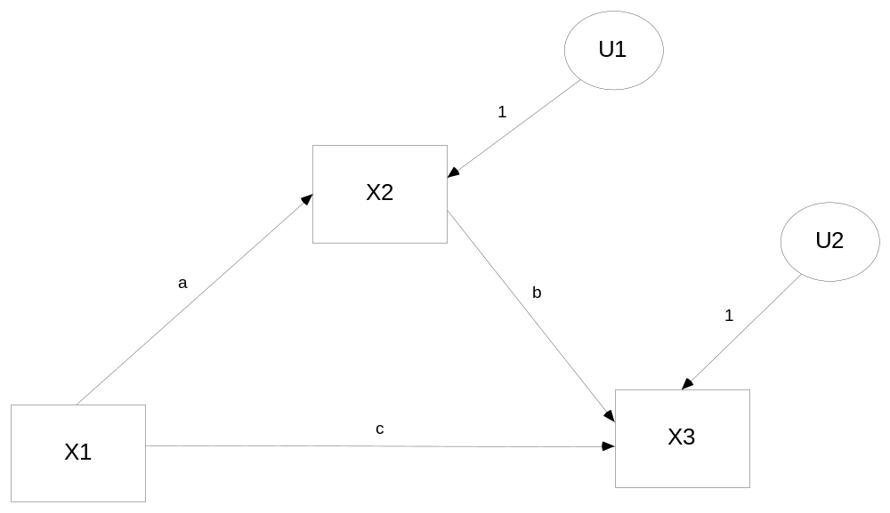
Figure 2
Simple Three Variable Latent Variable Model (Latent Variable Standardized)
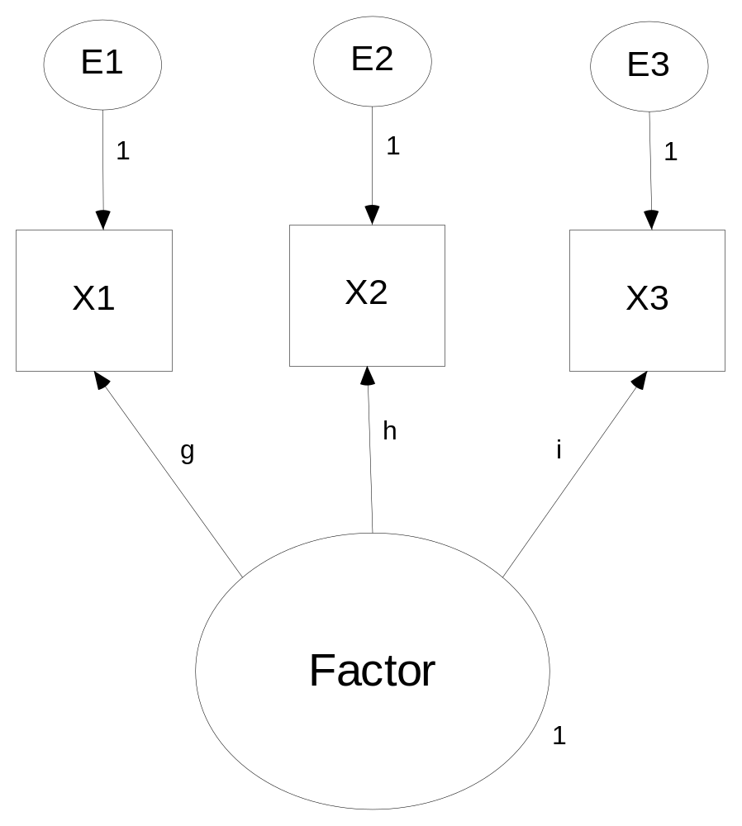
Figure 3
Identified Path Model with Four Omitted Paths
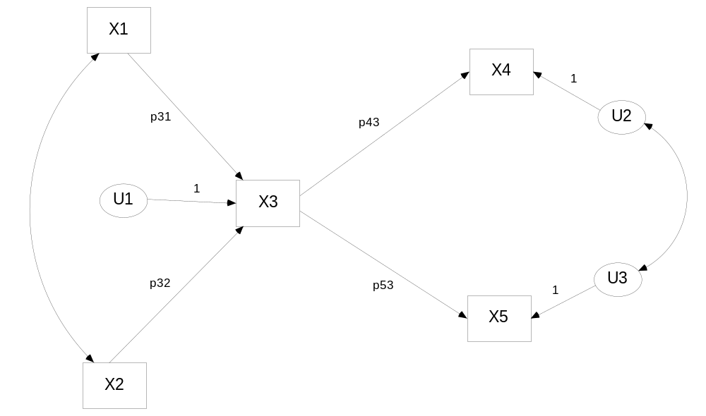

Figure 4
Feedback Model for Satisfaction with Stress as an Instrumental Variable
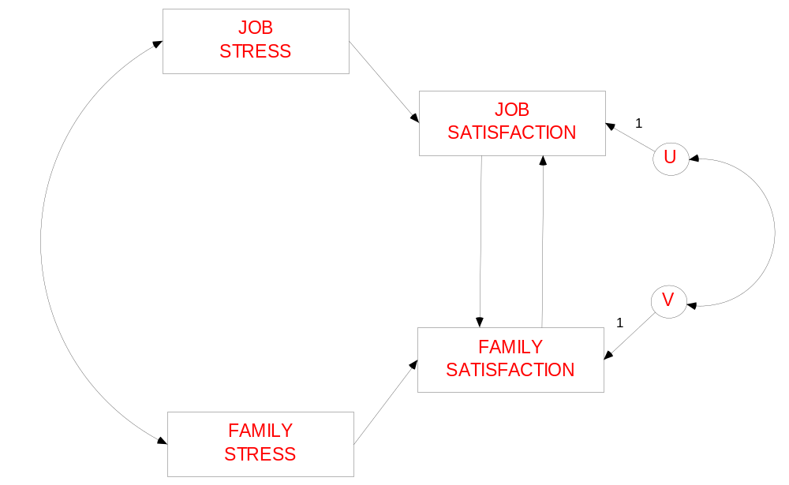
Figure 5
Example of Omitted Variable

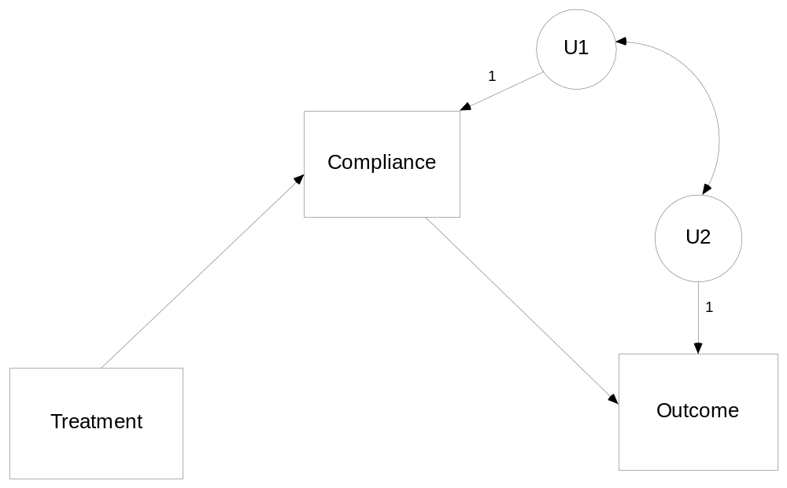
Figure 6
Two variables measured at four times with autoregressive effects
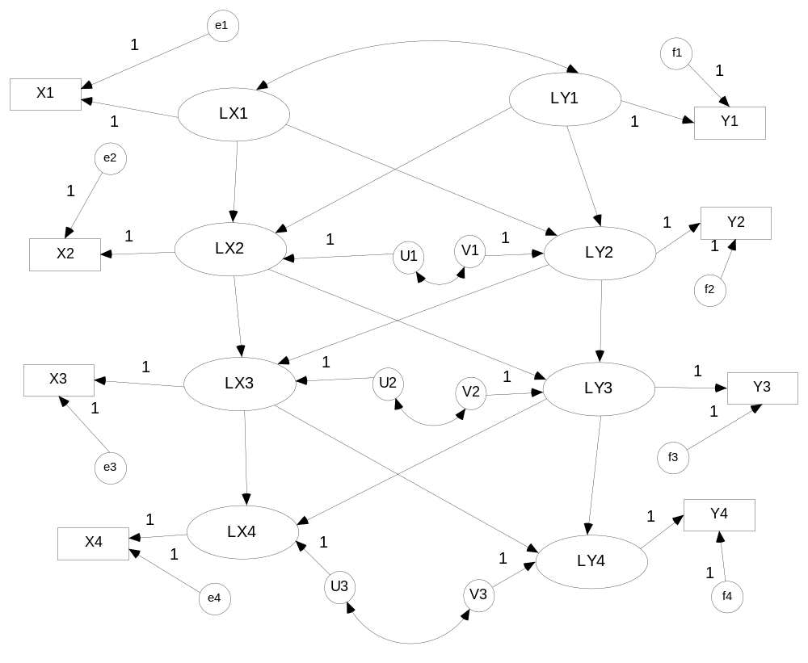
Figure 7
Latent Growth Model

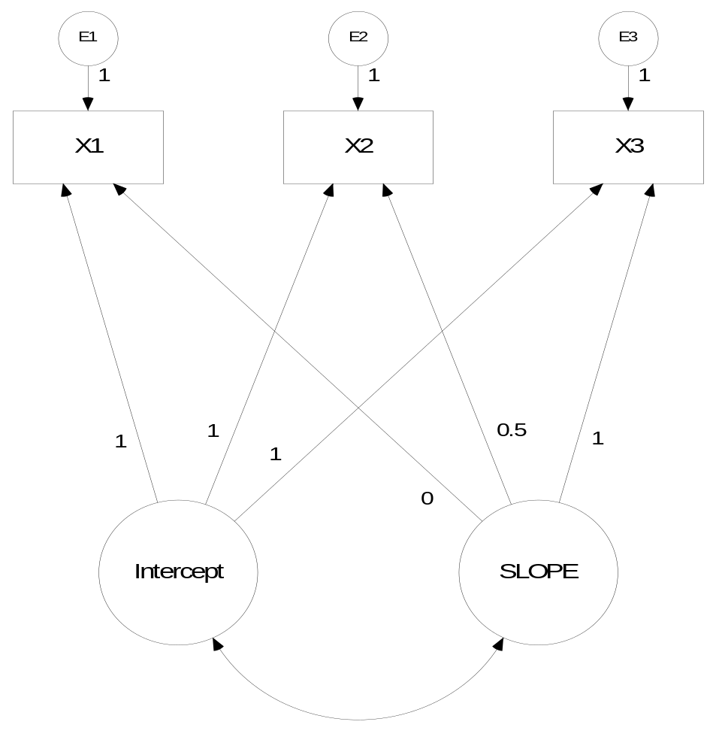
Figure 8
Model that Meets the Minimum Condition of Identifiability, but Is Not Identified Because of Restrictions
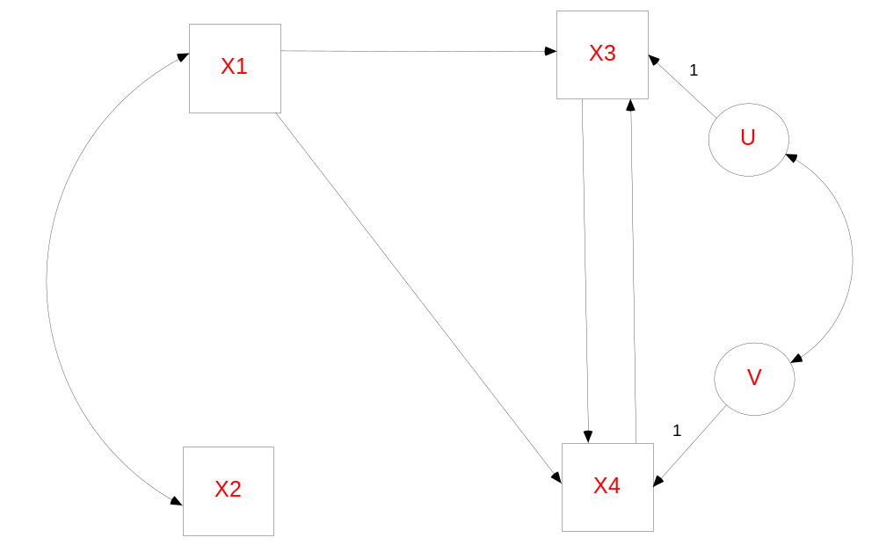
Figure 9
Model that Meets the Minimum Condition of Identifiability, with Some Parameters Identified and Others Over-Identified

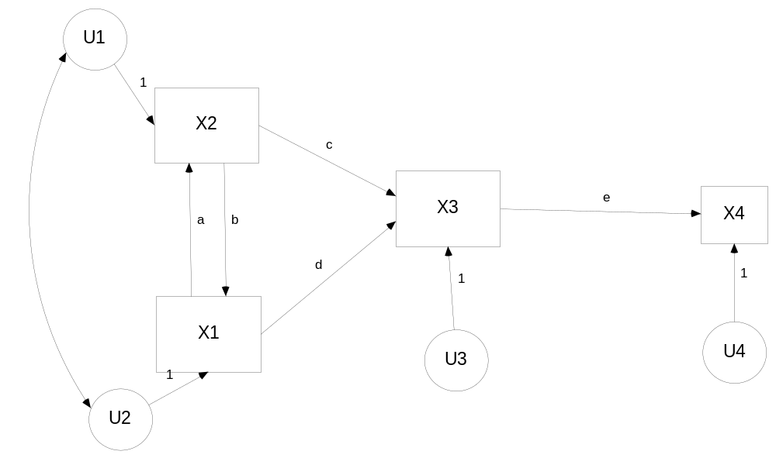
Figure 10
Model in Which Does Not Meet the Minimum Condition of Identifiability but a Standardized Stability Path Is Identified
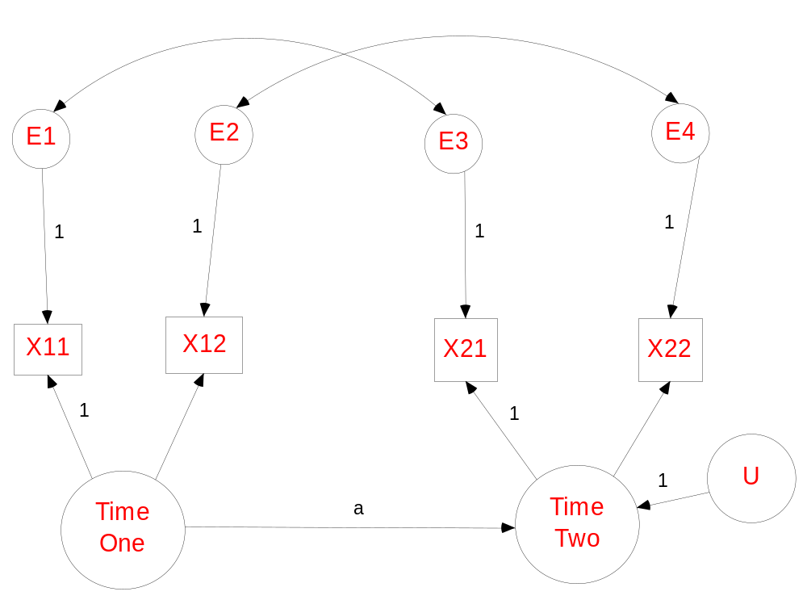
Figure 11
Latent Growth Curve Model with Exogenous Variables with Some of the Parameters Identified and Others Are Not
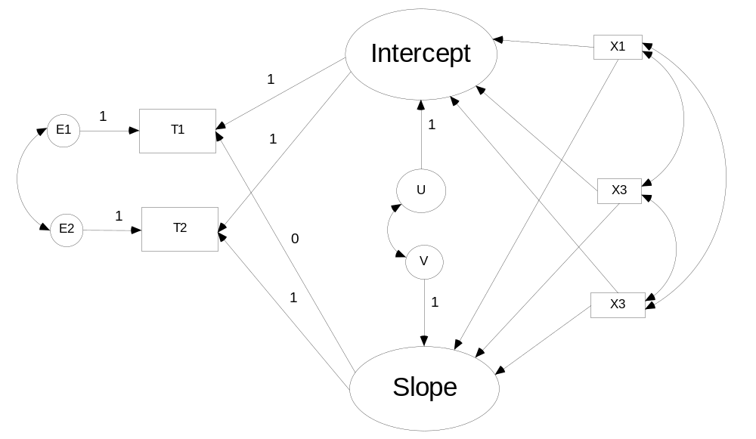
Footnotes

Here and elsewhere, we use the symbol “r” for correlation and “s” for variance or covariance, even if when we are discussing a population correlation which is typically denoted as “ρ” and population variance or covariance which is usually symbolized by “σ.”
The astute reader may have noticed that because the parameter is squared, there is not a unique solution for f, g, and h, because we can take either the positive or negative square root.
?Although there are two estimates, the “best” estimate statistically is the first (Goldberger, 1973).
?One could create a hypothetical variance-covariance matrix before one gathered the data, analyze it, and then see if model runs. This strategy, though helpful, is still problematic as empirical under-identification might occur with the hypothetical data, but not with the real data.
?To accomplish this in Amos, go to “Analysis Properties, Numerical” and check “Try to fit underidentified models.”
?If we use the conventional marker variable approach, the estimation of this model does not converge on a solution.

