Effect Size Heterogeneity: Main Analysis

Focal Effect Size (a)
We decomposed the focal interaction effects into two simple effects: victims (contrast 1 - “victims need empowerment than acceptance”) and perpetrators (contrast 2 - “perpetrators need acceptance than empowerment”). All effects were converted into Hedges’ g (SMD) and its corresponding sampling variances (vi) were also calculated. Below are the descriptive statistics of contrast 1: victims:
vars n mean sd median trimmed mad min max range skew kurtosis se
X1 1 16 -0.01 0.24 -0.01 0 0.22 -0.48 0.38 0.86 -0.09 -0.97 0.06
…and here are the descriptive statistics of contrast 2: perpetrators:
vars n mean sd median trimmed mad min max range skew kurtosis se
X1 1 16 0.1 0.24 0.11 0.09 0.26 -0.23 0.61 0.84 0.29 -0.87 0.06

Construct Validity of Experimental Manipulations (b)
In Study 4 of Shnabel and Nadler’s (2008) paper, there are two manipulations, so we have two bs: b₁ = role (victim vs. perpetrators) and b₂ = message (empowerment vs. acceptance). b here is defined as the absolute difference in manipulation success between the RP:P study and the ML5 study. Larger bs indicate that the manipulation in that specific site of ML5 worked more differently than the original RP:P. b is expressed in Hedges’ g unit.
Below is the descriptive statistics of b₁ (role):
vars n mean sd median trimmed mad min max range skew kurtosis se
X1 1 16 0.6 0.26 0.69 0.61 0.29 0.14 0.92 0.77 -0.33 -1.53 0.07
Averagely, the role manipulation in ML5 sites worked moderately different than RP:P (M = 0.601375).
Below is the descriptive statistics of b₂ (message):
vars n mean sd median trimmed mad min max range skew kurtosis se
X1 1 16 0.38 0.34 0.29 0.33 0.13 0.07 1.43 1.35 1.86 2.88 0.09
For message, the manipulation in ML5 sites were slightly to moderately different than the original RP:P study (M = 0.381375).

Measurement Invariance of the Outcome Measure (d)
We also calculated measurement invariance of the outcome measure by running a differential item functioning (DIF) analysis comparing the RP:P with ML5. Since ML5 implemented two protocols (RP:P and Revised protocols) and therefore applied different wording to the outcome measure, we ran DIF analysis for each protocol separately. d is defined as the absolute value of expected test score standardized differences (ETSSD), where the original RP:P sample was treated as the Reference group, while ML5 sites were the Focal groups. The magnitude can be interpreted using Cohen’s d guidelines (small ≈ 0.2, medium ≈ 0.5, large ≈ 0.8).

RP:P Protocol
On average, DIF causes participants in 8 replication sites with the RP:P protocol to score about one-third of a standard deviation different (M_{ETSSD} = 0.3662235) from participants in the RP:P study.

Revised Protocol
Averagely, participants’ observed test scores in ML5 with the Revised protocol differ by almost half of a standard deviation (M_{ETSSD} = 0.4748659) from participants in the RP:P study. One site (Western Kentucky University) has sparse data so we cannot calculate the ETSSD

Measurement Error (e)
e is defined as the absolute differences of marginal reliability ($ρ_{θ}$) between the scale used in the original RP:P study and the one used in ML5 sites. A larger value of e indicates that the amount of measurement error of the outcome measure at that specific ML5 replication site is more different from the one in RP:P study.
In general, the outcome measure used in the RP:P study and all ML5 sites showed high reliability, with very small variance (M = 0.9403102, SD = 0.006428), so differences in marginal reliability between RP:P and ML5 sites were also very small (M_{e} = 0.0048437).

Meta-Regression

Contrast 1: victims need more empowerment than acceptance
We ran a meta-analysis here:
ma_contrast1 <- metafor::rma(yi_contrast1, # effect sizes victims
vi_contrast1, # sampling variability
method="REML", slab=labels, data = ds_meta)
summary(ma_contrast1)
Random-Effects Model (k = 16; tau^2 estimator: REML)
logLik deviance AIC BIC AICc
0.4565 -0.9130 3.0870 4.5031 4.0870
tau^2 (estimated amount of total heterogeneity): 0.0025 (SE = 0.0173)
tau (square root of estimated tau^2 value): 0.0504
I^2 (total heterogeneity / total variability): 5.15%
H^2 (total variability / sampling variability): 1.05
Test for Heterogeneity:
Q(df = 15) = 16.4422, p-val = 0.3533
Model Results:
estimate se zval pval ci.lb ci.ub
0.0104 0.0555 0.1874 0.8514 -0.0984 0.1192
---
Signif. codes: 0 '***' 0.001 '**' 0.01 '*' 0.05 '.' 0.1 ' ' 1
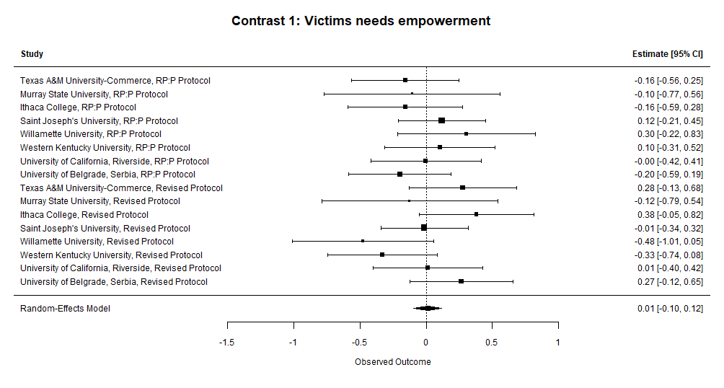
Here we can see that, after taking account for sampling variability, effect size heterogeneity was small (I² = 5.15%) and the pooled effect size was very close to zero.

ma_contrast1_mods <- metafor::rma(yi_contrast1, # effect size victims
vi_contrast1, # sampling variability
mods = ~ protocol_factor, # adding protocol types (0=RPP, 1=Revised) as moderator
method="REML", data = ds_meta)
summary(ma_contrast1_mods)
Mixed-Effects Model (k = 16; tau^2 estimator: REML)
logLik deviance AIC BIC AICc
-0.0328 0.0656 6.0656 7.9827 8.4656
tau^2 (estimated amount of residual heterogeneity): 0.0057 (SE = 0.0194)
tau (square root of estimated tau^2 value): 0.0755
I^2 (residual heterogeneity / unaccounted variability): 10.77%
H^2 (unaccounted variability / sampling variability): 1.12
R^2 (amount of heterogeneity accounted for): 0.00%
Test for Residual Heterogeneity:
QE(df = 14) = 16.2582, p-val = 0.2979
Test of Moderators (coefficient 2):
QM(df = 1) = 0.1506, p-val = 0.6980
Model Results:
estimate se zval pval ci.lb ci.ub
intrcpt -0.0126 0.0812 -0.1552 0.8767 -0.1718 0.1466
protocol_factor 0.0446 0.1149 0.3880 0.6980 -0.1806 0.2698
---
Signif. codes: 0 '***' 0.001 '**' 0.01 '*' 0.05 '.' 0.1 ' ' 1
As we see here, protocol types didn’t significantly moderate the effect size. Heterogeneity was still low.

ma_contrast1_mods <- metafor::rma(yi_contrast1, # effect size victims
vi_contrast1, # sampling variability
mods = ~ protocol_factor + # protocol types
b1_diff_rpp + # b1 - role manipulation effectiveness
b2_diff_rpp + # b2 - message manipulation effectiveness
etssd + # measurement invariance
path_e, # e - reliability differences
method="REML", data = ds_meta)
Warning: 1 study with NAs omitted from model fitting.
summary(ma_contrast1_mods)
Mixed-Effects Model (k = 15; tau^2 estimator: REML)
logLik deviance AIC BIC AICc
-0.1272 0.2544 14.2544 15.6349 126.2544
tau^2 (estimated amount of residual heterogeneity): 0.0084 (SE = 0.0258)
tau (square root of estimated tau^2 value): 0.0914
I^2 (residual heterogeneity / unaccounted variability): 14.94%
H^2 (unaccounted variability / sampling variability): 1.18
R^2 (amount of heterogeneity accounted for): 0.00%
Test for Residual Heterogeneity:
QE(df = 9) = 10.8335, p-val = 0.2873
Test of Moderators (coefficients 2:6):
QM(df = 5) = 2.4684, p-val = 0.7813
Model Results:
estimate se zval pval ci.lb ci.ub
intrcpt 0.0230 0.2534 0.0907 0.9277 -0.4736 0.5196
protocol_factor 0.0992 0.1537 0.6456 0.5186 -0.2020 0.4005
b1_diff_rpp 0.1043 0.2941 0.3546 0.7229 -0.4722 0.6807
b2_diff_rpp -0.2223 0.2920 -0.7613 0.4465 -0.7945 0.3500
etssd -0.0622 0.5011 -0.1241 0.9012 -1.0444 0.9200
path_e 0.5779 19.4468 0.0297 0.9763 -37.5371 38.6930
---
Signif. codes: 0 '***' 0.001 '**' 0.01 '*' 0.05 '.' 0.1 ' ' 1
None of the contextual effects were significant.

Contrast 2: Perpetrators need more acceptance than empowerment
We ran a meta-analysis here:
ma_contrast2 <- metafor::rma(yi_contrast2, # effect size perpetrator
vi_contrast2, # sampling variability
method="REML", slab=labels, data = ds_meta)
summary(ma_contrast2)
Random-Effects Model (k = 16; tau^2 estimator: REML)
logLik deviance AIC BIC AICc
-0.5260 1.0520 5.0520 6.4681 6.0520
tau^2 (estimated amount of total heterogeneity): 0.0162 (SE = 0.0228)
tau (square root of estimated tau^2 value): 0.1272
I^2 (total heterogeneity / total variability): 25.67%
H^2 (total variability / sampling variability): 1.35
Test for Heterogeneity:
Q(df = 15) = 19.2822, p-val = 0.2012
Model Results:
estimate se zval pval ci.lb ci.ub
0.0967 0.0633 1.5273 0.1267 -0.0274 0.2207
---
Signif. codes: 0 '***' 0.001 '**' 0.01 '*' 0.05 '.' 0.1 ' ' 1
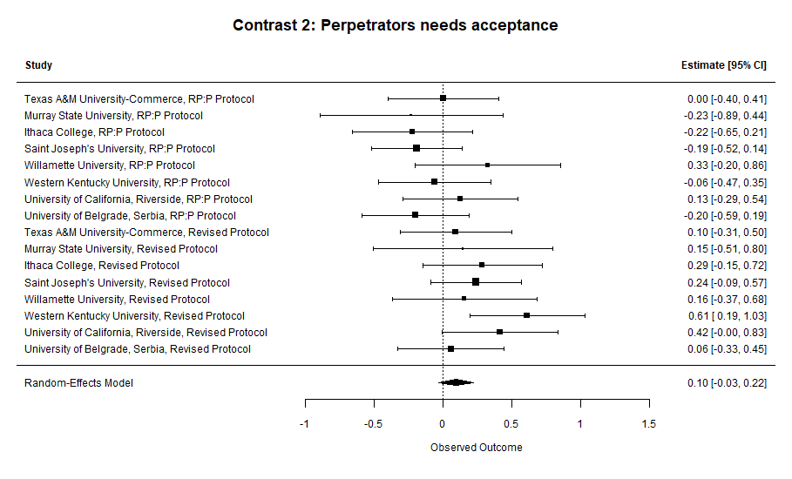
After taking account for sampling variability, the pooled effect size was a bit larger than the victims effect, even though the 95% CI still includes zero. Heterogeneity, though, was moderate (I² = 25.67%).
ma_contrast2_mods <- metafor::rma(yi_contrast2, # effect size victims
vi_contrast2, # sampling variability
mods = ~ protocol_factor, # adding protocol types (0=RPP, 1=Revised) as moderator
method="REML", slab=labels, data = ds_meta)
summary(ma_contrast2_mods)
Mixed-Effects Model (k = 16; tau^2 estimator: REML)
logLik deviance AIC BIC AICc
3.0603 -6.1205 -0.1205 1.7967 2.2795
tau^2 (estimated amount of residual heterogeneity): 0 (SE = 0.0170)
tau (square root of estimated tau^2 value): 0
I^2 (residual heterogeneity / unaccounted variability): 0.00%
H^2 (unaccounted variability / sampling variability): 1.00
R^2 (amount of heterogeneity accounted for): 100.00%
Test for Residual Heterogeneity:
QE(df = 14) = 10.0106, p-val = 0.7614
Test of Moderators (coefficient 2):
QM(df = 1) = 9.2717, p-val = 0.0023
Model Results:
estimate se zval pval ci.lb ci.ub
intrcpt -0.0699 0.0761 -0.9192 0.3580 -0.2190 0.0792
protocol_factor 0.3282 0.1078 3.0449 0.0023 0.1169 0.5394 **
---
Signif. codes: 0 '***' 0.001 '**' 0.01 '*' 0.05 '.' 0.1 ' ' 1
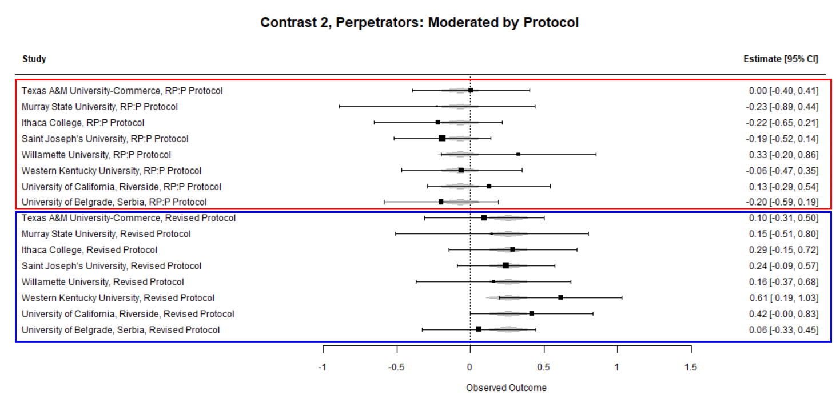
Protocol type significantly moderated the effect size (B = 0.32, p = .002) and explained the heterogeneity by 100% (R² = 100%). We can see in the forest plot that studies using RP:P protocol led to more variable effect sizes, but studies with the Revised protocol were consistently positive.

ma_contrast2_mods <- rma(yi_contrast2, # effect size perpetrators
vi_contrast2, # sampling variability
mods = ~ protocol_factor + # protocol type
b1_diff_rpp + # role manipulation effectiveness
b2_diff_rpp + # message manipulation effectiveness
etssd + # measurement invariance
path_e, # diff in reliability
method="REML", data = ds_meta)
Warning: 1 study with NAs omitted from model fitting.
summary(ma_contrast2_mods)
Mixed-Effects Model (k = 15; tau^2 estimator: REML)
logLik deviance AIC BIC AICc
2.5875 -5.1751 8.8249 10.2055 120.8249
tau^2 (estimated amount of residual heterogeneity): 0 (SE = 0.0216)
tau (square root of estimated tau^2 value): 0
I^2 (residual heterogeneity / unaccounted variability): 0.00%
H^2 (unaccounted variability / sampling variability): 1.00
R^2 (amount of heterogeneity accounted for): 100.00%
Test for Residual Heterogeneity:
QE(df = 9) = 5.2760, p-val = 0.8096
Test of Moderators (coefficients 2:6):
QM(df = 5) = 7.6728, p-val = 0.1752
Model Results:
estimate se zval pval ci.lb ci.ub
intrcpt -0.2706 0.2294 -1.1795 0.2382 -0.7202 0.1790
protocol_factor 0.2074 0.1401 1.4805 0.1387 -0.0672 0.4821
b1_diff_rpp 0.1509 0.2688 0.5613 0.5746 -0.3760 0.6778
b2_diff_rpp 0.1760 0.2689 0.6544 0.5129 -0.3511 0.7030
etssd 0.0011 0.4576 0.0024 0.9981 -0.8957 0.8979
path_e 20.3962 18.0517 1.1299 0.2585 -14.9844 55.7769
---
Signif. codes: 0 '***' 0.001 '**' 0.01 '*' 0.05 '.' 0.1 ' ' 1
None of the conceptually irrelevant context effects significantly moderated the effect sizes.

We specified an interaction term between protocol type and the absolute difference of role manipulation effectiveness (b₁).
# Interaction 1: Protocol × Role Manipulation (b1)
ma_c2_protocol_x_b1 <- metafor::rma(yi_contrast2, # effect size perpetrators
vi_contrast2, # sampling variability
mods = ~ protocol_factor * b1_diff_rpp, # interaction
method = "REML", data = ds_meta)
summary(ma_c2_protocol_x_b1)
Mixed-Effects Model (k = 16; tau^2 estimator: REML)
logLik deviance AIC BIC AICc
2.4605 -4.9210 5.0790 7.5035 15.0790
tau^2 (estimated amount of residual heterogeneity): 0 (SE = 0.0185)
tau (square root of estimated tau^2 value): 0
I^2 (residual heterogeneity / unaccounted variability): 0.00%
H^2 (unaccounted variability / sampling variability): 1.00
R^2 (amount of heterogeneity accounted for): 100.00%
Test for Residual Heterogeneity:
QE(df = 12) = 8.9547, p-val = 0.7068
Test of Moderators (coefficients 2:4):
QM(df = 3) = 10.3275, p-val = 0.0160
Model Results:
estimate se zval pval ci.lb ci.ub
intrcpt -0.0106 0.1822 -0.0582 0.9536 -0.3677 0.3464
protocol_factor 0.0156 0.3289 0.0475 0.9621 -0.6289 0.6602
b1_diff_rpp -0.1219 0.3400 -0.3584 0.7200 -0.7883 0.5445
protocol_factor:b1_diff_rpp 0.4724 0.4981 0.9484 0.3429 -0.5038 1.4486
intrcpt
protocol_factor
b1_diff_rpp
protocol_factor:b1_diff_rpp
---
Signif. codes: 0 '***' 0.001 '**' 0.01 '*' 0.05 '.' 0.1 ' ' 1
The interaction term wasn’t significant (B = 0.472, p = .342) perhaps due to low power, BUT QM statistics were significant (QM(3) = 10.32, p = .016), meaning that collectively the moderators as a set suggestively predicted the effect sizes.
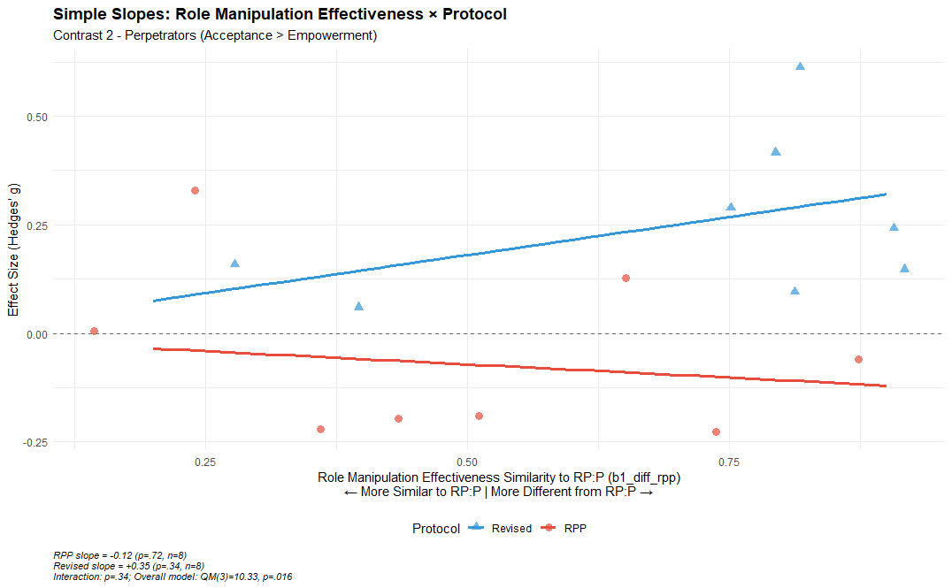
The ML5 sites with RP:P protocol (workplace) shows the expected pattern where closer manipulation success to the original RP:P study suggestively led to larger effects, which makes sense as they are using the same workplace scenario, so in this case, manipulation fidelity (specifically for role) appears beneficial.
For the Revised protocol (roommate), the ML5 sites with manipulation effectiveness more different from the RP:P study showed numerically larger effect sizes.

At last, we specified an interaction term between protocol type and the absolute difference of message manipulation effectiveness (b₂).
# Interaction 2: Protocol × Message Manipulation (b2)
ma_c2_protocol_x_b2 <- metafor::rma(yi_contrast2, # effect size perpetrators
vi_contrast2, # sampling variability
mods = ~ protocol_factor * b2_diff_rpp, # interaction
method = "REML", data = ds_meta)
summary(ma_c2_protocol_x_b2)
Mixed-Effects Model (k = 16; tau^2 estimator: REML)
logLik deviance AIC BIC AICc
2.1225 -4.2449 5.7551 8.1796 15.7551
tau^2 (estimated amount of residual heterogeneity): 0 (SE = 0.0183)
tau (square root of estimated tau^2 value): 0
I^2 (residual heterogeneity / unaccounted variability): 0.00%
H^2 (unaccounted variability / sampling variability): 1.00
R^2 (amount of heterogeneity accounted for): 100.00%
Test for Residual Heterogeneity:
QE(df = 12) = 9.6235, p-val = 0.6490
Test of Moderators (coefficients 2:4):
QM(df = 3) = 9.6587, p-val = 0.0217
Model Results:
estimate se zval pval ci.lb ci.ub
intrcpt -0.1027 0.3580 -0.2869 0.7742 -0.8043 0.5989
protocol_factor 0.3142 0.3738 0.8406 0.4006 -0.4184 1.0469
b2_diff_rpp 0.1083 1.1562 0.0936 0.9254 -2.1579 2.3745
protocol_factor:b2_diff_rpp 0.0088 1.1718 0.0075 0.9940 -2.2879 2.3055
intrcpt
protocol_factor
b2_diff_rpp
protocol_factor:b2_diff_rpp
---
Signif. codes: 0 '***' 0.001 '**' 0.01 '*' 0.05 '.' 0.1 ' ' 1
QM statistics were also significant (QM(3) = 9.65, p = .021) but interaction term wasn’t significant with small slopes (B = 0.008, p = .994), so probably nothing meaningful here.

