**VLearn - Virtual Reality based solution for children with learning disabilities and slow learners**

Shriram K. Vasudevan*

Department of Computer Science and Engineering,

Amrita School of Engineering, Coimbatore,

Amrita Vishwa Vidyapeetham,

Amrita University, India

Email: kv_shriram@cb.amrita.edu

*Corresponding author

Pranav B, Saravanan G,

Merin K. John and Athira Sasidharan

Department of Computer Science and Engineering,

Amrita School of Engineering, Coimbatore,

Amrita Vishwa Vidyapeetham,

Amrita University, India

Email: pranav.b11@gmail.com

Email: srvnngtm@gmail.com

Email: maryjohn8991@gmail.com

Email: [athirasasidhar556@gmail.com](mailto:athirasasidhar556@gmail.com)

**Abstract**: Autism Spectrum Disorder (ASD) is a developmental disorder which can be characterized by social and communication impairments, slow learning, combined with limited interests and repetitive behaviors. It affects as many as one in 59 children and is more prevalent in boys with one in 38 diagnosed with Autism Spectrum Disorder. But due to the social stigma associated with mental health and psychological issues, especially in countries like India, most cases go unreported or symptoms ignored. This project is an attempt to help address this issue by providing a means to assist in diagnosing ASD using telemedicine and also to provide an interactive and effective means of learning for children diagnosed with ASD or children with

slight learning disabilities. The system features games which have been proven to be effective with children diagnosed with ASD. Virtual reality which is being speculated to be a powerful tool in helping children with learning difficulties has been used to enhance the effectiveness of these games. The concept of dynamic difficulty is also integrated into the game in order to increase or decrease the challenge of each level depending on the performance of the child which further increases the effectiveness of the game.

**Keywords**: Autism, Slow Learners, Learning Difficulties, 3D, game, Virtual Reality, Hand Tracking, Interactive, Dynamic difficulty, Adaptive levels, Gesture detection, Leap Motion sensor

**1. Introduction**

Autism spectrum disorder impacts the nervous system and affects the overall cognitive, emotional, social and physical health of the affected individual. The range and severity of symptoms can vary widely. Common symptoms include difficulty with communication and learning, difficulty with social interactions, obsessive interests and repetitive behaviors. according to The Times of India it is estimated that 1 in 250 children in India are diagnosed with ASD and currently 10 million Indians are autistic. Current therapies in India which includes homeopathy, Ayurveda and Music Therapy. In addition to this there are a wide variety of Android and iOS applications that assist autistic children with communication. A good number of learning centers have faculty that is fully committed to helping these children.

**2. Literature Survey**

There has been a growing number of research work in the field of effective teaching methods for children with Autism spectrum disorders and other similar learning disorders. Many of the research shows reasonable success and the ones aligned with the specificities of our research work is presented here.

1. In this paper, solutions for communication development in children with ASD was given using an immersive virtual reality based application which utilises speech recognition for natural interaction. The results of the experiment showed improved performance with a computer augmented virtual environment than with a head mounted display. The results indicate that immersive VR proves to be more satisfactory when compared to traditional desktop applications for helping children with ASD.
2. This study investigates the effectiveness of virtual reality social recognition training in enhancing social skills of children with ASD. The metrics used to evaluate the effectiveness was emotional recognition, social attribution, attention and executive function. The results showed an improvement in emotional recognition, social attribution and executive function of analogical reasoning. This shows the effectiveness of Virtual Reality applications for helping improving social impairments in children with ASD.
3. In this study users communicated with avatars in a virtual reality environment in order to check its effectiveness to improve social interaction. The results showed that interactions with virtual avatars does translate to improvement in social interaction in real life.
4. In this article advantages of VR for individual for ASD was discussed along with identifying present challenges and general application design guidelines. It mostly explores the usefulness of VR platforms as a training tool for individuals with ASD and also talks about key gaps in the research currently going on as well as future research considerations.
5. This paper also discusses about the effectiveness of VR-based intervention in ASD. The study utilises clinical databases, web of science index, and Scimago Journal & Country Rank. The study suggests a moderate evidence for the effectiveness of VR based systems for treating children with ASD.
6. This study presents the effectiveness of Leap Motion based systems for treating children with ASD in a special school setting. The results of the application showed that the participants fine motor skills, their ability to recognise colours and fruits improved significantly.
7. This study assessed the effectiveness of gesture based applications for children with ASD. An application in order to increase engagement of children with ASD was designed and proved to be highly effective as well as commercially viable.

**2.1. Problem Statement**

We intend to develop an application to help children with conditions such as Autism Spectrum Disorder (ASD) to learn in a more effective way using Augmented and virtual reality which adapts it’s difficulty level in real time depending on the 1 performance of the child.

**2.2 Virtual Reality**

Virtual Reality is a computer generated environment which simulates 3 dimensional space. The VR world is made interactable in a realistic way using external hand held devices or sensors. Currently the 2 major standards for VR systems are head mounted displays or multi projected environments for an immersive experience.

Augmented Reality is a type of virtual reality which renders 3 dimensional digital images into the real world which can be viewed through a head mounted display, smartphone camera or smart glasses.

For providing an immersive and unobtrusive way to interact with our systems, the VR environment interaction using hand gesture recognition where the input is recorded through a Leap Motion controller. The Leap Motion controller simulates a 3 dimensional interactive space of maximum 8 feet above the sensor with a minimum close range distance of 1 inch above the controller. It utilises IR sensors and Leap Motion softwares for hand recognition. The sensor provides very accurate absolute position vectors with high precision. The sensor also accurately detects actual motion rather than simply an indication of motion. The technology also provides gesture recognition in the software packages which makes development time faster.

**3 Software components**

The project is built with unity using the Leap motion sensor. The leap motion sensor is integrated to unity’s development platform using the official SDK provided by Leap motion. Leap Motion interaction engine asset is being used to interact with the objects in the unity environment. The objects used in the unity scene have been designed using Blender.

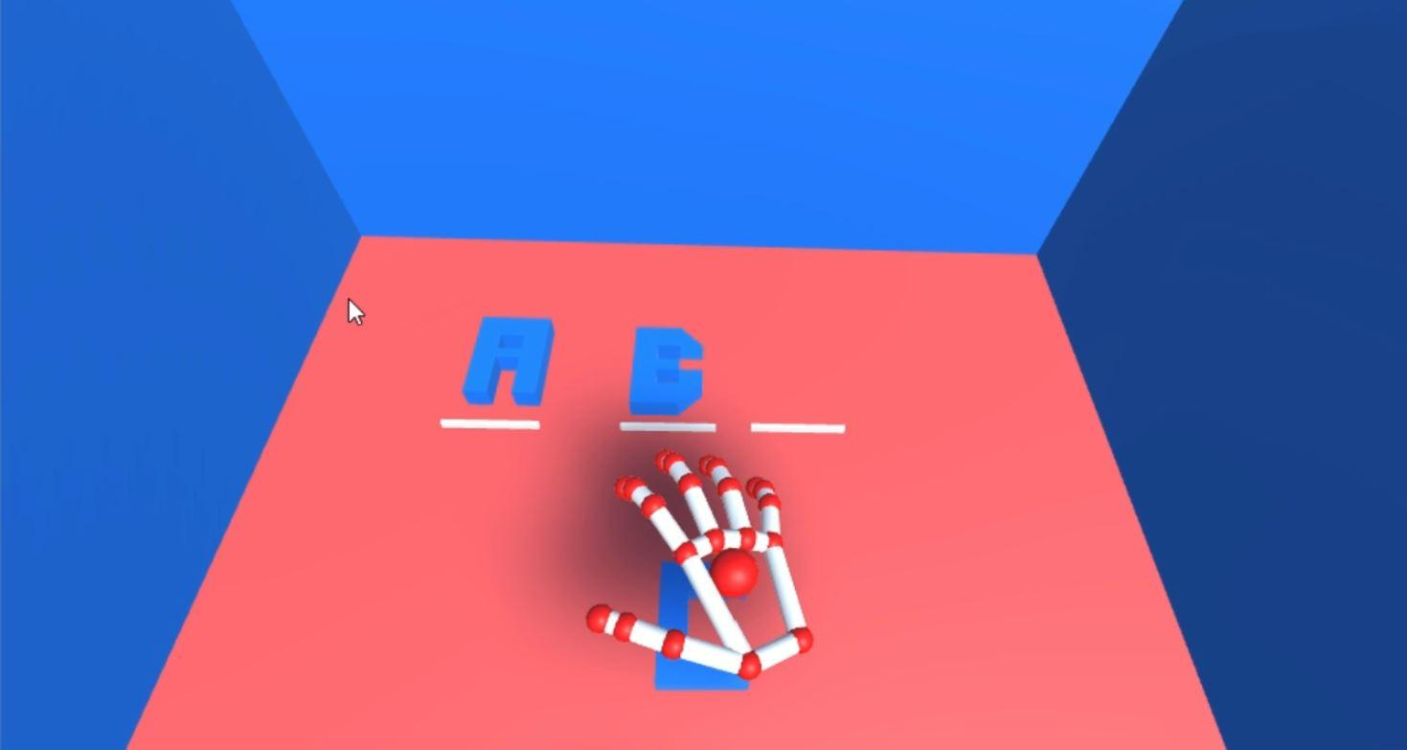

Example of the hand being recognized by the Leap Motion visualizer which is interfaced with unity.

#photo of a leap visualizer hand

**4 Proposed solution: System architecture**

We intend to develop an application to help children with conditions such as Autism Spectrum Disorder (ASD) to learn in a more effective way using Augmented and Virtual reality which adapts its difficulty level in real time depending on the performance of the child

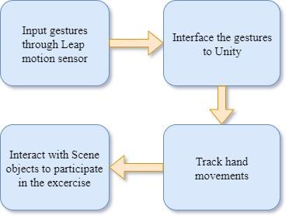

The application works on the basis of the integration explained in the above figure. The input gestures are first tracked by the infra-red cameras on the leap motion sensor. The gestures are then interfaced to unity by adding the leap motion SDK assets to unity. The application then converts the tracked gestures to actual hand movements to be shown on the screen. The hand movements are then used to interact with the scene objects using the leap motion interaction engine assets. The child then has to use his hand movements to complete the levels.

**5 Working of Built model**

The application built is an interactive game that works on the technology and hardware explained above. The game has been split into 3 sets of levels, each containing 5 levels. All the levels in the same set are of almost the same difficulty level. This game is specifically meant to teach and enhance their knowledge of alphabets and words. This game can be further improved by adding new levels for numbers etc. The alphabets are all modelled using blender to enhance the feel of actually holding the alphabets in the hand. The game tracks all the actions made by the child and evaluates them based on 4 specific metrics.

* recognition time
* Coordination time
* Total time taken to complete the level
* Number of wrong attempts

The game consists of fill in the blank types of exercises. There are one or more blanks on the screen depending on the difficulty level, which the child is expected to fill. The child has to grab the right alphabet from the lot and has to place it correctly in the given blank. This scoring of this process is based on the metrics mentioned above. The metrics have been chosen after extensive research on the problems faced by children diagnosed with Autism Spectrum Disorder, and based on the suggestions of physicians who work with children diagnosed with ASD.

Recognition time:

Once the level is shown to the child, partially completed patterns or common words are presented on the screen. The time taken by the child to recognize the correct alphabet for the blank and grab that alphabet is recorded and saved as the recognition time.

Coordination time:

Hand dexterity is one of the major issues with children diagnosed with autism spectrum disorder. The children have difficulty with fine movements such as holding delicate objects etc. The children after grabbing the correct alphabet for the blank have to hold it properly and place it in the correct blank. The time taken by the child to move the alphabet from its place to the correct blank is recorded as the coordination time.

Total time taken:

Total time taken is the sum of recognition and coordination time for all the blanks in that specific level. This time is tracked to keep a check if the child is struggling to complete the level. The levels are reset or moved to a previous level, if the child spends over a time limit on the same level, he is taken back to a previous level of lesser difficulty.

Number of wrong attempts:

As the name suggests, this field tracks the number of times the child has tried to place the wrong alphabet in the blank. Each time a wrong letter is placed in a blank, the letter snaps back to its original position. The child has to then try a different letter to fill the blank.

All the above-mentioned metrics are used to evaluate the child and the reports are shared with the physician or the child’s parents.

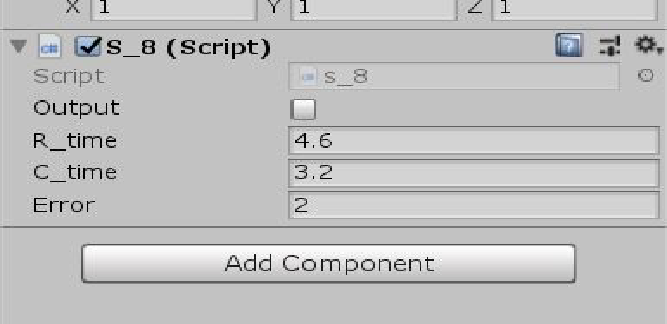

Dynamic Difficulty:

In order to keep the child from getting bored from trying easier levels and to prevent the child from struggling at higher difficulty levels, we follow a methodology called dynamic difficulty. Dynamic difficulty is where the difficulty of the level is chosen automatically by the game depending upon the performance of the child based on the above-mentioned metrics in that particular level. There are primarily two methods for adjusting the difficulty parameters:

1.Reactive- Reactive changes are simpler to execute and also happens during the interacting of the player and the game which can make the result of the changes predictable and effective. The problem with such a method Is that dynamic changes to behaviors and patterns in the game could make the game feel very unpredictable and sometimes even erratic which might reduce the immersion the player has from the game

2.Proactive- Proactive changes avoid the pitfall which reactive adjustments faces by pre-adjusting the game parameters before the player enters the level/scene but it has a few shortcomings as well. We cannot determine the number of changes the future state will undergo depending on the users' current actions and hence certain actions might cause the changes to go in loops which can cause undesirable changes to occur.

After careful consideration of the advantages and disadvantages of the two approaches we have chosen the proactive approach for our application.If the child keeps performing exceptionally and has cleared the qualification criteria for the current set of levels, the child is directly moved to the next set of levels, without completing the left-over levels in the same difficulty. If the child seems to struggle at a particular level the user is moved to a previous level. If the struggle persists, then the child is moved to the previous set of levels rather than just the previous level and has to complete the previous set before proceeding the current set. This keeps the child motivated when they are struggling and also provides more practice to them before they go on to higher difficulty levels. All the level transitions are tracked and recorded in the final report. The repetition of levels also gives an analytics point by comparing the different attempts on the same level.

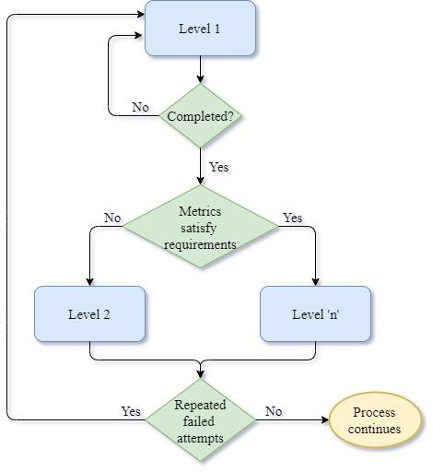

Level Set 1:

The levels in this set contain sequential alphabets with a single blank and starting from only one letter to choose from and moving up to 3 letter lot to choose from for the correct blank. This is the easiest set of levels. These levels mainly focus on getting the child accustomed to the game processes. They also have an option to reset the level by themselves. In such a case, the metrics are also reset and the unsuccessful attempt is ignored. They further have to start things from the beginning.

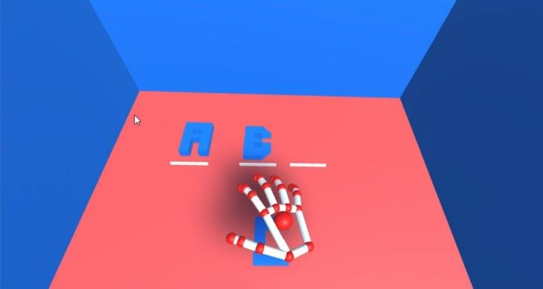

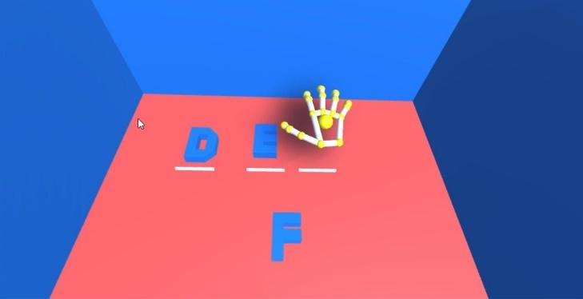

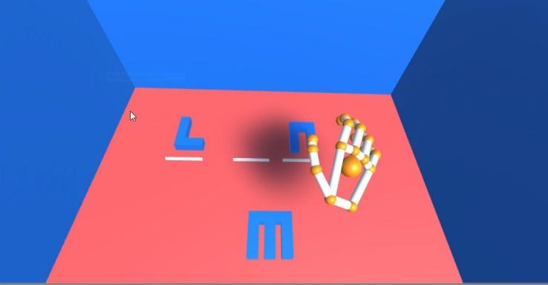

Level set 2:

These levels contain an image representing a 3-letter word and have 1 blank in them. These levels help in the identification of images by the child. This set is of a moderate difficulty level.

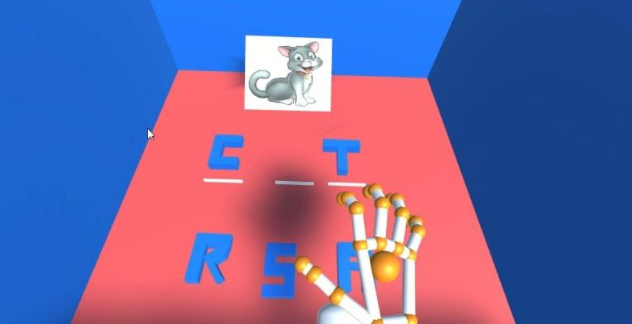

Level set 3:

This set has the hardest difficulty amongst the 3 set. This set also involves identification of an image and filling in the blanks. The increased difficulty is made possible by using 4 letter words and having multiple blanks in the words.

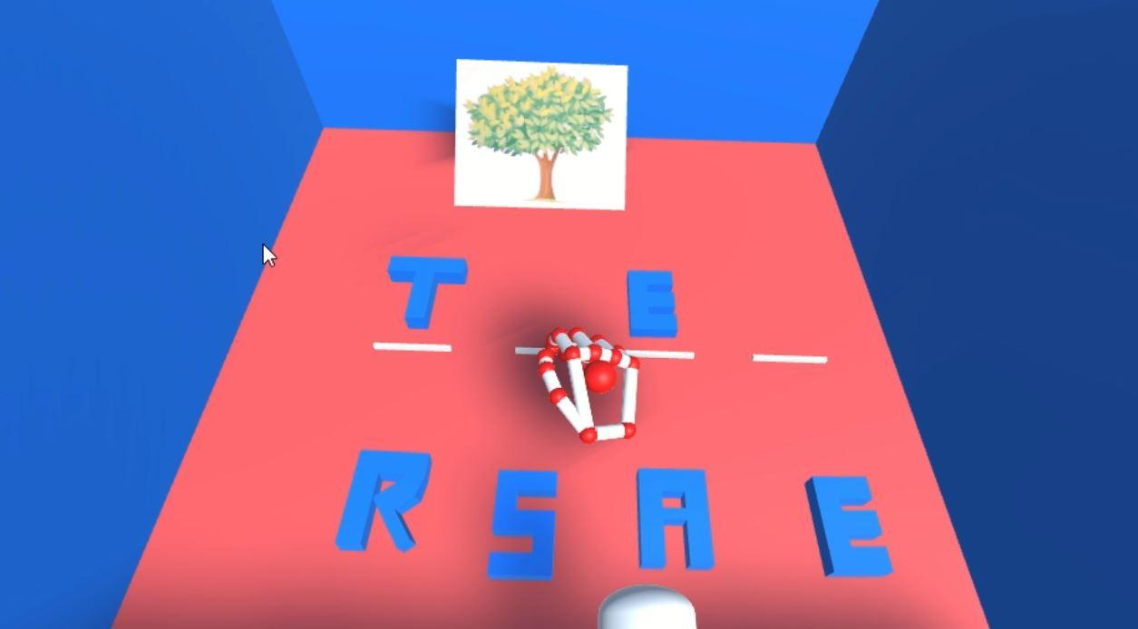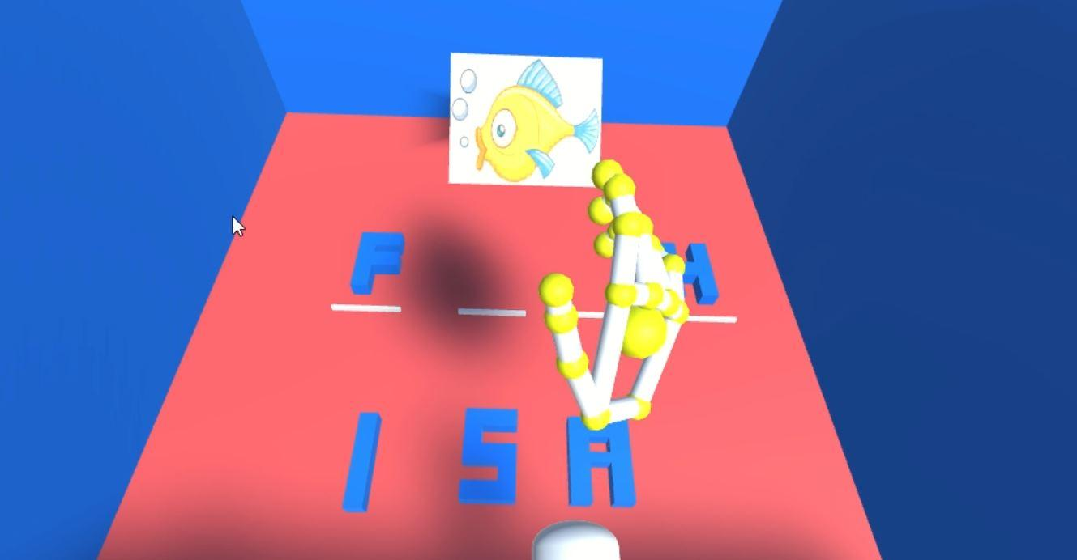

**6. Results**

The application was built successfully and functions as expected. Hand recognition was accurate and therefore accurate judgement of the child's coordination can be made. The dynamic difficulty module also allowed the application to be highly adaptive thereby providing effective learning to the child. The results of a test on one child is given below.

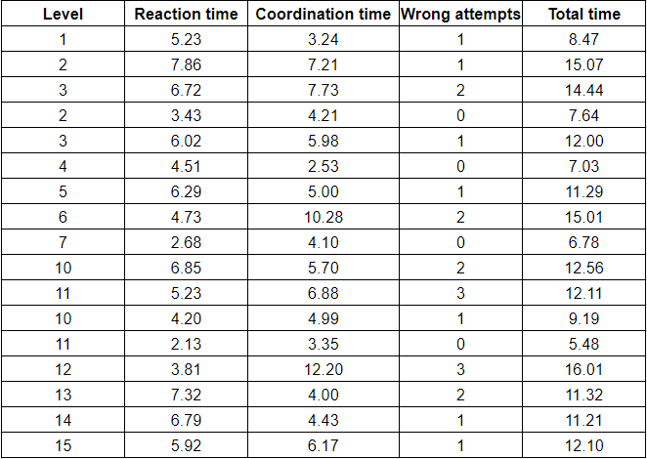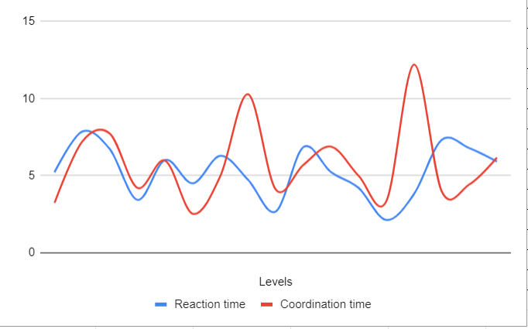

**7. Conclusion**

A system which gamifies proven traditional exercises into a Virtual Reality system has been created. The system is augmented using gesture recognition in order to assess as well as improve the coordination of the child as well as help increase interactivity with the system. Since the severity of learning disabilities varies widely, in order to make the system effective for a wide range of children, dynamic difficulty was introduced into the system.

The application can be further developed by improving on the mathematical function involved in obtaining the metric indicating the performance of the child. Continuous testing will be required to fine tune the right combination of the parameters in order to obtain an effective metric. Implementing deep learning into our system will allow the application to evolve into a robust Autism Diagnostic system as well and could prove to be effective because of the accurate parameters obtained from the motion sensors.

**Bibliography:**

[1] Osama Halabi, Samir A. El-Seoud, Jihad M. Alja'am, Hena Alpona ," Design of

Immersive Virtual Reality System to Improve Communication Skills in Individ-

uals with Autism",2017

[2] NyazDidehbani, TandraAllen, MichelleKandalaft, DanielKrawczyk, San-

draChapman," Virtual Reality Social Cognition Training for children with high

functioning autism",2018

[3] Stendal, Karen & Balandin, Susan. (2015). Virtual worlds for people with autism spectrum disorder: A case study in Second Life. Disability and rehabilitation.

[4] Lal Bozgeyikli ,Andrew Raij ,Srinivas Katkoori ,Redwan Alqasemi," A Survey

on Virtual Reality for Individuals with Autism Spectrum Disorder: Design Con-

siderations".2017

[5] Patricia Mesa-Gresa,Hermenegildo Gil-Gomez, Jose-Antonio Lozano-Quilis and

Jose-Antonio Gil-Gomez," E  
ectiveness of Virtual Reality for Children and Ado-

lescents with Autism Spectrum Disorder: An Evidence-Based Systematic Re-

view",2018

11

[6] Gaoxia Zhu , Su Cai , Yuying Ma , Enrui Liu "A Series of Leap Motion-Based

Matching Games for Enhancing the Fine Motor Skills of Children with Autism"

[7] Ti  
any Y. Tang, Mary Falzarano, Patricia A. Morreale "Assessment of the util-

ity of gesture-based applications for the engagement of Chinese children with

autism"