**CSE6224 SOFTWARE REQUIREMENTS ENGINEERING TRIMESTER 2510**

**PROJECT PART 1: SRS**

**Lecture section: TC1L**

**Tutorial section: TT3L**

|  |  |
| --- | --- |
| **Student Name** | **Student ID** |
| **Morgan Lee Guan Han** | **1211107272** |
| **ABDUL NASSER KOLATHUMKARA, MUHAMMED NAZIM** | **S-241UC241F9** |
| **Amir Hamzah bin Ahmad Shukri** | **1211106241** |

# 1. Introduction

## 1.1 Purpose

The purpose of the “Campus Accessibility Navigation System with Facilities and Event Integration” is to allow the staff, students and visitors of MultiMedia University (MMU) Cyberjaya to navigate the campus hassle free including ones with disabilities and to provide live alerts regarding the events and obstructions on campus.

## 1.2 Scope

The Campus Accessibility Navigation System is a standalone in-house application developed for Multimedia University **(MMU)** Cyberjaya. It is designed to support real-time; accessibility focused campus navigation integrated with the university’s facilities and event management systems. The system will function primarily as a kiosk application placed at strategic locations on campus (e.g, entrances, libraries, main halls), offering user interactive maps, accessible route suggestions, and dynamic information on construction, elevator status, and events.

This software system interfaces with the following:

* MMU Facilities Management System
* MMU Events Calendar and Student Affairs database
* Map Services API (for rending and routing)
* University Geo-database (buildings, paths, accessibility, features)

## 1.3 Product Overview

The “Campus Accessibility Navigation System with Facilities and Event Integration” is an in-house kiosk-based navigation system which is developed exclusively for MMU Cyberjaya. The system assists students, staff and visitors with and without disabilities in navigating the campus efficiently and safely.

The system is installed on kiosks placed in high traffic areas throughout the campus, The system offers real-time route planning based on accessibility features such as ramps, elevators, and step-free paths, and informs you about potential obstacles such as elevator outages or temporary closures.

The system is integrated with the “MMU Facility Management System”, “MMU Events Calendar and Student Affairs database”,” Campus GIS / Mapping Data” and “University Geo-database" which enables it to reflect the real world in real time.

Because the system is fully in-house and not reliant on external platforms or mobile web access, this kiosk-based system ensures dedicated, reliable functionality within the MMU network.

### 1.3.1 Product Perspective

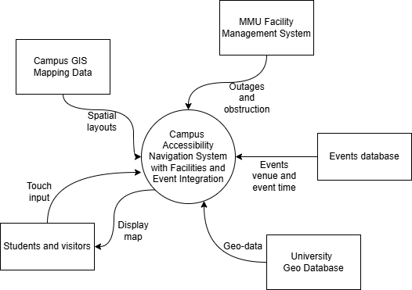

* MMU Facility Management System

Let’s Facilities Management Department (FMD) to provide real-time data on elevator outages, construction activities, and temporary accessibility barriers. These updates are reflected in the system to prevent routing through inaccessible areas.

* MMU Events Calendar and Student Affairs Database

Supplies up-to-date information on scheduled campus events, including location, timing, and temporary changes to accessibility (e.g., blocked paths, increased crowd traffic). This data allows the system to suggest alternate accessible routes and prepare users for event-related disruptions.

* Campus GIS / Mapping Data

Provides the base geospatial layout of the campus, including buildings, walkways, accessibility features (such as ramps and elevators), and points of interest.

* University Geo-Database

Offers precise geolocation and spatial metadata, enabling the system to align live campus updates with actual locations in real time. This integration helps ensure that the map interface accurately represents the physical layout and conditions of the campus environment.

### 1.3.2 Product Functions

* Display campus building and path layouts

The system provides an interactive map showing detailed layouts of campus buildings, walkways, and entrances.

* Show accessible route (ramps, elevators, lifts)

Users can view the location of critical accessibility features such as ramps, elevators, lifts, tactile walkways, and accessible restrooms on the system.

* View updates on outages and maintenance

The system delivers live updates regarding temporary disruptions such as elevator outages, construction zones, or path closures.

* Display university events calendar and venue details

The system is integrated with the university’s event calendar to display upcoming events and venue locations.

### 1.3.3 User Characteristics

* Students, Staff and Visitors

These users are expected to have basic computer skills. The kiosk interface is designed to be intuitive and requires no technical expertise. Most interactions involve simple touch-based navigation, searching for destinations, and viewing accessible routes or events.

* Administrators (FMD and Events Staff)

Administrators using the backend of the system such as facilities personnel and event coordinators are expected to have moderate to high technical skills. Their tasks may include updating event schedules, uploading maintenance alerts, managing accessibility data, and monitoring system performance.

## 1.3.4 Limitations

* Kiosk-Only Access

The system is restricted to in-house kiosk terminals and is not accessible via personal devices. This limits usage to individuals who are present at kiosk locations on campus.

* Hardware Dependency

Hardware malfunctions or network outages may affect system availability.

## 1.4 Definitions

Provide clear definitions for all key terms used in the Software Requirements Specification (SRS).

This section ensures that all stakeholders have a shared understanding of the terminology used

throughout the document. Definitions can include terms specific to the software system being

developed, technical jargon, or concepts that require further clarification.

Example:

• Application: A set of software programs designed to perform a specific function for the

user. In this context, it refers to the Research Grant Management System that helps

manage grant submissions and approvals.

Actual:

This section provides definitions for key terms used throughout the Software Requirements Specification (SRS) to ensure consistency and a shared understanding among all stakeholders.

|  |  |
| --- | --- |
| **Term** | **Definition** |
| Accessibility | The design and functionality of the system that allows individuals with disabilities or mobility impairments to navigate the campus independently |
| Application | The in-house software system being developed for MMU Cyberjaya to provide real-time campus navigation and accessibility information |
| Campus Map | A graphical representation of MMU’s campus layout including buildings, paths, ramps, and elevators used by the system for route planning |
| Facilities Management | The university department responsible for infrastructure maintenance and construction updates, which supplies facility status data to the system |
| Kiosk Terminal | A physical computer setup deployed on campus allowing users (student, staff, visitor) to access the application in a public space. |
| Event Calendar | The internal scheduling system of the university that contains official event data used to adjust routes dynamically and to promote on going events |
| Elevator Status System | The monitoring subsystem that tracks elevator functionality and availability within MMU buildings |
| Geo-data | Spatial data representing campus features such as building locations, paths, and elevation, used for route calculations |
| In-house Application | A software application developed and deployed within the university’s internal infrastructure, not accessible externally. |
| Route Planner | The component of the system that calculates accessible navigation path based on user input, obstacles, and real-time data |
| Administrative User (Staff) | Authorized MMU staff member with access to backend functions such as data updates, facility status, and event scheduling integration |
| Visitor | A non-MMU-affiliated individual using the public kiosk interface to access navigation features without authentication. |
| Student | A primary user of the system accessing navigation functions anonymously via kiosk or desktop without requiring login. |
| Static Map Data | Non-changing baseline data about campus layout used in conjunction with dynamic information for rendering map |

# 2. References

References list all the sources you’ve cited or consulted while preparing the SRS. These may

include standards (like ISO/IEC/IEEE 29148:2018), textbooks, research articles, technical

documentation, or software manuals.

Note: Use APA 7th edition format for consistency and credibility. This is especially helpful if your

SRS will be reviewed in academic settings or by non-technical stakeholders.

Example:

IEEE. (2018). ISO/IEC/IEEE 29148:2018 Systems and software engineering—Life cycle processes—

Requirements engineering. https://www.iso.org/standard/72089.html

Pohl, K. (2010). Requirements engineering: Fundamentals, principles, and techniques. Springer.

Actual:

IEEE. (2018). ISO/IEC/IEEE 29148:2018 Systems and software engineering—Life cycle processes—Requirements engineering. International Organization for Standardization. https://www.iso.org/standard/72089.html

Pohl, K. (2010). Requirements Engineering: Fundamentals, Principles, and Techniques (p. 813). Heidelberg: Springer. https://doi.org/10.1007/978-3-642-12578-2

W3C. (2018). Web Content Accessibility Guidelines (WCAG) 2.1. World Wide Web Consortium (W3C). https://www.w3.org/TR/WCAG21/

Larman, C. (2004). Applying UML and patterns: An introduction to object-oriented analysis and design and iterative development (3rd ed.). Pearson. https://personal.utdallas.edu/~chung/SP/applying-uml-and-patterns.pdf

University of Washington. (n.d.). AccessMap Seattle. Taskar Center for Accessible Technology. https://www.accessmap.io/

Multimedia University. (2024). MMU Facilities and Campus Services. https://www.mmu.edu.my/facilities/

# 3. Requirements

## 3.1 Functions

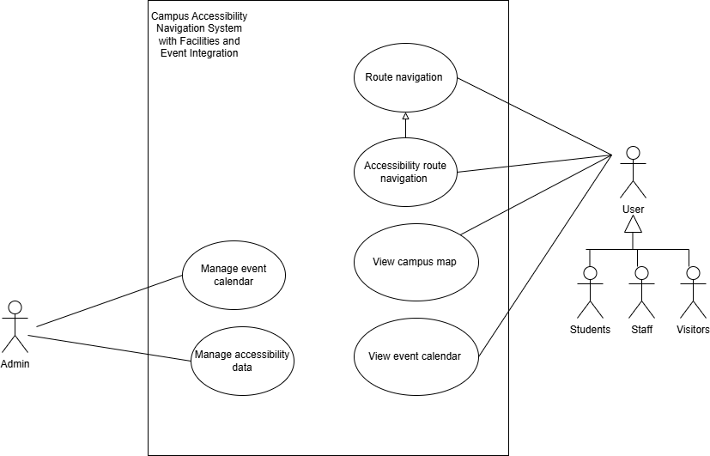

* Students, staff and visitors:
  + View event calendar

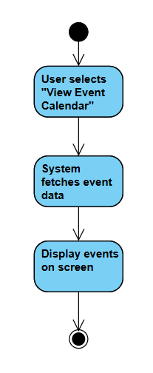

* + Route navigation

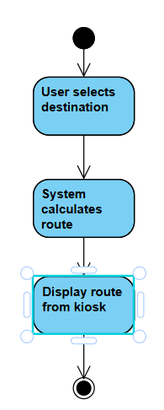

* + View campus map

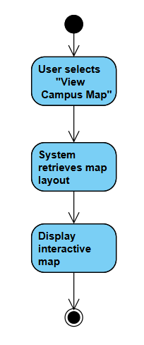

* + Accessibility route navigation

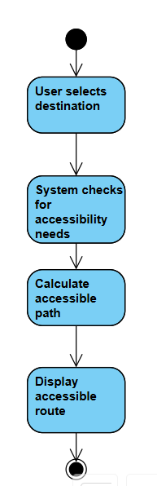

* Administrator
  + Manage event calendar

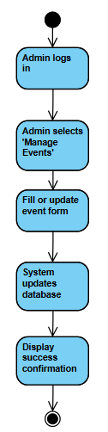

* + Manage accessibility data

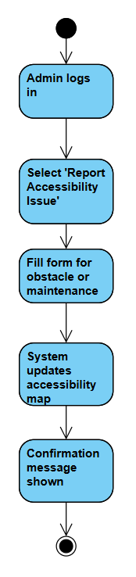

## 3.2 Performance Requirements

1. The system shall respond to route generation requests less than 3 seconds under normal load conditions
2. The system shall generate correct, accessible routes based on real-time availability of elevators, ramps, and walkways
3. The system shall notify users when no accessible path is available and provide alternate suggestions if possible.
4. The system shall reflect updates to event and facility data less than 1 minute of a change made in the source system.
5. The system should allow administrative users to verify real-time data updates manually through a diagnostic dashboard.
6. The system might log all verification activities for auditing purposes.

## 3.3 Usability Requirements

* Ease of use
  + The system shall allow users to do core tasks (e.g., finding a route or viewing events) within 3 clicks or less from the main screen.
* Learnability
  + New users shall be able to use the primary functions of the system within 2 minutes or less without external assistance.
* Efficiency
  + The system shall be able to search for a route to any building on campus within 30 seconds or less on average
* User satisfaction
  + A built-in feedback module shall allow the user to rate their experience on a 5-star scale after a task has been completed.

3.4 Interface Requirements

### • 3.4.1 System Interfaces: Interfaces with external systems or hardware.

* Facilities Management Department Systems
* University Events Management Systems

### • 3.4.2 User Interfaces: Describe the layout and interaction elements, e.g., navigation, buttons, data entry fields.

* The system shall provide a touch-based user interface with large, high-contrast buttons and icons to support ease of use and accessibility on kiosk devices.

### • 3.4.3 Hardware Interfaces: Specify hardware connections, devices, and communication protocols.

* The system shall operate on touchscreen kiosk terminals equipped with a minimum 1080p resolution display and a stable connection to the network via Ethernet.

• 3.4.4 Software Interfaces: Describe interactions with other software or APIs.

* The system will utilize OpenStreetMap API

• 3.4.5 Communications Interfaces: Specify protocols, message formats, and network requirements.

* Protocols:
  + HTTP/HTTPS for API calls
  + JSON/XML for data exchange
  + SSL/TLS encryption for secure communication
* Network:
  + Internal MMU network for administrative access and data sync
  + External internet access for public information (e.g., map services)

## 3.5 Logical Database Requirements

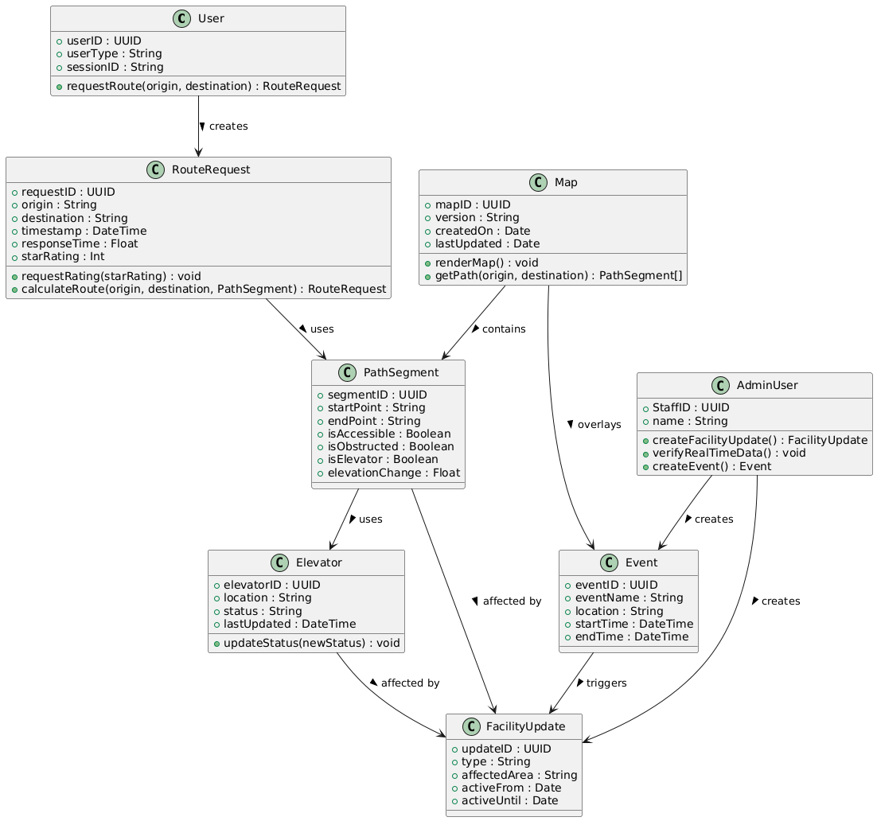

This section describes the core data entities, their attributes, relationships, and logical interactions. The system follows an object-oriented structure where each class represents a conceptual data model with attributes and operations.

User

• Attributes:

- userID (Primary Key)

- userType: Defines whether the user is a student, staff, or visitor.

- sessionID: Optional session tracking.

• Methods:

- requestRoute(origin, destination)

• Relationships:

- A User creates a RouteRequest.

RouteRequest

• Attributes:

- requestID (Primary Key)

- origin, destination

- timestamp

- responseTime

- starRating

• Methods:

- requestRating(starRating)

- calculateRoute(...)

• Relationships:

- Associated with multiple PathSegments used to build a complete route.

- Created by a User.

Map

• Attributes:

- mapID (Primary Key)

- version, createdOn, lastUpdated

• Methods:

- renderMap()

- getPath(origin, destination)

• Relationships:

- A Map contains multiple PathSegments.

- A Map may overlay real-time Event data.

PathSegment

• Attributes:

- segmentID (Primary Key)

- startPoint, endPoint

- isAccessible, isObstructed, isElevator

- elevationChange

• Relationships:

- Used by RouteRequest

- Related to Elevator if isElevator is true

- May be affected by a FacilityUpdate

Elevator

• Attributes:

- elevatorID (Primary Key)

- location, status, lastUpdated

• Methods:

- updateStatus(newStatus)

• Relationships:

- Used by PathSegment

- Affected by FacilityUpdate

Event

• Attributes:

- eventID (Primary Key)

- eventName, location, startTime, endTime

• Relationships:

- Overlays the Map

- Triggers one or more FacilityUpdate records

- Created by AdminUser

FacilityUpdate

• Attributes:

- updateID (Primary Key)

- type

- affectedArea

- activeFrom, activeUntil

• Relationships:

- Triggered by Event

- Created by AdminUser

- Affects PathSegments and Elevators

AdminUser

• Attributes:

- StaffID (Primary Key)

- name

• Methods:

- createFacilityUpdate()

- verifyRealTimeData()

- createEvent()

• Relationships:

- Creates FacilityUpdate

- Creates Event

Constraints

• Every RouteRequest must be linked to a valid User.

• Each PathSegment may only link to one Elevator (if applicable).

• An Event may trigger one or more FacilityUpdate records.

• Map must contain at least one PathSegment to be valid.

• FacilityUpdate dates (activeFrom < activeUntil) must be enforced.

• AdminUser must be authenticated internally.

## 3.6 Design Constraints

* The user interface must align with the university’s colour palette.
* The programming language used must be memory safe.
* All creative media assets used must be approved by the university

## 3.7 Software System Attributes

• Reliability: The system should be able to recover from a crash within 1 minute, ensuring minimal interruption.

• Availability: The system should be available during operational hours (7:00 am to 10:00 pm Monday to Sunday) and should be up 99.99% of the time.

• Security: The system should use role-based access control (RBAC) and encryption for all sensitive user data such as login details and feedback submissions.

• Maintainability: The system shall be developed using modular, well-documented code that adheres to standard best practices, which allows efficient troubleshooting and future expansions.

• Portability: The system shall run on Linux-based environments without requiring platform-specific configurations, ensuring seamless deployment on MMU internal servers.

## 3.8 Supporting Information

The Kano model evaluated from an online survey.

* User Roles: Satisfied if implemented.
* 3D Immersive Path Direction: An attractive feature.
* Live Alert: An attractive feature.
* Notifications for foot traffic and access limitations: An attractive feature.
* Event Awareness: Satisfied if implemented.
* Route Planning: Must have.
* Coloured Map: Satisfied if implemented.

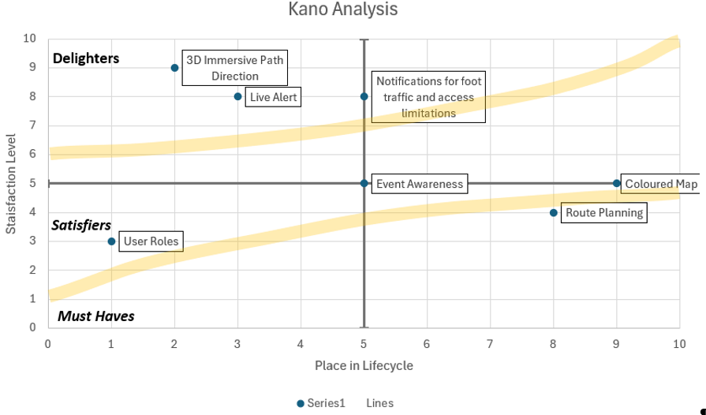

Problem Description:  
This project aims to keep students frequently updated with the physical status of its university campus regarding hazards, obstructions, or places of interest.

# 4. Verification

## 4.1 Verification Approach

1. The system shall be verified using unit testing, functional testing, and system integration testing to ensure conformance to performance and functional requirements
2. The system shall be tested by the development team and internal quality assurance (QA) staff assigned by the project lead.
3. The system shall undergo verification at each major development milestone, including:
   * Completion of the map and routing engine
   * Completion of real-time data integration
   * Prior to deployment on campus kiosks
4. The system should support simulated inputs for offline testing in the absence of live data feeds (e.g., elevator and event data)
5. The system might provide verification logs to support traceability and compliance tracking

## 4.2 Verification Criteria

1. The system shall respond to route generation requests less than 3 seconds under normal load conditions
2. The system shall generate correct, accessible routes based on real-time availability of elevators, ramps, and walkways
3. The system shall notify users when no accessible path is available and provide alternate suggestions if possible
4. The system shall reflect updates to event and facility data less than 1 minute of a change made in the source system
5. The system should allow administrative users to verify real-time data updates manually through a diagnostic dashboard
6. The system might log all verification activities for auditing purposes

# 5. Appendices

## 5.1 Assumptions and Dependencies

This section lists the conditions assumed to be true and external elements that the system depends on for correct operation and development.

1. The system shall depend on the availability of the internal MMU network to access facilities, maps, and event data.
2. The system shall depend on accurate and regularly maintained geo-data from the Facilities Management Department.
3. The system shall depend on the integration with the university’s Event Calendar system to retrieve scheduled campus events
4. The system should rely on the proper functioning of Map Service APIs to render map and path data.
5. The system might be impacted by power outages or network disruptions in campus kiosks or internal servers.

## 5.2 Acronyms and Abbreviations

|  |  |
| --- | --- |
| **Acronym/Abbreviation** | **Meaning** |
| API | Application Programming Interface |
| GIS | Geographic Information System |
| MMU | Multimedia University |
| QA | Quality Assurance |
| UI | User Interface |
| SRS | Software Requirements Specification |
| WCAG | Web Content Accessibility Guidelines |

## 5.3 Glossary (Optional Section)

|  |  |
| --- | --- |
| **Term** | **Definition** |
| User | Any individual who uses the system, including the different roles such as, visitor, student, and administrator, each with different permissions. |
| Pathway | A direction for people to walk along. It can be in buildings or outside, and it may be marked or unmarked. |
| Point of Interest | Places in which people would want to go to. It can be a building, room, or a facility such as, water refill station or a kiosk. |
| Accessibility infrastructure | A fixture or machinery that is designed to assist in vertical mobility. It can be stairs, elevators, etc. |
| Events | Special activities hosted by organizers that can potentially obstruct pathways. It can be in buildings or outside fields. These activities can be private or public. |
| Network | Refers to a private wired network own by MMU |
| Kiosk | A small device usually placed along pathways to provide information on a computer screen. It may be interactive or static. |