Workshop on LEM using python

Tutorial
Tutorial on 1-D modelling of river long profiles

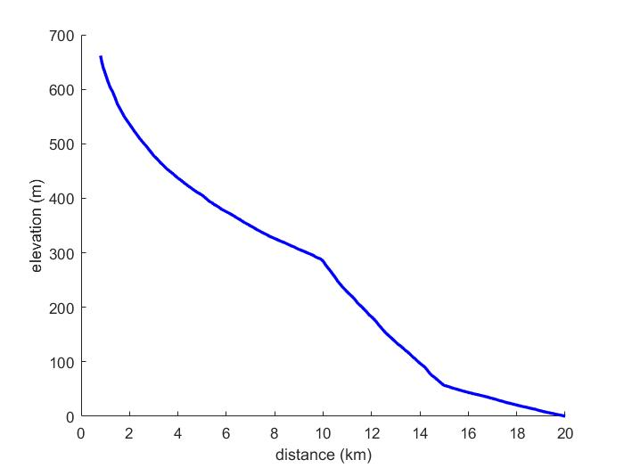

Tutorial on 1-D modelling of river long profiles

Objectives of the Tutorial:

to program in Matlab a simple 1-D profile model using Finite Difference scheme, and check results against analytic solution.

to experience numerical stability

to visualize the transient evolution of detachment and transport limited models following a base level fall, a climatic change or an uplift change.

I – Detachment limited river

A river whose profile is displayed in front page is displaying a clear nickpoint between 10 and 15km. In absence of further structural, geologic or tectonic information, we will try to reproduce this knickpoint by different scenario assuming a detachment limited model: incision rate = KA^{m}S^{n} with n and m fixed respectively at 1 and 0.5.

- Steady state uplift rate with spatial variations of uplift rates, and uniform erodibility coefficient K.
- Open in excel the profile of the river ‘River_profile.xlsx’ , and display the elevation and area profiles (you can also display a diagram Slope vs area)
- From the steady state equation seen during the class, estimate from the channel slope and the corresponding drainage area, the approximate uplift rate in the three main segments of the river (downstream the nickpoint, around the nickpoint, and upstream) _ we will assume that K = 2.10⁻⁵ yr⁻¹.
- Introduce on line 55 of the Matlab program, the 3 approximated values. Run the program, and modify the 3 values until obtaining a final profile that fits the observed river profile .
- What do you observe during the run? What would happen in nature if the river behaves like that? What would need to be modified in the program to account for this?

- Steady state uplift rate with spatial variations of erodibility coefficient K and uniform uplift rates.
- On line 55 of the Matlab program, impose a uniform uplift rate, and on line 57, try 3 values for K , run the program, and modify the 3 values until obtaining a final profile that fits the observed river profile .
- Do you observe the same phenomenon than during the runs of question 1? Why?

- Unsteady uplift rate with spatially uniform erodibility coefficient K and uplift rates.
- The unsteady scenario propose to explore a pulse of increased uplift between Timing(2) and Timing(3) (defined on line 59). The increase of uplift can be defined by the U_factor (Ufac on line 61)
- On lines 55 and 57 of the Matlab program, impose a uniform uplift rate and coefficient K, and play with the uplift increase factor and the Timing on lines 61 and 59, in order again to match, if possible, the observed river profile. In order to avoid random scenario, it is possible to roughly compute the wave speed of the receding nickpoint, and according to the distance between the base level and the knickpoint to estimate the Timing of the uplift perturbation.

- What do you conclude from these 3 scenarios?

