ETRACS Terminal Service API

Integration Guide

RAMESES SYSTEMS, INC

ETRACS Terminal Service API

Version 1.0

October 27, 2014

1. INTRODUCTION

The objective of this document is to define the ETRACS Terminal Service API (Application Programming Interface) to a level that enables prospective 3rd parties to understand the service concept and the interface requirement.

2. Activity Diagram

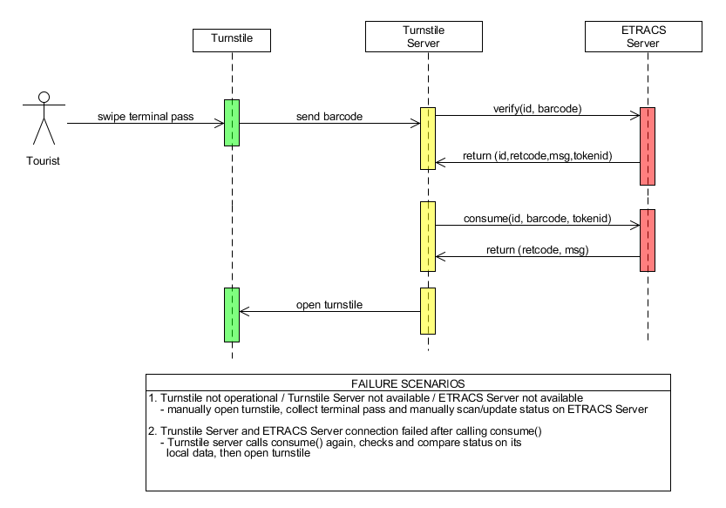

3. API Functions

3.1. Verify

Facility to check and validates the terminal pass information.

TRANSACTION | Verify Terminal Pass
METHOD | verify
PROVIDER URL | to be supplied by RAMESES
PARAMETERS
PROPERTY NAME | DATATYPE | DEFINITION
id | String | Turnstile ID  Required
barcode | String | Barcode Data  Required
RETURN VALUES (JSON format)
retcode | String | Response Code  0 – SUCCESS  1 – General Error  2 – Barcode does not exist  3 – Invalid Barcode  4 – Barcode has already been used  10 – Turnstile ID does not exist  11 – Turnstile ID is currently deactivated
message | String | Response Message
tokenid | String | Token ID

Verify Sample Request:

http://localhost:8070/.../AklanTerminalTicketService.verify?id=T001&barcode=1234567890

Verify Sample Response (JSON format):

{"retcode":0,"message":"Success","tokenid":"10042430231"}

3.2. Consume

Facility to mark the terminal pass as consumed or used.

TRANSACTION | Consume Terminal Pass
METHOD | consume
PROVIDER URL | to be supplied by RAMESES
PARAMETERS
PROPERTY NAME | DATATYPE | DEFINITION
id | String | Turnstile ID  Required
barcode | String | Barcode Data  Required
tokenid | String | Token ID  The tokenid you get from the verify method  Required
RETURN VALUES (JSON format)
retcode | String | Response Code  0 – SUCCESS  1 – General Error  2 – Barcode does not exist  3 – Invalid Barcode  4 – Barcode has already been used  5 – Invalid token id  10 – Turnstile ID does not exist  11 – Turnstile ID is currently deactivated
message | String | Response Message

Consume Sample Request:

http://localhost:8070/.../AklanTerminalTicketService.consume?id=T001&barcode=1234567890&tokenid=10042430321

Consume Sample Response (JSON format):

{"retcode":0,"message":"Success"}

